**Tools for ASP.NET development**

[](http://msdn.microsoft.com/en-us/rampup/bb352986.aspx)

Ascend to new heights in your career

[**http://msdn.microsoft.com/rampup**](http://msdn.microsoft.com/rampup)

Contents

Introduction 3

Visual Studio Web Development tools 3

Visual Web Developer 3

Smart Device Applications 3

Web Forms 3

XML Web Services 4

XML Support 4

The .NET Framework 4

Visual Web Developer 5

Better Source Code Editing 5

Visual Designer 9

ASP.NET Master Page Designer 9

Web Projects 12

Data Support 15

Standards Support 16

Summary 17

# Introduction

Visual Studio is a complete set of development tools for building ASP.NET Web applications, XML Web Services, desktop applications, and mobile applications. Visual Basic, Visual C++, Visual C#, and Visual J# all use the same integrated development environment (IDE), which allows them to share tools and facilitates in the creation of mixed-language solutions. In addition, these languages leverage the functionality of the .NET Framework, which provides access to key technologies that simplify the development of ASP Web applications and XML Web Services.

## Visual Studio Web Development tools

This section contains information about some of the latest tools and technologies available to Web Developers in this release of Visual Studio.

### Visual Web Developer

Visual Studio features a new Web page designer named Visual Web Developer that includes many enhancements for creating and editing ASP.NET Web pages and HTML pages. It provides a simpler, faster way to create Web Forms pages than in Visual Studio .NET 2003.

Visual Web Developer features improvements in all areas of Web site development. You can create and maintain Web sites as local folders, in Internet Information Services (IIS), or on an FTP or SharePoint server. The Visual Web Developer designer supports all ASP.NET enhancements, including nearly two dozen new controls that simplify many Web development tasks.

### Smart Device Applications

The Visual Studio integrated environment includes tools for targeting devices such as PDAs and Smartphones. Improvements include Visual C++ tools and native device runtimes, managed designers that provide improved platform-specific WYSIWYG and multiple form factor support, a new emulator, data handling tools similar to the desktop, and end-user deployment projects that eliminate the manual editing of .inf files.

### Web Forms

Web Forms are an ASP.NET technology that you use to create programmable Web pages. Web Forms render themselves as browser-compatible HTML and script, which allows any browser on any platform to view the pages. Using Web Forms, you create Web pages by dragging and dropping controls onto the designer and then adding code, similar to the way that you create Visual Basic forms.

### XML Web Services

XML Web Services are applications that can receive requests and data using XML over HTTP. XML Web Services are not tied to a particular component technology or object-calling convention and can therefore be accessed by any language, component model, or operating system. In Visual Studio, you can quickly create and include XML Web Services using Visual Basic, Visual C#, JScript, or ATL Server.

### XML Support

Extensible Markup Language (XML) provides a method for describing structured data. XML is a subset of SGML that is optimized for delivery over the Web. The World Wide Web Consortium (W3C) defines XML standards so that structured data will be uniform and independent of applications. Visual Studio fully supports XML, providing the XML Designer to make it easier to edit XML and create XML schemas.

## The .NET Framework

The .NET Framework is a multi-language environment for building, deploying, and running XML Web Services and applications. It consists of three main parts:

**Common Language Runtime**   Despite its name, the runtime actually has a role in both a component's runtime and development time experiences. While the component is running, the runtime is responsible for managing memory allocation, starting up and stopping threads and processes, and enforcing security policy, as well as satisfying any dependencies that the component might have on other components. At development time, the runtime's role changes slightly; because it automates so much (for example, memory management), the runtime makes the developer's experience very simple, especially when compared to COM as it is today. In particular, features such as reflection dramatically reduce the amount of code a developer must write in order to turn business logic into a reusable component.

**Unified programming classes**   The framework provides developers with a unified, object-oriented, hierarchical, and extensible set of class libraries (APIs). Currently, C++ developers use the Microsoft Foundation Classes and Java developers use the Windows Foundation Classes. The framework unifies these disparate models and gives Visual Basic and JScript programmers access to class libraries as well. By creating a common set of APIs across all programming languages, the common language runtime enables cross-language inheritance, error handling, and debugging. All programming languages, from JScript to C++, have similar access to the framework and developers are free to choose the language that they want to use.

ASP.NET ASP.NET builds on the programming classes of the .NET Framework, providing a Web application model with a set of controls and infrastructure that make it simple to build Web applications. ASP.NET includes a set of controls that encapsulate common HTML user interface elements, such as text boxes, buttons, and list boxes. These controls run on the Web server, however, and render their user interface as HTML to the browser. On the server, the controls expose an object-oriented programming model that brings the richness of object-oriented programming to the Web developer. ASP.NET also provides infrastructure services, such as state management and process recycling, that further reduce the amount of code a developer must write and increase application reliability. In addition, ASP.NET uses these same concepts to enable developers to deliver software as a service. Using XML Web Services features, ASP.NET developers can write their business logic and use the ASP.NET infrastructure to deliver that service via SOAP.

## Visual Web Developer

Visual Web Developer 2005 Express Edition is part of the Microsoft Visual Studio 2005 family, and is the best development tool for building data driven web applications with ASP.NET 2.0. As part of the Express family, Visual Web Developer provides a seamless upgrade path to Visual Studio Standard, Professional, and Team System.

Visual Web Developer is tuned to the specific needs of the Web developer through a new Web profile that exposes a menu and window layout optimized for Web development. The environment includes a best-of-breed HTML source editor, an improved visual page designer, a new project system, better support for working with data, and full XHTML standards support.  Collectively, these features enable you to develop data-driven Web applications faster and easier than ever before. Below we'll dive in and explore a few of the many Web development improvements coming with Visual Web Developer.

### Better Source Code Editing

Visual Web Developer has an improved HTML source editor which enables you to write and modify your pages faster. The source editor provides full Intellisense throughout your files and has new features for navigating and validating your markup.

#### Intellisense Everywhere

Intellisense -- the popup code hints which appear while you type -- has a dramatic impact on your productivity as a developer. While support for Intellisense in Visual Studio .NET 2003 is excellent today, support for Intellisense in Visual Web Developer gets even better.

In Visual Web Developer, Intellisense pops up everywhere. For example, you can take full advantage of Intellisense within the script blocks in single file ASP.NET pages. In addition, Visual Web Developer also supports Intellisense for ASP.NET Page Directives and for inline CSS style attributes within a page.

Visual Web Developer also provides Intellisense for all sections within a Web.Config configuration file, as well as any generic XML file that contains a DTD or XML Schema reference.

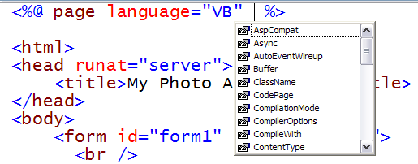

#### HTML Source Preservation

Visual Web Developer respects your HTML. The formatting of your HTML markup -- including all white space, casing, indention, carriage returns, and word wrapping -- is now preserved exactly as originally written, even when switching back and forth between the design view and source view of the page. You can completely trust Visual Web Developer to never modify your markup.

#### HTML Formatting Options

Visual Web Developer enables you to precisely control the format of all HTML and ASP.NET Server Control markup generated using the WYSIWYG designer.  You can now configure the tag casing, attribute quotation, indention style and word wrap characteristics of every html or server control tag in a page.  You can set these formatting options as defaults for all markup, as well as optionally override each formatting option on a per tag/control basis.  This provides you with the flexibility to fully control exactly how you want your markup to be generated.

HTML format settings can be exported and imported from Visual Web Developer to enable markup style standardization across multiple developers on a team.  Visual Web Developer also enables developers to easily apply HTML formatting rules to existing markup source (to handle those cases when you need to update existing HTML source with new formatting rules).

#### Tag Navigator

The HTML source editor within Visual Web Developer ships with a new �Tag Navigator� feature that enables developers to easily track their location and navigate within a complicated HTML document. The Tag Navigator displays the current "path" within the source of an HTML page by displaying a list of all the HTML tags which contain the tag where your cursor is currently located. Clicking on any of the nodes enables developers to optionally change the source level selection, and quickly move up and down a deep HTML hierarchy.

Imagine, for example, that you are editing the source of an HTML page with multiple nested HTML tables. Editing nested tables can be challenging since it is easy to get lost within the jumble of nested table rows and cells. However, by taking advantage of the Tag Navigator, you can avoid getting lost since the Tag Navigator continuously displays your current path within the hierarchy of table elements.

#### Tag Outlining

Tag Outlining enables you to work more effectively with large HTML documents. With Tag Outlining, you can right-click any HTML tag in the source editor and select Collapse Tag to hide the entire contents of the tag. Collapsing different regions of the HTML source code contained in a page makes it easier to focus on the particular region of the page which you need to edit.

#### Flexible Browser Targeting and Validation

Visual Web Developer enables you to easily target a specific HTML standard or browser when writing your HTML pages. For example, you can target your HTML pages to work with a particular browser such as Netscape Navigator 4.0 or Internet Explorer 6.0. Alternatively, you can target a particular HTML standard such as XHTML 1.0 Strict or XHTML 1.0 Transitional.

Your HTML will then be validated in real-time as you type in the source editor. Invalid HTML will automatically be underlined with a red squiggly (with a tooltip displaying an explanation of precisely how you violated the target). These validation errors are also summarized in real-time within the �Task List� window.

All browser/standard validation rules are pluggable within Visual Web Developer, and can be easily extended and customized by developers.  Visual Web Developer will include a number of automatic validation targets out of the box � including built-in validation support for XHTML, XHTML Transitional, and all major desktop and mobile browsers.

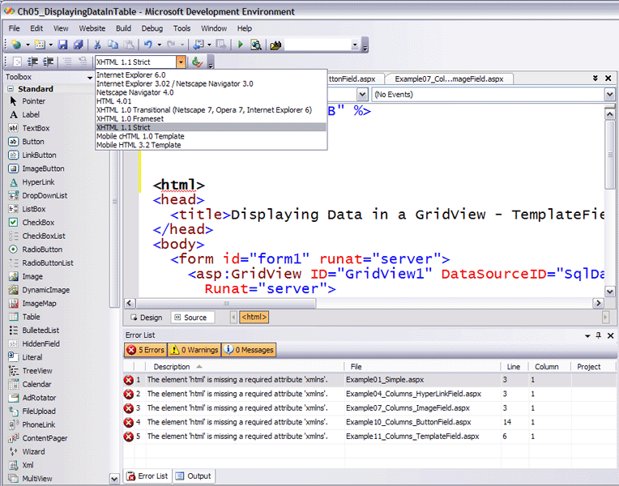  
Selecting a validation target

#### Code Refactoring

Code Refactoring enables you to easily and systematically make changes to your code. Code Refactoring is supported everywhere that you can write code including both code-behind and single-file ASP.NET pages. For example, you can use Code Refactoring to automatically promote a public field to a full property.

#### Intellitask

Intellitask is like a super smart clipboard designed for working with code. Intellitask improves your productivity by enabling you to easily apply standard code snippets anywhere within the source editor. Simply by right-clicking, you can inject common code into your pages. Visual Web Developer will ship with more than 200 web specific Intellitask code snippets out of the box.  Better yet, you can add your own code templates to Intellitask so that you can quickly modify your code in the future.

## Visual Designer

Visual Web Developer has an improved designer which makes it easier to visually build ASP.NET Web applications. By taking advantage of the new designer tools, you can build a feature rich, database-driven Web application without writing a single line of code.

### ASP.NET Master Page Designer

Master Pages enable you to create a common look and feel for the pages in an ASP.NET Web application. You can take advantage of Master Pages to create a single page layout and apply the page layout to multiple Content Pages.  For example, you can use a Master Page to ensure that every page in an application contains the same standard header, footer, and navigation bar.

Visual Web Developer provides full WYSWIYG authoring support for ASP.NET Master Pages. After you create a Master Page, you can apply the Master to new ASP.NET Pages within your Web site. Visual Web Developer provides great editing support when authoring an ASP.NET page based on a Master � enabling the designer to see what the combined page will look like, while simultaneously ghosting out all content from the Master that cannot be edited on the Content Page.

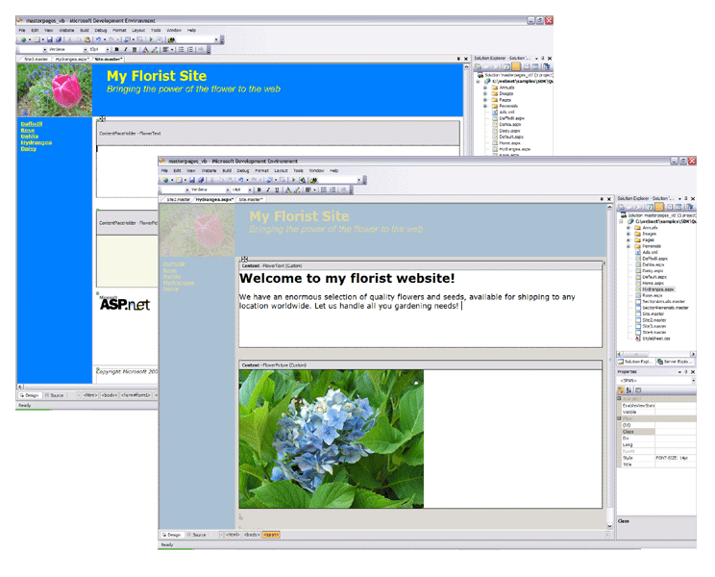Master Pages in the designer

#### Smart Tasks

Visual Web Developer enables you to perform many of the most common programming tasks directly from the designer surface. By taking advantage of Smart Tasks, You can create an entire, feature rich, database-driven Web application without writing a single line of code.

When you drag new controls onto the designer surface, a popup list of common tasks automatically appears. You can use the common tasks list to quickly configure a control's properties, as well as walk through common operations you might perform with it. For example, when you add a GridView control to a page, a common task list appears which enables you to quickly enable sorting, paging, or editing for the GridView.  When you add a TextBox control to a page, a common task list appears which enables you to quickly associate a validation control with the control.

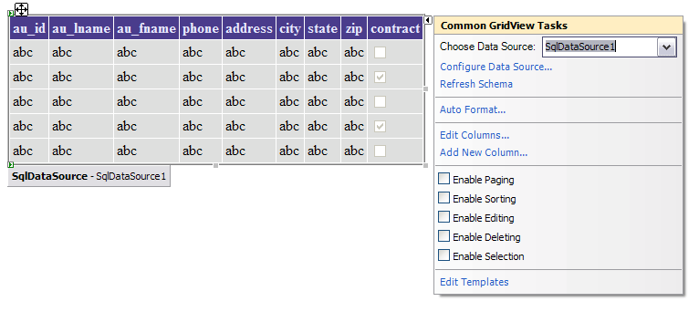Enabling GridView options with Smart Tasks

#### ASP.NET Template Editing

Visual Web Developer has better designer support for editing templates. You can take advantage of the new template editing features when working with data controls such as the DataList and GridView controls.

When adding a control to a template in the designer, you can easily specify the databound expressions to associate with the control properties. For example, if you drag a TextBox control onto a template, you can bind the TextBox control's Text property to a particular field from the data control's data source. The Edit Databindings dialog box provided by the Visual Web Developer template editing designer enables you to easily bind particular fields by name.

#### Table Editing

Visual Web Developer has better HTML table editing features. The improved Insert Table dialog box enables you to quickly control the look and feel of the new table when it is added to the designer surface. In addition, Visual Web Developer provides the ability to resize tables, table columns and table rows graphically within the designer surface (just click and hold down the appropriate element to size it).

## Web Projects

Visual Web Developer provides you with more flexibility and features for managing the files in your web projects. The new web project system includes new tools for accessing, compiling, and publishing your Web application projects.

#### File System Support

Visual Web Developer provides you with the option of creating a new Web application within any folder on your computer. When you create a file system project, you do not need to have IIS or Front Page Server Extensions installed on your computer. You can simply point at a folder and start building Web pages.  
   
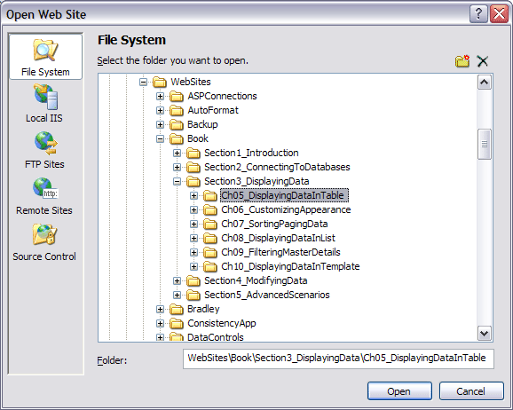Creating a File System Web site

Visual Web Developer includes its own built-in ASP.NET enabled Web server. This enables you to develop and debug Web applications on a computer without IIS installed.  It also enables developers to build and debug web applications without requiring Administrator access.

The built-in Web server provides you with a more secure way of building applications on a development machine. The built-in Web server cannot be accessed remotely (it can only be used by a local web browser) and it automatically shuts down when you close the Visual Web Developer development environment.

#### Local IIS Support (No FrontPage Server Extensions Required)

In addition to file system projects, Visual Web Developer now enables you to more easily manage projects which work with an IIS Web server. When you create a new IIS project, you can now view all of the Web sites and applications configured on your machine. You can even create new IIS Web applications or virtual directories directly from the New Web Site dialog box.

Frontpage Server Extensions (FPSE) are no longer required for locally developed IIS web applications. You can create and fully manage your websites without having to install or configure them.

#### FTP Support

Visual Web Developer now has built-in support for editing and updating remote web projects using the standard File Transfer Protocol (FTP). You can quickly connect to a remote Web site using FTP within the New Web Site and Open Web Site dialog box.

#### Web Publishing

With Visual Web Developer, you can now publish a Web site to a remote server easier than ever before. Built-in publishing features enable developers to easily keep files in a local project synchronized with files located on a remote Web server. Visual Web Developer provides automatic logging support for all files copied, and enables developers to quickly identify whether the latest files have been updated.  
   
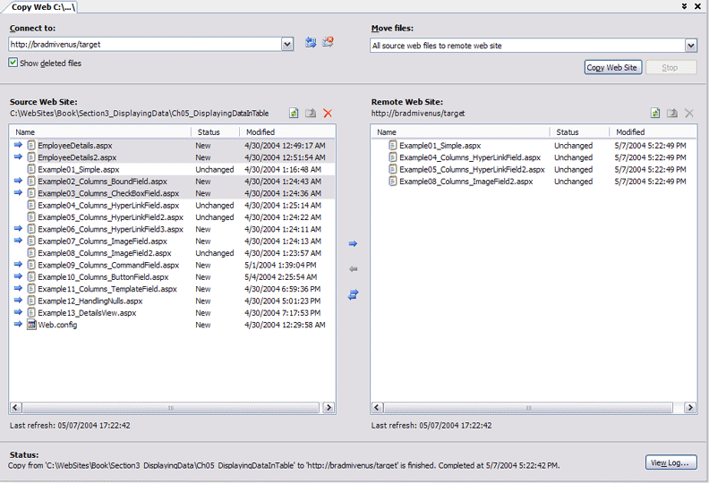Publishing a Web site to a remote Web server

#### Pre-Compiled ASP.NET Web Sites

Visual Web Developer now includes built-in IDE support for pre-compiling ASP.NET 2.0 applications.  By taking advantage of pre-compilation, you can automatically validate and compile all code in a site (including code-behind, inline code and business classes) and emit an output directory with only compiled .dll assemblies and the application's web.config file (all HTML markup and .aspx files will optionally be removed).  In addition, you can choose to obfuscate the resulting code as part of the pre-compilation process for greater intellectual property protection.

The pre-compilation feature enables developers to easily build and re-sell ASP.NET web applications without having to ship their source.  It can also improve the site's performance and startup time on a production server.

## Data Support

Visual Web Developer makes it much easier to work with data in your Web applications.

#### Drag and Drop Data Access

You can easily create a database-driven Web page by dragging and dropping data controls onto a page. By taking advantage of the new ASP.NET 2.0 data source controls, you can easily connect to a database, retrieve database records, and update database records without writing any code (or having Visual Studio write any code for you!).

Imagine, for example, that you want to display all the records from a Microsoft SQL Server database table named Products in a Web page. To do this, you simply need to drag two controls onto the page: a SqlDataSource control and a GridView control. By setting a few properties of these controls, you can automatically retrieve and display the records in a Web page.

#### Data Access Layer Designer

Visual Web Developer provides built-in designer support for building and maintaining a Data Access Layer within your web application.  The data designer enables developers to model database tables and stored procedures as components that encapsulate procedural ADO.NET data access logic.  You can then easily access and update your data from both web pages and business objects through these data components.

#### Powerful Object Data Binding

Visual Web Developer enables you to quickly create 3-tier applications with distinct presentation, business, and data layers. By taking advantage of the new ASP.NET ObjectDataSource control, you can declaratively bind data controls -- like the GridView, DataList, and DropDownList controls -- to a business or data component instead of binding the controls directly to a database.  This enables clean encapsulation and abstraction of functionality within your application � and eliminates the need to write any data access code in your presentation layer.

The development environment automatically guides developers through the process of binding a data control to a business object. Developers are prompted to select the particular methods from the business object to use for selecting, inserting, updating, and deleting data.  No code is required from the page developer.

#### Connection String Management

Visual Web Developer helps you avoid hard-coding database connection strings into your ASP.NET pages. All data connection dialogs and wizards provide you with the option of storing database connection strings in an application's Web.Config file.

Storing database connection strings in the Web.Config file makes your connection strings more manageable and more secure. If you need to change your database password, you need to change it at only one location.  The ASP.NET 2.0 MMC Admin tool automatically provides administrators with an easy to use interface for changing connection strings on servers. In addition, the tool can be used to encrypt connection strings on production servers.

## Standards Support

Visual Web Developer enables you to easily build applications that conform to industry and government standards. The development environment includes new tools for supporting W3C standards such as XHTML and government standards such as accessibility standards.

#### XHTML Compliant Designer

All HTML code generated by Visual Web Developer is XHTML compliant. For example, all the formatting options available from the toolbar generate HTML which is fully XHTML compliant. All tags generated by the designer are well-formed and properly cased for XHTML.

In addition to XHTML designer support, Visual Web Developer also includes tools for helping you write XHTML compliant code in the source editor. While working in the source editor, you can validate your HTML source code against either the XHTML 1.0 Transitional or XHTML 1.0 Strict standards. When your code doesn't successfully validate, you are provided with an explanation for the validation failure.

#### Accessibility Checker

Creating accessible Web pages -- Web pages which can be used by persons with disabilities -- is a requirement for many government agencies and large corporations. Visual Web Developer now enables you to easily validate and enforce accessibility standards.

You can use the integrated Visual Web Developer Accessibility Checker *(available in Visual Studio Standard Edition and above only)* to quickly identify accessibility problems in your application. The Accessibility Checker validates your ASP.NET pages against both the Section 508 and W3C Web Content Accessibility Guidelines (WCAG) standards, and will automatically output warnings and errors to the IDE Task List.

## Summary

Visual Web Developer is the best development tool for building dynamic, data driven web applications with ASP.NET 2.0. As detailed above, it provides it provides major enhancements for the Web application developer. With Visual Web Developer and the ASP.NET enhancements you will be able to build feature rich, database-driven Web applications faster and easier than ever before.