

Getting Started with Screen Capture Using Windows Media Encoder

Michael Patten
Microsoft Corporation
May 2004

Applies to:
Microsoft® Windows Media® Encoder 9 Series

Summary: Describes how to get started with the screen-capture feature in Windows Media Encoder. Learn how to capture a series of computer screens and the accompanying on-screen activities, such as typing and mouse movements. You'll create a Windows Media Video (.wmv) file, which you can then share with other people and play back in Windows Media Player. (17 printed pages)

Legal Notice
The information contained in this document represents the current view of Microsoft Corporation on the issues discussed as of the date of publication. Because Microsoft must respond to changing market conditions, it should not be interpreted to be a commitment on the part of Microsoft, and Microsoft cannot guarantee the accuracy of any information presented after the date of publication.
This White Paper is for informational purposes only. MICROSOFT MAKES NO WARRANTIES, EXPRESS OR IMPLIED, AS TO THE INFORMATION IN THIS DOCUMENT.
Complying with all applicable copyright laws is the responsibility of the user. Without limiting the rights under copyright, no part of this document may be reproduced, stored in or introduced into a retrieval system, or transmitted in any form or by any means (electronic, mechanical, photocopying, recording, or otherwise), or for any purpose, without the express written permission of Microsoft Corporation.
Microsoft may have patents, patent applications, trademarks, copyrights, or other intellectual property rights covering subject matter in this document. Except as expressly provided in any written license agreement from Microsoft, the furnishing of this document does not give you any license to these patents, trademarks, copyrights, or other intellectual property.
© 2004 Microsoft Corporation. All rights reserved.
Microsoft, MS-DOS, Windows, Windows Media, Windows NT, Windows Server, Active Directory, ActiveSync, ActiveX, Direct3D, DirectDraw, DirectInput, DirectMusic, DirectPlay, DirectShow, DirectSound, DirectX, FrontPage, HighMAT, JScript, Microsoft Press, MSN, NetShow, Outlook, PowerPoint, Visual Basic, Visual C++, Visual InterDev, Visual J++, Visual Studio, WebTV, Win32, and Win32s are either registered trademarks or trademarks of Microsoft Corporation in the U.S.A. and/or other countries.
The names of actual companies and products mentioned herein may be the trademarks of their respective owners.

Contents
Introduction 1
Preparing Your Computer for Screen Capture 1
Downloading Windows Media Encoder 1
Setting the Screen Resolution and Color Quality 1
Turning Off Your Screen Saver 2
Starting the Program You Want to Capture 3
Capturing Screens on Your Computer 3
Pausing or Stopping the Screen Capture 7
Reviewing Your Screen-Capture Video 7
Saving the Session Settings 8
Helpful Encoding Tips 8
Changing Your Encoding Settings 8
Capturing Video During the Screen Capture 10
Using Remote Desktop to Capture Screens 11
Troubleshooting 14
A Program Is Unresponsive 14
Screen Capture Loses Frames 15
For More Information 17

Introduction
The New Session Wizard in Microsoft® Windows Media® Encoder makes it easy to capture screen images in real-time. This wizard steps you through the basic screen-capture settings and then begins the screen-capture session for you.
During the session, you can capture your entire desktop screen, individual windows, or a specific region of the screen. The session also captures any on-screen activities, such as typing and mouse movements that occur. You can choose to broadcast your screen-capture video or encode it to a file just as you would any other content. The screen-capture video is encoded in Windows Media Format and can be played back in Microsoft Windows Media Player.
The screen-capture feature in Windows Media Encoder is useful for sharing events that occur on your computer screen with other people. For example, you might want to use your screen-capture video as part of computer training materials that show how to accomplish a computer task step-by-step.

Preparing Your Computer for Screen Capture
The following sections describe the tasks that you should complete before you begin capturing screens on your computer. Also, consider the following basic rules that can help improve your final screen-capture video:
- Capture only the minimum screen area that you need.
- Capture the screen size that you want for your final screen-capture video; do not use Windows Media Encoder to scale or resize the screens.
- Use the same screen resolution for capturing screens that you expect people to use when they view the final screen-capture video.

Downloading Windows Media Encoder
If you have not already done so, download and install Windows Media Encoder 9 Series (http://www.microsoft.com/windows/windowsmedia/9series/encoder/default.aspx).

Setting the Screen Resolution and Color Quality
Windows Media Encoder uses your computer's display settings to determine the screen resolution and color quality for the captured screen region. When you save the screen-capture session, these settings for your monitor are saved in the session file. If, after saving the session, you decide to change the resolution or color quality, you must create a new session to include these settings. Therefore, verify that your display settings are configured appropriately before you begin the screen capture.
By default, most computer screens are set to a resolution of 1024 x 786 pixels, whereas standard video uses a resolution of 720 x 480 pixels. On computers with slower processor speeds, CPU resources may not be sufficient to capture the entire screen at 1024 x 786 pixels and also simultaneously run a program. To improve your computer’s performance during the screen-capture session, especially if you plan to capture the entire computer screen, reduce the screen resolution and color quality.
To reduce the screen resolution and color quality
- Click Start, and then click Control Panel.
- Click Appearance and Themes, click Display, and then click the Settings tab.
- Note the current settings for Screen resolution and Color quality, so that you can reset these values after the screen capture is completed.
- For the Screen resolution, move the slider to 800 x 600 pixels.
- For the Color quality, click Medium (16 bit), and then click Apply.
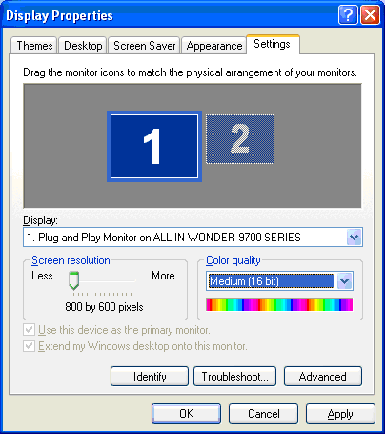
Figure 1. Windows XP Display Properties

Turning Off Your Screen Saver
If your screen saver appears during the screen-capture session, Windows Media Encoder will also capture the screen saver. Therefore, it is recommended that you turn off your screen saver before you begin a screen-capture session.
To turn off your screen saver
- Click Start, and then click Control Panel.
- Click Appearance and Themes, click Display, and then click the Screen Saver tab.
- In the Screen saver list, click (None).

Starting the Program You Want to Capture
If you want to capture a particular program window and not the entire computer screen, start the program that you want to capture before you begin the screen-capture session. If you do not start the program before you begin the screen-capture session, you will not be able to select the program window as the capture area in the New Session Wizard.

Capturing Screens on Your Computer
After you prepare your computer, as described in the previous section, use the following procedure to step through the basic screen-capture settings by using the New Session Wizard in Windows Media Encoder.
To begin capturing screens by using the New Session Wizard
- To start Windows Media Encoder, click Start, point to All Programs, point to Windows Media, and then click Windows Media Encoder.
When you start the Encoder, the New Session dialog box appears automatically and uses a fixed set of scenarios to help you begin the encoding process. If this dialog box does not appear, click New Session on the Encoder toolbar.
- On the Wizards tab, click Capture screen, and then click OK.
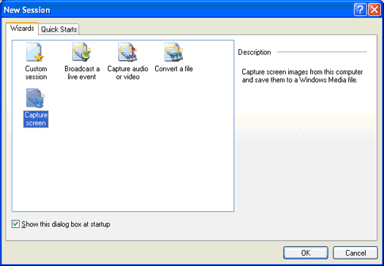
Figure 2. New Session dialog box
- On the Screen Capture Session page, click one of the following options, and then click Next:
- Specific window. Use this option if you want to restrict the capture area to a specific program window. The Encoder will not capture any new or pop-up windows that are displayed by the program. For example, if you choose to capture the Microsoft Outlook® window, the Encoder will not capture any separate message windows that appear, even if those message windows overlap the main program window that you are capturing. If you choose this option, go to step 4.
- Region of the screen. This option enables you to specify the region of the computer screen that you want to capture. The Encoder will capture the entire region that you specify regardless of the programs that are running. Use this option when you don't want to capture the entire screen, but you do want to capture all program and pop-up windows that appear within a selected region. If you choose this option, go to step 4.
- Entire screen. Capturing the entire computer screen is only recommended when users will play back your screen-capture video in full-screen mode on their computers (for example, by using the View full screen option in Windows Media Player). This is especially true if you capture the entire screen at a resolution of 1024 x 768 pixels. If you choose this option, go to step 5.
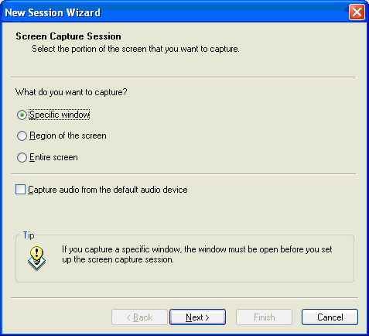
Figure 3. Screen Capture Session page
- Do one of the following:
- If you clicked Specific window in step 3, on the Window Selection page, select the program window that you want to capture, and then click Next.
The program window that you want to capture must be running in order to select it from the list. If you open a program during the screen-capture session, the program list does not automatically refresh.
- If you clicked Region of the screen in step 3, on the Screen Region page, select the region that you want to capture, either by clicking the screen region selection button and then using the mouse pointer to select the screen region, or by typing the specific coordinates of the region. Then, click Next.
Note To help you identify the window being captured, you can also select the Flash border during capture check box. If you are capturing a specific area of the screen, a flashing border around the capture area can help you ensure that the sections of the screen that you want to capture are within the designated capture area. Displaying a flashing border during the screen capture requires additional CPU resources, though, so if you know the window that you want to capture, do not select this option.
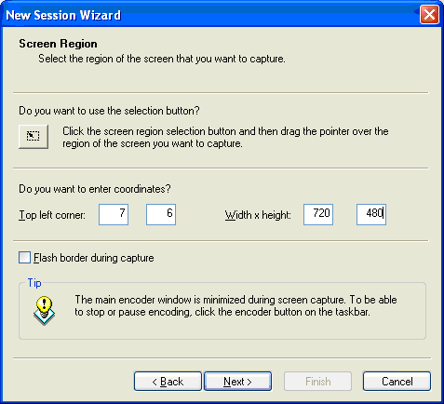
Figure 4. Screen Region page
Tip If you are planning to edit your screen-capture video in Microsoft Windows Movie Maker, set the screen-capture region to the same width and height as your Windows Movie Maker output file. Generally, if users will view your file at its full size, you should set the coordinates of your capture area to 720 x 480, as shown in Figure 4. It is recommended that you do not resize the Encoder screen-capture video in Windows Movie Maker.
- On the Output File screen, specify the path and file name of the screen-capture video that you want to create, and then click Next.
- To specify the encoding settings for your screen capture, click Low, Medium, or High, and then click Next. This option determines the profile that the Encoder will use to capture and encode the computer screens and defines the quality of your screen-capture video.
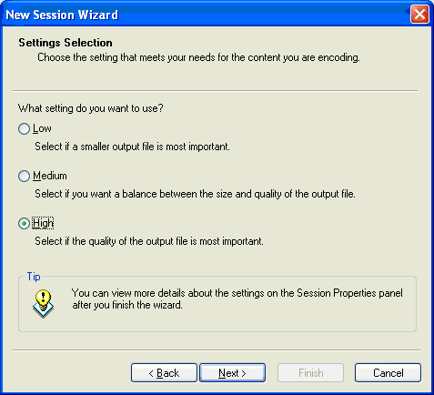
Figure 5. Settings Selection page
Tip After you complete the New Session Wizard, you can always go back and change the encoding settings by using the Custom Encoding Settings dialog box. For more information about the Custom Encoding Settings dialog box, see Changing Your Encoding Settings later in this article.
- On the Display Information screen, type the title, author, and other information that you want to display during playback, and then click Next.
Note You must enable captions in Windows Media Player in order to view this information during playback.
- Do one of the following:
- To begin the screen-capture session automatically when the wizard closes, on the Settings Review screen, click the Begin capturing screens when I click Finish check box, and then click Finish.
- To finish the wizard without beginning the screen-capture session automatically, on the Settings Review screen, click Finish. Then when you're ready to begin capturing screens, click Start Encoding on the Encoder toolbar.
Windows Media Encoder will be minimized on the Windows taskbar during the session. If you selected the Flash border during capture check box in step 4, the Encoder will flash a red border around the capture area. If you selected to capture a program window and that program is minimized, you may not see the flashing border.

Pausing or Stopping the Screen Capture
Use the following procedure to pause or stop a screen-capture session that is in progress.
To pause or stop the screen capture
- Click the Windows Media Encoder button, which is minimized on the Windows taskbar.
The Windows Media Encoder program window appears, and the screen-capture process pauses. While paused, the Encoder does not capture any of the screen images, which can be helpful if you want to rearrange your desktop without capturing the screen activities.
- Do one of the following:
- To resume the screen-capture process, click Start Encoding on the Encoder toolbar. The Encoder will be minimized and the screen-capture process will begin again.
- To stop the paused screen-capture process, click Stop on the Encoder toolbar. The Encoding Results page shows the results from your screen capture, including the session duration and bit rate.

Reviewing Your Screen-Capture Video
When you stop a screen-capture session, your screen-capture video is automatically saved to the output file that you specified in the New Session Wizard. You can then review the screen-capture video that you just created.
To review your screen-capture video
- On the Encoding Results screen, click Play Output File.
- or -
Go to the folder location that you specified for the output file in the New Session Wizard, and double-click the output file.
Windows Media Player automatically opens, and you can click the Play button to play your screen-capture video.

Saving the Session Settings
You can save the settings from your screen-capture session for later use. For example, you might want to repeat the same screen-capture session, or you might to want capture another set of screen images using the same encoding settings.
To save the session settings
- If you are satisfied with your screen-capture video and you want to save your session settings so that you can use them again, in Windows Media Encoder click File, and then click Save.
Note Keep in mind that if you capture a specific program window, the title of the window and its coordinates are saved along with all the other configuration information in the session file. If you use the session file for a subsequent screen-capture session, the Encoder looks for a window that matches the stored title. If the Encoder does not find one, it captures a window that matches the stored coordinates.

Helpful Encoding Tips
The following sections describe some additional encoding tips that can help you improve your screen-capture sessions and enhance the quality of your screen-capture videos.

Changing Your Encoding Settings
After reviewing your screen-capture video, you may want to change the encoding settings and then encode the file again to improve the quality of the screen-capture images.
To change the encoding settings
- On the Windows Media Encoder toolbar, click Properties, and then click the Compression tab.
- On the Compression tab, click Edit.
The Custom Encoding Settings dialog box shows the current encoding settings for your screen-capture video.
Note When you are capturing screens, it is important that Windows Media Video 9 Screen is selected as the codec on the Custom Encoding Settings dialog box. A codec is applied to a file when the file is encoded or recorded and determines the size of a file, the bit rate of a stream, and the way encoded video and audio content looks and sounds. The Windows Media Video 9 Screen codec is optimized for provide the best encoding results for screen-capture videos.
- To customize the encoding profile for your screen capture, click the tab that shows the bit rate in Kbps.
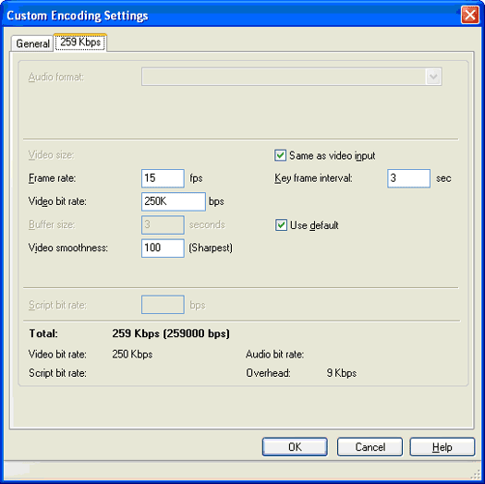
Figure 6. Default high-quality encoding profile
- Change one or more of the following custom encoding settings:
- Same as video input. For screen capture, select this check box.
- Frame rate. This value defines the number of frames per second (fps) to capture. The more frames per second that the Encoder captures, the smoother the video is, but the higher the bit rate required to capture the screens. A typical home video is 30 fps, but because the motion in screen-capture videos is relatively minimal and you are capturing at a higher resolution than a home video, you should not exceed a maximum value of 15 fps.
For low-bandwidth scenarios, it is recommended that you set the frame rate to 5 or 10 fps. Even at these low frame rates, you will be surprised at how smoothly the screen-capture images display during playback. If you notice that frames are being lost during the screen capture and that the playback is not smooth, the bit rate setting may be too low or the screen region you are capturing may be too large.
- Video bit rate. This value specifies the amount of bandwidth that will be used to capture the screen images. If you are streaming the screen-capture images over the Internet, pay careful attention to this value. For example, if you are streaming content to users who are connected to the Internet using a modem, set the video bit rate to a value between 20K and 40K. Remember to look at the total bit rate, which will include video and audio, as well as the overhead required to accommodate network traffic.
If users will download your screen-capture video from the Web or view it from their computers, you can set the video bit rate to a much higher value. You can experiment with this value until you achieve the frame rate and quality you desire. Higher bit-rate settings, such as 300K, 500K, and 700K, will require more CPU resources to encode.
- Buffer size. A buffer is a temporary storage area in memory where a program processes data before rendering it or sending it to a device, such as a hard disk drive or a computer over a network. The buffer size that you set will determine how much start-up delay and latency that users experience. In general, the larger the buffer size, the better the playback experience.
If you are streaming your screen-capture video over the Internet from a Windows Media Server, it is recommended that you use the default three-second buffer. This setting will eliminate buffering when users connect to the server and attempt to view the file. To improve the quality slightly, you can set the value to five seconds, but this setting may introduce some buffering delays. For direct computer or CD-ROM playback, you can set the value to 10 or 20 seconds.
- Video smoothness. For screen capture, it is recommended that you use the default value of 100.
- Key frame interval. This interval identifies the amount of time before the Encoder generates a new key frame. A key frame is an entire screen image captured by the Encoder. Uncompressed video contains only key frames, whereas compressed video uses a codec to create a limited number of key frames and then captures only the changes to the key frames rather than the entire screen image. If video contains a lot of motion, a lower key frame interval will produce better results, but will require more bandwidth. Recommended values for the key frame interval are 2, 4, 8, and 20 seconds. If you want to maximize bandwidth and allow the compression codec to insert key frames when needed, use a value of 20 seconds.

Capturing Video During the Screen Capture
If you plan to capture full-motion video during your screen-capture session, disable your computer's hardware acceleration. If you do not disable hardware acceleration, you may notice a black screen where you expect the video to display.
To disable hardware acceleration
- Click Start, and then click Control Panel.
- Click Appearance and Themes, click Display, and then click the Settings tab.
- Click Advanced, and then click the Troubleshoot tab.
- Note the current settings, so that you can reset them after you complete the screen capture.
- For Hardware acceleration, drag the slider to None, and then click Apply.
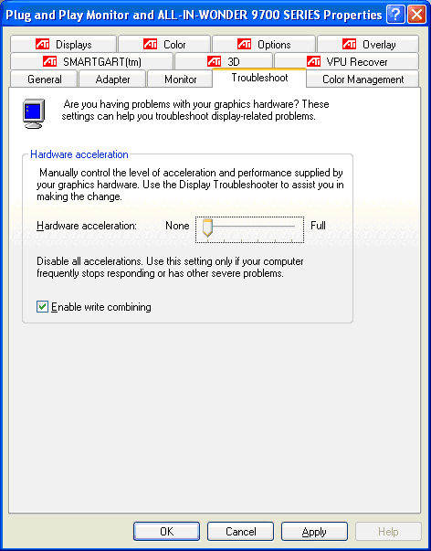
Figure 7. Display Properties dialog box

Using Remote Desktop to Capture Screens
You may experience performance-related issues when you simultaneously run a screen-capture session in Windows Media Encoder and a program window that you are capturing, because your computer may not have enough CPU resources available to effectively run both programs. In this case, you may want to run the screen-capture session on one computer and use the Remote Desktop feature of Windows XP to connect remotely over a network to a second computer to capture the program screens. For more information about resolving performance-related issues, see Troubleshooting later in this article.
The Remote Desktop feature enables you to connect to and display the entire computer screen from a remote computer. For example, from your laptop, you can access your desktop computer remotely as if you were actually sitting at that computer. In fact, all of your programs, printers, drives, and even sound are available over the remote-desktop connection.
Use the following procedure to enable the Remote Desktop feature, select the appropriate settings, and then establish the remote-desktop connection.
To use remote desktop to capture screens
- Verify that both computers are part of the same workgroup or domain, and that you have permissions to access both computers. For more information, see Windows Help and Support.
- On the computer that you want to connect to remotely, click Start, and then click Control Panel.
- Click Performance and Maintenance, click System, and then click the Remote tab.
- Click the Allow users to connect remotely to this computer check box.
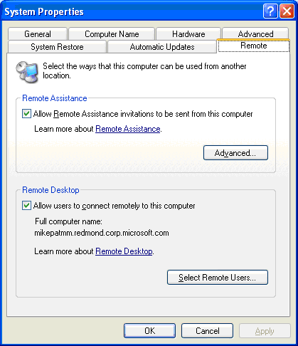
Figure 8. System Properties dialog box
- Click the Computer Name tab, and then write down the computer name.
When you connect remotely to this computer, you will need to specify this name.
- To establish the remote connection from the computer running Windows Media Encoder, click Start, point to Accessories, point to Communication, and then click Remote Desktop Connection.
- On the Remote Desktop Connection dialog box, click the General tab, and then type the remote computer name that you noted in step 5.
- Click the Display tab. For the Remote desktop size, drag the slider to Full Screen, and then for Colors, click an option with 24-bit or fewer colors.
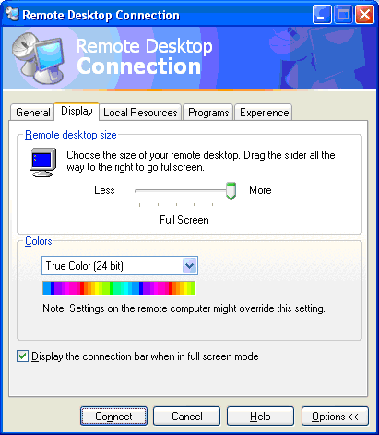
Figure 9. Remote Desktop Connection Display options
- Click the Local Resources tab, and then for Remote computer sound, click Do not play.
For the best screen-capture results, it is recommended that you not play remote computer sounds.
- Click the Experience tab, and for the connection speed, click LAN (10 Mbps or higher).
You may also want to disable other desktop options on the Experience tab in order to improve performance.
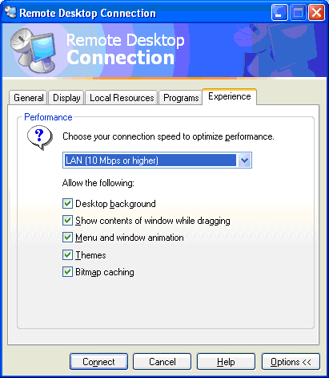
Figure 10. Remote Desktop Connection Experience options
- To establish the remote desktop connection, click Connect.
- To begin the screen-capture session in Windows Media Encoder, run the New Session Wizard. On the Screen Capture Session page, click Specific window, and then on the Window Selection page, select the remote-desktop window to capture.

Troubleshooting
When you capture and encode computer screens, you may experience some performance-related issues. To monitor and resolve these issues, review the following sections.

A Program Is Unresponsive
Screen capturing is a very CPU-intensive process and may cause some programs to become unresponsive to the mouse. For example, you may be unable to double-click an item on your desktop. In this case, determine whether the program provides an equivalent shortcut. In many cases, a program will provide a separate menu option that you can use as an alternative to the mouse.
If your program does not support an equivalent shortcut, you can turn on MouseKeys. With MouseKeys, you can control the mouse pointer by using the numeric keypad on your keyboard.
To turn on MouseKeys
- Click Start, and then click Control Panel.
- Under Pick a category, click Accessibility Options, and then on the Accessibility Options page, click Accessibility Options.
- Click the Mouse tab, and then click the Use MouseKeys check box.
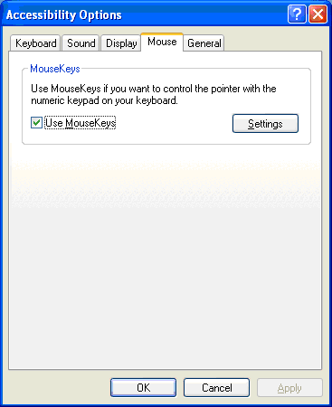
Figure 11. Mouse Accessibility Options
After MouseKeys is turned on, you can press the plus sign (+) on your numeric keypad to perform the same action as double-clicking a program. For more information about MouseKeys, see Windows Help and Support.

Screen Capture Loses Frames
Windows Media Encoder may lose frames during the screen-capture session, reducing the image quality of your screen-capture video. This issue typically occurs when a computer's CPU resources exceed 80%.
To prevent this issue, close all programs that you do not need for the screen-capture session. For additional guidelines to help you improve performance during screen-capture sessions, review the Windows Media Encoder Help topic, "Improving performance when encoding screens."
If the issue persists, consider using the Remote Desktop feature in Windows XP to run the program on a separate computer and capture the screens remotely. For more information, see Using Remote Desktop to Capture Screens earlier in this article.
It is also recommended that you monitor your computer's CPU resources during the screen-capture session. To do so, open Windows Task Manager before you start the session. If you are capturing the entire screen, you may also want to minimize Windows Task Manager to the Windows system tray so that you can monitor the CPU resources without capturing the Task Manager window.
To open Windows Task Manager
- Press CTRL+ALT+DELETE, and then click Task Manager.
- On the Windows Task Manager dialog box, click the Performance tab.
The Performance tab shows the percentage of CPU Usage and the CPU Usage History for your computer.
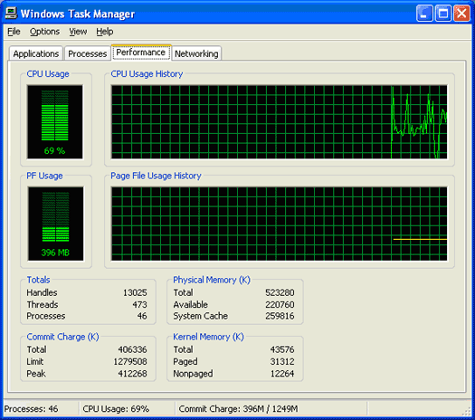
Figure 12. Windows Task Manager
- To display only the CPU Usage meter in the Windows system tray so that you can monitor CPU usage during your screen-capture session without displaying the Windows Task Manager window, minimize Windows Task Manager.

For More Information
- For more information about using Windows Media Encoder features for screen capture, see Windows Media Encoder Help.
- For more advanced screen-capture techniques and practices, see the "Best Practices for Using the Windows Media Screen Codec" white paper at the Microsoft Download Center (http://www.microsoft.com/downloads/).

