“Silverlight puts us two generations ahead of generic financial sites in terms of user experience.”

For more information about Silverlight, visit: [www.microsoft.com/silverlight](http://www.microsoft.com/silverlight)

For more information about other Microsoft customer successes, visit: [www.microsoft.com/casestudies](http://www.microsoft.com/casestudies)

To view an online demo of the Zignals charting tools, register at [www.zignals.com](http://www.zignals.com) and click the Help icon at [www.zignals.com/main/charts/trystockcharts.aspx](http://hwww.zignals.com/main/charts/trystockcharts.aspx).

Customer: Digital Minds Ltd.

Web Site: [www.zignals.com](http://www.zignals.com/) and [www.activateclients.com](http://www.activateclients.com)

Country or Region: Ireland

Industry: Financial services

Customer Profile

Zignals empowers investors with free, online portfolio-management tools that incorporate real-time communication and collaborative features for a user experience unparalleled on the Web. The company also offers a white-label version of its service to banks and brokerages.

Software and Services

* Technologies
* Microsoft Silverlight
* Microsoft .NET Framework
* Microsoft SQL Server® 2008
* Windows Server® 2008
* Microsoft Visual Studio®
* Microsoft Visual Studio 2008 SP1

Pat Brazel, CEO, Digital Minds

Business Needs

|  |  |  |  |
| --- | --- | --- | --- |
|  |  |  | Sl_h_rgb |

Zignals aims to transform investing for individuals by offering them sophisticated trading tools previously only available to industry professionals and by enabling new ways for people to collaborate on investment strategies for free. Zignals is run by Dublin, Ireland–based Digital Minds, which also offers a white-label version of its solution, called ActivateClients, to banks and brokerages.

In its startup phase, the company sought a development approach that would keep costs low while enabling a small team to create the unique and striking offering it needed to differentiate itself from other online finance sites. “We were looking to create an interactive Web interface for our application built on the Microsoft® .NET Framework,” says Scott Tattersall, CTO of Digital Minds. “Originally, we started working with AJAX and JavaScript, but it wasn’t possible to create the immersive experience we were seeking. Also, it was quite a burden to test the application across multiple browsers.”

Zignals was hesitant to work with Adobe Flash because of the impact that technology would have on its existing code base. “We would have to reengineer components like authentication to use Flash,” explains Tattersall. “Also, we didn’t want to create too many operational silos where we have specialized teams that work only on the interface, only on the business logic, or only on Web services.”

Solution

When the Zignals team discovered Microsoft Silverlight™, they quickly understood the benefits offered, both to their technical group and the overall business. For example, the ubiquity of the cross-browser, cross-platform plug-in would let their development team reuse their existing code base and development skills.

The company created the initial application in just six months, including a modular framework that enables the company to reuse components. “Working with Silverlight and the .NET Framework, we were able to separate everything we worked on into four layers: database, Web services, business logic, and interface controls,” says Tattersall. “This approach dramatically speeds the creation of new offerings, especially for our ActivateClients white-label applications.”

“We were excited about Silverlight from a technology perspective, but also from a business perspective,” says Pat Brazel, CEO of Digital Minds. “We realized that we could do things with the technology that we couldn’t with any other interactive Web technology. It exactly fit our goal of creating uniquely rich and responsive Web interfaces.”

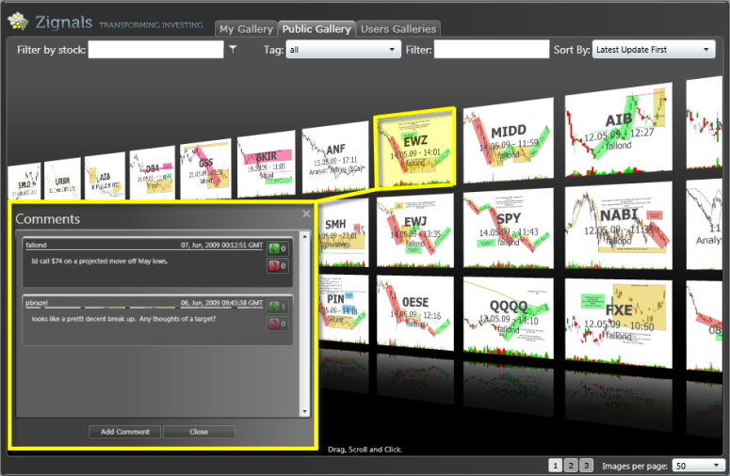

On the Zignals Web site, investors can create portfolios and access the same financial information that is available on generic sites. But by using Silverlight, Zignals adds powerful decision-support tools to strengthen investment strategies and the ability to create interactive charts that incorporate real-time data and share those charts with the Zignals community. The site also uses Silverlight to offer novel collaborative features that let investors simultaneously work on charts and chat in real time, as shown in Figure 1.

Banks and brokerages can brand these online tools and offer them to their customers or financial advisors through ActivateClients. “Our commercial solution works across all major browsers and operating systems because it is based on Silverlight and secures internal Web services through Windows® Communication Foundation,” says Brazel. “It has all the advantages of a desktop application without the complexity of deploying client software.”

Figure 1. Zignals offers individual investors sophisticated trading tools and unique collaborative features with its Silverlight-based application.

Benefits

Zignals takes advantage of the unique capabilities of Silverlight to offer up online investment tools unlike anything else available on the Web. In addition, the company uses the technical advantages of Silverlight to reuse more code, load-balance resources across projects, and quickly adjust its application to meet the needs of clients.

Uniquely Compelling Experience

The group quickly created visually stunning interfaces with highly customizable controls and flexible layout containers. The team used vector graphics, gradient, and animation features to add richness that is unusual for a Web application. “Even though it is delivered online, Zignals behaves like a desktop application,” says Brazel. “Silverlight puts us two generations ahead of generic financial sites in terms of user experience.”

Efficient Design and Development

Because Silverlight is compatible with the .NET Framework, Zignals did not have to rework its existing application code when creating the new interfaces. In addition, all the developers could easily move between various aspects of a project. “I estimate that we would have required a 50 percent larger team if we had segmented work out to specialized groups,” says Tattersall. “Because it’s all .NET programming, a single developer can easily switch from client-side code to server-side code. Also, changes to the interface do not affect the business logic.”

Rapid Results

Zignals draws on reusable interface, business logic, Web services, and database components to build new applications faster. Silverlight augments this agility with the ability to create interface skins. “Our development approach enables us to offer white-label commercial applications without having to extensively recode anything,” says Tattersall. “With the flexibility of Silverlight, we can quickly create branded applications or add functionality according to our clients’ needs.”