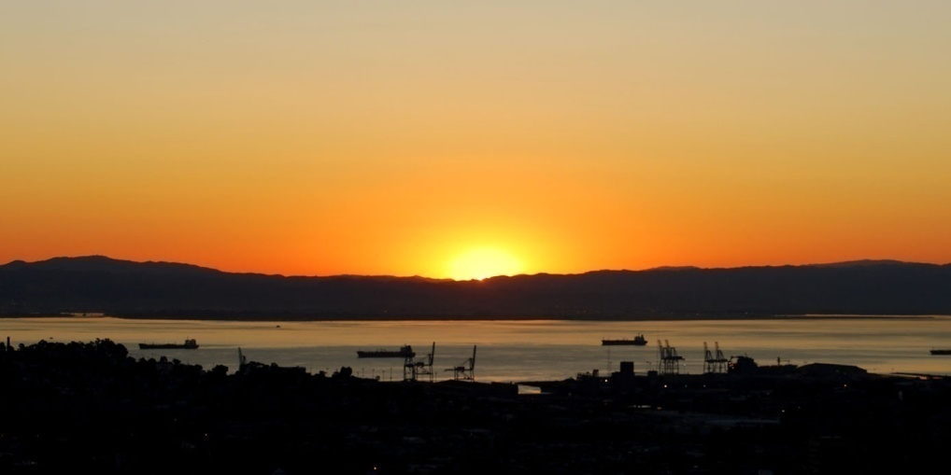

*<--- Insert your own image*

*(2.31″ x 4.36″).*

*Use grayscale to  
save colour ink.*

**Vacation photos**

**Backup: June 6, 2008**

Europe 2005, California 2007, family reunion back home

Budget, work files, taxes 2002 – 07, insurance list

**Backup files**

**October 17, 2008**

**Disc: 1 of 2**