# Seed packet template (final packet is 9.5″ wide and 6″ high)

Use text boxes or WordArt to add text to the seed packet, but make sure to keep text out of the area on the back indicated by grey lines. This area will be covered when the front panel is folded and pasted to the back panel.

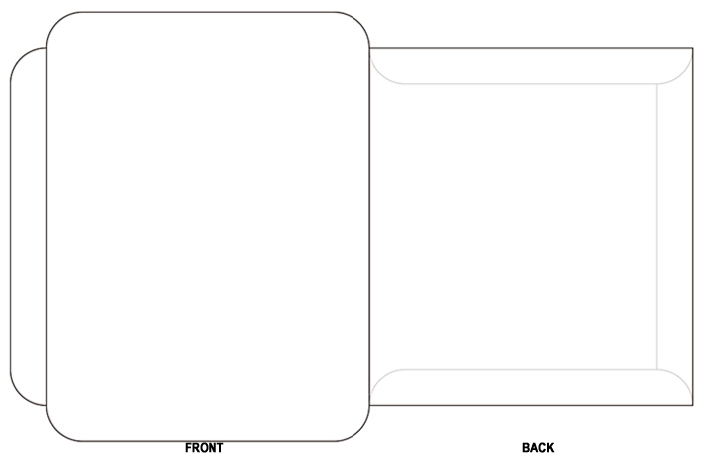

## Click here to add additional text or photos.

## Place seed instructions here.