

**Groovin’ – The Young Rascals**

**Soak Up the Sun – Sheryl Crow**

**The Boys of Summer – Don Henley**

**Summer in the City – The Lovin’ Spoonful**

**Pacific Coast Party – Smash Mouth**

**(Sittin’ On) The Dock of the Bay – Otis Redding**

**Good Vibrations – The Beach Boys**

**Good Day Sunshine – The Beatles**

**Island in the Sun – Weezer**

**Love Shack – The B-52s**

**Rockaway Beach – The Ramones**

**No Woman No Cry – Bob Marley**

**Fly – Sugar Ray**

**Patio Lanterns – Kim Mitchell**

**Summer of ’69 – Bryan Adams**

CD cover/insert

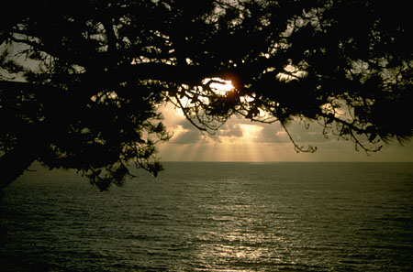**Step 1:** Replace image, text and playlist to match your music and theme.

Chill out • slow down • let go

**Step 2:** Print on highest or best setting.

**Step 3:** Trim to size and then fold in half at the arrow.

**Step 4:** Slip into your CD case.

chill out • slow down • let go