

Technical Overview of Windows Rights Management Services for Windows Server 2003

Microsoft Corporation
Published: November 2003
Updated: April 2005

Abstract
This white paper provides a technical overview of Microsoft® Windows® Rights Management Services (RMS) for Windows Server™ 2003, the reasons for implementing this technology, and the processes and steps involved with that implementation. Windows RMS is information protection technology that works with RMS-enabled applications to help safeguard digital information from unauthorized use. RMS augments an organization’s security strategy by providing protection of information through persistent usage policies, which remain with the information, no matter where it goes.

The information contained in this document represents the current view of Microsoft Corporation on the issues discussed as of the date of publication. Because Microsoft must respond to changing market conditions, it should not be interpreted to be a commitment on the part of Microsoft, and Microsoft cannot guarantee the accuracy of any information presented after the date of publication.
This document is for informational purposes only. MICROSOFT MAKES NO WARRANTIES, EXPRESS OR IMPLIED, AS TO THE INFORMATION IN THIS DOCUMENT.
Complying with all applicable copyright laws is the responsibility of the user. Without limiting the rights under copyright, no part of this document may be reproduced, stored in or introduced into a retrieval system, or transmitted in any form or by any means (electronic, mechanical, photocopying, recording, or otherwise), or for any purpose, without the express written permission of Microsoft Corporation.
Microsoft may have patents, patent applications, trademarks, copyrights, or other intellectual property rights covering subject matter in this document. Except as expressly provided in any written license agreement from Microsoft, the furnishing of this document does not give you any license to these patents, trademarks, copyrights, or other intellectual property.
The example companies, organizations, products, people and events depicted herein are fictitious. No association with any real company, organization, product, person or event is intended or should be inferred.
© 2005 Microsoft Corporation. All rights reserved.
Microsoft, the Windows logo, Windows, Windows Media, Active Directory, and Windows NT are either registered trademarks or trademarks of Microsoft Corporation in the United States and/or other countries.
The names of actual companies and products mentioned herein may be the trademarks of their respective owners.
Contents
Introduction 1
Overview: Managing Digital Information 2
Vulnerable Information 2
The Need to Augment an Organization's Security Strategy 2
Persistent Protection of Digital Information 3
Scenarios 4
Scenario 1: Protecting Confidential E-Mail Messages 4
Scenario 2: Enforcing Document Rights 4
Scenario 3: Protecting Sensitive Intranet Content 5
Scenario 4: Protecting Content at the Server Level 5
What Is Windows RMS? 6
The Basics: How Windows RMS Works 6
Components of Windows RMS Technology 7
Windows Rights Management Services Server Software 8
Windows Rights Management Services SDK 10
Windows Rights Management Client Software 10
Benefits of Windows RMS Technology 11
XrML: The Format for Trusted Information and Services 12
How XrML Works 12
More Information about XrML 12
Windows RMS Technology in Your Organization 13
The Standard RMS System Topology 13
Enrolling Servers in an RMS System 14
Setting Up Client Computers 15
Verifying the client component 15
Client computer activation 15
Certifying RMS Users 16
Enrolling Client Computers for Offline Publishing 16
Creating and Viewing Rights-Protected Information 17
Publishing to Anyone 19
Administering an RMS System 19
Usage Rights Policy Templates 19
Revocation Lists 21
Exclusion Policies 21
Logging 22
Integrating with Existing Systems 23
Summary 24
Related Links 25

Introduction
This white paper describes how digital information may be vulnerable when organizations solely rely on perimeter-based security methods. It introduces Microsoft® Windows® Rights Management Services (RMS) for Windows Server™ 2003 and explains how this technology can enhance an organization's overall information protection strategy.
Read about the features and benefits of Windows RMS technology, how this technology operates within an organization's infrastructure, and about scenarios that highlight Windows RMS capabilities. This information can help technical staff, technical business decision makers, and solution integrators make informed decisions about adopting and using Windows RMS.

Overview: Managing Digital Information
Organizations of all sizes are challenged to protect a growing quantity of valuable digital information against careless mishandling and malicious use. The increasing incidences of information theft and the emergence of new legislative requirements to protect data underscore the need for better protection of digital information.
This digital information may include dynamic, database-driven reports on an enterprise information portal, confidential e-mail messages, strategic planning documents, financial forecasts, contracts, military defense reports, and other sensitive information. The growing use of computers to create and work with this information, the introduction of extensive connectivity through networks and the Internet, and the appearance of increasingly powerful computing devices have made protecting enterprise data an essential security consideration.

Vulnerable Information
Organizations create and use a broad assortment of valuable data that they want and need to protect. This data can include the following:
- Traditional digital files and information. Typical examples of traditional digital files and information are e-mail communications, project-related documents, confidential reports, marketing plans, and product overviews. Information workers share these documents regularly through e-mail messages, conferencing applications, disk shares, and server-based or peer-to-peer systems. This category can also include other sensitive data, such as job performance reviews and personal records that users may need or want to maintain in a secure, readily available state.
- Proprietary data. Senior management uses this data to administer, monitor, and direct an organization's activities. This proprietary data might include an organization's sales and market share reports, financial performance information, and strategic forecasts and overviews. Improper use of this data may cause significant damage to an organization.

The Need to Augment an Organization's Security Strategy
Protecting digital information is a difficult and ongoing task. Typically, organizations secure digital information by using perimeter-based security methods. Firewalls can limit access to the network, and Access Control Lists (ACLs) can restrict access to specific data. In addition, organizations may use encryption and authentication technologies and products to help secure e-mail while in transit and to help ensure that the intended recipients are the first to open the messages.
These methods help organizations to control access to sensitive data. However, recipients are still free to do whatever they want with the information they receive. After access is granted, no restrictions control what can be done with the data or where it can be sent. Perimeter-based security methods simply cannot enforce business rules that control how people use and distribute the data outside the perimeter, or after the perimeter is penetrated.
Relying on an individual's discretion to determine to the manner in which they use and share digital information can introduce an unacceptable degree of risk into an organization’s security model. For example, it’s easy for users to mistakenly forward sensitive e-mail messages or documents to recipients who have malicious intent.
In addition to the threats of theft and mishandling, a growing list of legislative requirements adds to the ongoing task of protecting digital files and information. For example, many organizations must comply with Securities and Exchange Commission (SEC) fair disclosure codes, which address the problem of selective disclosure of certain information to inside investors. Similarly, the financial, government, healthcare, and legal sectors are increasingly taxed by the need to better protect digital files and information due to emerging legislative standards such as the Healthcare Insurance Portability and Accessibility Act (HIPAA) and the Gramm-Leach-Bliley Act (GLBA) in the financial services market.
Without an end-to-end solution in place to effectively control the use of digital information no matter where it goes, sensitive information can too easily end up in the wrong hands, whether maliciously or accidentally.

Persistent Protection of Digital Information
Digital information must be better protected. Although no form of information will ever be completely risk-free from unauthorized use and no single approach will shield data from misuse in all cases, the best defense is a comprehensive solution for safeguarding information.
As an essential part of an organization's overall security strategy, a solution for better information protection should provide the means to control how data is used and distributed beyond simple access control. It should help protect an organization's records and documents on the company intranet, as well as from being shared with unauthorized users. It should help to ensure that data is protected and tamper-resistant. When necessary, information should expire based on time requirements, even when that information is sent over the internet to other individuals.

Scenarios
Using Windows RMS represents an opportunity to protect and enhance all types of data in intranet and some extranet scenarios. The four scenarios described in the following sections illustrate the functionality and benefits of implementing RMS to help safeguard sensitive and proprietary information in the enterprise.

Scenario 1: Protecting Confidential E-Mail Messages
Brian, a company executive, needs to send a confidential e-mail with a document attached on a new project to his team. Using Windows RMS, his company has created a “Company Confidential” usage policy template, which automatically applies usage rights that have been centrally defined. Brian selects that template to add usage rights to his e-mail message, which automatically applies the same rights to the attached Microsoft Word 2003 document. The “Company Confidential” template specifies that employees within the organization can only read the information. As employees open the e-mail and the attachment, RMS-enabled Microsoft Outlook 2003 and Word 2003 transparently enforces the usage rights to the information. As specified by “Company Confidential” template, employees cannot copy, print, save, or edit either the e-mail message or the attached document, and they cannot forward the e-mail message. If they attempt to digitally share this information outside of the organization, the unauthorized recipient will be unable to open the information.
A team member sends a request to Brian asking permission to share the e-mail and attachment to an outside vendor that is working on the project. The vendor, which uses a hosting provider for its RMS solution, is a trusted partner within the company’s RMS environment. Brian applies rights that are appropriate for the vendor and then sends the e-mail to the vendor. The usage rights are again transparently enforced when the vendor receives and opens the e-mail and attachment.

Scenario 2: Enforcing Document Rights
Tom works at a financial services organization that manages the investments of large retirement accounts and leading corporations. From the company’s SAP system, he downloads financial information into an RMS-protected spreadsheet in Microsoft Office Excel 2003. After Tom has brought the information into a satisfactory presentation, he uploads the document to an internal file sharing server. Tom sends an e-mail to Julie, one of the company’s analysts, telling her that the information is available for her.
Julie plans to review the information and use it in her reporting. She has three business days to do so. Tom set the usage rights for just that amount of time, and he also made it impossible for Julie to forward or print the information. Julie understands and appreciates these restrictions, because they help remove a liability. The company needs to comply with regulation, including Securities Exchange Commission (SEC) rules that call for information protection. In addition, the company is publicly traded—inappropriate disclosure of financial information could have a negative impact on its stock price.
However, Julie does not manage to review the information in the time allowed. After three business days, she can no longer open the document, so she requests that Tom grant her more time to review the information. Tom grants the permission by extending the expiration of the document he posted on the internal file sharing server. Julie downloads this updated version and can review the information she needs in her report.

Scenario 3: Protecting Sensitive Intranet Content
Sharon, a sales executive for a large multi-national publishing company, along with her entire sales organization needs to view sales results that are stored in the online system on the corporate intranet. Because of the sensitive nature of this information, the company has decided to apply usage rights to the sales results. In this example, the company has applied “read-only” rights to the information, which allows the sales organization to view the sales results but not modify, copy, export, save, or print the information. At the same time, increased rights have been granted to Sharon and her immediate staff who will need the ability to copy or print the sales results for presentations and business reviews.
As a sales representative in Sharon's organization, Bill has access to the online sales system. Bill navigates to the past year's sales results, which are displayed on-screen within his RMS-enabled browser. "Read only" rights prevent Bill from printing or performing copy and paste functions.

Scenario 4: Protecting Content at the Server Level
Bill, a president for a financial services company, is concerned about maintaining the privacy of digital information contained in customer files. While company employees know that customer information must be protected, Bill doesn’t want to place the responsibility of safeguarding this information on the shoulders of these employees. As a result, Bill decides to implement a third-party workflow solution that integrates rights protection technology at the server level.
With this solution in place, Bill’s employees no longer have to worry about applying protection rights to customer information, as this step is automatically completed during the workflow process. Thus, when a new customer is entered into the system and their file work is processed, “read-only” rights are automatically applied to this information and only the customer’s account managers (as indicated during the setup process) are given this access.

What Is Windows RMS?
Microsoft Windows Rights Management Services (RMS) for Windows Server 2003 is information protection technology that works with RMS-enabled applications to help safeguard digital information from unauthorized use—both online and offline—inside and outside of the firewall. This product is designed for organizations that need to protect sensitive and proprietary information such as financial reports, product specifications, customer data, and confidential e-mail messages.
RMS augments an organization’s security strategy by providing protection of information through persistent usage policies (also known as usage rights and conditions), which remain with the information, no matter where it goes. RMS persistently protects any binary format of data, so the usage rights remain with the information, even in transport, rather than the rights merely residing on an organization’s network. This also enables usage rights to be enforced after the information is accessed by an authorized recipient—both online and offline—inside and outside of the organization.
RMS also allows third parties to integrate information protection for a comprehensive platform solution, enabling the integration of information protection into other information processing infrastructures, such as automated work flows, records and document management, e-mail message archiving, content inspection, and more.
RMS helps protects information through persistent usage policies by establishing the following essential elements:
- Trusted entities. Organizations can specify the entities, including individuals, groups of users, computers, and applications that are trusted participants in an RMS system. By establishing trusted entities, RMS can help protect information by enabling access only to properly trusted participants.
- Usage rights and conditions. Organizations and individuals can assign usage rights and conditions that define how a specific trusted entity can use protected information. Examples of named rights are permission to read, copy, print, save, forward, and edit. Usage rights can be accompanied by conditions, such as when those rights expire. Organizations can exclude applications and entities (as well as non-trusted entities) from accessing the protected information.
- Encryption. Encryption is the process by which data is locked with electronic keys. RMS encrypts information, making access conditional on the successful validation of the trusted entities. Once information is locked, only trusted entities that were granted usage rights under the specified conditions (if any) can unlock or decrypt the information in an RMS-enabled application or browser. The defined usage rights and conditions will then be enforced by the application.

The Basics: How Windows RMS Works
Windows RMS, which includes both server and client components, provides the following capabilities:
- Creating rights-protected files and containers. Users who are trusted entities in an RMS system can easily create and manage protected files using familiar authoring applications and tools that incorporate Windows RMS technology. For example, using common task management procedures within a familiar on-screen environment, organizations could assign usage rights and conditions to information, such as a dynamic, database-driven sales report on an enterprise information portal. Users could also apply usage rights and conditions to e-mail messages and documents using RMS-enabled applications.
In addition, RMS-enabled applications provide users with the option of applying centrally defined and officially authorized rights policy templates such as “Company Confidential.”
- Licensing and distributing rights-protected information. The XrML-based certificates issued by an RMS system identify trusted entities that can publish or view rights-protected information. Users who are trusted entities in an RMS system can assign usage rights and conditions to information they want to protect via an RMS-enabled application. These usage policies specify who can use the information and what they can do with it.
In a process that is generally transparent to the users, the RMS system validates the trusted entities and issues the publishing licenses that contain the specified usage rights and conditions for the information. The information is encrypted using the electronic keys from the RMS-enabled application and the XrML-based certificates of the trusted entities. After the information is encrypted or locked by this mechanism, only the trusted entities specified in the publishing licenses can unlock and use that information.
Users could then distribute the rights-protected information to other users in their organization via e-mail, internal servers, or external sites to enable trusted external partners to access the information.
- Acquiring licenses to decrypt rights-protected information and enforcing usage policies. Recipients who are trusted entities can open or view rights-protected information by using trusted computers and applications. These RMS-enabled applications enforce the usage rights which were defined by the author of the information.
In a process that is transparent to the recipient, the RMS server, which has the public key that was used to encrypt the information, validates the recipient’s credentials and then issues a use license that contains the usage rights and conditions that were specified in the publishing license. The information is decrypted using the electronic keys from the end-user license and the XrML-based certificates of the trusted entities. The usage rights and conditions are then enforced by the RMS-enabled application. The usage rights are persistent and enforced everywhere the information goes.

Components of Windows RMS Technology
RMS technology includes the following client and server software along with SDKs:
- Windows RMS server software is Web service for Windows Server 2003 that handles the XrML-based certification of trusted entities, licensing of rights-protected information, enrollment of servers and users, and administration functions.
- Windows Rights Management client software is a group of Windows APIs that facilitate the machine activation process and allow RMS-enabled applications to work with the RMS server to provide licenses for publishing and consuming rights-protected information.
- Software development kit (SDK) for the server and client components include documentation and sample code that enable software developers to customize their Windows RMS server environment and to create client- and server-based RMS-enabled applications.
For an end-to-end solution, the following is necessary:
- Windows RMS for Windows Server 2003
- Windows Rights Management client software
- RMS-enabled application or browser, such as Microsoft Office Professional Edition 2003, to create or view rights-protected information

Windows Rights Management Services Server Software
At the core of Windows Rights Management Services (RMS) is the server component that handles the certification of trusted entities, licensing of rights-protected information, enrollment of servers and users, and administration functions. It facilitates the steps that enable trusted entities to use rights-protected information.
Windows RMS augments an organization’s security strategy by providing protection of information through persistent usage policies. The following are features of RMS:
- Setup for trusted entities. Windows RMS provides the tools to set up and configure the servers, client computers, and users as trusted entities in an RMS system. This setup process includes the following:
- Server enrollment. Server enrollment is part of the RMS server installation process. During server enrollment, a public key from an organization’s root RMS server is signed by the Microsoft Enrollment Service. An organization has two options for server enrollment: an “online” enrollment, which requires an Internet connection from the RMS root server, or an “offline” enrollment, which allows an RMS server in an air-gap network (or a network not connected to the Internet) to be enrolled. The enrollment service creates and returns an XrML licensor certificate for that organization’s public key. The RMS Server Enrollment Service does not issue the public/private key pair to an organization’s root server; it merely signs the public key. The RMS Server Enrollment Service cannot be used to unlock an organization’s content. There is no attestation of identity during this process. All RMS servers—such as licensing servers, certification servers, and root servers—can be deployed in a clustered configuration for better load balancing.
By choosing the offline option for server enrollment available with RMS SP1, organizations obtain the XrML licensor certificate and import it into the RMS server in two separate steps, transporting the licensor certificate on physical media between an Internet-connected machine and a non-Internet–connected network.
- Sub-server enrollment. After an organization configures the root installation server for its RMS system, it can then sub-enroll and configure additional servers that will be part of the system. The server sub-enrollment process establishes the XrML-based certificates that enable the additional servers to issue licenses that are trusted by the RMS system.
- Client-computer activation. The RMS component that performs all encryption, decryption, signing, and validation steps necessary to publish and consume rights-protected information is called the “lockbox.” Machine activation is the process in which the lockbox is activated on the client machine. With RMS SP1, the client software ships with the lockbox already included, and it will generate the necessary keys and credentials itself, upon activation. The RMS SP1 client will self-activate upon first use by any user, including non-administrators.
- User certification. An organization must identify the users who are trusted entities within their RMS system. To do so, Windows RMS issues XrML-based certificates that associate user accounts with specific computers. These certificates, called “Rights Account Certificates” (RACs) enable users to participate in the RMS environment. Each certificate contains a public and private key that is used to license information intended for that user's consumption.
- Client enrollment. If client computers will be used to publish rights-protected information when they are not connected to the corporate network (offline publishing), a local enrollment process is required. Client computers enroll with the root installation server or a Windows RMS licensing server and receive rights management client licensor certificates (CLC), which enable users to publish rights-protected information from those computers without being connected to the corporate network.
- Publishing licenses that define usage rights and conditions. A trusted entity can use RMS-enabled applications to assign specific usage rights and conditions to their information, which are consistent with their organization’s business policies. These usage rights and conditions are defined within publishing licenses that specify the authorized users who can view the information and how that information can be used and shared.
RMS uses an XML vocabulary to express usage rights and conditions, the eXtensible rights Markup Language (XrML), version 1.2.1. For more information about XrML, see “XrML: The Format for Trusted Information and Services” later in this white paper.
- Use licenses that enforce usage rights and conditions. Each trusted entity that is a recipient of rights-protected information transparently requests and receives a use license from the RMS server by attempting to open the information. A use license is granted to authorized recipients. It contains the usage rights and conditions that individual has been granted for that information. An RMS-enabled application uses Windows RMS technology features to read, interpret, and enforce the usage rights and conditions defined in the use license.
- Encryption and keys. Protected information is encrypted to prevent unauthorized users from consuming it. An RMS-enabled application uses a symmetric key to encrypt the information. All RMS servers, client computers, and user accounts have a public/private pair of 1024-bit RSA keys. Windows RMS uses these public/private keys to encrypt the symmetric key in publishing and use licenses, and to sign rights management XrML-based certificates and licenses, ensuring access only to properly authorized users and computers.
- Rights policy templates. Administrators can create and distribute official rights policy templates that define the usage rights and conditions for a pre-defined set of users. These templates provide a manageable way for organizations to establish document classification hierarchies for their information. For example, an organization might create rights policy templates for its employees that assign separate usage rights and conditions for company confidential, classified, and private data. RMS-enabled applications can use these templates, which provide a simple, consistent way for users to apply policies to information.
- Revocation lists. Administrators can create and distribute revocation lists that identify and invalidate compromised principals. Revocation is a mechanism that revokes a credential, such as a certificate or license that has already been issued. The primary purpose of revocation is to prevent entities that are no longer trusted from participating in an RMS system. As an example, an organization's revocation list can invalidate the XrML-based certificates for specific computers or user accounts. If an employee is terminated, the principals involved can be added to the revocation list and can no longer be used for any RMS related operations. They can no longer be used to acquire new licenses.
- Exclusion policies. Administrators can implement server-side exclusion policies to deny license requests based on the requestor's user ID (Windows logon credential or .NET Passport ID), rights management account certificates, or rights management lockbox versions. Exclusion policies deny new license requests made by compromised principals, but unlike revocation, exclusion policies do not invalidate the principals. Administrators can also exclude potentially harmful or compromised applications so that they cannot decrypt rights-protected content.
- Logging. Administrators can track and audit the use of rights-protected information within an organization. RMS includes support for logging so that organizations have a record of RMS-related activities, including the publishing and use licenses that have been issued or denied.

Windows Rights Management Services SDK
Windows RMS technology includes the RMS SDK, a set of documentation and sample code that enables organizations to customize Windows RMS and to create RMS-enabled applications. The SDK includes simple object access protocol (SOAP) interfaces and client APIs that allow developers to create trusted client and server applications that are able to license, publish, and consume rights-protected information; for example:
- Integration with records or document management systems, enabling an organization to apply rights protection policies automatically to sensitive documents and records in repositories that live with the documents outside of the repository as users check out a document or record, as required by compliance regulations or to secure intellectual property
- Integration with e-mail archival systems to provide consistent application of an organization’s e-mail retention policies
- Integration with automated workflows enabling an organization to apply rights protection to a variety of business processes, so that users do not have to remember or understand where they need to apply rights protection
- Integration with content-inspection gateways, such as A/V scanners, so that an organization can consistently apply scanning or quarantine rules to RMS-protected content
- Issuing licenses to recipients ahead of the actual distribution of the rights-protected information (pre-licensing)
- Extending the RMS logging and auditing capability to provide advanced reporting of information usage.

Windows Rights Management Client Software
Each client computer in an RMS system must have the Windows Rights Management client software installed. This client component is a group of Windows Rights Management APIs, required to use RMS-enabled applications. Client components can be deployed using Windows Update, Software Update Services (SUS), or Microsoft Systems Management Server (SMS).

Benefits of Windows RMS Technology
Windows RMS technology enables important new functionality that enhances existing enterprise protection of sensitive and proprietary information. An organization can realize the following benefits from implementing this technology:
- Comprehensive control of information. Organizations can gain a new level of control over their sensitive and proprietary information, protecting it from carelessness and theft. Information workers can be empowered to share their ideas and innovations more confidently.
- Powerful, document protection features. Information owners can specify usage rights and conditions for their data, such as print, copy, and expire, giving them more features and options for protecting their information from unauthorized use.
- Extensive enterprise scenarios. RMS addresses a multitude of enterprise usage scenarios, from helping to safeguard proprietary information within an organization, to protecting confidential communications and documents that are distributed to trusted entities outside the corporate firewall.
- Simple tools for users. Users can assign usage rights and conditions to their information using any application that is RMS-enabled. They can specify who has permission to view the information, the specific rights of the recipients, and how long those recipients can access the data. Users can access the rights-protected information with the simple click of a mouse, as they would any other file. Verification of usage rights is transparent to users.
- Ease of implementation. RMS is designed to minimize the effort required by organizations to implement rights management. An administrator can easily set up and configure an RMS system, connect it to other enterprise-critical servers such as the Active Directory® directory service, build and enforce usage policies, and establish trusted entities outside the organization. Flexible options make it easy to deploy a single-box configuration or a global, distributed RMS system topology. As a stateless Web service, RMS can easily scale up or out to meet enterprise growth needs.
- Ease of administration. RMS augments an organization’s security strategy by providing protection of information through persistent usage policies, which remain with the information, no matter where it goes. Administrative features, such as official rights policy templates, revocation lists, and exclusion policies, provide centralized protection for an organization's sensitive and proprietary information. In addition, comprehensive logging allows management to monitor licensing activity, including granted and denied license requests.
- Application support. Through the SDK, third-party developers are able to develop RMS-enabled applications. Additionally, Microsoft is committed to shipping RMS-enabled software and anticipates that many Microsoft and non-Microsoft applications will support RMS technology. This approach will make it possible to incorporate RMS protection across the entire range of corporate information.
- Implementation of server-based solutions. With RMS SP1, use the “server lockbox” as a means to extend the range of possible RMS solutions to include server-based applications.
- A common RMS language. RMS uses eXtensible rights Markup Language (XrML) version 1.2.1 as the common language for expressing rights, which enables organizations to minimize the investment required to take advantage of RMS.
- Enhanced security. Require users to present an x.509 certificate from a smart card in order to obtain an RMS user credential. This provides an additional layer of security over the username and password required in Active Directory authentication.
- Meet FIPS compliance requirements. RMS uses Federal Information Processing Standards (FIPS)-certified cryptographic modules that are available in Microsoft Windows. FIPS is a requirement for cryptographic products sold to the United States Federal Government.

XrML: The Format for Trusted Information and Services
Microsoft believes strongly in the benefits of industry standards and well-documented technical specifications, such as HyperText Transfer Protocol (HTTP), Transmission Control Protocol/Internet Protocol (TCP/IP), and eXtensible Markup Language (XML), which have been tested and reviewed by standards organizations.
Industry standards must show technical competency. Therefore, standards organizations, such as the World Wide Web Consortium (W3C) and Moving Picture Experts Group (MPEG), review proposed standards to ensure that their developers follow the correct guidelines. In addition, standards organizations test proposed standards in numerous independent and networked scenarios.
Voluntary adherence to a standard rights expression language (REL) will develop critical rights management interoperability benefits that are currently latent. The emerging standard, XrML, which has been recognized by MPEG, offers many interoperability benefits. XrML provides a simple-to-use, universal method for expressing rights that are linked to the use and protection of digital information. Developers can easily integrate new and existing rights management systems. Microsoft, which has used XrML since its inception, looks forward to the many important benefits of rights management interoperability based on the XrML standard.

How XrML Works
XrML specifies an REL that trusted systems within a trusted environment can use to express usage policies for digital information. XrML licenses can be applied to digital information in any format, such as e-mail, office productivity tools, database contents, e-commerce downloads, line-of-business programs, and customer relationship management systems, to name a few. XrML licenses can then be enforced through any trusted rights management system that uses the XrML standard.
Rights are expressed in an XrML license attached to the digital information. The XrML license defines how the information owner wants that information to be used, protected, and distributed. Various interoperable rights management systems can easily interpret and manage these licenses because they all use the XrML standard.
Managing information online using XrML licenses provides easy access from any location. After the XrML license is downloaded, the rights are effective both online and offline, persisting with the digital information wherever it goes.
XrML supports an extensive list of rights, and application developers can define additional rights to meet their particular needs. This extensibility helps to ensure that organizations can build business, usage, and workflow models to meet their specific requirements.

More Information about XrML
For more information about XrML, see the XrML Web site at http://www.xrml.org/.

Windows RMS Technology in Your Organization
The following sections describe how an organization can implement and use RMS to safeguard digital information from unauthorized use. Learn about the following:
- The standard RMS system topology
- Enrolling servers in an RMS system
- Setting up client computers
- Certifying RMS users
- Enrolling client computers for offline publishing
- Publishing and consuming rights-protected information
- Publishing to anyone
- Administering an RMS system
- Integrating with existing systems

The Standard RMS System Topology
The standard topology for an RMS system consists of one or more physical servers that make up the Windows RMS root installation or cluster. The root installation provides both certification and licensing services. For multiple server deployments, servers can be configured as a cluster behind a single, shared URL.
All requests for XrML-based certificates and licenses are passed to the root cluster through the shared URL defined for that collection of servers. There are numerous implementations of virtual addressing, such as round-robin DNS, Windows Network Load Balancing service, hardware solutions, and so on. Virtual addressing provides load balancing across the servers and increases fault tolerance by removing the dependency on any one server for licensing and publishing.
Windows RMS requires a SQL database such as Microsoft SQL Server™ 2000 with Service Pack (SP) 3 or the Microsoft SQL Server 2000 Desktop Engine (MSDE) with SP3 for its configuration and policy information. MSDE is recommended only for a single-server configuration in low-volume or test environments. The configuration database stores, shares, and retrieves configuration and other data. There is one configuration database for each Windows RMS server cluster. The configuration database and logging database can be located on one of the physical servers in the cluster or on a separate server providing a remote SQL Server database instance.
The following diagram illustrates a standard deployment using a separate server running the SQL database server instance.

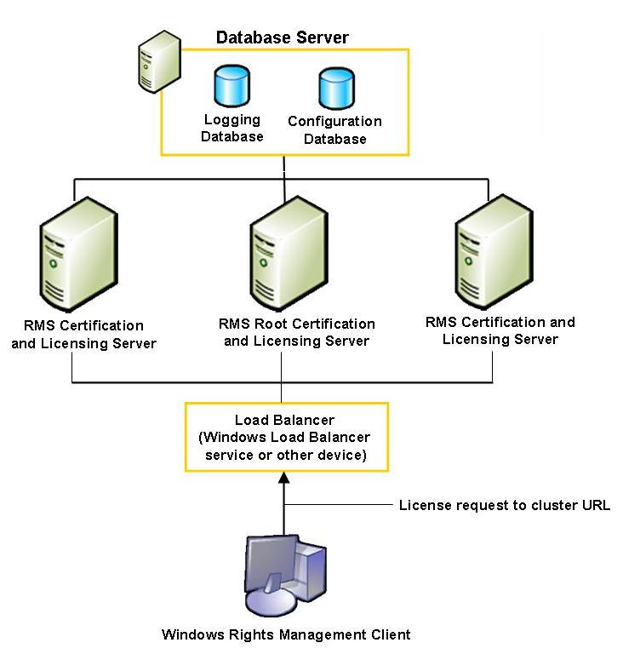
Figure 1 Standard Windows RMS system topology

Enrolling Servers in an RMS System
When organizations install Windows RMS, the installation process creates a Windows RMS Global Administration site that enables administrators to configure the servers and services in an RMS system. When a server is configured, Windows RMS determines whether it is the first RMS server in the system in order to set up the Windows RMS root cluster. During the online server enrollment process, the server sends a request for an RMS Server Licensor Certificate to the RMS Server Enrollment Service, a Web service. This request is made using Secure Socket Layer (SSL) security. The RMS Server Enrollment Service uses the information solely to issue the Windows RMS Licensor Certificate to the organization making the request.
The enrollment service creates and returns an XrML licensor certificate for that organization’s public key. The RMS Server Enrollment Service does not issue the public/private key pair to an organization’s root server; it merely signs the public key. The RMS Server Enrollment Service cannot be used to unlock an organization’s content. There is no attestation of identity during this process. All RMS servers—such as licensing servers, certification servers, and root servers—can be deployed in a clustered configuration for better load balancing.
With RMS SP1, RMS can now be operated in networks with no Internet connection, sometimes known as air-gap networks. With RMS SP1, server enrollment can be performed in an offline manner. Customers choosing the offline option will be able to obtain the XrML licensor certificate and import it into the RMS server in two separate steps, transporting the licensor certificate on physical media between an Internet-connected machine and a non-Internet-connected network.
An online enrollment process includes the following steps:
- The administrator installs Windows RMS server software on the root server.
- During configuration, the version of RMS installed on the server and the organization’s URL are collected and a public/private key pair is created.
- The server sends the public key along with the RMS version and URL information to the RMS Server Enrollment Service in a request for a Windows RMS Licensor Certificate.
- The RMS Server Enrollment Service returns the Windows RMS Licensor Certificate.
Enrollment using the RMS Server Enrollment Service is required for at least one server within every RMS system. Subsequent servers added to the Windows RMS root cluster use the same RMS Licensor Certificate. When you add a new server to an existing root installation or licensing-only server cluster, the new server is not explicitly enrolled because it takes on the entire existing configuration of the cluster.

Setting Up Client Computers
Every client computer that will participate in the RMS system must be set up so that it is established as a trusted entity within the RMS system. Client computer setup consists of verifying the presence of the Windows Rights Management client component and activating the client computer. After a client computer is set up, the infrastructure is in place to permit users with RMS-enabled applications to publish and consume rights-protected information.

Verifying the client component
Each client computer must have the Windows Rights Management client component installed. This component is available from the Windows Update Catalog or the Microsoft Download Web site. In the next version of Windows, the client component will be built into the operating system.
Organizations can use standard software deployment tools such as Microsoft Systems Management Server (SMS) to ensure their client computers have the component installed This component is required by RMS-enabled applications and is used for the client computer activation process.

Client computer activation
In RMS version 1.0, the client activation step required the client machine to connect via the RMS server to an Internet activation service hosted by Microsoft. This activation service generated a lockbox and machine certificate, validating the client machine to use RMS. With RMS SP1, the client machine activation step no longer requires this connection to Microsoft, or any Internet connection at all. Client machine activation has been updated to a “self-activation” model. The RMS SP1 client is delivered with the lockbox already included, with all the logic necessary to generate, store, and digitally sign the machine’s credentials. Using Windows encryption and data protection APIs, the RMS client will generate the necessary unique key material and digital signatures itself, upon activation.

Certifying RMS Users
The user certification process creates a rights management account certificate, which associates a user account with a specific computer and enables the user to access and use rights-protected information from that computer. The first time a user publishes rights-protected information or attempts to access rights-protected information on a client computer, the RMS-enabled application sends a request for an account certificate to the Windows RMS root installation.
The Windows RMS root installation validates the user by using Windows authentication and creates an account certificate for that user, including a public/private key pair, based on the user’s validated credentials. It encrypts the user's private key with the public key of the client computer's certificate and includes the encrypted key in the user’s account certificate. It then issues the account certificate to the requesting application. The application stores the account certificate on the computer or device so that it is available for subsequent publishing or use license requests.
User certification follows the client computer activation process because the certificate of the client computer is required to request the account certificate. Users must acquire an account certificate for each computer they use. If a user works at more than one computer, each computer is issued a unique account certificate, but they all contain the same private/public key pair for the user.
When an application requests a use license, it includes the user’s account certificate in the request. The Windows RMS licensing server uses the public key of the account certificate to encrypt the symmetric key from the publishing license, which was initially encrypted with the public key of the Windows RMS server. This process ensures that only the trusted entity can access and use the use license.

Enrolling Client Computers for Offline Publishing
Client computers can enroll with the RMS root installation or a licensing server to receive a rights management client licensor certificate, which enables users to publish protected information when the computers are not connected to the corporate network. In this case, the client computer, rather than the licensing server, signs and issues the publishing licenses that contain the usage rights and conditions for rights-protected information published from that computer.
Local enrollment includes the following steps:
- The client computer sends the user's account certificate and an enrollment request to the RMS server.
- The server validates that sub-enrollment is allowed based on the network administrator settings and that the account certificate is not on an exclusion list in the configuration database.
- The server creates a public/private key pair specifically for the purpose of offline publishing for the user making the request. It creates a client licensor certificate and places the public key in that certificate. It encrypts the private key with the account certificate public key and places that in the certificate.
- The root installation issues a client licensor certificate to the local computer.

Creating and Viewing Rights-Protected Information
To protect data with Windows RMS, information workers simply follow the same logical and fundamentally interlinked workflow they already use for their information.
The following diagram summarizes how Windows RMS works when users publish and consume rights-protected information.
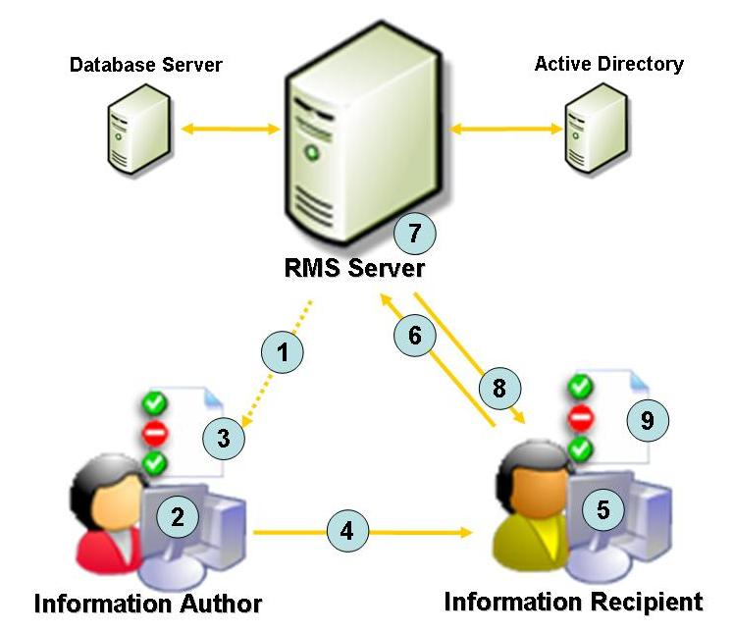
Figure 2 Workflow of creating and viewing rights-protected information
This process includes the following steps:
- Author receives a client licensor certificate from the RMS server the first time they rights-protect information. This is a one-time step that enables offline publishing of rights-protected information in the future.
- Using an RMS-enabled application, an author creates a file and defines a set of usage rights and conditions for that file. A publishing license is then generated that contains the usage policies.
- The application encrypts the file with a symmetric key which is then encrypted to the public key of the author’s Windows RMS server. The key is inserted into the publishing license and the publishing license is bound to the file. Only the author’s Windows RMS server can issue use licenses to decrypt this file.
- The author distributes the file.
- A recipient receives a protected file through a regular distribution channel and opens it using an RMS-enabled application or browser.
- If the recipient does not have an account certificate on the current computer, this is the point at which one will be issued.
- The application sends a request for a use license to the RMS server that issued the publishing license for the protected information. The request includes the recipient's account certificate (which contains the recipient's public key) and the publishing license (which contains the symmetric key that encrypted the file).
Note: A publishing license issued by a client licensor certificate includes the URL of the server that issued the certificate. In this case, the request for a use license goes to the Windows RMS server that issued the client licensor certificate and not to the actual computer that issued the publishing license.
- The Windows RMS licensing server validates that the recipient is authorized, checks that the recipient is a named user, and creates a use license.
- During this process, the server decrypts the symmetric key using the private key of the server, re-encrypts the symmetric key using the public key of the recipient, and adds the encrypted session key to the use license. This step ensures that only the intended recipient can decrypt the symmetric key and thus decrypt the protected file. The server also adds any relevant conditions to the use license, such as the expiration or an application or operating system exclusion.
- When the validation is complete, the licensing server returns the use license to the recipient's client computer.
- After receiving the use license, the application examines both the license and the recipient's account certificate to determine whether any certificate in either chain of trust requires a revocation list.
If so, the application checks for a local copy of the revocation list that has not expired. If necessary, it retrieves a current copy of the revocation list. The application then applies any revocation conditions that are relevant in the current context. If no revocation condition blocks access to the file, the application renders the data, and the user may exercise the rights they have been granted.
This process is essentially the same whether the recipient is within the publishing organization or outside of it. The recipient is not required to be inside the author's network or domain to request a use license. All that is required is a valid account certificate for the recipient and access to the licensing server that issued the publishing license.
Windows RMS can be set up to enable external sharing of rights-protected information. Users can share information with other trusted users over the Internet. This deployment offers the same level of protection as an intra-company Windows RMS deployment, because the rights that are attached to a rights-protected file must be licensed by an RMS server.
The external user can be validated by using the following credentials:
- User accounts created internally by the publishing organization, using Active Directory
- User accounts created by consuming organizations, if those organizations are trusted by the publisher's Windows RMS system
- User accounts created by Microsoft .NET Passport, if that service is trusted by the publisher's Windows RMS system
This enables organizations to share confidential documents and also to work together on trusted documents, such as contracts, over the Internet.

Publishing to Anyone
Publishing rights-protected information to named individuals or groups works well for most organizational needs, but there are also situations in which it is not the intent of the author to limit distribution. In this case, the author can select the option to publish to anyone, which does not limit the distribution of the information to named users or groups. When this option is selected, a use license will be granted to any user with an account certificate trusted by the RMS licensing server. For example, a human resources manager within an organization could apply the “publish to anyone” option to a document, such as a company policy handbook. All employees with trusted account certificates will then be able to view the handbook, and any usage rights applied to the handbook will be enforced.

Administering an RMS System
Windows RMS provides administrators with the following tools to help protect information through persistent usage policies:
- Usage rights policy templates
- Revocation lists
- Exclusion policies
- Logging

Usage Rights Policy Templates
From the Administrator Console on the Windows RMS server, administrators can create official rights policy templates, delete or modify existing templates, and specify the location of rights policy templates in the RMS system. Templates can include various conditions, such as specific recipients or Active Directory groups, how long a use license for the information remains valid, how long after publication the information can be accessed, and even custom values that are meaningful to a particular RMS-enabled application.
A template can also specify a revocation list. The template specifies the URL to the revocation list file and the number of days the revocation list is valid. When a recipient requests a use license based on the template, the system will check the revocation list before the user can access the protected information.
Rights policy templates are stored both in the configuration database and on a network share. When an author requests a publishing license, the RMS-enabled application copies the rights policy template from the network share. When a recipient requests a use license, the Windows RMS licensing server applies the rights policy template from the database; this process assures that the terms of a use license always reflect the most current version of the template.
The following screenshots show the template details.
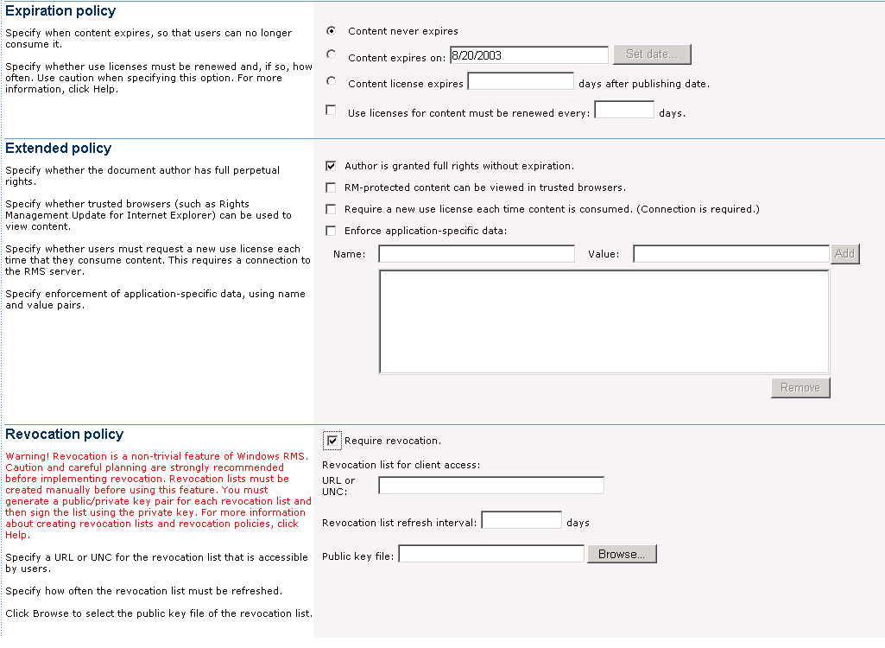
Figure 3 Rights policy template - screen 1

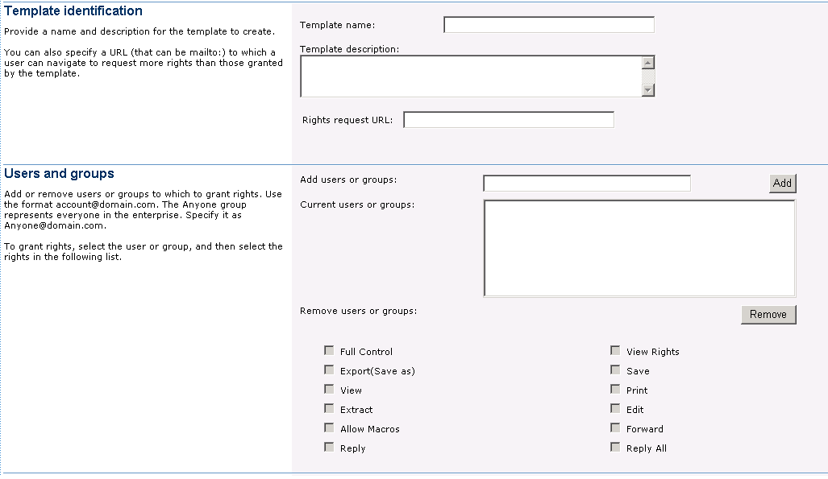
Figure 4 Usage rights policy template - screen 1

Revocation Lists
Administrators can create revocation lists that specify the users, applications, or other principals that should no longer have access to rights-protected information and, therefore, are barred from acquiring licenses from the RMS system. One or more XrML-based certificates involved in the process of issuing publishing or use licenses can specify a revocation list condition. RMS-enabled client applications check the revocation list whenever that condition is specified, and if any of the requesting principals are on the revocation list, the license request is denied.
Any certificate can be revoked. By default, only the entity that issued the certificate can revoke it, so only a revocation list that has been signed by that entity can revoke the certificate. Optionally, a certificate can also specify:
- An entity or list of entities that can revoke it. The revoking entity could be a third party.
- An empty public key as the revoking key so that certificate cannot be revoked.
Rights policy templates can also specify a revocation list condition. For example, an organization might want to check the revocation list for a template applied to company-sensitive information and skip the revocation list check for a template applied to less sensitive data. To further protect the information, the template can specify a valid time period for the revocation list. For example, the template might specify that the revocation list must have been created within the last 10 days, or it will not be accepted.
A revocation list is created as a plain text file in XML format that conforms to the XrML vocabulary and is signed by a private key using a utility provided by Windows RMS. The list can then revoke any principals named by the owner of the public key that corresponds to the private signing key. The file is placed in a location available to all users who require it, such as a URL that is accessible from both the corporate network and the Internet. This will assure that both internal and external users can access the file. If a revocation list condition is present and a valid revocation list cannot be located, access to the rights-protected information is denied.
An organization might specify principals in a revocation list for the following conditions:
- A private key is known or suspected to be compromised.
- An owner requests revocation of a key that is not believed to be compromised.
- A principal is no longer valid. (For example, an employee has been terminated.)
- A security enforcement flaw exists. (For example, a certificate issued to a client computer has been compromised.)
- Recertification is required due to authorization changes.

Exclusion Policies
From the Administrator Console in Windows RMS, administrators can set exclusion policies separately on each server or server cluster in the RMS system to prevent specific principals from acquiring new licenses from that server. Exclusion policies stop compromised principals from acquiring use licenses from RMS servers, but unlike revocation, exclusion does not invalidate the principals. Any existing licenses associated with excluded principals are still valid, but new licensing requests are denied.
Administrators can exclude the following principals:
- Rights management lockbox versions. An administrator can specify a lockbox version against which all licensing requests will be checked. If a request is made from a client computer with an earlier lockbox version, the request is denied. Lockbox exclusion also stamps every use license with a condition that it can only bind if the lockbox is current. Enforcing this condition in the license extends the reach of exclusion policies to computers that may not be used to acquire use licenses but are used to decrypt rights-protected information.
When an organization applies this exclusion policy, users cannot acquire new use licenses until they reactivate their computers. Their ability to access previously licensed files, however, will be unaffected. In order to preserve the user experience, administrators should deploy new lockboxes throughout their organization before enabling exclusion policies. Exclusion policies can then be used as a means to require upgrades for any computers that were not affected by the new lockbox deployment.
- User IDs. As a validation mechanism, administrators can exclude users by their IDs such that a user with an excluded ID is no longer permitted to make requests to Windows RMS servers for use licenses or client licensor certificate enrollment for offline publishing. The user, though, still retains access to all previously licensed information.
- Account certificates. If a user is a trusted entity, but there is reason to believe that the user's account certificate keys have been compromised, an administrator can exclude the public key for that account certificate. No new use licenses will be issued to an excluded public key, so the user must re-certify and be given a new account certificate with a new key pair. This new account certificate will be used for all future activities. However, the user retains the excluded account certificate to access previously licensed, rights-protected information.

Logging
Windows RMS installs support for logging during the initial RMS system setup; this logging service is enabled and started automatically. An RMS logging database is created in the SQL server database instance that is also used for the configuration database, and a private message queue in MSMQ is created to transmit the messages from the logging service to the database.
Administrators can enable or disable the logging service at any time. When enabled, the logging service will send all data about RMS requests to the logging database. Administrators can write SQL scripts to pare down the information so that only the specific information required by the organization is stored. RMS logs both successful and failed use license requests. This log enables an organization to record both the users who have successfully accessed rights-protected information and the users who attempted unauthorized access of rights-protected information.

Integrating with Existing Systems
RMS is designed to sustain existing investments and to integrate easily with new and existing applications in the following ways:
- Sustaining existing investments. Where possible, RMS is designed to make the most of existing infrastructure investments. For example, organizations can use domain structures such as Active Directory to publish rights-protected information to distribution lists. In addition, this technology works with existing authentication systems. Organizations can use widespread technologies like Windows Authentication or .NET Passport.
- Integrating with Microsoft applications. Microsoft is dedicated to integrating RMS technology into its systems and applications, and anticipates that many applications will incorporate RMS technology. Organizations that plan to use the next major version of the Windows operating systems on their client computers will have the necessary APIs to run RMS-enabled applications without requiring additional add-ons or software downloads.
- Integrating with in-house and other applications. The Windows Rights Management SDK is available through the Microsoft Download site, so that software developers can add RMS functionality to their programs. For the many organizations that create digital information using applications that were not developed by Microsoft, the availability of the RMS SDK enables a more comprehensive solution. For the recipients of rights-protected information who do not have access to RMS-enabled programs, a trusted RMS-enabled browser, the Rights Management Add-on (RMA) for Microsoft Internet Explorer, will be available as a free download.
The Windows Rights Management SDK provides these organizations with the technology needed to express, manage, and enforce usage policies using proprietary applications–another critical element of delivering RMS protection across the entire range of organizational information.

Summary
With the pervasiveness of the Internet and e-mail as common communication tools and the drive to reduce costs by reducing paper, most organizations extensively use and forward information digitally, increasing the risk of having confidential information accidentally or intentionally get into the wrong hands. The potential loss of revenue, competitive advantage, and customer confidence caused by information leaks can be costly to an organization. To safeguard sensitive information such as customer data, financial reports, product specifications, and confidential e-mail messages, organizations are looking to augment their security strategy. RMS helps protect information through persistent usage policies, which remain with the information, no matter where it goes.

Related Links
- Microsoft Windows Rights Management Services at http://www.microsoft.com/rms/
- Microsoft Security at http://www.microsoft.com/security
- Microsoft Privacy at http://www.microsoft.com/privacy
- Trustworthy Computing at http://www.microsoft.com/mscorp/innovation/twc/
For the latest information about Windows Server 2003, see the Windows Server 2003 Web site at http://www.microsoft.com/windowsserver2003.

Passed in 1996, HIPAA relates to healthcare coverage and, for example, how companies may use medical information.
Gramm-Leach-Bliley, also known as the Financial Services Modernization Act, was passed in 1999.

