# WHAT’S NEW IN BI

Deliver and Succeed with BI  
Microsoft SQL Server PowerPivot for SharePoint

Microsoft SQL Server PowerPivot technology gives users the ability to analyze massive quantities of data, and its seamless integration with Microsoft SharePoint Server 2010 helps IT departments monitor and manage how users collaborate. Use PowerPivot to expand the reach of BI in your organization through familiar technologies and platforms from Microsoft.

Learn more at <http://www.powerpivot.com>.

Microsoft SQL Server PowerPivot technology redefines how IT departments deliver and succeed with BI.

You can give your users the power to drill into any aspect of their business and compress decision cycles to gain deeper insight. You can enable your users to share their findings with others effortlessly and securely. You can increase the efficiency of your IT department through the PowerPivot Management Dashboard.

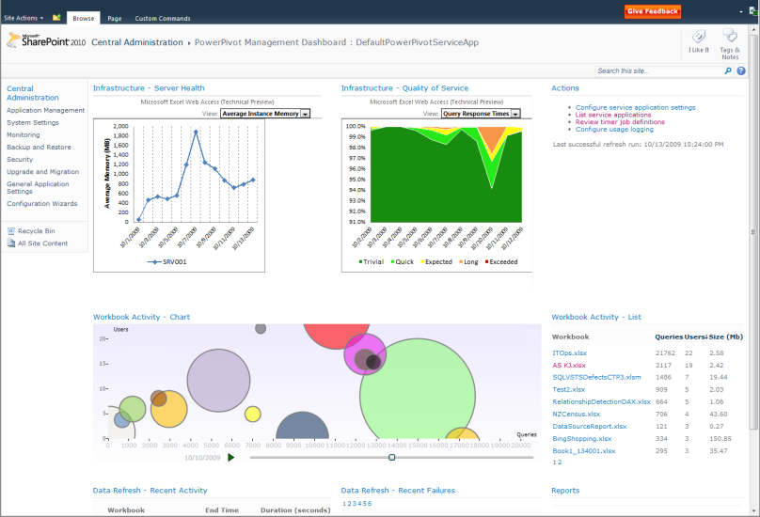

**PowerPivot Management Dashboard**

Give users the best data analysis tool available. Build on the familiarity of Excel to accelerate user adoption. Expand existing capabilities with column-based compression, an in-memory BI engine, virtually unlimited data sources, and new Data Analysis Expressions (DAX) in familiar formula syntax.

Facilitate knowledge-sharing and collaboration on user-generated BI solutions. Deploy SharePoint 2010 to provide the collaboration foundation with all essential capabilities, including security, workflows, version control, and Excel Services. Install SQL Server 2008 R2 to enable support for ad-hoc BI applications in SharePoint, including automatic data refresh, data processing with the same performance as in Excel, and the PowerPivot Management Dashboard. Now your users can access PowerPivot workbooks in the browser— without having to download workbooks and data to every workstation.

Increase BI management efficiency. Use the PowerPivot Management Dashboard to keep an eye on performance, availability, and quality of service. Discover mission-critical applications and ensure that proper resources are allocated.

Provide reliable access to trustworthy data. Take advantage of SQL Server Reporting Services data feeds to encapsulate enterprise systems and reuse shared PowerPivot workbooks as data sources in new analyses.

# Empower Your Users

Give your users the best authoring and publishing tools, enabling them to process enormous amounts of data from any location:

Use PowerPivot for Excel 2010 to process massive amounts of data in seconds. Capitalize on column-based compression and the in-memory BI engine available with PowerPivot technology, and take on advanced analysis using powerful DAX expressions.



**Processing Massive Amounts of Data**

Enjoy interactive slicing and dicing. Use familiar PivotTable views, charts, and slicers for interactive analysis. Sort, filter, and scroll through millions of rows with about the same performance as a few thousand.

Combine data from multiple sources. Take advantage of the new version of Analysis Services and Reporting Services in SQL Server 2008 R2 to use PowerPivot workbooks like a cube—and consolidate meaningful information from a multitude of sources, including relational databases, multidimensional sources, cloud services, data feeds, Excel files, text files, and data from the Web so users can use data feeds exposed through Reporting Services reports.

# Facilitate Sharing and Collaboration

Make it safe and easy for your users to work together and boost the productivity of your entire organization:

Capitalize on standard SharePoint features. Benefit from all the features that make SharePoint so effective, such as role-based security, workflows, and versioning.

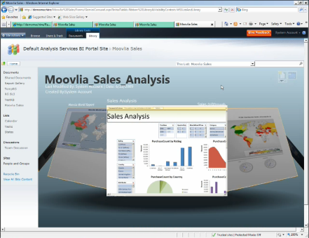

**PowerPivot Workbooks in SharePoint**

Provision SharePoint sites to share data models and analysis. Create a PowerPivot Gallery for your team where users can upload and find analyses, work seamlessly via Web browser, and enjoy SharePoint’s attractive user interface—browsing at its best—with the same performance and features as the Excel client.

Make decisions based on the most recent data. Schedule automatic data refresh for workbooks in SharePoint to ensure the data remains current automatically.

Maximize business insight. Reuse your shared applications as data sources—and take advantage of SharePoint permissions and workflows to coordinate how users share and collaborate on their own solutions.

# Increase IT Efficiency

Drive efficiency in your IT department by centralizing BI and data management and encapsulating enterprise data sources.

Give users virtually unlimited data access. Encapsulate mission-critical enterprise data sources for ad-hoc analysis by using SQL Server Reporting Services data feeds and PowerPivot workbooks as data sources.

Ensure data quality, integrity, and security. Support your business units in their decision-making by taking advantage of all technologies in the Microsoft BI Solution Stack. Provide your PowerPivot users with trustworthy data in a secure and compliant way.

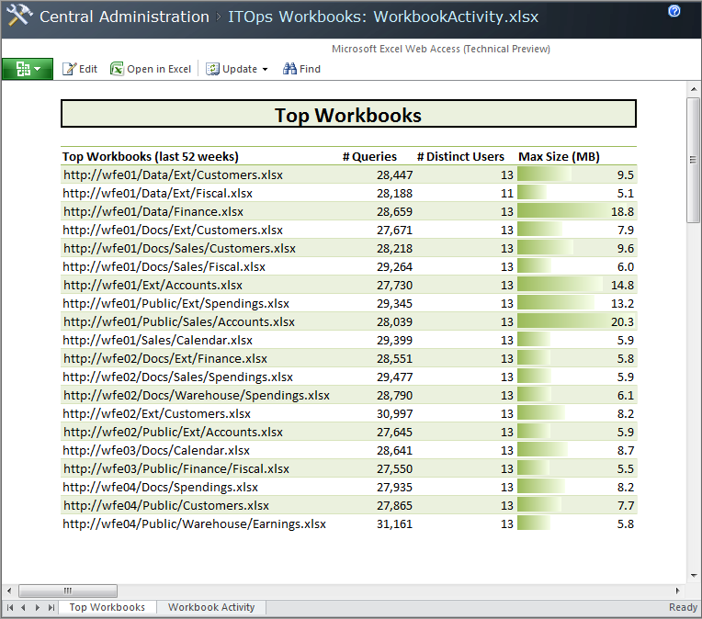

**Most Popular Workbooks in SharePoint**

Discover mission-critical self-service BI applications. Leverage the PowerPivot Management Dashboard to monitor your shared applications. Track usage patterns over time, drill down to reveal hidden details, discover mission-critical solutions, and make sure appropriate server resources are provisioned to ensure high availability and performance.

# Get Started Now

Deploy Microsoft SQL Server PowerPivot for SharePoint in your organization today. Empower your users to create and share robust workbook applications directly in Office 2010.

Learn more about Microsoft SQL Server PowerPivot for SharePoint and download the PowerPivot for Excel 2010 add-in at <http://www.powerpivot.com>.