Billions of dollars have been invested purchasing, tailoring, deploying and maintaining ERP, CRM, SCM, and other integrated business solutions, yet few companies see the promised benefits. Technology needs to do more than just automate the routine – it needs to mirror the ad-hoc practices that people actually perform.

**Office Business Applications Overview**

The alternative is inefficiency from duplication and assumptions made from not having the relevant data at hand.

The Results Gap

The failure to adequately connect people and their processes with the business data and processes embodied in line-of-business systems has become known as the *results gap*. The results gap translates directly into widespread failure to realize the expected returns on investments made in enterprise hardware and software.

This results gap occurs because systems can rarely take into account the true complexities of getting work done. Information workers use systems to obtain data, but the real work is done through a more fluid interaction between co-workers and other people. More than just retrieving information from one system and updating it in another, processes often involve collaboration, sharing, and discussion between people. These unstructured, ad hoc processes are not typically captured within the transactional system interactions.

The difference between effort expended and results achieved is the *results gap*.

According to a Gartner, Inc. research note "The Knowledge Worker Investment Paradox:[1]"

*In most enterprises, an employee will get 50 percent to 75 percent of his or her relevant information directly from other people.*

*More than 80 percent of the enterprise's digitized resources are not accessible to the enterprise as a whole because they reside in individual hard drives and in personal files.*

*The individual owns the key resource of the knowledge economy - tacit and explicit knowledge - and most of that knowledge is lost when he or she decides to leave the enterprise.*

Office Business Applications

Office Business Applications (OBA) are an emerging breed of application that leverages the power of the Office Business Platform, that is, the clients, servers, services, and tools that comprise the 2007 Microsoft Office system. People typically perform significant additional work outside of the formal processes of a line-of-business (LOB) system as they collaborate with other people via phone and email, obtain information from multiple sources in the form of documents and spreadsheets, and switch between online and offline modes for meetings and business trips. OBAs help simplify this interaction by fitting within the informal processes that information workers actually follow.

Enabling Collaboration

Business users are accustomed to getting work done through a document-centric paradigm. A document is created, revised, sent for approval, distributed, synchronized with LOB systems, and then filed for future use. LOB systems are great at handling transaction-oriented activities. But they are not suited to capture the significant work that happens in between the activities – the ad hoc collaboration.

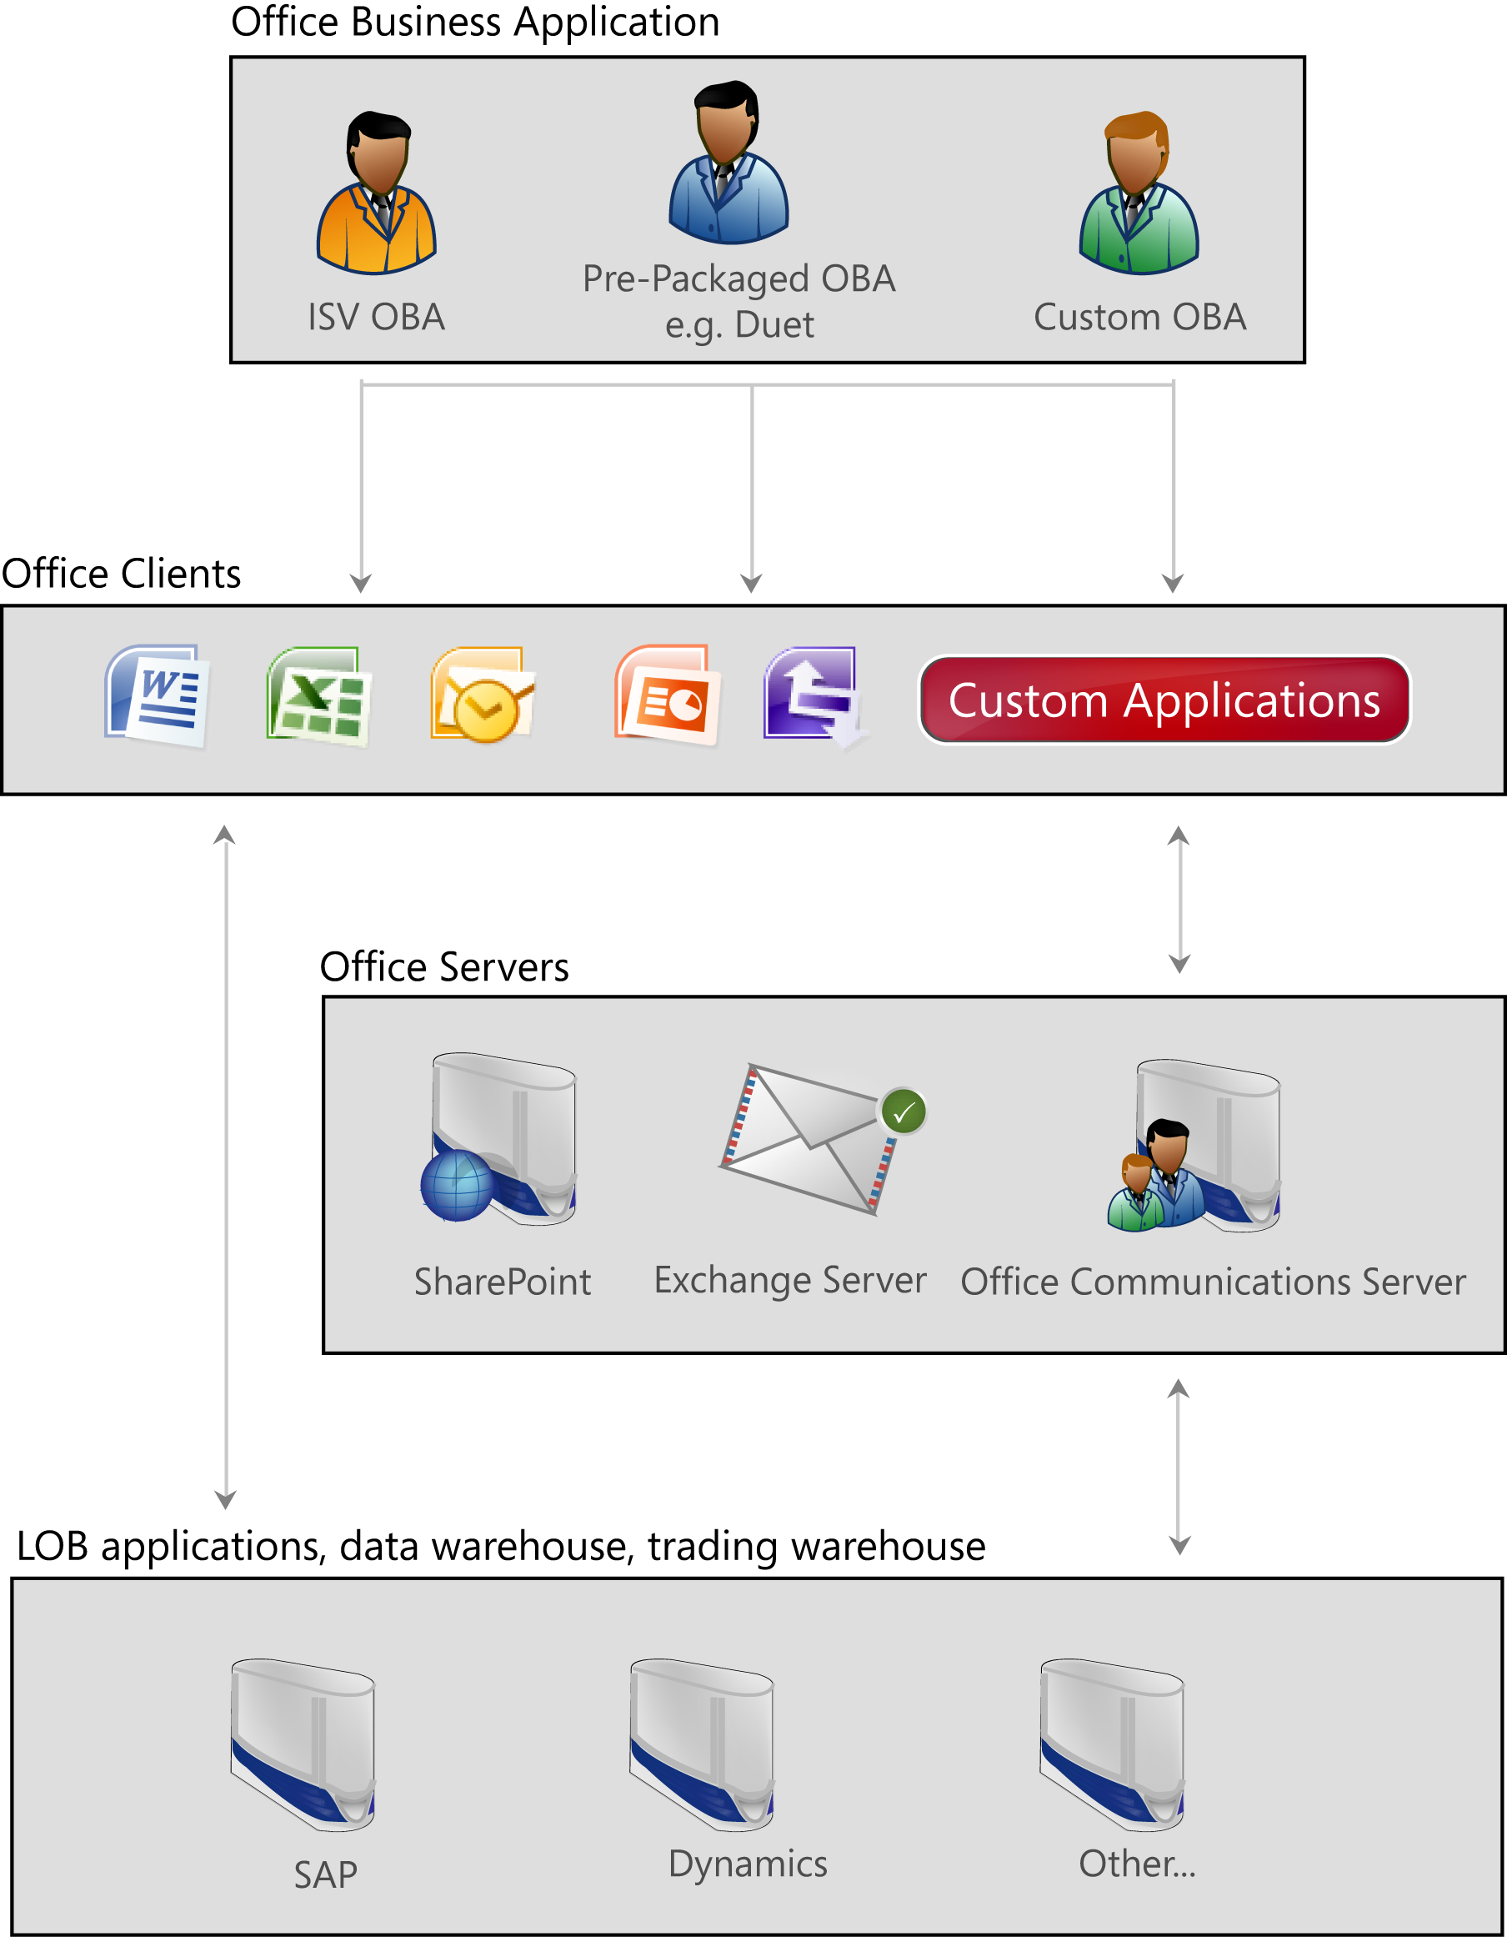

Think about sales managers who need to create a proposal. They must spend time researching prices, perhaps contacting suppliers and shipping companies, and talking to other members of the extended team to arrive at a suitable quote. Most of this work takes place outside of the transactional enterprise systems. Only after everything is assembled do they use the LOB system to create the final quote.

Unified communications across the 2007 Office line of products, such as instant messaging, document sharing, and user presence, further promote and simplify such ad hoc processes and keep people in the center of the workflow – where they belong.

Platform Capabilities

Office Business Applications are made possible by key platform capabilities, called OBA Services, in the 2007 Microsoft Office system. These consist of: workflow, search, the Business Data Catalog, a new, extensible user interface, Microsoft Office Open XML Formats, and the Web Site and Security Framework. These services can be used to extend Microsoft Office system investments in business intelligence, unified communications and collaboration, and enterprise content management, as well as other business applications by ISVs or corporate developers.

* **Workflow**Getting work done often requires multiple people to work with the same document. It’s too easy for documents to get “lost” in the Inbox, saved to the wrong location, end up with multiple versions, or otherwise taken out of the loop. Windows Workflow Foundation forms an integral part of the Office Business Platform to facilitate automated workflow processes. With a workflow, events can automatically trigger changes in the flow, or users can select actions based on their needs. For instance, an item may automatically be placed on hold, or forwarded for approval when a dollar amount exceeds a threshold. Several common workflows are provided out of the box and customized workflows can be easily created using available tools such as Microsoft Office SharePoint Designer 2007.
* **Search**The Office Business Platform offers a powerful search engine portal to find relevant results across the organization quickly. Not only is document content indexed, but a flexible metadata system allows advanced queries to be executed based on projects, people, and document types. Advanced tagging capabilities allow documents to carry contextual data beyond the actual contents. With some custom development, company-specific information such as insurance policy or claim numbers can be embedded for even better targeted search.
* **Business Data Catalog**Users require data from LOB systems every day yet the data is typically accessible only to a handful of individuals well versed in the LOB system interface. And if data does get extracted, it typically takes the form of copy-and-paste or data exporting operations to a document that is disconnected from the LOB system. Working with stale data often introduces errors and hinder productivity. The Business Data Catalog, or BDC, allows Office applications to reference read-only data from LOB systems. For example, using BDC, an InfoPath based purchase form could be setup to extract and auto fill customer details from one system, product details from another system, and financial details using a financial institution’s web service, thereby greatly simplifying the overall user experience.

“70% of CRM implementations simply fail.”

– *Butler Group*

* **Extensible User Interface**The 2007 Microsoft Office client applications, such as Outlook, Word, Excel, and InfoPath support a wide variety of customizations to add the exact features that people need. Custom Task Pane can host controls such as lists, buttons, and text boxes to present information from other sources for reference or integration within documents. Smart Tags allow contextual actions to appear based on text entered in the document, and ribbons can be created or extended to expose line-of-business logic and data.
* **Ecma Office Open XML File Formats**New, open file formats expand the use of documents throughout the enterprise. Generating automated documents is easier than ever, and companies benefit from documents that can be shared across platforms and between applications. Data can be embedded for tracking, workflow, LOB data associations, or even caching to allow offline editing of information.
* **Web Site and Security Framework**Companies can create web sites that are heavily customized for specific business, department, or personal needs. For example, a sales manager can see pending deals, top performers, and employee-level statistics while members of the team are only able to see information identified as relevant to their role. Documents can be viewed or modified in a browser, or downloaded for offline use. Both user- and role-based security create a range of options for restricting sensitive information, and delivering the most relevant experience.

Summary

Office Business Applications allow users to increase productivity by providing a seamless and integrated end to end user experience. Documents remain at the center of the experience, while deep integration with business logic, data, and services make them more relevant than ever. Users can collaborate and get work done in familiar ways. Server tools bring powerful search, portal technology, and advanced workflow to the enterprise.

For more information on the 2007 Microsoft Office system, visit http://office.microsoft.com.

For more information on Office Business Applications, visit: http://www.microsoft.com/office/oba.

Office Business Applications provide the following benefits to the enterprise:

|  |  |
| --- | --- |
| **Capability** | **Benefit** |
| **People-centric** | Office Business Applications allow people to follow proven processes. Instead of creating applications that alter the natural flow of information, OBAs are designed to fit into existing ad-hoc people processes. People can use documents for collaborating with each other, emailing, and sharing information, but with the added benefit of line-of-business integration to reduce errors and boost productivity. |
| **Extensible** | Microsoft Office client applications can be extended to create purchase orders, estimates, or invoices to address company-specific needs. Through customization, users can integrate data and business logic that is unique to each business. |
| **Familiar** | Knowledge workers are immediately ready to get started. By starting with the tools that they already know, the learning curve is considerably lessened. |
| **Connected** | A unified communications platform allows users to chat over a secure network with full logging and encryption capabilities, all under the control of enterprise servers. Presence makes it easy to see who is online and available. Document collaboration and application sharing can spur productivity in new ways, while voice or video chat can reduce conference costs. |
| **Open** | Files are easier to share with people inside and outside of the company with new open file formats. Companies can generate mass mailings or just augment new document templates with less effort. |

The information contained in this document represents the current view of Microsoft Corporation on the issues discussed as of the date of publication. Because Microsoft must respond to changing market conditions, it should not be interpreted to be a commitment on the part of Microsoft, and Microsoft cannot guarantee the accuracy of any information presented after the date of publication.

This document is for informational purposes only. MICROSOFT MAKES NO WARRANTIES, EXPRESS, IMPLIED OR STATUTORY, AS TO THE INFORMATION IN THIS DOCUMENT.

Microsoft may have patents, patent applications, trademarks, copyrights, or other intellectual property rights covering this document or the subject matter included in this document. The furnishing of this document does not give you any license to these patents, trademarks, copyrights, or other intellectual property.

© 2007 Microsoft Corporation. All rights reserved.

1. Gartner, Inc. research note "The Knowledge Worker Investment Paradox,"Regina Casonato and Kathy Harris, July 17, 2002