In order to keep companies agile, architects are faced with a challenge: combine the many technologies, platforms, and applications across the enterprise into a coherent infrastructure capable of meeting current demands and adapting to new ones.

**Office Business Applications**

*Architecture Overview*

The 2007 Microsoft Office system is more than just a productivity application suite. Architects can combine the powerful Office client applications and Office server infrastructure with existing backend applications to create powerful business applications. Using Microsoft Office as a business application platform creates new opportunities to introduce line-of-business integration, collaboration, and workflow, all while working within the existing user processes.

A Strategic Platform

Architects often must work with disparate Line-of-Business and server-side legacy systems. Decomposing legacy applications is a great start, but where to go from there? You have a lot of information available across various systems, but how do you make effective use of it? Capturing day-to-day processes can seem like an impossible task due to their flexible, people-driven nature, yet they clearly must be taken into account. And of course your users need tools with a familiar interface that don’t require a steep learning curve.

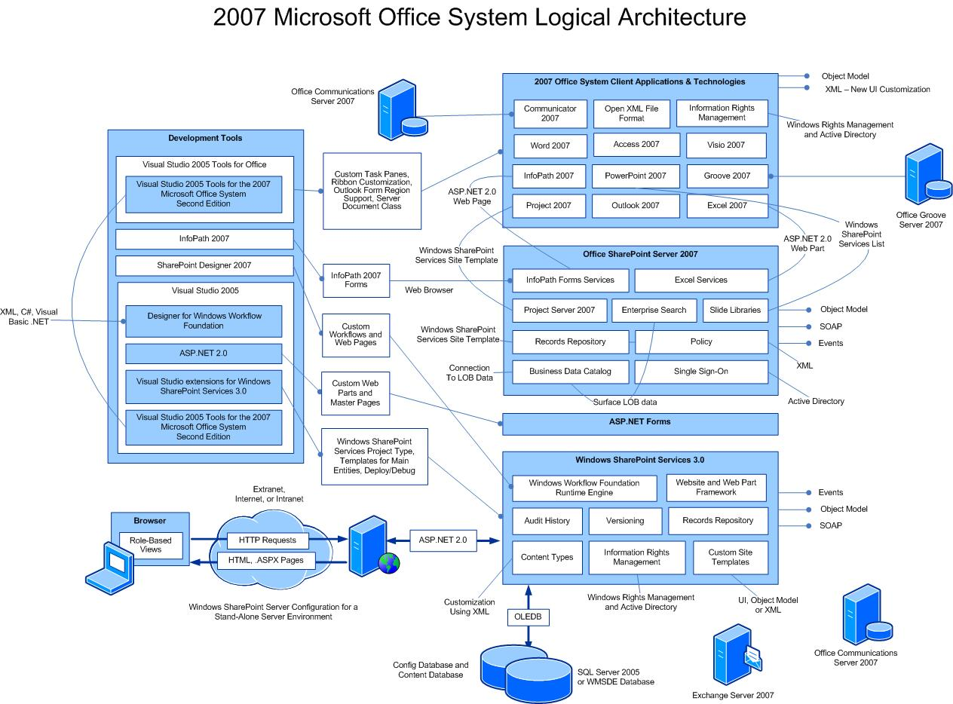

The 2007 Office system addresses these needs through an extensively customizable rich object and event model. Both client- and server-side extensions can be created using .NET API’s and SOAP-based Web services. Clients support augmentation with custom logic at the document- or application-level, while server-side plug-ins simplify working with documents, lists, and workflows at various points.

The Agile Enterprise

Decomposing legacy applications into services seems like a logical first step toward unlocking existing IT assets and adding greater flexibility overall. A Service-Oriented Architecture (SOA) normalizes the application topology, but a service cloud on its own isn’t enough. You also need to compose the services into applications and make the application accessible and user-friendly. In other words, enterprises need to work with the backend data and services in a way that is compatible with people’s work processes while housed in a user interface people will actually use.

Office Business Applications

Starting with decomposed services, Office Business Applications (OBAs) present users with proven client-side applications tied together with powerful server technology available in the 2007 Microsoft Office system.

The core of the 2007 Office system is comprised of:

* The **2007 Office client applications** including Outlook, Word and Excel
* **Office SharePoint Server 2007** providing a robust, scalable, and configurable infrastructure including ASP.NET Web parts and Web forms used for browser-based interaction
* **Technologies and services** such as Windows SharePoint Services, Excel Services, Windows Workflow, Windows Communication Framework, and XML
* **Collaboration features** managed by Office Communications Server 2007, Office Groove Server 2007, and Exchange Server 2007
* **Familiar development tools** such as SharePoint Designer, Visual Studio 2005 and Visual Studio Tools for Office 2005

Microsoft Office Clients

Extending familiar Office clients has gotten easier with the 2007 Office release and the accompanying Visual Studio 2005 Tools for the 2007 Microsoft Office system (VSTO 2005 SE). Applications can be built leveraging:

* Office 2007 Outlook
* Office 2007 Word
* Office 2007 Excel
* Office 2007 InfoPath
* Office 2007 PowerPoint
* SharePoint Designer 2007

Custom forms in Outlook can be used to host user interface controls with the ability to integrate business logic and data from various sources. Word and Excel offer programmability in the form of the Task Pane, Smart Tags, and the new Ribbon. This makes it possible to retain natural document interactions with structured business data and processes.

**Smart Tags** use regular expression pattern matching to recognize identifiers like phone numbers, government identification numbers, or custom account numbers within the text of a document. Relevant actions can be presented right alongside the data.

Users can view customer or other information in the **Task Pane** while working on the document. This eliminates the disconnect that occurs when users must switch to client application interfaces to transfer data back and forth. Data can be embedded in a static fashion, or retrieved live each time the document is opened, when the data is modified, or on-demand.

The **Ribbon** offers access to all of the features previously found in menus and toolbars, but with more flexibility. Extending the Ribbon is possible through a combination of code and XML markup files. Custom applications can also take advantage of the look-and-feel of Office 2007 through a no-cost, royalty-free licensing program.

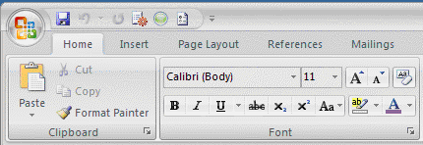

Ecma Office Open XML File Formats

Microsoft Office 2007 introduces new file formats that benefit both large and small companies. By converting to Open XML Formats, documents can be created independent of the Office client applications for compelling new lightweight server scenarios. Data can be integrated from various sources, and consumed in new ways. Even without the client applications, new documents can be created using standard XML technologies, such as the System.Xml namespace in .NET. Information can be indexed, searched, and reused more easily. File size is reduced through ZIP compression technology, and documents are more resilient to file corruption. Bandwidth is reduced and reuse of company data is increased.

Microsoft Office SharePoint Server 2007

Microsoft Office SharePoint Server offers workflow, search, Excel Services, the Business Data Catalog for LOB access, a Web site and security framework, and more. Integration with documents and their intrinsic data allow enterprises to wring more value out of their information. Excel Services and InfoPath Services simplify application composition by giving business users the ability to author business rules and calculations without the need to know code. This leads to reduced IT involvement, and a closer fidelity to user expectations. Documents become corporate assets, fully indexed, with the ability to create, publish, and manage centrally.

The Business Data Catalog (BDC) runs within Microsoft Office SharePoint Server to expose read-only data from LOB systems, databases, Web services, and more. Data is exposed as SharePoint tables and lists and can also be consumed by client customizations. The BDC is useful for mapping business data entities to back-end data stores, retaining descriptions of the entities and their attributes.

Technologies and Services

OBAs benefit from a variety of technologies and services built into the platform.

* **Excel Services** allows documents to be authored by business users using Excel as usual, and then saved to SharePoint Server. End users can view and interact with the documents in a Web browser, and software developers can invoke business logic stored within the documents programmatically.
* **Windows Workflow** functionality is built-into SharePoint Server. This makes it easy to capture a process such as a purchase order approval, and use it to reduce user errors and associated delays.
* The **ASP.NET 2.0** runtime supports rendering Web Pages and Web Parts to create and customize Web sites that exactly reflect company’s needs.

These services and others simplify the process of creating applications that meet user expectations. Requests to make an application “work more like Excel” are easy to fulfill. Small-scale department “applications” built up on macros and custom templates can be replaced with true application code that ties into the overall enterprise environment.

Tying it Together

Architects face a challenge when asked to unify processes across an enterprise. Service-Oriented Architectures are a good start, but they are incomplete without a strong user-interface and unifying platform. The 2007 Microsoft Office system has become more than a productivity suite. It brings together data and processes through its combination of clients, servers, services, and tools. Office Business Applications built on the 2007 Microsoft Office system can meet these needs via its extensive services, built in communication and collaboration, content management, and document-based capabilities.

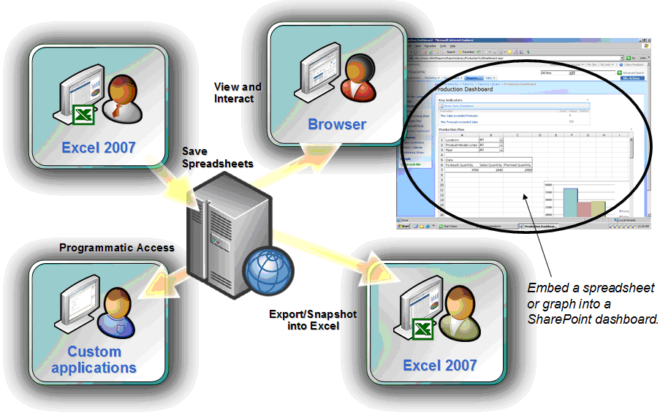

Next Steps

For more information on designing and building applications using the Microsoft Office system, visit <http://msdn.microsoft.com/architecture/office> or <http://www.microsoft.com/office/OBA>

Developing Office Business Applications with the 2007 Microsoft Office system offers the following benefits:

|  |  |
| --- | --- |
| **Capability** | **Benefit** |
| **Extensible architecture** | *Take Microsoft Office further*  The client and server applications offer immense functionality for modern business, but their extensibility hooks allow companies to take them further. A wealth of .NET classes across a large number of namespaces offers the ability to respond to client or server events or hook into the user interface at various levels. Implement requirements in the best possible place to drive productivity and increase efficiency. |
| **Familiar Office clients** | *Users already know the clients*  The advantage of using the 2007 Office client applications as the basis for company-specific solution cannot be overstated. Users know the interface, and are most productive at the document-based interactions. Existing workflow processes can be enhanced rather than reimplemented. |
| **.NET Framework** | *Exploit the power of .NET*  Visual Basic and Visual C# developers will feel at home writing managed client and server customizations. Full access to the Base Class Libraries provides data binding, ADO.NET, XML parsing, regular expressions, Web service support, and much more. Reuse existing code and leverage existing knowledge with the full power of the .NET 3.0 Framework. |
| **Visual Studio toolset** | *Work with the best tools around*  A platform without good tools has difficulty gaining traction. The 2007 Office system benefits from advanced programming and debugging tools available with Visual Studio. From the New Project or New File wizard, Office-specific templates make it easy to start coding. Strong team features make it easier for programmers to work together. |

|  |  |
| --- | --- |
| **Unified communications** | *Common chat, sharing, and collaboration*  Take advantage of instant messaging and presence features across both Office clients and custom client applications. Unified communications means one platform for chat, voice, video, application sharing, and document collaboration. Use the APIs to hook advanced messaging and presence capabilities into customizations. |
| **Open XML file format** | *Take documents to the next level*  The new open XML file formats enable developers to interact with documents in new ways. Standard XML and ZIP compression technologies provide a familiar foundation for creating, manipulating, and consuming documents without invoking the 2007 Office client applications. Any platform with XML parsing capabilities can interact with documents. Documents can store application-specific information used by customizations, or metadata extracted for search or other processing. |

This document is for informational purposes only. MICROSOFT MAKES NO WARRANTIES, EXPRESS, IMPLIED OR STATUTORY, AS TO THE INFORMATION IN THIS DOCUMENT.

Microsoft may have patents, patent applications, trademarks, copyrights, or other intellectual property rights covering this document or the subject matter included in this document. The furnishing of this document does not give you any license to these patents, trademarks, copyrights, or other intellectual property.

© 2007 Microsoft Corporation. All rights reserved.