Microsoft Office
Communications Server 2007 Technical Overview

Published: July 2007
Updated: February 2008
Information in this document, including URL and other Internet Web site references, is subject to change without notice. Unless otherwise noted, the companies, organizations, products, domain names, e-mail addresses, logos, people, places, and events depicted in examples herein are fictitious. No association with any real company, organization, product, domain name, e-mail address, logo, person, place, or event is intended or should be inferred. Complying with all applicable copyright laws is the responsibility of the user. Without limiting the rights under copyright, no part of this document may be reproduced, stored in or introduced into a retrieval system, or transmitted in any form or by any means (electronic, mechanical, photocopying, recording, or otherwise), or for any purpose, without the express written permission of Microsoft Corporation.
Microsoft may have patents, patent applications, trademarks, copyrights, or other intellectual property rights covering subject matter in this document. Except as expressly provided in any written license agreement from Microsoft, the furnishing of this document does not give you any license to these patents, trademarks, copyrights, or other intellectual property.
© 2008 Microsoft Corporation. All rights reserved.
Microsoft, Windows, Windows Server, Windows Media, Active Directory, ActiveSync, Outlook, PowerPoint, RoundTable, and SQL Server are either registered trademarks or trademarks of Microsoft Corporation in the United States and/or other countries.
All other trademarks are property of their respective owners.

Contents
Introduction 1
New Features 2
On-Premise Web Conferencing 2
Enterprise Voice 10
Enhanced Presence 19
Federation Enhancements 21
Simplified Deployment and Management 21
Client Applications 26
Architecture 26
Pool Configurations 27
Conferencing Components 31
Perimeter Network Configuration for IM and Conferencing 34
Call Flows Among Conference Components 36
VoIP Components 39
VoIP Configuration 43
Conference Data Storage 48
Protocols 48
What to Read Next 49

Introduction
Microsoft® Office Communications Server 2007 is the first Microsoft product to combine enterprise-ready IM (instant messaging), presence, conferencing, and VoIP (Voice over IP) telephony in a fully integrated unified communications solution. Office Communications Server 2007 provides richer presence capabilities, enhanced support for group IM, and improved deployment and management than its predecessor, Microsoft Office Live Communications Server 2005 SP1. To existing features, such as federation and public IM connectivity, Office Communications Server 2007 includes real-time conferencing hosted on servers inside your organization’s firewall and a full-featured, software-powered VoIP solution that can stand on its own or integrate easily with an existing PBX infrastructure.
Like Live Communications Server 2005, Office Communications Server 2007 is available in two editions, Standard Edition and Enterprise Edition:
- Standard Edition. Hosts all server components, as well as the database for storing user and conference information, on a single computer. Standard Edition provides full functionality for small organizations.
- Enterprise Edition. Separates server functionality from data storage to achieve higher capacity and availability. An Enterprise Edition pool typically consists of two or more Front End Servers, which are fronted by a hardware load balancer and connected to a Back-End Database. (It is also possible to deploy a single Front End Server without a load balancer.) Optionally, certain conferencing components can be deployed on separate computers for higher capacity and availability. Enterprise Edition is appropriate for medium, large, and very large organizations.
Both editions support the full suite of IM, presence, conferencing, and VoIP features.
This guide is divided into two main sections: New Features and Architecture. The New Features section provides a technical overview of the principal new features of Office Communications Server 2007, including the following:
- On-premise Web conferencing
- Group IM
- Audio and video
- Enterprise Voice
- Microsoft RoundTable™ communications and archival system
- Enhanced presence
- Federation enhancements
- Client applications
- Simplified deployment and management
The Architecture section discusses:
- Enterprise pool configurations
- Front End Servers
- Conferencing components
- Perimeter network topology
- Conference protocols
- Call flows among conference components
- VoIP components
- VoIP configuration
- VoIP call flow
- Conference data storage
- Perimeter network configuration
- Protocols
In addition, this overview includes suggestions for further reading.

New Features
This section provides a technical overview of new features in Office Communications Server 2007. These features are grouped under the following broad categories:
- On-premise Web conferencing
- Enterprise Voice
- Enhanced presence
- Federation enhancements
- Deployment and administration improvements
The following section, Architecture, discusses the server architecture that makes possible the features described below.

On-Premise Web Conferencing
Office Communications Server 2007 introduces the capability for enterprise users both inside and outside the firewall to create and join real-time Web conferences that are hosted on your organization’s internal servers. These on-premise conferences, or meetings, can be scheduled or unscheduled, and they can include IM, audio, video, application sharing, slide presentations, and other forms of data collaboration. Enterprise users can invite external users who do not have an Active Directory® Domain Services account to participate. Users who are employed by federated partners with a secure and authenticated identity can also join conferences and, if invited to do so, can act as presenters. This unified, server-based conferencing solution provides an alternative to hosted Web conferencing for organizations that require a more secure and controlled collaboration experience.

Multimedia Capabilities
Office Communications Server 2007 conferences provide a rich multimedia experience that include data collaboration, group IM, audio and video, and multiparty audio conferencing. For each media type there is a corresponding conferencing server, or MCU (multipoint control unit), that manages and coordinates use of that media type during the course of a meeting. Office Communications Server 2007 ships with four conferencing servers:
- IM Conferencing Server. Provides server-managed group IM.
- Web Conferencing Server. Enables multiparty data collaboration.
- A/V Conferencing Server. Enables audio and video conferencing.
- Telephony Conferencing Server. Enables audio conference integration with ACPs (audio conferencing providers).
The IM Conferencing Server and Telephony Conferencing Server always run as separate processes on the Standard Edition server or Enterprise Edition Front End Server. The Web Conferencing Server and A/V Conferencing Server can optionally be deployed on separate computers within an Enterprise pool.
Office Communications Server 2007 also supports multimedia conferencing with external users. This capability requires deploying the following media-specific edge servers in the corporate perimeter network:
- Access Edge Server. Validates and forwards SIP signaling traffic between internal and external users. Access Edge Server is the new name for what was known in Live Communications Server 2005 as the Access Proxy.
- Web Conferencing Edge Server. Enables data collaboration with external users.
- A/V Edge Server. Enables audio and video conferencing and A/V peer-to-peer communications with external users who are equipped with the Office Communicator 2007 client. Peer-to-peer communications traverse between the clients and do not go through the A/V Conferencing Server.
These edge servers can be installed on a single computer or on separate computers. For reasons of economy and simplicity, the recommended deployment for most organizations is to collocate the Web Conferencing Edge Server with the Access Edge Server but to install the A/V Edge Server, which requires greater bandwidth, on a separate computer. Group IM and data collaboration with external users also requires deploying an HTTP reverse proxy in the perimeter network.
The following sections discuss the four main types of multimedia conferencing:
- Group IM
- Data collaboration
- Audio/video
- Audio conferencing provider support

Group IM
Group IM refers to an IM conversation among three or more parties. You can create a group IM session in the following ways:
- Invite additional parties to a two-person IM conversation
- Send an instant message to multiple parties
- Send an instant message to a Microsoft Exchange Server distribution list
Users can add Microsoft Exchange Server distribution lists as contacts. The Microsoft Office Communicator 2007 client allows expansion of distribution lists through a Web service that is exposed on the server. This expansion allows users to invite one or more individual members of the group to an IM session. Distribution groups of up to 1000 users can be expanded, and an IM session can include as many as 100 members.
Note
The Microsoft Windows® Messenger 5.x and Office Communicator 2005 clients already support multiparty IM based on establishing separate connection between each two-user pair engaged in the conversation. A group IM session in Office Communications Server 2007 is implemented as a server-hosted conference. This approach is more scalable and offers greater flexibility to participants than a group conversation that is based on a large number of linked peer-to-peer conversations.

Data Collaboration
Office Communications Server 2007 Web conferencing supports a rich mix of data collaboration possibilities, including:
- PowerPoint support. Uploading and sharing slide decks created with the Microsoft PowerPoint® presentation graphics program, including animations and other rich features.
- Application and desktop sharing. Sharing applications among multiple participants and giving other participants control of the desktop or application. You can customize the level of sharing or control that you want to allow in your organization or disable this feature completely using WMI (Windows Management Instrumentation) or the Office Communications Server administrative snap-in.
- Microsoft Office Document Imaging (MODI) Support. Uploading and sharing of any document format that supports the MODI print driver, such as the full suite of Office documents.
- Web page. Sharing Web pages that can be viewed and navigated independently by all meeting participants.
- Multimedia. Viewing media files (such as Flash or Windows Media® technology files) by all meeting participants.
- Handouts. Exchanging files in their native formats among meeting participants.
- Snapshot. Capturing and displaying a static view of the desktop.
- Whiteboard. A place for free-form drawing and writing in a common shared space.
- Text. Writing and sharing text on a virtual whiteboard (separate from the graphical whiteboard features).
- Annotation. Annotating many types of slides.
- Polling. The ability to create questions and answers and compile and share responses from participants.
- Q&A. Asking and answering questions during a meeting.
- Chat. IM within the context of a meeting.
- Shared notes. The ability to edit and share meeting notes with other participants.
Data collaboration is managed by the Web Conferencing Server, which can be collocated with the Enterprise pool Front End Server or deployed in the same pool but on a separate computer. The data itself is stored in a file share created by an administrator.
Users can schedule data collaboration conferences with the Microsoft Outlook® conferencing add-in. Users can also add data collaboration to an existing IM session. Adding data collaboration to a peer-to-peer conversation escalates it to conference status, meaning that management of the conversation is turned over to Office Communications Server 2007, which enlists the Web Conferencing Server to manage data sharing among the parties to the conversation.
Office Communications Server 2007 also enables data collaboration with external users. The Web Conferencing Edge Server, which is deployed in the network perimeter, provides the bridge between the Web Conferencing Server and external users.

Audio and Video
Office Communications Server 2007 supports multiparty A/V (audio/video) conferencing. Users can specify A/V when scheduling a conference or can add audio or video to an existing IM conversation or conference call. Managing multiparty audio and video sessions is the job of the A/V Conferencing Server.
The A/V Conferencing Server can be collocated with the pool Front End Server or deployed in the pool on a separate computer for greater scalability. When deployed on a separate computer, the Audio/Video Conferencing Server can support up to 250 participants within a single session.
Office Communications Server 2007 also extends audio and video conferencing to external users. The Audio/Video Edge Server acts as a media relay for the transmission of both audio and video signals across corporate firewalls. This makes it possible to share audio and video with external users. The Audio/Video Edge Server can be collocated with the Access Edge Server or installed on a separate computer in the perimeter network.
Communicator clients support peer-to-peer A/V communication for users both inside and outside the organization’s firewall.

Microsoft RoundTable
Office Communications Server 2007 supports the Microsoft RoundTable communications and archival system, Microsoft’s new 360-degree surround audio/video conference-room device, which turns an online meeting into a true face-to-face experience. Attending a video conference by using RoundTable is much the same as attending a meeting in person. The audio and video of your entire conference room is delivered to a remote meeting location for your co-workers to interact in real time.

Audio Conferencing Provider Support
External audio conference participants who have not deployed Office Communications Server can participate through the services of a third-party Audio Conferencing Provider (ACP). The provider enables conferencing over an external PSTN bridge, with no interaction with internal VoIP audio conferencing.
ACP integration is managed by the Telephony Conferencing Server, which always runs as a separate process on either a Standard Edition server or Enterprise Edition Front End Server. Integration with the Audio Conferencing Provider occurs by configuring a federated connection with the external service provider, as you would with any other federated partner.

User Roles
Meeting participants fall into three groups:
- Organizer. The user who creates a meeting, whether impromptu or by scheduling. An organizer must be an authenticated enterprise user and have control over all end-user aspects of a meeting.
- Presenter. A user who is authorized to present information at a meeting, using whatever media is supported. A meeting organizer is by definition also a presenter and determines who else can be a presenter. An organizer can make this determination when a meeting is scheduled or while the meeting is under way.
- Attendee. A user who has been invited to attend a meeting but who is not authorized to act as a presenter.
A presenter can also promote an attendee to the role of presenter during the meeting.

User Types
Meeting participants can also be categorized according to their location and credentials. Administrators can use both of these characteristics to specify which users can have access to meetings. Users can be divided broadly into internal and external users:
- Internal users have Active Directory credentials within the enterprise and connect from locations inside the corporate firewall.
- External users are those who temporarily or permanently connect to an enterprise from locations outside the corporate firewall. They might have Active Directory credentials. Office Communications Server 2007 provides conferencing support for the following types of external users:
- Remote users have a persistent Active Directory identity within the enterprise. They include employees who are working at home or on the road, and others, such as employees of trusted vendors, who have been granted enterprise credentials for their terms of service. Remote users can create and join conferences and act as presenters.
- Federated users possess valid credentials with federated partners and are therefore treated as authenticated by Office Communications Server 2007. Federated users can join conferences and be promoted to presenters, but they cannot create conferences in enterprises with which they are federated.
- Anonymous users do not have an Active Directory identity and are not federated with the enterprise.
Customer data shows that many conferences involve external users. Those same customers also want reassurance about the identity of external users before allowing those users to join a conference. As the following section describes, Office Communications Server 2007 limits meeting access to those user types that have been explicitly allowed and requires all user types to present appropriate credentials at the time of entering a meeting.

Meeting Security and Access
To help ensure the privacy and confidentiality of meetings, a number of security features have been integrated into on-premise conferencing. All messaging and media are encrypted, as in Live Communications Server 2005. Office Communications Server 2007 provides additional safeguards for on-premise conferencing:
- Role-based security and authorization for conference control
- Scheduling permitted only to users who have Active Directory credentials in the internal network and are enabled for Office Communications Server 2007
- Conference passwords and digest authentication required for anonymous users to join meetings
Administrators can configure their Office Communications Server 2007 multimedia conferencing infrastructure to support meetings that include only the following types of users:
- Internal users only. If you do not deploy edge servers, all participants have persistent Active Directory identities within the enterprise and can connect only from within your organization’s firewall.
- Authenticated users only. All participants have Active Directory identities within the enterprise or within a federated enterprise, and they can connect from inside or outside your organization’s firewall.
Meetings that are open only to authenticated users can be of one of two types:
- Open Authenticated. All enterprise users can join the meeting. They join as attendees unless they have been designated as presenters by the meeting organizer. Federated users can join the meeting as attendees if they are invited by the organizer. Federated users cannot join the meeting as a presenter, but they can be promoted to presenter during the meeting.
- Closed Authenticated. Only authenticated users who are on the meeting organizer’s presenter and attendee lists are allowed to attend a closed authenticated meeting. For example, a work group or business unit might designate its regularly scheduled meeting as closed authenticated.
- Anonymous Allowed. A meeting to which anonymous users can be invited. The meeting organizer must be authorized to invite anonymous users to create a meeting of this type. Enterprise users join as attendees unless they have been designated as presenters by the meeting organizer. Anonymous users join only as attendees, although they can be promoted to the presenter role by the meeting organizer after they have entered the meeting. To enter a meeting, anonymous users must present a conference key, which they receive in an e-mail meeting invitation, and they must pass digest authentication.

Meeting Creation
An Office Communications Server 2007 user can create a meeting in one of the following ways:
- By scheduling a Web conference or conference call from the Conferencing Add-in for Microsoft Outlook.
- By creating a multiparty IM or A/V conferencing session from the Office Communicator 2007 client.
- By using the Share Information Using Live Meeting option in the Office Communicator 2007 client.
- By creating an unscheduled meeting by using the Meet Now functionality of the Microsoft Office Live Meeting 2007 client.
- By scheduling a Web conference or audio conference by using the Web Scheduler tool. You can download the tool from the Microsoft Web site at http://r.office.microsoft.com/r/rlidOCS?clid=1033&p1=websched.
When a meeting is created, a record is created in the back-end meeting database. The record contains essential information about the meeting, such as conference ID, organizer SIP URI, predefined presenter list, predefined attendee list, and anonymous user access key. This information is used by the server to activate the meeting at run time and to control who is admitted to the meeting.

Scheduling a Meeting
Office Communications Server 2007 takes advantage of the scheduling model in the Microsoft Outlook messaging and collaboration client, so that the steps required to schedule an online meeting are already familiar to new users. With the Conferencing Add-In for Microsoft Outlook installed, the organizer performs the following steps:
- Choose the desired meeting type: Open Authenticated, Anonymous Allowed, or Closed Authenticated.
- Specify whether the meeting is audio only or a Web conference.
- Add meeting participants (individually or from distribution lists).
- Select a day and time from the scheduling calendar.
- Indicate whether the meeting is recurring.
When the organizer is satisfied with the meeting settings, the organizer sends e-mail invitations to the selected participants. The meeting is added to the organizer’s calendar and, when accepted, to each invited participant’s calendar.
Note
A user can also schedule a meeting from within Office Communicator 2007, but this action simply opens an Outlook scheduling window. Communicator itself does not handle scheduling.

Creating an Unscheduled Meeting
You can also start an unscheduled meeting by clicking Meet Now in the Live Meeting 2007 client.
The sequence of steps that the initiator takes to create a new unscheduled conference is as follows:
- Select three or more participants (individually or from distribution lists).
- Choose whether to add video collaboration, data collaboration, or both.

Meeting Activation
A meeting is activated when the first participant successfully joins the meeting. The first user who joins the meeting can be an enterprise user, a federated user, or an anonymous user. Users are allowed to join the meeting regardless of their presenter or attendee role.
When a meeting is activated, an instance of the meeting, called the Focus, is created on the Office Communications Server front-end server. The Focus performs the following functions:
- Authenticates and authorizes participants according to the organizer’s meeting policy, as assigned by the server administrator
- Maintains a list of participants in the meeting that includes the following:
- Participants who are connected to the Focus
- Participants who are connected to each conferencing server
- Maintains the state for each conferencing server
- Maintains the state of the meeting (such as locked/unlocked)
A meeting can be activated at any time from the time the meeting is created until the meeting expires.

Meeting Deactivation
A meeting is deactivated when the Focus instance of the meeting is removed from the Front End Servers. A meeting can be deactivated any time after it is activated in the following ways:
- The organizer or a presenter manually ends the meeting.
- An administrator disables the meeting organizer for Office Communications Server or deletes the meeting organizer’s user account from Active Directory.
- All participants leave the meeting.
- Twenty-four hours (the default) have passed since the last participant joined the meeting. For details about changing the default setting, see the Microsoft Office Communications Server 2007 Administration Guide.
- Ten minutes (the default) have passed without an authenticated enterprise user being in the meeting. For step-by-step instructions about changing the default setting, see the Microsoft Office Communications Server 2007 Administration Guide.
When a meeting is deactivated, all remaining attendees are disconnected, all transient state information is deleted from the server, and all resources that were allocated for the meeting from instant messaging, audio conferencing providers (ACP), A/V Conferencing Servers, or Web Conferencing Servers are released.
A deactivated meeting still exists in the back-end meeting database and can be reactivated at any time until the meeting expires as described in the following section.

Meeting Expiration
To save disk space, Office Communications Server does not store meetings and their content indefinitely. When you create a meeting, the meeting is given an expiry time. When a meeting expires, the meeting data record is deleted from the back-end meeting database and all content data associated with the meeting is deleted. After a meeting expires, no participants, including the organizer, can join the meeting.
By default, the expiry time is based on the criteria:
- For a one-time scheduled meeting, the expiry time is the scheduled end time plus 14 days.
- For a recurring scheduled meeting with an end date, the expiry time is the scheduled end time of the last meeting occurrence plus 14 days.
- For an ad hoc IM or A/V conference, the expiry time is 8 hours.
- For a recurring scheduled meeting without a specified end date, the expiry time is 6 months after the last meeting activation.
In Office Communications Server, meeting expiration is controlled by processes that run on the Front End Server and the Web Conferencing Server. The processes are automatic and are based on an expiry time that is received from clients when the meeting is created. The expiration process running on the Front End Server deletes the meeting data record from the back-end database after the expiry date if the conference is not currently active. The expiry time is communicated to each conferencing server that is involved when the conference is activated. After the expiry time plus a 14-day grace period, the Web Conferencing Server deletes all conference content data (including uploaded slides, whiteboard sessions, and shared notes) from the presentation file share. This expiry period setting is configurable. For more information, see the Microsoft Office Communications Server 2007 Administration Guide.

Enterprise Voice
Enterprise Voice is Microsoft’s software-powered VoIP solution. Together with IM, conferencing, audio/video features, and full integration with Outlook and Exchange Unified Messaging, Enterprise Voice enables Communications Server users to choose the most appropriate way to communicate with colleagues throughout the enterprise. From their PCs, users can place a call by clicking an Outlook or Communicator contact. Users receive calls simultaneously on all their registered user endpoints. How they choose to answer the call is up to them. This feature also enables users to receive calls on their mobile phones or other mobile devices.
Enterprise Voice users can participate in IP voice sessions that traverse NATs and firewalls. This means that users working at home or on the road can call the enterprise from anywhere an Internet connection is available, without incurring long-distance charges or resorting to a VPN (virtual private network).
Enterprise Voice users receive call notifications on their computers, configure call forwarding in Office Communicator, and access voice mail either from their computer or by calling an access number. Users enjoy all these features without having to change their existing phone number and with minimal client configuration.
For the business customer, Enterprise Voice provides the following benefits over and above the productivity enhancements that accrue to users:
- Enterprise Voice can be implemented with minimal hardware additions and without extensive alterations to existing Office Communications Server 2007 and telephony infrastructures.
- Enterprise Voice can be partly or fully integrated with existing PBX systems, so that you can enjoy the advantages of Enterprise Voice without abandoning the familiarity of your PBX system.
- User deployment is easily reversed as circumstances require.
- Enterprise Voice relies on smart, least-cost routing algorithms for calls to the PSTN.
- Management of your VoIP infrastructure is fully integrated with existing Office Communications Server administrative tools.
- A distributed architecture eliminates bottlenecks and single points of failure in traditional communications networks.
The following sections discuss the various Enterprise Voice deployment options that are currently supported by Office Communications Server:
- Office Communications Server-PBX Coexistence
- Office Communications Server stand-alone

Important Voice Considerations: Please Read

Power, Network, or Telephone Service Outages
If there is an outage, disruption, or other degradation of the power, network, or telephone services at your location, the voice, instant messaging, presence, and other features of Office Communications Server 2007 and any device connected to Office Communications Server 2007 may not work properly.

Enterprise Voice Depends on Server Availability and Voice Client and Hardware Operability
Voice communications via Office Communications Server 2007 depend upon the availability of the server software and the proper functioning of the voice clients or the hardware phone devices connecting to the server software.

Alternative Means of Accessing Emergency Services
For those locations where you install a voice client (e.g., a PC running Office Communicator 2007 or an Office Communicator Phone Edition device), it is recommended that you maintain a backup option for users to call emergency services (911, 999, etc.) in case of a power failure, network connectivity degradation, telephone service outage, or other problem that may inhibit operation of Office Communications Server 2007, Office Communicator 2007, or the Phone Edition devices. Such alternative options could include a telephone connected to a standard PSTN line or a cell phone.

Emergency Calls and Multi-Line Telephone Systems
Please note that the use of a multi-line telephone system (MLTS) may be subject to U.S. (state and/or federal) and foreign MLTS laws that require the MLTS to provide a caller’s telephone number, extension, and/or physical location to applicable emergency services when a caller makes a call to emergency services (e.g., when dialing an emergency access number such as 911 or 999). Neither Office Communications Server 2007, Office Communicator 2007, nor Office Communicator Phone Edition Devices provide the caller’s physical location to emergency services when a caller dials emergency services. Compliance with such MLTS laws is the sole responsibility of the purchaser of Office Communications Server 2007, Office Communicator 2007, and Office Communicator Phone Edition devices.

Office Communications Server-PBX Coexistence
This option involves a PBX coexisting with Office Communications Server 2007 and Office Communicator 2007 to provide a flexible and powerful combination of traditional telephony and the benefits of unified communications, including rich audio, intuitive call control, enhanced presence notification, and the ability to communicate directly from Microsoft Office applications.
This Communications Server-PBX Coexistence option offers two alternatives:
- Native IP-PBX integration
- TDM-PBX integration through a media gateway

Native IP-PBX Integration
Native IP-PBX integration refers to full coexistence between Communications Server and a PBX that natively supports SIP and IP media in a format that is interoperable with Microsoft Enterprise Voice. With native PBX integration, all users in an organization can make and receive phone calls using their existing desktop PBX phone or Office Communicator 2007.
A call is anchored on the system that originates the call. Calls from the PSTN or internal PBX phones are anchored on the PBX. Calls initiated in Office Communicator are anchored on Office Communications Server. The system anchoring a call is configured to distribute the call to the other system in addition to ringing its own endpoints. All signaling and media is terminated and normalized on the Mediation Server, which mediates both signaling and media between the two systems.
The following diagram shows a typical topology for PBX integration.

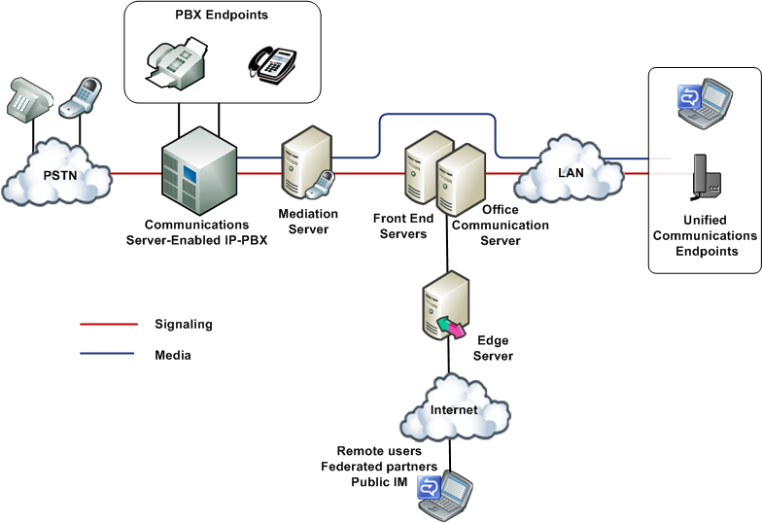
Figure 1. Native IP-PBX integration deployment option
PBX integration is possible only with an IP PBX that natively supports SIP and Internet protocol media in a form that is interoperable with Office Communications Server.
Only the latest IP-PBX models supports native PBX integration and even then it is likely that a software upgrade needs to be provided by the PBX vendor. These next-generation IP PBXs are being developed by several third-party vendors (for a list of vendors, see http://r.office.microsoft.com/r/rlidOCS?clid=1033&p1=IPpbxVend) and should be available soon, if they are not already. For information about the availability and functionality, consult each vendor directly.
The following simple call scenarios demonstrate how PBX integration works.

Outside Call to Internal User
Bob calls Alice from the PSTN. The call is routed by the PSTN service provider to the enterprise PBX, which rings Alice’s desktop PBX phone and also distributes the call to Office Communications Server. The PBX distributes the call by translating the incoming call alert to a SIP INVITE transaction and passing this request to the Mediation Server that connects it with Office Communications Server. In turn, Office Communications Server performs reverse number lookup on the called number to obtain all of Alice’s registered SIP endpoints and, after finding them, rings all the endpoints. Alice has the choice of answering the call on whichever endpoint device is most convenient. When Alice answers the call on one of her endpoints, all other endpoints stop ringing.
Ann, a mobile worker, calls Alice from her laptop by clicking Alice’s name in her Office Communicator Contacts list. The call takes the form of a SIP INVITE request. Office Communications Server performs reverse number lookup on the called number and rings all of Alice’s SIP endpoints. Office Communications Server also distributes the call to the PBX, which understands SIP and therefore uses the TEL URI to ring Alice’s desktop PBX phone. Once again, Alice has the option of answering the call on whichever device is most convenient.
Note
Voice calls between users outside the corporate firewall who are enabled for Enterprise Voice and using Office Communicator 2007 and internal users who are enabled for Communications Server 2005 SP1 and using Office Communicator 2005 should not be expected to work.

Internal Calls Among Users
Because all internal users are enabled for both PBX and VoIP calls, the device each user chooses to place a call determines which system handles the routing. If Alice uses her PBX phone to call Dan’s extension, the call is routed to Dan’s desktop phone by the PBX. But the PBX also distributes the call to Office Communications Server, which routes the call to all Dan’s SIP endpoints.
If Alice uses Office Communicator or a SIP phone to make the call, the SIP INVITE is sent to Office Communications Server, which routes the INVITE to all Dan’s SIP endpoints and forwards it to the PBX, which rings Dan’s desktop PBX phone.

Internal Call to Outside User
The routing of calls to external numbers depends on routing rules that are configured on both the PBX and Office Communications Server. Routing rules can be configure on Office Communications Server to route calls to phone numbers to the PBX or to a media gateway, if deployed.

Voice Mail
Users who are enabled for PBX integration, do not have access to Office Communications Server voice mail. Therefore, when deploying PBX integration, you should plan to keep the voice mail system on your PBX. If you eventually retire the voice mail system on your PBX, you can then disable PBX integration and reconfigure voice mail on Exchange Unified Messaging, as described in this guide.

Call Forwarding
Call forwarding can be configured on Office Communicator, the PBX phone, or both. If both are configured, both should point to the same destination.

Conferencing
Conference calls are established on the system that initiates the conference. If Office Communicator establishes a conference on the Office Communications Server A/V Conferencing Server, PBX telephones are enrolled in the conference by means of “dial out” as an outbound call leg. If a PBX user initiates a PBX conference, an Enterprise Voice user can join or be “dialed in” to the conference as a normal inbound or outbound call leg.

RCC
Remote call control (RCC) allows users to use Office Communicator to monitor and control their PBX phones. This feature is disabled for Enterprise Voice, but it remains available with PBX integration. If you have previously implemented RCC for your Office Communications Server users, there is no need to change that setting when you enable them for PBX integration.

TDM-PBX Integration Through a Media Gateway
In order to enable the coexistence scenario, in the event you have TDM-PBX infrastructure that supports forking of calls, an alternative approach is to deploy a Microsoft-certified media gateway or gateway/Mediation Server combination between Office Communications Server and the PBX.. A number of these media gateways are available within the Microsoft Unified Communications Media Gateway partner program (for the current list, see http://r.office.microsoft.com/r/rlidOCS?clid=1033&p1=IPpbxVend). These media gateways interoperate with the Office Communications Server Mediation Server by means of SIP and IP media and with the PBX by means of various telephony protocols.
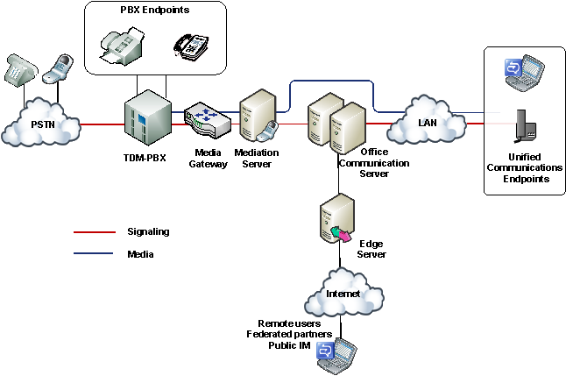
Figure 2. TDM-PBX integration through a media gateway

Office Communications Server Stand-alone
Three deployment scenarios use Office Communications Server 2007 as the sole telephony solution for part or all of an organization. These scenarios include the following deployments:
- Departmental deployment
- Greenfield deployment
The following sections describe these scenarios in detail.

Departmental Deployment
In this scenario, Office Communications Server is deployed as the sole telephony solution for individual teams or departments, while the rest of the users in an organization continue using a PBX. This incremental deployment strategy provides one way to introduce IP telephony into your enterprise through controlled pilot programs. Workgroups whose communication needs are best served by Microsoft Unified Communications are moved to Enterprise Voice, while other users remain on the existing PBX. Additional workgroups can be migrated to VoIP as needed.
The departmental option is recommended for clearly defined user groups that share communication requirements in common and lend themselves to centralized management. This option is also attractive for teams or departments that are spread over wide geographic areas, where the savings in long-distance charges can be significant. In fact, this option is useful for creating virtual teams whose members might be scattered across the globe. Such teams can be created, amended, or disbanded in rapid response to shifting business requirements.
The following figure shows the generic topology for deployment of Enterprise Voice behind a PBX. This is the recommended topology for departmental deployment.

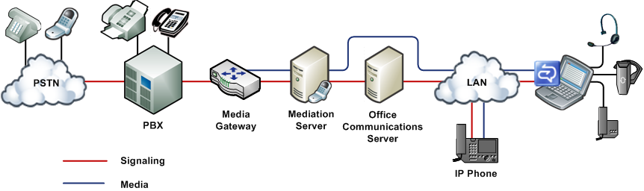

Figure 3. Departmental migration option
In this topology, selected departments or workgroups are enabled for VoIP. A media gateway links the VoIP-enabled workgroup to the PBX. Users enabled for VoIP, including remote workers, communicate across the IP network. Calls by VoIP users to the PSTN and to coworkers who are not enabled for VoIP are routed to the appropriate media gateway. Calls from colleagues who are still on the PBX system, or from callers on the PSTN, are routed to the media gateway, which forwards them to Office Communications Server 2007 for routing.
There are two recommended topologies for connecting Enterprise Voice with an existing PBX infrastructure for interoperability:
- Enterprise Voice behind the PBX. In this topology, all calls from the PSTN arrive at the PBX, which routes calls to Enterprise Voice users to a media gateway and calls to PBX users in the usual way. Table 1 shows the advantages and disadvantages of this topology.
Table 1. Advantages and Disadvantages of Deploying Enterprise Voice Behind PBX
Advantages | Disadvantages
The PBX still serves users not enabled for Enterprise Voice. | If necessary, tie line board in the PBX must be added for gateway connection.
The PBX handles all legacy devices. | The PBX must be configured to route Enterprise Voice numbers to the gateway.
Users can keep the same phone numbers.

- Enterprise Voice in front of the PBX. In this topology, all calls arrive at the media gateway, which routes calls for Enterprise Voice users to Communications Server and calls for PBX users to the PBX. Calls to the PSTN from both Enterprise Voice and PBX users are routed over the IP network to the most cost-efficient media gateway. Table 2 shows the advantages and disadvantages of this topology.
Table 2. Advantages and Disadvantages of Deploying Enterprise Voice in Front of PBX
Advantages | Disadvantages
The PBX still serves users not enabled for Enterprise Voice. | Existing gateways might not support desired features or capacity.
The PBX handles all legacy devices. | It might be necessary to reset trunks from the local exchange carrier to point to the media gateway.
Enterprise Voice users keep the same phone numbers.

The departmental option assumes that you have an existing PBX infrastructure and intend to introduce Enterprise Voice incrementally to smaller groups or teams within your organization. The greenfield option assumes that you are considering deploying Enterprise Voice at a site without traditional telephony infrastructure.

Greenfield Deployment
Enterprise Voice provides new businesses or even new office sites for existing businesses with the opportunity to implement a full-featured VoIP solution without having to worry about PBX integration or incurring the substantial deployment and maintenance costs of an IP-PBX infrastructure. This solution supports both onsite and remote workers.
In this scenario, all calls are routed over the IP network. Calls to the PSTN are routed to the appropriate media gateway. Office Communicator serves as a softphone. RCC is unavailable in this scenario because Office Communicator Phone Edition, like Office Communicator, provides click-to-call capability. Voice mail and auto-attendant services are available through the optional deployment of Exchange Unified Messaging.
Note
In addition to the network infrastructure that is required to support Office Communications Server 2007, a greenfield deployment might require a small PBX to support fax machines and analog or ISDN devices. In certain scenarios, this might require a new PRI (Primary Rate Interface) link with a new set of numbers.
The following figure shows a typical topology for a greenfield deployment.

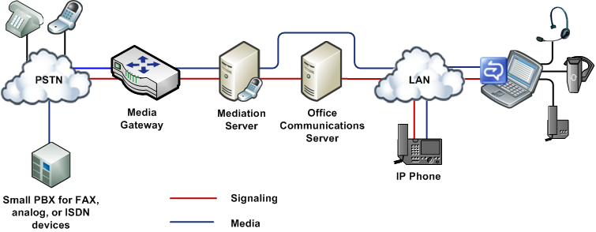

Figure 4. Greenfield deployment option

Call Answering, Outlook Voice Access, and Auto-Attendant
Call answering, Outlook voice access, and auto-attendant services are available through the integration of Office Communications Server and Exchange Server 2007 Unified Messaging (UM). Exchange UM is one of several server roles that you can install and configure on a computer that is running Exchange Server 2007. For stand-alone Enterprise Voice deployments, Unified Messaging combines voice messaging, fax receiving, and e-mail messaging into a single store that is accessible from a telephone (Outlook Voice Access) or a computer. Unified Messaging and Office Communications Server working together provide call answering, Outlook Voice Access, and auto-attendant services to departmental and greenfield Enterprise Voice deployments.
Note
Exchange UM is not required for Enterprise Voice deployments with PBX integration, because the PBX continues to provide voice mail and related services to all users.

Call Answering
Call answering is the taking of voice messages on behalf of users whose extensions are busy or are not answered. It includes playing a personal greeting, recording a message, and submitting the message to the Exchange Hub Transport Server to be queued up for eventual delivery to the user’s mailbox, which is stored on the Exchange mailbox server.
If a caller leaves a message, the message shows up in the user’s inbox. If a caller chooses not to leave a message, a missed call notification is stored in the user’s mailbox. Users can then access their inbox by using the Microsoft Outlook messaging and collaboration client, Outlook Web Access, Exchange ActiveSync®, or Outlook Voice Access. The subject and priority of calls can be displayed like those of e-mail messages.

Outlook Voice Access
Outlook Voice Access enables an Enterprise Voice user to access not just voice mail, but the Exchange inbox including e-mail, voice messages, calendar, and contacts from a telephony interface. The subscriber access number is assigned by an Exchange UM administrator.

Auto-Attendant
An auto-attendant is a feature of Exchange 2007 UM that can be used to configure a phone number that outside users can dial to reach company representatives. In particular, it provides a series of voice prompts that assist an external caller in navigating a menu system. The list of available options is configured on the Exchange UM server by the administrator.

Enhanced Presence
Office Communications Server 2007 provides the infrastructure to enable client applications to publish and subscribe to extended, or enhanced, presence information. The enhanced presence infrastructure includes categories and containers. Categories are individual pieces of presence information, such as status, location, or calendar state. Containers are logical buckets into which clients publish instances of various categories of presence information (as shown in the following figure). When change occurs, clients can publish an individual category instead of an entire presence document, as is the case with Live Communications Server 2005.
Figure 5. Levels of access to presence information
For example, if a fictitious user Tim is watching the presence of Joe, Joe can control what presence information Tim sees. If he places Tim in his Public container, Tim can only see Joe’s name, e-mail, and basic contact information. If Joe places Tim in his Personal container, Tim can see additional categories such as detailed contact information, additional numbers, and location.
Office Communications Server 2007 notifies watchers of presence changes, depending on the containers for which each watcher has permission. For example, as a sales representative moves from one part of town to another, his supervisor and wife might be notified of his movements, while individuals without the necessary permission for that container are not. Office Communications Server 2007 supports this functionality through the use of rich ACLs (Access Control Lists) that are based on containers and categories.
The principal client exposing enhanced presence information is Office Communicator 2007, in which users can assign their contacts to one of several presence levels, depending on how much information about themselves they want each contact to see. By design, each presence level corresponds to a container and is associated with a particular amount of information about a user. Contacts assigned to one level might see only the user’s name, job title, company, and e-mail address, while contacts who are assigned to another might, for example, see the user’s home and mobile phone numbers.
Administrators can also define custom states for a user or group and Office Communicator retrieves these custom states with custom activities from a Web site. For example, an administrator might want to provide a way for a recruiter in recruiting department to remain uninterrupted while interviewing. In this case, the administrator can create a custom state consisting of the Do Not Disturb icon and associate it with a string “interviewing” to define this activity.
Additional customizations allow application developers to create custom clients for publishing and subscribing to other publications from different clients. For more information, see the Unified Communications Managed API documentation.

Federation Enhancements
Office Communications Server 2007 supports all the federation and remote user scenarios that are currently enabled by Live Communications Server 2005. In addition, Office Communications Server 2007 introduces the following enhancements to existing federation support:
- Federated conferencing. Users in federated domains are considered to be authenticated for the purpose of joining on-premise conferences. A federated user cannot join a meeting as a presenter but can be promoted to a presenter during the meeting. Federated users cannot organize conferences that are hosted in your domain.
- Support for partners with multiple domain names. Enhanced federation now uses SANs (subject alternate names) in certificates to support enterprises that have multiple domain names. To make itself eligible for enhanced federation, an enterprise with multiple domain names can simply install a certificate that supports SANs on Live Communications Server 2005 SP1, Access Proxy, or Office Communications Server 2007, Access Edge Server.
- Improved monitoring and throttling capabilities for federated connections. With Office Communications Server, you can actively monitor connections with federated domains and limit the amount of traffic from any federated domain that is not on your Allow list. Additionally, Office Communications Server limits the number of internal users with which these federated domains can communicate. You can monitor this activity on your Access Edge Server using the Open Federation tab on the Status pane in Office Communications Server 2007 Computer Management snap-in. If you find that a federated domain has a legitimate, but higher than average, volume of communications with your organization, you can add the domain to your Allow list. If you suspect malicious activity, you can block the domain. For more information, see the information about managing federated partner access in the Microsoft Office Communications Server 2007 Administration Guide.

Simplified Deployment and Management
Office Communications Server 2007 has overhauled setup and management tools, procedures, and capabilities to make deployment and administrative tasks simpler, quicker, and easier. This section surveys the principal changes in management tools and procedures.

Summary of Management Improvements in Office Communications Server
Office Communications Server offers a variety of improvements, such as:
Deployment Planning
- New expanded Enterprise pool configuration improves scalability.
- Deployment and management of new server roles for conferencing, media, VoIP, and external-user support.
- Support for an Enterprise pool configuration consisting of a single Front End Server without a load balancer.
- Expanded load balancer support, now including offerings from F5, Cisco, Foundry, Nortel, and WebMux.
- The ability to delegate permissions setup, server management, user management, and other administrative tasks where read-only access is adequate.
- Support for disjoint DNS namespaces.
- Support for Universal Groups.
Installation
- Integrated setup and management of multiple server roles on a single computer.
- A new deployment wizard that clarifies deployment by specifying prerequisites and providing guidance at every step.
- Scenario-based deployment options that guide you from absolute zero to a functional system without having to leave the deployment wizard.
- New wizards that simplify configuration and reduce configuration mistakes.
- New streamlined certificate wizard that provides step-by-step guidance through the certification process.
- A single computer running Office Communications Server now requires only a single certificate regardless of the number of collocated components, resulting in greatly streamlined certificate management.
- Deployment has been simplified by eliminating the need for Domain Add.
- Adding a server to a pool is much simpler.
- A domain controller is no longer required to be available in the root domain of the forest.
Management
- New conferencing and VoIP policies for specifying and managing usage entitlements.
- Enhanced in-band provisioning for soft clients and devices.
- A redesigned status pane in the Office Communications Server 2007 administrative snap-in that makes configuration settings readily available without having to access individual property pages.
- New database queries and event logs, which are available through the status pane of the snap-in.
Administration
- An enhanced intelligent IM filter.
- Client version checking for the purpose of allowing or blocking certain client versions and devices.
- Improved archiving controls that enable global administrators to delegate per-user archiving.
- New call detail records (CDRs) that provide a way to collect IM, VoIP, and meeting usage statistics.
- New resource kit tools for CDR querying and reporting.
- New resource kit tools for Office Communications Server 2007 environment discovery.
Monitoring and Troubleshooting
- Enhanced MOM pack, which includes support for new server roles.
- A new tracing and logging tool, OCSLogger, for troubleshooting and debugging is available with the Office Communications Server 2007 administrative snap-in. This tool can be used to enable logging, collect and analyze logs, and package logs for sending to Microsoft Customer Support Services. This tool replaces the Flat File logging functionality in Live Communications Server 2005 SP1.
- A new log analysis tool, Snooper, is available from the resource kit tools for advanced analysis of protocol traffic (SIP, CCCP), troubleshooting voice call signaling, and viewing user and conference state information.
- A run-time diagnostics module that monitors problems (such as server connection and DNS failures, certificate validation failures, client authentication failures, and domain validation issues) and raises MOM enabled alerts.
- More detailed error information conveyed by server and client. Each error is associated with a unique ID, reason, and detailed parameters.
- RouteHelper, a resource kit tool that offers an alternative to the administrative snap-in for viewing, modifying, and testing Enterprise Voice number normalization rules, location profiles, voice policy, and routes.

New Deployment Tool
The new Office Communications Server 2007 deployment tool provides an end-to-end deployment solution. It provides step-by-step guidance not only through installation, but also through configuration and activation of all server roles, as well as validation of installed deployments.
The deployment tool guides administrators through the end-to-end deployment process by means of a variety of new wizards that take most of the guesswork out of common deployment tasks:
- Setup Delegation Wizard. Grants permissions on Active Directory objects to otherwise unauthorized administrators for the purpose of delegating setup tasks.
- Certificates Wizard. Configures a certificate for the local server based on server role and earlier deployment configurations. Using the wizard, an administrator can create a new certificate request, import a certificate, export a certificate, or assign an existing certificate. The certificate request can be created online and transmitted when completed or created and saved offline for submission at a later time.
- Create Enterprise Pool Wizard. Creates Active Directory objects and the pool’s back-end databases.
- Deploy Server. Installs and activates the Front End Server and all conferencing server components on a single Standard Edition server.
- Add Server to Pool Wizard. Installs and activates the Front End Server and all conferencing server components on a single Enterprise Edition: Consolidated Configuration server.
- Configuration Wizards. Provide step-by-step procedures for configuring each server role and pool.
- Activation Wizards. Requests the user input that is necessary to activate local servers.
- Validation Wizard. Provides step-by-step testing procedures to ensure that a deployment has been installed, configured, and activated correctly and is working properly.

Management Console Improvements
The Office Communications Server 2007 snap-in for MMC (Microsoft Management Console) has been redesigned to eliminate clutter, clarify descriptive text, improve discoverability, and reduce the number of exposed settings to those that administrators require for normal operations.
The Status pane of the Office Communications Server 2007 snap-in provides configuration settings at a glance for your forest, domains, pools, servers, and users. No longer is it necessary to navigate through the management console to find specific settings.
The Status pane also features a new Database tab, which can be used to query a pool’s back-end user and conferences databases. Each query is displayed as an expandable item in a list.

Universal Group Support
Office Communications Server 2007 supports the native mode universal groups in the Microsoft Windows Server® 2003 and Windows 2000 Server operating systems. Members of universal groups can include other groups and accounts from any domain in the domain tree or forest and can be assigned permissions in any domain in the domain tree or forest. Universal group support, combined with administrator delegation, greatly simplifies managing an Office Communications Server 2007 deployment. For example, it is no longer necessary to add one domain to another so that an administrator can manage both. Eliminating this requirement also simplifies deployment.

Enhanced in-band Provisioning
Office Communications Server 2007 administrators need to be able to customize clients in accordance with the requirements of their particular deployments. Administrators also need a centralized mechanism for enabling or disabling features according to security policy and network infrastructure. In-band provisioning provides a method for conveying such requirements to Office Communicator 2007 clients. Finally, in-band provisioning provides a way of configuring roaming clients, which are outside the reach of Group Policy.
Beginning with Office Communications Server 2007, in-band provisioning is extensible. Additionally, more settings are now provisioned by the server.
Office Communications Server 2007 uses in-band provisioning to convey the following categories of information to the client:
- User Identity. Includes display the name and e-mail address.
- Server Configuration. Includes such information as Address Book Server download URLs, group expansion Web Service URLs, console installation URLs, and conference troubleshooting URLs.

Integrated Address Book Server
Address Book Server daily provides global user information to Office Communicator clients. In Live Communications Server 2005 SP1, Address Book Server is optional and must be installed separately from the server. In Office Communications Server 2007, Address Book Server is a required fully integrated Front End Server component, which is installed as part of both Standard Edition and Enterprise Edition setup.
Address Book Server retrieves contact information from the Microsoft SQL Server™ 2005 or SQL Server Express Edition database on an Office Communications Server 2007 Standard Edition server or Enterprise pool. Address Book Server uses this information to generate a set of compressed full files and delta files, which are stored in a standard NTFS folder.

Meeting Policies
An administrator can easily define a global meeting policy by using the Office Communications Server 2007 administrative snap-in. An Office Communications Server 2007 meeting policy determines the maximum allowed meeting size, color definition for application sharing, types of supported media, and whether and how programs and desktops can be shared with federated and anonymous users. You can choose from one of five available policies or define a custom policy.

Call Detail Records
Call detail records (CDRs) provide a way to collect both IM and meeting data and to generate reports on usage characteristics, which can be used to determine network bandwidth load, employee usage patterns, and return on investment. CDRs capture data about user activities such as participating in IM conversations and starting and joining conferences.
CDRs allow enterprises to monitor the amount of IM and conferencing activity for the purpose of developing data and metrics about employee usage and productivity. Enterprise administrators can use such data to justify technology investments. Decision makers can use it to determine the return on investment.
Network administrators specify which IM and conferencing usage data to capture. IM data includes call details, file transfers, audio and video calls, and remote assistance calls. Meeting data includes the number of meetings, number of participants joining a meeting, number of data and Audio/Video instances joining a meeting, and details about peer-to-peer IM sessions and group IM sessions.
Important
CDRs do not capture the content of an IM conversation or meeting; they only monitor usage details.

Client Applications
Client applications are the tools with which end users access and use the IM, presence, and conferencing features that are made possible by Office Communications Server 2007. Without the clients, the features exist as mere potential. Without the server, the clients have nothing to do.
Office Communications Server 2007 supports the following client applications:
- Microsoft Office Communicator 2007. Office Communicator 2007 is the recommended Unified Communications client for Office Communications Server 2007. Office Communicator 2007 exposes to end users the presence, IM, and multimodal conferencing features that are supported by Office Communications Server 2007, including expanded presence information and user control over who sees it, group IM based on Exchange Distribution Lists, and the addition of audio and video to IM conversations.
- Microsoft Office Communicator Phone Edition. Microsoft has developed the Microsoft Office Communicator Phone Edition telephone for organizations or users who are more comfortable making calls from a phone-like device than from the Office Communicator software client. For most purposes, the Office Communicator Phone Edition phone is a physical version of Office Communicator, with a similar user interface and comparable functionality. Like Office Communicator, the Microsoft Office Communicator Phone Edition allows you to place a call either by using a numeric touchpad or by clicking one of your contacts. The Microsoft Office Communicator Phone Edition also supports enhanced presence, SIP signaling, and a user experience similar to that of Office Communicator, all in a desktop telephone. The Microsoft Office Communicator Phone Edition can be used to connect from home or in the office.
- Microsoft Office Live Meeting 2007 client. The Office Live Meeting 2007 client is the data collaboration and audio/video client for both Office Communications Server 2007 and the hosted Microsoft Live Meeting service, providing a unified collaboration experience across both server-based and service-based conferencing products.
- Microsoft Outlook Add-in. The Microsoft Outlook Add-in is the conference scheduling client for Office Communications Server 2007. It is compatible with Microsoft Office Outlook 2000, 2002, 2003, and 2007.

Architecture
Office Communications Server 2007 extends the architecture of Live Communications Server 2005 to include components that support VoIP and conferencing. This section discusses the following architectural features:
- Pool configurations
- Front-End Servers
- Conferencing components
- VoIP components
- Perimeter network configuration and components
- Conference protocols
- Conference call flow
Figure 6 illustrates a generic Office Communications Server topology, including the new VoIP and conferencing components.
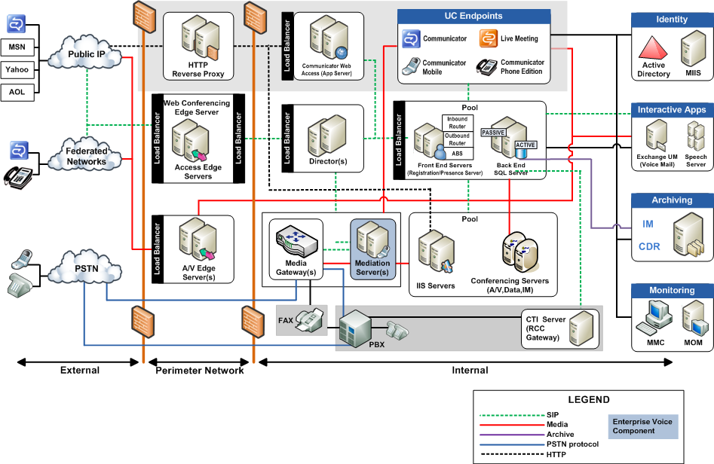
Figure 6. Office Communications Server 2007 reference architecture

Pool Configurations
An Office Communications Server 2007 pool consists of one or more Front End Servers that provide IM, presence, and conferencing services and are connected to a SQL Server database for storing user and conference information. Depending on the pool configuration, the database might reside on the same server. In addition, certain conferencing components might be deployed on the same physical computer, depending on the chosen pool configuration.
Office Communications Server 2007 offers three pool configurations: one Standard Edition configuration and the consolidated and expanded Enterprise Edition configurations. Both Enterprise Edition configurations consist of identical Front End Servers that are connected to a separate dedicated Microsoft SQL Server 2005 back-end database. (In an Enterprise pool, the Back-End Database must be on a dedicated computer, separate from all Enterprise Edition servers.)

Standard Edition Configuration
As shown in Figure 7, a Standard Edition server hosts all necessary services on a single Front End Server. Because it requires a minimal hardware investment and minimal management overhead, the Standard Edition configuration is ideal for small and medium-sized businesses and for branch offices. It is intended for deployments with fewer than 5,000 users either in total or at a particular location where high availability is not a requirement.
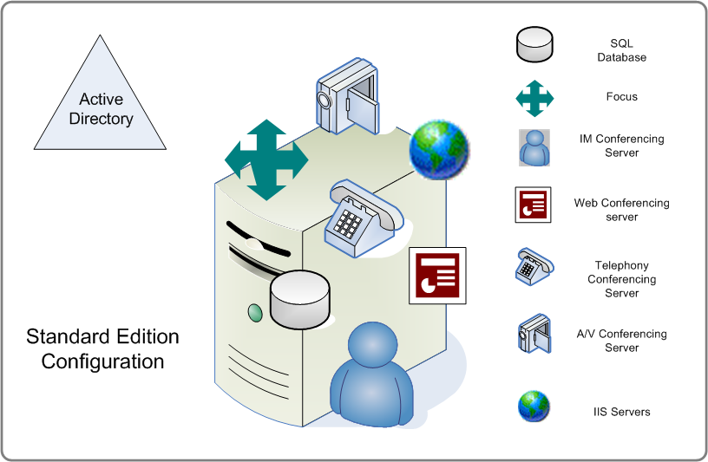
Figure 7. Standard Edition configuration

Enterprise Edition: Consolidated Configuration
Enterprise Edition: Consolidated Configuration is a pool configuration in which all server components are collocated on the pool’s Front End Servers (with the exception of the Back-End Database, which must reside on a separate dedicated computer). Consolidated Configuration provides scalability and high availability and yet is easy to plan, deploy, and manage.
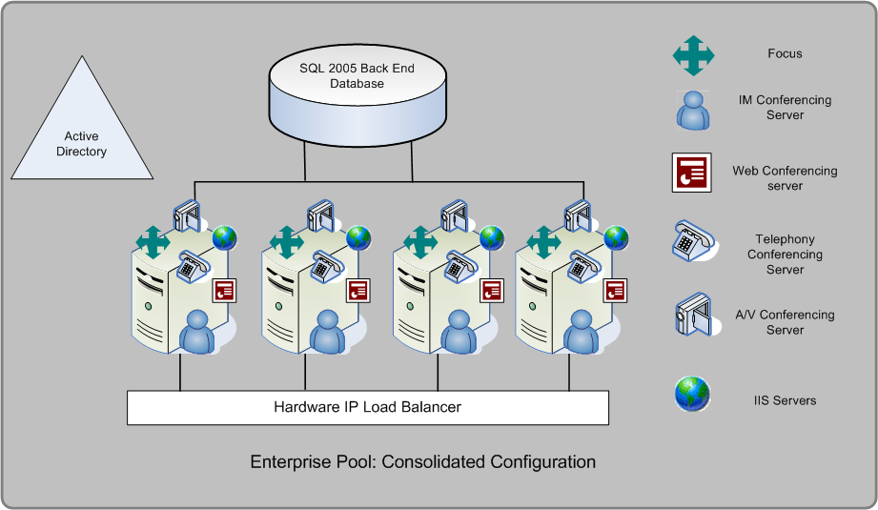
Figure 8. Enterprise Edition: consolidated configuration

Enterprise Edition: Expanded Configuration
Enterprise Edition: Expanded Configuration offers maximum capacity, performance, and availability for large organizations. As shown in Figure 9, in Expanded Configuration, Internet Information Services (IIS), the Web Conferencing Server, and the Audio/Video Conferencing Server are installed on dedicated computers separate from the pool’s Front End Servers. Expanded configuration enables organizations to scale up audio/video or Web conferencing requirements independently from other Enterprise Edition server components. For example, if an organization’s audio/video traffic increases more rapidly than other traffic, the organization can meet this increase by deploying only additional Audio/Video Conferencing Servers rather than entire Front End Servers.
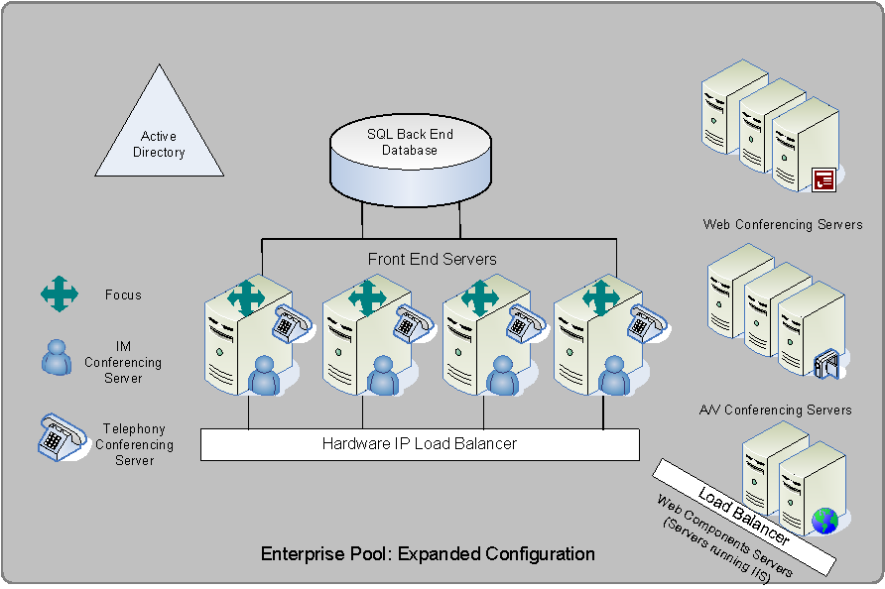
Figure 9. Enterprise Edition: expanded configuration
As the figure shows, the IM Conferencing Server and Telephony Conferencing Server are located on the Front End Server, even in the Expanded Configuration, while the Web Conferencing Server, A/V Conferencing Server, and IIS are installed on separate, dedicated computers. In the figure, the Front End Servers are connected to one hardware load balancer and the servers running IIS (Web Components Servers) are connected to a separate load balancer. You can, however, also use the same hardware load balancer for both the Web Components Servers and the Front End Servers.
The Office Communications Server 2007, Standard Edition or Enterprise Edition, Front End Server is responsible for the following tasks:
- Handling signaling among servers and between servers and clients
- Authenticating users and maintaining user data, including all user endpoints
- Routing VoIP calls within the enterprise and to the PSTN
- Initiating on-premise conferences and managing conference state
- Providing enhanced presence information to clients
- Routing IM and conferencing traffic
- Managing conferencing media
- Hosting applications
- Filtering SPIM (unsolicited commercial IM traffic)
The following sections provide a technical overview of the Front End Server components that enable conferencing and VoIP.

Conferencing Components
The principal conferencing components on the Front End Server are as follows:
- Focus
- Focus Factory
- Conferencing Servers (MCUs)
- Conferencing Server Factory

Focus
The Focus is the conference state server. It is implemented as a SIP user agent that is addressable by using a conference URI. The Focus runs in the User Services module of all Front End Servers. All group IM, multiparty A/V, and data collaboration sessions are managed on the server by the Focus.
The Focus Factory is the part of the Focus that is responsible for scheduling. When a user creates a new meeting, the meeting client sends a SIP SERVICE message to the Focus Factory, which creates a new instance of the conference in the conference database and returns information about the newly created conference to the client. A separate instance of the Focus exists for each active conference.
The Focus is responsible for the following tasks:
- Initiating conferences
- Enlisting required conferencing servers
- Authenticating participants before allowing them to enter a conference
- Enforcing the policy that specifies whether the meeting organizer is authorized to invite external users
- Maintaining SIP signaling relationships between conference participants and conferencing servers
- Managing conference state
- Accepting subscription to conferences and notifying users of changes in conference state, such as the arrival and departure of participants and the addition or removal of media
- Maintaining and enforcing conference policies and rosters
The Focus also enables the organizer to lock a meeting so that no more participants can enter after a certain time. For more information about how the Focus manages the lifetime of the meeting, see Meeting Deactivation and Meeting Expiration.

Focus Factory
The Focus Factory is responsible solely for scheduling meetings. When a user creates a new meeting, the meeting client sends a SIP SERVICE message to the Focus Factory, which creates a new instance of the meeting in the conference database and returns information about the newly created meeting to the client.

Conferencing Servers (MCUs)
Supporting multiparty conferences requires a new server role known as a conferencing server (also known as an MCU or multipoint control unit). A conferencing server is a pluggable component that is responsible for managing one or more media types. Office Communications Server 2007 includes four conferencing servers and the extensible architecture for adding more:
- IM Conferencing Server. Enables group IM by relaying IM traffic among all participants. When a third participant is added to a peer-to-peer IM conversation, the initiating client invites the IM Conferencing Server to the conversation. From that point, all messages among the participants are routed through the IM Conferencing Server. The IM Conferencing Server is an integral part of the Front End Server and cannot be installed on a separate computer.
- Telephony Conferencing Server. Responsible for ACP (audio conferencing provider) integration. Supports both dial-out and dial-in, as well as standard third-party call control features such as mute and eject. The Telephony Conferencing Server does not support mixing VoIP and PSTN in the same call. To connect dial-out to PSTN endpoints, a Mediation Server is required, as described later in this overview. The Telephony Conferencing Server is an integral part of the Front End Server and cannot be installed on a separate computer.
- Web Conferencing Server. Manages conference data collaboration, including native support for Microsoft Office PowerPoint presentations, Microsoft Office document sharing, white boarding, application sharing, polling, Q&A, compliance logging, annotations, meeting summaries, handouts, and various multimedia formats. The Web Conferencing Server uses PSOM (Persistent Shared Object Model), a Live Meeting protocol, for uploading slides to a meeting. The Web Conferencing Server can reside either on the Front End Server (Standard Edition and Enterprise Edition Consolidated Pool) or on a separate physical computer (Enterprise Edition Expanded Pool).
- A/V Conferencing Server. Provides multiparty IP audio and video mixing and relaying, including Microsoft RoundTable, by using industry standard RTP (Real-time Transport Protocol) and RTCP (Real-time Transport Control Protocol). The A/V Conferencing Server can reside either on the Front End Server (Standard Edition and Enterprise Edition Consolidated Pool) or on a separate physical computer (Enterprise Edition Expanded Pool).

Conferencing Server Factory
When the Focus requests a particular conferencing server for a meeting, the Focus sends the request to Conferencing Service Factory, which determines which conferencing server is available to service the request and returns its URL to the Focus. The Conferencing Server factory is responsible for provisioning a meeting for a particular media type on a Conferencing Server by using the local policies for creating meetings. A Conferencing Server factory provisions meetings according to local policies and takes into account the current load on the Conferencing Servers before assigning one to a meeting.

Other Server Components Required for Conferencing
Other important Front End Server components include the following:
SIP Proxy. The SIP Proxy (also known as the protocol stack or SIP stack) is the core protocol platform on which all other services are built. It provides the basic structure for networking and security and performs connection management, message header parsing, routing, authentication, and state management.
HTTP.SYS. The IIS (Internet Information Services) kernel-mode HTTP protocol stack. HTTP.SYS queues and parses incoming HTTP requests and caches and returns application and site content. IIS can reside either on the Front End Server (Standard Edition and Enterprise Edition Consolidated Pool) or on a separate physical computer (Enterprise Edition Expanded Pool).
User Services. Provides closely integrated IM, presence, and conferencing features built on top of the SIP Proxy. It also includes the Focus and Focus Factory.
User Replicator. Updates the user database to be synchronized with Active Directory. The Address Book Server uses information provided by User Replicator to update information from the global address list.
Server API. Provides basic scripting capability for creating custom message filters and routing applications. The scripts can either run in process or, where required, can be dispatched to a managed code application that is running in a separate process.
RTC Aggregate Application. Handles the aggregation of presence information across multiple endpoints.
Address Book Server. Provides global address list information from Active Directory to the Office Communicator client. Address Book Server was introduced with Live Communication Server 2005 SP1 as an optional separate application to be installed and managed separately. With Office Communications Server 2007, Address Book Server is mandatory and installed at the same time as other Front End Server components.
Outbound Routing Application. Manages all SIP message routing for Office Communications Server 2007.
Intelligent IM Filter. Filters incoming IM traffic by using administrator-specified criteria. It is used to block unsolicited or potentially harmful IM items from unknown endpoints outside the corporate firewall.

Internet Information Services (IIS)
Office Communications Server 2007 requires IIS either on every Front End Server (Consolidated Configuration) or on separate dedicated computers (Expanded Configuration). Office Communications Server 2007 relies on IIS for the following functions:
- The Live Meeting 2007 client uses IIS to download meeting content (such as PowerPoint presentations).
- Office Communicator uses IIS to download Address Book Server files when the client is outside the corporate firewall.
- An ASP.NET application running on top of IIS is used for the Group Expansion Web Service, which enables Office Communicator to expand distribution groups for purposes of group IM.
In Enterprise Edition: Expanded Configuration, IIS can be installed on computers that are separate from the Front End Servers. Multiple IIS servers must be fronted by a hardware load balancer.

Perimeter Network Configuration for IM and Conferencing
Office Communications Server 2007 allows users working outside the enterprise network to participate in on-premise conferences, complete with data collaboration and the ability to relay audio and video through your organization’s firewall. Office Communications Server 2007 also enhances existing support for remote access, federation, and public IM connectivity, which were introduced in Live Communications Server 2005 and Live Communications Server 2005 SP1.
Enabling conferencing and the ability to share data and media with users outside the corporate firewall requires two edge server roles that are new with Office Communications Server 2007: the Web Conferencing Edge Server and the A/V Edge Server.
The HTTP reverse proxy is not an Office Communications Server 2007 role, but it is required for to provide external access to Address Book file information, the ability to expand membership in distribution groups, and access to meeting content in Web conferences.
Figure 10 shows the servers that are required in the Office Communications Server 2007 perimeter network and the protocols they use to communicate with Internet clients on one side and with Enterprise Edition servers on the other.
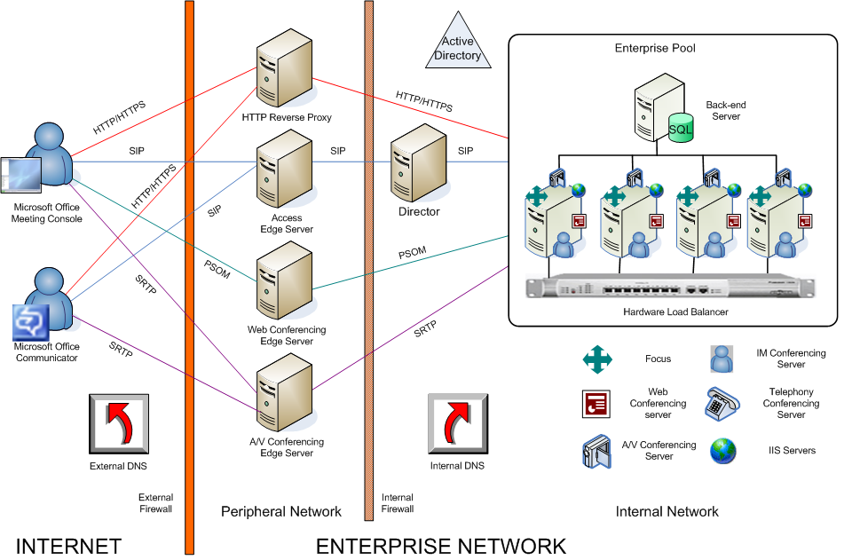
Figure 10. Office Communications Server 2007 external configuration
Required servers in the Office Communications Server 2007 perimeter network are as follows.

Access Edge Server
Formerly known as the Access Proxy, the Access Edge Server handles all SIP traffic across the corporate firewall. The Access Edge Server handles only the SIP traffic that is necessary to establish and validate connections. It does not handle data transfer, nor does it authenticate users. Authentication of inbound traffic is performed by the Director or the Front End Server. For more information, see the Microsoft Office Communications Server 2007 Planning Guide. A Director is an Office Communications Server 2007 Standard Edition server or Enterprise pool that does not home users and that resides inside the organization’s firewall. A Director is not mandatory but is strongly recommended. If a Director is not deployed, this authentication is performed on the Front End Server on the pool or Standard Edition server that you designate to do so. (Active Directory access is required to perform authentication, which the edge servers do not have because they are deployed in the perimeter network outside Active Directory.) The Access Edge Server is essential for all external user scenarios, including conferencing, remote user access, federation, and public IM connectivity.

Web Conferencing Edge Server
The Web Conferencing Edge Server proxies PSOM (Persistent Shared Object Model) traffic between the Web Conferencing Server and external clients. External conference traffic must be authorized by the Web Conferencing Edge Server before it is forwarded to the Web Conferencing Server. The Web Conferencing Edge Server requires that external clients use TLS connections and obtain a conference session key.

A/V Edge Server
The A/V Edge Server provides a single trusted connection point through which inbound and outbound media traffic can securely traverse NATs (network address translators) and firewalls. The industry standard solution for multimedia traversal of firewalls is ICE (Interactive Connectivity Establishment), which is based on the STUN (Simple Traversal Underneath NAT) and TURN (Traversal Using Relay NAT) protocols. The A/V Edge Server is a STUN server. All users are authenticated to secure both access to the enterprise and use of the firewall traversal service that is provided by the A/V Edge Server. To send media inside the enterprise, an external user must be authenticated and must have an authenticated internal user agree to communicate with him or her through the A/V Edge Server.
The media streams themselves are exchanged by using SRTP (Secure Real-time Transport Protocol), which is an industry standard for real-time media transmission and reception over IP.

HTTP Reverse Proxy
Office Communications Server 2007 conferencing support for external users also requires deploying an HTTP reverse proxy in the perimeter network for the purpose of carrying HTTP and HTTPS traffic for external users. The HTTP reverse proxy is used to download the following data for external users:
- Address Book Server files
- Web conferencing content
- Expanded distribution lists for group IM
The reverse proxy does not run Office Communications Server 2007 or carry SIP traffic.

Call Flows Among Conference Components
This section describes the sequence of call flows that are required among conference components to create a conference, invite the appropriate components and users, and enable participants to join. Figure 11 is a simplified representation of protocol traffic among conferencing components.
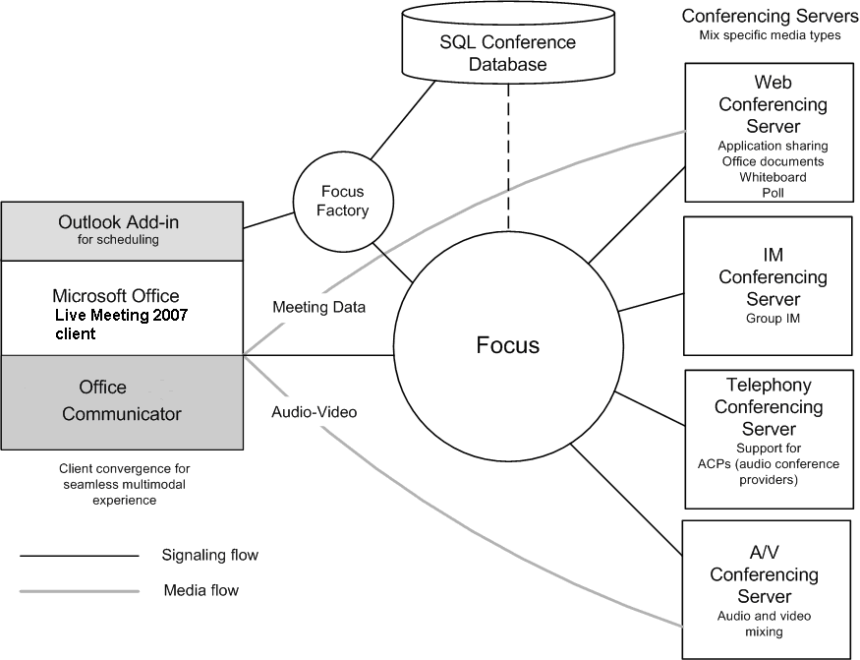
Figure 11. Office Communications Server 2007 signaling and media flow for conferencing

Scheduling a Conference
The sequence of steps by which this familiar scheduling model enables client and server cooperate to create a scheduled conference is as follows:
- Using organizer input, the scheduling client (Outlook) generates a unique conference ID.
- The scheduling client contacts the Focus Factory on the conferencing server (either Standard Edition or an Enterprise Edition Front End Server) and requests a new meeting. This request and subsequent meeting commands that are exchanged between client and servers use C3P over SIP.
- The Focus Factory determines whether the organizer is authorized to create a conference. If so, the Focus Factory returns a unique conference SIP URI to the scheduling client.
- The scheduling client, after receiving the conference SIP URI from the Focus Factory, uses it to create a Conference Join URL, which includes the conference ID, conference key, and parameters indicating whether the conference is audio only or a full collaborative meeting.
- The scheduling client sends an e-mail invitation to all meeting participants, including the organizer. This invitation contains the Conference Join URL, which participants click to join the conference.

Creating an Unscheduled Conference
The sequence of steps by which an unscheduled conference is created is similar to that for a scheduled conference:
- The scheduling client (Office Communicator 2007) generates a unique conference ID.
- The scheduling client contacts the Focus Factory on the conferencing server (either Standard Edition or an Enterprise Edition Front End Server) and requests a new meeting.
- On the server, the Focus Factory creates a new instance of the Focus for the scheduled conference and returns a unique conference SIP URI to the scheduling client. Depending on the media that is specified for the conference, the newly instantiated meeting Focus contacts the appropriate conferencing server factory with requests to allocate new Conferencing Servers for the meeting.
- The scheduling client, after receiving the conference SIP URI from the Focus Factory, uses it to create a Conference Join URI, which includes the conference ID, conference key, and parameters indicating whether the conference is audio only or a full collaborative meeting.
When a user clicks the Conference Join link in the invitation, the following events occur:
- The Live Meeting 2007 client starts on the user’s computer.
- The Live Meeting client automatically locates the appropriate Office Communications Server according to the user’s SIP URI and sends a SIP INVITE message to the Focus.
- The Focus challenges the user’s credentials by using NTLM or Kerberos authentication. Federated users are authenticated by the trusted-domain token in the message header. If the user does not pass authentication, the Focus uses digest authentication to request the conference key, which was generated at conference creation for the purpose of authenticating anonymous users.
- If the user passes authentication, the client subscribes to the conference package and sends invitations to join the appropriate conferencing servers for each media type.

Joining a Conference
A meeting invitation contains the following elements:
- The Conference Join URI
- A link for first-time participants to download the Live Meeting 2007 client. The invitation might contain two such links: one for internal and another for external users.
- Audio instructions
- Lists of participants.
- Troubleshooting information, including the following:
- Instructions for installing and running the Live Meeting 2007 client
- Meeting join information
- A customizable link to a Web page containing troubleshooting information or two links if internal and external users are to access separate troubleshooting sites.

VoIP Components
The principal VoIP components on the Front End Server are as follows:
- Translation Service
- Inbound Routing
- Outbound Routing

Translation Service
The Translation Service is the server component that is responsible for translating a dialed number into E.164 format according to the normalization rules that are defined by the administrator.

Inbound Routing Component
The Inbound Routing component handles incoming calls largely according to preferences that are specified by users on their Enterprise Voice clients. For example, users specify whether unanswered calls are forwarded or simply logged for notification. If call forwarding is enabled, users can specify whether unanswered calls should be forwarded to another number or to an Exchange 2007 Unified Messaging server that has been configured to provide call answering. The Inbound Routing component is installed by default on all Standard Edition servers and Enterprise Edition Front End Servers.

Outbound Routing Component
The Outbound Routing component routes calls to PBX or PSTN destinations. It applies call authorization rules to callers and determines the optimal media gateway for routing each call. The Outbound Routing component is installed by default on all Standard Edition and Enterprise Edition servers and on Enterprise Edition Front End Servers.
The routing logic that is used by the Outbound Routing Component is in large measure configured by network or telephony administrators according to the requirements of their organizations.

Other Server Components Required for VoIP
Other components residing on the Office Communications Server 2007 Front End or Director that provide essential support for VoIP, but are not themselves VoIP components, include the following.
User Services. Perform reverse number lookup on the target phone number of each incoming call and matches that number to the SIP URI of the destination user. Using this information, the Inbound Routing component distributes the call to that user’s registered SIP endpoints. User Services is a core component on all Front End Servers and Directors.
User Replicator. Extracts user phone numbers from Active Directory and writes them to tables in the RTC database, where they are available to User Services and Address Book Server. User Replicator is a core component on all Front End Servers.
Address Book Server. Normalizes enterprise user phone numbers that are written to the RTC database to E.164 format for the purpose of provisioning user contacts in Office Communicator 2007. The Address Book Server is installed by default on all Front End Servers.

Integration with the PSTN
An enterprise-grade VoIP solution must provide for calls to and from the PSTN without any decline in quality of service. In addition, users placing and receiving calls should not be aware of the underlying technology. From the user’s perspective, a call between the Enterprise Voice infrastructure and the PSTN should seem like just another SIP session.

Media Gateways
Media gateways are third-party devices that translate signaling and media between the PSTN and the Enterprise Voice infrastructure. Office Communications Server 2007 supports three types of media gateways:
- Basic Media Gateway. A basic media gateway requires the assistance of a new Office Communications Server 2007 server role, the Mediation Server, to present a PSTN call to an Enterprise Voice client connection. The Mediation Server also presents calls from Enterprise Voice clients to the basic media gateway for routing to the PSTN.
- Advanced Media Gateway. An Advanced Media Gateway combines the functionality of a Basic Media Gateway and that of the Mediation Server. An Advanced Media Gateway does not require a separate Mediation Server to handle the signal and media translation that is necessary to present a PSTN call as an Enterprise Voice client connection.
- Basic Hybrid Media Gateway. A basic hybrid media gateway collocates a basic media gateway with a Mediation Server on a single computer running Windows Server 2003. The Basic Hybrid Media Gateway is available from Microsoft partners for Office Communications Server 2007. It reduces installation and management overhead compared to deploying a Basic Media Gateway and Mediation Server on separate computers.

Mediation Server
The Office Communications Server 2007, Mediation Server, provides signaling and media translation between the VoIP infrastructure and a basic media gateway. A Mediation Server also links Office Communications Server with a PBX in both the departmental deployment and PBX integration topologies.
The Mediation Server is deployed as a stand-alone application inside the firewall. On the Office Communications Server side, Mediation Server listens on a single mutual TLS transport address. On the gateway side, Mediation Server listens on a single TCP or TLS transport address. TLS is recommended, but TCP is supported for gateways that do not support TLS.

The main functions of the Mediation Server are as follows:
- Encrypting and decrypting SRTP (Secure Real-time Transport Protocol) on the Office Communications Server side
- Translating SIP over TCP (for gateways that do not support TLS) to SIP over mutual TLS
- Translating media streams between Office Communications Server and the media gateway
- Connecting clients that are outside the network to internal ICE (Interactive Connectivity Establishment) components, which enable media traversal of NAT and firewalls
- Acting as an intermediary for call flows that a gateway does not support, such as calls from remote workers on an Enterprise Voice client
Figure 12 shows the signaling and media protocols that are used by the Mediation Server when communicating with a basic media gateway and the Enterprise Voice infrastructure.
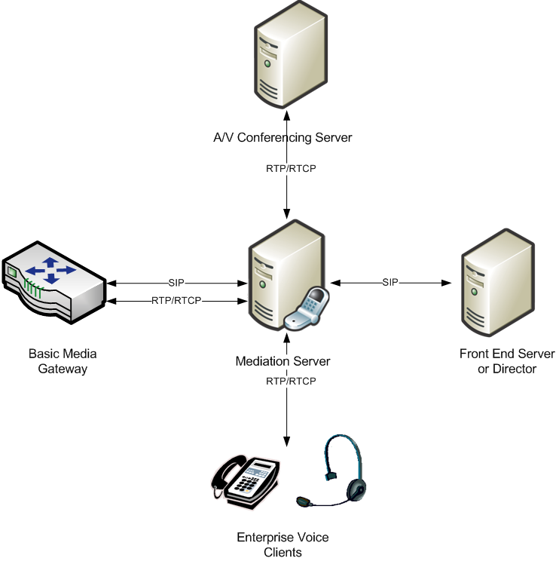
Figure 12. Signaling and media protocols used by the Mediation Server

From the perspective of the Enterprise Voice infrastructure, the combination of basic media gateway and Mediation Server appear as a single entity. Together, they are the logical and functional equivalent of an advanced media gateway. When advanced media gateways become available, enterprises that deploy them no longer have any need for a dedicated Mediation Server. Meanwhile, the basic hybrid media gateway provides an interim solution for organizations that prefer to avoid deploying and managing a gateway and Mediation Server separately.
Figure 13 shows the logical equivalence of an Advanced Media Gateway and the combination of a Basic Media Gateway and Mediation Server.
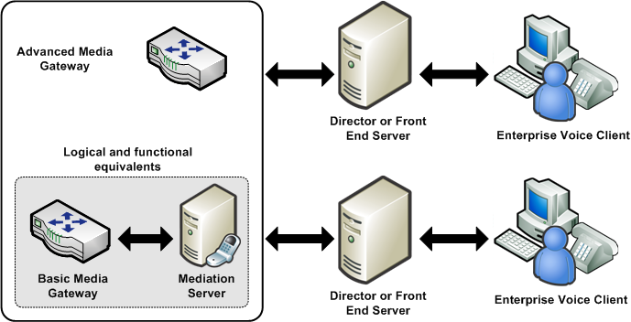
Figure 13. Equivalent media gateway topologies
A typical organization supports multiple gateway–Mediation Server combinations, depending on the number of office locations, the number and distribution of Enterprise Voice users, network traffic, and performance requirements.

Perimeter Network Configuration for VoIP
Outside callers who use Office Communicator for individual or conference calls rely on the Access Edge Server and the A/V Edge Server for voice communication with coworkers. For information about deploying edge servers, see the Microsoft Office Communications Server 2007 Edge Server Deployment Guide.

Access Edge Server
The Office Communications Server 2007 Access Edge Server provides SIP signaling for calls from Office Communicator users who are outside your organization’s firewall.

Audio/Video Edge Server
The Office Communications Server 2007 A/V Edge Server enables media traversal of NAT and firewalls. A caller using Office Communicator 2007 from outside the corporate firewall relies on the A/V Edge Server for both individual and conference calls.
The A/V Authentication Service is collocated with, and provides authentication services for, the A/V Edge Server. Outside users who attempt to connect to the A/V Edge Server require an authentication token that is provided by the A/V Authentication Service before their calls can go through.

VoIP Configuration
Configuring your Office Communications Server 2007 infrastructure for VoIP entails the following tasks:
- Normalizing phone numbers to the industry standard E.164 format
- Creating location-based dial plans, called location profiles, that specify how a string of numbers is translated based on the location from which it is dialed
- Defining phone usage records, which are used to define call permissions for users
- Creating routes, which specify the media gateways to be used for calls placed to defined telephone number patterns
The following sections discuss each of these tasks.

Phone Number Normalization
Phone number normalization is the process of translating number strings that are entered in various formats into a single standard format. Enterprise Voice requires normalized phone numbers to:
- Provide a consistent reference for reverse number lookup. Reverse number lookup is the process of mapping a user’s number to a corresponding SIP URI for the purpose of routing calls over the IP network to multiple user endpoints, including Office Communicator, the Office Communicator Telephone Experience, and call-handling options such as call forwarding and call answering.
- Identify and apply phone usage authorization (comparable to traditional “class of service” options) for the calling party.
- Route calls to the appropriate media gateway.
Office Communicator 2007 continues to rely on the Address Book Server for the phone number normalization that it requires for reverse number lookup. For more information, see the Microsoft Office Communications Server 2007 Planning Guide.
Communications Server 2007 normalizes phone numbers prior to performing reverse number lookup. If the normalized number matches the designated primary work number of a user with an Active Directory identity, the call is distributed to the endpoints that are associated with that user’s SIP URI. If the server does not find a match, which means that the target number is probably outside the enterprise, the Outbound Routing component checks the caller’s phone usage to determine whether a call to that number is authorized and then either directs the call to the appropriate media gateway or notifies the caller that the call is not allowed.

Location Profiles
Organizations that conduct business in more than one geographic location require some way to translate identical phone number strings into numbers that are valid for each location. A traditional PBX system solves this problem by maintaining separate numbering plans for each site. When a PBX receives a call to a particular user extension, there is no ambiguity about the appropriate destination, because the PBX is configured only for the site where it is deployed. The Enterprise Voice infrastructure, however, is quite different. Unlike the site-specific PBX, Enterprise Voice is distributed across the enterprise network, and dialing, say, extension 50100 reaches one number in Redmond and other, different numbers in Dallas, London, or Singapore.
The solution is location profiles. A location profile is a named set of normalization rules that translate phone numbers for a named location to a single standard (E.164) format for purposes of phone authorization and call routing. The normalization rules define how phone numbers expressed in various formats are routed for the named location. The same number string can be interpreted and translated differently, depending on the locale from which it is dialed.
Because the Enterprise Voice solution aims to provide a seamless experience to end users as they transition from an existing telephony system, it is critical that dialing habits be preserved through the transition. For example, if Bob at site A used to dial 12345 to reach Joe, it should be possible for him to continue to be able to reach Joe by dialing 12345 after he has moved to Enterprise Voice.
A large organization might need a separate location profile for each location where it maintains an office. If your organization has a legacy PBX deployed, as most do, you can use its dial plan to create location profiles.
Enterprise Voice clients are configured with a location profile. When a user makes a call to a destination that is not referenced as E.164 or SIP URI (user URI), the clients include a phone-context attribute that specifies the name of the location profile that needs to be used to translate the number.
For example: INVITE SIP:5550100;phone-context=redmond@contoso.com
The following mechanisms configure Enterprise Voice clients with the appropriate location profiles:
- Office Communicator
- Each Office Communications Server 2007 pool is configured with a location profile, which is sent to Office Communicator by means of in-band provisioning.
- Because a pool can serve multiple locations, the pool-level location profile might not be sufficient. Therefore, Office Communicator also supports configuring the location profile for the user by means of GPO (Group Policy Objects).
- Microsoft Office Communicator Phone Edition
- The list of supported location profiles and the pool-level default is sent to the device by means of in-band provisioning.
- Users can set a default location profile by using the user interface of the device. Each location profile has an ordered list of normalization rules, which are used to translate a dialed number. A normalization rule contains the following:
- Number pattern – regular expression
- Translation – translation pattern
For example:
NormRule1 ^5(\d{4})$ +1425555$1,
This rule translates the dialed number 50100 to the E.164 format +14255550100. The regular expression (^5(\d{4})$) matches any number that starts with the numeral 5 followed by any 4 digits.
Note
The order of the normalization rules in a location profile is significant because the first rule that matches is used to translate the number. If no match is found, an error response is sent to the caller.
Figure 14 illustrates three location profiles for locations in Redmond, Dallas, and New York and contains some example normalization rules that are contained as part of the location profiles.
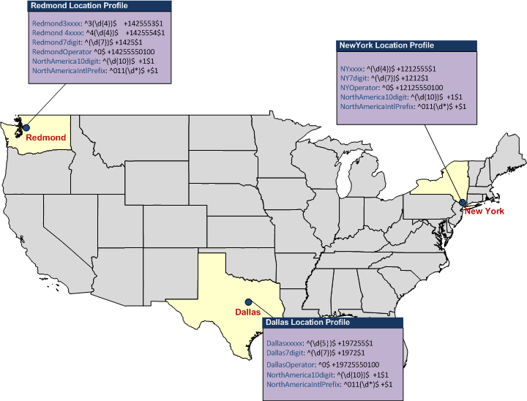
Figure 14. Location profiles for Redmond, Dallas, and New York

Phone Usage Records
Phone usage records provide a quick, simple way to assign call permissions to users as well as to facilitate route prioritization and selection. For example, a temporary contract employee might not be authorized to make long-distance calls or only certain employees or workgroups might be allowed to place international calls. A phone usage record is an arbitrary label that you create to identify a category of call destinations. Examples include Local, Area Code, State, Province, USA, Singapore, and International. In this regard, phone usage records are similar to what in traditional telephony is known as “class of service.” Phone usage records, however, offer greater flexibility because they are applied to both user policies and routes, making it possible to formulate very precise phone authorizations for both individuals and groups.
By assigning phone usage records to both user policies and outbound call routes, you indicate which users are allowed to make calls that use particular routes. When a user places a call, Office Communications Server 2007 matches the caller with the route. If the phone usage record for the route also appears in the voice policy assigned to the caller, the call is allowed to go through. If the caller does not have a phone usage record that matches one of those that are assigned to the particular route used for the called number, the server refuses the call.
The following steps are involved in using phone usage records:
- Administrators create policies that contain a set of phone-usage attributes.
Note
The sequence of phone usage attributes in the policy is significant; we recommended that you arrange attributes from most-preferred to least-preferred.
- Users are assigned a policy based on their calling privileges.
- Routes are assigned phone usage records, which serve to match routes with the users who are authorized to use them. That is, users can place calls that use only the routes for which they have matching phone usage records.

Routes
When Office Communications Server determines that a dialed number needs to be routed to a PSTN gateway, the routing table is queried to determine the optimal gateway for the call.
The policy of the calling user (or a user transferring the call), along with the dialed number, determine the gateway to which the call should be routed. The following example illustrates the logic used by the routing application:
routeList = null;
foreach ( usage in caller.usages ) – order of usages matters
foreach ( route in routesWithUsage[ usage ] )
if ( route.RegexPattern.Matches ( targetPhoneNumber ) )
routeList.Append ( route );

The following are examples of failover logic related to gateway selection:
- When there are multiple gateways that serve a particular route, a round-robin algorithm is used to distribute the calls across the multiple gateways.
- Each gateway is configured with a maximum number of failed call attempts before traffic to the gateway is throttled. The default number of attempts is ten, but this value can be changed by using a WMI (Windows Management Instrumentation) script. For a particular call, a given gateway cannot be attempted more than once. If all gateways that serve a particular route are marked as unavailable, the server drops the call and notifies the client. You can also configure a gateway to be removed from the selection logic for some period of time. The unresponsive gateway is removed from the list of available gateways for increasing periods of time, up to a maximum of 60 minutes, during which time the server repeatedly attempts to elicit a positive response. After receiving a positive response, the server returns the gateway to the list of available gateways.
Route
Pattern
Phone Usage
Attributes
Gateway
Delhi
-
All
^(
\
d*)$
Delhi
Delhi
-
gw1 port
Redmond
-
Local
^
\
+1425(
\
d*)$
Local
RedmondTemps
Redmond
-
gw1 port
Redmond
-
gw2 port
Zurich
-
Local
^
\
+141(
\
d*)$
Local
Zurich
-
gw1port
Users
Phone Usage attributes
Delhi users (ex:
Rahul
)
Delhi
Redmond FTEs (ex:
Alice
)
Local Long
-
Distance Redmond
Redmond Executives
Local Long
-
Distance International
Redmond
Redmond Temps (ex: Bob)
RedmondTemps
Match first sought for ‘Local’ phone
-
Usage attribute (L to R execution)
Matches
–
Redmond
-
Local
Dialed number compared against
pattern in matched rule
Matches
–
^
\
+1425(
\
d*)$
Call routed using either
Redmond
-
gw1 or Redmond
-
gw2
Alice dials +14255550100
Phone
-
usage attribute is retrieved
from her User policy
Local Long
-
Distance Redmond
Order is important
Figure 15. Example of routing logic
Note
Only calls from users who are enabled for Enterprise Voice are routed by using the previously defined procedure. If no match is found in the routing table, the call is refused.
For detailed examples and best practice recommendations, see the Microsoft Office Enterprise Voice Planning and Deployment Guide.

Conference Data Storage
Office Communications Server 2007 maintains meeting state and presence data in separate databases. The database resides on a Standard Edition server or the Back-End Database Server for an Enterprise Edition pool.
The conference database stores information about each meeting currently configured on a server. This information includes the conference ID, associated security keys, expiration time, and user roles and privileges. The conference database also includes information about each meeting that is running on a server, so that if a meeting fails, its state can be quickly restored and the meeting resumed without loss of content. The conference database is implemented as a separate table in the same database that contains information about user registration and presence.
Meeting content, unlike the meeting state, is not stored in the Back-End Database. Instead, meeting content is stored on a dedicated file share created by the administrator. In Standard Edition deployments, this file share is normally created on the Standard Edition server. In Enterprise Edition deployments, this file share is normally created on a separate computer from the Front End Servers.

Protocols
The Unified Communications vision that is embodied in Office Communications Server 2007 is built on SIP (Session Initiation Protocol), an industry standard, application layer signaling protocol for starting, controlling, and ending communication sessions in an IP-based network. SIP is formally described in the IETF (Internet Engineering Task Force) reference specification RFC 3261. By using SIP, one user can explicitly invite another to join a conversation or multimedia session. A SIP session begins when the second user accepts a SIP INVITE request.
In Office Communications Server 2007, SIP is used for IM, conferencing, presence subscriptions, video, and VoIP, providing a common user experience across all these communication modes. Signaling for phone calls coming from the PSTN is converted to SIP by the media (PSTN) gateway.
Although SIP sessions can include the sharing of real-time media, SIP itself does not handle the actual media data, such as audio, video, and application sharing. In practical terms, this separation means that SIP and various media protocols can evolve independently.
Other protocols that are used in Office Communications Server 2007 include the following:
- HTTP (Hypertext Transfer Protocol). A standard Internet protocol that in Office Communications Server 2007 is used for communication between the Focus and conferencing servers, downloading Address Book Server updates to clients, and downloading meeting content to users.
- C3P (Centralized Conference Control Protocol). A custom protocol for communicating conference creation and control commands from clients to Office Communications Server 2007. C3P commands are carried as XML in SIP SERVICE or INFO messages. CP3 commands are also carried over HTTPS to all conferencing servers.
- PSOM (Persistent Shared Object Model). A custom protocol for transporting Web conferencing content.
- SRTP (Secure Real-time Transport Protocol). An IETF standard protocol that is used in Office Communications Server 2007 for securely transporting audio and video content to various media devices. It is based on the RTP that defines a packet format for carrying audio and video over IP networks.
- RTCP (Real-Time Control Protocol). An IETF standard protocol used in conjunction with RTP and SRTP to convey information about the signal quality of an audio/video conferencing session to various media devices.

What to Read Next
Documentation for Microsoft Office Communications Server 2007 and Microsoft Office Communicator 2007 is available from the Office Communications Server Web site: http://r.office.microsoft.com/r/rlidOCS?clid=1033&p1=library. The following table shows documents to look at next.
Table 3. Office Communications Server 2007 and Office Communicator 2007 Documentation
To learn about | Read this guide
Planning for deployment | Microsoft Office Communications Server 2007 Planning Guide
Preparing Active Directory | Microsoft Office Communications Server 2007 Active Directory Guide
Deploying Standard Edition | Microsoft Office Communications Server 2007 Standard Edition Deployment Guide
Deploying Enterprise Edition | Microsoft Office Communications Server 2007 Enterprise Edition Deployment Guide
Deploying Edge Servers | Microsoft Office Communications Server 2007 Edge Server Deployment Guide
Planning and Deploying Enterprise Voice | Microsoft Office Communications Server 2007 Enterprise Voice Planning and Deployment Guide
To learn about | Read this guide
Deploying Office Communicator | Microsoft Office Communicator 2007 Planning and Deployment Guide
Deploying the Live Meeting 2007 client | Deploying the Live Meeting 2007 Client for Office Communications Server 2007
Deploying Archiving and CDR Server | Microsoft Office Communications Server 2007 Archiving and CDR Server Deployment Guide
Backing up and restoring data | Office Communications Server 2007 Backup and Restore Guide
Migration from Live Communications Server 2005 SP1 | Migrating to Microsoft Office Communications Server 2007

