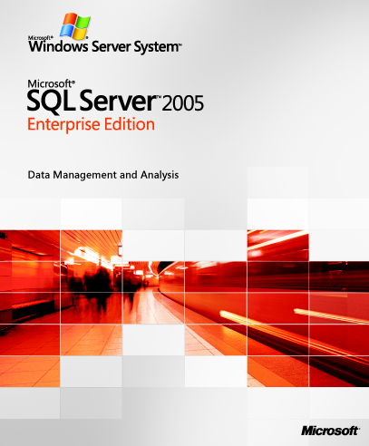

Organizations today are facing several unique data challenges: the proliferation of data and systems across their enterprise; the need to provide employees, customers, and partners with consistent access to that data; the desire to better equip information workers with meaningful information to drive informed decisions; and the mandate to control costs without sacrificing application availability, security, or reliability.

The next release of SQL Server is designed to help enterprises address these challenges. SQL Server 2005 is Microsoft’s next-generation data management and analysis solution that will deliver increased security, scalability, and availability to enterprise data and analytical applications while making them easier to create, deploy, and manage.

Building on the strengths of SQL Server 2000, SQL Server 2005 will provide an integrated data management and analysis solution that will help organizations of any size to:
- Build and deploy enterprise applications that are more secure, scalable, and reliable.
- Maximize the productivity of IT by reducing the complexity of creating, deploying, and managing database applications.
- Empower developers through a rich, flexible, modern development environment for creating more secure database applications.
- Share data across multiple platforms, applications, and devices to make it easier to connect internal and external systems.
- Deliver robust, integrated business intelligence solutions that help drive informed business decisions and increase productivity across your entire organization.
- Control costs without sacrificing performance, availability, or scalability.

Read on to learn more about the advancements SQL Server 2005 will deliver in three key areas: enterprise data management, developer productivity, and business intelligence.

Enterprise Data Management
In today’s connected world, data and the systems that manage that data must always be available to your users. With SQL Server 2005, users and IT professionals across your organization will benefit from reduced application downtime, increased scalability and performance, and tight security controls.

SQL Server 2005 will include enhancements to enterprise data management in the following areas:
- Availability. Investments in high availability technologies, additional backup and restore capabilities, and replication enhancements will enable enterprises to build and deploy highly reliable applications.
- Scalability. Scalability advancements such as partitioning, snapshot isolation, and 64-bit support will enable you to build and deploy your most demanding applications using SQL Server 2005.
- Security. Enhancements such as “secure by default” settings and an enhanced security model will help provide a high level of security for your enterprise data.
- Manageability. A new management tool suite, expanded self-tuning capabilities, and a powerful new programming model will increase the productivity of database administrators.
- Interoperability. Through deep support for industry standards, Web services, and the Microsoft .NET Framework, SQL Server 2005 will support interoperability with multiple platforms, applications, and devices.

Developer Productivity
One of the key barriers to developer productivity has been the lack of integrated tools for database development and debugging. SQL Server 2005 will provide advancements that fundamentally change the way that database applications are developed and deployed.

Enhancements for developer productivity will include:
- Improved tools. Developers will be able to use one development tool for Transact-SQL, XML, Multidimensional Expression (MDX), and XML for Analysis (XML/A). Integration with the Visual Studio® development environment will provide more efficient development and debugging of line-of-business and business intelligence applications.
- Expanded language support. With the common language runtime (CLR) hosted in the database engine, developers will be able to choose from a variety of familiar languages to develop database applications, including Transact-SQL, Microsoft Visual Basic® .NET, and Microsoft Visual C#® .NET.
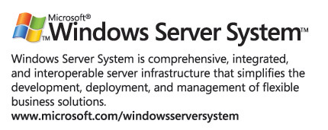
This document is developed prior to the product's release to manufacturing, and as such, we cannot guarantee that all details included herein will be exactly as what is found in the shipping product. The information contained in this document represents the current view of Microsoft Corporation on the issues discussed as of the date of publication. Because Microsoft must respond to changing market conditions, it should not be interpreted to be a commitment on the part of Microsoft, and Microsoft cannot guarantee the accuracy of any information presented after the date of publication. The information represents the product at the time this document was printed and should be used for planning purposes only. Information subject to change at any time without prior notice. This document is for informational purposes only. MICROSOFT MAKES NO WARRANTIES, EXPRESS OR IMPLIED, IN THIS DOCUMENT. Microsoft, Visual Basic, Visual C#, Visual Studio, the Windows logo, and Windows Server System are either registered trademarks or trademarks of Microsoft Corporation in the United States and/or other countries. The names of actual companies and products mentioned herein may be the trademarks of their respective owners.
Part Number 098-99945
- XML and Web services. SQL Server 2005 will support both relational and XML data natively, so enterprises can store, manage, and analyze data in the format that best suits their needs. Support for existing and emerging open standards such as Hypertext Transfer Protocol (HTTP), XML, Simple Object Access Protocol (SOAP), XQuery, and XML Schema Definition (XSD) will also facilitate communication across extended enterprise systems.

Business Intelligence
The challenge and promise of business intelligence revolves around providing employees with the right information, at the right time. Accomplishing this vision demands a business intelligence solution that is comprehensive, more secure, integrated with operational systems, and available all day, every day. SQL Server will help companies to achieve this goal with SQL Server 2005.

Business intelligence advancements will include:
- Integrated platform. SQL Server 2005 will deliver an end-to-end business intelligence platform with integrated analytics including online analytical processing (OLAP); data mining; extract, transformation, and load (ETL) tools; data warehousing; and reporting functionality.
- Improved decision making. Advancements to existing business intelligence features, such as OLAP and data mining, and the introduction of a new reporting server will provide enterprises with the ability to transform information into better business decisions at all organizational levels.
- Security and availability. Scalability, availability, and security enhancements will help to provide users with uninterrupted access to business intelligence applications and reports.
- Enterprise-wide analytical capabilities. An improved ETL tool will enable organizations to more easily integrate and analyze data from multiple heterogeneous information sources. By analyzing data across a wide array of operational systems, organizations may gain a competitive edge through a holistic understanding of their business.

Additional Information
SQL Server 2005 is part of the Windows Server System™—a comprehensive and integrated server infrastructure that simplifies the development, deployment and operations of a flexible business solution.
For more information on SQL Server 2005, visit http://www.microsoft.com/sql/2005/.

