

Microsoft Outlook 2003 with Business Contact Manager Update

Product Guide

May 2005


May 2005

Contents

Introduction 1
Abstract 1
Background 1
Small-Business Marketplace 1
Managing customer information and sales opportunities 2
Design Goals 3
Improve productivity 3
Connect business information 4
Ensure ease of use 5
What’s New in Outlook 2003 with Business Contact Manager Update 6
Functionality 8
Organize and manage important business information in one place 8
Track sales opportunities effectively to maximize revenue 9
Market more effectively through personalized communications 9
Spend more time with customers, rather than with computers 9
Solving Business Problems: Scenarios 10
Scenario 1: Wingtip Toys 10
Scenario 2: Contoso 13
Features Overview 15
Accounts and Business Contacts 15
Accounts and Business Contacts 15
Business Opportunities 16
Reporting 17
Integration with Office 17
Integration with Office 18
System Requirements 18

Introduction

Abstract
Welcome to the Microsoft® Outlook® 2003 with Business Contact Manager Update Product Guide. This guide can help you evaluate Outlook 2003 with Business Contact Manager Update by providing details on customer scenarios, product design goals, and features and functionality.
Outlook® 2003 with Business Contact Manager Update extends the functionality of Outlook 2003 and was specifically designed to give entrepreneurs, sales people, and employees in small businesses a customer management solution to help them better manage and share their customer information and sales opportunities in a single place. Outlook 2003 with Business Contact Manager Update, available in June 2005, offers new performance enhancements and functionality, including the ability to share customer information with coworkers and support for synchronizing business contacts to a Microsoft Windows Mobile™-based Pocket PC.

The ability to share business contacts, accounts, and opportunities provides employees and managers with a comprehensive view of customer communications and contact information, helping businesses more easily and consistently follow up with customers and sales opportunities. And with support for synchronizing business contacts with a Pocket PC, users can easily access their business contact information with them while out of the office or on the road.

Background

Small-Business Marketplace
For small businesses, life is more complex—and more challenging—than ever. Customers expect faster, more personalized service. Employees require instant access to ever-increasing volumes of information. Marketing budgets are small and competition is fierce. And although a number of tools and technology are available to address these issues, small businesses do not typically have the information technology (IT) staff to implement and integrate new software, much less the time and resources to retrain all of their employees. Small businesses need the software they already know and use every day to address their key challenges, including the following:
- Keeping track of customer information in one place, so commitments and opportunities don’t fall through the cracks.
- Managing overwhelming amounts of information and e-mail messages.
- Finding the right information faster to make better decisions and take more effective action.
- Enabling employees to be more efficient, whether working in the office or remotely.

Managing customer information and sales opportunities
Small businesses face challenges in connecting with customers effectively and managing sales opportunities more efficiently. To acquire new customers and deliver the efficient, consistent service that keeps those customers coming back, small businesses must organize business contacts and account information so that it is quickly consolidated, and easily shared and accessible by multiple users. They must also track and manage leads and sales opportunities effectively, and find efficient, cost-effective ways to market products and services to prospects and existing customers.

For many small businesses a desktop solution that helps business owners and sales people manage customer contacts and sales opportunities is more than sufficient, while other small businesses may need a full-fledged, customizable, server-based customer relationship management (CRM) solution that offers more advanced functionality. Indeed, the market for affordable, easy-to-use basic contact management applications is large: According to AMI-Partner Research, 73 percent of small businesses with one to nine employees already use business contact management software. With the latest peer-to-peer sharing applications, small businesses can now have all the tools they need to effectively manage business contacts and sales opportunities.

For many small businesses information about sales opportunities and accounts exists in multiple applications and various online and print sources, forcing employees to spend valuable time juggling different applications and finding sales-related data. Nor can these businesses efficiently manage sales opportunities or market to new and existing customers; that can directly result in missed opportunities, poor business decisions, and ultimately, lost revenue. Finally, when busy employees are presented with new applications that might at least partially address the situation, they often have neither the time nor will to learn to use new software.

Designed specifically for small businesses with 1-25 employees, Outlook 2003 with Business Contact Manager Update equips business owners and sales people with the tools to manage opportunities, accounts, and individual business contacts efficiently and easily, within the Outlook application they use every day.

As an enhanced version of Outlook 2003 with Business Contact Manager helps individual users:

- Organize customer information in one location so that it is quickly accessible and shared by multiple users.
- Find important documents and information instantly.
- New! Share customer information with coworkers within a peer to peer network.
- New! Synchronize Business Contacts in Outlook 2003 with Business Contact Manager to a Windows Mobile™-based Pocket PC.
- Market effectively with e-mail and print marketing campaigns.
- Use reporting tools to prioritize business tasks.
- Use Outlook 2003 with Business Contact Manager Update in combination with Microsoft Windows® Small Business Server 2003, Microsoft Exchange Server 2003, and hosted Exchange Server 2003.
- Integrate with Microsoft Office Small Business Accounting 2006.

Ideal for businesses looking for more than basic contact management software, Outlook 2003 with Business Contact Manager Update also provides a seamless upgrade path to Microsoft Business Solutions Customer Relationship Management, the CRM solution that enables multiple users to view, update, and share complete customer information across teams and departments.

Design Goals

Outlook 2003 with Business Contact Manager Update was designed to enable small businesses to take full advantage of Outlook, the contact and e-mail management application they already use. Without leaving the familiar Outlook environment, employees are equipped with the tools and information they need to track, manage and share their customer information and sales opportunities with other employees, and connect information and processes so that they can capitalize on sales opportunities more effectively. Specific design goals include the following:

Improve productivity
- Track business contacts easily. By managing business contacts, accounts, and sales opportunities within Outlook, users have consolidated access to the information they need to work effectively with customers and other business contacts. All information related to interactions with individuals or companies—including e-mail messages, appointments, phone calls, calendar items, notes, documents, and faxed or scanned items—can be accessed, viewed, and updated from one location.

- Manage opportunities to maximize sales potential. Within Outlook, users can manage sales opportunities throughout the sales cycle, as well as view updated, detailed product information to help predict revenue potential and ensure accurate quotes.

- Manage follow-up with reporting tools. Reports help users gain insight into their business, prioritize sales-related tasks, and manage follow-ups efficiently.

- New! Synchronize Business Contacts with a Windows Mobile™-based Pocket PC. Synchronize your Business Contacts in Outlook 2003 with Business Contact Manager Update to your Pocket PC and take your Business Contacts and associated history with you while out of the office or on the road. Business Contacts for Pocket PC is available as a download from the Microsoft Download Center and Office Online Downloads at www.microsoft.com/downloads/details.aspx?FamilyId=F3BC2918-C310-4599-81D1-558CF385ED88.

Connect business information
- Manage business contacts using an integrated application. By integrating with Office applications, such as Publisher 2003 and Microsoft List Builder, Outlook 2003 with Business Contact Manager Update makes it easy to build customer relationships through personalized e-mail marketing campaigns, as well as design customized print and e-mail newsletters and communications.
Visit http://www.microsoft.com/smallbusiness/products/online/lb/detail.mspx to learn more about Microsoft List Builder.

- Work easily with other Office applications. By linking Office documents to accounts, business contacts, and sales opportunities, users can maintain a complete view of customer-related information, including product information, within Outlook 2003 with Business Contact Manager Update.

- Import contact information from other applications with just a few clicks. Customer data can be transferred from other applications quickly and easily including from Microsoft® Office Word 2003, Microsoft Office Excel® 2003, and Microsoft Office Access 2003, as well as improved support for ACT! and other programs. Easily copy or move your existing Outlook contacts into Outlook 2003 with Business Contact Manager Update.

Ensure ease of use
- Work within Outlook. Because Outlook 2003 with Business Contact Manager Update enables Outlook users to work within the application they already know, the learning curve is virtually eliminated, freeing small business users to focus on what’s important: their customers.

- Find important documents instantly. Simply by clicking a customer or sales opportunity, users can view a relationship history and then access all associated Outlook items and documents, including faxed and scanned documents.

- Manage mailing lists easily. Working with Microsoft List Builder, a separate fee-based Web service, users can easily create and manage customized permission-based e-mail marketing campaigns. Know the success of your campaigns with reports that track how many recipients opened your e-mail message and where they clicked. Learn more about Microsoft List Builder at www.microsoft.com/smallbusiness/products/online/lb/detail.mspx.

- Manage the flood of e-mail. Handling the increasing volume of e-mail can be annoying and time-consuming. Manage e-mail more efficiently and respond to changing business conditions quickly with enhanced Outlook 2003 e-mail capabilities. Reading Pane improvements, Desktop Alerts, Quick Flags, and Search Folders help you spend less time organizing and responding to e-mail.
- Protect your business from spam and viruses. Junk e-mail filtering and improved content blocking help to reduce the amount of bothersome spam your employees receive, helping increase employee efficiency. Outlook 2003 analyzes incoming e-mail for the timing and content of the e-mail and examines the structure of the e-mail to determine if it might be junk. The user can adjust the sensitivity level of the junk-mail filter, and specific e-mail senders can be added or removed from a junk mailer’s list. Improved integration of third-party anti-virus software and e-mail attachment blocking help reduce the risk of virus threats and the loss of time and money from virus attacks.

What’s New in Outlook 2003 with Business Contact Manager Update
Outlook 2003 with Business Contact Manager Update has several new functionalities to help small businesses work more efficiently and faster.

New! Share customer information and communication history across your business
Share your Outlook 2003 with Business Contact Manager Update information —business contacts, accounts, and sales opportunities— across a PC network with
designated coworkers (for example, the business owner, the administrative assistant, or a customer service person). This gives the business owner a comprehensive view of customer information and sales opportunities across the company. And it enables coworkers to fill in for each other.

- Share business contact, accounts, customer histories, and opportunities with others and access a common database with changes to that database being shown at all workstations.
- Allow others, such as a sales manager, to view your business contacts, accounts, customer histories, and opportunities by sharing your Outlook with Business Contact Manager Update database.
- Enable your employees to immediately view changes made on one workstation throughout the network and on mobile devices as well.
- Respond quickly to customers with comprehensive customer information, including contact information, communications history and financial history (viewing financial information requires access to financial information stored in Small Business Accounting 2006).
- Help your sales leads easily see who is working on what and what stage in the sales process each account is in.

Note: Outlook 2003 with Business Contact Manager Update is designed to work with technology used most often by small businesses, including in a PC (peer-to-peer) network and with the most common e-mail protocols (POP3, IMAP, or HTML). To use sharing functionality, the host machine must be running Windows 2000 with SP3 or Windows XP Professional Edition.
New! Synchronize Business Contacts with your Pocket PC
Synchronize your Business Contacts in Outlook 2003 with Business Contact Manager Update to your Pocket PC and take your Business Contacts and associated history with you while out of the office or on the road.

- Make changes to Business Contacts for Pocket PC and have them automatically synchronized with your business contacts in Outlook 2003 with Business Contact Manager on your office computer just as soon as the Pocket PC is back in its cradle.
- Synchronize and share data with other employees. After you update your Pocket PC with changes, return it to the cradle, and your office computer is updated, then coworkers with sharing rights can receive those same updates.
Note: Windows Mobile–based Pocket PC synchronization capability is available as a no-charge download to Outlook 2003 with Business Contact Manager Update users at
www.microsoft.com/downloads/details.aspx?FamilyId=F3BC2918-C310-4599-81D1-558CF385ED88.
New! Use within a Microsoft Exchange Server environment.
Based on feedback from our small business customers, Outlook 2003 with Business Contact Manager Update now also works in combination with Microsoft Windows® Small Business Server 2003, Microsoft Exchange Server 2003, and hosted Microsoft
Exchange Server 2003.
Note: Outlook 2003 with Business Contact Manager Update does not use the sharing functionality in Windows Small Business Server 2003 or Exchange Server 2003 to share business contacts.
New! Access customer financial data stored in Microsoft Office Small Business Accounting 2006
If you use Microsoft Office Small Business Accounting 2006 together with Outlook 2003 with Business Contact Manager Update, the financial history from Small Business Accounting 2006 can be linked to your customer’s account information, bringing together the latest customer communication and financial data and gives companies the tools they need to combine their financial and customer information with their productivity software to help them work more effectively.

Using Small Business Accounting 2006 with Outlook 2003 with Business Contact Manager Update gives employees access to customer contact information and a complete view of each customer’s financial history, so employees have all the information they need when speaking with customers. And if an employee using Small Business Accounting with Business Contact Manager Update has sharing rights, even more financial information is visible for each of the accounts.

When you use Outlook 2003 with Business Contact Manager Update and Small Business Accounting together you can:

- Access Financial History and a Complete Summary—View the details on past and current quotes, sales orders, invoices, credit history, outstanding balances, and payment information—so that you are always up to date on your customers' financial status directly from the account.

- Create Quotes and Invoices—You can easily create and process quotes and invoices from opportunities within Outlook 2003 with Business Contact Manager and transfer them directly into Office Small Business Accounting 2006. This can reduce errors and the time spent on paperwork, giving you an effective solution for completing day-to-day financial tasks.

- Track Your Billable Tasks and Appointments— Integration of Small Business Accounting 2006 with Outlook 2003 with Business Contact Manager Update enables employees to mark appointments, meetings and phone logs in their Outlook calendars as billable time, and then transfer that information to Small Business Accounting 2006, helping small business more efficiently track billable time.

- Access Relevant Data—With financial histories and complete customer summaries, you can give your sales leads access to better information than ever before for forecasting revenues and allocating resources.

Functionality
By helping small businesses manage and share customer-related information in one place, Outlook 2003 with Business Contact Manager Update extends Outlook 2003 from an e-mail and address management application to a powerful customer information management tool. Intuitive, easy-to-use features enable users to do the following:

Organize and manage important business information in one place
- Create and manage accounts, business contacts, and sales opportunities in Outlook 2003.
- Establish account hierarchies between companies and the individual contacts who work there.
- Automatically associate Outlook e-mail messages, notes, and calendar items—as well as link documents—with accounts, business contacts, and sales opportunities.
- Instantly view activity history and all associated items for an account, business contact, or sales opportunity.
- Attach scanned documents to accounts, business contacts, and sales opportunities for a complete view of business relationships.
- Synchronize business contacts with a Pocket PC so that business contacts and associated communication are immediately available whether in the office or on the road.

Track sales opportunities effectively to maximize revenue
- Track opportunities through the sales cycle from within Outlook and instantly view the sales stage, revenue potential, and probability of closing.
- Run reports that monitor the status of sales efforts and help prioritize sales-related tasks.
- Quickly sort and filter information to view the data most relevant to sales efforts.
- Export reports to Microsoft Excel or Microsoft Word for further analysis and formatting.
- Import price lists from Excel to help evaluate revenue potential, build accurate quotes, and respond quickly to requests for product information.
- View the company’s sales pipeline of comprehensive customer financial history and transaction, contact, and communications information when Small Business Accounting is used with Outlook 2003 with Business Contact Manager Update.

Market more effectively through personalized communications
- Purchase targeted leads from the Microsoft Sales Leads service and automatically import them to Outlook.
- Use Microsoft List Builder to create custom mailing lists, send prospects and customers targeted e-mail marketing campaigns, and track campaign results.
- Automatically process opt-out requests and bounced e-mail messages using Small Business Center List Builder.
- Create impressive marketing newsletters and mailings in-house for print, the Web, and e-mail using customizable Publisher.

Spend more time with customers, rather than with computers
- Eliminate the learning curve with features that are easy to use and that integrate fully with Outlook and Office.
- Import contact information quickly from Office programs, ACT!, and other applications.
- Print calendars and contact lists to fit paper-based formats, including Franklin Planner, Day-Timer, and more.

Solving Business Problems: Scenarios

The following scenarios illustrate how two different companies might work with Outlook with Business Contact Manager Update and Small Business Accounting to manage opportunities more efficiently, connect with customers more effectively, and provide employees with easy-to-use tools that help them work at maximum potential.

Scenario 1: Wingtip Toys
Wingtip Toys, an education games distributor, has 10 employees, including 4 employees who manage sales efforts in addition to other responsibilities. To keep pace within a competitive market, the business recently expanded its distribution line from 10 to 25 items. Inquiries and sales have increased significantly, but the company cannot afford to hire more employees.

Problem: Methods for managing sales-related processes and information are inefficient, leading to missed opportunities, erratic service, and frustrated customers and employees.

Employees at Wingtip Toys rely on ad hoc tracking methods for managing sales opportunities and customer accounts, wasting considerable time tracking down information scattered across e-mail messages, documents stored in various applications, and paper trails. Because the number of inquiries from customers and prospects has increased significantly over the past few months, employees often have an assortment of phone slips and e-mail requests, struggling to decide who they should contact first. As a result, important sales opportunities often fall through the cracks and follow-ups occur erratically or not at all—all too often, prospects and customers are forced to call in to check up on a pending sale or a reorder for products, and then deal with an employee who cannot locate the information they need.

Though not ideal, the situation has been manageable—until now, when an expanded product line and the need for increased sales revenue to accommodate business growth have pushed existing resources to the breaking point. For example, employees cannot keep track of pricing for new items, so it is nearly impossible for them to forecast revenue for pending sales or build accurate quotes for customers. Adding to the pressure is the fact that the Wingtip Toys' customer base is increasingly made up of larger companies with multiple contacts interested in multiple products. The staff does not have an effective way to organize account and contact information that ensures they respond to the right people with the right information. Frustrated with working 12-hour days, no one is willing to spend even more time learning the new software that the business owner wants to purchase.

Solution: Outlook with Business Contact Manager Update

Keep all customer data in one place
Because employees at Wingtip Toys already use Outlook to manage e-mail messages and addresses, they can take advantage of Outlook with Business Contact Manager Update to create manage, and share not only contacts, but also sales opportunities and customer accounts, within the familiar Outlook environment.

For example, they can use the Accounts and Business Contacts feature to establish explicit associations between the companies they are doing business with and the individual contacts who work there—eliminating confusion when they are working with companies with multiple contact points. Locating information related to sales opportunities and accounts is no longer a problem, as users can automatically link e-mail messages, notes, and other Office documents—as well as attach faxes and scanned documents—to business contacts, accounts, and sales opportunities.

If employees receive a call from a customer or a sales prospect, they can instantly view an up-to-date account or contact history and access all associated information quickly and easily, including notes from phone calls with different contacts at the company, as well as any e-mail message received from the account since it was first opened. They can also record sales stage, referral sources, and other useful information and store it within the account activity history when using Business Contact Manager Update with Small Business Accounting 2006.

Access Business Contacts when out of the office on a Pocket PC
With the additional ability to synchronize Business Contacts in Outlook 2003 with Business Contact Manager Update to a Pocket PC, employees at Wingtip Toys can easily access business contact information and associated history with them when out of the office. When the Pocket PC is returned to its cradle the employees Business Contacts are automatically synchronized to Outlook 2003 with Business Contact Manager Update on the desktop computer.

Track leads and opportunities more effectively
In addition to gaining easy access to organized, comprehensive account and contact information, Wingtip Toys employees can use the Business Opportunity function to track leads and sales prospects throughout the sales cycle. Simply by clicking the opportunity form, they can view complete activity history and the product name or service being sold, as well as the sales stage and probability of closing the sale. Relevant information can be associated with the opportunity at any time, including up-to-date product pricing information that can be imported easily.
If using with Office Small Business Accounting 2006 (available in the US only) with Outlook 2003 with Business Contact Manager Update, the financial history from Small Business Accounting 2006 can be linked to a Wingtip customer’s account information. This allows Wingtip employees to then use that information to assess revenue potential; build accurate quotes; and provide fast, accurate answers to questions from customers.

Gain insight into the sales pipeline and prioritize sales-related tasks
Reporting capabilities within Outlook with Business Contact Manager Update also help ensure that follow-up tasks and sales opportunities are managed more effectively. For example, salespeople can choose from 20 reports and filter data to view status for accounts they are working on, or to show customers and opportunities that have not been contacted recently. Equipped with this information, they can more easily set priorities for sales efforts, organize daily tasks, and make sure that customer requests and follow-up opportunities do not fall through the cracks.
When Outlook with Business Contact Manager Update is used with Small Business Accounting 2006, users can accurately measure and predict sales activity across opportunities and existing customers. User can also run reports that show sales status, order information, and the probability of closing for all opportunities and accounts, or for a specific subset that they can define.

Share critical sales information with others
Wingtip Toys sales people can now share their Outlook 2003 with Business
Contact Manager Update information —customers, accounts, and sales opportunities— across a PC network with designated coworkers. This gives the business owner a comprehensive view of customer information and sales opportunities across the company. And it enables coworkers to fill in for each other. Wingtip Toys employees can now see directly into their company’s sales pipeline when using Outlook with Business Contact Manager Update in conjunction with Small Business Accounting 2006. Employees with relevant, appropriate access can respond quickly to customers with comprehensive customer financial history and transaction, contact, and communications information.

Note: Outlook 2003 with Business Contact Manager Update is designed to work with technology used most often by small businesses, including in a PC (peer-to-peer) network and with the most common e-mail protocols (POP3, IMAP, or HTML). To use sharing functionality, the host machine must be running Windows 2000 with SP3 or Windows XP Professional Edition.

Eliminate the learning curve
Finally, salespeople at Wingtip Toys don't have to take time out of their busy schedules to deal with the frustrations of learning new software. Instead, they can continue to work within Outlook 2003, using intuitive tools that elevate Outlook as a powerful sales tool.

Scenario 2: Contoso
A small company that offers a specialized line of products and services, Contoso has one salesperson, Karen Archer, responsible for managing business accounts and marketing efforts.

Problem: Contoso wants to increase company exposure to new and existing customers, and in particular, to find ways to build market segments based on specific customer preferences.

In an effort to widen customer reach, Karen wants to expand marketing efforts to new and existing customers. Specifically, she wants to incorporate organized e-mail and print marketing campaigns that target specific customer groups and incorporate leads drawn from a variety of sources. Though she uses Outlook to manage her personal and business e-mail messages, all business contact and account information is stored in a separate application. Mailing lists for leads taken from the customer Web site and other sources are also stored separately and maintained manually. Karen has used this information to create some marketing campaigns, but she has not found a cost-effective and efficient way to consolidate customer information into organized mailing lists or to create and manage e-mail and print marketing efforts that target specific groups of customers.

Solution: Outlook 2003 with Business Contact Manager Update

Consolidate contact and account information in one place
Using Outlook 2003 with Business Contact Manager Update, Karen can consolidate all customer information—including business contacts, accounts, and address lists—in one place. Though her original goal was not to track sales opportunities and manage accounts within Outlook, she soon realized the value of taking full advantage of Outlook 2003 with Business Contact Manager Update: In addition to importing contact information and address lists from other applications to Outlook, she can also manage sales efforts without leaving the familiar Outlook environment. By doing so, she could establish organized, efficient methods for tracking and managing leads and opportunities throughout the sales cycle.

Build customer relationships through personalized e-mail marketing campaigns
For most small businesses, permission-based e-mail marketing campaigns are the most cost-effective way to reach new and existing customers. Export your business contacts in Outlook 2003 with Business Contact Manager Update to Microsoft List Builder– a separate fee-based Web service– to create targeted e-mail marketing campaigns. Choose from a variety of templates or design your own using Publisher 2003 and quickly and easily create professional-looking e-mail newsletters, targeting different customer segments with personalized messages.
Know the success of your campaigns with reports that track how many recipients opened your e-mail message and where they clicked. List Builder can automatically process opt-out requests and bounced e-mail messages and track response rates, making it easy to evaluate the results of each campaign. After evaluating the success of a given campaign, she can make smarter decisions about the customer demographics she wants to target and about the content she wants to include in her campaigns. By taking full advantage of these integration capabilities, she no longer needs to worry about keeping the company "top of mind" with the market segments she wants to reach.
Visit http://www.microsoft.com/smallbusiness/products/online/lb/detail.mspx to learn more about Microsoft List Builder.

In addition, because Outlook with Business Contact Manager Update integrates with Publisher 2003 and Word 2003, Karen can easily send personalized Publisher publications and Word documents by e-mail to business contacts. She can also design impressive sales and marketing materials for print and the Web in Publisher 2003 and create multimedia presentations in PowerPoint 2003, saving them directly to a CD for distribution.

Communicate efficiently with enhanced security
Karen can keep her e-mail organized, her inbox less cluttered, and her PC safer with improved junk-mail filtering and blocking of unsafe attachments. Using the new larger Reading Pane and Mail Desktop Alerts, Karen can manage her e-mail more efficiently and respond faster to her customers.

Features Overview

Accounts and Business Contacts
Create, manage, share, accounts and business contacts in Outlook 2003 with Business Contact Manager Update. Establish associations between companies and individual contacts, and automatically capture Outlook e-mail messages, notes, and calendar items, as well as link documents, for immediate access to relevant information.

Accounts and Business Contacts
Outlook with Business Contact Manager automatically links business contacts, incoming and outgoing e-mail messages, notes, appointments, and tasks to the appropriate Account, Business Contact, or Opportunity record, organizing your important customer information in one place and making it easy to track activity. Also, you can link other items such as phone call logs, Microsoft Office files, and scanned documents to records, accessing them directly from within Outlook with Business Contact Manager Update.

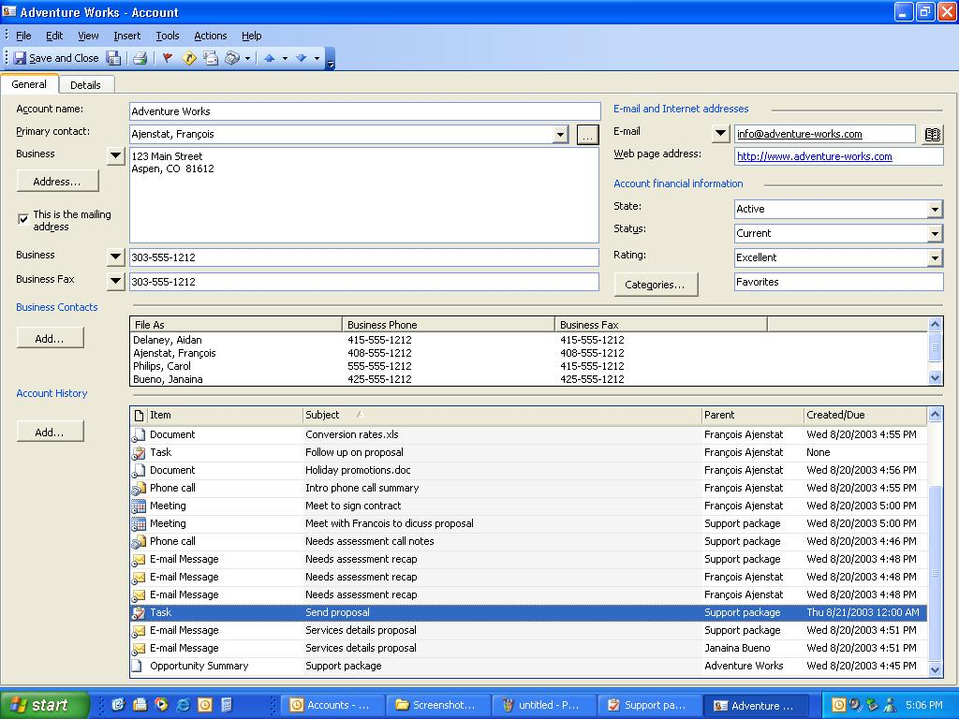

Business Opportunities
Manage sales opportunities throughout the sales cycle with instant access to information such as the sales stage, revenue potential, and probability of closing sales.

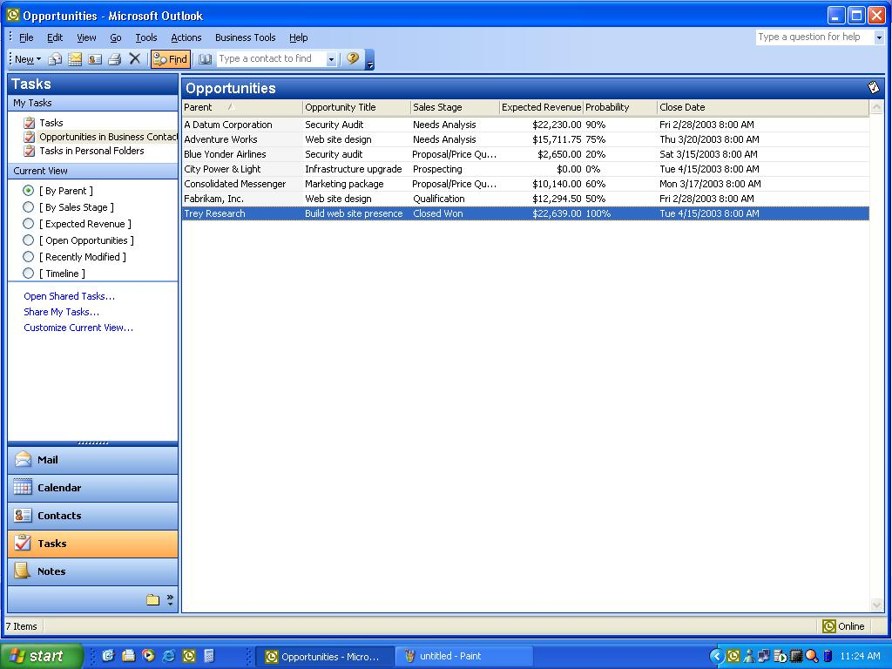
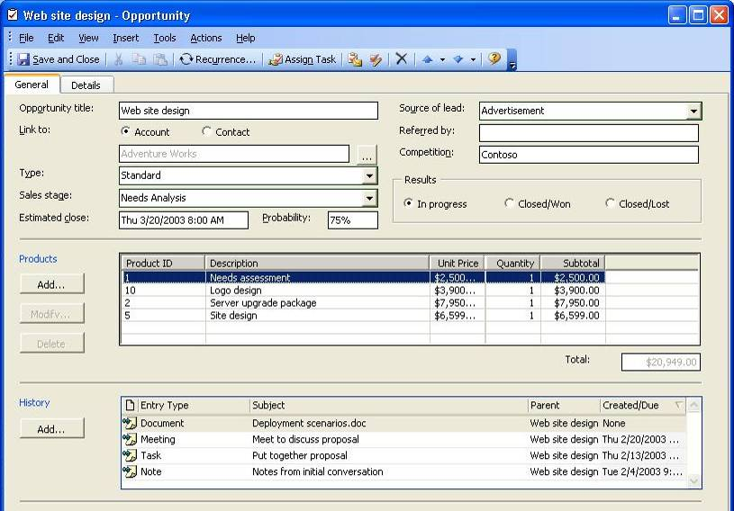
Activity History: Consolidate all Outlook items and documents related to accounts, contacts, or opportunities for easy retrieval.
Product List: Store price lists for products and services to help manage sales opportunities more effectively.
Business Opportunities: Easily track opportunities through the sales cycle.

Reporting
Choose from a set of 20 preformatted reports to help monitor the status of sales efforts, prioritize sales-related tasks, and gain insight into sales pipeline activity using Small Business Accounting with Outlook with Business Contact Manager Update.
Quickly sort and filter information to view the data most relevant to the sales efforts and export results to Excel for further analysis.
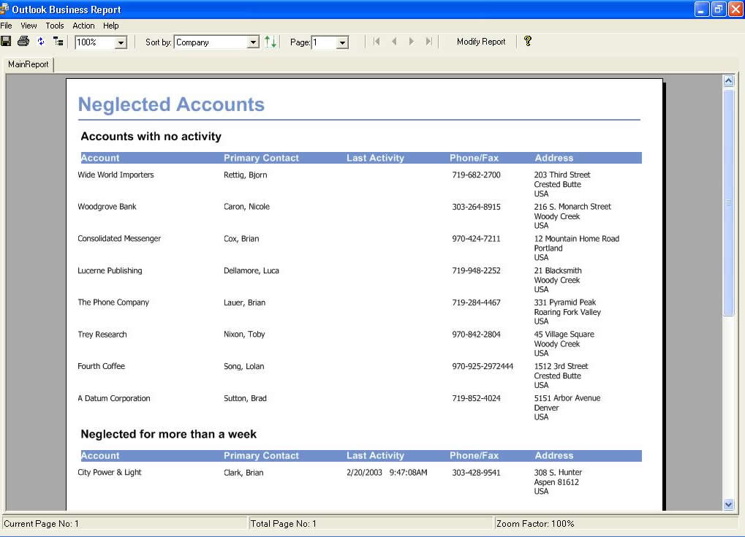
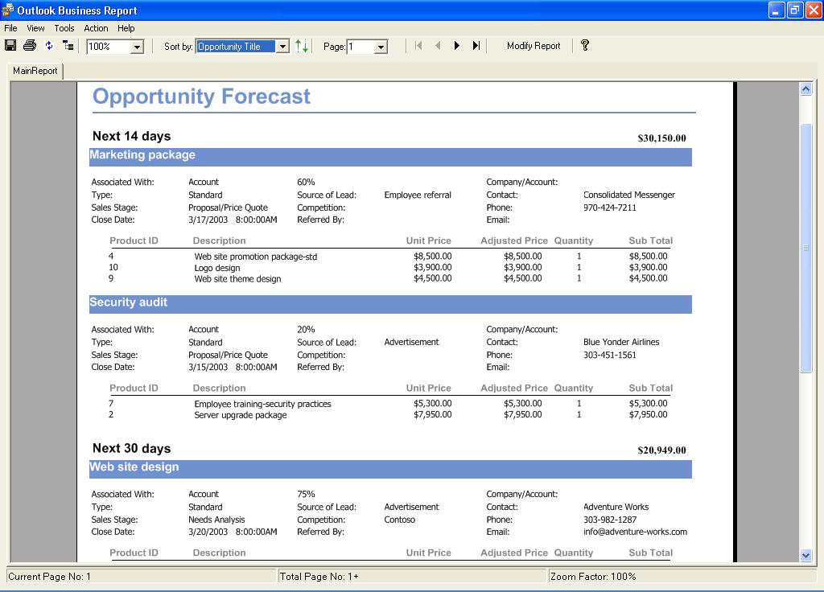
Ensure sales opportunities don't fall through the cracks with reports that show customers who haven't been contacted recently.
Stay fully informed with information about sales stage, anticipated close date, and detailed product and pricing information.
Gain accurate insight into the sales pipeline with detailed forecasting reports.

Integration with Office
Work seamlessly with Office applications. Link Office documents with contacts and accounts, import price lists from Excel, and create personalized newsletters, e-mails, and print and Web materials using Publisher and Word templates.

System Requirements

System requirements for running Outlook 2003 with Business Contact Manager Update are as follows:

- Personal computer with Intel Pentium 450-MHz or faster processor (Pentium III or equivalent recommended)
- 256 MB of RAM or greater
- 360 MB of available hard-disk space;
- Windows XP or later, or Windows 2000 with Service Pack 3;
- To use Sharing functionality, the host PC must be running Windows 2000 with SP3 or Windows XP Professional Edition.

For complete system requirements for Office Small Business Edition 2003 or Office Professional Edition 2003, visit http://www.microsoft.com/office/editions/prodinfo/smallbusiness/2003edition/sysreq.mspx.

This document is for informational purposes only. MICROSOFT MAKES NO WARRANTIES, EXPRESS OR IMPLIED, IN THIS SUMMARY.
The example companies, organizations, products, people, and events depicted herein are fictitious. No association with any real company, organization, product, person, or event is intended or should be inferred.
© 2005 Microsoft Corporation. All rights reserved. Microsoft, Excel, IntelliMouse, the Office logo, Outlook, PowerPoint, Windows Mobile, Windows Server, and Windows are either registered trademarks or trademarks of Microsoft Corporation in the United States and/or other countries. The names of actual companies and products mentioned herein may be the trademarks of their respective owners.

Eligible users can download Outlook 2003 with Business Contact Manager Update at no cost, or order a CD. U.S. shipping and handling charges apply. For details, visit www.microsoft.com/office/outlook/contactmanager/ prodinfo/update.mspx
Outlook 2003 with Business Contact Manager Update does not use the sharing functionality in Windows Small Business Server 2003 or Exchange Server 2003 to share business contacts.
Microsoft Office Small Business Accounting 2006 is available separately, only in the U.S. Availability scheduled for fall of 2005.
Microsoft Office Small Business Accounting 2006 is available separately, only in the U.S. Availability scheduled for fall of 2005.

