mslogo_gray_0_2_0_68_cmyk.pngWith an Enterprise Agreement (EA) from Microsoft, you get the flexibility you need to help grow your business—without stopping to purchase incremental licenses every time you need them. Then, once a year,   
you are required to align your EA with the total number of licenses you’ve added in the previous 12 months. This is the True-up process: an inventory of all the qualified desktops, users, and processors added to your organization over the course of the year, along with any additional product use requiring a license from Microsoft. It gives you a chance to ensure that you are managing and tracking your licenses efficiently. When you know what software you have and what you are actually using, you get a better picture of your business   
to help you plan for the future.

The

True-up

Guide

Helping you through  
the process.

This guide is designed as a single point of reference to help you simplify and streamline the True-up process.   
If you have questions at any time, you can contact your reseller or Microsoft account team for assistance.   
You will find their latest contact information listed on your Summary of Agreements. You can also visit www.microsoft.com/licensing.

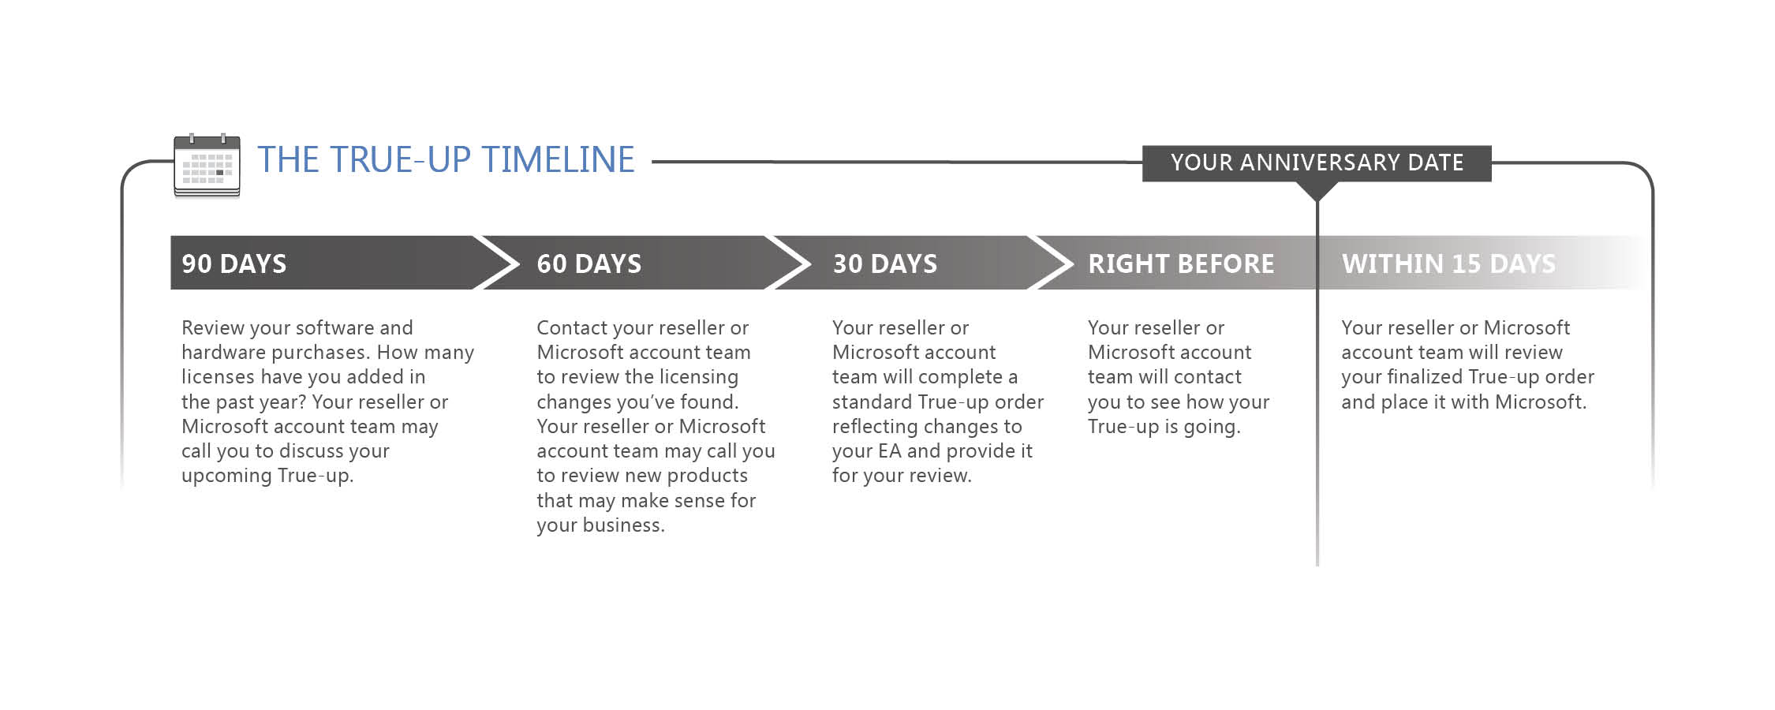

Upon True-Up completion  
Your purchase history and license summary will be updated and available for viewing via the Volume Licensing Service Center Web site at **www.microsoft.com/licensing/servicecenter**.

Need help?  
Contact your reseller or Microsoft account team. Or check the Microsoft Volume Licensing Services Web site at   
**www.microsoft.com/licensing**.

A Microsoft EA offers your organization a cost-effective way to acquire the latest Microsoft technology to help standardize your IT infrastructure and simplify license management. Because you need to place only one order   
per year, your EA can also streamline the procurement process and reduce the time spent managing your   
software licenses.

## About your Enterprise Agreement.

Your EA has a three-year term, with the option to be renewed after each cycle. As part of the EA, your company   
is required to perform an annual True-up inventory to identify the number of qualified desktops and users, servers, CPUs, computers, and other devices running Microsoft software, and take into account any licenses that may have been added during the previous 12 months. This inventory is required at the end of each of the three years of the agreement.

While you may place any number of orders throughout the calendar year, the annual True-up order must be submitted in the period between 60 days prior to and 15 days after the anniversary of the EA enrollment date.

If you have not used any additional EA products within the calendar year, you are still responsible for submitting an Update Statement (zero-usage order), which must be signed by an authorized signatory within your organization. However, if you have started using Microsoft products that are not included in your EA, you will need to talk with your reseller or Microsoft account team about placing a new order to have these products added to your EA.

Your business is changing—how does that affect your EA?

Your organization is unique, and its systems, applications, and services are tailored to meet your enterprise requirements. As a result, an enterprise has many different configurations of servers, Client Access Licenses (CALs), management servers, operating systems, and desktop computer applications that may be in use at any one time. Because of this, your system configuration may change over the course of the EA license cycle, and result in an increase in some licensed products. The True-up process provides a simple, effective way to account for any increase in licensed products and ensure your licensing is current and accurate.

These systems and services vary with each customer, so a number of licensing scenarios can apply. We suggest   
that you ask the following kinds of questions to help identify possible areas of growth and change:

* Did our computer or employee (user) base grow this year?
* Did we make any acquisitions?
* Did we increase the number of our servers? Did we cluster any servers?   
  Did we set any of them for warm or hot disaster recovery?
* Have we deployed any virtualized server or desktop environments?
* Did we roll out any desktop applications, such as Microsoft Office Project, Microsoft Office Visio,   
  Microsoft Office OneNote, or Microsoft MapPoint?
* Did we put into production any piloted products or applications?
* Are we using Microsoft Systems Management Server to provide data for the True-up?
* Do we have an effective Software Asset Management (SAM) program in place?

Multiple product categories are licensed under the EA agreement, depending on the licensing offers you have chosen, all of which need to be reconciled as part of the annual True-up:

## Methods for inventorying EA licenses.

* Enterprise Products: This is the core product set under your EA, which is licensed according to the total Qualified User or Qualified Desktop count for your organization.
* Additional Products: This list includes any product other than an Enterprise Product that you have chosen to license under your EA Enrollment. Product licensing requirements vary according to the product.
* Application Platform products: This core product set is under your Enrollment for Application Platform. Inventory timing requirements depend on your chosen True-up option.
* Core Infrastructure products: This core product set is under your Enrollment for Core Infrastructure.

It is important that the inventory address all of these categories as they apply to your organization. Because of   
the differences in how the products are licensed, an organization could have growth in the use of Additional Products, even in a year where the desktop or user count remained flat. Understanding the software assets within your organization can help you maintain control of your business and optimize your resources to match your business strategy. Accurately tracking your software inventory will provide benefits far beyond the annual   
True-up process with Microsoft. Although the complexities of managing software across an organization can be challenging, there are some consistent methods that can provide structure to inventorying your EA licenses.

Your company’s inventory approach will depend on your system setup. Here are three different methods for inventorying EA licenses:

|  |  |
| --- | --- |
| iStock_000007459290Small_RGB.jpgGet help from  a sam partner. | Consulting with a Microsoft SAM partner can help you assess your software environment and build a customized process to conduct True-ups quickly, accurately, and in a repeatable way. Microsoft SAM partners are experts in Software Asset Management processes, discovery tools, and Microsoft licensing.  A cost-effective SAM engagement gives you the data you need to complete your True-up and a  customized plan for managing software assets and future True-up reviews.  Your Microsoft account team can help connect you with a SAM partner and get you started with  a SAM engagement for your True-up. |
| iStock_000007459290Small_RGB.jpgUse automated tools and processes. | You may already use a software inventory tool to help manage your software assets, and this tool is useful during the True-up process. A SAM partner can work with your existing tools, or help you identify new ones that can help you streamline your True-up inventory.  **Microsoft Systems Management Server** is a self-monitoring system that makes it easy to compare inventory over any number of years. It can help you automate device discovery, and collect hardware  and software inventory from servers, mobile devices, and terminal-based clients to produce a standard inventory report.  Your reseller or Microsoft account team should work with you to review the results of your inventory report and adjust EA licenses as necessary. Consider both your hardware purchases and overall licensing usage throughout the True-up time frame. |
| iStock_000007459290Small_RGB.jpgTake a manual inventory. | Enlist your staff in helping you take an inventory of your environment, and to document all servers, computers (desktops, laptops, and terminals), and mobile devices that use Microsoft-licensed software.  If you are participating in a SAM engagement, your SAM partner can help you identify ways to streamline this process, depending on your unique setup and needs. |

What systems need to be inventoried?

## Get started on your True-up!

During your True-up process, the following elements should be inventoried:

* Devices, including all servers, computers (desktops, laptops, and terminals), and mobile devices that use Microsoft-licensed software. You must document the number of the devices and the service date.
* The number of qualifying, underlying operating system (OS) licenses on desktops, including the type of OS and service date.
* All Microsoft application software. The application systems listed to the right are representative of EA application components that your EA may cover and are thus possibly part of the True-up exercise. Note: This is a partial list for reference only. For the most current product list, go to www.microsoft.com/licensing/about-licensing/product-licensing.aspx#tab=2.
* The number of User CALs and Device CALs within your enterprise. User CALs provide a many-to-one relationship and allow multiple users to use   
  a single device to access software (for call center terminals and airport kiosks, for example). Device CALs provide the familiar one-to-one relationship for a device to access software. Windows Server 2003 R2 allows you to set a server to accept either of these CALs, but not both   
  at the same time, so it is very important to inventory and review this information during your True-up process.

Looking forward: Best practices.

Perform a SAM review.

Your annual True-up event is an ideal time to perform a Software Asset Management review. SAM is a set of industry best practices that can help   
you control costs, improve compliance and security, and anticipate future software needs as your company grows. Visit www.microsoft.com/sam   
for tips and tools to help you perform a software inventory. Additionally, Microsoft has hundreds of accredited SAM partners that are able to provide cost-effective True-up assistance. To learn more or find a SAM partner near you, go to www.microsoft.com/sam and click on the Partner tab.

Use this year to prepare for next year.

After you complete the True-up process, you should retain a copy of your inventory to use in the future. This copy is especially important if you are completing the process manually. We also recommend that you consider performing interim quarterly inventories of your licensed IT infrastructure   
to reduce the time it takes to perform the annual True-up exercise. An established SAM strategy can help streamline this process.

Resources and Support.

* If you need more information, please visit **www.microsoft.com/licensing**.
* For additional questions regarding Microsoft Volume Licensing Services   
  or Software Assurance benefits, please contact your reseller or Microsoft account team, or call your local Volume Licensing Service Center support number, which you can find at **www.microsoft.com/licensing/servicecenter/Help/Contact.aspx**.
* For more information on Software Asset Management, please visit   
  **www.microsoft.com/sam** to download a SAM Optimization Kit or find   
  an accredited SAM partner.

**Microsoft Servers**

* BizTalk Server Branch, Standard and Enterprise Editions
* Commerce Server Standard and Enterprise Editions
* Dynamics CRM Professional and Enterprise Servers
* Dynamics CRM Workgroup Server
* Exchange Server Standard and Enterprise
* FAST Search Server for SharePoint
* Forefront Threat Management Gateway Standard and Enterprise Editions
* Forefront Unified Access Gateway
* Groove Server
* Identity Lifecycle Manager (ILM)
* Office Communications Server Standard and Enterprise Editions
* Project Server
* Search Server
* SharePoint Server
* SharePoint Server for Internet Sites Enterprise
* SQL Server Enterprise, Small Business Edition, Standard, Workgroup and Web
* System Center Configuration Manager
* System Center Data Protection Manager
* System Center Essentials
* System Center Operations Manager
* System Center Reporting Manager
* System Center Virtual Machine Manager
* System Center Virtual Machine Manager Workgroup Edition
* Virtual Earth Server
* Virtual Server Standard and Enterprise Editions
* Visual Studio Team Foundation Server
* Visual Studio Team Lab Management
* Windows HPC Server
* Windows Server HPC Edition
* Windows Server HPC Edition without Hyper-V
* Windows Server Standard, Enterprise and Datacenter
* Windows Web Server

**Microsoft Operating Systems\***

* Windows 7 Professional
* Windows 7 Enterprise

**Microsoft Desktop Applications**

* Microsoft Office Professional Plus\*\*
* Microsoft Office Project Professional
* Microsoft Office Project Standard
* Microsoft Office Visio Professional
* Microsoft Office Visio Standard

\*Note: Windows desktop operating system upgrade licenses offered through the EA are not full licenses,   
and require a qualifying, underlying operating system license for each Qualified Desktop on which the upgrade license is deployed. True-up for Windows OS upgrade is based upon Qualified Desktop count.

\*\*True-up for Office Professional Plus is based upon Qualified Desktop count.