

Microsoft® Office Live Communications Server 2005 Feature Guide

Microsoft Corporation
Published: October, 2004

Abstract
Microsoft® Office Live Communications Server 2005 delivers instant messaging and presence as part of a scalable, enterprise-grade solution offering enhanced security, seamless integration with other Microsoft products, and an extensible, industry-standard development platform. Your organization can realize cost savings and improved business efficiencies, increased individual productivity and enhanced intellectual property protection with this easy-to-manage, highly available solution.
With Live Communications Server, your team can connect with co-workers, partners, suppliers and customers in real time, share critical and time-sensitive information and collaborate with other organizations as easily as they do today with co-workers, while taking advantage of built-in security measures to help safeguard your proprietary business information.
This version’s targeted new features facilitate real-time communication across multiple geographies, time zones and organizational boundaries, enabling you to make better decisions faster. This white paper describes the benefits of Live Communications Server and provides specific examples of organizations that have realized value from these new methods of real-time communication.

This is a preliminary document and may be changed substantially prior to final commercial release of the software described herein.
The information contained in this document represents the current view of Microsoft Corporation on the issues discussed as of the date of publication. Because Microsoft must respond to changing market conditions, it should not be interpreted to be a commitment on the part of Microsoft, and Microsoft cannot guarantee the accuracy of any information presented after the date of publication.
This document is for informational purposes only. MICROSOFT MAKES NO WARRANTIES, EXPRESS OR IMPLIED, AS TO THE INFORMATION IN THIS DOCUMENT.
Complying with all applicable copyright laws is the responsibility of the user. Without limiting the rights under copyright, no part of this document may be reproduced, stored in or introduced into a retrieval system, or transmitted in any form or by any means (electronic, mechanical, photocopying, recording, or otherwise), or for any purpose, without the express written permission of Microsoft Corporation.
Microsoft may have patents, patent applications, trademarks, copyrights, or other intellectual property rights covering subject matter in this document. Except as expressly provided in any written license agreement from Microsoft, the furnishing of this document does not give you any license to these patents, trademarks, copyrights, or other intellectual property.
© 2004. Microsoft Corporation. All rights reserved.
Microsoft, Active Directory, the Office logo, Outlook, PowerPoint, Excel, SharePoint, Window and Windows Messenger are either registered trademarks or trademarks of Microsoft Corporation in the United States and/or other countries.
The names of actual companies and products mentioned herein may be the trademarks of their respective owners.

Contents
Contents 1
Overview of Live Communications Server 2005 2
Standard and Enterprise Editions 2
Live Communications Server Feature Comparison 4
Key Benefits of Live Communications Server 2005 6
Cost Savings and Increased Productivity 6
Integration with the Microsoft Office System and Windows Server System 6
Enterprise-Grade Solution 9
Scenarios and Examples 12
Timely Info: Presence, Contacts and IM at Work 12
Instant Meetings: Reducing Travel Costs 12
Sharing Documents: Reduce Network Load 12
Support Staff: Saving Time and Money 12
Working Across Firewalls: Better Decisions, Faster 14
The Call Center: Customer Satisfaction 14
Development with Live Communications Server 15
Platform for Extensibility 15
Partner Solutions 15
System Requirements 16
Standard Edition 16
Enterprise Edition 17
Summary 18
Additional Resources 18

Overview of Live Communications Server 2005
Microsoft® Office Live Communications Server 2005 (Live Communications Server 2005) provides a powerful, scalable, enterprise-grade IM (instant messaging) and integrated presence solution. IM is the ability to transfer text messages in real time over an Internet Protocol (IP) network such as the Internet or a corporate network. Presence awareness is the ability to detect another user’s availability on one or more devices. Live Communications Server also supports peer-to-peer audio, video, application-sharing and data collaboration, instantly accelerating the workflow of today’s information workers. Live Communications Server 2005 improves business efficiencies across organizational boundaries by extending IM and other real-time communication capabilities to trusted partners, customers and suppliers.
This groundbreaking version of Live Communications Server uses a highly available, scalable architecture and improved administration tools to make it simple to deploy and manage real-time communications in an enterprise. Integrated with both the Microsoft Office System and the Windows Server System, Live Communications Server 2005 fits seamlessly into your existing work processes and infrastructure to deliver immediate benefits to your organization.

Standard and Enterprise Editions
Organizations may choose from two editions of Live Communications Server 2005, Standard or Enterprise. Each is tailored to meet specific organizational needs identified by customers. Please see Error: Reference source not found for more information on the differences between the product editions.
Live Communications Server 2005 Standard Edition consists of a single, stand-alone IM and presence server along with a local MSDE (Microsoft Data Engine) database for storing user data. A Live Communications Server 2005 Standard Edition server uses the same basic platform as a Live Communications Server 2003, but now supports up to 15,000 concurrent connections. Standard Edition is the appropriate choice in small deployments where enterprise-level capacity and performance are not required.
Live Communications Server 2005 Standard Edition assigns users to a single home server. Although a domain might contain two or more home servers, each user is assigned to only one home server. User data, such as contact lists and registration status, are stored in a SQL MSDE database on the same server.
Live Communications Server 2005 Enterprise Edition utilizes a new concept called a server pool. A server pool consists of a group of Enterprise Edition front-end servers connected to a separate, shared SQL Server database. This two-tier architecture enables Enterprise Edition to deliver substantial improvements in availability, scalability, performance and data recovery.

Live Communications Server 2005 Enterprise Edition is different from Standard Edition in the following ways:
- Availability: Enterprise Edition uses two-tier server architecture that enables users to find and connect to the next available Enterprise Edition server, even if one or more have failed.
- Scalability: In large deployments, numerous individual Standard Edition home servers may be necessary to manage users and direct traffic. Since all user data is stored in a central SQL server with Enterprise Edition, you can simply add more Enterprise Edition front-end servers to handle to increasing load and capacity.
- Two-Tier Architecture: Live Communications Server 2005 Enterprise Edition enables two new server roles: a front-end pool of Enterprise Edition servers for handling client connections and a back-end database server (using SQL Server) for storing user data.
- Data Recovery: In addition, Enterprise Edition uses SQL server to store user data. SQL can be clustered and/or backed up for improved data safety using standard SQL data recovery processes.

Table 1: Live Communications Server Feature Comparison
KEY:  = Feature Included  = Improved in LCS 2005  = New in LCS 2005 | Live Communications Server 2003 | Live Communications Server 2005 Standard Edition | Live Communications Server 2005 Enterprise Edition
Connect and Collaborate
Microsoft® Office Live Meeting integration
Share security-enhanced IM and presence between 2 or more organizations
Connectivity to MSN, AOL and Yahoo networks¹
Presence Awareness and Contacts
Presence status control (online, away, busy)
Turn off Notifications
Server-side or "roaming" contact list
Integration with Microsoft Office programs
Offline Status
150+ Contacts supported
Real-Time Collaboration Features
Instant messaging (IM)
Audio and Video
Handwriting messages (ink support)
Application and Whiteboard sharing
Desktop sharing (remote assistance)
Point to Point File transfer
Server Performance
Active User Capacity | 8-10,000 per server | Up to 15,000 per server | Over 100,000 per server pool
Scalability Planning Tools
Failover support for planned growth or unplanned downtime
Clustering Capability
Security
Archiving and logging
Advanced logging
IM Text encryption
Audio and Video encryption
Kerberos and NT LAN Manager (NTLM) authentication
Administration and Reporting
Administration through Microsoft Management Console (MMC)
Ability to Manager Live Communications Server 2003 and 2005 Servers
Support for Microsoft Operations Manager
Active Directory directory service integration
Group Policy Object Management
Administration through Microsoft Management Console (MMC)
Enable users by per-user, bulk-user and per-feature basis
Data recovery
XML-based Management Tools
Extensible Based Platform
Server application programming interface (API)
Updated Client APIs

¹ Connectivity to public IM networks (MSN, AOL, Yahoo) will be an additional cost. Pricing and licensing details will be announcement soon. See the How to Buy Live Communications Server page for more information.

Key Benefits of Live Communications Server 2005

Cost Savings and Increased Productivity
Live Communications Server provides both instant messaging and presence awareness, a critical enterprise capability allowing users to discover if others are available to collaborate, communicate and share information. With advanced presence technology, Live Communications Server offers instant access to team members, partners, suppliers and customers across multiple geographies, time zones and organizational boundaries. This means timely information can flow rapidly and efficiently, reducing costs and enabling better, faster decision-making.
When information workers can see their colleagues on instant messenger (IM), they can immediately get the answers to quick questions involving work issues. Cutting through the e-mail clutter and less invasive than a phone call, IM focuses in on the exact information needed to keep business processes moving forward.
For example, Live Communications Server enables users to display their status (away, idle, busy, etc., to other users. One can also determine who is offline or unavailable. By right-clicking on a user that is offline, users will see if a contact is available via other forms of communication such as e-mail or telephone (if the organization has taken advantage of telephony integration). The new advances in Live Communications Server 2005 allow people to communicate across firewalls with the same enterprise-grade benefits as internal-only conversations enjoyed in previous versions. Workers can also log in to their IM interface from remote locations using a simple Internet connection and their Live Communications Server-compatible instant messaging client. These specific real-time communications capabilities immediately increase the productivity of team members regardless of their physical location.

Integration with the Microsoft Office System and Windows Server System
Microsoft works to ensure that customers can extend current infrastructure investments, yet have the opportunity to incorporate new technologies into existing computing environments. Live Communications Server 2005 is part of the Windows Server System, and adheres to the common engineering criteria described in this Windows Server overview: http://www.microsoft.com/windowsserversystem/overview/commoncriteria.mspx.
Integrating presence with the Microsoft Office System is unique to Live Communications Server. Rather than forcing people to break concentration in order to get the information they need to complete their work, Live Communications Server provides in-context communication to keep your team on task and increase their productivity. Workers may instantly find and communicate with people from within familiar programs such as Microsoft Outlook, Microsoft Excel and Microsoft Word. This integration occurs wherever the user sees a ‘pawn,’ the icon representing a person’s presence status. When co-workers have accurate information about team members’ availability, they do not waste time trying to contact them through inappropriate means. This translates into increased productivity and frequently reduces costs as well.
Table 2: Microsoft Products with Presence Powered by Live Communications Server
Feature | Application
Instant Messaging | Microsoft® Windows Messenger
Collaboration | Microsoft® Office SharePoint Portal Server  Microsoft® Windows SharePoint Services  Microsoft® Office Live Meeting
Communication | Microsoft® Outlook  Microsoft Exchange Server 2003
Productivity | Microsoft® Excel  Microsoft® Word  Microsoft® PowerPoint  Microsoft® Office Visio  Microsoft® Publisher

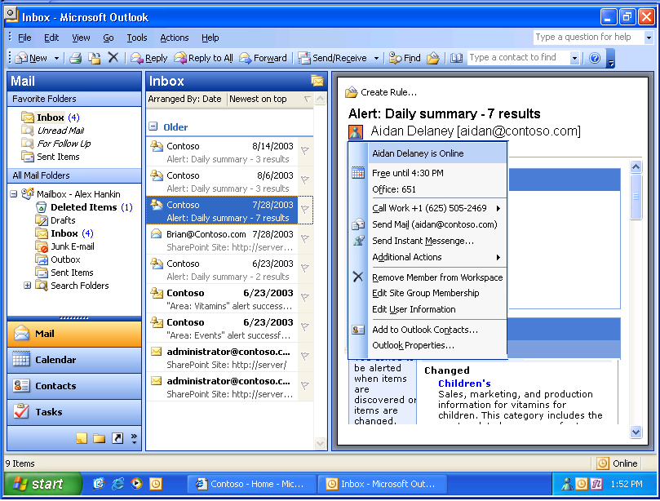
Presence icons automatically appear next to people’s names in several leading Microsoft products (See Error: Reference source not found). This kind of information makes it clear when and where you can reach your colleagues at a moment’s notice.
Figure 1: Presence within Microsoft® Office Outlook

Customers will find presence awareness already built into Microsoft® Outlook 2003, a leading communication tool in today’s business world. Connecting with colleagues is as easy as hovering over a presence icon, so people can instantly see if someone is online or busy. This information is available for everyone connected to not just those listed in a contact list.
The advent of intranet and extranet portals allows people to share documents, calendars, contact lists and more without the problems of asynchronous collaboration. Rather than sending a document to several individuals, it is much faster and more efficient to publish it once, referring colleagues to a Web site. There, several people can work or provide comments on the same document; eliminating multiple outdated versions and cluttered e-mail strings.
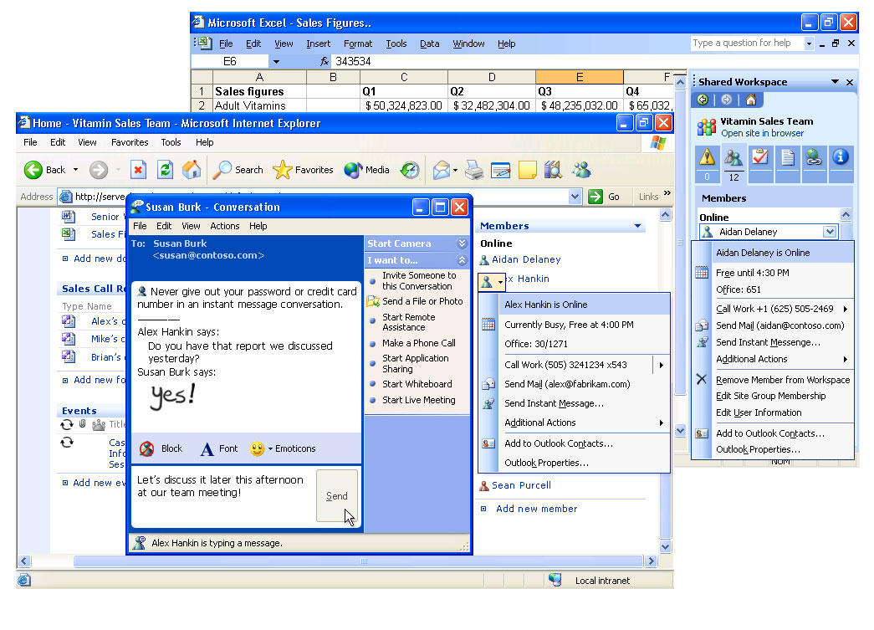
To support these scenarios, SharePoint offers presence awareness throughout its interface. Presence icons show up in lists and XML-based Web parts. Meeting Workspaces (created on SharePoint team sites with the click of a button from Microsoft Outlook) provide dynamic presence icons next to each team member’s name. Member Lists, with presence icons for each person who is a member of that SharePoint site, are also conveniently visible to the users.
Figure 2: Presence in Microsoft® SharePoint and Microsoft® Office Excel
Workers can instantly see who is online and available to discuss documents or upcoming meetings, regardless of time zone or location. With Microsoft® Exchange integration, the user can even check a person’s schedule and get up-to-date availability information directly from their calendar. This makes it easy to determine when someone will be free to communicate.

Presence is integrated into other Microsoft Office System programs through Document Workspaces and Smart Tags. Smart Tags are XML-based tools that recognize certain names, phrases or numbers in Microsoft Word and Excel. The item appears with a subtle dotted red underline, letting the user know there is a range of actions that can be taken instantly with a click of the mouse. Examples include sending an e-mail, checking someone’s schedule, initiating an instant message or finding out someone’s job title. Adding presence information to these programs with Live Communications Server allows the user to communicate with relevant people directly within a familiar interface.

Enterprise-Grade Solution
IT managers appreciate the numerous Live Communications Server 2005 improvements in administration, security, scalability and reliability. It fits smoothly into an existing Microsoft infrastructure as part of the Windows Server System and the Microsoft Office System. By directly lowering the costs of managing a real-time communications infrastructure, Live Communications Server makes it easier to deliver cutting-edge communication services to all end-users.

Architecture and Scalability
Live Communications Server 2005 Standard Edition consists of a single, stand-alone IM and presence server along with a local MSDE (Microsoft Data Engine) database for storing user data.
- All user data stored on single “home server”
- User data stored locally in SQL MSDE database
- Supports approx 15,000 active users per server
- Requires Windows 2003 for server installation
- Requires Active Directory running Windows 2000 SP3 or Windows 2003
- Offers remote user access and federation features
The Live Communications Server 2005 Standard Edition provides 50% more capacity than the 2003 version, supporting up to 15,000 concurrent active users. For those enterprises with tens of thousands of employees, or those wishing to take advantage of a clustered architecture, Live Communications Server 2005’s Enterprise Edition is appropriate.
Live Communications Server 2005 Enterprise Edition consists of a pool of servers connected to a separate, shared SQL Server database. This two-tier architecture enables Enterprise Edition to deliver substantial improvements in availability, scalability, performance and data recovery.
- All user data stored on SQL 2000 back-end server. Can utilize new or existing SQL server database
- Front-end/back-end server architecture offering fail-over support
- Supports over 100,000 active users per “server pool”
- Requires Windows 2003 for server installation
- Requires Active Directory running Windows 2000 SP3 or Windows 2003
- Requires SQL Server 2000 SP3 for back-end database
- Offers remote user access and federation features

Security and Privacy
Live Communications Server 2005 is specifically designed to help address business requirements for heightened security in today’s computing environments. In accordance with the Microsoft company-wide Trustworthy Computing initiative, Live Communications Server 2005 provides many new features and enhancements to improve reliability, manageability, and security.
A key benefit for IT managers using Live Communications Server 2005 is the control of sensitive corporate information. When end-users have public IM clients at work, conversations are exposed rather than encrypted. These public IM services do not provide logging or archiving capabilities, making it impossible to comply with any applicable regulations such as the Sarbanes-Oxley Act (financial services) and the Health Insurance Portability and Accountability Act (HIPAA).

Manageability
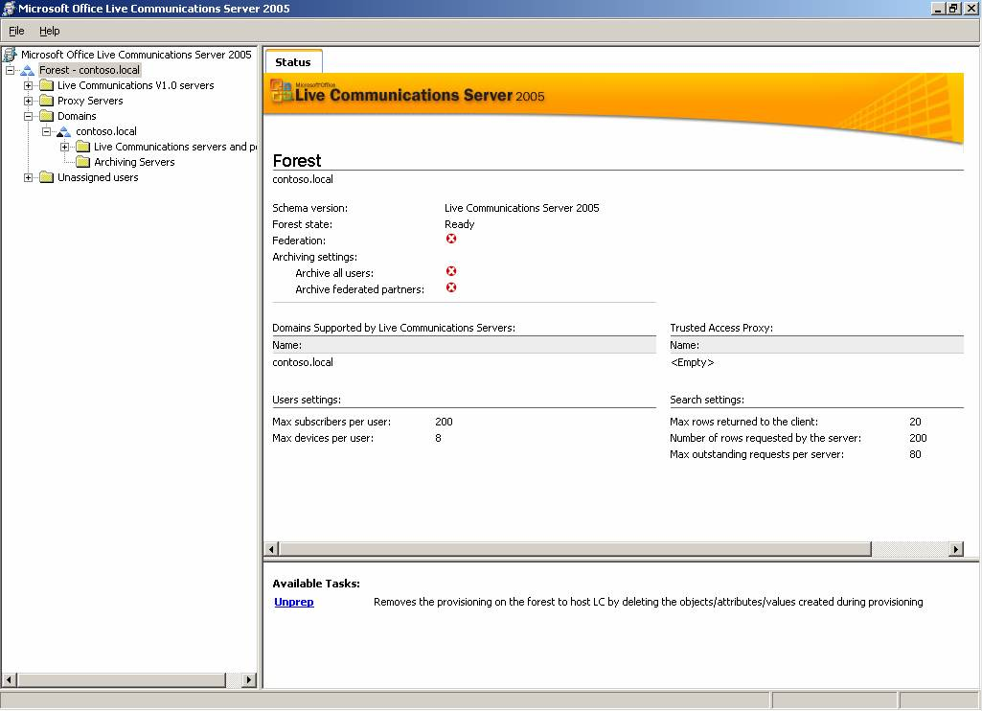
With the new management tools built into Live Communications Server 2005, IT managers can get more of the info they need about their server environment at a glance. They save time and reduce training costs by using familiar Windows GUI-based administration tools, including Windows Management Interface (WMI), Microsoft Management Console (MMC) and Microsoft Operations Manager (MOM) to manage users, servers and global settings, plus monitor the entire real-time collaboration system. (See Error: Reference source not found).
Figure 3: Live Communications Server 2005 Advanced Management Tools

There are also robust new planning and deployment tools to simplify common setup tasks.
Live Communications Server works seamlessly with existing Microsoft infrastructure elements such as Windows Active Directory® and Windows Server 2003. This makes it easy for the IT manager to consolidate network, server and IM user resources, giving them more security and control over the network.

Location-Independent Access
With Live Communications Server 2005, the IT manager can offer seamless access to remote and home workers without the need for Virtual Private Networking (VPN). When someone wants to send a quick IM, requiring them to log on to a VPN is often time-prohibitive.
Simplified, extended user access is also at the heart of the new ‘federation’ feature, whereby different organizations can communicate with each other through IM across firewalls. The IT manager provides lists of approved users to another region, network forest or company, and communication may ensue. This is especially useful for acquisitions or companies with more than one geographic center.
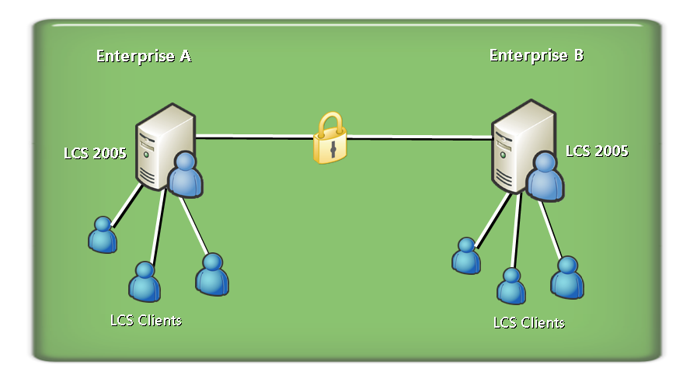Figure 3: Federation with Live Communications Server

Scenarios and Examples

Timely Info: Presence, Contacts and IM at Work
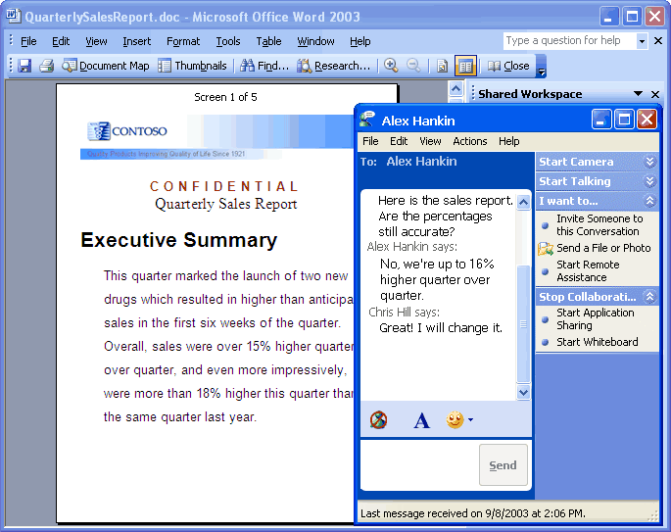
Live Communications Server 2003 makes it possible for collaboration and communication to be part of every application. Presence information from the server can be integrated into productivity applications and enterprise LOB applications. When users are working in a document and have questions, they can initiate an IM session with a team member, use Windows Messenger to share the file, and make changes to the file immediately.

Instant Meetings: Reducing Travel Costs
When IM does not provide enough collaborative discussion, users can immediately initiate an audio conversation, using a regular computer microphone and speakers or a headset device. Users can also make PC-to-phone and phone-to-PC audio calls through the standard public switched telephone network (PSTN) with an appropriate gateway deployment. Video conferencing adds another dimension to audio. In a video conference, users can see and hear each other in real time.
Figure 4: Instantly Connecting with Work Contacts

Sharing Documents: Reduce Network Load
With file transfer, users can transfer files as part of an IM conversation, reducing e-mail storage capacity as users share files in a targeted fashion, without using e-mail.
With the whiteboard feature, users can write as they might in a conference room on a traditional whiteboard. Additionally, users can paste content from other applications into the whiteboard if they want to share information without allowing other users to see their desktop.

Support Staff: Saving Time and Money
Moving help desk response from e-mail and/or phone to IM means faster resolution of issues and lower telephone charges. The remote assistance capabilities of Live Communications Server and Microsoft® Windows Messenger allow help desk personnel to provide instant help to users, no matter where they are located. The technician can either view or take complete control of the machine, enabling them to better diagnose issues and fix them quickly (See Error: Reference source not found).
By using Live Communications Server as a real-time communications platform, user lists are fully authenticated through Active Directory, so staff can feel comfortable using this capability.
This scenario can save hours of time for IT personnel on a weekly basis, translating into thousands of dollars in cost reductions. When common user issues can be dealt with remotely, as they occur, technical staff can work equally well on-site or remotely. Users will not be stuck waiting for someone to help them, as this type of assistance is easily provided on an ad-hoc basis.
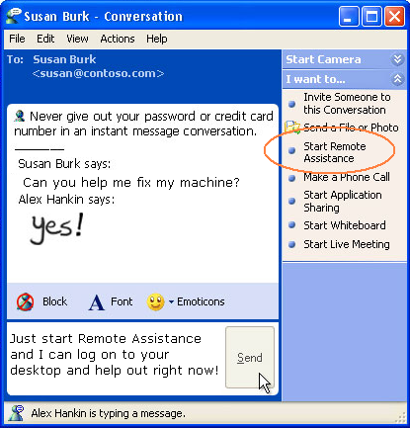
Figure 6: Remote Desktop Assistance with Live Communications Server

Working Across Firewalls: Better Decisions, Faster
With the new federation feature, different organizations can share authenticated, encrypted instant messaging and presence information between teams. This enables collaboration to take place between suppliers, customers, partners, and different divisions of the same organization. Often companies will have separate networks for new acquisitions, geographically dispersed groups or different business units. With federation, all these teams can instantly be connected.

The Call Center: Customer Satisfaction
When call center employees communicate with customers, they often need to discuss matters with a supervisor. With instant messaging, the worker can identify what supervisor is available to approve a special request or speak directly to a customer.
In the past, call center employees would have had to put the customer on hold while physically searching for an available supervisor, sometimes even having to call the customer back after e-mailing or phoning a co-worker. This typically would take several hours to days to resolve customer issues. Now, these requests can be completed within minutes, increasing customer satisfaction and saving precious minutes of call center employees’ time.

Development with Live Communications Server

Platform for Extensibility
The architecture of Live Communications Server uses the industry-standard protocols Session Initiation Protocol (SIP) and SIP for Instant Messaging and Presence Leveraging Extensions (SIMPLE), and includes a rich set of application programming interfaces (APIs). Microsoft supports these standards because of their broad potential in future communications, a potential that goes far beyond instant messaging. Corporate telephony systems such as PBX and PSTN, videoconferencing, interactive voice responses, voice over Internet Protocol (VoIP) and other solutions can all integrate with Live Communications Server using these protocols.
Live Communications server offers both client and server Software Development Kits SDKs to encourage innovative uses of real-time communication information. There is a library of information online at the Microsoft Office Developer Center: http://msdn.microsoft.com/office/understanding/livecomm/default.aspx.

Partner Solutions
The Microsoft real-time communications partner ecosystem is particularly rich because the presence information provided by Live Communications Server is so valuable. Partner solutions for Live Communications Server fall into three main categories: platform extensions, vertical solutions and complementary services. Several key scenarios are described in Table 3, below. This is not a complete list of partner solutions for Live Communications Server 2005; rather it is a high-level representation of the most commonly offered products and services. Refer to the Live Communications Server Partner Directory for more information: http://directory.partners.extranet.microsoft.com/advsearchresults.aspx?productscsv=25
Table 3: Partner Solutions for Live Communications Server
Scenario | Solution
Collaboration | Integrated Conferencing  Multi-Party Voice/Video/Data  Persistent Chat
Client Access | Web Browser Client  SMS Gateway  Mobile Clients
Security | Anti-Virus and Content Checking  Compliance and Logging  Session Border Control
Business Process | Alerts
Systems Management | Load Balancing  Backup/Restore  Clusters and SANs

System Requirements
When designing new product releases, Microsoft balances new features and functionality with providing customers the highest possible level of interoperability and/or coexistence with previous product versions.

Standard Edition
To use Microsoft® Office Live Communications Server 2005 Standard Edition, you need:
- PC with a Pentium III compatible 550 MHz or higher processor, Dual Pentium 4-compatible 3.0 GHz recommended
- Microsoft Windows Server 2003 Standard, Enterprise or Datacenter Editions
- 256 MB of RAM or above, 2 GB of RAM recommended
- Dual 36 GB Ultra2 SCSI hard drives recommended
- Super VGA (800x600) resolution monitor, (1024X768) resolution is recommended
- Internet connection is required for viewing online help and documentation
Additional items or services required to use certain features:
- Microsoft Office Live Communications Server requires Microsoft Windows Active Directory 2000 SP3 or 2003.
- Microsoft® SharePoint® Portal Server or Windows SharePoint® Services for presence integration with portals and team sites.
Archiving Service and Database Requirements
- Installation of the User Services component of the Standard Edition Live Communications Server 2005 will result in the installation of a dedicated Microsoft SQL™ Desktop Engine 2000 Service Pack 3a database instance.
- The Archiving Service requires a separate server with Microsoft SQL Server™ 2000 Standard or Enterprise Edition with service pack 3a.
Network Requirements
- For some features to work properly, Live Communications Server 2005 servers must be a member of a Microsoft Windows 2000 or Windows Server™ 2003 domain. A 100-megabits per second (Mbps) network interface card (NIC) is recommended.
Client Software Requirements
- The recommended client for accessing a Live Communications Server 2005 is Windows® Messenger 5.1 running on Microsoft Windows® XP or Windows 2000.
For more detailed server and client requirements, please visit www.microsoft.com/office/livecomm.

Enterprise Edition
To use Microsoft® Office Live Communications Server 2005 Enterprise Edition, you need:
- PC with a Pentium III compatible 550 MHz or higher processor, Dual Pentium 4-compatible 3.0 GHz recommended
- Microsoft Windows Server 2003 Standard, Enterprise or Datacenter Editions
- 256 MB of RAM or above, 2 GB of RAM recommended
- 36 GB Ultra2 SCSI hard drives is recommended
- Super VGA (800x600) resolution monitor, (1024X768) resolution is recommended
- Internet connection is required for viewing online help and documentation
Additional items or services required to use certain features:
- Microsoft Office Live Communications Server requires Microsoft Windows Active Directory 2000 SP3 or 2003
- SharePoint® Portal Server or Windows SharePoint® Services for presence integration with portals and team sites
Database Requirements
- Installation of Live Communications Server 2005 Enterprise Edition Database will require Microsoft SQL Server 2000 Standard or Enterprise Edition with Service Pack 3a or higher. The SQL database should be installed on a separate machine:
- PC with a Pentium 4 compatible 3.0 GHz or higher processor
- Microsoft Windows Server 2003 Standard, Enterprise or Datacenter Editions
- 4 GB of RAM or above, 8 GB of RAM recommended
- Dual 36 GB Ultra2 SCSI hard drives recommended
For more detailed server requirements, see www.microsoft.com/sql/techinfo/planning.
Network Requirements
- For some features to work properly, Live Communications Server 2005 servers must be a member of a Microsoft Windows 2000 or Windows Server™ 2003 domain. A 100 megabits per second (Mbps) network interface card (NIC) is recommended.
Client Software Requirements
- The recommended client for accessing a Live Communications Server 2005 is Windows® Messenger 5.1 running on Microsoft Windows® XP or Windows 2000.
- For more detailed client requirements, see www.microsoft.com/office/livecomm.

Summary
Microsoft® Office Live Communications Server 2005 provides cost savings, improved business efficiencies and increased productivity in an enterprise-grade server. With standard protocols, advanced deployment and management tools, a strong partner ecosystem and innovative client features, Live Communications Server is the clear choice for today’s organizations.

Additional Resources
For more information, visit
- Microsoft® Office Live Communications Server: http://www.microsoft.com/office/livecomm
- Microsoft® Office Live Communications Server Deployment and Technical Resources http://office.microsoft.com/en-us/FX011450741033.aspx
- Microsoft® Windows SharePoint Services and
Microsoft® Office SharePoint Portal Server: http://www.microsoft.com/sharepoint
- Microsoft® Windows Messenger: http://www.microsoft.com/office/livecomm
- Microsoft® Windows Server: http://www.microsoft.com/windowsserversystem
- Microsoft® Office System: http://www.microsoft.com/office/system

For detailed system requirements and help planning, deploying and maintaining your Live Communications Server environment, please visit the Live Communications Server Deployment Resources Center. From http://www.microsoft.com/office/livecomm, choose the “Deployment Resources” link to download the specific product documentation that aligns with your deployment phase.

