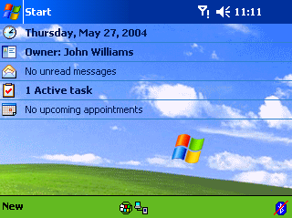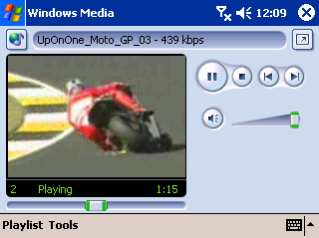

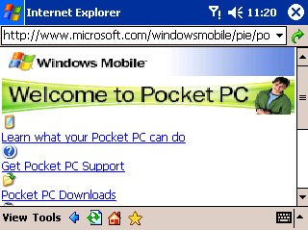

For more information, contact:
Josh Kerwin
Waggener Edstrom
(425) 638-7000
joshk@wagged.com

Erica Garver
Waggener Edstrom
(503) 443-7000
ericag@wagged.com

Rapid Response Team
Waggener Edstrom
(503) 443-7070
rrt@wagged.com

Windows Mobile™ 2003
Second Edition
Software for Pocket PCs

Reviewers Guide
August 2004

This is a preliminary document and may be changed substantially before final commercial release of the software described herein.
The information contained in this document represents the current view of Microsoft Corp. on the issues discussed as of the date of publication. Because Microsoft must respond to changing market conditions, it should not be interpreted to be a commitment on the part of Microsoft, and Microsoft cannot guarantee the accuracy of any information presented after the date of publication.

This reviewers guide is for informational purposes only. MICROSOFT MAKES NO WARRANTIES, EXPRESS OR IMPLIED, AS TO THE INFORMATION IN THIS DOCUMENT.

Complying with all applicable copyright laws is the responsibility of the user. Without limiting the rights under copyright, no part of this document may be reproduced, stored in or introduced into a retrieval system, or transmitted in any form or by any means (electronic, mechanical, photocopying, recording or otherwise), or for any purpose, without the express written permission of Microsoft Corp.

Microsoft may have patents, patent applications, trademarks, copyrights or other intellectual property rights covering subject matter in this document. Except as expressly provided in any written license agreement from Microsoft, the furnishing of this document does not give you any license to these patents, trademarks, copyrights or other intellectual property.

The example companies, organizations, products, people and events depicted herein are fictitious. No association with any real company, organization, product, person or event is intended or should be inferred.

 2004 Microsoft Corp. All rights reserved.

Microsoft and Windows Mobile are either registered trademarks or trademarks of Microsoft Corp. in the United States and/or other countries.

Bluetooth is a trademark owned by the Bluetooth SIG Inc. and any use of such marks by Microsoft Corp. is under license.

The names of actual companies and products mentioned herein may be the trademarks of their respective owners.

CONTENTS

Highlights of Windows Mobile 2003 Second Edition Software for Pocket PCs…………….Page 1
Changing the View Mode……………………………………………………………………………..Page 2
Using One-Column Browsing………………………………………………………………………..Page 3
Using Shorthand with Transcriber………………………………………………………………….Page 4
Changing Font Size……………………………………………………………………………………Page 6
Uning Wi-Fi Protected Access………………………………………………………………………Page 7

Overview

HIGHLIGHTS OF WINDOWS MOBILE 2003 SECOND EDITION SOFTWARE FOR POCKET PCS
This guide’s purpose is to walk you through Microsoft® Windows Mobile™ 2003 Second Edition software and explain the new end-user features. This guide complements the full Windows Mobile 2003 Reviewers Guide and should be viewed with the original guide when looking for a comprehensive account of Windows Mobile features.

What Is Windows Mobile 2003 Second Edition Software?
Windows Mobile 2003 Second Edition software is a new release of Windows Mobile 2003 software for Pocket PCs and Smartphones that extends the Windows Mobile platform to enable exciting hardware innovation. The Second Edition naming marks it as an extension of the Windows Mobile 2003 platform, not an entirely new software version. Although there are several new features that end users will be able to take advantage of, the primary focus for this release has been to enable partner innovation.

What This Release Means for Future Devices: Innovation
One of the most exciting enhancements that Second Edition offers is support for a variety of new screen sizes, shapes, orientations and resolutions. Future Pocket PCs will be able to take advantage of dynamic switching from portrait to landscape mode, allowing users to operate their devices in an entirely new fashion.

Second Edition software also will support higher-resolution screens. Original equipment manufacturers (OEMs) can take advantage of the software’s native support for VGA output for Pocket PCs and QVGA output for Smartphones to build devices with high-resolution screens, which will offer clearer text, sharper images and the ability to view more content on the same size screen.

In addition to landscape support, Windows Mobile 2003 Second Edition supports square-screen formatting. This will enable entirely new form factors for Windows Mobile-based devices and may work particularly well for future messaging-centric devices. Pocket PC OEMs now can build devices that take advantage of the following screen resolutions: 240x240, 240x320, 320x240, 480x480, 480x640 and 640x480.

What’s New for Users
Although enabling OEMs to build innovative devices is the focus of the Second Edition update, users will see several new features in new devices running the software. These features include the ability to change the screen view from portrait to landscape mode, support for Wi-Fi Protected Access for increased wireless security, one-column browsing in Microsoft Internet Explorer, new transcriber shorthand capabilities, and the ability to personalize font sizes.

The step-by-step walk-through on the following pages offers more information and screen shots that detail enhancements in Windows Mobile 2003 Second Edition.

Pocket PCs running Windows Mobile 2003 Second Edition software can now switch between standard portrait viewing mode and landscape mode. Landscape mode provides a different way to use programs and a wider viewing area for activities such as entering data and viewing Web pages. Standard Windows Mobile applications automatically accommodate the new landscape setting.

CHANGING THE VIEWING MODE

To change from standard portrait mode to landscape mode:
- From the home page, tap once on the Start icon, and then tap on the Settings icon. Click on the System tab at the bottom of the page. Now locate and tap on the icon titled Screen. Your screen should look like the one below.

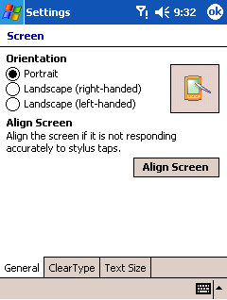

- Now tap in the circle that reads Landscape under the Orientation section. You can choose either left-handed or right-handed modes. After making your selection, tap on the OK icon in the upper-right corner.

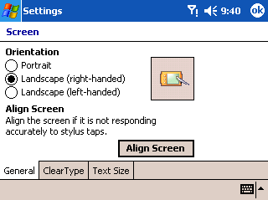

Pocket PCs now have enhanced Web-browsing capabilities with Windows Mobile 2003 Second Edition software. One-column browsing reduces the amount of horizontal scrolling necessary to view content on a Web page.

USING ONE-COLUMN BROWSING

To change to one-column browsing:
- Tap on Start in the upper-left corner of the home page, and then tap on the Internet Explorer icon. Now tap on the View tab in the bottom left, and tap on the Layout option. You are presented with three options: Desktop, Default and One Column.

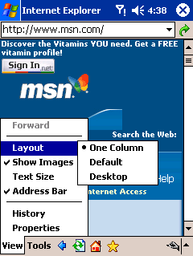

- Tapping on the One Column selection will automatically change how the browser renders the page, providing you with a single scroll bar on the side. Below is an example showing the default browser setting on the left and one-column browsing on the right.

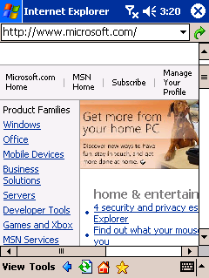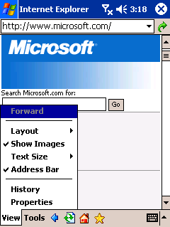

Windows Mobile 2003 Second Edition software for Pocket PCs now supports a new transcriber feature called shorthand that allows you to quickly insert preselected phrases, dates and more with the entry of short abbreviations or symbols. These same abbreviations also can be used to automatically launch programs by using the Run Program function.

USING SHORTHAND WITH TRANSCRIBER

Example: You could set “calc” as a shorthand term that, when written, would insert the phrase “Calculators are great!” or would immediately launch the calculator application.

To program a shorthand feature:
- Access a program such as Microsoft Word or Notes. In the bottom-right corner, tap on the triangle and select Transcriber. With transcriber selected, click on the triangle again and select Options. This brings you to the Input menu. Click on the Options box, and then on the Advanced tab at the bottom of the Transcriber Options page.

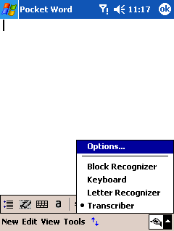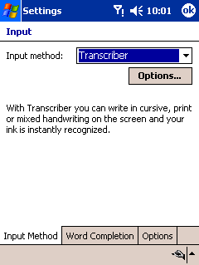

- Now tap on the Settings box in the shorthand selection area.

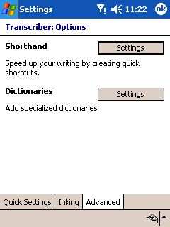

- Choose what type of shorthand you’d like to create (Text Expansion, Function or Run Program), and then tap on Next. In the shorthand text box, type in the abbreviation or symbol you want to use to represent the action or phrase. The second box allows you to enter the text that you want to appear when you write your abbreviation. After you have entered your shorthand and chosen a result, tap on the Finish button. To exit the settings menu, tap on the OK button until you are back to your document.

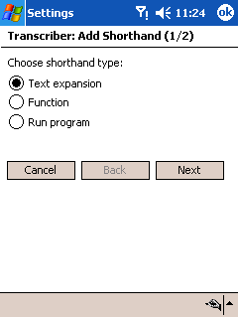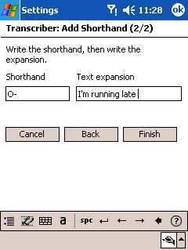

Pocket PCs running Windows Mobile 2003 Second Edition software enable you to change the font size of the text on your device. You can increase font size for easier readability or decrease font size to view more content on the screen.

CHANGING FONT
SIZE

To change the font size:
- From the home screen of your Pocket PC, tap on Start, and then on Settings. Select the System tab at the bottom, and then tap on the Screen icon. Of the bottom three tabs, tap on the Text Size tab.

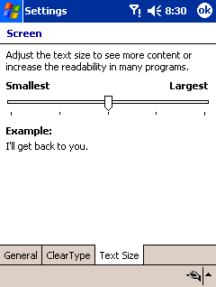

- From here you can find the font size that best suits you by moving the slider from Smallest to Largest. Click on OK after choosing the size you would like to use. The home screens below display the smallest and largest font settings.

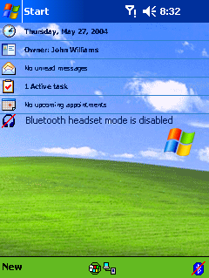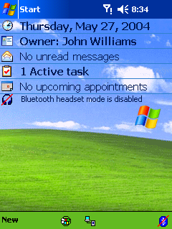
Wi-Fi Protected Access (WPA) is a security enhancement that increases the level of encryption and authentication for Wi-Fi wireless LAN systems. Pocket PCs running Windows Mobile 2003 Second Edition software enable you to connect to wireless LAN networks using WPA.

USING WI-FI PROTECTED ACCESS

For full details on connecting to a wireless LAN with your Pocket PC, please see the full Windows Mobile 2003 software reviewers guide.

To access the WPA feature:
- Tap on the Start icon on the home page, tap on Settings, and then select the Connections tab at the bottom of the screen. Now tap on the Network Cards icon. If your device has integrated Wi-Fi or you’ve added a Wi-Fi card and it is turned on, you will see the available networks here.

(Note: Your network icon name and method of configuring your wireless network may vary depending on the brand of device you are using. Consult the device manual as needed.)

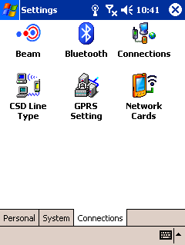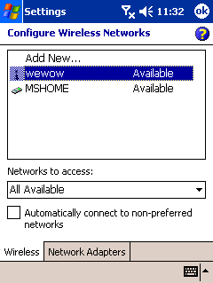

- Select the network that you want to connect to by tapping on its name. This brings up configuration settings for your network. Tap the Network Key tab at the bottom. Now under the Authentication pull-down menu, you can select WPA. You can now select Temporal Key Integrity Protocol (TKIP) under the data encryption pull-down menu should your network use this instead of Wired Equivalent Privacy (WEP).

