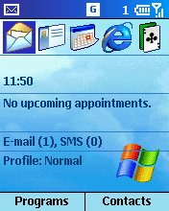
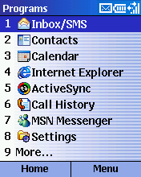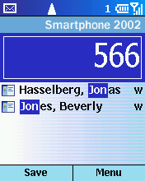

Windows MobileTM Software for Smartphones
Reviewers Guide

For more information, press only:

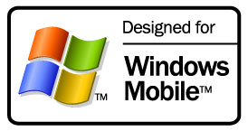
Brandi Cook
Waggener Edstrom
(503) 443-7000
brandic@wagged.com

Danielle Carter
Waggener Edstrom
(503) 443-7000
jacksonj@wagged.com

Rapid Response Team
Waggener Edstrom
(503) 443-7070
rrt@wagged.com

The information contained in this document represents the current view of Microsoft Corp. on the issues discussed as of the date of publication. Because Microsoft must respond to changing market conditions, it should not be interpreted to be a commitment on the part of Microsoft, and Microsoft cannot guarantee the accuracy of any information presented after the date of publication.
This document is for informational purposes only. MICROSOFT MAKES NO WARRANTIES, EXPRESS OR IMPLIED, IN THIS DOCUMENT.
© 2003 Microsoft Corp. All rights reserved.
Microsoft, Windows Mobile, the Windows logo, the Microsoft Internet Explorer logo, Windows Media, Outlook, Windows, MSN, the MSN logo, Windows NT, ActiveSync, Xbox and JScript are either registered trademarks or trademarks of Microsoft Corp. in the United States and/or other countries.
The names of actual companies and products mentioned herein may be the trademarks of their respective owners.
Contents
Introducing Windows Mobile Software for Smartphones 1
Easily access information 1
More than just talk 1
Personal and fun 2
Windows Mobile Software for Smartphones: Standard Features 3
Evaluation Requirements and Recommendations 4
Desktop Platform System Requirements 4
Additional Configuration Notes 4
Hardware Overview 5
Connection Manager 5
Configuring Windows Mobile-Based Smartphone for GSM/GPRS Networks 7
Configuring Windows Mobile software for dial-up access to a corporate network connection 9
Configuring Windows Mobile software for a VPN connection into a corporate network connection 9
Configuring Windows Mobile software for a proxy server 9
Synchronization of e-mail and personal data 10
Configuring Windows Mobile software for server synchronization 11
Configuring Windows Mobile software for server POP3/IMAP4 e-mail 12
A Full-Featured Telephone 13
Making a call 13
Receiving a call 14
Personalization Options 14
Integrated Applications 16
Inbox for E-Mail and SMS Messages 16
Accessing and composing e-mail 16
Managing Contacts 17
Calendar 18
Internet Browsing With Pocket Internet Explorer 19
MSN Messenger 20
Windows Media Player 21
Other Features 21
Voice Notes 21
Conclusion 22

Introducing Windows Mobile Software for Smartphones
This guide introduces Microsoft® Windows MobileTM software for Smartphones, which opens a new chapter in mobile phone technology by combining the best of mobile voice and data communications with the best of personal information management software. This brief tour will highlight many of Windows Mobile software for Smartphone’s features while familiarizing users with its controls and interface.
When Microsoft Corp. entered the mobile devices industry, it was with the belief that people wanted to be able do more on a mobile device. Microsoft applied this philosophy as it built Windows Mobile software, first for the Pocket PC and then for Smartphone.
Windows Mobile introduces an entirely new mobile phone experience through the integration of smart software and small, stylish handsets. Windows Mobile allows users to do the following:

Easily access information
Wireless connectivity is becoming more widely available, and no single device can ever meet the needs of all users. Everyone faces a different set of priorities and scenarios every day. Business and personal users communicate remotely through different combinations of voice, e-mail, instant messaging, short message service (SMS), online forums and even video. And when they leave their home or office, they might carry several devices to stay connected to people and information they count on.
As technologies have evolved, manufacturers are striving to make wireless devices more useful, convenient and, inevitably, smaller. With Windows Mobile software for Smartphone, Microsoft, OEMs and mobile operators have created a small, sleek device for people who depend on staying connected to information and each other while mobile. It just might be the perfect combination of beauty and brains.
Windows Mobile software for Smartphone also provides an open platform upon which independent software vendors can develop a variety of consumer and enterprise-oriented applications. The localization features of Windows Mobile software Smartphone that support many languages make this a compelling device for mobile operators and developers alike.
Note: Cellular voice and data plan required for Internet and phone access. Some features may vary due to carrier. See device manufacturer and mobile operator for details.

More than just talk
Windows Mobile-based Smartphone is a full-featured mobile phone first — in function, form and performance. With Windows Mobile software, customers can easily synchronize all their important phone numbers from Outlook® with their device, which saves time and makes dialing instant and easy. Advanced calling features such as three-way calling and speaker phone are easy to find and use with the Windows Mobile software for Smartphone interface.
What really sets Windows Mobile-based Smartphones apart are its one-handed access to the most popular personal digital assistant (PDA) functions, e-mail and text messaging, Web capabilities, and robust connectivity options, all in a handset comparable in size to today’s mainstream cellular phones.
Windows Mobile software for Smartphones provides familiar versions of software on the device, which can be easily integrated with users’ desktop PCs, so they can access information while away from home or office. Users can synchronize their e-mail, Calendar and Contacts over the air continually, without ever having to physically connect the phone to a desktop PC. No manual synchronization is necessary (unless they choose to sync a Windows Mobile-based Smartphone directly to their desktop PC). When people look at their Windows Mobile-based Smartphone, they see current data.
As a result, Windows Mobile-based Smartphone users can stay in touch with people and information, keep on top of all their messages, and be reminded of appointments throughout the day.

Personal and fun
Windows Mobile software for Smartphones delivers a rich set of applications, highly integrated telephony functionality and an open development platform. Mobile professionals will appreciate how much they can do with this one device. During the course of a conversation, the user can place a call, schedule a meeting and record it in the Calendar, as well as browse for new messages. Windows Mobile-based Smartphone’s integrated applications allow people to work efficiently while they’re away from their desktop PC, making it a truly personal and powerful mobile phone for both work and personal life.
Information technology (IT) administrators will appreciate Windows Mobile software’s compatibility with a variety of connectivity options, Web and security protocols, and configurations for synchronizing data, which allows them to extend enterprise resources to their mobile work force with little or no user involvement.
Included with Windows Mobile software are all the multimedia features today’s consumers expect, including instant messaging, the ability to send and receive photos, and Windows Media® Player, which lets users listen to music and view videos. Windows Mobile software is also a great platform for games. The Secure Digital/Multimedia Card expansion slot provides storage space for users to further customize their phone with games, hours of music, pictures or video.
Above all, Windows Mobile software is simple to use. Windows Mobile-based Smartphone is a mobile phone for the masses that allows users to shop over the Internet, play games, listen to music and organize their lives.

Windows Mobile Software for Smartphones: Standard Features
Feature | Description
Mobile Phone
Handset | Windows Mobile-based Smartphone is a small and lightweight mobile phone, featuring easy, one-handed dialing and navigation.
High-resolution color | The color screen allows users to view e-mail, browse Web sites and see images easily.
Phone options | Conference calling, speed dial and speakerphone are all available with Windows Mobile software.
Profiles | Profiles allow users to adjust the ring volume and other phone settings in one step to accommodate external environments such as noisy work areas, meetings and airplanes.
Smartdial | As a user dials a phone number or begins to type in a contact name, the Smartdial feature displays possible matches from Contacts, SIM and Call History for fast dialing.
Call History | Every call (including missed calls) is automatically logged with the other party’s name and phone number, as well as the date, time and length of the call.
Device security | Device lock and subscriber identity module (SIM) lock can be used to help protect a Windows Mobile-based device from unauthorized use or tampering.
Conference Call | Windows Mobile software allows users to establish a conference call with multiple parties at once.
Security | Users can help protect their data by using the PIN feature to lock the keypad; the SIM card also can be locked to block any incoming or outgoing communication on Windows Mobile software for Smartphone.
Personalization
Home screen | The customizable home screen provides quick access to personal and relevant information such as network information, new-message alerts and meeting reminders, as well a taskbar for easy access to Windows Mobile software applications.
Ring tones | Users can download their favorite ring tones from mobile operators or third parties. Users also can use some of the many unique ring tones preloaded on the phone.
Familiar Interface
User-friendly interface | Windows Mobile software has an intuitive, familiar-looking interface that is simple to operate; it behaves exactly the way most users would expect it to.
Synchronization with desktop Outlook | Continual synchronization wirelessly or through the Outlook messaging and collaboration client on PCs keeps the information on Windows Mobile-based Smartphone consistent and up to date with a user’s PC.
Consistent accounts and passwords | Users can incorporate the same profiles and user accounts they’ve set up on their PC, such as those for Exchange, Passport, MSN® Messenger Service and Contacts.
Text Messaging
Instant messaging | Windows Mobile software has built-in support for MSN Messenger instant messaging.
Voice response | Users can record voice messages, which are sent as e-mail attachments, as an efficient alternative to keying in text messages.
T9 text input | Windows Mobile software includes T9 predictive text input to simplify and speed up messaging.
Pocket Outlook
Unified Inbox | The Inbox stores e-mail, SMS messages, meeting requests and voice-mail notifications in one central place. It can be configured to receive e-mail over the air from multiple sources, including Exchange Server, IMAP or POP3/SMTP e-mail services.
Calling from the contact list | Users can initiate a call or message directly from the contact list, depending on the user-defined default communication method for that contact.
Hot-linked contact information | Not only are all of the fields available on a desktop viewable on Windows Mobile software, but a user also can select any of the contact information within each record to immediately send a message with any available communication method (such as SMS, e-mail or mobile phone number), all with one-click access.
Contact filtering | Contacts can be categorized as business, personal and miscellaneous, for faster viewing.
Calendar | Users have seamless integration between the Calendar on their phone and on their PC. Users also can set audio alerts for appointments and accept or decline calendar invitations.
Voice Notes | Memos, shopping lists and other action items can be recorded and kept in a list of Voice Notes.
Tasks | Users can create, view and track new Tasks on their Windows Mobile-based Smartphone.
Pocket Internet Explorer
Internet access | Windows Mobile software offers easy access to the Internet, giving users access to Web content and services tailored to Windows Mobile-based Smartphone and other mobile devices. Windows Mobile software supports XML, HTML and cHTML, and WAP.
Security standards | The browser supports numerous security protocols, including Secure Sockets Layer (SSL) and Wireless Transport Layer Security (WTLS), helping enable secure corporate access and online transactions such as shopping.
Entertainment
Windows Media Player | With a plug-in memory card, users can store and play several hours of music. Windows Mobile software also supports video playback. Windows Mobile software supports MP3, Windows Media Audio (WMA) and Windows Media Video (WMV), and offers the ability to play streaming audio and video.
Games | Windows Mobile software includes Solitaire. Users can play other games downloaded from mobile operators or third parties. Games can be stored on the device or on a memory card.

Evaluation Requirements and Recommendations
Refer to the following guidelines as you set up your testing environment.

Desktop Platform System Requirements
- Windows® XP, Windows 98, Windows Millennium (Windows Me), Windows 2000 or Windows NT® 4.0 (Service Pack 6) operating system
- CD-ROM drive
- Super VGA or better video card
- One available USB port
- TCP/IP protocols
- A dial-up or direct connection to the Internet
- Microsoft Internet Explorer 4.01 or later browser software
- Microsoft Outlook 98 or later
- Microsoft ActiveSync® 3.7 technology.

Additional Configuration Notes
If you are not a current Outlook user, it’s a good idea to load Outlook on your desktop PC and enter a few contacts, calendar events and e-mail items before you set up the Windows Mobile-based Smartphone to provide some information to transfer to the device.

Currently, the Windows Mobile software platform is available for GSM/GPRS and CDMA/1X-RTT voice and data standards. To test Windows Mobile software, users will need to be within a GSM/GPRS or CDMA/1X-RTT service area. Configuration may differ according to type of device and mobile operator.

Hardware Overview
Before assembling and turning on your Windows Mobile-based Smartphone, take a moment to become familiar with the keypad. Windows Mobile-based Smartphones do not have a touch-screen interface. All Windows Mobile software commands and functions are accessible by hardware controls.
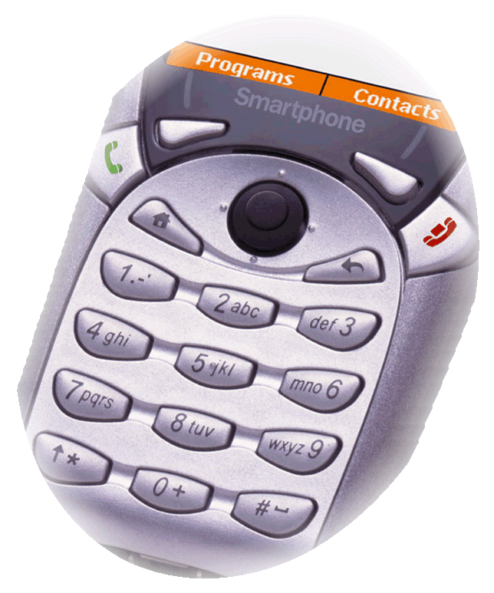
Joystick provides four-way navigation and action
Home
Left soft key
Right soft key
Back

- Left and right soft keys. These context-sensitive keys are used for different purposes, depending on the active application. Their function is shown above them on the Windows Mobile-based Smartphone screen.
One-handed operation: Windows Mobile-based Smartphones are designed for one-handed operation, whereas touch-screen devices require the use of both hands. The joystick, soft keys and numbered menus allow for quick and simple access to all features.
- Joystick and Action key. In the center of the navigation pad, the joystick, also referred to as the Action key, allows you to scroll around the screen. Pressing down on the joystick takes action on the selected item.
- Home. A dedicated button takes you back to the home screen.
- Back. This key does the following, depending on the context:
- Takes you back through previous application windows
- Closes the displayed menu
- Clears the text if an edit window is open
- Send and End keys. These keys are on either side of the navigation pad. Send is used to dial a selected number and answer incoming calls. End is used to disconnect.

Connection Manager
Windows Mobile software for Smartphones supports multiple connection types and modes while keeping the technology in the background. Connection Manager is the umbrella name for the smart connectivity available through Windows Mobile software, where all connection settings and configurations are stored. It can configure RAS (PPP), VPN (PPTP), GPRS, CDMA and NDIS connections and proxy settings in the device’s applications. Connection Manager manages connection requests from various applications, prioritizes the requests, and manages all active connections. Connection Manager uses presupplied information from the mobile operator or corporate IT department to make the best connection available. Consequently, it is unlikely that a user would have to manually go into Connection Manager and configure the options.
- From the home screen, go to Programs > Settings > Data Connections. Note the existing connections configured for your Windows Mobile-based Smartphone.
- Select Menu > Edit Connections. Connections are organized into dial-up, VPN, proxy and GPRS categories. Select one of these, and press Menu to add or edit a connection.
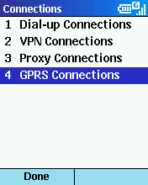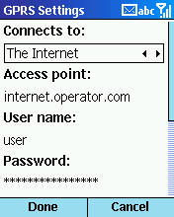

Configuring Windows Mobile-Based Smartphone for GSM/GPRS Networks
The following steps are for the manual configuration of Windows Mobile software without the use of a PC. For users with a PC, the simplest and fastest way to configure Windows Mobile software is with the CD included with the device.
- Insert the subscriber identity module (SIM) card provided with your evaluation materials. To do so, remove the casing on the back of the phone. The slot for the SIM card is underneath the battery. Insert the battery and close the case.
- You may be able to use the SIM card from your own cellular phone (if the phone is not locked to a specific mobile operators SIM card). If you are using a GSM mobile phone today, your phone is equipped with a SIM card, essentially a small card that uniquely identifies and authenticates you to the network. Windows Mobile software will accept your SIM card and apply your existing service (phone number, authentication, user and contact information stored on your card) to the Windows Mobile-based device.
SIM migration: Windows Mobile software lets you import any SIM contacts into the Contacts application, making all SIM data available.
- Turn Windows Mobile-based Smartphone on by pushing the power button. (For more information on the location of the power button, please refer to the hardware information that has been provided.) The home screen appears as Windows Mobile software searches for the network, and a signal strength indicator appears in the taskbar in the upper-right corner.
- Windows Mobile software is preconfigured with the appropriate connection settings out of the box. For your reference, we have also included the access point name (APN).
Windows Mobile software supports CDMA, which does not require any configuration from the user. It is done by the mobile operator.

The APN address is:

- Set the time and date:
  - Push the left soft key to select Programs.
  - Use the joystick to navigate to Settings.
  - Use the joystick to navigate to Date and Time.
  - Select your time zone, and enter the current date and time.
  - Push the left soft key when you are Done.
There are a number of ways to configure your Windows Mobile software for network and e-mail connectivity. Some users may choose to configure multiple connectivity options to meet the different scenarios that can occur when accessing the Internet, WAP networks and corporate networks via multiple data transports. Depending on the user needs, you can do the following:
- Desktop Configurator. The desktop configurator comes on the Windows Mobile software Companion CD and runs on a user’s desktop PC. It helps the user set up Windows Mobile software to accept a variety of connection options. A wizard takes the user through a step-by-step process for setting up dial-up connections, a virtual private network (VPN) connection and an Internet proxy connection, among others.
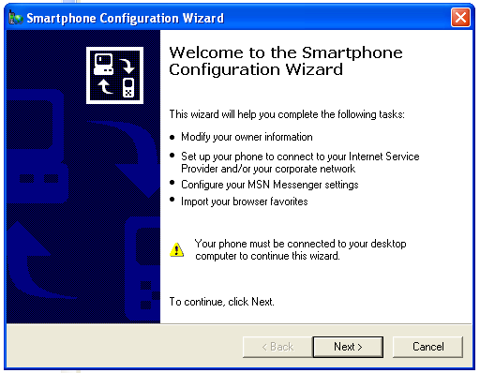
- Over-the-air (OTA) provisioning/device management. This allows the user to download information, including games, ring tones, software updates, e-mail and calendar updates. The OTA services are determined by the operator; specific offerings may vary.
- Manual configuration. The user also has the ability to set up or edit all connection and e-mail settings manually. Special symbols are accessed by holding down the pound (#) key.
- Using a memory card. Using secure digital (SD) cards or multimedia cards (MM) allows for fast configuration of devices when restoring or configuring multiple devices with an identical configuration.

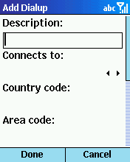
Configuring Windows Mobile software for dial-up access to a corporate network connection
- Go to Programs > Settings > Data Connections.
- Open the menu and select Edit Connections.
- Open Dial-up Connections.
- Open the menu and select Add.
- Fill in the fields for (Corporate Network) Dial-up:
- Description:
- Connects to: [from menu using joystick] My Corporate Network
- Country code:
- Area code:
- Phone number:
- Username: [your username]
- Password: [your password]
- Domain: [your domain]
- Press Done twice.

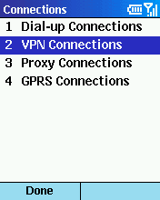
Configuring Windows Mobile software for a VPN connection into a corporate network connection
- Go to Programs > Settings > Data Connections.
- Open the menu and select Edit Connections.
- Open VPN Connections.
- Open the menu and select Add.
- Fill in the fields for (Corporate Network) Dial-up:
- Description:
- Server:
- Connects from:
- Connects to:
- Username: [your username]
- Password: [your password]
- Domain: [your domain]
- Press Done twice.

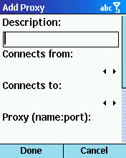
Configuring Windows Mobile software for a proxy server
- Open Proxy Connections.
- Open the menu and select Add.
- Fill in the fields for (proxy server) (HTTP):
- Description: i
- Connects from: My Corporate Network
- Connects to: The Internet
- Proxy: [Press the 1 key multiple times for the colon, the 8 key four times for the numeral 8.]
- Press Done.
- Open the menu and select Add.
- Fill in the fields for SOCKS4, for use with MSN Messenger:
- Description: IM
- Connects from: My Corporate Network
- Connects to: The Internet
- Proxy:
- Type: SOCKS4
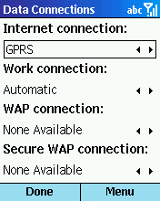
- Press Done three times to close the Data Connections control panel.

Synchronization of e-mail and personal data
Windows Mobile software supports personal (POP3) and corporate (IMAP4) e-mail. For a complete mobile communication solution, Microsoft offers Mobile Information Server, which extends Exchange e-mail across wireless networks and, with Server ActiveSync technology, provides over-the-air synchronization of Contacts, Calendar and Inbox to Windows Mobile software for Smartphone. Where available, this can even be done through high-speed, packet-based data services.

Note: This step is not required to continue through this guide.

Configuring Windows Mobile software for server synchronization
- Select Programs > ActiveSync.
- Open the menu and select Options.
- Select Connection.
- Fill in the fields for your account:
- Username: [your username]
- Password: [your password]
- Domain: [your domain]
- Server name: www.devicesrus.net
- Press Done.
- From the ActiveSync Options menu, open Calendar, Contacts and Inbox, and make sure that the Synchronize option is checked in each. This step enables you to configure the number of days’ worth of e-mail to download and how much of each message should initially be downloaded.
- To initiate synchronization, select ActiveSync and then Sync. You can also sync your inbox by pressing Send/Receive.
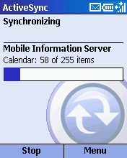

Configuring Windows Mobile software for server POP3/IMAP4 e-mail
- Select Programs > Inbox/SMS.
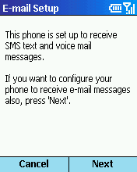
- Open the menu and select Options.
- Select E-mail Setup.
- Select Next to move forward with setting up your POP3/IMAP4 e-mail account.
- Fill in the fields for your account:
- Your name: [your Name]
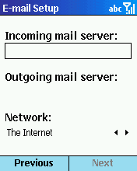
- E-mail Address: [your e-mail address]
- Server Type: [POP3 or IMAP4]
- Select Next.
- Fill in the fields for your account:
- Incoming mail server: [your POP3 incoming mail server]
- Outgoing mail server: [your POP3 outgoing mail server]
- Network: [The Internet]
- Select Next.
- Fill in the fields for your account:
- Username: [your username]
- Password: [your password]
- Domain (if necessary): [your domain]
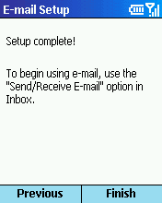
- Check save password.
- Select Next.
- To complete setup, select Finish.
- Press Done.
- To download your e-mail, select menu > Send/Receive E-mail.

A Full-Featured Telephone
First and foremost, Windows Mobile software is a flexible, intuitive and feature-rich mobile phone.

When you first turn on a Windows Mobile-based Smartphone, the home screen appears. This is the central access point to all Windows Mobile software features and applications, and it is within two clicks of any application or personal data you need. The home screen contains a taskbar across the top (and other at-a-glance information, including network and device status, call progress, new messages and appointments). (You’ll see how to customize the home screen later in the tour.)

As highlighted earlier, Windows Mobile software also includes several intuitive hard and soft keys to facilitate simple navigation regardless of the application.
- Home key. This key takes you back to the home screen at any time, from any application.
- Back key. Similar to the Back button in a Web browser, this hard key lets you move back one screen at a time until you reach the home screen. When inputting text, the Back key is used for deleting characters.
- Joystick. This hardware feature allows you to quickly navigate the screen and scroll through different menus.
- Send/End keys. These keys are used to initiate or end a phone call, and also serve as multifunction soft keys, depending on the menu or application you are currently viewing.

Making a call
There are several ways to make a phone call:
- Dialing a number using the keypad. Press the Home key (if you are not currently on the home screen), then simply dial a phone number on the keypad. Press the Action key on the joystick to connect, or use the Send button on the left side of the keypad. Note how easy this is to do with one hand.
- Dialing from Contacts. From the home page, press the right soft key to go into Contacts. Use the joystick to scroll up and down the list, and press the Action key to go into a selected contact. Scroll down to the phone number of your contact, and press the Action key again to dial the number.
Searching for a contact name: As an alternative to scrolling through the Contacts list, enter the first few letters of a name to locate the record of the person you want to call. You need not press a button multiple times to enter a “b” or “c,” for example. Simply press the “2” button once for “a,” “b” or “c.”
- Smartdial. After you have stored contacts into your phone, you will notice when dialing a new phone number from the home screen that contact names appear below the number as you enter it. This Smartdial feature makes it even faster to call someone in your Contacts list.
- Numerical Smartdial. From the home screen, slowly dial a few numbers, such as 1-4-2-5. The contact names shift with each new number you enter, as the possible number of matching contacts gets smaller. Scroll down to one of the listed contacts and press the Action key. This dials the number automatically.
- Alphabetical Smartdial. Now try the same thing with a name. From the home screen, start spelling out the last name of a contact.

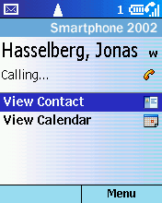
In call features: While in a call, a user can conference friends or colleagues into a call, place a call on hold or even mute the call.

- Most recent call list. From the home screen, press the Send button to bring up a list of your most recent calls. Select a contact and press Send again, or Action, to dial the person’s number.

Receiving a call
Incoming calls bring up this screen, displaying the name of the caller:
Flexibility for mobile operators: Wireless operators can adjust Windows Mobile software menus to accommodate specific service offerings. Slight interface differences can occur, depending on the operator.
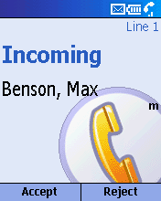
Making Windows Mobile-based Smartphone
your own: Users can personalize their Windows Mobile-based Smartphone with sounds and volumes, color schemes, images, Web favorites, and mobile services.

Personalization Options
Windows Mobile-based Smartphones can be customized by mobile operators and users to meet their business needs, work preferences and personal tastes. Operators can offer different screens, features and content. Individual users can customize their phone in the following ways:
- From the home screen, select Programs > Settings.
- Telephony. These options let users take advantage of telephone services including call barring, call forwarding, call waiting and caller ID.
- Sounds. In addition to setting ring tones, users can select different sounds for reminders and new-message notifications.
- Profiles. Windows Mobile software supports eight profiles — customizable Windows Mobile software settings appropriate for specific situations, such as being in a meeting or in a car. Users can easily toggle between several profiles, including the following, as their environment changes:
Custom ring tones: In addition to nearly 30 built-in sounds, users can personalize Windows Mobile-based Smartphone with their own .WAV files.
  - Automatic — Based on information in your calendar, Windows Mobile software will automatically mute your phone during meetings and then turn the sounds back on when you’re available.
  - Silent — vibrate mode
  - Meeting — all sounds muted
  - Loud — ring tones changed to high volume
  - Headset
  - Radio off — PIM features for places such as airplanes
  - Speaker phone — higher volume activated for use in conference calls or in the car
- Expansion slot. Users can store several hours of music and video using a Secure Digital or Multimedia Card in the memory card expansion slot (card not included). Currently there are cards with as much as 512 MB of memory giving users hours of entertainment possibilities with Windows Mobile-based Smartphones including games, music, video and other applications.
From the Settings menu, select Profiles. Activate the Silent profile by pressing 2 or the Action key. A check mark appears next to the selected profile. Select Done. Note that the home screen reflects the profile change.
Quicklist: By quickly pushing the power button, a quicklist of common functions appears. Included here are Device Lock, Keypad Lock and other profiles. Users can also quickly lock the keypad by holding down the end call key.

- Home screen. Users can adjust the appearance and contents of their home screen using several preloaded color and image options. A free Theme Generator also is available for download from http://www.smartphone.com/.
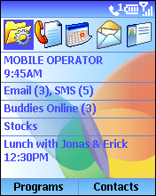

Integrated Applications
In addition to its flexibility and convenience as a mobile phone, Windows Mobile software incorporates applications that help people stay on top of their electronic communications and personal data. All applications are tightly integrated with the phone to fully leverage the wireless data capabilities and to ensure an easy user experience.
- To bring up the Programs menu, select Programs from the home screen using the left soft key.

Inbox for E-Mail and SMS Messages
Windows Mobile software for Smartphone has one Inbox for all text messages received on the device — e-mail, SMS messages and voice-mail notifications. The technology used to send and receive a message is transparent to users.
Easy one-handed navigation: To toggle through the Inbox, you can use the left and right arrows on the joystick

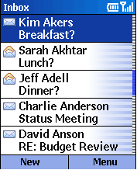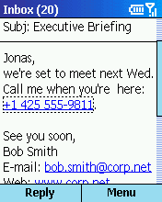
Message folders: Folders can be accessed from the Inbox screen by going to Menu > Show Folders.

Accessing and composing e-mail
- From the Programs menu, select Inbox/SMS, or simply press 1. The Inbox screen appears with a list of text messages.
- Open any message by highlighting and pressing the Action key.
- Scroll through the message. Any blue underlined elements in the message can be acted upon by highlighting the element and pressing the Action key. Attachments can be accessed, embedded phone numbers can be dialed, and Web pages can be viewed directly from a text message in the Inbox.
SMS: Sending an SMS requires using a phone number while sending an e-mail requires an e-mail address. However, when receiving an SMS, a name will appear rather than just a number.
- Go to the next message by right-clicking on the joystick. This enables the user to quickly browse through a large number of e-mail messages without having to open and shut each one.
- If testing on Mobile Information Server (MIS), locate and open the message from John Kelly titled “Xbox® is coming … .” Highlight the attachment and press the Action key. Windows Media will activate and play the video attachment. Press the Back key to return to the message.
- Press the left soft key to reply to the sender.
- Now you’re going to use the voice recorder to send an audio response. Press the right soft key to access the message menu. Select Insert Recording. Press the left soft key once to begin recording and a second time to stop recording. Select Done, and you’ll see that the voice message has been attached to your response.
- Typing a message on Windows Mobile software is made easy with several built-in responses including common salutations. Windows Mobile software also supports T9, a predictive text-input software that completes partially entered words with the most statistically probable word. The more this text-entry mode is used, the larger and more successful the T9 dictionary becomes, saving considerable text-entry time. To activate this feature, simply push the star (*) key while in a message screen.
- Position the cursor in the message body. Press the right soft key to access the menu, and select Insert Text. Select one of the nine preprogrammed phrases. Select Insert.
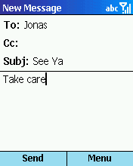
- Now finish the message by entering “Take care” manually.
- Press # to add a space.
- Press * to make the first letter uppercase.
- Press 8, and a capital T will appear.
- Press 2 for “a”, 5 for “k”, 3 for “e” and # for a space. Note that Windows Mobile software anticipated the word, and each letter came up on screen as intended.
- Press 2273 for “care.” Note that “case” appears on screen, and it is underlined. That means there are alternative words that Windows Mobile software recognizes for the same number sequence. Press the + key (or zero) to scroll through the alternatives. The first option should be “care.”
- Press 1 for a period, and add a space to accept the word.

- Press the left soft key to send the message, or select Menu > Cancel Compose to delete the message.

Managing Contacts
The Contacts application was built to enable convenient, efficient communication. Within a Contacts record, every phone number, e-mail address, SMS address and URL is live, allowing users to dial a call or compose a message in one click. To make its use even easier, each contact can be assigned a default communication method, such as dialing the contact’s office phone number. This allows users to initiate communication directly from the Contacts list without having to open the record and select one of the communication options.
Adding contacts: Contacts can be entered into a Windows Mobile-based Smartphone in several ways: by keying information into the Windows Mobile-based Smartphone itself, by beaming infrared data from another device, by receiving the data as an e-mail attachment, and most important, by synchronizing the Windows Mobile software with the user’s desktop Outlook using ActiveSync.

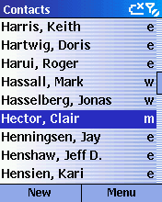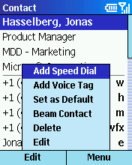

- From the home screen, go into Contacts using the right soft key. Note that you can highlight any contact, and press the Send key to initiate the contact’s default communication method.
Communicate with contacts: Users can communicate with contacts without opening a contact card: If you are in contact view, like the ‘Hector, Clair’ shown at right, move the hardware joystick right or left and the letter to the right of the name will change from M (mobile number) to W (work number, or H (home number), allowing the user to press Send and call that number.
- Using the joystick, select a contact, and press the Action key to open the record.

- Highlight a work or home phone number, and then select Menu > Add Speed Dial.
- Highlight Keypad Assignment, and press the Action key to see the list of speed-dial numbers and which contacts they’ve been assigned to. Select an available speed-dial number. Press Done, and then press Done again to return to the contact’s record.
- To use the speed-dial feature, return to the home screen, and press and hold the speed-dial number you just assigned.

Calendar
Windows Mobile software’s Calendar feature is a condensed version of the Outlook Calendar. Calendar has several view modes (today, agenda view, week or month) that allow users to review their schedules, add new appointments and drill down to Calendar details easily.

Appointment data may come from Internet calendars or Outlook, or be beamed from another device or downloaded from a Web site. E-mail meeting requests are supported as well. From the Inbox, users can respond with Accept, Tentative or Deny, and the meeting will be recorded automatically into the Calendar, just as it is in Outlook on the desktop.

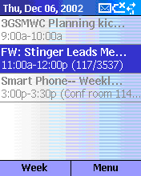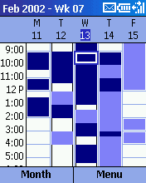

- From the home screen, go to Programs > Calendar. Scheduled appointments for today (if any) are listed on this screen.
- Add an appointment. Select Week with the left soft key.
- Select Menu > New.
- Enter “dentist” as the subject, using the number keys. Set the time as 4 p.m. to 5 p.m. today, and adjust the other fields as you like. Press Done.
- At either the week or month calendar view, highlight the appointment time or day, and press the Action key to see the appointments for that time block. Click the Action key again to drill down on a specific appointment, or edit the appointment by selecting Menu with the right soft key and Edit.
- Press the Home key. Note that today’s 4 p.m. dentist appointment appears on the home screen.

Internet Browsing With Pocket Internet Explorer
As more and more phones move into the feature-phone realm, offering rudimentary browsing capabilities, Microsoft sets a high standard by offering the same robust browser as Pocket PC, optimized for a Windows Mobile-based Smartphone.
Multimode browsing: Windows Mobile software for Smartphone offers the same browser software as Windows Mobile software for Pocket PC, which means it supports HTML 3.2, cHTML, MSXML, JScript®, WAP 1.2.1 and WTLS (wireless transport layer security).

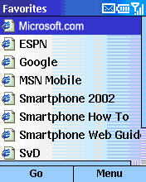

In addition, the browser is flexible: Favorites and options can be reset according to the user’s preferences, and users can access any URL or get a list of their recent online history. Furthermore, Smart Look-Up speeds the entry of URLs (Note: Windows Mobile software Favorites also can be added via the desktop).

- From the home screen, select Programs > Internet Explorer. The Favorites page is essentially the starting point for Windows Mobile-based Smartphone Internet browsing, enabling quick access to the user’s most frequently used Web sites.
GPRS = Internet: General packet radio service (GPRS) is technology that enables any GSM network to be fully Internet-capable. GPRS supports standard data protocols such as IP and X.25. The icon indicates that the Windows Mobile-based Smartphone is within GPRS coverage, and indicates the signal strength.
- Select one of the Favorites links, and select Go to get online.
- Return to Favorites, and select Menu > Go To.
- At the Go To screen, press and hold the Back button to clear any text in the URL box, and type in “msn.” Windows Mobile software will offer any choices from your call history or Favorites that match “msn,” and it will build a URL by adding the standard Web prefix and suffix.
- Scroll down to http://www.msn.com/ and select Go.

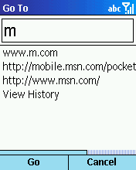

- Try some other URLs. A few sites with content optimized for Windows Mobile software include these:
http://www.devicesrus.net/spportal/
http://pda.ananova.com/
http://www.msnbc.com/
http://www.handango.com/

MSN Messenger
Windows Mobile software has a built-in MSN Messenger client for instant messaging. It has the core functionality and look that customers are used to from their PC, modified to fit the Windows Mobile software interface.
Features for easy instant messaging: Windows Mobile software’s MSN Messenger supports automatic logon when a connection is available, as well as a menu of common phrases, called My Text, which can be a real time saver. Windows Mobile software also supports multiperson instant messaging, so users can chat with more than one person at the same time.

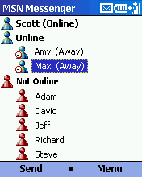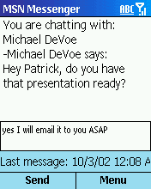

Windows Media Player
Windows Mobile software includes Windows Media Player, which supports local and wireless streaming audio and video playback. A number of file formats are supported including WMA and MP3. Audio can be heard through the speaker on Windows Mobile-based Smartphones or through a plug-in headset. The memory card slot on Windows Mobile-based Smartphones provides the flexibility for users to store video clips and many hours of music on MMC or SD cards.
Multimedia: Windows Media Player supports local and streaming video, audio and music files on Windows Mobile software, providing a rich experience for business and personal use.

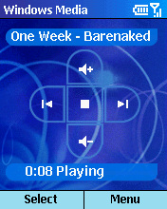

To listen to your music, simply use the Joy Stick:
- To stop or start play, push the middle of the Joy Stick once.
- Tap the Joy Stick to the right to fast forward and the left to rewind.
- To adjust volume, simply tap the Joy Stick up or down.

Other Features

Voice Notes
Windows Mobile software focuses its notes application around audio notes. The Voice Notes recorder allows people to input and review their voice notes.

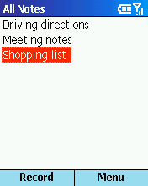

- From the Programs menu, press 9 and then 3.
- Select Record, and Stop when you’re through recording.
- With your new recording highlighted, select Menu > Rename.
- Press and hold the Back key to erase the default name.
- Now we’ll type in “biz mtg.” In this mode, each key scrolls through its assigned letters as you press the key.
- Type 2 twice, quickly, and pause. The “b” should appear.
- Type 4 three times quickly for the “I,” and so on. Remember the # key inserts a space. Press Done when you’re finished renaming your note.
- With your new Voice Note highlighted, play back the note by pressing the Action key.

Conclusion
This tour has given you a feel for the versatility and depth of Windows Mobile-based Smartphones as a tool for mobile professionals and consumers to stay connected and up to date. As a mobile phone and an extension of the user’s desktop Outlook, Windows Mobile-based Smartphones offer a combination of features unmatched by any other wireless phone.

Thank you for taking the time to evaluate Windows Mobile software for Smartphones. We encourage you to continue browsing the interface and exploring the many features that we haven’t touched on in this guide.

#########

