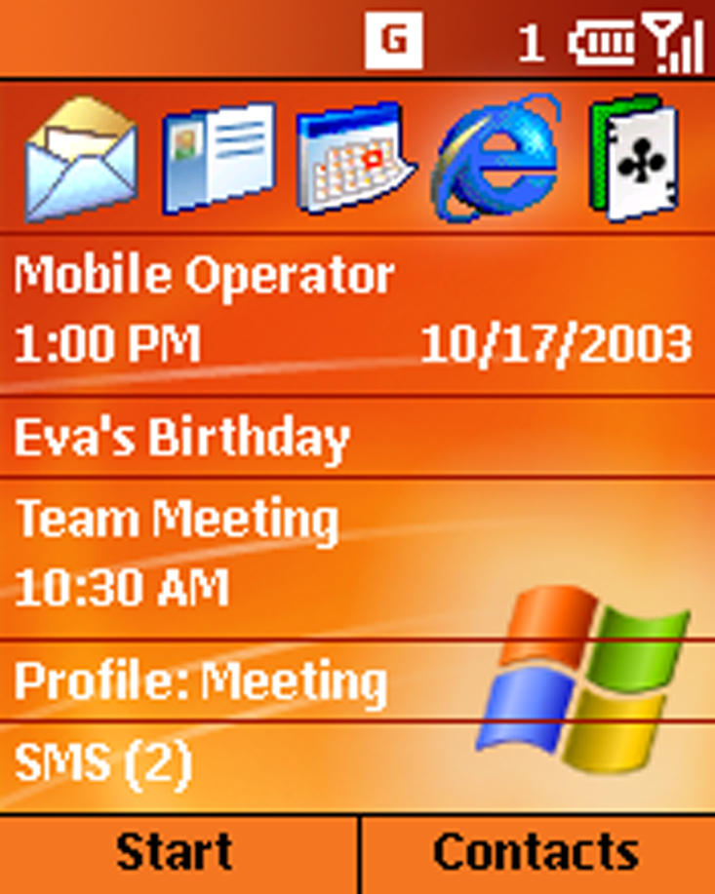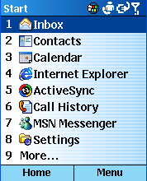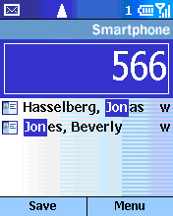

Windows MobileTM 2003 Software for Smartphones
Reviewers Guide

For more information, press only:

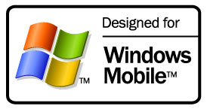
Brandi Cook
Waggener Edstrom
(503) 443-7000
brandic@wagged.com

Jackson Jeyanayagam
Waggener Edstrom
(503) 443-7000
jacksonj@wagged.com

Rapid Response Team
Waggener Edstrom
(503) 443-7070
rrt@wagged.com

The information contained in this document represents the current view of Microsoft Corp. on the issues discussed as of the date of publication. Because Microsoft must respond to changing market conditions, it should not be interpreted to be a commitment on the part of Microsoft, and Microsoft cannot guarantee the accuracy of any information presented after the date of publication.
This document is for informational purposes only. MICROSOFT MAKES NO WARRANTIES, EXPRESS OR IMPLIED, IN THIS DOCUMENT.
© 2003 Microsoft Corp. All rights reserved.
Microsoft, Windows Mobile, the Windows logo, the Microsoft Internet Explorer logo, Windows Media, Outlook, Windows, MSN, the MSN logo, Windows NT, ActiveSync and JScript are either registered trademarks or trademarks of Microsoft Corp. in the United States and/or other countries.
The Bluetooth trademarks are owned by its proprietors and used by Microsoft under license.
The names of actual companies and products mentioned herein may be the trademarks of their respective owners.
Contents
Introducing Windows Mobile Software for Smartphones 1
Easily access information 1
More than just talk 1
Personal and fun 2
Windows Mobile 2003 Software for Smartphone: Standard Features 3
Evaluation Requirements and Recommendations 6
Desktop Platform System Requirements 6
Additional Configuration Notes 6
Hardware Overview 7
Connection Manager 8
A Full-Featured Telephone 9
Making a call 9
Receiving a call 11
Personalization Options 11
Integrated Applications 12
Inbox for E-Mail and SMS Messages 12
Accessing and composing e-mail 13
Managing Contacts 14
Calendar 14
Internet Browsing With Pocket Internet Explorer 15
MSN Messenger 17
Windows Media Player 18
Other Features 18
Voice Notes 18
Conclusion 19
Appendix – Connection Manager 20
Configuring Windows Mobile-Based Smartphone for GSM/GPRS Networks
20
Configuring Windows Mobile software for dial-up access to a corporate network connection 20
Configuring Windows Mobile software for a VPN connection into a corporate network connection 21
Configuring Windows Mobile software for a proxy server 21
ActiveSync: Configuring Windows Mobile software for server synchronization
22
Setting up Data Connections 23
Configuring POP3/IMAP4 e-mail 24

Introducing Windows Mobile Software for Smartphones
This guide introduces Microsoft® Windows MobileTM 2003 software for Smartphones, which opens a new chapter in mobile phone technology by combining the best of mobile voice and data communications with the best of personal information management software. This brief tour will highlight many of the features while familiarizing users with its controls and interface.
When Microsoft entered the mobile devices industry, it was with the belief that people wanted to do more on their mobile devices. Microsoft applied this philosophy as it built Windows Mobile software, first for the Pocket PC and then for Smartphone.
Windows Mobile introduces an entirely new mobile phone experience through the integration of smart software and small, stylish handsets. Windows Mobile allows users to do the following:

Easily access information
Wireless connectivity is becoming more widely available, and no single device can ever meet the needs of all users. Everyone faces a different set of priorities and scenarios every day. Business and personal users communicate remotely through different combinations of voice, e-mail, instant messaging, short message service (SMS), online forums and even video. And when they leave their home or office, they might carry several devices to stay connected to people and information they count on. With that in mind, Microsoft has included support for the .NET Compact Framework in the new Windows Mobile 2003 for Smartphones software, which enables a new era of mobile XML-based Web services.
As technologies have evolved, manufacturers are striving to make wireless devices more useful, convenient and, inevitably, smaller. With Windows Mobile software, Microsoft, OEMs and mobile operators have created small, sleek devices for people who depend on staying connected to information and each other while mobile. It just might be the perfect combination of beauty and brains.
Windows Mobile software also provides an open platform upon which independent software vendors can develop a variety of consumer and enterprise-oriented applications. And new support for IPv6, the newest version of Internet Protocol (IP), allows the Windows Mobile software to take advantage of the most current Internet and Web-based information and services while ensuring seamless integration with desktop applications. The localization features of Windows Mobile software support many languages and make this a compelling device for mobile operators and developers alike.
Note: Cellular voice and data plans are required for Internet and phone access. Some features may vary based on the mobile operator. See device manufacturer and mobile operator for details.

More than just talk
Windows Mobile-based Smartphone is a full-featured mobile phone — in function, form and performance. With Windows Mobile software, customers can easily synchronize their personal information from Outlook® with their device, which saves time and enables easy dialing of contacts. Advanced calling features such as three-way calling and speaker phone are easy to use with the interface.
What really sets Windows Mobile-based Smartphones apart are its one-handed access to the most popular personal information management (PIM) functions,
e-mail and text messaging, Web capabilities, and robust connectivity options, all in a handset comparable in size to today’s mainstream mobile phones.
Windows Mobile software provides familiar versions of software on a handset, which can be easily integrated with users’ desktop PCs, so they can access information while away from home or office. With the use of Exchange 2003 or third party email redirector solutions, users can synchronize their e-mail, Calendar and Contacts over the air continually, without ever having to physically connect the phone to a desktop PC. No manual synchronization is necessary (unless they choose to sync Window Mobile software directly to their desktop PC). When people look at their Windows Mobile-based Smartphone, they see current data.
As a result, users can stay in touch with people and information, keep on top of all their messages, and be reminded of appointments throughout the day.

Personal and fun
Windows Mobile software for Smartphone delivers a rich set of applications, highly integrated telephony functionality and an open development platform. Mobile professionals will appreciate how much they can do with this phone. During the course of a phone conversation, the user can schedule a meeting and record it in the Calendar, as well as browse for new messages. And a variety of new ring tone playback and development features allows mobile operators and consumers to add new and customized ring tones. Windows Mobile software’s integrated applications allow people to work efficiently while they’re away from their desktop PC, making it a truly personal and powerful mobile phone for both work and personal life.
Information technology (IT) administrators will appreciate the software’s compatibility with a variety of connectivity options, Web and security protocols, and configurations for synchronizing data, which allows them to extend enterprise resources to their mobile work force with little or no user involvement. New support for Microsoft .NET, IPv6 and Bluetooth wireless connectivity help ensure that Windows Mobile 2003 software for Smartphone is the best platform for keeping people with on-the-go lifestyles connected to their information with industry-leading technologies. Similarly, new support for IPSec/L2TP virtual private networking (VPN) connections enables business users to connect to their corporate data securely and swiftly.
Included with Windows Mobile-based Smartphones are all the multimedia features today’s consumers expect, including instant messaging, the ability to send and receive photos, and Windows Media® Player, which lets users listen to music and view videos. Windows Mobile software is also a great platform for games. The Secure Digital/Multimedia Card expansion slot provides storage space for users to further customize their phone with games, hours of music, pictures or video.
Above all, Windows Mobile software is simple to use. It is a mobile phone for the masses that allows users to shop over the Internet, play games, listen to music and organize their lives.

Windows Mobile 2003 Software for Smartphone: Standard Features
Feature | Description
Mobile Phone
Handset | Windows Mobile-based Smartphones are small and lightweight mobile phones, featuring easy, one-handed dialing and navigation.
High-resolution color | The color screen allows users to view e-mail, browse Web sites and see images easily.
Phone options | Conference calling, speed dial and speakerphone are all available with Windows Mobile- based Smartphones.
Smartdial | As a user dials a phone number or begins to type in a contact name, the Smartdial feature displays possible matches from Contacts, SIM and Call History for fast dialing.
Profiles | Profiles allow users to adjust the ring volume and other phone settings in one step to accommodate external environments such as noisy work areas, meetings and airplanes.
Call History | Every call (including missed calls) is automatically logged with the other party’s name (when the name is in the contact list) and phone number, as well as the date, time and length of the call.
Device security | Device lock and subscriber identity module (SIM) lock can be used to help protect a Windows Mobile-based device from unauthorized use or tampering.
Conference Call | Windows Mobile allows users to establish a conference call with multiple parties.
Security | Users can help protect their data by using the PIN feature to lock the keypad; the SIM card also can be locked to block any incoming or outgoing communication on Windows Mobile-based Smartphones.
Suspend/Resume** | Windows Mobile 2003 adds Suspend/Resume support for GSM-based Windows Mobile based-Smartphones and Dormant Mode support for CDMA- and Windows Mobile based-Smartphones. When a voice call is placed or answered during an active data session, the data connection is paused during a voice call and resumed immediately after the voice call ends..
SIM management** | End users can now add, delete and edit contacts directly to their SIM while using their Windows Mobile-based device with GSM/GPRS networks.
Alternate line service indicator** | Windows Mobile 2003 includes support for the industry-standard two-line voicemail indicator.
Personalization
Home screen | The customizable home screen provides quick access to personal and relevant information such as network information, new-message alerts and meeting reminders, as well a taskbar for easy access to Windows Mobile applications.
Ring tones | Users can download their favorite ring tones from mobile operators or third parties or can use some of the many unique ring tones preloaded on the phone. Users also have the ability to record their own ring tones to WMA, Wav. or Midi formats.
Familiar Interface
User-friendly interface | Windows Mobile software has an intuitive, familiar-looking interface that is simple to operate and behaves exactly the way most users would expect it to.
Synchronization with desktop Outlook | Continual synchronization wirelessly or through the Outlook messaging and collaboration client on PCs keeps the information on Windows Mobile software consistent and up to date with a user’s PC.
Consistent accounts and passwords | Users can incorporate the same profiles and user accounts they’ve set up on their PC, such as those for Exchange, Passport, MSN® Messenger Service and Contacts.
Text Messaging
Instant messaging | Windows Mobile software has built-in support for MSN Messenger instant messaging.
Voice response | Users can record voice messages, which are sent as e-mail attachments, as an efficient alternative to keying in text messages.
T9 text input | T9 predictive text input to simplify and speed up messaging is included.
MSN Messenger IPv6 support** | MSN Messenger now supports IPv6, allowing users to enjoy enhanced interoperability with other IPv6-based applications and systems.

Pocket Outlook
Unified Inbox | The Inbox stores e-mail, SMS messages, meeting requests and voice-mail notifications in one central place and can be configured to support several email accounts. It can be configured to receive e-mail over the air from multiple sources, including Exchange Server, IMAP or POP3/SMTP e-mail services.
Calling from the contact list | Users can initiate a call or message directly from the contact list, depending on the user-defined default communication method for that contact.
Hot-linked contact information | Not only are all of the fields available on a desktop viewable on but a user also can select any of the contact information within each record to immediately send a message with any available communication method (such as SMS, e-mail or mobile phone number), all with one-click access.
Contact filtering | Contacts can be categorized as business, personal and miscellaneous, for faster viewing.
Calendar | Users have seamless integration between the Calendar on their phone and on their PC. Users also can set audio alerts for appointments and accept or decline calendar invitations.
Voice Notes | Memos, shopping lists and other action items can be recorded and kept in a list of Voice Notes.
Tasks | Users can create, view and track new Tasks on their Windows Mobile-based Smartphone.
Pocket Internet Explorer
Internet access | Windows Mobile software offers easy access to the Internet, giving users access to traditional Web content and services as well as content tailored to Windows Mobile software and other mobile devices. Windows Mobile software supports XML, HTML and cHTML, xHTML and WAP.
Security standards | The browser supports numerous security protocols, including Secure Sockets Layer (SSL) and Wireless Transport Layer Security (WTLS), helping enable secure corporate access and online transactions such as shopping.
Extended protocol support** | Windows Mobile 2003 now includes support for XHMTL, Cascading Style Sheets, JavaScript 5.5, Windows Markup Language 2.0, IPv6, WTLS and animated images.
Entertainment
Windows Media Player | With a plug-in memory card, users can store and play several hours of music. Windows Mobile 2003 software also supports video playback. It also supports MP3, Windows Media Audio (WMA) and Windows Media Video (WMV), and offers the ability to play streaming audio and video.
Support for Windows Media Player 9 Audio and Video and Windows Media Audio (WMA) Ring Tones** | Windows Mobile users can now watch and listen to multimedia content encoded in the Windows Media Player 9 format. Windows Media Audio files can be used as ring tones. WMA ring tones can support Digital Rights Management for protecting the intellectual property associated with the ring tone
Games | Windows Mobile 2003 software for Smartphone includes Solitaire and “Jawbreaker”, a great game for short breaks which is new to Windows Mobile 2003 software. Users can play other games downloaded from mobile operators or third parties. Games can be stored on the device or on a memory card.
International
New Windows Mobile languages** | Windows Mobile 2003 supports the following languages: Japanese, Chinese (Simplified and Traditional), Dutch, Danish, English, German, French, Italian, Brazilian, Portuguese, Finnish, Norwegian, Korean, Spanish and Swedish.
East Asian Smartdial** | Contact names in Japanese and Chinese (Simplified and Traditional) can now be filtered using Smartdial in both Dialer and Contacts.

Bluetooth
Bluetooth® Partnership Wizard and Additional Bluetooth profiles ** | Windows Mobile users can now easily connect to other Bluetooth devices. This wizard turns the radio on, searches for available devices, and then asks the user to set a PIN to pair with a device. Profiles for Object Push and Dialup Networking are included in ROM
ActiveSync
Configurable synchronization schedules** | Users can configure separate wireless synchronization schedules for peak and nonpeak hours, as well as while roaming. ActiveSync® technology can also synchronize in the background, without turning on the screen or backlight, which saves power.
IPv6-based ActiveSync** | While connected to the desktop, Windows Mobile 2003-based Smartphones can synchronize in mixed IPv6 and v4 environments.
SecureID support** | Exchange ActiveSync can support authentication with RSA SecureID.
Security
SSL support** | The Secure Sockets Layer (SSL) security protocol is supported for IMAP, POP3 and SMTP e-mail.
IPSec/L2TP support** | Windows Mobile 2003 supports the IPSec/L2TP Virtual Private Network protocol, which offers users a more secure way to access their remote information.
Certificate management** | Windows Mobile users can now manage their client and root certificates, and common certificates are now included.
Windows CE .NET
.NET Compact Framework in ROM** | Windows Mobile 2003 includes the .NET Compact Framework in ROM, which enables the development and deployment of .NET applications for Windows Mobile-based devices.
Inbox/SMS
Multiple inbox support** | Separate inbox stores are provided for ActiveSync and SMS, and each POP3 or IMAP account. Windows Mobile can now support up to eight message accounts.
Always-up-to-date e-mail** | For users who synchronize with Exchange 2003, Windows Mobile 2003 can be configured to synchronize e-mails as they arrive on the server, keeping users up to date with their e-mail. These settings can be configured either on the device or the desktop.
Moving messages** | Users can now move messages from one folder to another on their device, enabling them to be more productive on the go.
Extensible EMS** | Windows Mobile 2003 supports pluggable transcripts such that operators and ISVs can now create plug-ins for certain popular applications such as Enhanced Message Service (EMS) and Multimedia Messaging Service (MMS).
SMS character counter** | A running characters total is displayed in the title bar as SMS messages are composed. If the character count goes over the 160 limit, a message is displayed.
IPv6 support** | Inbox now supports IPv6, which means Windows Mobile users can enjoy enhanced interoperability with other IPv6-based applications and systems.
Separate e-mail signatures** | Windows Mobile users can set up a default signature for each messaging account.

Evaluation Requirements and Recommendations
Refer to the following guidelines as you set up your testing environment.

Desktop Platform System Requirements
Windows® XP, Windows 98, Windows Millennium (Windows Me), Windows 2000 or Windows NT® 4.0 (Service Pack 6) operating system
CD-ROM drive
Super VGA or better video card
One available USB port
TCP/IP protocols
A dial-up or direct connection to the Internet
Microsoft Internet Explorer 4.01 or later browser software
Microsoft Outlook 98 or later
Microsoft ActiveSync 3.7.1.

Additional Configuration Notes
If you are not a current Outlook user, it’s a good idea to load Outlook on your desktop PC and enter a few contacts, calendar events and e-mail items before you set up the Windows Mobile-based Smartphone to provide some information to transfer to the device.* Outlook is provided on the CD that comes with the handset.

Currently, the Windows Mobile for Smartphone platform is available for GSM/GPRS and CDMA/1X-RTT voice and data standards. To test Windows Mobile software, users will need to be within a GSM/GPRS or CDMA/1X-RTT service area. Configuration may differ according to type of device and mobile operator.

Hardware Overview
Before assembling and turning on your handset, take a moment to become familiar with the keypad. Windows Mobile software for Smartphone does not have a touch-screen interface. All of its commands and functions are accessible by hardware controls.
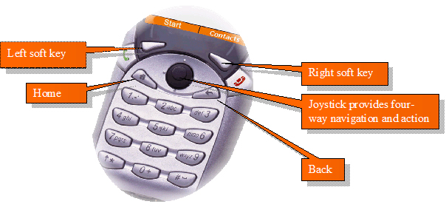

Left and right soft keys. These context-sensitive keys are used for different purposes, depending on the active application. Their function is shown above them on the Windows Mobile-based Smartphone screen.
One-handed operation: Smartphone software is designed for one-handed operation, whereas touch-screen devices require the use of both hands. The joystick, soft keys and numbered menus allow for quick and simple access to all features.
Joystick and Action key. In the center of the navigation pad, the joystick, also referred to as the Action key, allows you to scroll around the screen. Pressing down on the joystick takes action on the selected item.
Home. A dedicated button takes you back to the home screen.
Back. This key does the following, depending on the context:
- Takes you back through previous application windows
- Closes the displayed menu
- Clears the text if an edit window is open
Send and End keys. These keys are on either side of the navigation pad. Send is used to dial a selected number and answer incoming calls. End is used to disconnect.

Connection Manager
Windows Mobile 2003 software for Smartphones supports multiple connection types and modes while keeping the technology in the background. Connection Manager is the umbrella name for the smart connectivity available through Windows Mobile software for Smartphones, where all connection settings and configurations are stored. It can configure RAS (PPP), VPN (PPTP), GPRS, CDMA and NDIS connections and proxy settings in the device’s applications. Connection Manager manages connection requests from various applications, prioritizes the requests, and manages all active connections. Connection Manager uses presupplied information from the mobile operator or corporate IT department to make the best connection available. Consequently, it is unlikely that a user would have to manually go into Connection Manager and configure the options. For details on manual configuration, please go to the appendix.
There are a number of ways to configure your Windows Mobile software for Smartphones for network and e-mail connectivity. Some users may choose to configure multiple connectivity options to meet the different scenarios that can occur when accessing the Internet, WAP networks and corporate networks via multiple data transports. Depending on the user needs, you can do the following:
- Over-the-air (OTA) provisioning/device management. This allows the user to download information, including games, ring tones, software updates, e-mail and calendar updates. The OTA services are determined by the operator; specific offerings may vary.
- Manual configuration. The user also has the ability to set up or edit all connection and e-mail settings manually. Special symbols are accessed by holding down the pound (#) key.
- Using a memory card. Using secure digital (SD) cards or multimedia cards (MM) allows for fast configuration of devices when restoring or configuring multiple devices with an identical configuration.
Synchronization of e-mail and personal data

Windows Mobile s 2003 software for Smartphones supports several ways to sync data to the device including ActiveSync, POP3/IMAP and Exchange 2003, as well as third party email redirector solutions. For a complete mobile communication solution, Microsoft Exchange 2003 offers over-the-air synchronization or customers can use Exchange 2000 with Mobile Information Server

If you are interested in testing the complete mobile communication solution with Exchange, please contact your local Microsoft contact. For more details on synchronization of e-mail and personal data please go to the appendix.

A Full-Featured Telephone

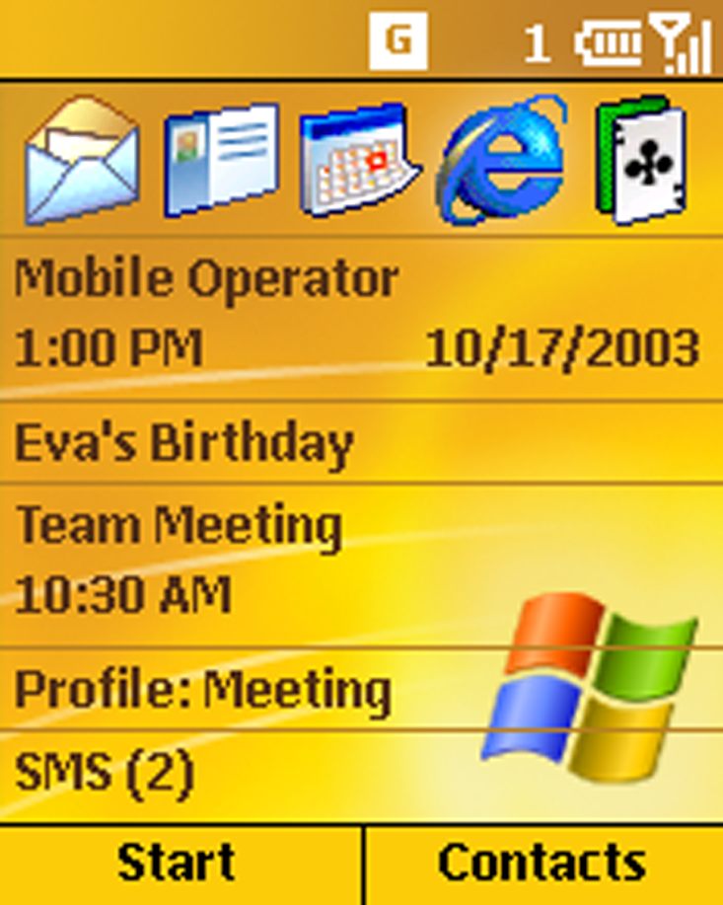

First and foremost, Windows Mobile-based Smartphones are flexible, intuitive and feature-rich mobile phones.

When you first turn on Windows Mobile-based Smartphones, the home screen appears. This is the central access point to all Windows Mobile software features and applications, and it is within two clicks of any application or personal data you need. The home screen contains a taskbar across the top (and other at-a-glance information, including network and device status, call progress, new messages and appointments). (You’ll see how to customize the home screen later in the tour.)

As highlighted earlier, Windows Mobile-based Smartphones also includes several intuitive hard and soft keys to facilitate simple navigation regardless of the application.
- Home key. This key takes you back to the home screen at any time, from any application.
- Back key. Similar to the Back button in a Web browser, this hard key lets you move back one screen at a time until you reach the home screen. When inputting text, the Back key is used for deleting characters.
- Joystick. This hardware feature allows you to quickly navigate the screen and scroll through different menus.
New Feature
Suspend/Resume for GSM and Dormant mode for CDMA allows devices to maintain a data connection when the user is on the phone or the phone is off.
- Send/End keys. These keys are used to initiate or end a phone call, and also serve as multifunction soft keys, depending on the menu or application you are currently viewing.

Making a call
There are several ways to make a phone call:
Dialing a number using the keypad. Press the Home key (if you are not currently on the home screen), then simply dial a phone number on the keypad. Press the Action key on the joystick to connect, or use the Send button on the left side of the keypad. Note how easy this is to do with one hand.
Dialing from Contacts. From the home page, press the right soft key to go into Contacts. Use the joystick to scroll up and down the list, and press the Action key to go into a selected contact. Scroll down to the phone number of your contact, and press the Action key again to dial the number.
Searching for a contact name: As an alternative to scrolling through the Contacts list, enter the first few letters of a name to locate the record of the person you want to call. You need not press a button multiple times to enter a “b” or “c,” for example. Simply press the “2” button once for “a,” “b” or “c.”
Smartdial. After you have stored contacts into your phone, you will notice when dialing a new phone number from the home screen that contact names appear below the number as you enter it. This Smartdial feature makes it even faster to call someone in your Contacts list.
- Numerical Smartdial. From the home screen, slowly dial a few numbers, such as 1-4-2-5. The contact names shift with each new number you enter, as the possible number of matching contacts gets smaller. Scroll down to one of the listed contacts and press the Action key. This dials the number automatically.
- Alphabetical Smartdial. Now try the same thing with a name. From the home screen, start spelling out the last name of a contact.

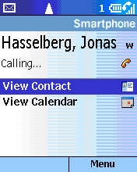
In call features: While in a call, a user can conference friends or colleagues into a call, place a call on hold or even mute the call.
Flexibility for mobile operators: Wireless operators can adjust Windows Mobile software for Smartphones menus to accommodate specific service offerings. Slight interface differences can occur, depending on the operator.

Most recent call list. From the home screen, press the Send button to bring up a list of your most recent calls. Select a contact and press Send again, or Action, to dial the person’s number.

Receiving a call
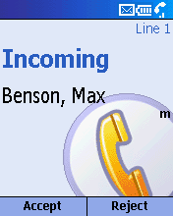
Incoming calls bring up this screen, displaying the name of the caller in your contacts or the phone number if not.

Making Windows Mobile- based Smartphone
your own: Users can personalize their Windows Mobile-based Smartphone with sounds, ring tones and volumes, color schemes, images, Web favorites and mobile services.

Personalization Options
Windows Mobile-based Smartphones can be customized by mobile operators and users to meet their business needs, work preferences and personal tastes. Operators can offer different screens, features and content. Individual users can customize their phone in the following ways:
- From the home screen, Select Start > Settings.
- Phone. These options let users take advantage of telephone services including call barring, call forwarding, call waiting, caller ID and other related features.
- Sounds. In addition to setting ring tones, users can select different sounds for reminders, new-message notifications and alarms.
- Profiles. Windows Mobile software supports eight profiles — customizable Windows Mobile software settings appropriate for specific situations, such as being in a meeting, in a car or outdoors. Users can easily toggle between several profiles, including the following, as their environment changes:
Custom ring tones: In addition to nearly 30 built-in sounds, users can personalize Windows Mobile-based Smartphone with their own .WMA and .WAV files.
  - Automatic — Based on information in your calendar, Windows Mobile software will automatically mute your phone during meetings and then turn the sounds back on when you’re available.
  - Normal
  - Silent — vibrate mode
  - Meeting — all sounds muted
  - Outdoor — ring tones changed to high volume
  - Headset
  - Car
  - Speaker phone — higher volume activated for use in conference calls or in the car
- Home screen. Users can adjust the appearance and contents of their home screen using several preloaded color and image options. A free Theme Generator also is available for download from www.microsoft.com/windowsmobile
- About. This provides information about device and software specifications.
- Accessibility. Users can modify font size, volume and timeout delays for ease of use.
- Beam. This allows users to receive data beamed from other devices to their phone.
- Bluetooth. The Windows Mobile 2003 software provides support for Bluetooth wireless connectivity technology, enabling devices to locate and bond with users’ phones when activated.
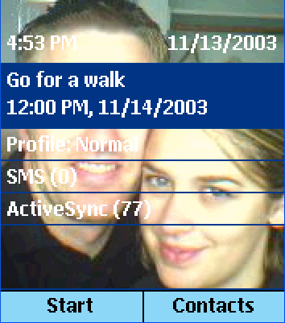
Easy one-handed navigation: To toggle through the Inbox, you can use the left and right arrows on the joystick

Integrated Applications
In addition to its flexibility and convenience as a mobile phone, Windows Mobile software for Smartphones incorporates applications that help people stay on top of their electronic communications and personal data. All applications are tightly integrated with the phone to fully leverage the wireless data capabilities and to ensure an easy user experience.
To bring up the Start menu, select Start from the home screen using the left soft key.

Inbox for E-Mail and SMS Messages
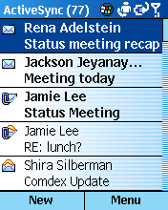
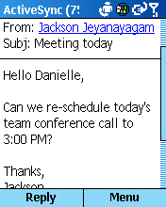
Windows Mobile software for Smartphones has one Inbox for all text messages received on the device — e-mail, SMS messages and MMS messages.
Message folders: Folders can be accessed from the Inbox screen by going to Menu > Show Folders.

Accessing and composing e-mail
- From the Start menu, select Inbox, or simply press the corresponding menu number to the left on the dial pad. The Inbox screen appears with a list of messages. As you press right or left on the joystick you will notice that you are toggling between Email, SMS and MMS.
- Open any message by highlighting and pressing the Action key.
- Scroll through the message. Any blue underlined elements in the message can be acted upon by highlighting the element and pressing the Action key. Attachments can be accessed, embedded phone numbers can be dialed, and Web pages can be viewed directly from a text message in the Inbox.
SMS: Sending an SMS requires using a phone number while sending an e-mail requires an e-mail address. However, when receiving an SMS, a name will appear rather than just a number.
- Go to the next message by pressing right on the joystick. This enables the user to quickly browse through a large number of e-mail messages without having to open and shut each one.
- Press the left soft key to reply to the sender.
- Now you’re going to use the voice recorder to send an audio response. Press the right soft key to access the message menu. Select Insert Recording. Press the left soft key once to begin recording and a second time to stop recording. Select Done, and you’ll see that the voice message has been attached to your response.
New Feature
Windows Mobile 2003 can now support up to eight separate inbox message accounts for ActiveSync, SMS and each POP3 or IMAP account.
- Typing a message on a Windows Mobile-based Smartphone is made easy with several built-in responses including common salutations. Windows Mobile software also supports T9, a predictive text-input software that completes partially entered words with the most statistically probable word. The more this text-entry mode is used, the larger and more successful the T9 dictionary becomes, saving considerable text-entry time. To activate this feature, simply push the star (*) key while in a message screen.
- Position the cursor in the message body. Press the right soft key to access the menu, and select Insert Text. Select one of the nine preprogrammed phrases. Select Insert.
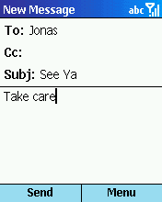
- Now finish the message by entering “Take care” manually.
- Press # to add a space.
- Press * to make the first letter uppercase.
- Press 8, and a capital T will appear.
- Press 2 for “a”, 5 for “k”, 3 for “e” and # for a space. Note that Windows Mobile software anticipated the word, and each letter came up on screen as intended.
- Press 2273 for “care.” Note that “case” appears on screen, and it is underlined. That means there are alternative words that Windows Mobile software recognizes for the same number sequence. Press the + key (or zero) to scroll through the alternatives. The first option should be “care.”
- Press 1 for a period, and add a space to accept the word.

- Press the left soft key to send the message, or select Menu > Cancel Compose to delete the message.
- Alert. The phone will prompt you with the message verifying your decision to delete the message. Select Yes or No with the soft keys.

Managing Contacts
The Contacts application was built to enable convenient, efficient communication. Within a Contacts record, every phone number, e-mail address, SMS address and URL is live, allowing users to dial a call or compose a message in one click. To make its use even easier, each contact can be assigned a default communication method, such as dialing the contact’s office phone number. This allows users to initiate communication directly from the Contacts list without having to open the record and select one of the communication options.
Adding contacts: Contacts can be entered into a Windows Mobile based Smartphone in several ways: by keying information into the phone itself, by beaming infrared data from another device, by receiving the data as an e-mail attachment, and most important, by synchronizing the Windows Mobile software with the user’s desktop Outlook using ActiveSync.

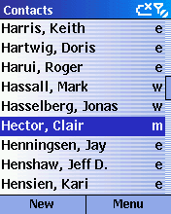
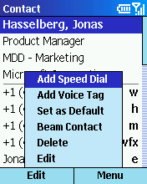

Communicate with contacts: Users can communicate with contacts without opening a contact card: If you are in contact view, like the ‘Hector, Clair’ shown at right, move the hardware joystick right or left and the letter to the right of the name will change from M (mobile number) to W (work number, or H (home number), allowing the user to press Send and call that number.

- From the home screen, go into Contacts using the right soft key. Note that you can highlight any contact, and press the Send key to initiate the contact’s default communication method.
- Using the joystick, select a contact, and press the Action key to open the record.

- Highlight a work or home phone number, and then select Menu > Add Speed Dial.
- Highlight Keypad Assignment, and press the Action key to see the list of speed-dial numbers and which contacts they’ve been assigned to. Select an available speed-dial number. Press Done, and then press Done again to return to the contact’s record.
- To use the speed-dial feature, return to the home screen, and press and hold the speed-dial number you just assigned.
New Feature
Several new usability improvements for personal information management (PIM) include these:
Weekends highlighted in color
Easier time-zone handling
“Free” appointments do not show as conflicting with other meetings
Counter for yearly reminders
Location info for all-day events
Dismiss all
Time at top of reminder screen

Calendar
Windows Mobile software’s Calendar feature is a condensed version of the Outlook Calendar. Calendar has several view modes (today, agenda view, week or month) that allow users to review their schedules, add new appointments and drill down to Calendar details easily.

Appointment data may come from Internet calendars or Outlook, or be beamed from another device or downloaded from a Web site. E-mail meeting requests are supported as well. From the Inbox, users can respond with Accept, Tentative or Deny, and the meeting will be recorded automatically into the Calendar, just as it is in Outlook on the desktop.

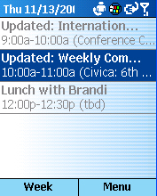
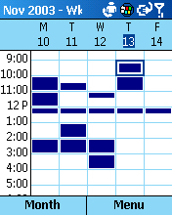

- From the home screen, go to Start > Calendar. Scheduled appointments for today (if any) are listed on this screen.
- Add an appointment. Select Week with the left soft key.
- Select Menu > New.
- Enter “dentist” as the subject, using the number keys. Set the time as 4 p.m. to 5 p.m. today, and adjust the other fields as you like. Press Done.
- At either the week or month calendar view, highlight the appointment time or day, and press the Action key to see the appointments for that time block. Click the Action key again to drill down on a specific appointment, or edit the appointment by selecting the left soft key or by selecting Menu with the right soft key and then Edit.
- Press the Home key. Note that today’s 4 p.m. dentist appointment appears on the home screen.

Internet Browsing With Pocket Internet Explorer
As more and more phones move into the feature-phone realm, offering rudimentary browsing capabilities, Microsoft sets a high standard by offering the same robust browser as Pocket PC, optimized for Windows Mobile software for Smartphones.
Multimode browsing: Windows Mobile software offers the same browser software as Pocket PC, which means it supports HTML 3.2, cHTML, MSXML, JScript®, WAP 1.2.1 and WTLS (wireless transport layer security).
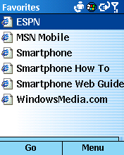

In addition, the browser is flexible: Favorites and options can be reset according to the user’s preferences, and users can access any URL or get a list of their recent online history. Furthermore, Smart Look-Up speeds the entry of URLs (Note: Windows Mobile software Favorites also can be added via the desktop).

- From the home screen, select Start > Internet Explorer. The Favorites page is essentially the starting point for Internet browsing, enabling quick access to the user’s most frequently used Web sites.
GPRS = Internet: General packet radio service (GPRS) is technology that enables any GSM network to be fully Internet-capable. GPRS supports standard data protocols such as IP and X.25. The icon indicates that phone is within GPRS coverage, and indicates the signal strength.
New Feature
Pocket Internet Explorer new supports XHTML, IPv6, Cascading Style Sheets, JavaScript 5.5, Windows Markup Language 2.0, and WTLS and animated images.
- Select one of the Favorites links, and select Go to get online.
- Return to Favorites, and select Menu > Address Bar.
- At the Address Bar screen, press and hold the Back button to clear any text in the URL box, and type in “msn.” Windows Mobile software will offer any choices from your call history or Favorites that match “msn,” and it will build a URL by adding the standard Web prefix and suffix.
- Scroll down to http://www.msn.com/ and select Go.
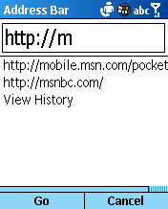

- Try some other URLs. A few sites with content optimized for Windows Mobile software include these:
http://www.devicesrus.net/spportal/
http://pda.ananova.com/
http://www.handango.com/

MSN Messenger
Windows Mobile software for Smartphones has a built-in MSN Messenger client for instant messaging. It has the core functionality and look that customers are used to from their PC, modified to fit the Windows Mobile interface.
Features for easy instant messaging: Windows Mobile software for Smartphone’s MSN Messenger supports automatic logon when a connection is available, as well as a menu of common phrases, called My Text, which can be a real time saver. Windows Mobile software also supports multiperson instant messaging, so users can chat with more than one person at the same time.
New Feature
MSN Messenger now supports IPv6 for enhanced interoperability with other IPv6-based applications and systems.

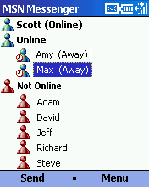

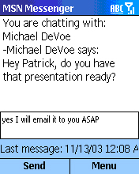
New Feature
SMS character counter displays a running character total in the title bar as SMS messages are composed. If the character count goes over 160, a message is displayed.

Windows Media Player
Windows Mobile software for Smartphones includes Windows Media Player, which supports local and wireless streaming audio and video playback. A number of file formats are supported including WMA and MP3. Audio can be heard through the speaker on handset or through a plug-in headset. The memory card slot on handset provides the flexibility for users to store video clips and many hours of music on MMC or SD cards. Windows Mobile 2003 includes support for Windows Media Player 9 Audio and Video, so users can now watch and listen to multimedia content encoded in the Windows Media Player 9 format.
Multimedia: Windows Media Player supports local and streaming video, audio and music files on Windows Mobile based Smartphones, providing a rich experience for business and personal use.

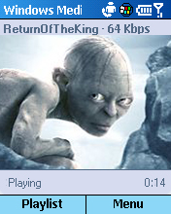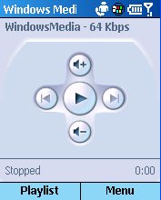
New Feature
Windows Media Player may be used as a playback engine to enable the Windows Mobile based Smartphones to play WMA files as incoming call phone ring tones. Windows Media Player ring tones can support Digital Rights Management for protecting the intellectual property associated with the ring tone.

To listen to your music, simply use the Joy Stick:
- To stop or start play, push the middle of the Joy Stick once.
- Tap the Joy Stick to the right to fast forward and the left to rewind.
- To adjust volume, simply tap the Joy Stick up or down.

Other Features

Voice Notes
Windows Mobile software for Smartphone focuses its notes application around audio notes. The Voice Notes recorder allows people to input and review their voice notes.

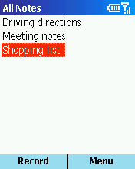

- From the Start menu, press 9 and then 9 again and then press Voice Notes or the corresponding number.
- Select Record, and Stop when you’re through recording.
- With your new recording highlighted, select Menu > Rename.
- Press and hold the Back key to erase the default name.
- Now we’ll type in “biz mtg.” In this mode, each key scrolls through its assigned letters as you press the key.
- Type 2 twice, quickly, and pause. The “b” should appear.
- Type 4 three times quickly for the “I,” and so on. Remember the # key inserts a space. Press Done when you’re finished renaming your note.
- With your new Voice Note highlighted, play back the note by pressing the Action key.

Conclusion
This tour has given you a feel for the versatility and depth of Windows Mobile 2003 software for Smartphones as a tool for mobile professionals and consumers to stay connected and up to date. As a mobile phone and an extension of the user’s desktop Outlook, Windows Mobile based Smartphones offers a combination of features unmatched by any other wireless phone.

Thank you for taking the time to evaluate Windows Mobile software for Smartphones. We encourage you to continue browsing the interface and exploring the many features that we haven’t touched on in this guide.

#########

Appendix – Connection Manager

Configuring Windows Mobile-Based Smartphone for GSM/GPRS Networks
The following steps are for the manual configuration of Windows Mobile software for Smartphones without the use of a PC. For users with a PC, the simplest and fastest way to configure Windows Mobile software is with the CD included with the device.
- Insert the subscriber identity module (SIM) card provided with your evaluation materials. To do so, remove the casing on the back of the phone. The slot for the SIM card is underneath the battery. Insert the battery and close the case.
- You may be able to use the SIM card from your own cellular phone (if the phone is not locked to a specific mobile operators SIM card). If you are using a GSM mobile phone today, your phone is equipped with a SIM card, essentially a small card that uniquely identifies and authenticates you to the network. Windows Mobile software will accept your SIM card and apply your existing service (phone number, authentication, user and contact information stored on your card) to the Windows Mobile based device.
SIM migration: Windows Mobile software lets you import any SIM contacts into the Contacts application, making all SIM data available.
- Turn Windows Mobile-based Smartphone on by pushing the power button. (For more information on the location of the power button, please refer to the hardware information that has been provided.) The home screen appears as Windows Mobile software searches for the network, and a signal strength indicator appears in the taskbar in the upper-right corner.
- Windows Mobile software is preconfigured with the appropriate connection settings out of the box. For your reference, we have also included the access point name (APN).
Windows Mobile software supports CDMA, which does not require any configuration from the user. It is done by the mobile operator.

The APN address is:

- Set the time and date:
  - Push the left soft key to select Start.
  - Use the joystick to navigate to Settings.
  - Use the joystick to navigate to More… > Date and Time.
  - Select your time zone, and enter the current date and time.
  - Push the left soft key when you are Done.

Configuring Windows Mobile software for dial-up access to a corporate network connection
- Go to Start > Settings > More… > Data Connections.
- Open the menu and select Edit Connections.
- Open Dial-up Connections.
- Open the menu and select Add.
- Fill in the fields for (Corporate Network) Dial-up:
- Description:
- Connects to: [from menu using joystick] My Corporate Network
- Country code:
- Area code:
- Phone number:
- Username: [your username]
- Password: [your password]
- Domain: [your domain]
- Press Done twice.

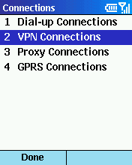
Configuring Windows Mobile software for a VPN connection into a corporate network connection
- Go to Start > Settings > More… > Data Connections.
- Open the menu and select Edit Connections.
- Open VPN Connections.
- Open the menu and select Add.
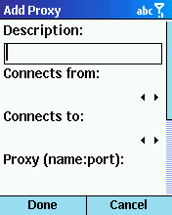
- Fill in the fields for (Corporate Network) Dial-up:
- Description:
- VPN type:
- Server:
- Connects from:
- Connects to:
- Username: [your username]
- Password: [your password]
- Domain: [your domain]
- IPSec authentication:
- IPSec Pre-shared key:
- Press Done twice.

Configuring Windows Mobile software for a proxy server
- Open Proxy Connections.
- Open the menu and select Add.
- Fill in the fields for (proxy server) (HTTP):
- Description:
- Connects from: Work
- Connects to: The Internet
- Proxy (name: port): [Press the 1 key multiple times for the colon, the 8 key four times for the numeral 8.]
- Type:
- User name:
- Password:
- Press Done.
- Open the menu and select Add.
- Fill in the fields for SOCKS4, for use with MSN Messenger:
- Description: IM
- Connects from: Work
- Connects to: The Internet
- Proxy:
- Type: SOCKS4
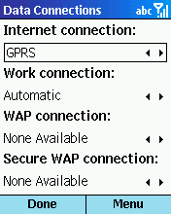
Press Done three times to close the Data Connections control panel.

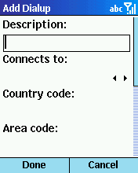

ActiveSync: Configuring Windows Mobile software for server synchronization
- Select Start > ActiveSync.
- Open the menu and select Options.
- Select one of three sync schedules: Mobile, PC or Server.
- Select Mobile Schedule:
- Fill in the fields for Mobile Schedule
- Peak time sync:
- Off-peak time sync:
- Roaming sync
- Press Done.
- Select PC Schedule.
New Feature
Suspend/Resume feature allows GSM- and CDMA-based Smartphones to maintain a data connection when the user is on the phone or the phone is off.
- Fill in the fields for PC Schedule:
- Use (select the PC you want to sync with)
- Press Done.
- Select Server Schedule
- From the Server Schedule menu, open Inbox, Calendar and Contacts and make sure that the Synchronize option is checked in each. This step enables you to configure the number of days’ worth of e-mail to download and how much of each message should initially be downloaded.
- Select Connection and fill in the fields
- User name:
- Password:
- Domain:
- Server name:
- Press Done.
- Select Conflicts, and select whether to replace items on the device or on the server when a conflict occurs.
- Press Done three times.
- To initiate synchronization, select ActiveSync and then Sync. You can also sync your inbox by pressing Send/Receive.
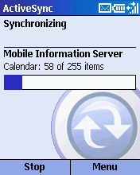

Setting up Data Connections
- From the home screen, go to Start > Settings > More… > Data Connections. Note the existing connections configured for your Windows Mobile software.
- Select Menu > Edit Connections. Connections are organized into dial-up, VPN, proxy and GPRS categories. Select one of these, and press Menu to add or edit a connection.
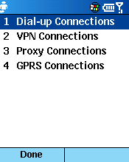
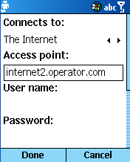

Configuring POP3/IMAP4 e-mail
- Select Start > Inbox.
- Open the Menu and select Options.
- Select Account Setup.
- Select Menu > New to move forward with setting up your POP3/IMAP4 e-mail account.
- Fill in the fields for your account:
- Your name: [your Name]
- E-mail Address: [your e-mail address]
- Automatic setup: [Attempt to obtain e-mail settings from the Internet]
- Select Next. Phone will attempt to obtain settings, but manual entry is recommended for corporate e-mail.
- Fill in the fields for your account:
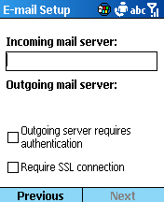
- User name: [your user name]
- Password: [your password]
- Domain (if necessary): [your domain]
- Check save password.
- Fill in the fields for your account:
- Server type:
- Account name:
- Network:
- Select Next.
- Fill in the fields for your account:
- Incoming mail server: [your POP3 incoming mail server]
- Outgoing mail server: [your POP3 outgoing mail server]
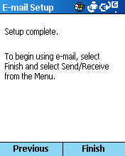
- Network: [The Internet]
- Select Next.
- Fill in the fields for your account:
- Download the following messages: [All messages, first 500 bytes]
- Select Next.
- Fill in the fields for your account:
- Connect automatically and check for messages: [Never]
- Select Next.
- To complete setup, select Finish.
- Press Done.
- Confirm: Would you like to download mail for this account now? [Yes, No]

