

Quick Migration with Hyper-V
White Paper

Published: February 2008
For the latest information, please see www.microsoft.com/windowsserver2008/virtualization/default.mspx

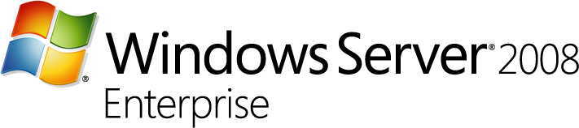
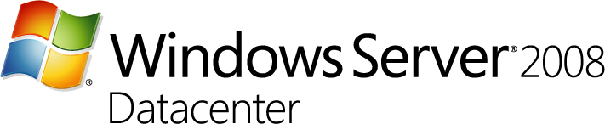

Contents
Introduction 1
The Need for High Availability and Quick Migration 1
What Is Hyper-V Technology? 2
Hyper-V Architecture 2
Quick Migration 3
Scenario: Quick Migration with Hyper-V 5
System Requirements 6
Set Up a Cluster 7
Create a Highly Available Virtual Machine 8
Fail Over a Workload with Quick Migration 17
Security Considerations 21
Conclusion 22
Appendix: Glossary 23
Related Links 25

Introduction
Most mid-sized to large businesses want to implement high availability within their virtual infrastructures. Quick migration makes this possible. Quick migration takes advantage of the failover clustering functionality and the Windows Server® Hyper-V™ hypervisor-based virtualization technology included in many 64-bit editions of Windows Server® 2008. Quick migration can provide a wide variety of services through a small number of physical servers and, at the same time, maintain the availability of those provided services. If a physical host server experiences an unscheduled service disruption or requires scheduled downtime, another host server is ready to begin supporting services quickly, with minimal downtime.
In this white paper, we begin with an introduction to quick migration and the Hyper-V technology. We then describe how to apply quick migration to enhance the availability of services. We explore how you can prepare for planned downtime by using quick migration to save the state of a running virtual machine, move the storage connectivity from one physical server to another, and then restore the virtual machine (for unplanned downtime, the virtual machine is failed over automatically and the state is not saved). We examine a specific scenario, assuming that Windows Server® 2008 Enterprise or Windows Server® 2008 Datacenter is already installed. We explain how to set up the failover clustering service, how to configure Hyper-V, and how to use quick migration to fail over a workload and maintain services.
(Note: this white paper is based on beta code and is subject to change.)

The Need for High Availability and Quick Migration
Today’s IT departments are under increasing pressure to manage and support expanding computer resources while at the same time reducing costs. Server virtualization, which lets multiple operating systems run concurrently on the same physical server, has become a broadly accepted method to meet these requirements. By converting under-utilized physical servers into virtual machines that run on a single physical server, organizations can reduce space and hardware costs in the data center. Because virtual machines are generally much faster to recover in a disaster than physical computers are, virtualization also increases server uptime and reliability.

Business Continuity and Disaster Recovery
Business continuity is defined as the ability to minimize both scheduled and unscheduled downtime. This includes time lost to routine functions, such as maintenance and backup, in addition to unanticipated outages. Hyper-V provides business continuity through quick migration, empowering businesses to meet stringent uptime and response metrics.
Disaster recovery is a key component of business continuity. Natural disasters, malicious attacks, and even simple configuration problems such as software conflicts can cripple services and applications until administrators resolve the problems and restore any backed-up data. Taking advantage of the clustering capabilities of Windows Server 2008, Hyper-V provides support for disaster recovery within IT environments and across data centers using geographically dispersed clustering capabilities. Rapid and reliable disaster and business recovery helps ensure minimal data loss and powerful remote management capabilities.

Windows Server 2008 Enterprise and Windows Server 2008 Datacenter
Quick migration takes advantage of the failover clustering functionality and the Hyper-V virtualization included in many editions of Windows Server 2008, providing a powerful tool for maintaining server availability and meeting changing business computation needs.

What Is Hyper-V Technology?
Windows Server 2008 Hyper-V is the hypervisor-based virtualization feature included as part of Windows Server 2008. Hyper-V is installed and managed as a role under Windows Server 2008, just like DHCP, file services, and print services. A hypervisor is a thin layer of software that makes it possible for multiple operating systems to run on a host computer at the same time. The hypervisor software runs directly on the hardware platform and beneath all of the operating systems running on the computer; the kernel interfaces with the hypervisor to provide the best overall performance and scalability. In many ways the hypervisor is similar to a kernel: it manages memory, schedules threads (virtual processors), and handles basic functionality of the system.
Some of the capabilities of Hyper-V include x86 and x64 guest support, the ability to run guest machines in a multi-processor environment, large memory allocation per virtual machine, integrated virtual switch (which enables virtual LAN [VLAN] tagging for complex network configurations) support, and the ability to migrate virtual machines across hosts with minimal downtime (quick migration).
Windows Server Hyper-V includes synthetic device drivers, which improve performance by dramatically reducing the number of times the computer’s CPU needs to switch between kernel mode (the mode in which the trusted code in the operating system performs the task) and user mode (the mode in which the applications run); switching between modes is expensive in terms of clock cycles.

Hyper-V Architecture
Hyper-V supports isolation using partitions in which the operating systems execute. There is a parent (or root) partition running either a full installation of Windows Server 2008 or a Server Core installation (which provides a minimal environment for running specific server roles). The virtualization stack, a collection of software components that work together to support the virtual machines, runs in the this parent partition and has direct access to the hardware devices. From the root partition, child partitions can be created; these child partitions can run different operating systems, including hypervisor-aware operating systems and previous operating systems. The child partitions do not have direct access to the hardware resources. Their requests are redirected through the parent partition via a virtual machine bus (VMBus), a subsystem for exchanging requests and data (see Figure 1).
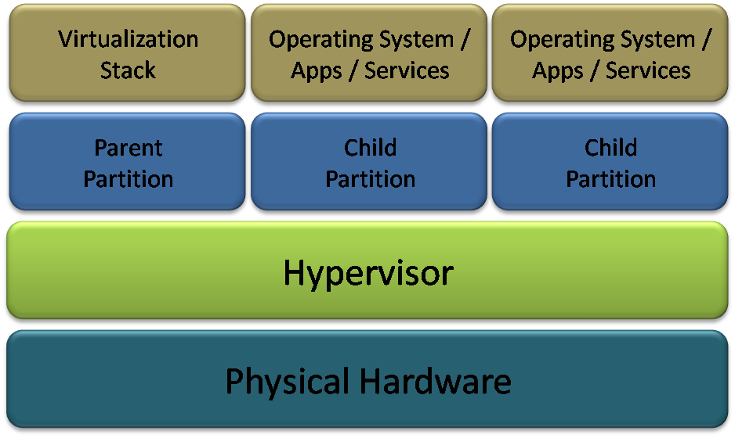
Figure 1 Hyper-V architecture

Quick Migration
With quick migration, you can rapidly migrate a running virtual machine from one physical host system to another with minimal downtime, taking advantage of the familiar high-availability capabilities of Windows Server and Microsoft® System Center management tools. Using Windows Server Hyper-V and the quick migration capability, you can consolidate physical servers and, at the same time, maintain the availability and flexibility of business-critical services during scheduled maintenance, or quickly restore services after unplanned downtime.
In previous versions of Windows®, Windows saw the files that make up the virtual machines (the virtual hard disk [VHD] files) on the logical unit numbers (LUNs); the Windows Cluster Administrator saw just the LUNs, and could not recognize that virtual machines were on these LUNs until they were registered and associated through the use of a script. Windows Server 2008, however, can recognize a virtual machine and therefore does not require a script to shut down, migrate, and restart the virtual machine as it moves between hosts; this makes migration of virtual machines faster and easier.
With Windows Server 2008 Enterprise and Windows Server 2008 Datacenter, you can run each server that provides client services as a guest virtual machine on a physical server and configure the physical server as a node in a failover cluster (a group of connected computers that work together to provide high availability for services through redundant nodes). You can then make the virtual hard disk of the guest virtual machines available to the other nodes within the cluster, so each server providing client services now runs as a highly available virtual machine. With this configuration, other physical servers in the cluster are ready to support the guest virtual machines when needed through quick migration.
For a planned migration, quick migration saves the state of a running guest virtual machine (memory of original server to disk/shared storage), moves the storage connectivity from one physical server to another, and then restores the guest virtual machine onto the second server (disk/shared storage to memory on the new server). The speed of the migration depends on how much memory needs to be written to disk, and on the speed of the connectivity to storage; generally, migration takes just a few seconds. In the case of unplanned downtime, you would not be able to save the state of your workload; instead, the images written to the disk would be failed over from the shared storage automatically.
Note that to use quick migration with the new Windows Server Hyper-V functionality, you have to create a cluster. You therefore need to use Windows Server 2008 Enterprise or Windows Server 2008 Datacenter to take advantage of quick migration.

Scenario: Quick Migration with Hyper-V
To illustrate the capabilities and the ease of use of quick migration with Hyper-V, we examine a simple scenario that uses two host physical servers (or nodes), with a virtual machine (a guest) on one of the host machines. The network topology for the scenario is shown in Figure 2. Only one of the two nodes hosts the virtual machine at any given time; this is called an active/passive cluster. The other node is standing by and would take over hosting the virtual machines were the first node to fail. In this scenario, we migrate a workload from the first node to the second node—you could use this procedure if you needed to perform maintenance on your first node. Note that you can also run an active/active cluster configuration, in which each node in the cluster is running virtual machines.
The following diagram shows the cluster setup for this scenario. The public network is used to connect these cluster nodes, in addition to the virtual machine, to other network resources, such as domain controllers, printers, and routers. The private network is used exclusively for cluster-related network traffic and it lets the cluster nodes verify the state of other cluster nodes. The network used to connect shared storage to the cluster depends on what type of shared storage you use; this can be Fibre Channel or iSCSI.
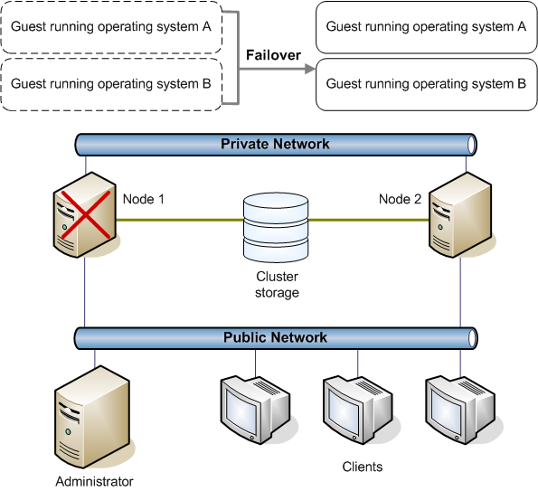
Figure 2 Quick migration scenario schematic

System Requirements
The following system requirements include software, hardware, network, and storage requirements for a quick migration scenario.

Software Requirements
Following are the software requirements for the host nodes:
- You must have Windows Server 2008 Enterprise or Windows Server 2008 Datacenter (with Hyper-V) installed on the nodes. Because Hyper-V role is included with the operating system, you can create the virtual machine and move it between nodes using quick migration (in conjunction with cluster services).
- You need licensed copies of the operating system and other software that you run on the guest virtual machine. Windows Server 2008 Enterprise allows four virtual image use rights, while Windows Server 2008 Datacenter allows unlimited virtual instances.
- Your system must be using a name-resolution service, such as Domain Name System (DNS), DNS dynamic update protocol, Windows Internet Name Service (WINS), or Hosts file. In most cases, DNS should be sufficient.
- All nodes in the cluster must be in the same Active Directory® domain. As a best practice, all nodes should have the same domain role.

Hardware Requirements and Guidelines
In addition to the system requirement for Windows Server 2008, the two key requirements for the Hyper-V platform are a 64-bit server environment and support for hardware-assisted virtualization technology, such as Intel Virtualization Technology (Intel VT) or AMD Virtualization (AMD-V).
Following are the hardware requirements for the two nodes:
- The two nodes in the cluster must have identical hardware and the same processor architecture.
- The failover cluster is installed on a storage area network (SAN), and has multiple devices and clusters sharing the SAN with a cluster; therefore, the hardware components must be compatible.
The table below lists specifications that each host computer should meet:
Table 1: Minimum Host Computer Prerequisites
Hardware | Minimum Requirement
Minimum CPU speed | 1.0 GHz
Processor information | Intel VT or AMD-V
Minimum RAM | 512 MB (additional memory needed for each guest operating system)
Required available hard-disk space | 2 GB on each node. Additional disk space needed on shared storage for each guest operating system.

(Note: this white paper is based on beta code and is subject to change.)

Network Requirements and Guidelines
Following are the network requirements for the two nodes:
- Each of the cluster nodes requires at least two network adapters and must be connected by two or more independent networks. At least two LANs or VLANs are required to prevent a single point of failure.
- The two nodes in the cluster must be able to access an Active Directory domain controller. The cluster service requires that the nodes be able to contact the domain controller to function correctly. The domain controller should be in the same location and on the same LAN as the nodes in the cluster.

Storage Requirements and Guidelines
Following are the storage requirements for the two nodes:
- An external disk storage unit must be connected to all nodes in the cluster. This external storage unit is used as the cluster storage. You should also use some type of hardware redundant array of independent disks (RAID).
- If you are using iSCSI, each node must have a network adapter dedicated to the cluster storage.

Set Up a Cluster
To perform quick migration, you must first set up a cluster with your servers. For this scenario, the cluster will have only two nodes (though up to 16 nodes are supported). Setting up a cluster in Windows Server 2008 is intuitive, quick, and simple. Setup is streamlined; you can create the entire cluster in one seamless step. You simply name the cluster, dictate which servers will be in the cluster, and let the wizard do the rest.
In this scenario, we use only one virtual machine. In general, the number of virtual machines running per host depends on several things, including physical memory, processor, and workload running in the guest operating system. With Hyper-V, you define the amount of memory available to a virtual machine. That memory allocation can be altered to reflect the needs of the virtual machine. Hyper-V supports both 32-bit and 64-bit systems as guest operating systems, and supports up to 64 GB of RAM in each guest operating system. Windows Server Hyper-V also supports allocating up to four physical CPU cores to each guest operating system.

Install Windows Server 2008
The first step is installing Windows Server 2008 Enterprise or Windows Server 2008 Datacenter in the same domain on the host servers that will become the cluster nodes. You must be logged on locally with a domain account that is a member of the local administrators group on all nodes. You then install the failover cluster feature; Hyper-V will be installed by default.
Once Windows Server 2008 Hyper-V is installed, it can be managed via the Microsoft Management Console (MMC) in the same way that other server roles are managed. Select Hyper-V Manager from the Administrative Tools folder on the Start menu to start the Hyper-V MMC console. You can manage either the local system, or connect to other servers and manage them as well. Within the Hyper-V Manager console, you can easily create new virtual machines, modify the settings for the host and virtual machines, stop and start virtual machines, and take snapshots—all using the familiar wizard-based Windows interface.

Configure the Cluster
Next, you can set up and configure the server cluster using the wizards. Note that you must connect both nodes to shared storage—this enables the failover from one node to another.
Set up network
To create the two-node cluster, start by setting up the network. Ensure that the network adapter binding is set in the correct order and configure the private network adapters. Next, configure the public network adapters, using DHCP or static IP addresses. To verify that the private and public networks are communicating properly, ping all IP addresses from each node. (To ping an IP address means to search for and verify it.) You should be able to ping all IP addresses, both locally and on the remote nodes.
Set up and configure cluster disks
The first step in setting up disks for a cluster is to configure the cluster disks you plan to use. It is necessary to complete this step before you configure the cluster because shared storage is a requirement for creating a cluster. You can step through the wizards to configure the cluster disks. When you have done so, you have two computers running Windows Server that are connected to each other via both a public and private network. Each computer is configured to be able to access the same shared storage device. You are now ready to create the server cluster that will use these two computers.
Create the server cluster
To create the host cluster, you must first provide all initial cluster configuration information. To do this, you can use the New Server Cluster Wizard. After stepping through the wizard for the first node, validate the configuration from the Failover Cluster Management, and then configure the second node using the Add Node Wizard. You now have a simple two-node cluster that is ready to host virtual machines.

Create a Highly Available Virtual Machine
You are now ready to create a virtual machine and set up the host cluster using the Hyper-V virtualization feature in Windows Server 2008. In this scenario, we create a virtual machine on the first node. With quick migration, the workload on this virtual machine can then be almost seamlessly failed over to the second node with minimal disruption to the services running on it.

Create a Virtual Machine
You can use Hyper-V to easily create a virtual machine with the New Virtual Machine Wizard. The wizard lets you define the name and location, the size of the memory, and the network information. This virtual machine will reside on the shared storage (you manually select this location in the dialog box), and can be hosted by either of your cluster nodes. Note that any workload can be placed on this virtual machine.
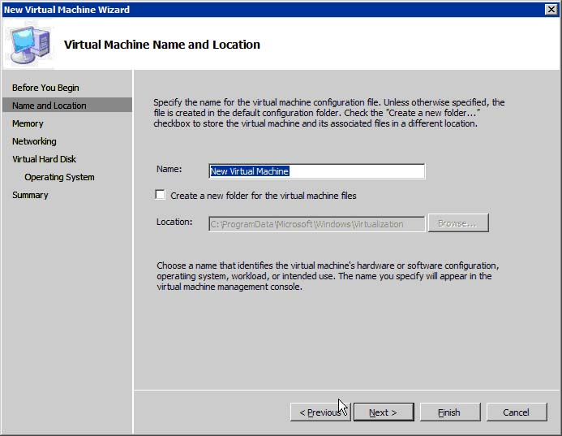
Figure 3 New Virtual Machine Wizard
Create the host cluster
Once you have your virtual machine residing on the shared storage, you can create the host cluster. With quick migration and Hyper-V, there are really just two questions that you need to answer:
- Which resources do you want to make highly available?
- Which virtual machines do you therefore want to cluster?
The rest is simple. The process is wizard-driven and fast.
Use a wizard within the Cluster Management snap-in to set up the host cluster. The wizard provides a fully integrated experience, enabling you to select the service or application that you wish to configure for high availability from a long list of options.
In the following figure, the virtual machine option is selected as the service or application to make highly available.
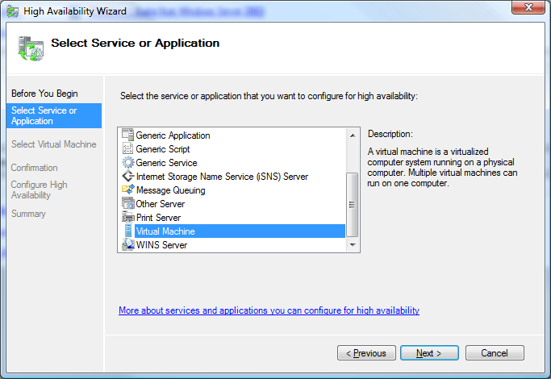
Figure 4 High Availability Wizard
A wizard scans for configuration files (VMCs), and a list of all available virtual machines, their status, and their host servers is displayed. Virtual machines are added to the list dynamically. You can select multiple virtual machines to make highly available in a single action. In Figure∙5, virtual machine guest1 and virtual machine Guest7 are selected.
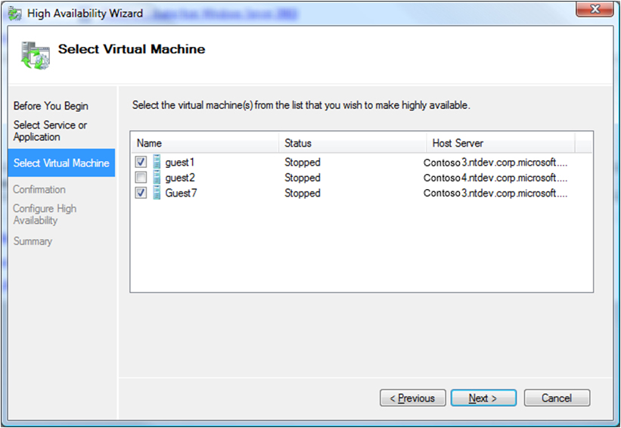
Figure 5 Select Virtual Machine page

You can then confirm which virtual machines you want to cluster (see Figure 6).
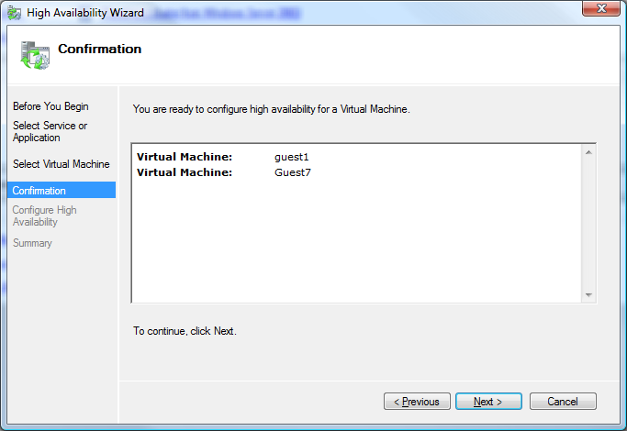
Figure 6 Confirmation page

Much of the work is done for you by the wizard. The following figure shows the Configure High Availability page of the High Availability Wizard—when the wizard is finished, you will have a host cluster (see Figure 7).
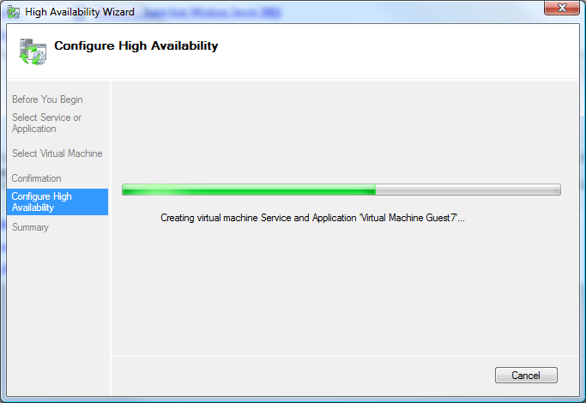
Figure 7 Configure High Availability page

The final page of the wizard provides a summary. You can view a report detailing your host cluster (see Figure 8).
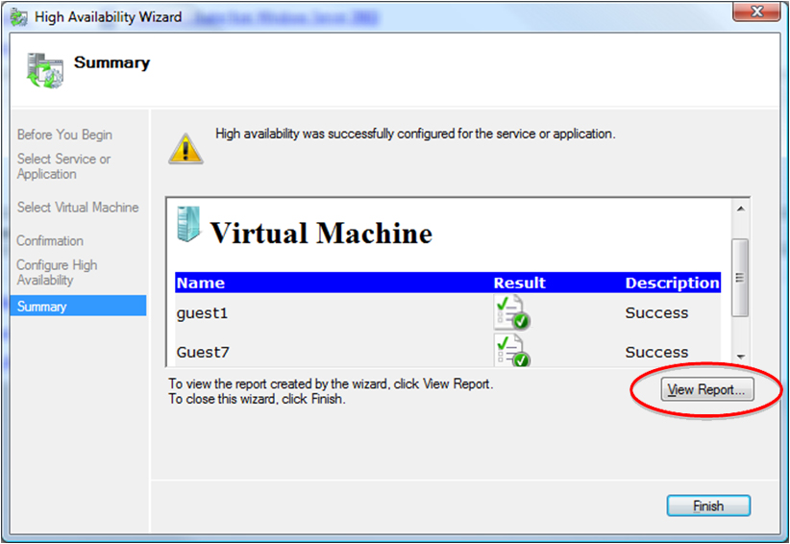
Figure 8 Summary page

A rich HTML log showing actionable errors can be displayed for review as well (see Figure 9).
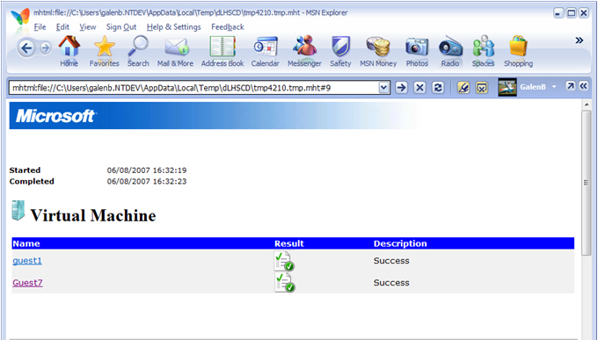
Figure 9 HTML log

The virtual machines are now clustered, along with the appropriate shared storage. Hyper-V actions are natively exposed in the Cluster snap-in, so you can move to the Failover Cluster Management console in Windows and configure the behavior of your virtual machines further in the Actions pane (see Figure 10).
You can see the status of virtual machine Guest7 in the Failover Cluster Management console under Services and Applications. Guest7 has not yet been brought online.
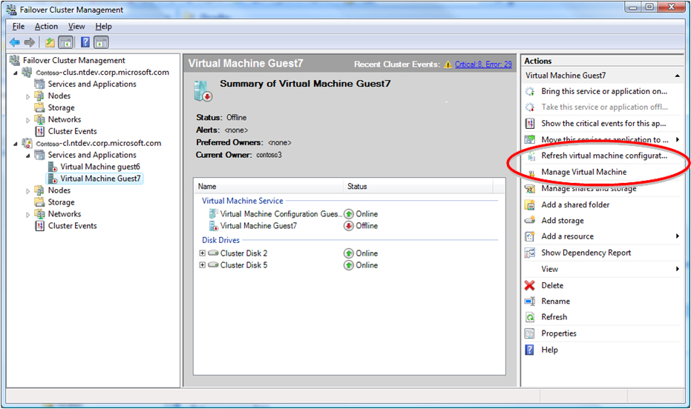
Figure 10 Failover Cluster Management console

While a virtual machine is being brought online, you can get very detailed information as to the background actions and status on the Summary page, so that you know exactly what is happening (see Figure 11 and Figure 12).
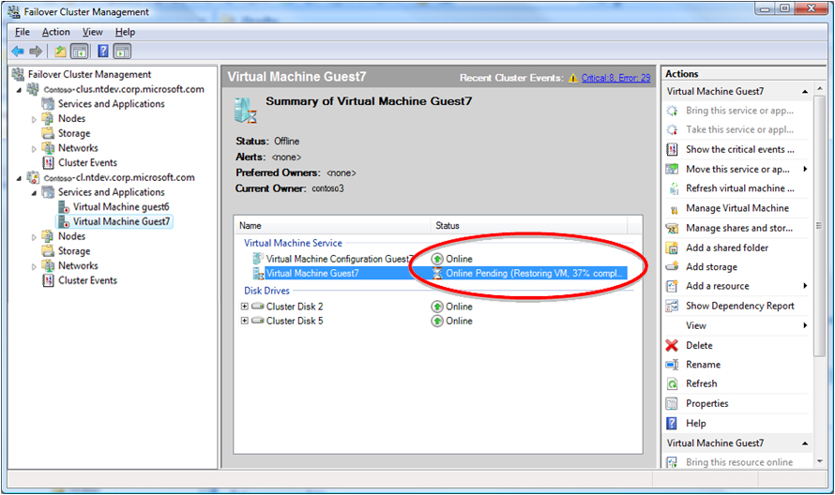
Figure 11 Failover Cluster Management, bring online

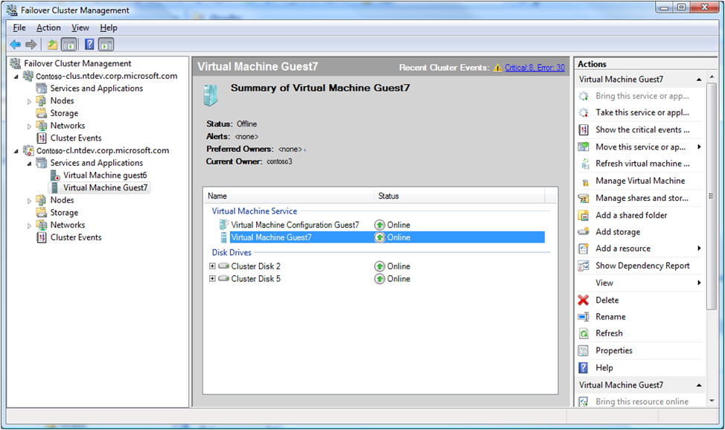
Figure 12 Failover Cluster Management, virtual machine is online

Fail Over a Workload with Quick Migration
Once your virtual machine is online, you can use quick migration to quickly move it between your host servers.
The Hyper-V Manager provides information about your host server. In the following figure, you can see that virtual machine Guest1 is running on node constoso4.
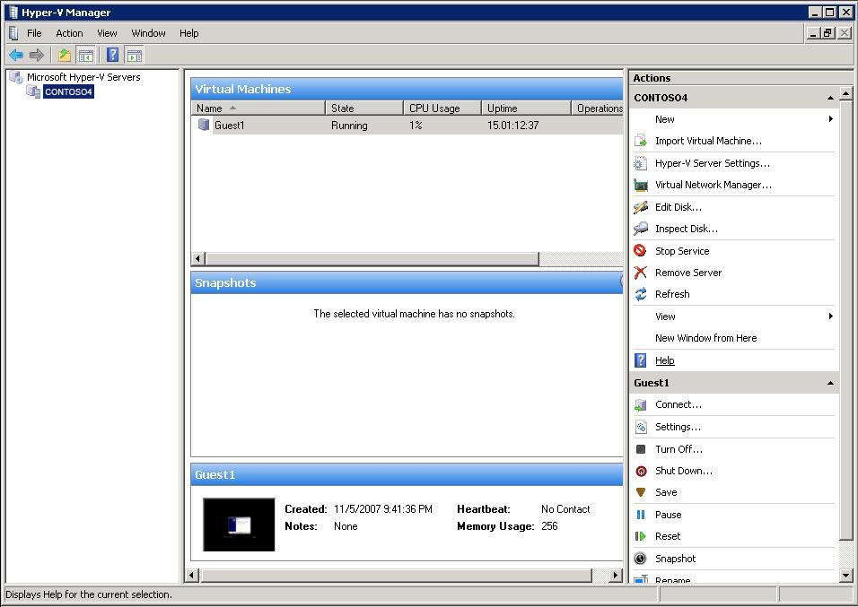
Figure 13 Hyper-V Manager

To begin the quick migration, start in the Failover Cluster Management console. Here you can view the virtual machines running on the individual nodes. Highlighting a virtual machine provides a summary of its properties, as shown in the following figure for node contoso3.
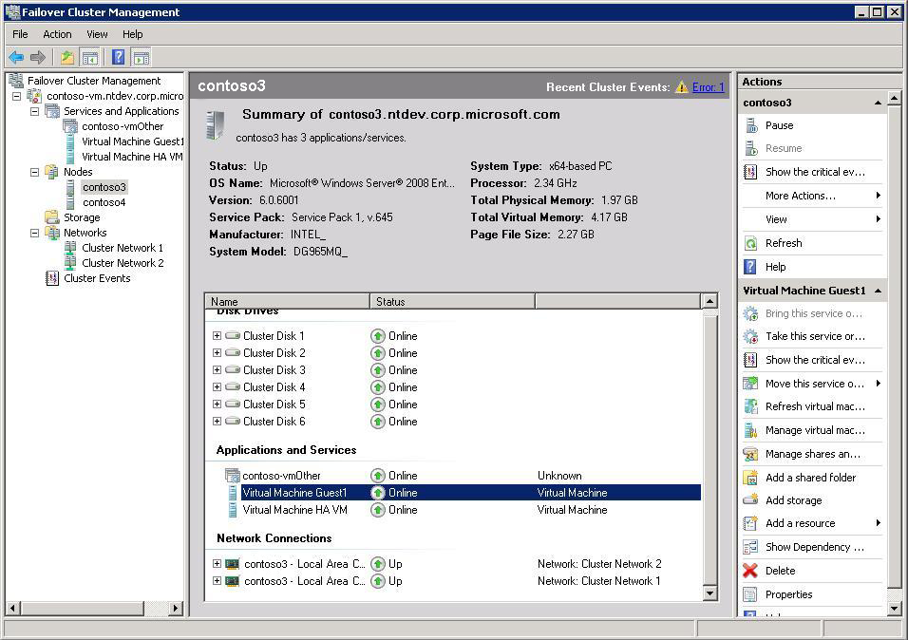
Figure 14 Failover Cluster Manager

Right-click on the virtual machine name; the Actions menu appears. You now have the option to move the virtual machine to another node and you can choose the destination node. In the following figure, Virtual Machine Guest1 will be moved from node contoso3 to contoso4.
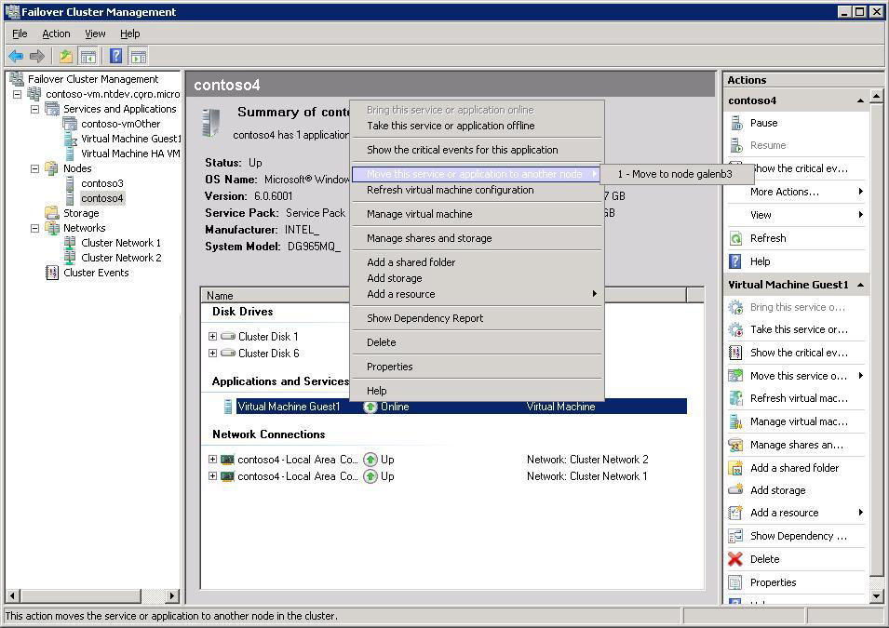
Figure 15 Actions menu
Once the command has been run, the virtual machine enters a pending state before it is moved. In the following figure, Virtual Machine Guest1 is in a pending state.
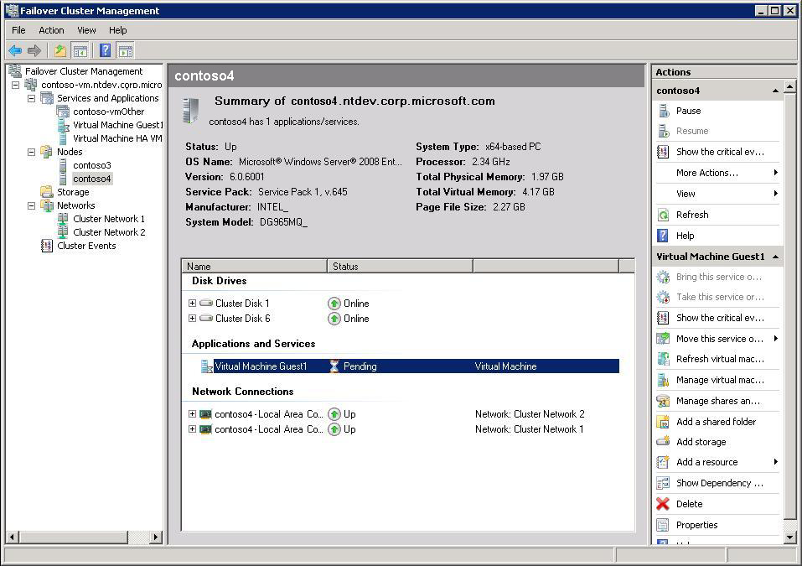
Figure 16 Migration pending

After a few seconds, the virtual machine appears on the destination node and the status will return to Online. In the following figure, the Virtual Machine Guest1 is Online and is hosted on node contoso4. The quick migration process is complete.
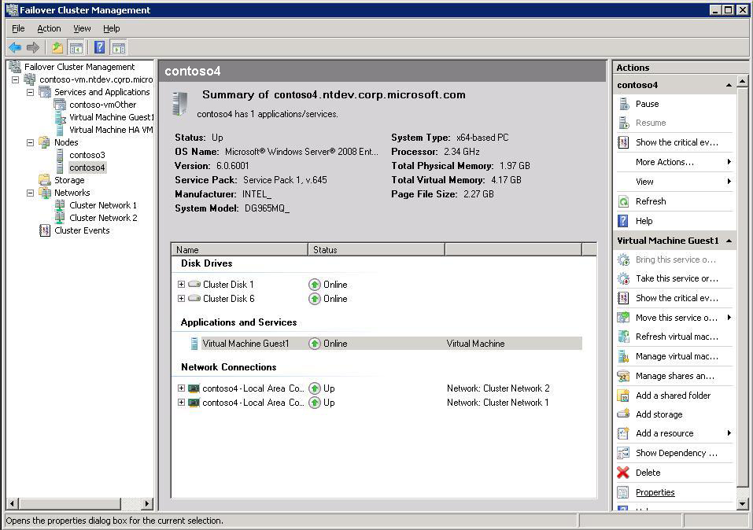
Figure 17 Migration complete

Security Considerations
Firewall and antivirus software running on the host operating system do not protect guest operating systems. To obtain this protection, you must install firewall and antivirus software directly on the guest operating systems.

Conclusion
You can take advantage of Windows Server 2008 Hyper-V and the clustering functionality in Windows Server 2008 Enterprise or Windows Server 2008 Datacenter to provide high-availability and disaster-recovery capabilities to your server workloads. With quick migration, you can quickly and easily move virtual machines between your host servers with minimal downtime.
Hyper-V, the hypervisor-based virtualization feature included as part of Windows Server 2008, contains everything needed to support machine virtualization. Hyper-V enables your IT organization to reduce costs, improve server utilization, and create a more dynamic IT infrastructure. With Hyper-V, you can virtualize multiple operating systems—Windows, Linux, and others—on a single server and fully apply the power of x64 computing.

Appendix: Glossary
The following terms are helpful in understanding quick migration in Windows Server 2008.
active/passive and active/active cluster configurations
Two forms of server clusters. In active/passive clustering, the cluster includes active nodes and passive nodes—the passive nodes are only used if an active node fails. In active/active clusters, all nodes are active—in the event of a failover, the remaining active node takes on the additional processing operations, which causes a reduction in the overall performance of the cluster. Active/passive cluster configurations are generally recommended over active/active configurations because they often increase performance, availability, and scalability.
cluster service
Service that facilitates clustering of nodes. Included with Windows Server 2008.
cluster storage
Storage that is attached to all nodes of the cluster. Each disk on the cluster storage is owned by only one node of the cluster at a time. The ownership of disks moves from one node to another during failover or when the administrator moves a group of resources to another node.
failover
The process of taking a group of clustered resources (such as a disk on which data is stored) offline on one node and bringing them online on another node. The cluster service ensures that this is done in a predefined, orderly fashion, so that users experience minimal disruptions in service.
Fibre Channel
A gigabit-speed network technology primarily used for storage networking.
guest
An operating system running as a virtual machine in Windows Server Hyper-V. Multiple guests can run on one host, and each guest can run one or more applications.
heartbeat
Nodes in a cluster communicate using their cluster service. The cluster service keeps track of the current state of the nodes within a cluster and determines when a group and its resources should fail over to an alternate node. This communication takes the form of messages that are sent regularly between the two nodes' cluster services. These messages are called heartbeats.
host
A physical server on which a version of Windows Server 2008 is running.
Hyper-V
A hypervisor-based virtualization system for 64-bit versions of Windows Server 2008. The Windows hypervisor is a thin layer of software between the hardware and the operating system that enables multiple operating systems to run, unmodified, on a host computer at the same time. It provides simple partitioning functionality and is responsible for maintaining strong isolation between partitions. It has an inherently secure architecture with minimal attack surface, as it does not contain any third-party device drivers.
logical unit numbers (LUNs)
A unique identifier used on a SCSI bus to differentiate up to eight separate devices.
node
A computer system (server or host) that is a member of a cluster.
quick migration
Saves the state of a running virtual machine (memory to disk), moves the storage connectivity from one physical server to another, and then restores the virtual machine (disk to memory).
Server Core
An installation option for the Windows Server 2008 operating system which provides a minimal environment for running specific server roles; this reduces the maintenance and management requirements and the attack surface for those server roles.
Small Computer System Interface (SCSI)
A set of standards for physically connecting and transferring data between computers and peripheral devices. The SCSI standards define commands, protocols, and interfaces.
VHD
Virtual hard disks are stored as files accessible by the host operating system; the files can be local or anywhere the host can access (file server, SAN, etc.).
Virtual LAN (VLAN)
A group of hosts with a common set of requirements that communicate as if attached, regardless of physical location. A VLAN enables end stations to be grouped even if not located on the same LAN segment. The network can be reconfigured through software (instead of physically relocating devices).

Related Links
The following Web pages provide additional information about Microsoft virtualization solutions and related technologies:

For Windows Server Hyper-V Frequently Asked Questions, see:
http://www.microsoft.com/windowsserver2008/virtualization/faq.mspx

For more information about Windows Server Hyper-V, see:
http://www.microsoft.com/windowsserver2008/virtualization/default.mspx

For the Windows Server virtualization team blog, see:
http://blogs.technet.com/virtualization/archive/2006/06/14/WinHEC-2006-Slides.aspx

This is a preliminary document and may be changed substantially prior to final commercial release of the software described herein.
The information contained in this document represents the current view of Microsoft Corporation on the issues discussed as of the date of publication. Because Microsoft must respond to changing market conditions, it should not be interpreted to be a commitment on the part of Microsoft, and Microsoft cannot guarantee the accuracy of any information presented after the date of publication.
This white paper is for informational purposes only. MICROSOFT MAKES NO WARRANTIES, EXPRESS OR IMPLIED, IN THIS
DOCUMENT.
Complying with all applicable copyright laws is the responsibility of the user. Without limiting the rights under copyright, no part of this document may be reproduced, stored in, or introduced into a retrieval system, or transmitted in any form or by any means (electronic, mechanical, photocopying, recording, or otherwise), or for any purpose, without the express written permission of Microsoft Corporation.
Microsoft may have patents, patent applications, trademarks, copyrights, or other intellectual property rights covering subject matter in this document. Except as expressly provided in any written license agreement from Microsoft, the furnishing of this document does not give you any license to these patents, trademarks, copyrights, or other intellectual property.
© 2008 Microsoft Corporation. All rights reserved.
Microsoft, Active Directory, Hyper-V, Windows, Windows Server, and the Windows logo are either registered trademarks or trademarks of Microsoft Corporation in the United States and/or other countries.

