Published: August 2005
Live Communications Server 2005 with SP1
Enterprise Edition Deployment Guide



The information contained in this document represents the current view of Microsoft Corporation on the issues discussed as of the date of publication. Because Microsoft must respond to changing market conditions, it should not be interpreted to be a commitment on the part of Microsoft, and Microsoft cannot guarantee the accuracy of any information presented after the date of publication.
This White Paper is for informational purposes only. MICROSOFT MAKES NO WARRANTIES, EXPRESS, IMPLIED OR STATUTORY, AS TO THE INFORMATION IN THIS DOCUMENT.
Complying with all applicable copyright laws is the responsibility of the user. Without limiting the rights under copyright, no part of this document may be reproduced, stored in or introduced into a retrieval system, or transmitted in any form or by any means (electronic, mechanical, photocopying, recording, or otherwise), or for any purpose, without the express written permission of Microsoft Corporation.
Microsoft may have patents, patent applications, trademarks, copyrights, or other intellectual property rights covering subject matter in this document. Except as expressly provided in any written license agreement from Microsoft, the furnishing of this document does not give you any license to these patents, trademarks, copyrights, or other intellectual property.
Unless otherwise noted, the example companies, organizations, products, domain names, e-mail addresses, logos, people, places, and events depicted herein are fictitious, and no association with any real company, organization, product, domain name, e-mail address, logo, person, place, or event is intended or should be inferred.
© 2005 Microsoft Corporation. All rights reserved.
Microsoft, Active Directory, Outlook, Windows, Windows Server, and Windows Server System are either registered trademarks or trademarks of Microsoft Corporation in the United States and/or other countries.
The names of actual companies and products mentioned herein may be the trademarks of their respective owners.

CONTENTS

Introduction 1
Live Communications Server 2005 Enterprise Edition Overview 2
Infrastructure Requirements 3
Overview of the Deployment Process 4
Supported Configurations 5
Supported Communication 5
Deploying a Live Communications Server Enterprise Pool 6
Overview of Procedures for Deployment 7
Prerequisites 8
Creating the Enterprise Pool 10
Installing the Enterprise Edition Files 15
Activating Live Communications Server 2005 Enterprise Edition 18
Installing the Archiving Service 22
Deploying the Load Balancer, VLAN, and VIP 23
Configuring Enterprise Edition Servers 23
Configuring Using the Administrative Snap-In 24
Exporting Pool and Server Settings Using the Command-Line Tool 26
Configuring Settings Using WMI Interfaces 26
Requesting and Configuring Certificates and TLS 26
Configuring Certificates on Your Enterprise Edition Servers 27
Configuring Mutual TLS Connections 31
Configuring Certificates for Automatic Routing Among Pools and Standard Edition Servers 33
Configuring the Preferred Authentication Protocol 33
Configuring DNS, Client Access and User Settings 34
Installing and Configuring the Your Client 34
Ensuring Your Clients Can Connect to Live Communications Server 34
Creating and Configuring Users in Active Directory 40
Configuring Your Clients to Recognize Certificates 42
Configure SIP URI Domains and Other Global Settings 43
Clustering Live Communications Server 2005 Back-End 44
Additional Operations 44
Changing the Database Used by a Pool 45
Backup and Restore Operations for Live Communications Server 2005 Enterprise Edition 49
Removing Live Communications Server 2005 Enterprise Edition 51
Appendix A Load Balancer Requirements and Prerequisites 55
Load Balancer Requirements 55
Prerequisites for a Load Balancer Connecting to a Pool 56
Appendix B Enabling Activation Without Using Domain Admins Credentials 59
Step 1 Add the user account to the RTCDomainServerAdmins groups 59
Step 2 Grant the User Permissions to Edit a Service Account 60
Step 3 Grant Rights on the Computer Object 61
Step 4 Grant the User Rights to Modify Membership in the RTCHSDomainsServices Group 62
Appendix C Additional Resources 63

Introduction
This document guides you through the deployment of a Microsoft® Office Live Communications Server 2005 Enterprise pool in your organization for a single domain, single forest topology. It contains the following sections:
- Live Communications Server Enterprise Edition Overview, which explains how the Enterprise Edition varies from the Standard Edition and explains the two basic components of an Enterprise pool: Live Communications Server 2005 Back-End Database and a minimum of one Live Communications Server 2005 Enterprise Edition server.
- Infrastructure Requirements explains the necessary prerequisites for installing Live Communications Server. For example, Active Directory® directory service must be deployed, DNS (Domain Name System) must be configured, and PKI (Public Key Infrastructure) must be available.
- Overview of the Deployment Process guides you through the high-level deployment steps.
- Deploying Your First Enterprise Pool guides you through the process of deploying an Enterprise pool by creating the pool, installing the files on each Enterprise Edition Server within the pool, and activating Enterprise Edition Server.
- Configuring Enterprise Edition Servers explains how to configure your Enterprise Edition Servers by using the Live Communications Server 2005 administrative snap-in, the command-line tool, LcsCmd.exe, and the WMI (Windows Management Instrumentation) interfaces.
- Requesting and Configuring Certificates and TLS explains how to configure certificates on Microsoft Windows Server™ 2003 Enterprise CA (certification authority) and enable TLS (Transport Layer Security) on your servers.
- Configuring DNS, Client Access, and User Settings explains how to configure DNS, your users, and your clients for Live Communications Server access.
- Configuring SIP URI Domains and Other Global Settings explains how to configure SIP URI (Session Initiation Protocol Uniform Resource Identifier) domains and other global settings for your Enterprise pool.
- Clustering the Live Communications Server 2005 Back-End Database explains the basic steps required to cluster your back-end database to scale out your deployment or increase availability.
- Additional Operations includes procedures that you may require after deployment, such as backing up your data, instructions for how to restore Live Communications Server data in the event of data loss, changing the database used by Live Communications Server and removing Live Communications Server.
- Appendix A Load Balancer Requirements and Prerequisites summarizes Live Communications Server 2005 requirements for a load balancer and the tasks you must complete before deploying a load balancer.
- Appendix B Enabling Activation Without Using Domain Admins Credentials explains how to grant a user without Domain Admins credentials permissions to activate a server.
- Appendix C Additional Resources contains links to additional documentation and resources that will help you maximize your understanding of Live Communications Server and its related technologies.

Live Communications Server 2005 Enterprise Edition Overview
Live Communications Server 2005 offers a Standard Edition and an Enterprise Edition.
- Live Communications Server 2005 Standard Edition is designed for use in small- or medium-sized organizations to support a maximum of 20,000 users distributed across multiple Standard Edition Servers. A single Standard Edition Server can support up to 15,000 users on the recommended high-end hardware and software. This server is a stand-alone server with a local MSDE (Microsoft Desktop Engine) database that stores user data.
- Live Communications Server 2005 Enterprise Edition is designed for use in larger organizations. It is intended for large-scale deployments supporting up to 125,000 users. In an Enterprise deployment, one or more Live Communications Servers, deployed behind a load balancer, form what is called an Enterprise pool and share a central SQL database that stores user data.
An Enterprise pool consists of two basic components:
- Live Communications Server 2005 Back-End Database that provides shared storage for all Enterprise Edition servers within the pool. This database runs on Microsoft SQL Server™ 2000 SP3a (Service Pack 3a) and can be clustered in an active-passive configuration for higher availability.
- Live Communications Server 2005 Enterprise Edition Servers that are connected to the back-end database server. Client requests are distributed across the Enterprise Edition Servers to provide scalability and failover.
Enterprise Edition Servers in a pool are connected to a load balancer that distributes incoming requests from clients across these servers. A load balancer is always required when you deploy a pool.
For deployments of up to 20,000 users, we recommend that you use a Standard Edition Server. The Live Communications Server 2005, Access Proxy, Director, and Proxy servers require only a Standard Edition license and product key, even though they are included with both Standard Edition and Enterprise Edition.

Infrastructure Requirements
Before you install a Live Communications Server 2005 Enterprise pool ensure that your environment meets the following prerequisites:
- Active Directory is deployed.
- Domain controllers are running Microsoft Windows® 2000 SP4 or Windows Server 2003.
- Global catalog servers are running Windows 2000 SP4 or Windows Server 2003, and that you have at least one global catalog server in the forest root.
- Live Communications Server 2005 Active Directory preparation is complete. You can create a pool after Prep Schema and Prep Forest are run, but completing all Active Directory preparations steps is recommended.
- PKI is deployed and configured, either by using PKI from Microsoft or a third-party CA infrastructure. If you plan to use TLS for client connectivity, consider using an existing certification authority.
- DNS is deployed and configured correctly.
- Servers running Live Communications Server 2005 Enterprise Edition require Windows Server 2003, Standard Edition, Windows Server 2003, Enterprise Edition, or Windows Server 2003, Datacenter Edition.
- SQL Server 2000 SP3a instance is installed on the server that will host Live Communications Server 2005 Back-End Database for the pool. The SQL service should run as a domain user account with local administrator permissions on the server by using either Mixed Mode or Windows Authentication. Using Windows Authentication is recommended. Either a default instance or a named instance is supported.
- A supported load balancer is required for a pool. For more information about the supported topologies and load balancer configurations see the Microsoft Office Live Communications Server 2005 Planning Guide at http://office.microsoft.com/en-us/FX011450741033.aspx.
Important
After installing SQL Server 2003 SP3a, be sure to download and install the MS03-031 security fix. For more information about this security fix, read the security bulletin on the Microsoft Web site at http://www.microsoft.com/technet/security/bulletin/MS03-031.mspx.

Overview of the Deployment Process
The following flowchart illustrates the process of deploying an Enterprise pool and configuring your users for Live Communications Server 2005. After you deploy your Enterprise pool, perform the following three steps in any order:
- Configure certificates
- Configure a load balancer
- Configure DNS
For the purposes of simplicity these steps are presented in a linear fashion.
Figure 1 Live Communications Server deployment flow chart

Supported Configurations
Live Communications Server 2005 Enterprise pool supports the following configurations:
- One or more Enterprise Edition Servers using a Live Communications Server Back-End Database. Enterprise Edition Servers are connected to a load balancer and client requests are distributed across these servers.
- An Enterprise pool configured as a Director, which is a pool with no users and is used to proxy incoming requests. The Director directs and distributes incoming requests among your other internal Live Communications Servers. A Director can also be used to help apply additional security when enabling federation or remote access in your Live Communications deployment. The Director server is placed inside the internal network between the Access Proxy and a Live Communications Server 2005 Standard Edition server or a Live Communications Server 2005 Enterprise pool.
- Remote user access and federation are supported on an Enterprise pool; however, an Access Proxy is required and a Director is strongly recommended.
For more information about deploying a Director, Access Proxy, or Proxy see the Microsoft Office Live Communications Server 2005 Planning Guide and the Deployment Series. For more information about configuring remote user access and federation see Live Communications Server 2005 Deploying Access Proxy and Director. All are available at http://office.microsoft.com/en-us/FX011450741033.aspx.

Supported Communication
Live Communications Server 2005 supports three types of communication:
- Server
- Client-Server
- Client-Client

Server Communication
All server-to-server communication, either inside the internal network boundary, outside the internal network boundary, or across the internal network boundary requires MTLS. Without MTLS, users may be able to log in to Live Communications Server and view other users’ presences, but IM communication will not work.

Client-Server Communication
Client-to-server and server-to-client communication can be TCP or TLS within the internal network perimeter, outside the internal network perimeter, or across the internal network perimeter. We recommend that you use TLS when communicating outside or across the network perimeter because this protocol helps to provide higher security levels. TLS requires PKI and certificates, whereas TCP does not.

Client-Client Communication
All client communication passes through at least one Live Communications Server 2005 server. Client-to-client communication never bypasses a server.

Deploying a Live Communications Server Enterprise Pool
Deploying Live Communications Server 2005 Enterprise pool involves three phases:
- Creation of an Enterprise pool.
- Installation of Live Communications Server 2005 Enterprise Edition files.
- Activation of Live Communications Server 2005 Enterprise Edition.
Completion of these three phases sets initial configurations for Enterprise pool in Active Directory and on the local computer. This enables the service to start. Tasks completed by these three phases include:
- Creating or preparing a service account.
- Assigning permissions and memberships to the account.
- Adding domain global groups to the local Enterprise Edition Server groups.
- Creating or modifying Active Directory objects used by Live Communications Server 2005.
- Registering the SPN (security principal name), which is required to provide client-server authentication, and is required for starting the service.
Depending upon your deployment, additional tasks might be necessary and might include:
- Certificate configuration
- Client configuration
- Director deployment
- Access Proxy deployment
- Proxy deployment
- Remote user access or federation configuration
Important
Before deploying an Enterprise pool, verify that no applications are using ports 5060 and 5061. These ports are used to send SIP communications.

Overview of Procedures for Deployment
This section provides step-by-step instructions for deploying an Enterprise pool by using Setup.exe, a GUI deployment tool that guides you through the required deployment procedures for different Live Communications Server 2005 Server roles. To help facilitate the process, Setup.exe explains tasks, provides tips about permissions and prerequisites, includes warnings, and uses task wizards to lead you through the steps.
Table 1 lists the procedures for the initial deployment of the first Live Communications Server 2005 Enterprise pool.
Note
You can also use the command-line utility, LcsCmd.exe, to deploy Live Communications Server 2005. For more information about deploying through a command line, see the Live Communications Server 2005 Command-Line Reference at http://office.microsoft.com/en-us/FX011450741033.aspx.
Table 1 Overview of tasks for deploying Live Communications Server 2005
Procedure | Administrative Credentials or Roles Required
Create the Enterprise pool. | RTCDomainServerAdmins and local administrator on the back-end server.  In the forest root domain, Enterprise Admins or Domain Admins can be used instead of the RTCDomainServerAdmins.
Install files for each server. | Local administrator
Activate each server. | Domain Admin and RTCDomainServerAdmins credentials in a child domain.

Prerequisites
Important
For security reasons, installing an Enterprise Edition Server or a Back-End Database on a domain controller is not recommended. Live Communications Server 2005 Setup adds the Live Communications Server 2005 domain administrators group (RTCDomainServerAdmins) to the computer's local administrators group to enable certain required permissions to manage Live Communications Server infrastructure.
On a domain controller, the local administrators group is actually the domain’s administrative group, which would give RTCDomainServerAdmins group an escalation of privileges. Also, all Live Communications Server local groups (RTC Server Local Group) are promoted to domain local groups which can cause problems particularly if you deploy more than one Live Communications Servers on domain controllers (including a Live Communications Server 2003 home server). For example, uninstalling one of these Live Communications Servers will break the other Live Communications Servers on domain controllers because if you uninstall, it will remove the unique instance of the domain local groups that all these servers rely on for required permissions.
Before you create your Enterprise pool, ensure the following prerequisites are met:
- SQL Server 2000 SP3a is installed on the server where you want to install your Live Communications Server 2005 Back-End Database and the SQL and the MS03-031 security patch and all other security patches for SQL are installed. For more information about the MS03-031 patch, read the security bulletin on the Microsoft Web site at http://www.microsoft.com/technet/security/bulletin/MS03-031.mspx.
- Windows Script Hosting, 5.6 is installed on the server where you want to install your Back-End Database You can download this version from the Microsoft Web site at http://r.office.microsoft.com/r/rlidLCS?clid=1033&p1=2&p2=library&p3=updatewsh. By default, Windows Script Host 5.1 is installed on Windows 2000 Servers. If you plan to install your Back-End Database on a Windows 2000 Server, ensure that you update this version before you create your pool.
- The FQDN of each server is correct. Changing the FQDN of a Live Communications Server after deployment is not supported.
- All Active Directory preparation steps are complete.
- Before installing and activating Live Communications Server 2005 Enterprise Edition, verify that no applications are using ports 5060 and 5061. These ports are used to send SIP communications through Live Communications Server 2005.
Note
Create Enterprise Pool can be run after Prep Schema and Prep Forest are completed. However, if you are deploying in a domain other than the forest root domain, we recommend that you complete all Active Directory preparation steps before creating an Enterprise pool.
- For deployments within a domain that is outside of the forest root, add the deploying user or user group to the RTCDomainServerAdmins security group. You must be a member of the RTCDomainServerAdmins security group to activate a server in a domain that is outside of the forest root.
- Determine if the TEMP environment variable folder is encrypted, and if it is, change the variable to point to a folder that is not encrypted.
The next two procedures take you through implementing the latter two points.

Adding an Account to the RTCDomainServerAdmins Group for Non-Forest Root Deployments
If you are deploying Live Communications Server 2005 Enterprise pool in a domain outside of the forest root, add the deploying user or user group to the RTCDomainServerAdmins Global Security group. You must be a member of the RTCDomainServerAdmins Global Security group to activate a server in a domain that is outside of the forest root.
To add a domain administrator to the RTCDomainServerAdmins security group
- Log on to a computer by using Domain Admins or Account Operators credentials for the domain where you will deploy Live Communications Server 2005 Enterprise Edition.
- Click Start, point to Programs, point to Administrative Tools, and then click Active Directory Users and Computers.
- Under the domain node in the console tree, click the Users folder, right-click RTCDomainServerAdmins, click Properties, and then click Members.
- Click Add, and in the Enter the object names to select box, enter the name of the user with Domain Admins credentials who will be installing the Enterprise Edition Server.
- Click OK twice.
- If the user who will be installing Enterprise Edition Server is the currently logged on user, log off and log back on to refresh the access token to ensure that the Domain Admins account has access as per the RTCDomainServerAdmins security group.

Determining if the Temp Folder Is Encrypted
Before you begin the installation of Enterprise Edition Server, determine if the folder specified by the TEMP environment variable, usually the Temp folder, is encrypted. If the folder specified by the TEMP environment variable is encrypted, Live Communications Server 2005 Enterprise Edition Setup will fail. To successfully install Enterprise Edition Server, you must identify the Temp folder, determine whether it is encrypted, and if so, assign the TEMP variable to a folder that is not encrypted.
To identify the Temp folder
Open a command prompt and type SET. The output of this command shows the environment variables and their current values. The identification of the TEMP environment variable follows the TEMP= entry in the console output.
To determine whether a folder is encrypted
- Right-click Start, and click Explore.
- Browse to and right-click the folder identified in the procedure above.
- Click Properties.
- Click Advanced.
- If there is a check mark in the Encrypt contents to secure data check box, the folder is encrypted. If the check box is clear, the folder is not encrypted.
- If the folder is not encrypted, proceed with installation. If the folder is encrypted, you must assign the TEMP environment variable to a folder that is not encrypted, by doing the following:
- Find a folder that is not encrypted that you want to assign to the TEMP environment variable.
- Right-click My Computer.
- Click Properties.
- Click Advanced.
- Click Environment Variables.
- Under User Variables for UserName, click TEMP.
- Click Edit.
- Enter Variable Value=<drive>\<directory>.
- Click OK three times to save the value.

Creating the Enterprise Pool
When you create an Enterprise pool, Setup creates Active Directory objects and settings for the pool and the SQL database used by the pool to store user data and configuration settings. These Active Directory settings include the pool FQDN, which is comprised of the pool name and the FQDN of the domain in which the pool is deployed. When you configure client connectivity this FQDN is registered in DNS.
The pool FQDN must meet the follow requirements:
- Each pool’s FQDN must be unique in the forest.
- The pool FQDN and all Live Communications Server FQDNs cannot match any other server or pool FQDN in the forest.
- The pool FQDN must be added as a DNS entry (A record) to enable SIP invite sessions and messages to work correctly. Clients that are trying to initiate a SIP INVITE session will need to be able to DNS resolve the Pool FQDN. Without the DNS entry, login using a server FQDN may work, but the SIP INVITE sessions (messages) will fail since the clients cannot resolve the pool FQDN.
To create a pool using Setup
- Log on to your Live Communications Server 2005 Back-End Database with an account that is a member of RTCDomainServerAdmins group and local administrator on the back-end server.
- On the Live Communications Server installation folder or CD, run Setup.exe to start the Deployment Tool.
Notes
- If you want to run Create Enterprise Edition Pool from another server in your domain, you must install the SQLDMO files on the server from which you run Setup. SQLDMO is installed on any computer that has SQL Server or SQL Server client tools installed. You must also install Windows Script Host 5.6 available on the Microsoft Web site at
http://r.office.microsoft.com/r/rlidLCS?clid=1033&p1=2&p2=library&p3=updatewsh
- If you want to use a Windows 2000 Server for your back-end database, verify that the Windows Script Host 5.6 is installed on the server. You can download this version from the Microsoft Web site at http://r.office.microsoft.com/r/rlidLCS?clid=1033&p1=2&p2=library&p3=updatewsh. By default, Windows Script Host 5.1 is installed on Windows 2000 Servers. Ensure that you update this version.

Figure 2 Enterprise Edition Deployment Tool
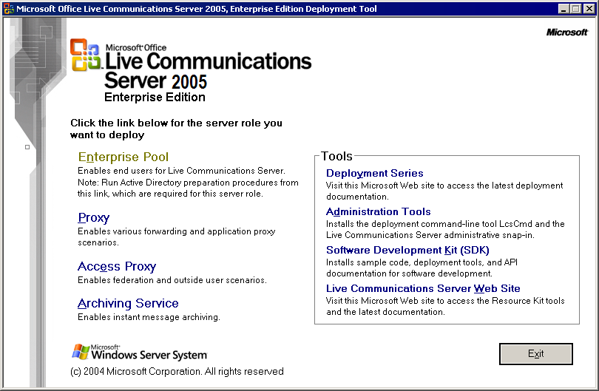
- In the Deployment Tool, click Enterprise Pool. As shown in the following figure, check marks appear next to the Prep Schema, Prep Forest and Prep Domain steps because these steps have already been completed. In this example, the pool is being created in a single domain environment, Domain Add to Forest Root task is unavailable because this task is unnecessary. If you are deploying in a child domain, verify that this task also displays a check mark.
Figure 3 Live Communications Server 2005 Enterprise Pool Setup
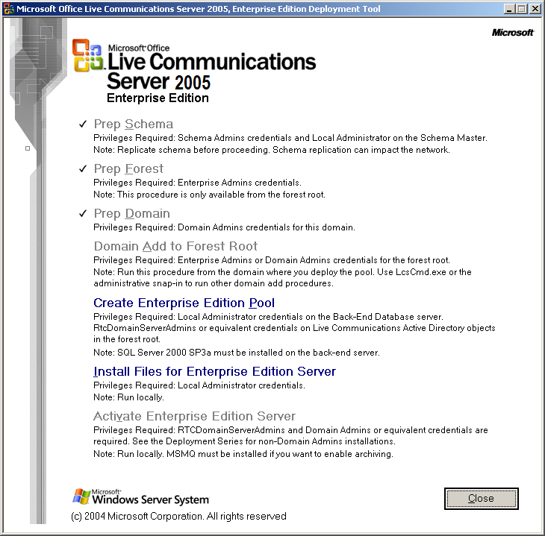
- Click Create Enterprise Edition Pool. This task is available even after you create your pool. Once you have completed your Active Directory preparation, this task is always available to allow you to create additional pools.
- On the Welcome to the Create Enterprise Pool page, click Next.
- On the Create Enterprise Pool page, under Enter a pool name, type a meaningful name for the pool.
Figure 4 Create Enterprise Pool page
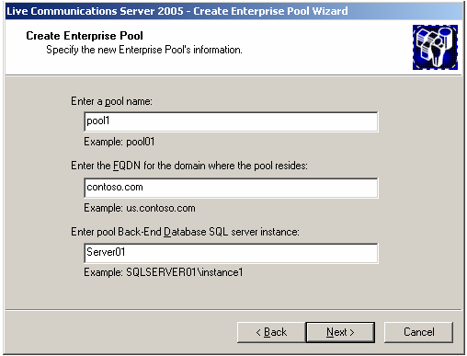
- Under Enter the FQDN for the domain where the pool resides, type the FQDN of the domain where you are installing the pool.
All servers that you add to this pool must be in the pool’s domain.
- Under Enter pool Back-End Database SQL server instance, enter the name of the SQL server that will host Live Communications Server 2005 Back-End Database and the name of the database instance. If you are using the default instance, specify the name of the SQL server. Otherwise, enter the SQL server and instance using the following syntax: <server>\<instance name>.
- Click Next.
Note
Each pool must use a separate back-end database. Two pools cannot share the same Live Communications Server 2005 Back-End Database.
- On the Option for Re-Using Existing Database page, click Replace any existing database if you want to overwrite an existing user database. By default, setup will attempt to re-use any database files in the location you specify later in the wizard.
- On the Choose Destination Locations page, select the locations where the SQL database and transaction logs will be stored. These are the locations on the SQL server where you want to write the SQL database and transaction logs. If you are using a clustered SQL back-end, ensure that you point your transaction log files and database files to shared storage that both cluster nodes can access. Click Next.
Note
If you overwrite a database, all data in that database will be lost.
Figure 5 Select locations for your database and transaction logs
Tip
Placing your transaction logs and database files on separate physical hard disks is recommended. Ensure that the files are not placed on a page file or system disk. For more information about storing files on separate hard disks, see the Microsoft Office Live Communications Server 2005 Planning Guide at http://office.microsoft.com/en-us/FX011450741033.aspx.
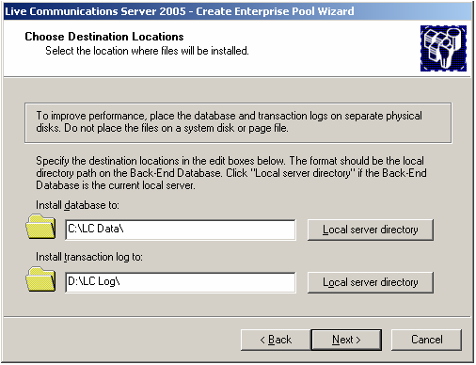
- On the Ready to Create Enterprise Pool page, review your selections and click Next to begin.
- On the Create Enterprise Pool Wizard has completed page, click View Log. Look for Success under Execution Result at the end of each task to verify that installation completed successfully. Close the Log window when you finish.
Figure 6 Live Communications Server Deployment Log
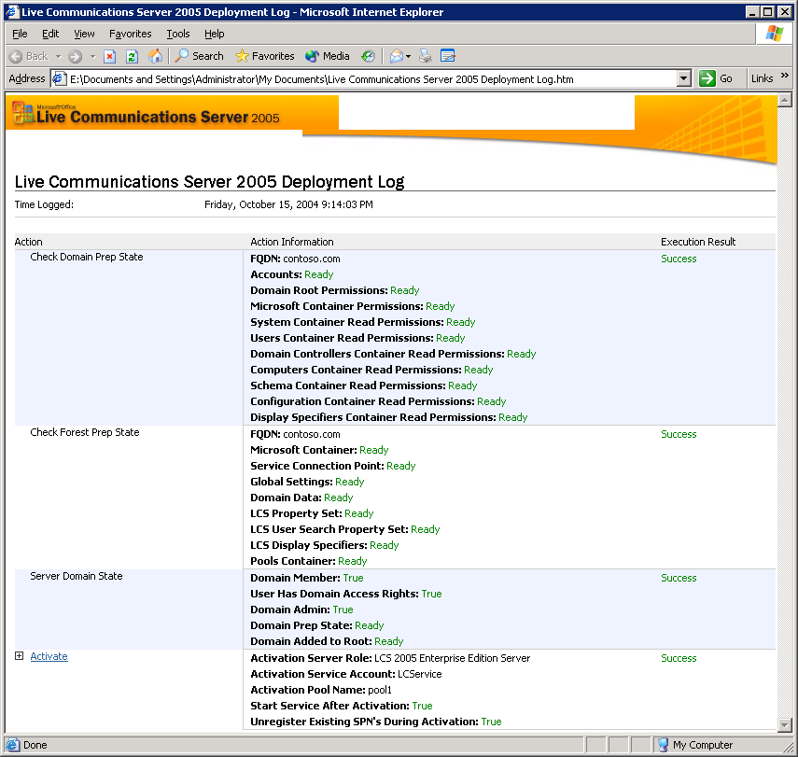
- Click Finish to close the wizard.

Installing the Enterprise Edition Files
Tip
Before activating the first server in the pool, wait for Active Directory replication among all domain controllers to complete, or force replication manually.
For each server within a pool you must install Enterprise Edition files. The installation process performs the following tasks:
- Installs and registers the files for the server in the pool.
- Creates and initializes the WMI settings.
- Creates local groups and sets up permissions for this server.
The installation procedure copies the files to the local computer, but it does not run the actual setup and activation of an Enterprise Edition Server. After the installation process completes, activation performs additional configuration settings to allow the service to start.
This procedure must be run locally from the server where the Live Communications Server 2005 Enterprise Edition files will be installed.
Important
For security reasons,installing an Enterprise Edition Server or a Enterprise Pool Back-End Database on a domain controller is not recommended.
To install Live Communications Server 2005 Enterprise Edition files using the Deployment Tool
- Log on to the server where you want to install the files by using the local administrator or equivalent permissions. If you want to activate immediately after installation, domain admins and RTCDomainServer credentials are also required (only domain admins credentials are required for activation within the forest root domain).
- On the Live Communications Server install folder or CD, run Setup.exe to start the Deployment Tool.
- Click Enterprise Pool.
- Click Install Files for Enterprise Edition Server. The Live Communications Server 2005 Setup Wizard starts.
Figure 7 Setup Screen
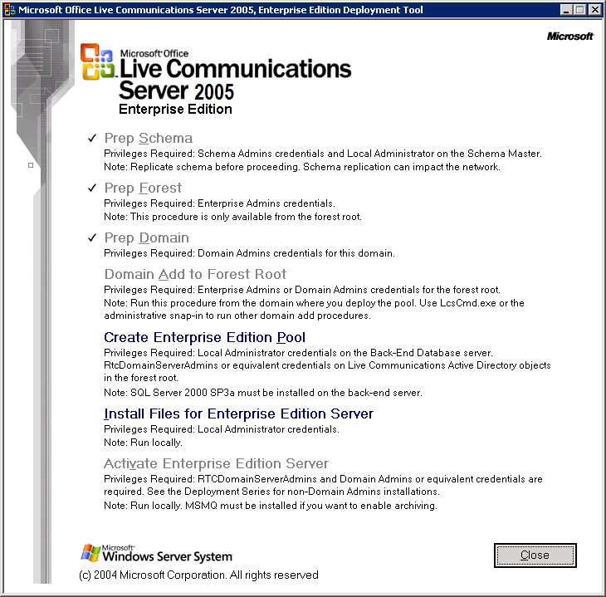
- On the Welcome to the Setup Wizard for Microsoft Office Live Communications Server 2005 page, click Next.
- On the License Agreement page, read the license agreement, and if you agree, click I accept the terms in the license agreement, and then click Next.
- On the Customer Information page, in User name, enter a user name, in Organization, type the name of your organization, and under Product key, type your Live Communications Server 2005 product key.
Figure 8 Customer Information page
Note
If you are using a volume license CD, the product key field is configured for you and the product key field does not appear in the dialog box.
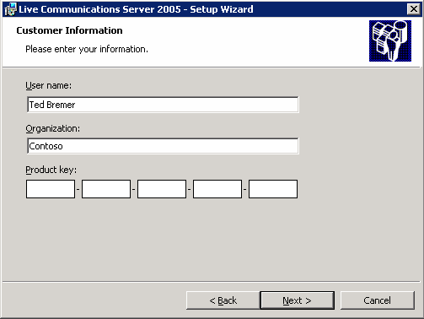
- Click Next.
- On the Choose Destination Locations page, accept the default destination folder or specify another directory where you want to install the Live Communications Server 2005 files, and then click Next. By default the files are installed in the <drive letter>:\Program Files\Microsoft LC 2005\Server directory.

Figure 9 Choose Destination Location page
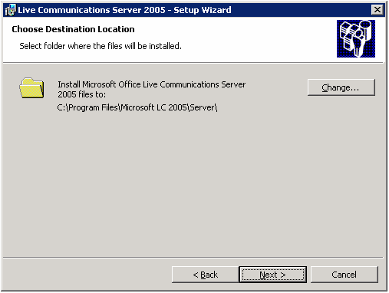
- On the Ready to Install the Program page, confirm settings chosen, and then click Install.
- In the Server Activation message box, click one of the following:
- Yes if you want to activate now and proceed to the next section.
- No if you want to activate later.
Figure 10 Server Activation Dialog Box
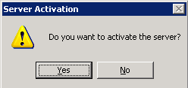

Activating Live Communications Server 2005 Enterprise Edition
This procedure configures a server within a pool in Active Directory and on the server itself to enable each Live Communications Server service (RtcSrv) to start.
Activation performs the following tasks:
- Creates or configures a service account.
- Assigns permissions and memberships to the account.
- Adds domain global groups to the local pool groups.
- Creates or modifies Active Directory objects used by Live Communications Server 2005, including the Pool and Server objects.
- Registers the SPN, which is required for the servers within the pool to provide client and server authentication.
- Starts the Live Communications Server service.
To activate a server, you must use an account with Domain Admins or equivalent credentials in the domain where the pool is being deployed. In a domain outside of the forest root domain, the account must also have RTCDomainServerAdmins credentials. See “Appendix B Enabling Activation Without Using Domain Admins Credentials” to grant a user who is not a member of Domain Admins group the necessary permissions to activate a Live Communications Server.
To activate Live Communications Server
Before you activate the first server in the pool, ensure that replication has completed after the pool was created.
- Log on to the computer where you want to deploy your Live Communications Server by using Domain Admins and RTCDomainServerAdmins or equivalent credentials. In the forest root domain only Domain Admins credentials are required.
- On the Live Communications Server install folder or CD, run Setup.exe to start the Deployment Tool.
- Click Enterprise Pool.
- Click Activate Enterprise Edition Server.
This task is unavailable if you have not already installed the files first.
- On the Welcome to the Activate Enterprise Edition Server page, click Next.
- On the Select Enterprise Pool page, select the pool to which you want to add this server, and then click Next.

Figure 11 Select Enterprise Pool page
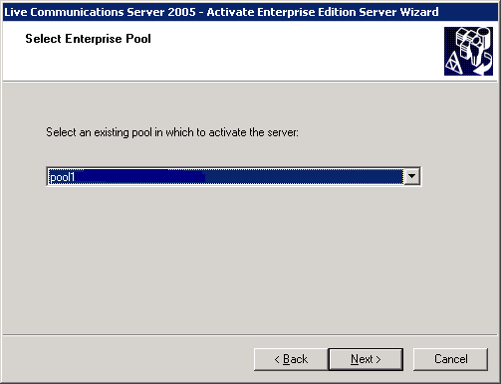
- On the Select Service Account page, enter a new or existing service account to use for this server, and enter the password. The default account is LCService. For a new account, ensure that you use a strong password that meets your organization’s Active Directory password requirements. Click Next to continue.
Figure 12 Select Service Account page
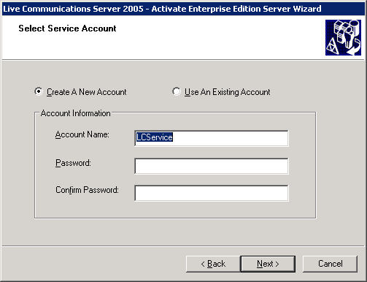
By default, Setup configures this account password to expire in 14 days. When the service account password expires, the service stops. You must then change the password and restart the service. If this is not acceptable in your organization, modify the service account configuration in Active Directory Users and Computers.
WARNING
Live Communications Server 2005 does not support the “Smart card is required for interactive logon” user account option on any Live Communications Server service account. If the Live Communications Server service account is configured this way, the Live Communications Server service will not start, and clients will not be able to log on to a SIP server. Setting this option on an account automatically sets the password to a random and complex value, and sets the Password Never Expires account option. If the Live Communications Server service account has been configured to require a Smart Card for interactive logon, remove this requirement as follows:
1. Open Active Directory Users and Computers.
2. Right-click the service account and click Properties.
3. Click the Account tab.
4. In Account options, clear Smart card is required for interactive logon and click Apply.
5. Reset the password of the service account back to the original.
6. Start the service.

- On the Option to Enable IM Archiving page, click Enable Archiving only if you have already installed MSMQ on your server and an Archiving Server is set up for this pool. See “Installing the Archiving Service” later in this document for more information. Click Next to continue.
- On the Start Service Option page, clear the Start the service after activation check box if you do not want the service to start at the end of the activation procedure. Clear this option to configure certain settings on the server before starting the service, or to wait for Active Directory settings created in the Activation procedure to finish replicating among domain controllers.

Note
If the service cannot start because required Active Directory settings have not replicated, activation will complete, but it will not start the service. After replication completes, manually start the service.
Figure 13 Start Service Option page
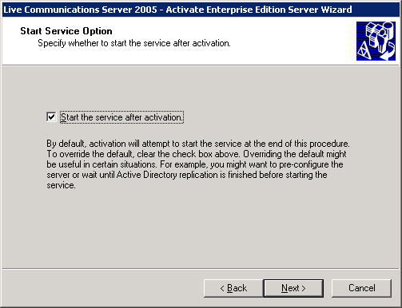
- On the Ready to Activate Enterprise Edition Server page, review your selections and click Next to begin.
- On the Activate Enterprise Edition Wizard Completed page, click View Log. Look for Success under the Execution Result at the end of each task to verify that installation completed successfully. Close the Log window when you finish.
- Click Finish to close the wizard.

Installing the Archiving Service
You can install the Archiving service during or after activation of Live Communications Server 2005 Enterprise Edition.
Important
Archiving on a pool configured as a director is not recommended and will archive messages inconsistently. If you want to archive federated conversations, configure archiving on your internal servers to do so.
For more information about the Archiving service, see the Live Communications Server 2005 Deploying Archiving guide at http://office.microsoft.com/en-us/FX011450741033.aspx.

Deploying the Load Balancer, VLAN, and VIP
Important
By default, Setup configures the service account password to expire in 14 days. When the service account password expires, you must specify service account’s new password for Live Communications Server and restart the service. If this is not acceptable in your organization, modify the service account configuration in Active Directory Users and Computers.
A load balancer is a required in a Live Communications Server 2005 Enterprise pool. It performs the critical role of delivering scalability and high availability across multiple servers connected to a centralized database on the Live Communications Server 2005 Back-End Database.
Port 5060 and port 5061 are required for SIP communication. Additionally, to successfully move users from a pool, you must have a load balancer configured to use port 135 or the move user operation will fail.
Appendix A provides a general summary of the load balancer prerequisites and requirements. For more information about supported topologies and configurations for load balancers and Live Communications Server see the Microsoft Office Live Communications Server 2005 Planning Guide at http://office.microsoft.com/en-us/FX011450741033.aspx.
During this process you will need to request the relevant network and DNS administrator for a VIP (virtual IP) address as well as static IP address for every server within the pool that you are planning to deploy. These static IP addresses will then be assigned to each server in the pool.

Configuring Enterprise Edition Servers
For both Standard Edition Servers and Enterprise pools, all pool-level settings are stored in the Configuration Database (RTCConfig) in the MSDE or SQL server, respectively. Server-level settings are stored in the WMI repository and are stored for each server and include server-specific settings. Both types of settings are managed by the Live Communications Server 2005 WMI provider and are accessible by using the Live Communications Server 2005 administrative snap-in, the command-line tool, LcsCmd.exe, or the WMI interface.
Once Live Communications Server 2005 Enterprise Edition is installed, configure your servers by using the following methods:
- Using the Live Communications Server 2005 administrative snap-in. You can access the administrative snap-in on any Live Communications Server joined to an Active Directory domain, or any computer joined to an Active Directory domain where the Live Communications Server 2005 administration tools are installed.
- Using the Live Communications Server 2005 command-line (LcsCmd.exe) export-import configuration tool. LcsCmd.exe offers to export pool and server-level configuration settings from an existing server or a lab deployment to ensure a consistent configuration. LcsCmd.exe is installed on each Live Communications Server and on the CD.
- Using the WMI to programmatically modify settings. All pool and server settings are exposed through the WMI interfaces. Scripts and tools are available from the Live Communications Server 2005 Resource Kit.

Configuring Using the Administrative Snap-In
After you have installed Live Communications Server, use the Live Communications Server administrative snap-in to configure your server.
To start the administrative snap-in
Click Start, point to Programs, point to Administrative Tools, and click Live Communications Server 2005. The Live Communications Server administrative snap-in shows your Live Communications Server topology.
Figure 14 Live Communications Server 2005 Administrative Snap-in
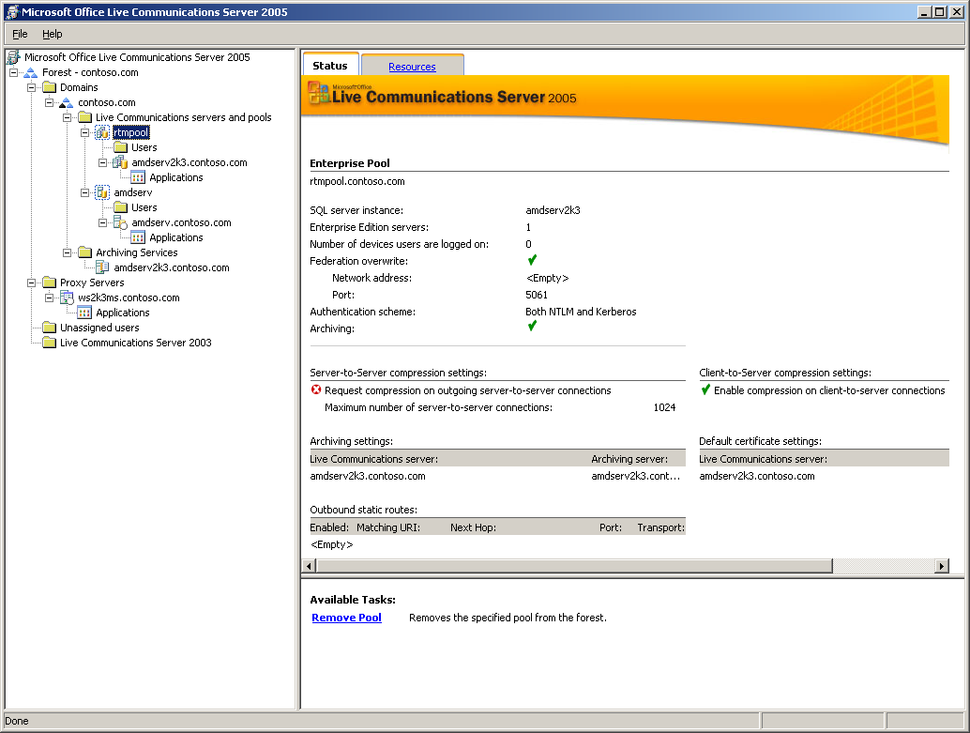
Two nodes show the tree view for Standard Edition Server or an Enterprise Edition Server:
- <Pool or server> node allows you to manage pool-level settings that apply to all Enterprise Edition Servers within a pool or the Standard Edition Server.
- FQDN (fully qualified domain name) node of each server allows you to manage individual server settings applied to the computer itself.
To access pool-level settings
- Right-click the Enterprise pool and then click Properties.
Figure 15 Pool Properties sheet
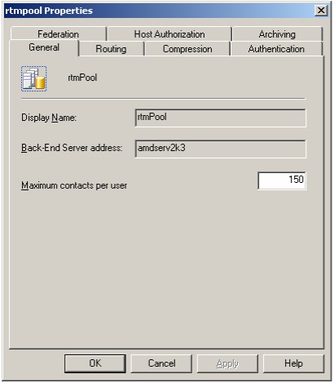
To access server-level settings
- Expand the Enterprise pool.
- Right-click the FQDN of the server you want to access and click Properties.
Figure 16 Server Properties sheet
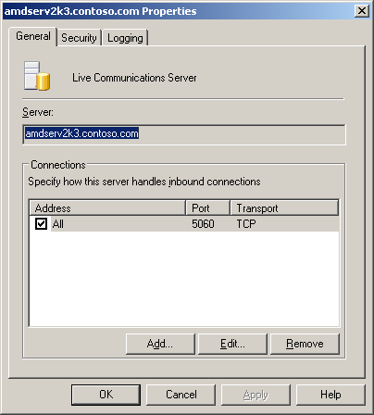

Exporting Pool and Server Settings Using the Command-Line Tool
The LcsCmd.exe command-line tool provides a way to export and import all the pool- and server-level settings as a group using the ImportPoolConfig, ExportPoolConfig, ImportServerConfig, and ExportServerConfig commands. Import and export settings ensure uniform configuration among servers or pools in your environment or to backup a configuration for recovery purposes. You can backup an existing configuration before making any changes so you can restore the existing settings if a problem arises.
When you import server-specific settings, any computer settings that are unique to a computer are not imported. For example, when you import settings from one server to another, the IP address is not overwritten. You must configure these settings manually.
For more information about deploying Live Communications Server 2005 through a command line, see the Live Communications Server 2005 Command-Line Reference at http://office.microsoft.com/en-us/FX011450741033.aspx.

Configuring Settings Using WMI Interfaces
All settings available from the Live Communications Server 2005 administrative snap-in and from the LcsCmd.exe tools are also exposed in the WMI interfaces. Both the administrative snap-in and the command-line tools use the WMI interface to configure settings. Scripts and tools are available from the Live Communications Server 2005 Resource Kit. These interfaces are documented in the Live Communications Server 2005 Resource Kit document files.
You can use these interfaces to programmatically manage your server and pool configuration settings. For example, you can create a script or tool that configures your required settings for static routes, or archive and use this script to configure servers uniformly.
WMI is also used in Live Communications Server as the interface for all data stored for Live Communications Server. In addition to server- and pool-level settings, you can also mange global settings, user SIP settings, and user data using WMI interfaces. The Resource Kit provides samples for the following tasks:
- Populating contacts for all users hosted on Enterprise Edition Server. For example, you can add all users in a department or a smaller company to everyone’s contact list so your users do not have to manually add these contacts.
- Enabling groups of users for Live Communications Server. You can programmatically enable users for SIP, host them on a specific server, and configure the required settings.

Requesting and Configuring Certificates and TLS
To help increase security, consider configuring TLS and certificates on your Live Communications Servers and clients. TLS and MTLS require certificates, whereas TCP does not. To implement TLS and certificates you must configure:
- Live Communications Server 2005 to communicate with other Live Communications Server 2005 servers to use MTLS. This is required for IM communications between users to function correctly.
- Windows Messenger 5.1 clients within the internal network perimeter to use either TCP or TLS to communicate with Live Communications Server 2005 servers and clients.
- Clients outside the internal network perimeter to use TLS to communicate with Live Communications Server servers and clients within the internal network perimeter and other remote clients.
This section covers server configuration and assumes that your organization already has a PKI and CA.
This section highlights:
- Configuring certificates on each local server
- Configuring Mutual TLS connections
- Configuring certificates used for automatic routing
- Configuring the preferred authentication protocol
For more information about the certificate requirements and supported topologies in Live Communications Server 2005, see the Live Communications Server 2005 Configuring Certificates guide at http://office.microsoft.com/en-us/FX011450741033.aspx.

Configuring Certificates on Your Enterprise Edition Servers
Live Communications Server 2005 supports a Windows Server 2003 Enterprise CA running on the following Windows Server 2003 editions:
- Windows Server 2003, Enterprise Edition
- Windows Server 2003, Datacenter Edition
Live Communications Server 2005 supports a Windows Server 2003 standalone CA running on the following Windows Server 2003 editions:
- Windows Server 2003, Standard Edition
- Windows Server 2003, Enterprise Edition
- Windows Server 2003, Datacenter Edition
Live Communications Server 2005 supports a Windows 2000 standalone CA running on the following Windows 2000 editions:
- Windows 2000 Server
- Windows 2000 Advanced Server
- Windows 2000 Datacenter
This section explains how to configure certificates on your Enterprise Edition Servers using Windows Server 2003 Enterprise CA and assumes that you have deployed a PKI and an Enterprise CA on Windows Server 2003.
Before you install your certificates, refer to the Live Communications Server 2005 Configuring Certificates document for certificate requirements, other configurations, implementing best practices, and a broader explanation of how Live Communications Server works with certificates.
You can issue certificates for Live Communications Server 2005 from a root CA without using a subordinate CA. This topology might suffice for a lab deployment. However, this is not accordance with implementing best practices, which are:
- Do not issue certificates to users or computers directly from the root certification authority.
- Deploy at least a two-level CA hierarchy comprised of Root-Issuer CAs to provide flexibility and to insulate the root certification authority from attempts to compromise its private key by malicious individuals.
Configuring certificates on your servers involves the following steps:
- Download the CA certification path
- Install the CA certification path
- Request the certificate
- Install the certificate
The following instructions assume that the computer and user have the ability and the permission to access the internal CA by using the physical network and Certificate Services Web enrollment. If you use an external CA, check with your external CA for instructions.

Considerations for a Mixed Client Environment
If your organization uses Windows Messenger 5.1 and Communicator with DisableStrictDNSNaming policy disabled and you want to use the same pool to serve both the types of clients, then a Director should be used to redirect the clients to the Enterprise pool. DNS SRV records must be published for the Director instead of the pool.
Both the sip.domain.com and sipinternal.domain.com FQDN should point to a Standard Edition Server configured as a director that routes requests to the pool. The server certificate on the Director should use the local machine FQDN in the subject name (SN) and use local machine machine FQDN, sip.domain.com and sipinternal.domain.com in the subject alternate name (SAN), where domain is the SIP domain used by your organization.

Step 1 Download the CA Certification Path
Use the following steps to download the CA certificate path.
To download the CA certification path
- With your Enterprise root CA offline and your Enterprise subordinate (issuing) CA Server online, log on to your Live Communications Server. Click Start, click Run, type http://<name of your Issuing CA Server>/certsrv, and then click OK.
- From Select a task, click Download a CA certificate, certificate chain, or CRL.
- From Download a CA Certificate, Certificate Chain, or CRL, click Download CA certificate chain.
- In the File Download dialog box, click Save.
- Save the .p7b file on a drive on your server. If you open this .p7b file, the chain will have the following two certificates:
- <name of Enterprise root CA> certificate
- <name of Enterprise subordinate CA> certificate

Step 2 Install the CA Certification Path
Use the following steps to install the CA certificate path in the trusted root certifications authorities on each Enterprise Edition Server.
To install the CA certification path
- Click Start, click Run, type mmc, and then click OK
- On the File menu, click Add/Remove Snap-in.
- In the Add/Remove Snap-in dialog box, click Add.
- On the Available Standalone Snap-ins list, click Certificates, and click Add.
- Click Computer account, and then click Next.
- In the Select Computer dialog box, ensure that Local computer: (the computer this console is running on) is selected, and then click Finish.
- Click Close and click OK.
- In the navigation pane of the Certificates console, expand Certificates (Local Computer).
- Expand Trusted Root Certification Authorities.
- Right-click Certificates, point to All Tasks, and then click Import.
- In the Import Wizard, click Next.
- Click Browse and go to where you saved the certificate chain, select the p7b file, and click Open.
- Click Next.
- Accept the default value Place all certificates in the following store and ensure that Trusted Root Certification Authorities appears under the Certificate store.
- Click Next.
- Click Finish.

Step 3 Request the Certificate
Use the following steps to request a certificate used for authentication on each server.
To request the certificate
- Open a Web browser and type http://<name of your Issuing CA server>/certsrv and press ENTER.
- Click Request a Certificate.
- Click Advanced certificate request.
- Click Create and submit a request to this CA.
- In Certificate Template, select the Web Server template.
- In Identifying Information for Offline Template, in Name, type the FQDN of the pool.
- In Key Options, in CSP, verify that the default value, Microsoft RSA SChannel Cryptographic Provide is selected. If it is not, select it now.
- Select the Store certificate in the local computer certificate store check box.
- Click Submit.
- Click Yes in the Potential Scripting Violation dialog box.

Step 4 Install the Certificate
Use the following procedure to install the certificate.
To install the certificate on the computer
If your CA requires CA administrator approval to issue a certificate, the administrator must manually approve or deny the certificate issuance request on the issuing CA. Otherwise, click Install this certificate and in the Potential Scripting Violation dialog box, click Yes.
To manually approve a certificate issuance request after the request is made
- Log on as a member of the Domain Admins group to the Enterprise subordinate CA server.
- Click Start, click Run, type mmc, and then press ENTER.
- On the File menu, click Add / Remove Snap-in.
- Click Add.
- In Add Standalone Snap-in, click Certification Authority, and then click Add.
- In Certification Authority, leave the default option Local computer (the computer this console is running on).
- Click Finish.
- Click Close and then click OK.
- In the MMC, expand Certification Authority, expand your Issuing certificate server.
- Click Pending request.
- In the details pane, right-click the request identified by its request ID, point to All Tasks, and then click Issue.
- On your server from which you requested the certificate, click Start, and then click Run.
- Type http://<name of your Issuing CA Server>/certsrv and click OK.
- From Select a task, click View the status of a pending certificate request.
- From View the Status of a Pending Certificate Request, click your request.
- Click Install this certificate.

Configuring Mutual TLS Connections
Configuring MTLS is required in order for servers within the pool to route to other servers in this pool. Additionally if you have multiple servers in an Enterprise pool or multiple pools in your Live Communications Server 2005 deployment you may need to configure MTLS because the servers and pools use MTLS (Mutual TLS) to connect to each other. A similar procedure is required to configure TLS for client connections to your pool. For client connections, TLS is recommended to help increase security.
To configure an MTLS connection
- Click Start, point to Programs, point to Administrative Tools, and click Live Communications Server 2005.
- In the console tree, click the Forest node.
- Expand subsequent nodes under the Domains node until you reach the domain where the pool resides.
- Expand the Live Communications Servers and Pools that you want to configure.
- Expand the pool.
- Right-click the FQDN of the server in the pool, and then click Properties.
- On the General tab, click Add.
Figure 17 Authenticating a remote server using MTLS
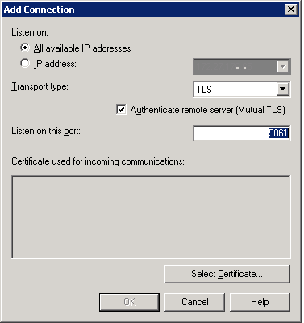
- On the Add Connection page, do the following:
- Select whether you want this connection to listen on all available IP addresses (default) or enter a specific IP address.
- Click TLS as the Transport type. This automatically activates the Authenticate remote server (Mutual TLS) check box and defaults the Listen on this port value to port 5061.
- Click Select Certificate, highlight the issued computer certificate, and then click OK three times.
Caution
The default port number, 5061, for Authenticate remote server (Mutual TLS) must not be changed as servers expect to communicate with other servers over this port. The Mutual TLS check box must be selected to enable communication between servers running Live Communications Server 2005.

Configuring Certificates for Automatic Routing Among Pools and Standard Edition Servers
Configure a default server certificate because Live Communications Servers use Mutual TLS to connect among each other for automatic routing of user traffic (which is always routed first to the sender’s pool or server and then to the recipient’s pool or server). The same certificate that is configured to enable MTLS for automatic routing among pools and servers can also be used for static routes that you may create.
To configure the default certificate used for automatic routing among pool and servers
- Click Start, point to Programs, point to Administrative Tools, and click Live Communications Server.
- In the console tree, expand the Forest node.
- Expand Domains.
- Expand subsequent nodes under the Domains node, expand the domain where your server resides.
- Expand Live Communications Servers and Pools.
- Expand the pool.
- Right-click the FQDN of the server, and then click Properties.
- Click the Security tab.
- Click Select Certificate.
- In Select Certificate, select your certificate, and click OK twice.

Configuring the Preferred Authentication Protocol
The following procedure is required to configure your preferred client authentication protocol if you are supporting NTLM for some of your users. Outside users supported by the Live Communications Server 2005 Access Proxy server will always require NTLM. By default, this setting is configured to the Kerberos protocol, such that the pool will not support client connections unless your organization supports Kerberos.
To configure preferred authentication protocol
- Click Start, point to Programs, point to Administrative Tools, and click Live Communications Server 2005.
- In the console tree, click the Forest node.
- Expand subsequent nodes under the Domains node until you reach the domain where your pool resides.
- Expand Live Communications Servers and Pools.
- Right-click the pool, and then click Properties.
- Click the Authentication tab.
- Click the Authentication Scheme drop-down list and then click the authentication scheme that will be supported. You can choose from Kerberos, NTLM, or Both NTLM and Kerberos. The default value is Both NTLM and Kerberos.

Configuring DNS, Client Access and User Settings
Important
When Both NTLM and Kerberos is selected, authentication with Kerberos is always used when the client attempts to be authenticated. If Kerberos authentication fails it does not fall back and attempt to use NTLM.
Before you can connect your Live Communications Server 2005 Standard Edition users, you must deploy Windows Messenger on all client computers. Communicator 2005 running on Windows XP SP2 is the recommended client configuration, but Windows Messenger 5.1 is also supported.
After you have installed Live Communications Server 2005 and deployed Windows Messenger, you must configure client access. Configuring client access involves the following tasks:
- Installing and configuring the client.
- Ensuring Your Clients Can Connect to Live Communications Server.
- Creating and configuring users in Active Directory.
- Configuring your clients to recognize certificates issued by your certification authority.

Installing and Configuring the Your Client
Install and configure Communicator 2005 or Windows Messenger 5.1 to test and verify the implementation of your servers running Live Communications Server. These clients can be downloaded from the Microsoft Web site.

Ensuring Your Clients Can Connect to Live Communications Server
To use Live Communications Server 2005, your clients must be able to resolve to the FQDN of the Enterprise pool. There are two methodologies for provisioning the client to connect to the Live Communications Server.
- Automatic Configuration: Creating a DNS Record and Enabling Auto Configuration. Client will automatically query for DNS SRV resource record and will either directly connect or be redirected to the correct Live Communications Server. This requires creating a DNS SRV resource record for your Enterprise pool. The pool FQDN must be resolvable by clients to enable SIP invite sessions and messages to work correctly. Clients that are trying to initiate a SIP INVITE session will need to be able to DNS resolve the pool FQDN. Without the DNS entry, login using a server FQDN may work, but the SIP INVITE sessions (messages) will fail since the clients cannot resolve the pool FQDN.
- Manual Configuration: Modify the Host File or Registry and Manually Connecting. Client can be preconfigured to connect to the FQDN of a specific server. This can be achieved by configuring the relevant registry key by using Group Policy settings. Alternatively, this can be performed by manually providing the FQDN of the pool.

Automatic Configuration
Automatic configuration of your clients involves two steps.
- Creating a DNS Resource that contains one of the following tThe VIP of your load balancer which is required for a pool.
- Enabling automatic configuration of your clients.

Step 1 Configuring DNS
Configuring DNS involves:
- Creating a DNS server (SRV) record for the FQDN of the Enterprise pool.
- Creating a host (A) record for the server record that points to the VIP of the pool’s load balancer.
By configuring a DNS SRV resource record for Live Communications Server, you can test the bootstrapping process of the client in which it locates Live Communications Server without the client having been preconfigured with the name of its server or pool. An example of a DNS SRV resource record is: _sipinternaltls._tcp.example.com, where _sipinternaltls represents the service, _tcp represents the transport protocol, and example.com represents the SIP URI namespace for the example domain. To perform this procedure, you must be a member of the administrators group of the DNS server.

Creating a DNS SRV Record
Important
The client only uses the first A record, of multiple A records, returned as a response to the DNS query, if this server is unavailable the client does not try any other of the records until the query result is flushed from the DNS cache and replaced with a DNS response with a different record ordering.
To create a DNS SRV record
- To open DNS, click Start, click Control Panel, double-click Administrative Tools, and then double-click DNS.
- In the console tree for your domain, expand Forward Lookup Zones, right-click the domain.
- Click Other New Records.
- In Select a resource record type, select Service location (SRV).
- Click Create Record.
- Select one of the following:
- If your organization uses only Communicator clients:
  - If you are using TLS, type _sipinternaltls for the Service, type _tcp in Protocol, and then type 5061 in Port Number.
  - If you are using TCP, type _sipinternal for the Service, type _tcp in Protocol, and then type 5060 in Port Number.
- If your organization uses Windows Messenger clients:
  - If you are using TLS, type _sip for the Service, type _tls in Protocol, and then type 5061 in Port Number.
  - If you are using TCP, type _sip for the Service, type _tcp in Protocol, and then type 5060 in Port Number
- If your organization uses a mix of clients, publish one of each SRV record, and point both SRV records to the internal FQDN of your Enterprise pool used by your clients. Add cross reference to cert portion.
- In Host offering this service, type the FQDN of the pool and enter the VIP address assigned to the pool’s load balancer.
For your clients to connect to your Enterprise pool, an A record must exist for the pool that points to the VIP of the load balancer connected to your pool. When a client connects to the Live Communications Server, DNS returns the first A record it finds for a host name.

Creating a DNS A Record for Your Enterprise Pool
To create the Live Communications Server A (host) resource record for your pool
- To open DNS, click Start, click Control Panel, double-click Administrative Tools, and then double-click DNS.
- In the console tree for your domain, expand Forward Lookup Zones, right-click the domain.
- Click New Host (A).
- In Name (uses parent domain name if blank), type the host name of the server running Live Communications Server.
- In IP Address, enter the VIP address of the load balancer to which the pool is connected. All client connections are routed through this load balancer to servers in the pool.
- If you have a reverse DNS lookup zone, click the Create Associated Pointer Record (PTR) check box. Otherwise, do not select this check box.
- Click Add Host, click OK, and then click Done.
To verify the creation of a DNS SRV resource record
To verify the existence of the created DNS SRV resource record from any computer on the network, use the network diagnostic tool, Nslookup.exe. For illustration purposes, the following steps use example.com for the domain portion of the SIP URI namespace.
If you deployed TLS, use the following steps:
- Click Start, click Run, type cmd, and press ENTER.
- Type nslookup, and then press ENTER.
- Type set type=srv, and then press ENTER.
- Select one of the following options:
- For deployments with Communicator clients only, type _sipinternaltls._tcp.example.com, and then press ENTER. The output displayed for the TLS record is as follows:
Server: <dns server>.corp.example.com
Address: <IP address of DNS server>
Non-authoritative answer:
_sipinternaltls._tcp.example.com SRV service location:
priority = 0
weight = 0
port = 5061
svr hostname = sipinternaltls.example.com
sipinternaltls.example.com internet address = <VIP address of the load balancer or IP of a single Enterprise Edition Server >
sipinternaltls.example.com internet address = <VIP address of the load balancer or the IP address of a single Enterprise Edition Server>
- For deployments with Windows Messenger 5.1 clients, type _sip._tls.example.com, and then press ENTER. The output displayed for the TLS record is as follows:
_sip._tls.example.com SRV service location:
priority = 0
weight = 0
port = 5061
svr hostname = sip.example.com
sip.example.com internet address = <VIP address of the load balancer >
sip.example.com internet address = <VIP address of the load balancer >

If you deployed TCP, use the following steps:
- Click Start, click Run, type cmd, and press ENTER.
- Type nslookup, and then press ENTER.
- Type set type=srv, and then press ENTER.
- Select one of the following:
- For deployments with Communicator clients only, type _sipinternal._tcp.example.com, and then press ENTER. The output displayed for the TCP record is as follows:
Server: <dns server>.corp.example.com
Address: <IP address of DNS server>
Non-authoritative answer:
_sipinternal._tcp.example.com SRV service location:
priority = 0
weight = 0
port = 5060
svr hostname = sip.example.com
sip.example.com internet address = <IP address 1 of the VIP address of the load balancer>
sip.example.com internet address = <IP address 2 of the VIP address of the load balancer>
- For deployments with Windows Messenger 5.1 clients, type _sip._tcp.example.com, and then press ENTER. The output displayed for the TCP record is as follows:
Server: <dns server>.corp.example.com
Address: <IP address of DNS server>
Non-authoritative answer:
_sip._tcp.example.com SRV service location:
priority = 0
weight = 0
port = 5060
svr hostname = sip.example.com
sip.example.com internet address = <IP address 1 of the VIP address of the load balancer>
sip.example.com internet address = <IP address 2 of the VIP address of the load balancer>

Next verify that the FQDN of the pool can be resolved by DNS where the IP addressed returned is the VIP of your load balancer.
- Click Start, click Run, type cmd, and press ENTER.
- Type ping <FQDN of the Enterprise pool> and press ENTER.
- Verify that you receive a response similar to the following:
Reply from 172.27.176.117: bytes=32 time<1ms TTL=127
Reply from 172.27.176.117: bytes=32 time<1ms TTL=127
Reply from 172.27.176.117: bytes=32 time<1ms TTL=127
Reply from 172.27.176.117: bytes=32 time<1ms TTL=127

Step 2 Enabling Automatic Configuration
After configuring the DNS SRV resource record you can choose to automatically configure the connection settings in either Communicator or Windows Messenger 5.1
To enable automatic configuration for Communicator clients
- With Communicator open, click the Actions menu, and then click Options.
- Click the Accounts tab.
- Click Advanced, and then click Automatic Configuration.
- Click OK twice.

To enable automatic configuration for Windows Messenger clients
- With Windows Messenger open, click the Tools menu, and then click Options.
- Click the Accounts tab.
- If necessary, click the My contacts include users of a SIP Communications Server check box and type <username>@<SIP namespace>. For example, ted@contoso.com.
- Under SIP Communications Service Account, click Advanced.
- In the SIP Communication Service Connection Configuration dialog box, click the Automatic Configuration option.
- Click OK twice.

Manually Enabling Client Connectivity to Live Communications Server
To manually enable client connectivity to a Live Communications Server Enterprise pool without using the SRV records, you must manually configure each client to connect to the FQDN of the pool. If you do not publish an A record for your pool, you must modify the Hosts file for clients to resolve the pool FQDN.
Note
Modifying the host file is not a requirement for Live Communications Server and is only needed if your organization does not use DNS.
To modify the host file on a client computer
- Log on to the client computer.
- Click Start, click Run, type %windir%\system32\drivers\etc, and then press ENTER.
- Open the Hosts file by using Notepad.
- Add the following line to the end of the host file:
<VIP_address_of_the_load balancer> <FQDN_of_the_pool>

To manually configure connectivity
- Open Windows Messenger.
- On the Tools menu, click Options.
- Click the Accounts tab.
- Click Advanced.
- Click Configure Settings.
- In Server name or IP address, type either the name of the server or the IP address.
- Click the protocol that you want to use to connect.

To manually configure connectivity
- Open Windows Messenger.
- On the Tools menu, click Options.
- Click the Accounts tab.
- Click Advanced.
- Click Configure Settings.
- In Server name or IP address, type either the name of the server or the IP address.
- Click the protocol that you want to use to connect.

Creating and Configuring Users in Active Directory
After deploying your pool and performing the necessary configuration, create or enable the user accounts in Active Directory that will be using the Live Communications Server services.
The following procedures are required to add users to their respective Live Communications Server. The Live Communications Servers periodically request and store its user information from Active Directory.

Creating User Accounts
Create the user accounts in Active Directory to use the Live Communications Server services.
To create user accounts
- Open the Active Directory Users and Computers snap-in.
- Create an organizational unit that contains all the users you want to create for the Live Communications Server services or you can create users by right-clicking the Users container, clicking New, and then clicking User.
- Complete the New Object - User Wizard.

Configuring User Accounts for Live Communications Server
You can configure user accounts for Live Communications Servers in one of two environments:
- Configure mail-enabled and mailbox-enabled user accounts.
- Configure user accounts that are not mail-enabled or mailbox enabled.
To configure mail-enabled or mailbox-enabled user accounts for Live Communications Server
- Log on to a Live Communications Server or a computer with the Live Communications Server Administration tools installed and joined to an Active Directory domain with an account that has RTCDomainUserAdmins permissions.
- Open Active Directory Users and Computers. Click Start, click Run, type dsa.msc, and then click OK.
- Right-click the user or users whom you want to enable, and click Enable users for Live Communications.
- On the Welcome to Enable Users Wizard page, click Next.
- In Select a Pool, select the pool that will host these users, and then click Next.
- Click Finish.
The SIP URI for these users is automatically populated by using the default e-mail address of the user.
To configure a user account for Live Communications Server that is not mail-enabled or mailbox-enabled
- Log on to a Live Communications Server or a computer with the Live Communications Server Administration tools installed and joined to an Active Directory domain with an account that has RTCDomainUserAdmins permissions.
- Open Active Directory Users and Computers. Click Start, click Run, type dsa.msc, and then click OK.
- Right-click the user account you want to enable for Live Communications Server, and then click Properties.
- Click the Live Communications tab, and then click Enable Live Communications for this user.
- In the SIP URI field type: sip:username@dns root domain.com. This example uses sip:user1@woodgrovebank.com.
Tip
The Live Communications tab is only available on a Live Communications Server or a server with the Live Communications Server Administration Tools installed.
- Click the drop-down arrow in the Server or pool field, and click the pool you want to assign this user account to — keeping in mind that careful planning should take place to determine the number of users per server.
- Click OK.

Configuring Your Clients to Recognize Certificates
Important
Ensure that the domain portion of the SIP URI used in step 4 is a supported domain. Supported domains are listed in the General tab of the Live Communications Global Setting Properties page of the forest node.
To use TLS on your clients, the client computer must trust your certification authority and the certificate chain. Unless you use a CA that is one of the default trusted CAs on a Windows operating system, you must manually configure your clients to recognize the certificate issued by your CA and used by your Live Communications Server.
To configure your client to trust the certification authority and certificate chain
- Log on to your client computer with local administrator rights.
- Click Start, click Run, type http://<name of your CA>/certsrv in the Open box, and click OK.
- Click Download a CA certificate, certificate chain or CRL.
- Click Install this CA chain.
- In the Potential Scripting Violation dialog box, click Yes.
- Once the certificate is successfully installed, click Back.
- In CA certificates, select the certificate.
- Click Download a certificate.
- Click Save, and save the certificate to a local drive on your computer.
- Click Start, click Run, type mmc, and then click OK.
- On the File menu, click Add/Remove Snap-in.
- Click Add.
- Select Certificates.
- In Certificate Snap-in, click Computer account.
- Click Next.
- In Select Computer, ensure that Local computer (the computer this console is running on) is selected.
- Click Finish.
- Click Close and then click OK.
- In MMC, expand Certificates, expand Trusted Root Certification Authorities.
- Right-click Certificates, and then click Import.
- In the Certificate Import Wizard, click Next.
- On the File to Import page, click Browse.
- In the Open dialog box, click Files of type, and select All Files (*.*).
- Browse to your certificate and click Open.
- Complete the wizard with the default selections.

Configure SIP URI Domains and Other Global Settings
Live Communications Server 2005 stores global settings in the forest root domain under the Microsoft container (CN=Global Container,CN=Microsoft,CN=RTC Service,CN=Systems, DC=domain…). These global settings are used by your entire Live Communications Server deployment in the organization. The settings include:
- The list of SIP URI domains supported in the organization.
- Settings for end-user registration and user search.
- Global settings for enabling federation and remote access user in the organization. For more information about enabling federation and remote access user, see the Live Communications Server 2005 Deploying Access Proxy and Director guide at http://office.microsoft.com/en-us/FX011450741033.aspx.
- Global setting defaults for user archiving. For more information about global settings, see the Live Communications Server 2005 Deploying Archiving at http://office.microsoft.com/en-us/FX011450741033.aspx.
The following procedure is necessary to allow your Live Communications Servers to recognize and validate your user URI domains component of your Live Communications Server 2005 deployment. Run this procedure initially to add any domains that are part of your SIP URI namespace. Also remember to run this procedure again if you add additional SIP URI domains to your Live Communications Server 2005 deployment at a later time. By default, the forest root domain will be added to this list. If your SIP URI namespace is flat and based upon your forest root, then you do not have to perform this task.
As an example, suppose your organization uses the following user SIP URIs <user>@sales.contoso.com, <user>@corp.contoso.com, and <user>@support.contoso.com. In this example, you must add corp.contoso.com, sales.contoso.com, and supoort.contoso.com.com to the SIP URI domain list. However, if you are only supporting user SIP URIs of contoso.com namespace, then you will only need to add contoso.com to the SIP URI domain list. Additionally, if contoso.com is the forest root domain, it is added by default to the list of SIP URI domains.
To configure the list of SIP URI domains that are part of the Live Communications Server 2005 deployment
- Click Start, point to Programs, point to Administrative Tools, and then click Live Communications Server 2005.
- In the console tree, right-click the Forest node.
- Click Properties.
- Click the General tab to view the list of domains.
- Click Add and enter the domain you want to include in your Live Communications Server environment.

Clustering Live Communications Server 2005 Back-End
To improve availability, consider clustering the back-end database of your pool. Before you configure your cluster, determine the number of servers within the pool required in your environment. For more information about planning for high availability, see the Microsoft Office Live Communications Server 2005 Planning Guide at http://office.microsoft.com/en-us/FX011450741033.aspx.
A high availability deployment requires the following:
- Determine your hardware needs and the number servers within the pool needed to meet your business and availability requirements.
- Deploy each server within the pool with sufficient capacity, that is, available disk space and a high-speed processor.
- Cluster the SQL back-end database to provide failover and eliminate a single point of failure for the database. Live Communications Server 2005 supports a Windows Server 2003 two-node active passive cluster.
- Install Windows Server 2003, Enterprise Edition, in a two-node active passive cluster.
- Install SQL Server 2000 SP3a, Enterprise Edition, as a virtual server on the cluster.
- When creating an Enterprise pool, ensure that you point your transaction logs and database files to the shared drive.
For more information about Windows Server 2003 clusters, see the Windows Server 2003 and SQL Server 2000 documentation links at the end of this document.

Additional Operations
This section explains some general maintenance tasks and other procedures that may be required after your deployment. It contains the following:
- Changing the database used by a pool
- Backup and restore operations for Live Communications Server
- Removing Live Communications Server 2005

Changing the Database Used by a Pool
If necessary, you can change the databases used by a pool. Two databases are used by Live Communications Server:
- RTC database contains user data including your users’ contacts and allow and block lists.
- RTCConfig contains pool-level settings such as archiving and federation.
When you change a database, you must export the database from the existing database to keep these settings and import them into the new databases.
Changing the databases used by the pool involves the following steps:
- Export the data from the existing databases, RTC and RTCConfig.
- Create new databases, RTC and RTCConfig.
- Update the databases in Active Directory and WMI.
- Import the existing configuration data into the RTCConfig database.
- Restart the Live Communications Server service (RTCsrv) on each Enterprise Edition Server.
- Verify that User Replicator completes.
- Import the existing user database into the RTC database.

Step 1 Export Data from the Existing Databases, RTC and RTCConfig
Before you change the database used by the pool, you must export the existing data from your user database and your configuration database (RTC and RTCConfig, respectively). The RTC database contains your users’ contact lists, and allow and block lists and the RTCConfig database contains your pool configuration.
Live Communications Server 2005 provides command-line tools to export data from these databases:
- Dbimpexp.exe to export the data from the RTC database.
- LcsCmd.exe to export data from your RTCConfig database.
To export data from an existing RTC database
- Log on to the on the computer from which the data is to be exported by using RTCDomainUserAdmins credentials. You can use any Live Communications Server within the pool.
- Stop Live Communications Server service (RtcSrv).
- On that same computer, go to the directory where Dbimpexp.exe is installed. The default location is the <drive letter>:\Program Files\Microsoft LC 2005\Server\Support folder. The Dbimpexp tool must be run from a local directory.
- Type the following:
dbimpexp.exe /hrxmlfile:“<drive>:\<filename.xml>”

- Place the xml file in a secured location.
To export data from an existing RTCConfig database
- Log on to the computer from which the data is to be exported by using RTCDomainServerAdmins credentials. You can use any Live Communications Server within the pool.
- Stop Live Communications Server service (RtcSrv).
- To export the pool configuration database data, type the following command:
Lcscmd /forest[:<forest FQDN>] /action:ExportPoolConfig /poolname:<Pool Name> /poolbe:<Pool BackEnd name\sql instance name> /configFile:<file name>

Step 2 Create new databases, RTC and RTCConfig
On the computer where you want to install your database, ensure the following:
- The computer is running Windows Server 2003 or Windows 2000 Server.
- SQL 2000 SP3a is installed.
- The default SQL instance or a named SQL instance has been created.
To set up the new a user database and configuration database
- On the new SQL server hosting the database, log on by using RTCDomainServerAdmins credentials.
- Go to a command prompt.
- To create a new RTC database, run:
cscript.exe dbsetup.wsf /sqlserver:server_name\[instance name] /sqlfilepath:"path to the dbsetup.wsf file" /dbpath:"the database folder on the SQL box for Live Communications Server database" /logpath:"the database transaction log folder for the database" /serveracct:Domain Name\RTCHSDomainServices /adminacct: Domain name\RTCDomainServerAdmins

If you want to use the default SQL instance, you do not need to specify an instance name in the /sqlserver parameter.
- To create a new RTCConfig database, run:
cscript.exe PoolCfgDbSetup.wsf /sqlserver:server_name\[instance name] /sqlfilepath:"path to the PoolCfgDbSetup.wsf file" /dbpath:"the database folder on the SQL box for Live Communications Server configuration database" /logpath:"the database transaction log folder for the database" /lcsvcgroup:Domain Name\RTCHSDomainServices /srvadmingrp:Domain name\RTCDomainServerAdmins /usradmingrp:Domain name\RTCDomainUserAdmins /serverrole:FE

If you want to use the default SQL instance, you do not need to specify an instance name in the /sqlserver parameter.

Step 3 Update the Databases in Active Directory and WMI
After you create the new SQL databases, update Active Directory and WMI with the new database information.
To update the pool database and its setting in Active Directory and WMI classes
- Log on to the server where you created your back-end database by using local administrator and RTCDomainServerAdmins credentials.
- From the Live Communications Server install folder or CD, run:
LcsCmd.exe /forest /action:UpdatePoolBackend /poolname:”pool name of your old pool” /poolbe:”new sql instance name for the pool – machine\instance name“

The value specified for the pool name in the /poolname must match the original pool name.

Step 4 Import the Existing Configuration Data into the RTCConfig Database
After you have updated Active Directory and WMI settings, import the data from the old RTCConfig database into the new RTCConfig database. If you do not perform this step, all pool-level settings revert to the default settings; any configuration changes you have made at the pool level are lost.
To import data into the RTCConfig database
- On an Enterprise Edition Server within the pool, or a server with the Live Communications Server 2005 administration tools installed, log on by using RTCDomainServerAdmins credentials.
- Go to <drive letter>:\Program Files\Common Files\LC 2005 directory.
- Open a command window.
- Type the following command:
Lcscmd /forest /action:ImportPoolConfig /poolname:<Pool Name> /configFile:<file name>

Step 5 Restart the Live Communications Server Service (RTCsrv) on Each Enterprise Edition Server
After you have re-created the RTC and RTCConfig databases, you must restart the Live Communications Server. Restart the Live Communications Server service (rtcsrv) on each Enterprise Edition Server within the performing by doing one of the following:
- From the command line, type:
Net stop rtcsrv
Net start rtcsrv

- In Services, right-click rtcsrv, click Stop, and then click Start.

Step 6 Verify User Replicator Completes
Verify that the User Replicator completes: Only one server in the pool is assigned the user replication task. To determine which server in the pool runs the user replicator:
- Log on to the Live Communications Server 2005 Back-End Database by using RTCDomainUserAdmins credentials.
- Run the Dbanalyze tool. (This tool is available in the Live Communications Server 2005 Resource Kit.) Type Dbanalyze.exe /report:diag /poolfqdn:<fqdn for the pool>. The report shows which server within the pool is assigned the user replicator. In the following example, server03 is assigned the user replication task:
Task Name Fqdn
----------------- -------
Endpoint Expiration server01.contoso.com

Subscription Expiration server02.contoso.com

User Replication server03.contoso.com

Nightly Maintenance server04.contoso.com

- On the server that is assigned the user replicator, open the Event Viewer. Click Start, point to Programs, point to Administrative Tools, and then click Event Viewer.
- Click Application Logs, and click the Source column to sort by source.
- Look for Live Communications User Replicator as the source with the event ID 30024. The event shows the following text:
User Replicator has completed initial synchronization of domain <domain name> (DN: <distinguished name>) and the database. Future synchronization for this domain will occur as changes are made in Active Directory.

Check this event for all the domains with users enabled for Live Communications Server.

Step 7 Import the Existing User Data into the RTC Database
Use the following procedure to import data into the RTC database.
To import the existing user data
- Log on to the Live Communications Server to which the data is to be imported by using RTCDomainUserAdmins credentials.
- Stop the Live Communications Server service.
- On that same computer, go to Program Files\Microsoft LC 2005\Server\Support folder.
- To import the data from the existing user database, type the following:
dbimpexp.exe /import /hrxmlfile:<file path for the user data XML that was previously exported> /sqlserver:<EE pool backend servername\sql_instance>

Backup and Restore Operations for Live Communications Server 2005 Enterprise Edition
To backup and restore SQL Clusters, Live Communications Server 2005 will support only a simple backup. Contacts and transactions created since the last backup operation was performed will be lost, and will have to be redone manually. You should perform full backups every 24 hours. In the event of a disk failure, computer failure, or database corruption; restore the database from the backup copy.
With the simple recovery model, the database can be recovered to the point of the last backup. However, you cannot restore the database to the point of failure or to a specific point in time.

Backing Up a Database
Important
You must use the same service account to back up and restore the SQL database.
Use the following procedure to back up a SQL database. Live Communications Server uses two SQL databases: RTC and RTCConfig.
To perform a simple backup
- Log onto your SQL Server and open Enterprise Manager.
- Expand a server group, and then expand a server.
- Expand Databases, right-click the database, point to All Tasks, and then click Backup Database.
- In the Name box, type the backup set name. Optionally, in Description, type a description of the backup set.
- Under Backup, click Database - complete.
- Under Destination, click Tape or Disk, and then specify a backup destination.
- If no backup destinations appear, click Add to add an existing destination or to create a new one.
- Under Overwrite, do one of the following:
- Click Append to media to append the backup to any existing backups on the backup device.
- Click Overwrite existing media to overwrite any existing backups on the backup device.
- Optionally, click the Schedule check box to schedule the backup operation to run later or periodically.
- Optionally, click the Options tab and do one or more of the following:
- Click the Verify backup upon completion check box to verify the backup.
- Click the Eject tape after backup check box to eject the tape when the backup operation is complete. This is available only with tape devices.
- Click the Check media set name and backup set expiration check box to prevent accidental overwrites. In Media set name, type the name of the media to be used for the backup operation. Leave this blank when specifying only the backup set expiration.
- If it is the first use of the backup media, or you want to change an existing media label, under Media set labels, click the Initialize and label media check box and type the media set name and media set description. The media can be initialized and labeled only when overwriting the media.

Restoring a Database
The following steps guide you through restoring a database.
To a restore database
- Log on to the SQL Server.
- In Enterprise Administrator, expand a server group, and then expand a server.
- Expand Databases, right-click the database, point to All Tasks, and then click Restore Database.
- In the Restore as database box, type or select the name of the database to restore, if different from the default. To restore the database with a new name, type the new name of the database.
- Click Database.
- In the First backup to restore list, click the backup set to restore.
- In the Restore list, click the database backup to restore.
- Optionally, click the Options tab and do the following:
- In Restore as, type the new name or location for each database file comprising the database backup. Specifying a new name for the database determines automatically the new names for the database files restored from the database backup.
- Click Leave database operational. No additional transaction logs can be restored if no further transaction log or differential database backups are to be applied.
- Click Leave database nonoperational, but able to restore additional transaction logs if another transaction log or differential database backup is to be applied.

Recovering an Active Directory Domain
The user database (RTC) on Live Communications Server 2005 Back-End Database retains a mapping of Active Directory user GUIDs (globally unique identifiers) and SIDs (security identifiers) to the user and SIP URI. As a result, backups taken of the SQL database contain these mappings.
If Active Directory encountered a problem and was not restored as part of the disaster recovery procedure, a database restoration of the RTC database can restore Live Communications Server 2005.
If you must restore the Active Directory domain, these mappings will change and you will need to export user data using the Live Communications Server database (RTC), rebuild your Active Directory domain, and import user data back into the database. If you rebuild a domain you cannot simply restore the database backup because it now contains obsolete mappings to the previous domain. See Steps 2 and Step 5 in the section titled “Changing the Database Used by a Pool” earlier in this document.

Removing Live Communications Server 2005 Enterprise Edition
Use the following procedure to remove a Live Communications Server 2005 Enterprise pool. To minimize service downtime, you should first move any users on this server to another pool before you deactivate and uninstall the last server in the pool. This involves several procedures: for each server in the pool, you should deactivate and then uninstall files. When all of the servers and users in the pool have been removed, you can then remove the pool from Active Directory.
Important
If you do not deactivate your server before you uninstall Live Communications Server, Active Directory is not updated and problems can occur.
To deactivate each server in the pool
- Log on to a computer as a user with Domain Admins credentials for the domain where the pool is deployed. If the domain is a child domain, the user will also need to have RTCDomainServerAdmins credentials. The computer can be anywhere in the enterprise as long as it is joined to a domain and the user has relevant credentials.
- Open the Live Communications Server 2005 administrative snap-in: Click Start, point to Programs, point to Administrative Tools, and then click Live Communications Server 2005.
- In the console tree, expand Live Communications Server 2005.
- Expand the forest node.
- Expand subsequent nodes under the Domains node until you reach the domain that the server or pool resides in.
- Expand the Live Communications servers and pools node.
- Right-click the FQDN of the server and click Deactivate.
To uninstall the files on all but the last server in the pool
- Log on to the Live Communications Server by using local administrator credentials.
- Click Start, point to Control Panel, and then click Add or Remove Programs.
- In Add or Remove Programs, click Live Communications Server 2005, and then click Change.
- In the Setup Wizard, click Next.
- On the Program Maintenance page, confirm that the action is set to Remove, click Next.
To remove a pool
This is the last procedure you can run only after deactivating and uninstalling files for all but the last server within the pool.
- Log on to a computer by using RTCDomainServerAdmins credentials for the domain where the pool is deployed. The computer can be anywhere in the enterprise as long as it is joined to a domain and the user has relevant credentials.
Important
Do not remove a pool unless you are certain that the pool is no longer used by any servers or users. Uninstall and deactivate all but one server in the pool before removing the pool. After removing this pool, you must delete its configuration from the load balancer.
- Open the Live Communications Server 2005 administrative snap-in: Click Start, point to Programs, point to Administrative Tools, and then click Live Communications Server 2005.
- In the console tree, expand Live Communications Server 2005.
- Expand the forest node.
- Expand subsequent nodes under the Domains node until you reach the domain that the server or pool resides in.
- Expand the Live Communications servers and pools node.
- Right-click the pool, and then click Remove pool.
- Open the log file and ensure no users remain assigned to this pool. Right-click the pool, and then click Remove pool.
- Now you can proceed to uninstall Live Communications Server from this server, which is the last server to uninstall.

Remove the Service Account Used by the Pool
The above procedures (deactivating and uninstalling and removing the pool) do not remove the service account because these procedures cannot determine whether the existing account was created prior to the pool creation. If you allowed activation to create a new service account, and you do not plan to recreate the pool, you should remove the service account to avoid the possibility that it might be accessed by an unauthorized user.
If you used an existing account during activation, then you must decide if this service account should be retained after the pool is removed. If not, then delete the service account after you have removes the pool.

Checking for Unassigned Users
If you force removal of a pool with users still assigned to it, these users still exist in Active Directory as SIP-enabled users. However, the msRTCSIP-PrimaryHomeServer attributes which points to the server or pool that hosts the user are cleared, so the user is no longer assigned to a pool. If an error occurs, a user can remain assigned to a removed pool. If this happens, you cannot move this user to another pool or server until you manually clear the msRTCSIP-PrimaryHomeServer attribute that points to the removed pool.
After removing the pool, check the log file for any users who remain assigned to the removed pool. Manually clear the msRTCSIP-PrimaryHomeServer attribute for any users assigned to the removed pool. The Live Communications Server 2005 Resource Kit provides a tool, Lcsclean, that you can use to clear this attribute.

Appendix A Load Balancer Requirements and Prerequisites
The following section explains the basic requirements and configuration of a load balancer. For information about load balancing and Live Communications Server 2005, see the Microsoft Office Live Communications Server 2005 Planning Guide at http://office.microsoft.com/en-us/FX011450741033.aspx. For detailed steps about configuring a specific load balancer, see the partner documentation at http://directory.partners.extranet.microsoft.com/advsearchresults.aspx?productscsv=25.

Load Balancer Requirements
Important
Before you configure your load balancer, for each server in your pool, verify that no applications are using ports 5060 and 5061. These ports are used to send SIP communications. Port 135 must also be configured on load balancers to enable server-side block and allow functionality for users and move user scenarios to pools over DCOM; for example, performing remote DCOM-based database operations. At a minimum, configure the load balancer to support port 5061 for TLS and port 135 for DCOM.
A load balancer for the Live Communications Server 2005 pool must meet the following requirements.
- Must expose a VIP Address through ARP (Address Resolution Protocol).
- The VIP must have a single DNS entry, called the pool FQDN.
- The VIP must be a static IP address.
- Must allow multiple ports to be opened on the same VIP. Specifically, it must expose the ports 5060, 5061, and 135.
- The load balancer must provide TCP-level affinity. This means that the load balancer must ensure that TCP connections can be established with one Live Communications Server in the pool and all traffic on that connection will be destined for that same Live Communications Server.
- The load balancer must provide a configurable TCP idle-timeout interval with a maximum value greater than or equal to the minimum of the REGISTER refresh / SIP Keep-Alive interval.
- The load balancer should support a rich set of metrics (round robin, least connections, weighted and so forth). A weighted least connections-based load balancing mechanism is recommended for the load balancer. This means that the load balancer will rank all Live Communications Servers based on the weight assigned to them and the number of outstanding connections. This rank will then be used to pick the Live Communications Server to be used for the next connection request.
- The load balancer must be able to detect Live Communications Server availability by establishing TCP connections to ports 5060, 5061 or both (often called a ‘heartbeat’ or ‘monitor’). The pooling interval must be a configurable value with a minimum value of at least five seconds. The load balancer must not select a Live Communications Server that shuts down until a successful TCP connection (heartbeat) can be established again.
- Every Live Communications Server must have exactly one network adapter. Multihoming a Live Communications Server is not supported. If a 10/100 network adapter does not meet the required bandwidth constraints, a gigabit network adapter must be used.
- The network adapter must have at least one static IP address. This IP address will be used for the incoming load-balanced traffic.
- The computer must have a registered FQDN. The IP address registered for this FQDN must be publicly accessible from within the enterprise.
- Less than one gigabit capacity for up to 50,000 concurrent client connections. One gigabit of capacity is required to support more than 50,000 concurrent client connections.
- The load balancer must allow for adding and removing servers to the pool without shutting down.
- NAT (network address translation) capable.
- Support IP forwarding.

Prerequisites for a Load Balancer Connecting to a Pool
Before configuring a load balancer to connect to the Live Communications Server 2005 Enterprise pool, you must configure the following:
- A static IP address for servers within your pool.
- For each server within the pool a certificate issued for both user and server authentication issued by a certification authority in the pool’s local domain.
- A VIP address and a DNS record for the load balancer.
- Test users created and SIP-enabled in the pool.
- Install root certificate from CA in the domain (or trusted CA) on client computers.
- Log on to all servers in the pool using TLS to ensure server and client certificates are working.
- Port 135 must also be configured on load balancers to enable server-side block and allow functionality for users and move user scenarios to pools over DCOM, for example, performing remote DCOM-based database operations. We recommend that at a minimum configure:
- TLS pool on port 5061
- DCOM pool on port 135
Optionally, the TCP pool on port 5060 may be configured for clients to connect to the load balancer through TCP.
- Depending on the network setup, IP forwarding may be required to provide direct connectivity to servers within the pool from servers or computers outside of the pool.

Appendix B Enabling Activation Without Using Domain Admins Credentials
Activation of either the Standard Edition Server or Enterprise Edition Server within a pool requires Domain Admins or equivalent privileges.
You can allow an administrator who is not a member of the Domain Admins group to activate a server by setting ACEs on particular objects before installing the server and granting the rights to install the server to this administrator’s account.
The following permissions are required to run activation:
- Permissions on the local computer, which are granted with local administrator credentials.
- Permissions on the Live Communications Server Active Directory objects. This requires RTCDomainServerAdmins credentials.
- Permissions on the domain service account.
- Permissions on the Computer object.
- Permissions to modify membership in the RTCHSDomainServices group.
- Permissions to modify membership in the Domain Users group.
To grant a user these permissions perform the following tasks:
- Add the user account to the RTCDomainServerAdmins groups.
- Grant the user account permission for the service account.
- Grant the user account rights on the Computer object.
- Grant the user rights to modify membership in the RTCHSDomainsServices group.

Step 1 Add the user account to the RTCDomainServerAdmins groups
Membership in the RTCDomainServerAdmins group allows a user to create Active Directory objects for the Live Communications Server in the current domain and in the forest root during activation. Membership in this group also gives the user permission to run Prep Domain and Domain Add in this domain.
To add an account to the RTCDomainServerAdmins security group
- Log on to a computer by using Domain Admins or Account Operators credentials for the domain where you will deploy Live Communications Server 2005.
- Open Active Directory Users and Computers: Click Start, click Programs, click Administrative Tools, and then click Active Directory Users and Computers.
- Under the domain node in the console tree, click the Users folder, right-click RTCDomainServerAdmins, click Properties, and then click Members.
- Click Add, in the Enter the object names to select box type in the name of the user who will be installing Live Communications Server 2005.
- Click OK twice.
- If the user who will be installing Live Communications Server is the currently logged on user, log off and log back on to refresh the access token.

Step 2 Grant the User Permissions to Edit a Service Account
This procedure assumes that you will use an existing service account rather than create a new account during activation.
Write access on the validated SPN service account used by the server is required. While installing the software on a Standard Edition Server or Enterprise Edition Server, the server registers its SPN in Active Directory. This is required for the Kerberos protocol authentication to function.
To grant write access on the validated SPN service account
- In the root domain open a command window.
- Use the Checkspn.vbs tool, which is available in the Live Communications Server 2005 Resource Kit, and type:
cscript checkspn.vbs /setace.

This step allows you to set the SPN using the Active Directory security Microsoft Management Console (MMC) in the next step.
- In the domain where Live Communications Server will be installed open ADSIEdit.
- In ADSIEdit, expand Domain, expand DC, and expand Users or the container where the service account exists.
- Right click the service account and click Properties.
- Click the Security tab.
- Click Advanced.
- Click Add.
- Enter the group or account name of the administrator who will install the Live Communications Server 2005 and click OK.
- In the Permission dialog box, next to Validated Write to Service Principal Name, click the Allow check box.
- In Apply onto, select This object only.
- Click the Properties tab.
- In the Permission dialog box, next to Write servicePrincipalName, click the Allow check box.
- In Apply onto, select This object only and click OK three times.

Step 3 Grant Rights on the Computer Object
Rights on the Computer object are required to create the Live Communications Server object under the Computer object. The following permissions are usually required. If you encounter problems after granting these permissions, one workaround is to grant full control of the computer object:
- List Contents
- Read All Properties
- Write All Properties
- Create All Child Objects
To grant rights on the computer object
- In ADSIEdit, in the domain where Live Communications Server will be installed, expand Domain, expand DC, and expand CN=Computers.
- Right click the target computer for Live Communications Server and click Properties.
- Click the Security tab.
- Click Advanced.
- Click Add.
- Enter the account or group name of the administrator who will install the Live Communications Server. Click OK.
- In the Permissions Entry dialog box, next to List Contents, Read All Properties, Write All Properties, and Create All Child Objects, click the Allow check box.
- Click OK three times.

Step 4 Grant the User Rights to Modify Membership in the RTCHSDomainsServices Group
The ability to modify membership in the RTCHSDomainServices group is required during activation so that the service account can be added to the RTCHSDomainServices group.
To grant rights to modify membership in the RTCHSDomainServices group
- In ADSIEdit, expand Domain, expand DC and, expand CN=Users or the container where the RTCHSDomainServices group exists.
- Right click RTCHSDomainServices and click Properties.
- Click the Security tab.
- Click Advanced.
- Click Add.
- Enter the account or group name of the administrator who will install the Live Communications Server. Click OK.
- In the Permissions Entry dialog box, click the Properties tab.
- On the Properties tab, click the Allow check box for Read Members and Write Members.
- Click OK three times.
Note
Activation also attempts to remove the provisioned service account from its membership in the Domain Users group. This action is performed for security purposes to prevent the domain service account from receiving remote login privileges it would receive as part of the Domain Users group. This step is only performed if the user has permission to read and write members in the Domain Users group; otherwise, it is skipped. This can be addressed in non-Domain Admins activation by either giving this administrator temporary permissions to modify membership in the Domain Users group or to notify a user with Domain Admins credentials to do this offline.

Appendix C Additional Resources
For more information about deploying Live Communications Server Enterprise Edition, see the following resources:

Live Communications Server 2005 documentation
The following Live Communications Server documents are referenced in this document and all are available at http://office.microsoft.com/en-us/FX011450741033.aspx.
- Microsoft Office Live Communications Server 2005 Planning guide
- Live Communications Server 2005 Active Directory Preparation guide
- Live Communications Server 2005 Deploying Access Proxy and Director guide
- Live Communications Server 2005 Command-Line Reference guide
- Live Communications Server 2005 Deploying Archiving guide
- Live Communications Server 2005 Configuring Certificates guide

Certificates
- Best Practices http://www.microsoft.com/technet/prodtechnol/windowsserver2003/technologies/security/ws3pkibp.mspx
- Microsoft Systems Architecture http://www.microsoft.com/resources/documentation/msa/2/all/solution/en-us/msa20rak/vmhtm122.mspx
- Implementing and Administering Certificate Templates in Windows Server 2003 http://www.microsoft.com/technet/prodtechnol/windowsserver2003/technologies/security/ws03crtm.mspx
- Key Archival and Management in Windows Server 2003 http://www.microsoft.com/technet/prodtechnol/windowsserver2003/technologies/security/kyacws03.mspx
- Windows Server 2003 PKI Operations Guide http://www.microsoft.com/technet/prodtechnol/windowsserver2003/technologies/security/ws03pkog.mspx
- Managing a Windows Server 2003 Public Key Infrastructure
http://www.microsoft.com/technet/prodtechnol/windowsserver2003/technologies/security/mngpki.mspx
- Advanced Certificate Enrollment and Management http://www.microsoft.com/technet/prodtechnol/windowsserver2003/technologies/security/advcert.mspx

Windows Clustering
- Microsoft Windows Server System™ Clustering services http://www.microsoft.com/windowsserver2003/technologies/clustering/default.mspx
- Clustering Services in Windows Server 2003 http://www.microsoft.com/technet/prodtechnol/windowsserver2003/technologies/clustering/default.mspx
- Guide to Creating and Configuring a Windows Server 2003 Cluster http://www.microsoft.com/technet/prodtechnol/windowsserver2003/technologies/clustering/confclus.mspx
- Clustering Technologies community
http://www.microsoft.com/windowsserver2003/community/centers/clustering/default.mspx
- Windows Server 2003 Clustering Services Technology Center http://support.microsoft.com/default.aspx?scid=fh;EN-US;winsvr2003clust

SQL Server 2000
- Failover Clustering in SQL Server 2000 (Analyzing Availability and Recovery Requirements)
http://msdn.microsoft.com/library/default.asp?url=/library/en-us/adminsql/ad_bkprst_7drn.asp
- Creating a Failover Cluster
http://msdn.microsoft.com/library/default.asp?url=/library/en-us/adminsql/ad_clustering_2icn.asp
- Backing Up and Restoring Databases http://msdn.microsoft.com/library/default.asp?url=/library/en-us/adminsql/ad_bkprst_9zcj.asp
- Designing a Backup and Restore Strategy (Creating a Failover Cluster) http://msdn.microsoft.com/library/default.asp?url=/library/en-us/adminsql/ad_clustering_2icn.asp
- Simple Recovery (Analyzing Availability and Recovery Requirements)
http://msdn.microsoft.com/library/default.asp?url=/library/en-us/adminsql/ad_bkprst_7drn.asp

