Microsoft Office 2000 Developer Product Information

Evaluation Guide

Welcome to the Microsoft® Office 2000 Developer Evaluation Guide. Office 2000 is the most programmable version of Office to date, with enhancements that enable developers to customize and integrate Office more than ever before. Office 2000 Developer is the edition of Microsoft Office designed to meet the needs of millions of professional developers building solutions with Microsoft Office and Visual Basic® for Applications (VBA). These developers recognize the benefits of reusing rich application functionality to quickly build solutions that customize and integrate Office with line-of-business applications and data.

Microsoft Office and Customizable Applications
Today there is a tremendous focus on thin clients and browser technology. But it is important to recognize that most productivity and line-of-business applications are still rich-client applications that deliver the power of the Microsoft® Windows® platform. These applications on the desktop have evolved, however. Most Windows-based applications are starting to integrate with the Internet and the Web. They are also continuing to provide functionality to customize applications to meet specific business needs.

Microsoft has delivered on its vision for customizable applications by establishing the Component Object Model as the standard for exposing application functionality. Also part of the vision, Visual Basic for Applications delivers a common programming experience across programmable applications.

These customizable applications can be integrated with existing investments in information technologies. They can also be used to provide a buy and customize alternative to solutions that are built from scratch.

Benefits of Application Customization
Customizable applications are packaged applications that can be tailored to fit specific business needs. This class of applications enables developers to quickly build solutions that end users can easily learn. For MIS and business managers, customization means that solutions can be developed quickly and deployed easily, with minimal maintenance. In an industry familiar with two-year backlogs for new applications and high end-user training costs, these solutions provide a tremendous business benefit in terms of return on investment (ROI) and timeliness.

Faster Development Cycles Through Object Reuse. Developers can utilize existing functionality because customizable applications expose their functionality as reusable objects. By reusing objects from customizable applications, developers can build more powerful solutions and write less code. Less code means more productive developers and faster development cycles. In an environment of rapidly changing business requirements, faster development cycles and increased developer productivity can create significant competitive advantages.
Lower Training Costs and Greater Productivity from Familiar User Interfaces. The benefits of customizable applications also enrich the organization through greater end-user productivity. Custom solutions can utilize functionality that is familiar to users with application customization. Consequently, end users can leverage their training with the customizable applications to get up to speed more quickly. In a sense, custom solutions built with customizable applications inherit end-user skills.
Greater Value from Desktop Application Investment Through Customization. Customizable applications allow developers to customize off-the-shelf productivity applications to meet specific business needs. By automating processes, extending the application’s existing functionality or tailoring the application interface to a set of user-specific needs, developers can create customized versions of the programmable applications that are infinitely more valuable than the original applications were right out of the box.
Application Customization and Integration with Visual Basic for Applications (VBA). One of the most significant technologies that contribute to the extent to which an application is customizable is Visual Basic for Applications (VBA). VBA provides developers with a consistent development language and environment for customizing and integrating applications. Part of the Visual Basic Technology family, VBA is the version of Visual Basic designed specifically for hosting in applications.

Since Microsoft announced licensing of VBA to ISVs in June 1996, over 70 applications in 23 separate vertical markets have shipped with VBA. This means companies can connect desktop solutions with every part of their organization, across multiple line of business applications. The increasing number of VBA-enabled applications provide more opportunities for application customization and integration by helping developers use their investments in training and knowledge of the Visual Basic development system.

With VBA, developers can benefit from the increased performance of code running in the same memory space as the host application (up to 200 times faster than running outside of the application). In addition, Visual Basic is one of the most popular developer languages, enabling millions of developers to build solutions with Microsoft Office, or any other VBA host. Through Microsoft’s VBA licensing program, these developers can now utilize their VBA skill set across a broad category of applications from third parties.

Over 2 million developers build solutions with Microsoft Office, making it the second largest platform targeted by developers after the Microsoft Windows operating system. Microsoft Office 2000 Developer was designed to provide this growing community of developers with the tools and documentation for building solutions with VBA and Office (as well as the growing number of third-party VBA enabled applications). Developers have told us that their important requirements for a rapid, application customization and development tool include:

- Build Solutions Faster with Microsoft Office and VBA
- Easy Access to Data
- Simplify Deploying and Managing Solutions

Overview of New Features
From the process of gathering data and information to publishing content on the Web, Office 2000 extends the reach of productivity applications. These enhancements, combined with the addition of Visual Basic for Applications (VBA) in FrontPage 2000, Outlook 2000, and third-party applications, extend the reach of the developer using Office and VBA. Microsoft Office 2000 Developer enables programmers using VBA to build solutions that utilize the power and functionality of Office by delivering productivity, data access and deployment tools for solutions built with Microsoft Office. Because the VBA environment is consistent across all VBA enabled applications, these tools will work in any application that hosts VBA 6.0.

Productivity Tools
Professional developers demand professional tools for building solutions. Developers who build solutions with Microsoft Office need productivity tools and team-oriented tools for managing their solutions. Office 2000 Developer includes enhanced productivity tools and documentation to make developers more productive.

Feature | Description
Microsoft Office 2000, Premium Edition | Office 2000 Developer includes Microsoft Office 2000 Premium to provide developers with all of the applications delivered in the Office family. With Office Premium, developers can build solutions that range from small business to enterprise level. With the integrated support for HTML and the Microsoft FrontPage® 2000 Web site creation and management tool, developers can build solutions that extend to the Web.  Office 2000 Premium includes the following:  - Word 2000  - Microsoft Excel 2000  - PowerPoint® 2000  - Microsoft Access 2000  - Outlook® 2000  - Publisher 2000  - FrontPage 2000  - PhotoDraw™ 2000  - Small Business Tools
COM Add-In Designer and Visual Studio Templates | Create stand-alone COM Add-ins (DLLs that can be used across multiple Office applications) from within the VBA development environment. Developers using the Visual Studio® development system can also use the Visual Basic, Java, and C++ templates that are included to build COM Add-ins for Office.
VBA Code Librarian | Reuse code stored in a centralized database that developers can share across teams. Includes large database of prewritten code for standard routines for both Office and VBA.
VBA Code Commenter | Create well-commented code by automatically adding comments and headers to procedures using customizable templates.
VBA Error Handler | Automate the creation of standardized error handler code (on a module, procedure, and project level) using a customizable template.
WinAPI Viewer | Easily find reusable Windows functions or mail functions by navigating the API Viewer (application programming interface) with the included API text files for the Win32® API and MAPI.
VBA String Editor | Quickly and accurately build strings for SQL statements or long scripts to embed in VBA code by using the WYSIWYG string editor interface.

Data Access
One of the most common types of Office solutions is one in which data is delivered directly to the desktop. Data resides in a variety of formats and in a multitude of databases—ranging from desktop to enterprise. Developers need tools that provide easy access to data, regardless of where that data resides. Office 2000 Developer delivers tools and components that make it easy to integrate data into Office solutions.

Feature | Description
ADO Data Control | Manages the connection through ADO/OLEDB and binds user form controls, like text boxes, to the data source.
Data Binding Manager | Manages the interaction between data consumers and data sources.
Data Environment Designer | Easily connect VBA code to external data sources by creating data-bound forms and controls through a visual user interface.
Data Report Designer | Quickly build sophisticated reports by dragging elements from the Data Environment without writing any code.
Data-Bound ActiveX® Controls | Enhanced FlexGrid control displays hierarchical data, while the Data Repeater control provides an interface to repeat ActiveX controls and form an easily scrollable set of records.
Redistributable MSDE | Includes licensing for royalty-free redistribution of the Microsoft Database Engine (MSDE) along with the Microsoft Access Run Time.

Deployment and Management
Once solutions have been built, developers need to provide methods for distribution and support that ensures satisfied end users and solutions that work. Microsoft Office 2000 Developer provides the tools for creating professional set up routines that deliver all of the components required by the solution, as well as tools for integrating end user support. In addition, Microsoft Office 2000 Developer contains the licensing for royalty free redistribution of Access based solutions to provide the most flexible installation options.

Feature |  | Description
Visual SourceSafe™ and Visual SourceSafe Integration | Collaborate, share, and secure source code as a team. Microsoft Office 2000 Developer includes both the Microsoft Visual SourceSafe version control system and integration tools for accessing Visual SourceSafe directly from within the VBA IDE.
Package and Deployment Wizard |  | Package applications for installation and deployment. The Package and Deployment Wizard guides you through the steps of identifying dependency files for redistribution of solutions built with Office and generates a professional Setup routine for end users.
Access Run Time |  | Redistribute Microsoft Access solutions without requiring Access on the desktop with this royalty-free run-time edition of Access.
MSDE |  | Redistribute a database with 100 percent code compatibility with SQL Server™ 7.0 royalty-free. Create a single Access 2000 client-server solution that scales from Windows 95 or Windows 98 to multiprocessor clusters running SQL Server 7.0 and Windows NT®, Enterprise Edition.
Microsoft Replication Manager |  | View and manage replicated Microsoft Jet databases over a network or the Internet. Enables scheduled, unattended synchronization of database files from distributed locations.
HTML Help Workshop |  | Complete authoring environment for HTML Help, including a screen capture utility.
Microsoft Agent Software Development Kit (SDK) |  | Agent Character Editor for use with Microsoft Agent and header files that define the COM interfaces to the Agent Server.
Answer Wizard SDK |  | A tool for building a natural language query interface for help topics, displayed in HTML Help.

Build Solutions Faster with Microsoft Office and VBA

Developers building solutions with Microsoft Office 2000 will benefit from the consistent VBA development environment implemented throughout Office. With support for add-ins and designers in the VBA IDE, VBA 6.0 enables a new level of customization and extensibility tools for the developer. Microsoft Office 2000 Developer delivers a series of tools that integrate directly into the VBA environment. These tools make the programmer more productive and reduce development time. In addition, Microsoft Office 2000 Developer provides a series of designers that extend the functionality of VBA. There are also tools that enable developers to build COM Add-ins (fully compiled DLLs) to extend the Microsoft Office environment. Getting to data is critical. The tools simplify building reusable complex queries and reports that bind to enterprise data.

Microsoft Office 2000 Premium
To provide developers building solutions with Microsoft Office 2000 the most complete set of tools, Microsoft Office 2000 Developer includes Office 2000 Premium—the edition of Office that provides the full set of desktop productivity applications.

Office 2000 Premium includes the following:
- Word 2000
- Excel 2000
- PowerPoint 2000
- Access 2000
- Outlook 2000
- Publisher 2000
- FrontPage 2000
- PhotoDraw 2000
- Small Business Tools

For a description of the programmability enhancements found in Microsoft Office 2000 Premium, please refer to the Office 2000 Programmability Enhancements Guide below.

COM Add-In Designer
The COM Add-In Designer is a tool that enables developers to create an extension to any of the Office applications—Word, Excel, Access, PowerPoint, Outlook, or FrontPage. COM Add-ins are useful for adding functionality at the application level where the code applies to any document, spreadsheet, or presentation. For example, a developer could use a COM Add-In to build an add-in that could query customer information from a SQL Server database and insert that information into an Outlook message. A COM Add-in is a dynamic-link library (DLL) that is specially registered so that it can be loaded by the Office 2000 applications. There are COM Add-ins templates included for:
- Microsoft Office 2000 Developer
- Microsoft Visual C++® 6.0
- Microsoft Visual J++® 6.0
- Microsoft Visual Basic 6.0

Developers using Microsoft Office 2000 Developer can use the COM Add-in Designer (as well as the Data Environment and Data Report Designer) by creating a standalone, Add-in project (see Figure 1).

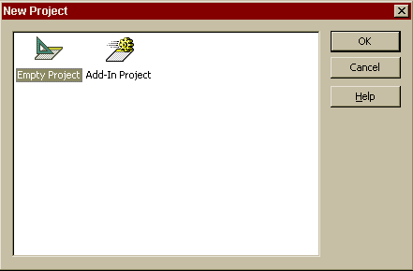

Figure 1: File – New Project now includes an option for a COM Add-In project.
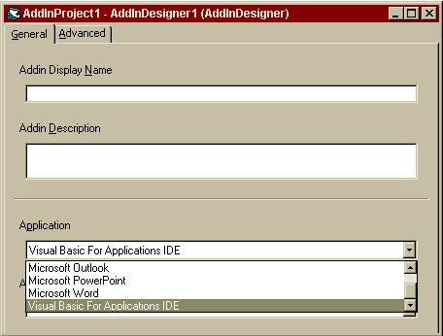

Figure 2: Specific Office applications can be targeted with the Add-In Designer.
Since VBA 6.0 also supports COM Add-ins, you can now create add-ins for the Visual Basic for Applications Editor. By creating COM Add-ins for the Visual Basic Editor, you can customize your development environment and work with components in a VBA project from code. For example, one of the interesting new features of Office 2000 is the ability to use the new Office Clipboard to collect and paste multiple items. This feature isn’t included in the Visual Basic environment, but you could easily reuse the functionality off Office 2000 to include that functionality in the VBA Editor.

When you create a COM Add-in for the Visual Basic Editor, it will also appear in the Visual Basic Editor in Access, Excel, PowerPoint, FrontPage, and any other VBA host applications on the computer where the COM Add-in DLL is registered.

Debugging with Run Project Mode
One of the greatest benefits to developing solutions with VBA is the ability to debug working code inside the host application. VBA 6.0 provides a new feature—Run Project Mode (see Figure 3)—to enable code to execute for debugging and testing, without requiring a DLL to be built.

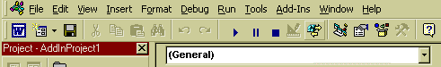
Run Project Mode
Figure 3: Run Project Mode facilitates real-time debugging without building a DLL.
Other advantages include:
- You can make edits to the code in the Add-In while it is running and not cause the Add-In to stop running. (Edit and Continue.)
- You can run individual procedures (to debug them for instance) without needing to start the entire Add-In.
- Debugging is more realistic because the BASIC code is being run in-proc with the host—just as it will from the created DLL.
- The source for the Add-In project is stored in a single binary .VBA file instead of multiple text files.

New VBA Productivity Tools
Several of the enhancements in the VBA development environment are available through the new Add-In Manager (see Figure 4). The Add-In Manager lists the add-ins that ship with Office 2000 Developer, as well as any other Add-ins created for the VBA IDE. Developers can select Load Behavior to control the current state of each add-in or to have the add-in loaded on startup.

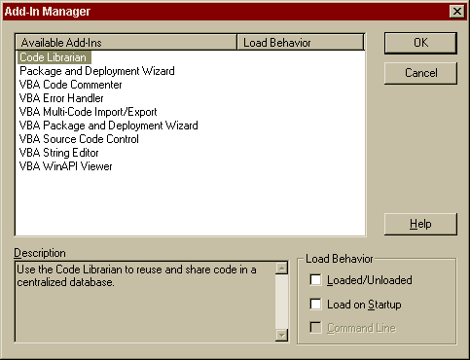
Figure 4: The VBA Add-In Manager displays the status of each COM Add-In.

VBA Code Librarian
The VBA Code Librarian is a new add-in available in VBA that is used to store and retrieve code modules, functions, and snippets. It is organized by categories and keywords (see Figure 7).

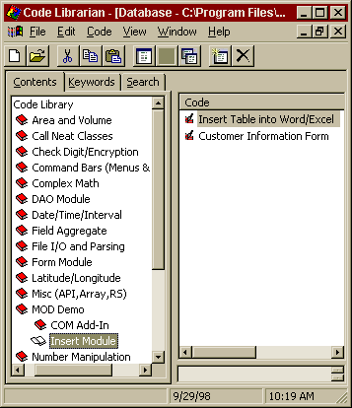

Figure 7: The Code Librarian displays a hierarchical tree of code modules.
Developers can easily drag code from the Code Librarian window onto the Code Editor window.

For example, a developer created a large number of code modules and functions that will be reused. In the past, the developer stored these items in separate folders and attempted to remember the folder locations and module names. As the developer’s personal library grows larger, it becomes difficult to organize and remember what each module represents. With the Code Librarian Add-In loaded, the developer can move existing reusable modules and functions into the Code Librarian and then categorize each piece of code. Furthermore, finding the right snippet by using the search capabilities to search through the code title and descriptions, as well as the code itself, is simple. Once the developer finds the right piece of code, it can be inserted directly into current modules.

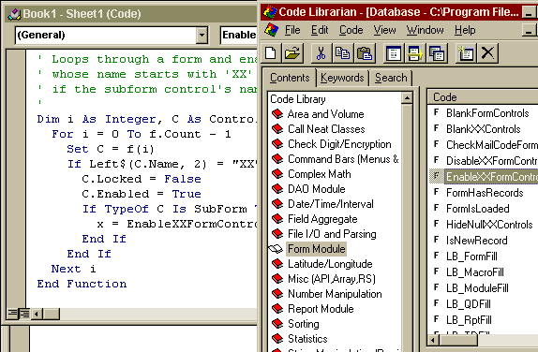

Figure 8: Developers can drag code modules from the Code Librarian into the Visual Basic Editor.
After the proper code is located, a developer can drag the code snippet icon into the Visual Basic Editor (see Figure 8). Notice that the inserted code is completely formatted, including comments.

The VBA Code Librarian ships with a starter set of sample code to help developers work with Office 2000 and VBA. These samples are drawn from the Office 2000/Visual Basic Programmer's Guide as well as from our Product Support group, which has included some of the most requested code snippets. Updates to this sample code will be available on the Office Developer Forum at http://www.microsoft.com/officedev.

Developers using Visual Studio will also benefit from the Code Librarian since it can run in standalone mode and drag code into the Visual Studio IDE.

VBA Code Commenter
The VBA Code Commenter is designed to add structured headers to the procedures within a VBA project. It functions by merging a user-supplied template with the code in a project. This enables developers to accommodate design consistency or departmental requirements with very little effort. And since templates can be created at any time and saved for later use, each developer can apply specific comment syntax to their area of a project, at the Project, Module, or specific Procedure level.

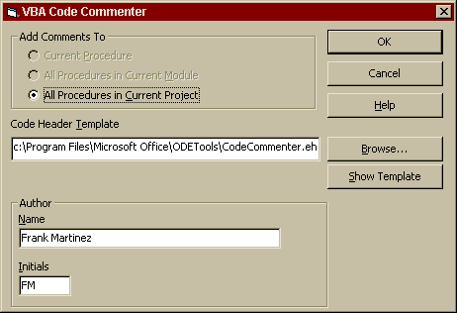
Figure 9: Developers can select the project’s scope and the templates to be used for the comment form.

VBA Error Handler
The VBA Error Handler is designed to help developers avoid one of the tedious tasks of VBA development: adding standardized error handlers to every single procedure.

Consider a scenario where a VBA developer has created a complex VBA project with no error handling. The developer later realizes there is a programmatic need, and a departmental requirement, to add error handling for all projects. A developer loads the VBA Error Handler Add-In and selects Add-Ins, VBA Error Handler to solve this problem. This brings up the following user interface:

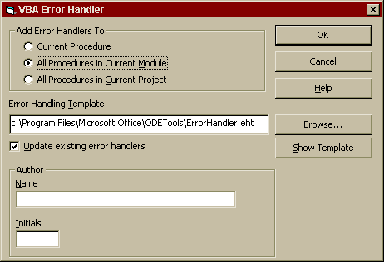
Figure 10: New error handlers can be added or updated with the Error Handler Add-In.
The developer can select the All Procedures in Current Project option and click OK. Error handlers are then inserted into every procedure in their project (see Figure 13), and requirements are satisfied.

Both the Error Handler and Code Commenter derive formatted text from a default template included with Office 2000 Developer (see Figure 11). This template can be edited. It can also be replaced with custom templates (.txt files) that might be required for specific projects or teams.

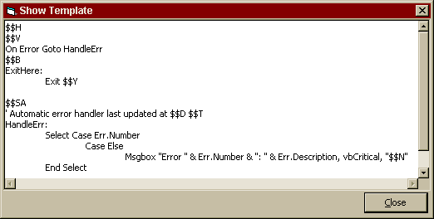
Figure 11: Error Handler text is displayed from the default template.

Printed Developer Documentation
More and more developer documentation is moving to online Help files. We heard from our developers that they prefer having the printed documentation so we included the three printed books (below) to provide developers with a central resource that is easy to navigate. The online documentation will contain these three books, as well as context-sensitive help and the entire MSDN™ library collection.

Office 2000/Visual Basic Programmer's Guide
The Microsoft Office 2000/Visual Basic Programmer’s Guide is about using the applications and components in Microsoft Office 2000 to build custom solutions. This is the definitive resource for developers who are creating custom solutions based on Office applications. From the overall design of your solution to the nitty-gritty details of implementing it, this book tells you what you need to know to get things done quickly and efficiently. All of the sample code and solutions referenced in The Office 2000/Visual Basic Programmer’s Guide are included on the Microsoft Office 2000 Developer CD-ROM. In addition, the Code Librarian ships with the commented sample code for easy use.

Getting Results with Office 2000 Developer
This documentation provides information about installing the product, and getting up and running with the tools, as well as user information concerning technical support and accessibility issues.

Object Model Guide
This document consists of object model diagrams for each Microsoft Office application, as well as components available for use within an Office application. The object model diagrams included show how the objects in an object model fit together.

An application or component programmatically exposes its functionality through objects. You work with an object by using its properties and methods. Objects are named according to the portion of an application they represent, and they are ordered in a hierarchy.

You can use these diagrams as a handy shortcut to finding the object you want to work with and understanding how that object fits into the overall object model exposed by an application.

MSDN Office 2000 Developer Version
This version of MSDN includes the entire library of development knowledge on Microsoft platforms and technologies, plus specific Help files for Office 2000 Developer features.

Easy Access to Data

Universal Data Access is Microsoft's strategy for providing high-performance access to all types of information (including relational and non-relational data) across organizations, from the desktop to the enterprise. Universal Data Access enables Office developers, through Visual Basic for Applications, to access any data source on any platform. Universal Data Access consists of three core technologies: OLE DB, Open Database Connectivity (ODBC), and ActiveX Data Objects (ADO).

OLE DB and ODBC
OLE DB is Microsoft’s system-level programming interface to diverse data sources. OLE DB specifies a set of Microsoft COM interfaces that encapsulate, or hide, various database management system services. OLE DB is designed for non-relational as well as relational information sources on disparate platforms. These include electronic mail and file system stores; text, graphical, and geographical data; and custom business objects.

ODBC continues to provide standard access to most relational database systems on the market. In addition, the OLE DB Provider for ODBC uses existing ODBC drivers to access relational data. Visual Basic for Applications includes new Microsoft-developed OLE DB providers and/or ODBC drivers to Microsoft SQL Server, Microsoft Access, Microsoft Visual FoxPro® database management system, and Oracle databases.

ActiveX Data Objects
ADO is Microsoft's strategic, high-level interface to data, completely isolating developers from the underlying OLE DB and ODBC technologies. ADO supplies an open, application-level data access object model that enables corporate developers to write database applications over OLE DB data using any language. Visual Basic for Applications can use ADO to access data. Through ADO, developers now have access to more types of data than ever before and will need to spend far less time writing complex client/server code.
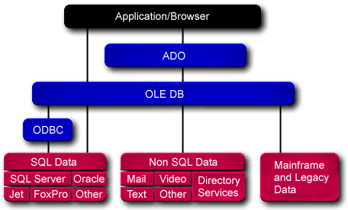
Figure 12: The Universal Data Access Architecture provides a unified layer of interoperability across multiple, traditional, and non-traditional data sources. These data sources can be located on any platform, such as Windows NT operating systems, UNIX, and SNA-based host environments.

ADO Data Control
The ADO Data Control (ADODC) will enable developers to quickly create connections between data-bound controls and data providers using the simplicity of ADO. For Office developers who were comfortable with Remote Data Objects (RDO), ADODC is similar in function, but significantly more powerful than RDO.

Consider a scenario where Maria has an OLEDB provider for SQL Server, and she wants to create a form that lets users browse through a Customer table. Maria adds the ADODC to the project, drops it on a form, and sets some connect properties. After that, Maria adds some text boxes and labels, binds the text boxes to the ADODC, and then runs the form. The ADODC handles the connection through ADO/OLEDB and binds the text boxes to the Customer table. The user can then scroll through the Customer records, make changes, add new records, and commit them to the database by simply moving off the current record.

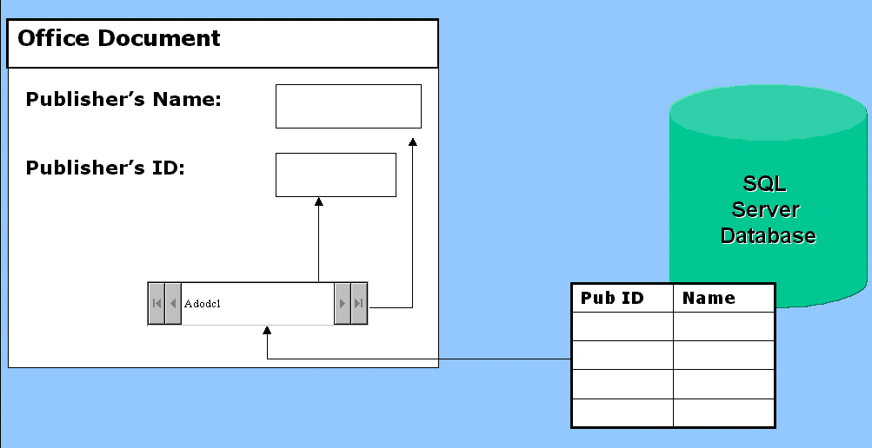
Figure 13: The ADO Data Control provides an abstracted connection to a SQL Server database, without any coding required.
Essentially, the scenario is exactly the same as with the Remote Data Object—except that ADO and OLEDB provide the management of data, not RDO. If the user does not have an OLEDB provider for their particular database, but does have an ODBC driver, they will be able to go through the ODBC OLEDB Provider and still get at their data, until such time as a native OLEDB provider is brought to market.

Data Binding
To use data binding, developers only have to set properties to tell the data source control where the data is coming from (for example, an Oracle server) and which other component (referred to as the data consumer) is to display and/or update the data. VBA then automatically handles moving the data back and forth from the data source to the data consumer, as well as updating the data when necessary.

Designers for Data Environments and Data Reports
In addition to the COM Add-In Designer discussed above, Office 2000 Developer provides two additional designers created to support solutions that access and present corporate data. These designers are available when you create a stand-alone project as described above, and are accessed from the Insert menu (see Figure 14).

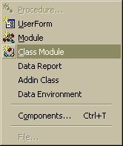
Figure 14: Inserting a Data Report or Data Environment.

Data Environment Designer
One of the most powerful new features in Visual Basic for Applications is the Data Environment Designer, which provides an easy-to-use, design-time interface for creating business-rule specific, ADO-based COM objects. For example, a developer may want to create an object that aggregates data from three different database tables. These tables can be joined into a single object with its own properties, methods, and events. Once these objects are created, they can be saved and reused.

Developers can use the Data Environment user interface to create hierarchical views of data within the development environment. Hierarchies give developers the ability to build components that easily handle parent-child relationships between recordsets, customize groupings of data, and enable developers to specify aggregate calculations over child recordsets. For example, a shop owner may want to be able to look at a particular customer’s master information, such as the customer’s address, and then drill down into more detailed information such as the customer’s order history.

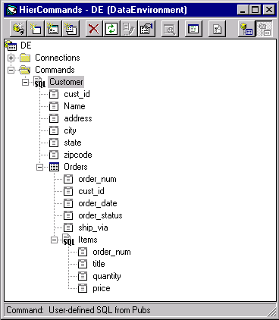
Parent (master) recordset based on SQL query
Child recordset based on SQL table
Child recordset based on SQL query
Figure 15: The Data Environment Designer enables you to visually create, modify, and reuse hierarchical recordset command objects without having to write a single line of code.
Working with a Data Environment object is just like working with any other COM object. From the outside, an object created with the Data Environment Designer is accessed using the familiar object.property or object.method syntax. On the inside, Data Environment objects interact with OLE DB and ADO on behalf of the developer.

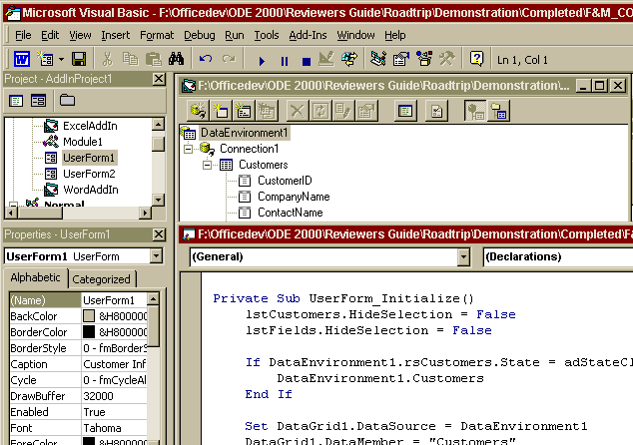
Figure 16: With just a few lines of code, developers can reuse a Data Environment object created by another developer. Reuse with other comparable tools often involves copying, pasting, and hard-coding the entire data structure into the new project.
Rather than requiring developers to independently create their own data access objects, they can be created once and reused, either in the same project or other tasks. This object reusability allows easier data-access standardization in team-based development and further increases developer productivity by reducing redundant work.

Data Report Designer
The Data Report Designer is a new, integrated report writer that makes it easy for developers to create sophisticated printed reports and provides programmatic control at run-time. The Report Designer is fully integrated with the Data Environment Designer. Developers can use a drag operation to move individual data fields or entire recordsets from the Data Environment to easily create new reports. For a greater level of control, developers can use code to manage formatting, printing, previewing, calculation, and saving of their hierarchical reports.

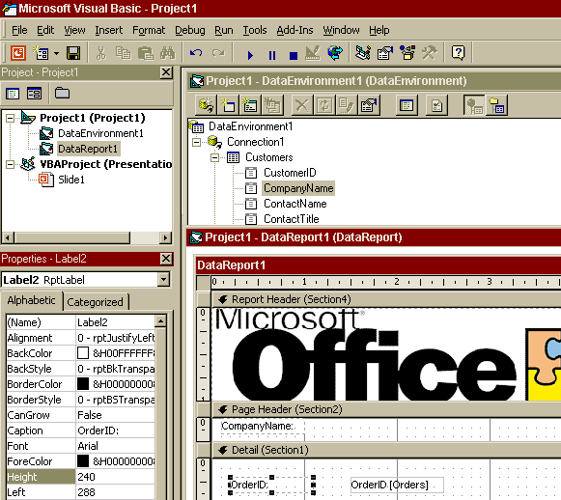
Figure 17: Use the new, banded Report Writer to create sophisticated reports using drag functionality.
The Data Report Designer is ideal to use in conjunction with the hierarchical commands created in the Data Environment Designer. The Data Report Designer is a versatile data report generator that enables developers to create reports from a live data source. In addition to creating printable reports, you can also export the report to HTML or text files.

Data-Bound ActiveX Controls
The enhanced FlexGrid control in Microsoft Office 2000 Developer has been integrated with the Data Environment Designer for easy on-screen display of hierarchical data. When the new hierarchical FlexGrid control is bound to an object created by the Data Environment Designer containing nested recordsets, additional display options become available. These additional display options make it possible to display grouped, related, and calculated recordsets.

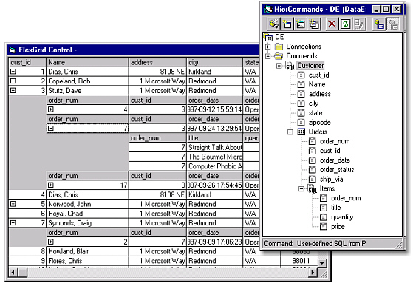
Figure 18: This is an example of the new hierarchical FlexGrid in its expanded display format. Note the customer order details are displayed in a customizable, hierarchical format.
Another control that greatly expands how developers can display data is the new Data Repeater control. Using this control, developers can easily repeat arbitrary ActiveX controls to provide the user with an easily scrollable set of records. Combined with the ability to create sophisticated data-aware ActiveX controls, the Data Repeater control makes creating intuitive interfaces easy.

Figure 19 is an example of the Data Repeater control that enables the user to scroll between different records.

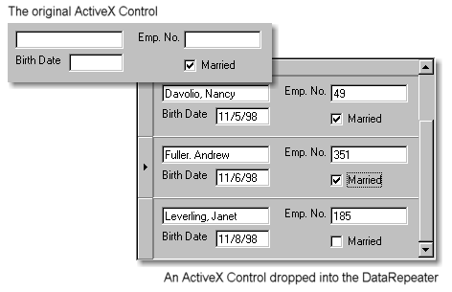
Figure 19: As you can see, when combined with the ability to create sophisticated data-aware ActiveX controls, the Data Repeater control makes creating intuitive interfaces easy.

Microsoft Data Engine (MSDE)
MSDE is a SQL Server compatible data engine for storing data in Microsoft Access 2000. Developers can now choose MSDE, an improved version of Jet 4.0 (which is the default Access 2000 data engine), or Access as a front-end to Microsoft SQL Server versions 6.5 or 7.0.

Developers are able to choose the data engine that best addresses their specific needs, while continuing to enjoy the ease-of-use of Access 2000. MSDE offers customers 100 percent code compatibility with SQL Server, protecting customer investments as database needs grow. MSDE enables a developer to create a single Access 2000 client-server solution that scales from a PC running the Windows 95 or Windows 98 operating system and Access 2000 to multiprocessor clusters running SQL Server 7.0 and Windows NT, Enterprise Edition.

Using MSDE as the Access data engine means that all information, tables, queries, reports, application code, and stored procedures will automatically work with Microsoft SQL Server. Customers that later want to scale up their database can choose MSDE to make migration to SQL Server easier.

New Access 2000 tools allow users to easily create and manage server-side objects—including, tables, views, stored procedures and database diagrams—from the Access 2000 design-view. These tools help Access power users and developers extend their database knowledge to the client-server environment.

The Microsoft Office 2000 Developer data tools simplify working with data by weaving data intelligence directly into the fabric of the design environment. By making the entire environment data-aware and by providing a tightly integrated set of data design, programming, and reporting tools, Microsoft Office 2000 Developer dramatically simplifies building applications that work with data.

Simplify Deploying and Managing Solutions

Once solutions have been built, developers need to manage source code, distribute custom solutions in a secure package and provide support that ensures satisfied end users. Microsoft Office 2000 Developer provides the tools for securing source code, creating professional set up routines that deliver all of the components required by the solution, as well as tools for integrating end user support. In addition, Microsoft Office 2000 Developer contains the licensing for royalty free redistribution of Access based solutions to provide the most flexible installation options.

Access Run Time
Office 2000 Developer will continue to include the Access Run Time, giving developers the ability to redistribute Microsoft Access solutions without requiring Access on the desktop. Microsoft Office 2000 Developer also provides the licensing required for redistribution of MSDE, the SQL-compatible data engine that ships with Microsoft Office. Solutions built with MSDE can easily scale up to SQL Server 7.0.

Microsoft Replication Manager
Replication Manager provides a safe and easy-to-use tool for managing large enterprise applications where there is a requirement for solution developers to provide a link between corporate servers and mobile users. Replication Manager schedules updates among replicas, determines which objects in the database are replicated, and manages multiple replica sets at one time. It has been updated in Office 2000 Developer to support Jet 4.0.

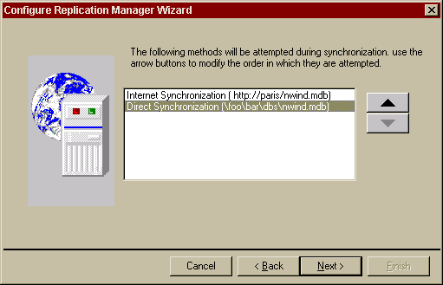
Figure 21: Replication Manager can be configured for local or Internet synchronization.
By using Replication Manager, developers can easily create replicas for all appropriate data formats and manage synchronization locally or across the Internet (see Figure 2). For example, a mobile sales team could use Jet databases on laptop machines while on the road, then later connect to a SQL Server, via the Internet, for updates. Using Jet on a local machine, laptop, or desktop, eliminates the need for support of mobile salespeople and remote offices where the skills required to manage a SQL Server are absent.

Package and Deployment Wizard
The Package & Deployment Wizard has been entirely re-architected for Office 2000 Developer. This wizard will make it easy for Office developers to build professional setup routines that can be used to install their solutions on end-user computers. The wizard offers developers complete control over what changes will be made to end-user computers, and limited control over the interface of the installer program.

For example, an organization has developed a complicated Excel workbook that must be made available for local use by customers, some of who have Internet access and some of whom do not. A developer can open the workbook in Excel, go to the Visual Basic Editor, and choose Package & Deploy Wizard from the Add-Ins menu (see Figure 22).

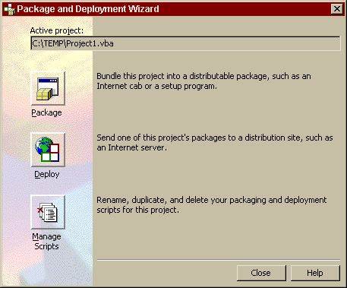
Figure 22: Select an option for distributing a custom solution from the wizard dialog.
The wizard walks the developer through a series of screens to specify options such as the Readme file to include and the title of the application, and the Wizard automatically includes files referenced by the project (such as ActiveX controls and referenced documents, spreadsheets, or databases).
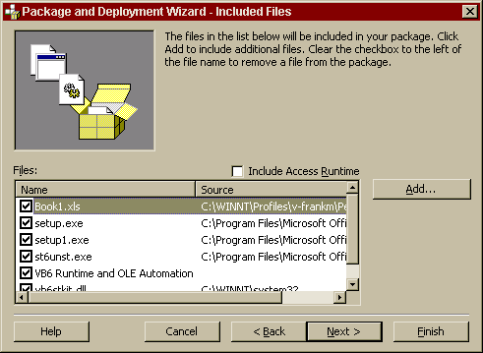
Figure 23: Files to be associated with the solution can be changed at any time, including the Access Runtime.
The Package & Deployment Wizard will work in any of the VBA hosts in Office 2000 (Access, Excel, PowerPoint, Word, FrontPage, and Outlook). In addition, nearly all of its functionality will be available to any third-party VBA host that licenses VBA 6.0. The Package & Deployment Wizard will also include a special option to install the Microsoft Access 2000 run-time files (see Figure 22), continuing the precedent established by previous versions of the Setup Wizard to make it easy to distribute license-free database solutions.

Visual SourceSafe Integration
Office 2000 Developer provides integrated source code control, code sharing, and code reuse for Office projects. Developers not only have easy-to-use version control for private office projects, but when working in a team environment, they can automate the process of managing the source code with read/write security, file sharing, source code browsing, and many other shared code services.

Office 2000 Developer integrates Microsoft Visual SourceSafe version control system into VBA, offering a secure environment for source code. Microsoft Visual SourceSafe protects your team’s most valuable assets, and gives you the tools you need to work efficiently within complex development and authoring environments. Store current files along with past changes to documents, source code, and Web content, so you can easily recreate previous versions and maintain an audit trail for any file.

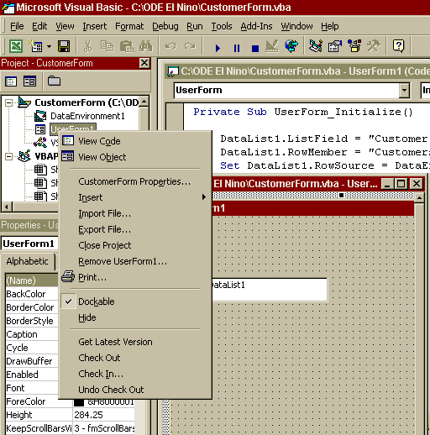

Figure 5: Check In and Check Out functions are right-click enabled from any resource in the Project Explorer.

In a team environment, the ability to maintain tight control of code versions shared by a number of developers reduces the chance for lost work. Different members of a development group, perhaps from different business units, can effectively contribute to a solutions framework by checking their code in or out (see Figure 7) without disrupting the integrity of trusted source code.

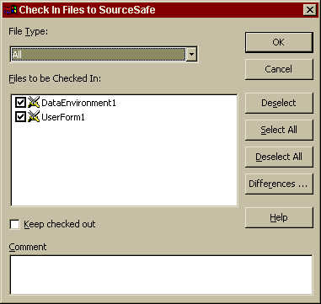

Figure 6: Visual SourceSafe confirms the files that are checked in and the file types. It also allows for comparisons and/or comments.
Tight integration between Visual SourceSafe and Microsoft Access is also offered with an Access Add-In, which gives developers the ability to directly check in and check out Access Data Page components.

Intelligent Assistance Platform
End-user assistance is a time-consuming set of tasks that can exponentially increase with the complexity of an application or custom solution. Microsoft has dedicated considerable research to understanding how to implement effective Help systems. Office 2000 Developer includes an advanced set of tools to simplify these tasks.

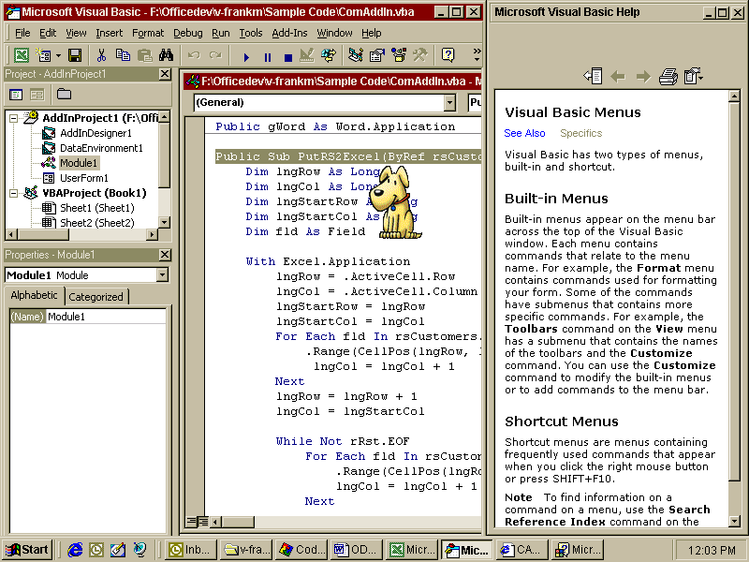
Figure 20: Developers can deploy advanced, context-sensitive assistance, similar to what is included with Office 2000, using the intelligent assistance tools.

Answer Wizard SDK
Office developers have consistently requested a tool to take advantage of the primary access method for assistance in Office applications—the Answer Wizard. The Answer Wizard SDK enables Office developers to provide their customers with a natural-language query interface to topics with HTML Help as the result. Creating an Answer Wizard index for a Help file is a resource-intensive manual process that would be too expensive for most developers to consider. Even with adequate manpower, it would be very difficult for a development team to author an Answer Wizard index that performs as well as what ships with Office 2000.

The SDK enables automated creation of high-quality Answer Wizard files. The tool relies on a training algorithm that adjusts the probabilities of term/topic associations in response to pass/fail analysis of questions associated with topics. Users of the tool will only need to select the HTML files to be indexed, associate questions for which those topics are the best answers, and start the compile process.

HTML Help Workshop
HTML Help Workshop is a stand-alone program for creating Help systems using source files based on Hypertext Markup Language (HTML). With its easy-to-use interface, HTML Help Workshop enables developers to organize the many files that make up the content of a help system into a single project file (.hhp), and to author HTML (.htm, .html) files via a text editor. Developers can also create and edit contents (.hhc) and index (.hhk) files, add graphic (.gif, .jpeg, .png) files, and insert the HTML Help ActiveX Control (the primary navigation tool in HTML Help) into .htm files.

The HTML Help API compliments the HTML Help Workshop, making it possible to display a Help window from any Office application or custom solution. By using the Help API, an application or solution has complete control over the type, style, and position of the Help window.

MS Agent SDK
Office Assistants are fully exposed in the Office programmability model, enabling developers to include customized behavior in Office solutions with the MS Agent SDK. The SDK includes an Agent Character Editor that lets you compose your own characters for use with Microsoft Agent, and header files that define the COM (Component Object Model) interfaces to the Agent Server.

You can use the Office Assistant to animate characters that interact with your users, provide context-sensitive help, highlight parts of your user interface, collect information from users, or otherwise provide a social interface to your application that many users find interesting and fun to use.

The Office Assistant character is drawn onscreen without an enclosing window and can interact with other elements of the application interface, pointing out controls or directing the user’s attention to specific sections of a document.

The Assistant’s Balloon object enables the Assistant to communicate with and get feedback from your users. Balloon objects are designed to let you create a simple interface for user interaction.

Programmability Enhancements to Office 2000 Premium

Because Microsoft Office resides at the crossroads of the digital nervous system, developers have recognized the opportunity to improve end users’ ability to gather, analyze, synthesize and publish through customizing, automating, and integrating Office in their solutions. Office 2000 makes the Office solutions platform even more compelling through an improved programming model, better connectivity to data, and easier publishing to the Web.

Improved Programming Model
Office 2000 provides the most compelling evidence so far of Microsoft’s commitment to making Office a powerful solutions platform. In Office 2000, Microsoft exposes over 600 programmable objects to developers via COM; they represent millions of lines of code written and tested by Microsoft developers.

In addition, the add-in architecture enhancements provide developers with a unified COM-based architecture for creating a single add-in that adds functionality to all of the Office 2000 applications. By providing developers with a unified COM-based, add-in architecture, developers can create a single add-in that will add functionality to all of the Office 2000 host applications.

In addition to exposing its applications’ functionality, Office 2000 takes programmability a step further with discrete programmable objects in the form of Office Web components. These components are ActiveX Controls that deliver a subset of the rich functionality of the Excel spreadsheet, chart, and PivotTable® dynamic views features. With these smaller, single-purpose building blocks, developers can build solutions that integrate powerful functionality without having to run the entire Excel application. Because these building blocks are ActiveX components, developers can host the functionality in custom solutions (Visual Basic forms, Office documents) as well as in the browser.

As always, Microsoft has also provided a common integrated development environment for developers to automate the Office functionality. Because VBA is found throughout Microsoft Office and third-party applications, developers can create solutions that integrate multiple applications throughout the entire line of business.

Office 2000 provides developers with significant enhancements in the following areas:

- Access to application functionality and code security
- Integration with corporate data
- Interactive, data-aware Web solutions and content publishing

Conclusion

Organizations need the ability to harness information technology to provide a competitive advantage. Microsoft’s vision for corporate computing encompasses a corporate digital nervous system to provide a free flow of information that empowers corporations to react faster to changing business needs, make more informed decisions, get closer to customers and business partners, and focus on business, not technology. Common productivity tools for end users and tools for developers are two key building blocks in enabling corporations to achieve a digital nervous system.

Microsoft has made Office 2000 the ideal set of common productivity tools for corporations trying to build a digital nervous system by improving the Office programming model, making it easier for Office users to work with data and simplifying the process of publishing to the Web. By giving developers access to all of the Office 2000 functionality, Microsoft has created a platform rich in opportunity for developers to customize and automate Office 2000 to deliver rich desktop solutions that integrate seamlessly with the Web.

With Office 2000, end users can now participate in the Web in ways never before possible. As more end users and IT managers benefit from the ease of use, speed of development, and quality of solutions built with Microsoft Office, the demand for Office 2000 solutions will continue to grow. Developers will need powerful programming tools to help satisfy the growing demand. Office 2000 Developer delivers the powerful programming tools and information for building and managing this new breed of Office and Office Web-based solutions.

