

Step-by-Step Guide to Migrating from Software Update Services to Windows Server Update Services
Microsoft Corporation
Published: June 3, 2005
Author: Tim Elhajj
Editor: Sean Bentley

Abstract
This paper describes how to migrate from Microsoft® Software Update Services (SUS) to Windows Server™ Update Services (WSUS). In it, you will find step-by-step procedures for installation and configuration of the WSUS server on the SUS server. You will also find procedures for migration of approvals and updates from the SUS server. If you have multiple SUS servers in your organization, there are also optional steps offered for consolidating these servers on the WSUS server.

The information contained in this document represents the current view of Microsoft Corporation on the issues discussed as of the date of publication. Because Microsoft must respond to changing market conditions, it should not be interpreted to be a commitment on the part of Microsoft, and Microsoft cannot guarantee the accuracy of any information presented after the date of publication.

This White Paper is for informational purposes only. MICROSOFT MAKES NO WARRANTIES, EXPRESS, IMPLIED OR STATUTORY, AS TO THE INFORMATION IN THIS DOCUMENT.

Complying with all applicable copyright laws is the responsibility of the user. Without limiting the rights under copyright, no part of this document may be reproduced, stored in or introduced into a retrieval system, or transmitted in any form or by any means (electronic, mechanical, photocopying, recording, or otherwise), or for any purpose, without the express written permission of Microsoft Corporation.

Microsoft may have patents, patent applications, trademarks, copyrights, or other intellectual property rights covering subject matter in this document. Except as expressly provided in any written license agreement from Microsoft, the furnishing of this document does not give you any license to these patents, trademarks, copyrights, or other intellectual property.

Unless otherwise noted, the example companies, organizations, products, domain names, e-mail addresses, logos, people, places, and events depicted herein are fictitious, and no association with any real company, organization, product, domain name, e-mail address, logo, person, place, or event is intended or should be inferred.

©2005 Microsoft Corporation. All rights reserved.

Microsoft, SQL Server, Windows, and Windows Server are either registered trademarks or trademarks of Microsoft Corporation in the United States and/or other countries.

All other trademarks are property of their respective owners.

Contents
Step-by-Step Guide to Migrating from Software Update Services to Windows Server Update Services 7
Step 1: Review WSUS Installation Requirements for Migrating from Software Update Services 8
Software Requirements 8
Windows Server 2003 8
Windows 2000 Server 8
Disk Requirements and Recommendations 9
Step 2: Install MSDE on Your Server (Windows 2000 only) 10
Step 3: Install WSUS on Your SUS Server 15
Step 4: Configure WSUS 20
Step 5: Migrate Content and Approvals from SUS to WSUS 23
Step 6: Decommission SUS and Move WSUS to Port 80 25

Step-by-Step Guide to Migrating from Software Update Services to Windows Server Update Services
This guide offers instruction for installing Microsoft Windows Server Update Services (WSUS) on a computer with Microsoft Software Update Services (SUS) running either Microsoft Windows Server 2003 operating systems (except for Web Edition and all 64-bit versions) or Windows® 2000 Server. If you want to install WSUS on a computer that does not have SUS installed and then migrate SUS approvals and updates, see the “Deploying Microsoft Windows Server Update Services” white paper.
Windows Server Update Services (WSUS) is the next iteration of Software Update Services (SUS). Although you cannot upgrade a SUS server to a WSUS server, there is support for migrating your approvals and updates from SUS to the new WSUS server. This ensures that you do not have to download the same updates twice, nor spend time approving previously approved updates. If you are using multiple SUS servers to target updates to computers fulfilling specific roles on the network, you can map SUS approvals to WSUS computer groups as you migrate the approvals. This allows you to consolidate multiple SUS servers on a single WSUS server.
It is simple to introduce WSUS into your production environment. You can install WSUS and SUS on the same computer and both will function. You can also have SUS and WSUS environments running simultaneously on your network. However, you can never synchronize a SUS server with a WSUS server or vice versa. Beyond the migration, the two update solutions are completely isolated from one another. This enables you to test WSUS in your production environment while relying on SUS to update client computers. When WSUS testing is complete and you are comfortable with the new solution, you can decommission SUS.

Step 1: Review WSUS Installation Requirements for Migrating from Software Update Services
The following are the baseline installation requirements for WSUS installations that use the default options. You can find hardware and software requirements for other installations in the “Deploying Microsoft Windows Server Update Services” white paper.
Hardware recommendations for a server with up to 500 client computers are as follows:
• 1 gigahertz (GHz) processor
• 1 gigabyte (GB) RAM

Software Requirements
The following is a list of required software for each operating system that supports WSUS. Ensure that the computer you will use for the WSUS server meets this list of requirements prior to your running WSUS Setup. If any of these updates require restarting the computer when installation is completed, you should restart your server prior to installing WSUS.

Windows Server 2003
The following software is required for running WSUS on Windows Server 2003:
• Microsoft Internet Information Services (IIS) 6.0.
• Background Intelligent Transfer Service (BITS) 2.0; go to the Download Center at http://go.microsoft.com/fwlink/?LinkId=47251.
• Microsoft .NET Framework 1.1 Service Pack 1 for Windows Server 2003; go to the Download Center at http://go.microsoft.com/fwlink/?LinkId=47358.
An alternative is to go to Windows Update at http://go.microsoft.com/fwlink/?linkid=47370 and scan for Critical Updates and Service Packs. Install Microsoft .NET Framework 1.1 Service Pack 1 for Windows Server 2003.

Windows 2000 Server
The following software is required for running WSUS on Windows 2000 Server:
• Microsoft Internet Information Services (IIS) 5.0. For instruction about how to install IIS, see the “Deploying Microsoft Windows Server Update Services” white paper or Help and Support Center in Windows 2000 Server.
• Background Intelligent Transfer Service (BITS) 2.0; go to the Download Center at http://go.microsoft.com/fwlink/?LinkId=46794.
• Database software that is 100-percent compatible with Microsoft SQL. To obtain Microsoft SQL Server 2000 Desktop Engine (MSDE 2000) Release A, go to the Download Center at http://go.microsoft.com/fwlink/?LinkId=47366.
• Microsoft Internet Explorer 6.0 Service Pack 1; go to the Download Center at http://go.microsoft.com/fwlink/?LinkId=47359.
• Microsoft .NET Framework Version 1.1 Redistributable Package; go to theDownload Center at http://go.microsoft.com/fwlink/?LinkId=47369.
• Microsoft .NET Framework 1.1 Service Pack 1; go to the Download Center at http://go.microsoft.com/fwlink/?LinkId=47379.
An alternative is to go to Windows Update at http://go.microsoft.com/fwlink/?linkid=47370 and scan for Critical Updates and Service Packs. Install Microsoft .NET Framework 1.1 Service Pack 1 for Windows 2000 Server.

Disk Requirements and Recommendations
To install WSUS, the file system of the server must meet the following requirements:
• Both the system partition and the partition on which you install WSUS must be formatted with the NTFS file system.
• A minimum of 1 GB free space is required for the system partition.
• A minimum of 6 GB free space is required for the volume where WSUS stores content; 30 GB is recommended.
• A minimum of 2 GB free space is required on the volume where WSUS Setup installs Windows SQL Server 2000 Desktop Engine (WMSDE).

Step 2: Install MSDE on Your Server (Windows 2000 only)
If you are using WSUS with Windows 2000 Server and do not have access to Microsoft SQL Server 2000, you should install Microsoft SQL Server 2000 Desktop Engine (MSDE) prior to running WSUS Setup. This section gives step-by-step instructions for this task.
If you are installing to a Windows Server 2003 operating system, you do not need to do this step; skip to Step 3: Install WSUS on Your SUS Server
Installing MSDE on Windows 2000 Server is a four-step process. First, you must download and expand the MSDE archive to a folder on the server you want to be your WSUS server. Next, at the command prompt, use command-line options to run MSDE Setup, set the sa password, and assign WSUS as the instance name. Then, when the MSDE installation finishes, you should verify that the WSUS instance is running as a Windows NT service. Finally, you must add a security patch to MSDE to protect your WSUS server.
Step 2 contains the following procedures:
• Download and expand the MSDE archive.
• Install MSDE.
• Verify that the MSDE database instance is running.
• Update MSDE.
You must download and expand the MSDE archive to a folder on the server you want to be your WSUS server. To obtain SQL Server 2000 Desktop Engine (MSDE 2000) Release A, go to the Download Center at http://go.microsoft.com/fwlink/?LinkId=47366.
To expand the MSDE archive
1. Double-click the MSDE archive (MSDE2000a.exe).
2. Read the license agreement, and click I Agree.
3. In the Installation Folder box, type a path, and then click Finish. For example, type C:\MSDE2000. The MSDE archive copies MSDE installation files to the installation folder you specify.
Installation Folder Page
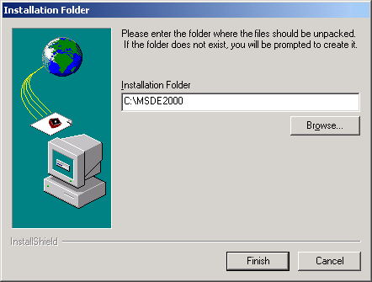

Now you install MSDE, set the sa password, and assign an instance name.
To install MSDE, set the sa password, and assign an instance name
1. At the command prompt, navigate to the MSDE installation folder specified in the previous procedure.
2. Type the following:
setup sapwd="password" instancename="WSUS"
where password is a strong password for the sa account on this instance of MSDE. This command launches the MSDE setup program, sets the sa password, and names this instance of MSDE to WSUS.
To verify that the WSUS instance of MSDE was installed
1. Click Start, and then click Run.
2. In the Open box, type services.msc and then click OK.
3. Scroll down the list of services, and verify that a service named MSSQL$WSUS exists.
MSSQL$WSUS
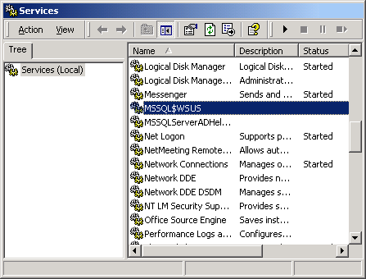

You must download and install the security patch described in the bulletin,"MS03-031: Cumulative Security Patch for SQL Server." To obtain SQL Server 2000 (32-bit) Security Patch MS03-031, go to the Download Center at http://go.microsoft.com/fwlink/?LinkId=37271.
To read bulletin MS03-031, go to the Microsoft Help and Support Web site at http://go.microsoft.com/fwlink/?LinkId=37270.
To install SQL Server 2000 (32-bit) Security Patch MS03-031
1. Double-click SQL Server 2000 (32-bit) Security Patch MS03-031 (SQL2000-KB815495-8.00.0818-ENU.exe).
2. On the Welcome page, click Next.
3. Read the End User License Agreement, click I accept the license terms and conditions, and then click Next.
4. On the Instance to Update page, use the Instance box to select the WSUS instance, and then click Next.
Instance to Update Page
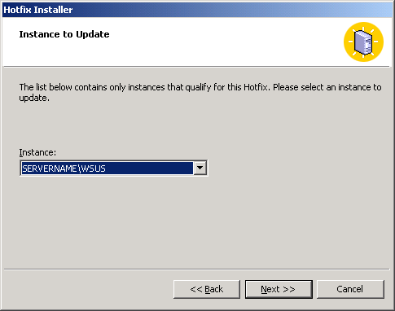

5. On the Authentication Mode page, select Windows Authentication, and then click Next.
Authentication Mode Page
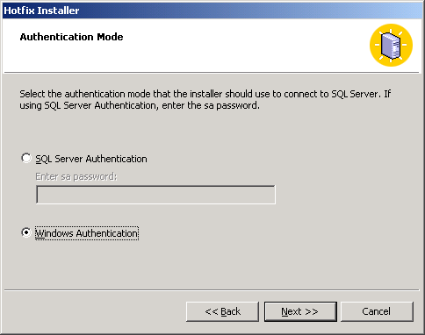

6. On the Ready to Install page, click Install.
Ready to Install Page
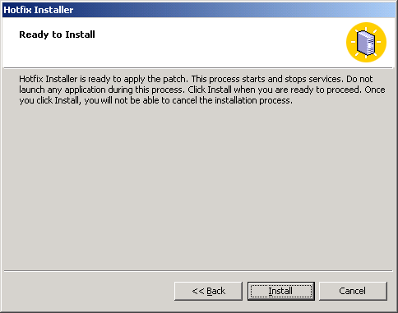

7. On the Hotfix Complete page, click Finish.

Step 3: Install WSUS on Your SUS Server
After reviewing the installation requirements and optionally installing MSDE, you are ready to install WSUS. The following procedure uses the default WSUS installation options for Windows 2000 Server with SUS installed. This requires you to supply database software, store updates locally, and use the custom Web site on port 8530. If you are using Windows Server 2003, you do not have to supply database software. Although some illustrations may look slightly different from screens in Windows Server 2003, the steps are very similar. Any procedural differences are called out in the text of this guide.
You must log on to the server you plan to install WSUS on by using an account that is a member of the local Administrators group. Only members of the local Administrators group can install WSUS.
To install WSUS on Windows 2000 Server with SUS
1. Double-click the installer file WSUSSetup.exe.
Note:
The latest version of WSUSSetup.exe is available on the Microsoft Web site for Windows Server Update Services at http://go.microsoft.com/fwlink/?LinkId=47374.
2. On the Welcome page of the wizard, click Next.
3. Read the terms of the license agreement carefully, click I accept the terms of the License Agreement, and then click Next.
4. On the Select Update Source page, you can specify where clients get updates. If you select the Store updates locally check box, updates are stored on the WSUS server and you select a location in the file system to store updates. If you do not store updates locally, client computers connect to Microsoft Update to get approved updates.
Keep the default options, and click Next.
Select Update Source Page
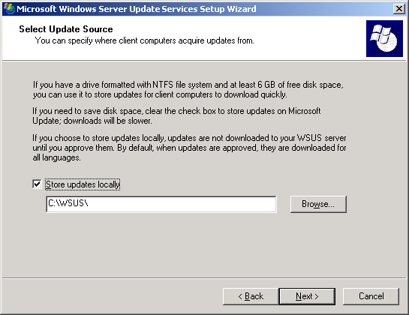

5. On the Database Options page, do one of the following depending on the operating system you are using:
• For Windows Server 2003, click Install SQL Server desktop engine (Windows) on this computer.
• For Windows 2000 Server, click Use an existing database server on this computer, select the instance name from the SQL instance name box, and then click Next.
Database Options Page
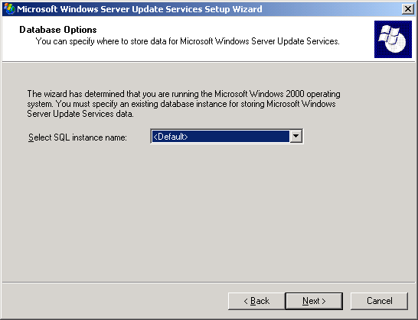

6. On the Web Site Selection page, click Create a Microsoft Windows Server Update Services Web site.
This page also lists two important URLs based on this selection: the URL to which you will point WSUS client computers to get updates, and the URL for the WSUS console where you will configure WSUS.
7. On the Mirror Update Settings page, you can specify the management role for this WSUS server. If this is the first WSUS server on your network or you want a distributed management topology, skip this screen.
If you want a central management topology, and this is not the first WSUS server on your network, select the check box, and type the name of an additional WSUS server in the Server name box. For more information about management roles, see the “Deploying Microsoft Windows Server Update Services” white paper.
Keep the default option, and click Next.
Mirror Update Settings Page
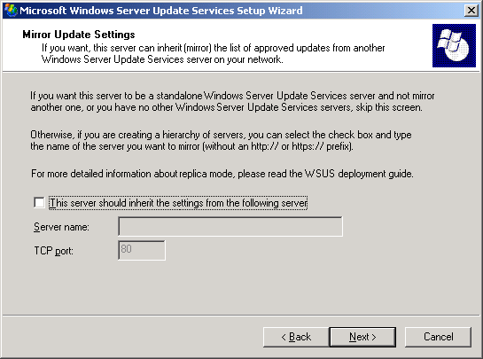

8. On the Ready to Install Windows Server Update Services page, review the selections, and click Next.
Ready to Install Windows Server Update Services Page
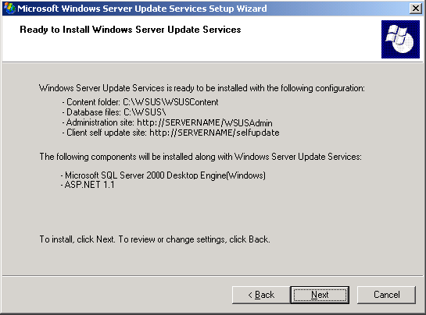

9. If the final page of the wizard confirms that WSUS installation was successfully completed, click Finish.

Step 4: Configure WSUS
After installing WSUS, you are ready to access the WSUS console in order to configure WSUS and get started. By default, WSUS is configured to use Microsoft Update as the location to obtain updates. If you have a proxy server on your network, use the WSUS console to configure WSUS to use the proxy server.
After you configure the network connection, you can obtain updates. Consider using the WSUS synchronization option for deferred downloads, which is enabled by default. Also, configure WSUS to download updates for the same number of languages that SUS was configured to download updates. By default, WSUS is configured to download all languages. These configurations ensure that you do not unnecessarily download updates already on your network or in languages that you do not require.
To get updates, you must synchronize the WSUS server. Synchronization involves the WSUS server contacting Microsoft Update. After making contact, WSUS determines if any new updates have been made available since the last time you synchronized. Because this is the first time you are synchronizing the WSUS server, all of the updates are available and are ready for your approval for installation.
Note:
If approvals are created on the WSUS server before approval migration is performed, the explicitly created approvals are overwritten by the migration of approvals.
Step 4 contains the following procedures:
• Open the WSUS console.
• Configure proxy-server settings so that WSUS can obtain updates.
• Configure WSUS language settings.
• Synchronize your WSUS server.
To open the WSUS console
• On your WSUS server, click Start, point to All Programs, point to Administrative Tools, and then click Microsoft Windows Server Update Services.
Note:
You must be a member of either the WSUS Administrators or the local Administrators security groups on the server on which WSUS is installed in order to use the WSUS console.
If you do not add http://WSUSWebsiteName to the list of sites in the Local Intranet zone in Internet Explorer on Windows Server 2003, you might be prompted for credentials each time you open the WSUS console.
If you change the port assignment in IIS after you install WSUS, you need to manually update the shortcut on the Start menu.
You can also open the WSUS console from Internet Explorer on any server or computer on your network at the following URL: http://WSUSServerName:[port]/WSUSAdmin
To specify a proxy server
1. On the WSUS console toolbar, click Options, and then click Synchronization Options.
2. In the Proxy server box, select the Use a proxy server when synchronizing check box, and then type the proxy server name and port number (port 80 by default) in the corresponding boxes.
3. If you want to connect to the proxy server by using specific user credentials, select the Use user credentials to connect to the proxy server check box, and then type the user name, domain, and password of the user in the corresponding boxes. If you want to enable basic authentication for the user connecting to the proxy server, select the Allow basic authentication (password in clear text) check box.
4. Under Tasks, click Save settings, and then click OK in the confirmation dialog box.
To specify WSUS language options (optional)
1. On the WSUS console toolbar, click Options, and then click Synchronization Options.
2. Under Update Files and Languages, click Advanced, then read the warning and click OK.
3. In the Advanced Synchronization Options dialog box, under Languages, select one of the following language options, and then click OK.
• Download only those updates that match the locale of this server (Locale) where Locale is the name of the server locale. This means that only updates targeted to the locale of the server will be downloaded during synchronization.
• Download updates in all languages, including new languages This means that all languages will be downloaded during synchronization. If a new language is added, it will be automatically downloaded.
• Download updates only in the selected languages This means that only updates targeted to the languages you select will be downloaded during synchronization. If you choose this option, you must also choose each language you want from the list of those available.
To synchronize your WSUS server
1. On the WSUS console toolbar, click Options, and then click Synchronization Options.
2. Under Tasks, click Synchronize now.

Step 5: Migrate Content and Approvals from SUS to WSUS
Now that you have configured and synchronized WSUS, you can migrate content and approvals from the SUS server(s) in your environment to your WSUS server. Migrate content and approvals from the local SUS server first. If you have additional SUS computers, you can configure SUS for remote migration and then migrate any remote content and approvals, mapping these approvals to a WSUS target group. This is optional.
Step 5 contains the following procedures:
• Migrate local content and approvals.
• Create WSUS target groups for mapping remote SUS approvals (optional).
• Share remote content on SUS for migration to WSUS (optional).
• Migrate remote content and approvals, mapping approvals to WSUS target groups (optional).
Use WSUSutil.exe to migrate local SUS content and approvals. By default, WSUSutil.exe appears in the following location:
WSUSInstallationDrive:\Program Files\Update Services\Tools
You must be a member of the local Administrators group on the WSUS server to import approvals or content from SUS. These operations can only be run from the WSUS server itself. You can only run WSUSutil.exe on a 32-bit platform.
Although SUS does not have to be running in order for you to move updates or approvals, you do have to make sure that SUS is not synchronizing before you migrate content or approvals. Although WSUSutil.exe allows you to move both approvals and updates, you are not required to migrate one, the other, or both.
To migrate local content and approvals from SUS and map approvals to the All Computers target group on WSUS
1. At the command prompt, navigate to the directory that contains WSUSutil.exe.
2. Type the following:
wsusutil.exe migratesus /content PathToLocalSUSContent /approvals SUSServerName /log filename
For example:
wsusutil.exe migratesus /content c:\sus\content\cabs /approvals sus1 /log local_migration.log
Mapping remote approvals to a WSUS computer group is optional. It is helpful if you have multiple SUS servers in a single location and want to consolidate the SUS servers onto one WSUS server. If you intend to map remote SUS approvals to a WSUS computer group, first create the group on WSUS.
To create a computer group
1. In the WSUS console toolbar, click Computers.
2. Under Tasks, click Create a computer group.
3. In the Group name box, type a name for your new computer group, and then click OK.
Once you have created the WSUS target group, you can migrate remote approvals and content by using WSUSutil.exe. This command-line utility uses HTTP to get approvals and SMB to copy updates from a remote SUS installation. To copy updates from a remote computer, this tool requires Read share permissions on the remote SUS Content folder and all its subfolders.
To share remote content on SUS for migration to WSUS
1. On the remote SUS computer, locate the SUS content store in the file system. By default, SUS content is stored in C:\SUS\Content\.
2. Right-click the Content folder, and then click Sharing and Security (or Sharing, on computers running Windows 2000).
3. In the Properties dialog box for the Content folder, click Share this folder.
4. Click the Security tab, and ensure that the Everyone group has Read NTFS permissions for the Content folder.
5. Click OK.
6. Repeat this step on each SUS server you intend to migrate.
To migrate remote content and approvals from SUS and map approvals to a custom computer group on WSUS
1. At the command prompt, navigate to the folder that contains WSUSutil.exe.
2. Type the following:
wsusutil.exe migratesus /content LocationOfRemoteSUSContent /approvals SUSServerName "WSUSTargetGroupName" /log filename
For example:
wsusutil.exe migratesus /content \\sus1\content\cabs /approvals sus1 "all desktops" /log remote_migration.log

Step 6: Decommission SUS and Move WSUS to Port 80
Once you have tested WSUS in your environment, you are ready to decommission the SUS server and then change the WSUS Web site from the custom port (8530) to port 80.
As the SUS clients check in with the WSUS server, they will begin to appear in the WSUS console. Note that you do not need to make any changes to Group Policy to get the SUS clients to appear in the WSUS console.
If you prefer to leave your updating solution on a port other than port 80, you can leave WSUS on the custom 8530 port and change the client policy to point to this port on your WSUS server. You still need to leave the virtual selfupdate directory on port 80 to allow client computers that are not WSUS-compatible to get updated to the WSUS-compatible client.
To decommission SUS
1. Click Start, and then click Run.
2. In the Open box, type inetmgr and then click OK.
3. In IIS, right-click the SUS Web site, and then click Stop.
To switch WSUS to port 80
1. Click Start, and then click Run.
2. In the Open box, type inetmgr and then click OK.
3. In IIS, right-click the WSUS Web site, and then click Properties.
4. In the WSUS Administration Properties dialog box, change the value in TCP port from 8530 to 80.
Note:
If you change the port number after installing WSUS, you have to create a new shortcut on your Start menu with the new URL to access the WSUS console from the Start menu. See Help and Support for instruction on creating shortcuts.

