
Effectively Using IPP Printing

Microsoft Corporation
Published: January 2003

Abstract
Microsoft® Windows® 2000 print servers introduced support for the Internet Printing Protocol (IPP) 1.0 specification, both in the form of a Web-based management infrastructure as well as support for printing over HTTP, and this support was continued in Windows Server 2003. This paper discusses the different aspects of IPP and recommended deployment methods. The paper is designed for systems integrators, administrators, and architects who are planning, deploying, or managing Windows print servers.

This is a preliminary document and may be changed substantially prior to final commercial release of the software described herein.
The information contained in this document represents the current view of Microsoft Corporation on the issues discussed as of the date of publication. Because Microsoft must respond to changing market conditions, it should not be interpreted to be a commitment on the part of Microsoft, and Microsoft cannot guarantee the accuracy of any information presented after the date of publication.
This document is for informational purposes only. MICROSOFT MAKES NO WARRANTIES, EXPRESS OR IMPLIED, AS TO THE INFORMATION IN THIS DOCUMENT.
Complying with all applicable copyright laws is the responsibility of the user. Without limiting the rights under copyright, no part of this document may be reproduced, stored in or introduced into a retrieval system, or transmitted in any form or by any means (electronic, mechanical, photocopying, recording, or otherwise), or for any purpose, without the express written permission of Microsoft Corporation.
Microsoft may have patents, patent applications, trademarks, copyrights, or other intellectual property rights covering subject matter in this document. Except as expressly provided in any written license agreement from Microsoft, the furnishing of this document does not give you any license to these patents, trademarks, copyrights, or other intellectual property.
© 2002 Microsoft Corporation. All rights reserved.
Microsoft, Active Directory, Windows, the .NET logo, Windows NT and the Windows logo are either registered trademarks or trademarks of Microsoft Corporation in the United States and/or other countries.
The names of actual companies and products mentioned herein may be the trademarks of their respective owners.

Contents
Introduction 1
Enabling Web-based Printer Management and Internet Printing 2
Web-based Printer Management 5
Internet Printing 8
HTTP Printer Connection through Web Browser 8
RPC Printer Connection through Web Browser – Preferred Method 8
Summary 9
Related Links 10

Introduction
Microsoft® Windows® 2000 introduced support for the Internet Printing Protocol (IPP) 1.0 specification and Windows Server 2003 continues this support. There are two main components to IPP:
- Web-based printer management, which offers the ability to administer, connect to, and view printers through a Web browser.
- Internet printing, which enables connecting to a printer using the printer’s URL.
This white paper discusses the uses of both components and describes how to enable and disable each.

Enabling Web-based Printer Management and Internet Printing
The only prerequisite for enabling Web-based printer management and Internet printing is that Internet Information Server (IIS) be installed and running on a print server. IIS is installed by default for Windows 2000 Server versions and can be installed as an optional component on Windows 2000 Professional, Windows XP, or Windows Server 2003.

Web-based printer management is available by default after installing IIS on a Windows 2000 or Windows XP machine (although Windows XP and Windows 2000 Professional have a 10-connection limit, and therefore don’t perform very well as Internet print servers). However, disabling the Web-based Printing policy removes the ability to perform Web-based printer management and Internet Printing on a server.
Note: If using Windows 2000 or Windows XP, you must either reboot the system or restart the spooler service after installing IIS to get the Web-based printer management and Internet printing functionalities.
Note: The Web-based Printing policy does not exist on Windows Server 2003. Instead, use the IIS Security Console (described below) to add and remove Internet Printing and Web-based printer management functionality.
When IIS is installed on a Windows Server 2003 machine, the Internet Printing and Active Server Pages components, which are necessary for enabling Web-based printer management and Internet printing, are not installed by default. However, electing to install the Internet Printing component will automatically install the Active Server Pages component by default. This behavior is controlled through the Internet Printing and Active Server Pages check boxes in the IIS installation.
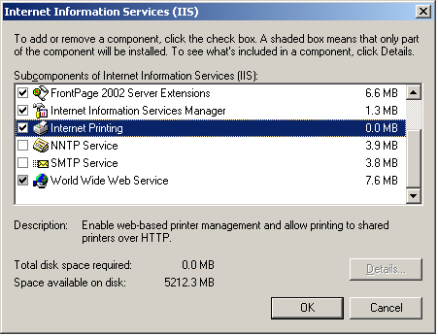
To control this:
- Open Control Panel, select Add or Remove Programs, and click Add/Remove Windows Components.
- Select Application Server, and then click Details.
- Check Internet Information Service (IIS), and then click Details.
- Select the Internet Printing check box to enable the component, or cancel the selection to disable it (see the figure above).
- Select World Wide Web Services (see above), and then click Details.
- Select the Active Server Pages check box to enable the component, or cancel the selection to disable it, and then click OK in all remaining open dialog boxes. (Note: after enabling the Internet Printing component, the Active Server Pages check box will automatically be selected.)
- Click Next to proceed with the installation.

Assuming that the Internet Printing and Active Server Pages components are checked during the IIS installation, Web-based printer management and Internet Printing will work with the default settings in the IIS Security Console.
To modify the web-server extension configuration for these components, run the IIS Security Console and select the Web Service Extensions folder.
To enable Web-based printer management, set the status of Active Server Pages to Allowed. (This option is selected by default.)
To enable Internet Printing as well as Web-based printer management, set the status of Internet Printing to Allowed. (This option is selected by default.)
To accomplish these tasks, right-click My Computer, expand Services and Applications, expand Internet Information Services (IIS), select Web Service Extensions, select Internet Printing or Active Server Pages, and then click Allow.
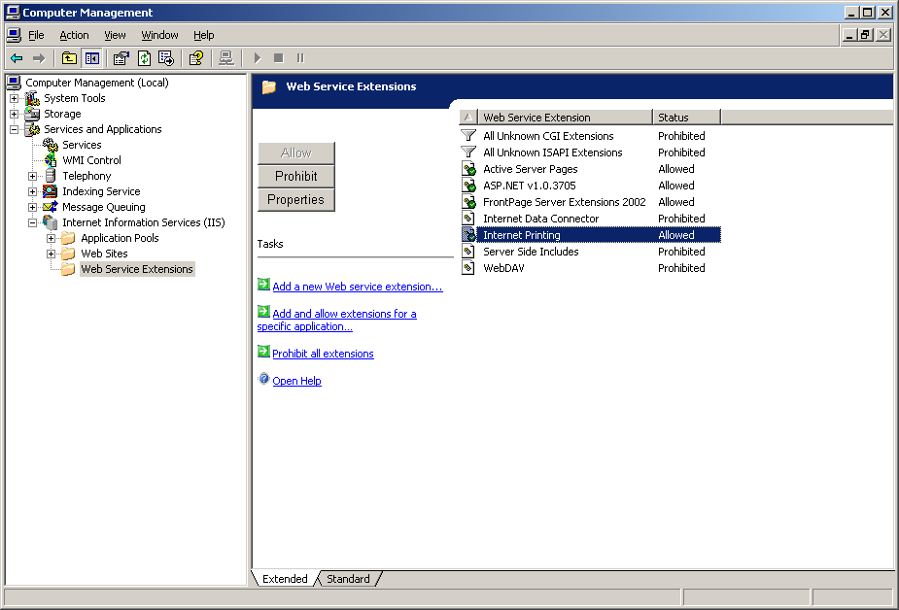
After changing the status of a Web service, such as changing Internet Printing from Prohibited to Allowed, save the configuration so that the settings are preserved in case IIS is restarted. To do this, right-click the Internet Information Service (IIS) node in the left pane, select All Tasks, and then select Save Configuration to Disk.

Note: If Active Server Pages is set to Allowed and Internet Printing is set to Prohibited, only Web-based management is enabled. Users cannot connect to any shared printers through Internet Printing. The Connect button is dimmed and not available on the printer management Web page.
If the Internet Printing option is set to Allowed but Active Server Pages is set to Prohibited, users can connect to printers through their URLs in the Add Printer Wizard; however, they cannot access the Web-management pages at all.

Web-based Printer Management
Web-based printer management is very simple to use. When a printer is created and shared, it becomes available for management through an Internet browser. To access the Web-based feature, use the following URL:
http://printserver/printers
Where printserver is your print server’s computer name.
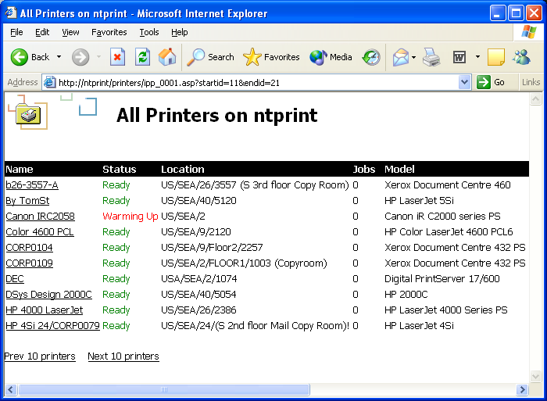
The Web page lists all shared printers on the server, along with their status, location, jobs, and so on. For example, the print server NTPRINT might look like this:

When you select a printer, you can view the document list, properties, and device status for that printer. You can also connect to the printer by selecting the Connect option under Printer Actions. Through the Web page, users can pause and resume the printer; purge the print queue; and pause, resume, or cancel specific print jobs provided they have adequate permission to perform these actions for the printer. The following figures show the Document List, Properties, and Device Status view for a particular printer on NTPRINT.

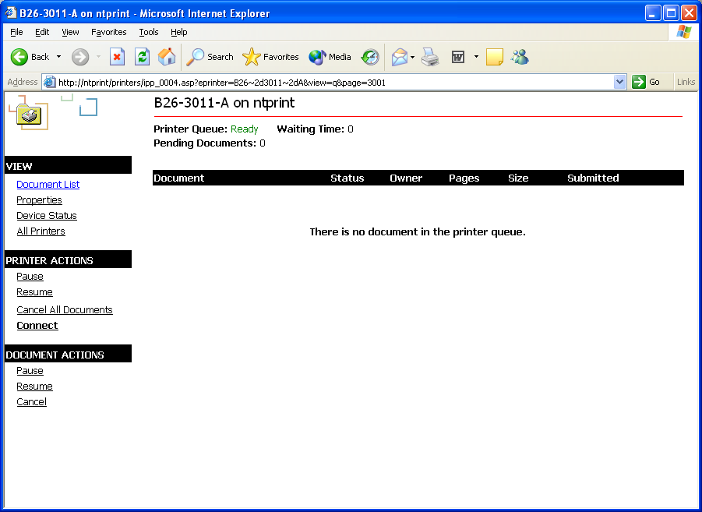

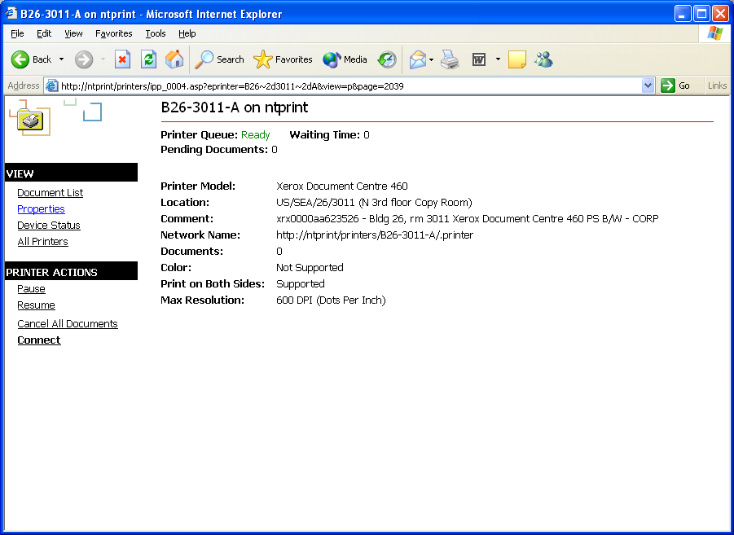

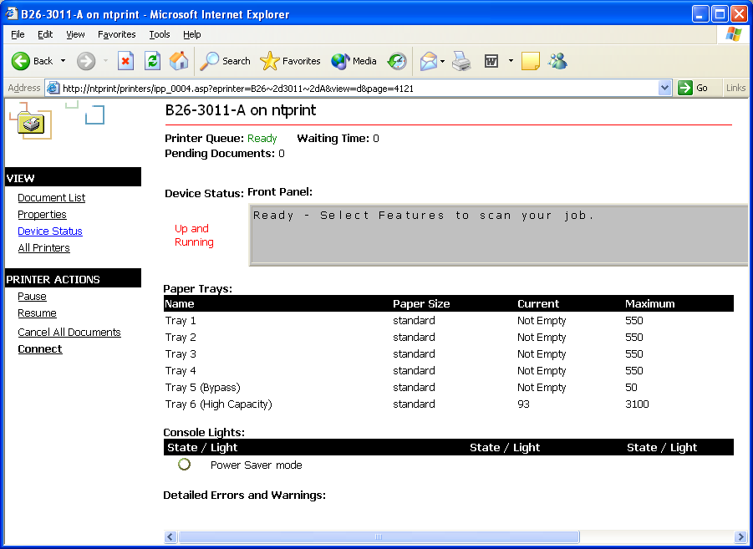

Most Windows clients in use today have built-in support for IPP or can download IPP support from the Microsoft Web site (http://www.microsoft.com). When a client has IPP support installed, they can view and connect to printers from within their Web browser. Microsoft strongly recommends the use of the Web-based printer management technology, particularly for corporations that want to deploy a Web-based solution for finding and connecting to printers.
With the Web-based printer management, many organizations create customized pages that make it easy for their users to find and select printers by clicking a simple link. For example, a business could create a map of the corporate campus in HTML, and add URL links to all the public printers.
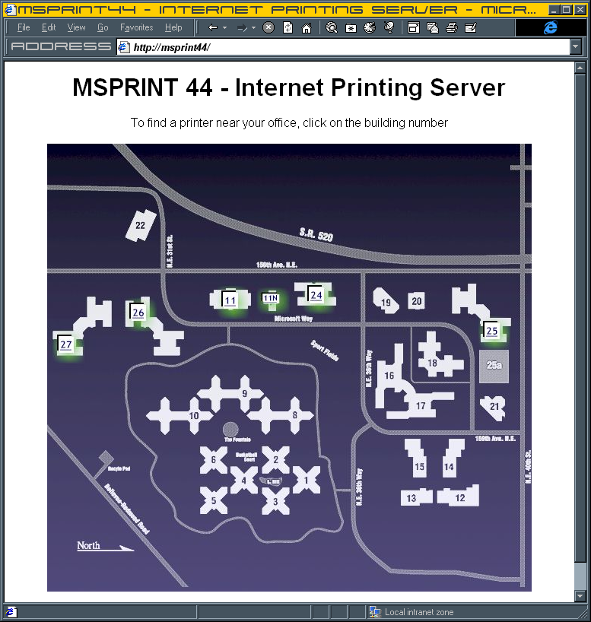
The example to the right shows a server that uses a custom image map to show a graphical layout of the Microsoft Redmond Campus. By clicking one of the buildings highlighted in green, a user can browse that building’s printers on a floor-by-floor basis. If the user selects a specific printer, they can view the printer’s status pages or even install the printer.

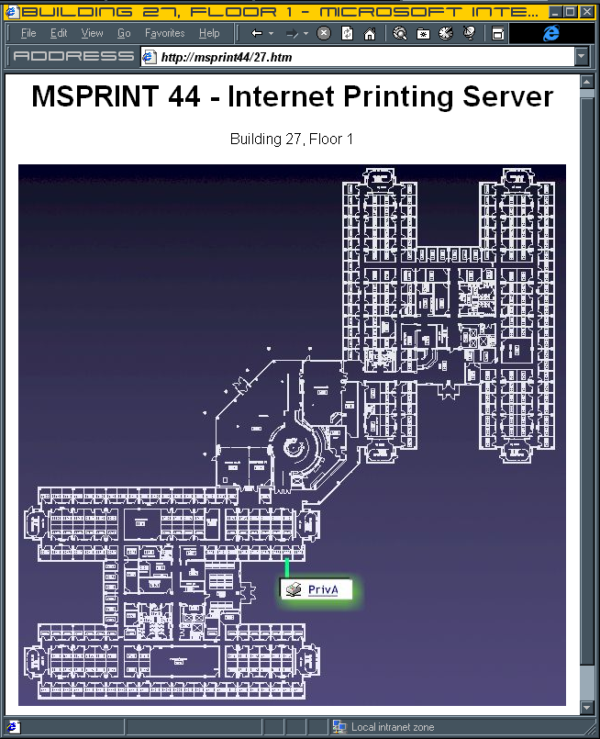

Internet Printing
When a user connects to a printer through the Web-based printer management, one of two things can happen: Either Windows creates an IPP printer connection using an HTTP port, or Windows creates an RPC (remote procedure call) “true-connect” printer connection.

HTTP Printer Connection through Web Browser
If a client’s Microsoft® Internet Explorer security settings for web content zone that the print server is a part of are set to medium or higher, Windows creates an IPP printer connection using an HTTP port. Because this technology requires the installation of a local printer queue (unlike a true Point-and-Print connection, which uses RPC), the client must have either Local Admin or Power User status with the added Load and unload device drivers privilege on the local machine. (On Windows 2000, this connection also works if the client has only Power User privilege.)
This solution is recommended only for Internet sites–specifically, untrusted sites viewed by a browser in which the security settings must be set to medium or higher.
Note: If the Internet Explorer security is set to high, the Connect link on the Web management page for that printer does not show up at all, preventing users from connecting to the printer through the Web page.
This type of printing works very well to print data in one location on a page at another location that does not share security or network infrastructure. However, HTTP printer connections are more limited than RPC true-connections (described below) in a Windows printing environment, as they do not support enhanced metafile (EMF) features.
Note: If a client connects to the printer by typing the printer URL in the Add Printer Wizard rather than going through a Web browser, the result is always an HTTP printer connection, regardless of the Internet Explorer security settings. For more information, see the Knowledge Base article “Add Printer Wizard Forces HTTP Connections to Windows 2000 Internet Print Servers” at http://support.microsoft.com/default.aspx?scid=kb;en-us;Q222078

RPC Printer Connection through Web Browser—Preferred Method
If a client’s Internet Explorer settings for the web content zone that the print server is a part of are set to medium-low or lower, when the client chooses the connect option in a Web browser, Windows automatically creates an RPC true-connect printer connection. True-connect, or UNC, connections have many benefits over true IPP printer connections and should be used for intranet printing (local to the company) where the security setting in Internet Explorer can be set to medium-low safely. True-connect connections are supported through the Windows remote spooler, which is where the vast majority of Microsoft’s future innovation will be—in the RPC printer connection rather than the IPP printer connection state.
For additional information about RPC connections, see the “Point and Print Technical Overview” white paper at www.microsoft.com/windows2000/technologies/fileandprint/print/default.asp

Summary
The two components of IPP Printing are powerful tools when used properly. Although the Web printer management framework provides ease of user access and powerful administrative capabilities, Microsoft recommends that users connect through RPC whenever possible and that organizations use the true IPP printing over HTTP only in the case of printing over the Internet.

Related Links
See the following resources for further information:
- For more information about deployment and management of Windows print servers, see Windows Server 2003 Deployment Resource Kit (not yet released when this paper was published).
- For more information about the Windows 2000 and Windows Server 2003 architecture, see the “Display and Print Devices” sections in the Windows Driver Development Kit at http://www.microsoft.com/ddk
- For more information about connectivity options and support protocols in Windows 2000, see Microsoft Windows 2000 Server Resource Kit published by Microsoft Press.
- For the latest information about Windows 2000 Printing, see the Windows 2000 Print Server Web site at http://www.microsoft.com/windows2000/technologies/fileandprint/print/default.asp.
- For the latest information about Windows 2000 Server, see the Windows 2000 Server Web site at http://www.microsoft.com/windows2000/server.
- For the latest information about Windows Server 2003, see the Windows Server 2003 Web site at http://www.microsoft.com/windowsserver2003/default.mspx.

