Overview  Country or Region: United States  Industry: Transportation—Telematics service provider  Customer Profile  Based in Seattle, Washington, Zonar develops solutions that help commercial and public enterprises throughout the United States to inspect, track, and manage vehicle fleets.  Business Situation  Zonar needed mapping technology that would make it easier to offer high-performance technology, meet the expectations of its enterprise customers, and develop new products more efficiently.  Solution  In January 2009, Zonar switched from Google Maps for Enterprise to integrate its Electronic Fleet Management solution with the Bing™ Maps for Enterprise platform.  Benefits  - Customer expectations satisfied  - Enhanced user experience  - More efficient development  - Competitive advantage |  |  | “Our evaluation showed that Bing Maps for Enterprise is a better fit for us. The tremendous level of innovation in Bing Maps is more in tune with what our public sector and enterprise customers expect.”  Mike McQuade, Chief Technology Officer, Zonar
 |  |  | Zonar integrates software, hardware, and Web technologies to help commercial and public enterprises inspect, track, and manage vehicle fleets. The company’s third-party supplied mapping technology wasn’t keeping pace with what Zonar and its enterprise-class customers needed. Zonar wanted to offer the features and data that its customers demanded without sacrificing application speed or performance, and make it faster and less expensive to release new products and updates. To more easily tailor its solutions to customer expectations, Zonar integrated its Electronic Fleet Management solution with the Bing™ Maps for Enterprise platform. Now Zonar can develop products more efficiently, and offer the advanced features and high performance that will help its customers operate more effectively.
 |  |  | 

Situation
Zonar develops solutions that integrate software, hardware, and Web technologies to help public and private fleets inspect, track, and manage their fleet vehicles. Head-quartered in Seattle, Washington, Zonar provides services for commercial and public enterprises throughout the United States, including many Fortune 500 companies.

Utilities, material and waste haulers, public and school bus systems, and construction companies use Zonar’s Electronic Fleet Management solution to track vehicles with Global Positioning System (GPS) technology, capture field-inspection data, and monitor students and passengers. By integrating relevant data with the map-based interface of Zonar’s Ground Traffic Control application, fleet managers can develop a real-time, global visualization of their fleet operations.

Zonar originally built a map tile server, but because the solution was complex, costly, and difficult to update, the company turned to Google Maps for Enterprise in 2006. Using Google mapping imagery, Zonar began to more easily provide the location-based services that its customers needed.
“For us, the bird’s-eye view in Bing Maps is much more useful than Google’s Street View. With bird’s-eye view, our customers can look at an area in context, see the approaches, find the turn-arounds, plan routes, and better reconstruct actions.”
Mike McQuade, Chief Technology Officer, Zonar

Before long, the needs of Zonar’s enterprise-class customers began taxing the capabilities of the company’s mapping environment. “Our enterprise customers expect data to be simple to navigate and easy to search,” says Mike McQuade, Chief Technology Officer at Zonar. “They don’t want limits on how they can use features, and they need the geo-data updated frequently.”

Zonar needed mapping technology that would make it easier to tailor solutions to meet its customers’ needs and help them manage their fleets more effectively, reduce fuel and maintenance costs, and minimize their environmental impact. It wanted to offer the features and data its customers demanded without sacrificing performance. It also wanted to develop and release new products and updates more easily, quickly, and inexpensively.

Solution
After a period of evaluation in 2008, Zonar decided to switch from Google Maps for Enterprise. In January 2009, it began integrating its Electronic Fleet Management solution with the Bing™ Maps for Enterprise platform.

“Our evaluation showed that Bing Maps for Enterprise is a better fit for us,” says McQuade. “The tremendous level of innovation in Bing Maps is more in tune with what our public sector and enterprise customers expect.”

With the Bing Maps interactive map interface, customers can choose between a road map, a satellite image, or a combination view. By integrating GPS tracking data, fleet managers can locate vehicles in real time on the map, and then query inspection, vehicle, driver, route, destination, and other data by clicking on the vehicle markers (See Figure 1).

Zonar customers can zoom out for a global view of their fleet or zoom in for a detailed view of a single route, destination, or vehicle, even taking advantage of the bird’s-eye view based on oblique aerial images that have been taken from low altitude and all four compass directions. “For us, the bird’s-eye view in Bing Maps is much more useful than Google’s Street View,” says McQuade. “With bird’s-eye view, our customers can look at an area in context, see the approaches, find the turn-arounds, plan routes, and better reconstruct actions.”

Using the application programming interface (API) in Bing Maps for Enterprise, developers at Zonar were able to easily deploy features without sacrificing application performance. Zonar has found that the map data in Bing Maps is updated frequently, and because the reverse geo-coder in Bing Maps is based on parcel data, customers can find an address for a location on a map much more accurately.

Before launching in April 2009, Zonar previewed the updated application for a diverse sample of its customers. “They all wanted to know how soon they could have it,” says McQuade. “We heard things like ‘impressive’, ‘fast’, ‘gorgeous.’ It was all very positive.”
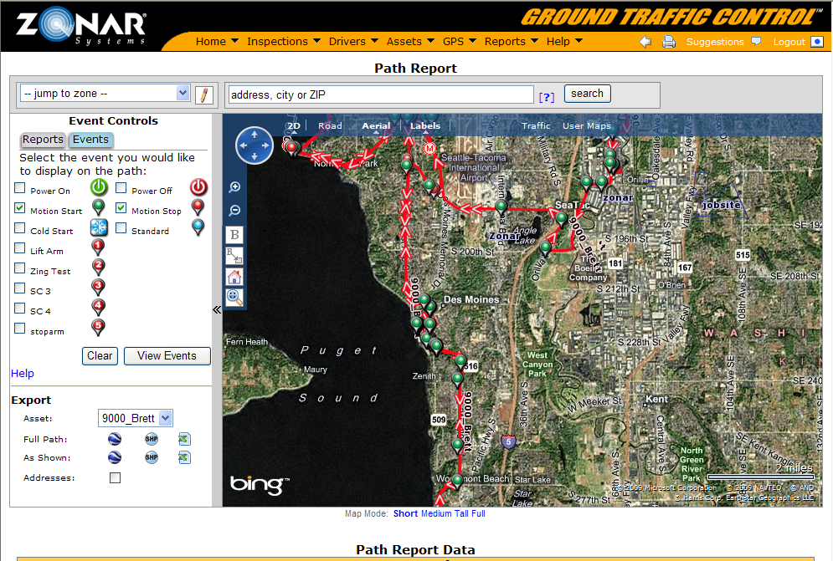
Figure 1. Zonar users can locate vehicles in real time on the Bing Maps interface, and query data by clicking on vehicle markers.

Benefits
Using Bing Maps for Enterprise, Zonar is able to present its enterprise customers with a mapping solution that provides advanced features, critical information, and high performance. The company will be able to develop and release new products and updates more quickly and at less cost, and remain competitive by helping its customers operate more efficiently.
“People are looking to do more with less, and squeeze more utilization out of their assets. With Bing Maps, we have the enterprise-ready platform we need to continue making real products that save money for real companies.”
Mike McQuade, Chief Technology Officer, Zonar

Customer Expectations Satisfied
With Bing Maps, Zonar can offer its customers a more usable set of features that are tailored to their business needs. With its old mapping environment, if a customer wanted to add many pop-up windows to a map, or had to rely on the reverse geo-coder too often, it could compromise application performance, resulting in delays when users tried to search for information.

“Bing Maps is faster across the board,” says McQuade. “Application speed won’t limit how many pop-up balloons a customer can put on a map or how quickly users can search addresses.”

More features and better performance will help customers further save maintenance costs, reduce fuel consumption, and improve their environmental footprint. With frequent data updates, Zonar can provide its customers with the most current maps available. “Our customers often operate in newly developed areas, and Microsoft has the most thoroughly updated data,” says McQuade.

Enhanced User Experience
Zonar customers will benefit from more intuitive navigation and search functionality that will make it easier for them to find specific data.

“Managing a vehicle fleet can be extremely fast-paced, making sure routes aren’t crossing each other, optimizing the use of 300 or 400 vehicles at a time,” says McQuade. “Taking advantage of the usability of the Bing Maps interface, we will be able to provide a better user experience and make our customers more productive.”

More Efficient Development
Zonar needed only half the time it expected to integrate its solution with Bing Maps, and the company anticipates it will be able to release new products and updates more quickly. Zonar developers have found it easy to use the Bing Maps API to overlay data on top of the maps and ensure the system performs across all browsers.

“With Bing Maps, it will be easier for us to solve the problems our customers are asking us to solve,” says McQuade. “The Bing Maps API is mature and well thought out. Every time we thought we had to build something, it was already done.”

Competitive Advantage
By developing a solution that will simplify workloads and improve processes for its customers, Zonar has remained competitive, even during a period of economic uncertainty. “People are looking to do more with less, and squeeze more utilization out of their assets,” says McQuade. “With Bing Maps, we have the enterprise-ready platform we need to continue making real products that save money for real companies.”

Bing Maps for Enterprise
For More Information
For more information about Microsoft products and services, call the Microsoft Sales Information Center at (800) 426-9400. In Canada, call the Microsoft Canada Information Centre at (877) 568-2495. Customers who are deaf or hard-of-hearing can reach Microsoft text telephone (TTY/TDD) services at (800) 892-5234 in the United States or (905) 568-9641 in Canada. Outside the 50 United States and Canada, please contact your local Microsoft subsidiary. To access information using the World Wide Web, go to: www.microsoft.com

For more information about Zonar products and services, visit the Web site at: www.zonarsystems.com

This case study is for informational purposes only. MICROSOFT MAKES NO WARRANTIES, EXPRESS OR IMPLIED, IN THIS SUMMARY.

Document published May 2009

Software and Services
- Microsoft Virtual Earth

Bing Maps for Enterprise is the mapping platform from Microsoft, used by thousands of companies, governments, developers, individuals, and communities around the globe. The platform, previously known as Virtual Earth, delivers global maps coverage with enterprise-class reliability, availability, and scalability
For More Information
For more information about Microsoft products and services, call the Microsoft Sales Information Center at (800) 426-9400. In Canada, call the Microsoft Canada Information Centre at (877) 568-2495. Customers who are deaf or hard-of-hearing can reach Microsoft text telephone (TTY/TDD) services at (800) 892-5234 in the United States or (905) 568-9641 in Canada. Outside the 50 United States and Canada, please contact your local Microsoft subsidiary. To access information using the World Wide Web, go to: www.microsoft.com

For more information about Zonar products and services, visit the Web site at: www.zonarsystems.com

This case study is for informational purposes only. MICROSOFT MAKES NO WARRANTIES, EXPRESS OR IMPLIED, IN THIS SUMMARY.

Document published July 2009

Software and Services
- Bing Maps for Enterprise

For more information, visit: www.microsoft.com/maps

