Forefront Edge Security & Access Demos -
Script Steps

Demo version 3.1a - 27-Jan-2007
Ronald Beekelaar
v-ronb@microsoft.com

Before You Begin

The Forefront Edge Security & Access Demos is a combination of the ISA Server 2006 Demos and the Intelligent Application Gateway (IAG) 2007 Lab, and consist of four different demonstration scenarios:
• Secure Remote Access with IAG 2007
• Secure Remote Access with ISA 2006
• Branch Office Security with ISA 2006
• Internet Access Protection with ISA 2006

You can perform the four demonstrations independent of each other.

The first demonstration scenario is based on the Intelligent Application Gateway (IAG) 2007 Lab, and makes use of four virtual machines. The graphic below shows the physical network layout of the virtual machines for the IAG 2007 demonstration scenario.
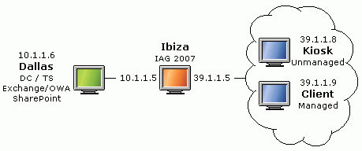

The remaining three demonstration scenarios are based on the ISA Server 2006 Demos, and make use of five virtual machines.
The graphic below shows the physical network layout of the virtual machines for the ISA 2006 demonstration scenarios.

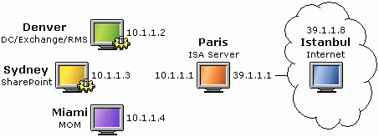

All these virtual machines run Windows Server 2003 R2 Enterprise Edition.
To simulate the experience of a client computer, Kiosk, Client, and Istanbul are configured to use the Luna Windows XP style user interface.

Start Page

To start the virtual machines, and to explain the demonstrations layout, you can use the Start Page application (Forefront-edge-demo (start page).hta). This application shows the functional network layout for each of the four demonstration scenarios.

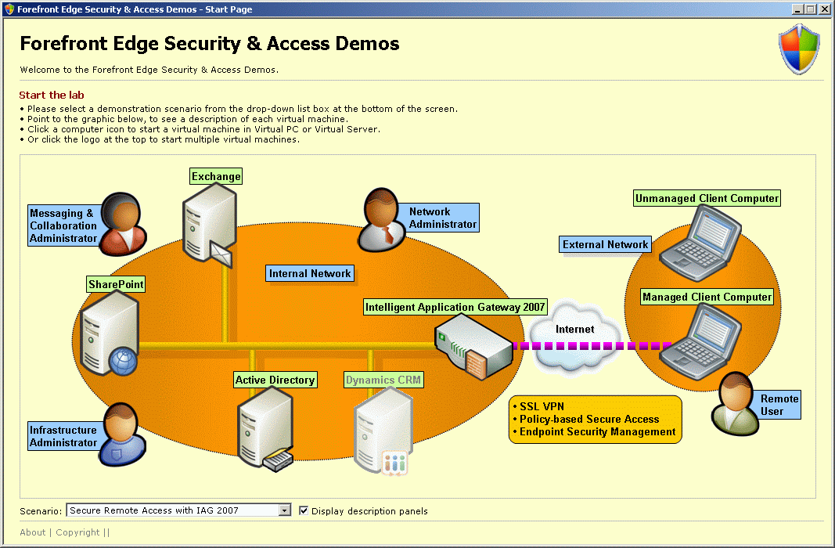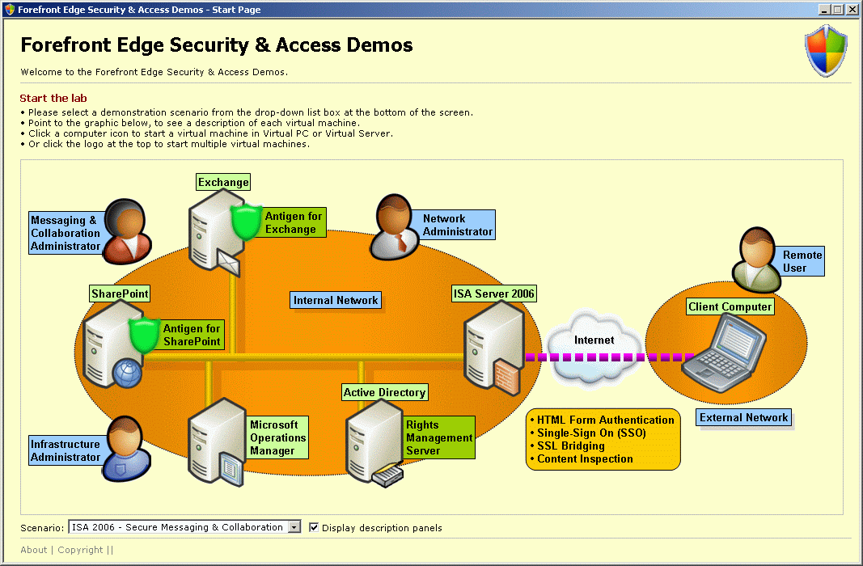
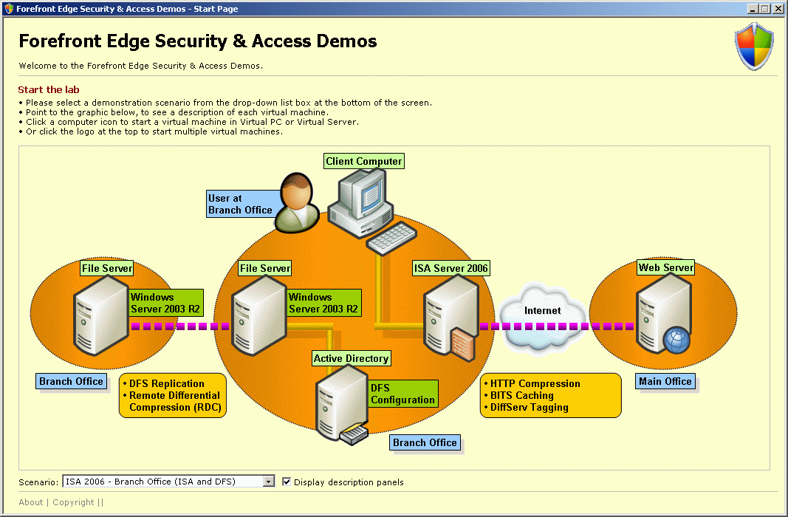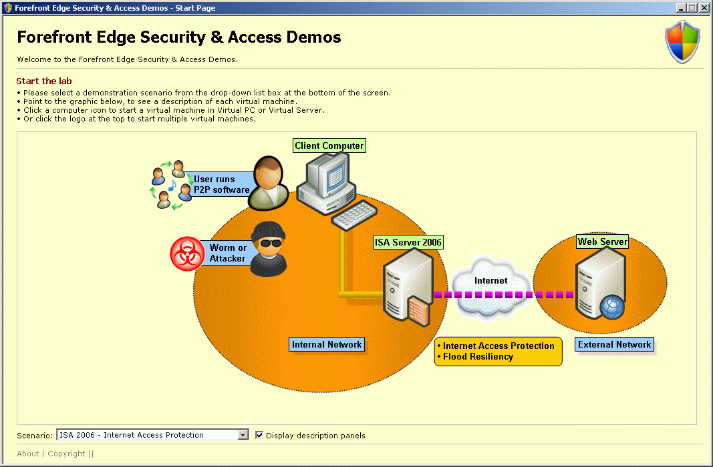

A descriptive panel appears when you hover you mouse point over a computer icon in the Start Page graphics. You can start a virtual machine in Virtual PC or Virtual Server, by clicking a computer icon.

Note: To make it easier to describe the functional network layout, the same physical virtual machine (e.g. Denver) may appear multiple times in the same Start Page graphics (e.g. as Exchange Server, and as Domain Controller).

Not all virtual machines are use in each demonstration scenario. Click the shield logo () on the Start Page graphics to start the virtual machines for that demonstration scenario.

Log on information:
• User name: Administrator (except on Istanbul: Marc)
• Password: password

This is the list of software running on each virtual machine:

Denver
• Windows Server 2003 R2 EE
• Active Directory (contoso.com)
• Certification Authority
• Internet Authentication Service (Radius)
• IIS 6.0
• Exchange Server 2003 SP2
• Antigen 9.0 for Exchange
• RMS SP1 server
• MOM 2005 agent

Sydney
• Windows Server 2003 R2 EE
• IIS 6.0
• SharePoint Services 2.0 SP2
• Antigen 8.0 for SharePoint
• RMS SP1 client

Miami
• Windows Server 2003 R2 EE
• MOM 2005 SP1 server
• Management packs for Antigen 9.0, RMS, ISA Server 2006

Paris
• Windows Server 2003 R2 EE
• ISA Server 2006 SE
• MOM 2005 agent

Istanbul
• Windows Server 2003 R2 EE
• IIS 6.0
• RMS SP1 client
• RMS Add-on for Internet Explorer
• Word 2003
Dallas
• Windows Server 2003 R2 EE
• IIS 6.0
• Exchange Server 2007
• SharePoint Services 3.0

Ibiza
• Windows Server 2003 R2 EE
• ISA Server 2006 SE
• Intelligent Application Gateway (IAG) 2007

Client
• Windows Server 2003 R2 EE
• Windows Defender

Kiosk
• Windows Server 2003 R2 EE

Secure Remote Access with IAG 2007-
Demonstration Script

Introduction

IMPORTANT - Demo software
This set of software has been tested, and should only be used, in the demonstration scenarios outlined in the demonstration script.

This demonstration consists of one exercise.

In the exercise you will connect to the IAG Web portal from a managed client computer (Client), and from an unmanaged client computer (Kiosk). Then you will look at the endpoint security policy configuration, and application configuration.

Note: The first time you connect to the OWA Web site, or the SharePoint Web site, it may take a few minutes before these Web sites appear. When you perform this demonstration for a live audience, you may want to connect to those Web sites beforehand, and then close the IAG Portal Web site again. The next time that you connect to these sites (during a live demonstration), the response times are much faster.

The demonstration uses the following four virtual machines: Dallas - Ibiza - Client - Kiosk.

Presenter Script | Detailed steps
- Perform the following steps on the Client computer.
- From the Client computer, let's connect to the IAG Web portal.  (c) The Web portal requires authentication. | - On the Client computer, log on with the following credentials:  • User name: Marc  • Password: password  - The Client computer represents a corporate client computer.  - Open Internet Explorer. On the Favorites menu, click IAG Portal.  - On the IAG logon screen, log on with the following credentials:  • User name: Marc  • Password: password  and then click Submit.  - The IAG Web portal appears. The portal contains six applications that we can use.  - IAG considers the Client computer a so-called Privileged Endpoint. Notice in the top-right corner that IAG allows a connection for 24 hours.
- Note: In the six tasks below, you can select any of the applications that you want to access. You do not have to do all six tasks.
- Open the OWA application.  Notice that you do not need to authenticate again to connect to the OWA Web site. The single-sign on, is handled by the IAG server. | - On the IAG Web portal, click OWA 2007.  - IAG opens a connection to the Exchange server on Dallas, and provides access to our mailbox through OWA.  - Note: The first time any OWA Web site is opened, it may take a few moments before the OWA screen appears.  - On the IAG toolbar, click the home icon ( ) to go back to the IAG Web portal.
- Another well-known Web application is SharePoint.  IAG understands the URLs that SharePoint uses, and can selectively allow or block application-specific operation, like uploading of documents. | - On the IAG Web portal, click SharePoint 2007.  - IAG opens a connection to the SharePoint Web site on Dallas.  - Note: The first time the SharePoint Web site is opened, it may take a few moments before the Web site appears.  - On the Contoso Portal Web site, in the Shared Documents section, click Add new document.  - IAG is application-aware. It recognizes the Upload commands from SharePoint. In the current configuration, uploading a document to the SharePoint site is not possible unless the Client computer runs an antivirus application.  - On the IAG toolbar, click the home icon ( ) to go back to the IAG Web portal. Click OK to confirm that you navigate away from the SharePoint Web site.
- A Remote Desktop connection is not a Web-based protocol.  However, IAG can tunnel non-Web traffic in a SSL tunnel. | - On the IAG Web portal, click Remote Desktop to Dallas.  - IAG will start a remote desktop connect to the Dallas computer. The Remote Desktop protocol (TCP port 3389) is tunneled through an SSL connection to Ibiza.  - In the system tray, you can see a little icon ( ) that indicates that the network traffic for this application is using SSL tunneling.  - On the Log On to Windows dialog box, click Cancel.
- Access to file shares is another good example, of how IAG allows secure access to resources.  The Web interface even provides automatic access to the home directory of the user that connects to the special File Access application. | - On the IAG Web portal, click File Access.  - IAG opens a tree view of the shares that Marc can access, including his home directory.  - In the left pane, expand Dallas, and then select Documents.  - The Documents share on Dallas is made available through an HTTPS connection.  - On the IAG toolbar, click the home icon ( ) to go back to the IAG Web portal.
- If you need full access to multiple servers and multiple protocols, when remotely connecting to the corporate network, then you can configure a Network Connector.  This sets up an SSL VPN connection that can be used for any IP-based network protocol, connecting to any servers on the internal corporate network. | - On the IAG Web portal, click Network Connector.  - IAG creates an SSL VPN tunnel to the corporate network behind the IAG server.  - Open a Command Prompt window.  - At the command prompt type ipconfig, and then press Enter.  - The Client computer has received an IP address from the Corporate network (10.1.1.31 or higher). Any protocol can be used to connect through the SSL VPN tunnel to servers on the internal network.  - Close the Command Prompt window.  - On the Start menu, click Run.  - In the Run dialog box, type \\dallas, and then click OK.  - Through the SSL VPN connection you can see the shares on Dallas.  - Close the dallas window.  - In the system tray, right-click the Network Connector icon ( ), and then click Disconnect Network Connector.
- Besides the well-known applications, let's have a look at a custom, or proprietary application.  Even if IAG doesn't know about a particular application, it can still be set up at the IAG Web portal. | - On the IAG Web portal, click Contoso Payroll.  - IAG opens a connection to a custom Web application from Contoso Finance.  - Note: Even though IAG has configuration information about many well-known applications, you can provide access to custom Web applications as well.  - In the Contoso Payroll Web page, click Submit.  - The sample application shows an Earnings Statement graphic for employee 5551212.  - On the IAG toolbar, click the home icon ( ) to go back to the IAG Web portal.  - Close the IAG Web portal.
- Perform the following steps on the Kiosk computer.
- Lets' compare the Web portal experience between the managed Client computer, and a computer named Kiosk.  IAG endpoint security policies specify which application is available under with (security requirements) conditions.  (d) For grayed out applications (unavailable), you can find out what policy caused the application to become unavailable. | - On the Kiosk computer, log on with the following credentials:  • User name: Marc  • Password: password  - The Kiosk computer represents a public computer that is not fully trusted by IAG.  - Open Internet Explorer. On the Favorites menu, click IAG Portal.  - On the IAG logon screen, log on with the following credentials:  • User name: Marc  • Password: password  and then click Submit.  - The IAG Web portal appears.  - Notice that for the same user (Marc) the portal only contains two available applications. Endpoint (client computer) security policies on the IAG server specify that only OWA and SharePoint are available to client computers that are not fully trusted. Two other applications are grayed out, and the Network Connector and Contoso Payroll applications are not displayed at all.  - At the end of the (grayed out) Remote Desktop to Dallas row, click Details.  - In this lab environment, the configured security policy requirement is that Windows Defender needs to be installed on the client computer, in order to use the Remote Desktop to Dallas application.  - Close the IAG Error Page window.
- When the client computer connects to the IAG server, the server checks the compliance with the endpoint security policies.  In this case, the Kiosk computer is not a Privileged Endpoint. | - On the IAG toolbar, click the System Information icon ( ).  - At the last row of the System Information window, notice that IAG does not consider the Kiosk computer a so-called Privileged Endpoint.  - Close the System Information window.  - Notice in the top-right corner that IAG only allows a connection for 60 minutes.  - Close the IAG Web portal.
- Perform the following steps on the Ibiza computer.
- Let's look at the configuration settings of IAG.  On the portal, you can specify endpoint policies for each application independently. | - On the Ibiza computer, log on with the following credentials:  • User name: Administrator  • Password: password  - On the Start menu, click IAG Configuration.  - In the Configuration dialog box, in the password text box, type password, and then click OK.  - The IAG Configuration console opens.  - In the IAG Configuration console, expand HTTPS Connections (not HTTP Connections), and then select Portal1.  - Portal1 contains the six application definitions that are on the IAG Web portal site.  - In the right pane, select the SharePoint 2007 application, and then click Edit.  - In the Application Properties dialog box, on the General tab, in the Endpoint Policies section, open the Access drop-down list box.  - You can select many different endpoint policies, which specify the endpoint requirements to have access to this application.  - For Web applications, there are separate endpoint policies for Access, Download, Upload and Restricted Zone access.  - Click Cancel to close the Application Properties dialog box.
- IAG has an easy-to-understand and powerful Endpoint security editor.  You can select from many of the pre-defined endpoint policies, or create your own. | - Select the Remote Desktop to Dallas application, and then click Edit.  - The Remote Desktop to Dallas application has a (custom) access endpoint policy named Has Defender. If Windows Defender is not installed on the client computer, then this application link on the IAG Web portal is grayed out.  - Click Edit Policies.  - Scroll the list of policies, select Has Defender, and click Edit.  - In the Policy Editor dialog box, select Anti Spyware.  - IAG knows about many products. This makes it very easy to configure endpoint security policies.  - Click Cancel to close the Policy Editor dialog box.  - Click Close to close the Policies dialog box.  - Click Cancel to close the Application Properties dialog box.
- A special distinction is made for the condition whether a client computer is considered a Privileged session, or not.  In the lab environment, the Client computer is a Privileged Endpoint, while the Kiosk computer is not.  For demonstration purposes, the requirement "Has Defender" is used. | - In the right pane, in the Security & Networking section, after Advanced Trunk Configuration, click Configure.  - In the Advanced Trunk Configuration dialog box, select the Session tab.  - In the Endpoint Policies section, you can specify what endpoint security policy defines whether a client computer is considered a Privileged EndPoint or not. In the lab environment, the same Has Defender policies is used for that.  - In the right side of this dialog box, you can see the list of settings you can configure differently for Default Sessions (for non-privileged endpoint) and Privileged Sessions (for privileged endpoints). This includes the 24 hours (1140 minutes) or 60 minutes log on time  - Click Cancel to close the Advanced Trunk Configuration dialog box.
- If you want to add an application to the IAG Web portal, then you can run a Wizard which takes you trough a few steps.  For many applications, IAG knows about specific details for that application. | - In the Application section, click the top Add button.  - It is very easy to add an application to the IAG Web portal. IAG automatically knows how to tunnel the application through an SSL connection.  - In the Web Application drop-down list box, select Microsoft CRM 3.0, and then click Next.  - When adding an application, a wizard asks for configuration parameters, such as the endpoint security policies, server names, and the TCP port number.  - Click Cancel to close the Wizard.  - Close the IAG Configuration console.

Secure Remote Access with ISA 2006 -
Demonstration Script

Introduction

This demonstration consists of two exercises:
• ISA Server HTML Form Authentication, Single-Sign On (SharePoint portal site and Outlook Web Access), and RMS
• Configuration of ISA Server, Antigen for Exchange, and Antigen for SharePoint.

Demonstration

In this demonstration, I am going to show you how Microsoft's comprehensive security products portfolio can help your protect your information and control access.

In the demonstration, we have a remote user trying to access internal corporate resources.

I will show you how network administrators can use ISA Servers to provide secure remote access, and how security administrators can use Antigen to provide anti-virus protection for their Exchange, and SharePoint servers.

You will also see how these products integrate deeply not just with Exchange and SharePoint, but also with identity management capabilities of Active Directory, and how they work with Microsoft Operations Manager to provide centralized monitoring.

This demonstration will focus on:
1. Ease of use for the end-user accessing information, and
2. Simplicity for the IT administrators who need to setup, manage and secure the IT environment.

The scenario is about a company called Contoso which uses Exchange for e-mail, and SharePoint for document collaboration.
Contoso has a substantial mobile workforce that needs fast and secure remote access to these resources.

Presenter Script | Detailed steps
- Perform the following steps on the Istanbul computer.
- Marc is one of the road warriors for Contoso. He is currently visiting a customer site and needs to check in with his office.  Let's go to his laptop. Marc uses his browser to get to Contoso's secure portal. | - On the Istanbul computer, log on with the following credentials:  • User name: Marc  • Password: password  - On the Start menu, click Contoso Portal  - Contoso Portal is a shortcut to https://portal.contoso.com, which resolves to the external IP address of ISA Server.  - ISA Server displays a Web form, asking for credentials to log on.
- Before he can get to the portal, he is presented a logon form by ISA Server.  ISA Server protects Contoso's edge and provides secure remote access. Marc needs to identify himself by keying in his credentials. So let’s go do that. | - In the ISA Server 2006 Web form, complete the following information:  • Security: This is a private computer  • Domain\user name: Contoso\Marc  • Password: password  and then click Log On.  - By indicating that this is a private computer, ISA Server uses a much longer idle time-out.  - By default, on a public computer, ISA Server requires the user to re-authenticate after 10 minutes idle time. On a private computer, ISA Server allows 360 minutes idle time, before asking for re-authentication.
- Contoso uses SharePoint to provide a single portal that gives users access to their Outlook inbox, in addition to document collaboration capabilities.  Marc sees an e-mail from his colleague Lisa with an attached zip file that he opens. | - On the SharePoint portal site, in the Inbox Web part, right-click the e-mail from Lisa, and then click Open.  - ISA Server uses the credentials from the Web form to authenticate to Sydney (for the SharePoint Web site), and to Denver (for the Outlook inbox).  - In the e-mail, right-click the Project Launch.zip attachment, and then click Open.  - In the File Download dialog box, click Open.  - Windows Explorer displays the contents of the Project Launch.zip attachment file.
- In the zip file, Marc finds a text file named eicar.txt, which he opens.  Antigen for Exchange has detected and removed a virus that was hidden in the zip file. | - In the Windows Explorer window, right-click eicar.txt, and then click Open.  - The text file contains a message from Antigen for Exchange.  - Apparently the zip file contained a virus (eicar.com), which Antigen detected and removed.  - Close Notepad.  - Close the Windows Explorer window with the zip file contents.  - Close the Launch Files e-mail window.
- Marc and Lisa happen to be friends, and Lisa wants to get hold of a new song that Marc's been telling her about.  Since it is too large to send over e-mail, she asks him to upload it to the internal SharePoint site, and try to bypass security by changing the file extension. | - Use Windows Explorer (or My Computer) to open the C:\Tools folder on Istanbul.  - Right-click LatestHit.mp3, and click Rename.  - In the text box, replace the name by LatestHit.txt, and then press Enter.  - In the Rename message box, click Yes to confirm that you want to change the file name extension.  - The file is renamed from LatestHit.mp3 to LatestHit.txt.  - Close the C:\Tools folder.
- Marc attempts to upload the renamed music file.  Antigen for SharePoint blocks the upload of the renamed music file, as Contoso considers this inappropriate content. | - On the SharePoint portal site, in the Shared Documents Web part, click Add new document.  - On the Upload Document page, click Browse.  - In the Choose File dialog box, browse to C:\Tools, select LatestHit.txt, and then click Open.  - The C:\Tools\LatestHit.txt file is selected.  - On the Upload Document page, click Save and Close.  - The upload does not succeed. Antigen for SharePoint blocks the upload of the renamed music file.  - Note: SharePoint names this page Virus Found, because an application (Antigen) that uses the virus scanning API of SharePoint blocks the upload. However, the file is blocked, because of a File Filter rule in Antigen to block music files. This is not a virus.  - On the Virus Found page, click Home.
- The portal site contains two confidential documents about future plans. Let's see what happens if Marc wants to print a copy of these documents.  Marc can successfully open the documents through the portal site, but Rights Management Server does not allow Marc to print, copy or save the confidential documents. | - On the SharePoint portal site, in the Shared Documents Web part, click Merger Details.  - In the File Download dialog box, click Open to confirm that you want to open the Merger Details.doc document.  - The document is protected by Rights Management Server (RMS). Istanbul connects to the RMS server (on Denver) to verify Marc's rights for this document.  - In the Connect to Denver.contoso.com dialog box, complete the following information:  • User name: contoso\marc  • Password: password  and then click OK.  - Note: In the current lab environment, the single-sign on functionality does not work yet for the RMS server.  - Office Word 2003 opens the rights-protected Merger Details.doc document.  - In Word, on the File menu, attempt to Print the document.  - Rights management does not allow Marc to print the document.  - Select a part of the document, right-click the selected text, and then attempt to Copy the selection.  - Rights management does not allow Marc to copy the contents of the document.  - On the File menu, click Permission.  - Notice that Marc is only allowed to View the document contents. All other operations on this confidential document are disabled.  - Click OK to close the My Permission dialog box.  - Close Word.

Configuration

In the steps below, let's examine how the different security products are configured to provide the demonstration.

On all computers (except Istanbul), you can log on with user name Administrator, and password password.
On Istanbul the logged on user is Marc.

Presenter Script | Detailed steps
- Perform the following steps on the Paris computer.
- Let's find out how Contoso's administrators make the security in the demonstration possible.  First have a look at the configuration of the ISA Server 2006 on the Paris computer.  - ISA Server has configured different rules for the different Web sites that Marc accessed during the demonstration. The rules use the same Web listener (Contoso SSO Listener), which provides the Web form to authenticate and the Single Sign-On (SSO) functionality to those Web sites. Marc only has to authenticate once to access those Web sites.  Paris is not in the domain, but uses the new LDAP Authentication functionality in ISA Server 2006 to verify Marc domain credentials against the Denver domain controller.  - ISA Server truly understands the way Exchange and SharePoint work. It provides wizard to make it really use to create rules to set up secure access to these servers. | - On the Paris computer, log on with the following credentials:  • User name: Administrator  • Password: password  - On the Start menu, click ISA Server 2006.  - The ISA Server 2006 console opens.  - In the ISA Server console, in the left pane, select Firewall Policy.  - ISA Server has configured different rules [..].  - In the task pane, select the Tasks tab.  - ISA Server truly understands [..]
- Perform the following steps on the Denver computer.
- Lisa had sent an e-mail to Marc from an unmanaged computer, which was infected by a virus. The virus was in the zip file included as attachment with the e-mail.  That is exactly why Contoso needs multiple layers of defense. In additions to ISA Server protecting the network edge, Contoso uses Antigen to provide protection for Exchange, and SharePoint.  Antigen for Exchange scans all messages, and all attachments, including the contents of zip files, or other "container" files.  - Antigen uses multiple anti-virus scan engines from different providers to scan the same message. You can use up to 9 different anti-virus engines.  Using multiple anti-virus engines provides failover capability if a scan engine fails. It also ensure that new viruses are detected as soon as possible when the first engine has updated its signatures.  - In the Incidents work panel, you can see that Antigen detected a virus inside the Project Launch.zip file. | - On the Denver computer, log on with the following credentials:  • User name: Administrator  • Password: password  - On the Start menu, click Antigen 9.0 Exchange.  - In the Connect to Server dialog box, ensure that Denver is selected, and then click OK.  - The Microsoft Antigen for Exchange 9.0 console opens.  - In the left pane, in the Settings area, click Antivirus.  - Antigen users multiple [..].  - In the Report area, click Incidents.  - In the Incidents work panel, [..].
- Perform the following steps on the Sydney computer.
- Now let's take a look at Antigen for SharePoint.  One of the primary concerns for Contoso's security administrators is to prevent users from uploading unwanted files to the portal site. By using Antigen, they can define policies to block a wide range of files, in addition to virus protection.  - And what you just saw, Marc could not get past this by just changing the file extension, because Antigen checks the contents of the file to determine the file type. | - On the Sydney computer, log on with the following credentials:  • User name: Administrator  • Password: password  • Log on to: SYDNEY (this computer)  - On the Start menu, click Antigen 8.0 SharePoint.  - In the Sybari Client dialog box, ensure that Sydney is selected, and then click OK.  - The Sybari Antigen for SharePoint 8.0 console opens.  - In the left pane, in the Filtering area, click File.  - In the top work panel, ensure that SharePoint (Realtime Scan Job) is selected, and then in the lower work panel, scroll the list of File Types until you see MP3File.  - And as you just saw, [..]
- Perform the following steps on the Miami computer.
- To ensure that the environment is monitored and running smoothly, Contoso uses Microsoft Operation Manager (MOM) to gain visibility into the state of all the machines in the environment.  MOM also provides a central location to collate and analyze the alerts from the different server products, including the security products in the network.  - The MOM server uses MOM agents on Denver (Antigen, RMS) and Paris (ISA Server 2006) to collect events.  Management packs for Antigen, ISA Server 2006 and RMS are installed on the MOM server, to provide analysis information about these products. | - On the Miami computer, log on with the following credentials:  • User name: Administrator  • Password: password  - On the Start menu, click MOM Operator Console.  - The MOM Operator console opens.  - In the left pane, click Events.  - The MOM server uses MOM agents [..]

Branch Office Security with ISA 2006 -
Demonstration Script

Introduction

This demonstration consists of three exercises:
• ISA Server uses HTTP compression to save bandwidth on the connection to branch offices
• ISA Server uses BITS caching to save bandwidth on the connection to branch offices
• Windows Server 2003 R2 uses DFS Replication and Remote Differential Compression (RDC) to avoid backup operations at the branch offices, and to save bandwidth when accessing files in branch offices.

The demonstration uses the following four virtual machines: Denver - Sydney - Paris - Istanbul.

Presenter Script | Detailed steps
- Perform the following steps on the Istanbul computer.
- In this scenario, ISA Server compresses HTTP content, so that less bandwidth is used when sending or receiving HTTP traffic in branch offices.  Let's start a performance monitor on the Web server (Istanbul) in this scenario, so that we can see how much bandwidth is used when the Web server response to HTTP requests. | - On the Istanbul computer, log on with the following credentials:  • User name: Administrator (or Marc)  • Password: password  - In the C:\Tools folder, open the Perfmon-sent.msc performance console.  - The Perfmon-sent console will display the amount of data (KB/sec) sent from the Web server (Istanbul).
- Perform the following steps on the Denver computer.
- Let's also start a performance monitor on the client computer (Denver) in the branch office, so that we can see how much bandwidth is used when ISA Server sends the data. | - On the Denver computer, log on with the following credentials:  • User name: Administrator  • Password: password  - In the C:\Tools folder, open the Perfmon-received.msc performance console.  - The Perfmon-received console will display the amount of data (KB) sent from the ISA Server to the branch office.
- Currently HTTP Compression is not enabled on the ISA Server yet.  The content.asp file that we request is 92 KB in size.  In the performance monitor, you see a single peak of 80 to 90 KB. The content is not compressed yet. | - Open Internet Explorer, and then on the Favorites menu, click HTTP Compression content (Istanbul).  - Internet Explorer requests the http://istanbul.fabrikam.com/content.asp file, and displays its contents.  - Switch to the Perfmon-received.msc console.  - The peak represents the traffic sent by ISA Server.  - Note: If the data happens to arrive at exactly the performance poll interval, then you may see a twice as wide peak of about 45-60 KB. The chance on that is very small.
- When you refresh the Web page, the performance monitor shows another 80-90 KB peak. | - In Internet Explorer, click the Refresh button, or press F5.  - The Server time value in the Web page changes, indicating that the page is refreshed.  - Switch to the Perfmon-received.msc console to show the next peak.
- Perform the following steps on the Istanbul computer.
- The performance monitor on Istanbul also shows two peaks at around 80-90 KB. | - On the Istanbul computer, switch to the Perfmon-sent.msc console.  - The Web server also sent the data uncompressed.
- Perform the following steps on the Paris computer.
- On ISA Server 2006, you can enable HTTP compression.  ISA Server can use compression when sending HTTP data to client computers (or downstream ISA Servers), and ISA Server can request compression when connecting to Web servers (or upstream ISA Servers).  (e) Let's enable compression now.  ISA Server is configured to use compression when responding to HTTP request from clients on the Internal network, and when sending HTTP requests to the External network. | - On the Paris computer, log on with the following credentials:  • User name: Administrator  • Password: password  - On the Start menu, click ISA Server 2006.  - The ISA Server console opens.  - In the ISA Server console, in the left pane, expand Configuration, and then select General.  - In the middle pane, click Define HTTP Compression Preferences.  - On the General tab, select the Enable HTTP compression check box.  - Select the Return Compressed Data tab.  - ISA Server is configured to use compression when responding to HTTP requests from the Internal network.  - Select the Request Compressed Data tab.  - ISA Server is configured to request data when sending HTTP requests to the External network.  - Click OK to close the HTTP Compression dialog box.  - Click Apply to save the changes, and then click OK to close the Saving Configuration Changes dialog box.
- Perform the following steps on the Denver computer.
- When using HTTP compression, ISA Server only uses half the bandwidth for sending the HTTP content to the client computers. | - On the Denver computer, click the Refresh button, or press F5.  - Notice that the Server time value on the Web page changes, indicating that the page is refreshed.  - Switch to the Perfmon-received.msc console.  - The performance monitor shows a peak of about 40 KB.
- Perform the following steps on the Istanbul computer.
- The performance monitor on Istanbul also shows a peak of about 40 KB. | - On the Istanbul computer, switch to the Perfmon-sent.msc console.  - ISA Server requested compressed data, so the Web server also uses compression when sending data to ISA Server.

In the exercise below, you will demonstrate the BITS Caching functionality of ISA Server.

Presenter Script | Detailed steps
- Perform the following steps on the Paris computer.
- In this scenario, ISA Server caches the HTTP content returned from the Windows Update and Microsoft Update site. When using a caching ISA Server in a branch office, the bandwidth used to obtain updates is reduced.  The BITS protocol (or rather HTTP file range requests) are used to connect to Windows Update and Microsoft Update.  ISA Server 2006 can cache HTTP file range responses, in addition to traditional caching of complete files.  (b) Let's have a look at the Microsoft Update cache configuration on ISA Server.  When caching is enabled, BITS caching of Microsoft Update sites, is enabled as well.  (g) For demonstration purposes, the domain of the Web server in the demo is added as well. | - On the Paris computer, in the ISA Server console, in the left pane, expand Configuration, and then select Cache.  - In the middle pane, select the Cache Rules tab.  - By default, ISA Server 2006 has two predefined cache rules.  - Right-click the Microsoft Update Cache Rule, and then click Properties.  - Select the Advanced tab.  - Although you cannot change the grayed out option, by default BITS caching is enabled in this rule.  - On the To tab, select Microsoft Update Domain Name Set, and then click Edit.  - ISA Server contains a list of all the Windows Update and Microsoft Update sites. For each of those sites, BITS caching is enabled.  - Click Cancel to close the Microsoft Update Domain Name Set Properties dialog box.  - On the To tab, select Fabrikam.com Domain.  - Note: To demonstrate BITS caching in the demo environment, the fabrikam.com domain is added to the rule.  - Click Cancel to close the Microsoft Update Cache Rule Properties dialog box.
- Perform the following steps on the Denver computer.
- Instead of connecting to Windows Update or Microsoft Update, we use a small application that uses BITS (and HTTP File Range requests) to download a file or part of a file.  The BITS protocol transfers the file. ISA Server caches the file content | - On the Denver computer, in the C:\Tools\BITS folder, start the bitsclient.hta application.  - BITS Client is a graphical user interface around the command line tool named bitsadmin.exe, which is part of the Windows XP SP2 Support Tools.  - In the BITS Client window, click Transfer.  - The BITS protocol is used to download a 90 KB file from the Istanbul Web server.  - The file is transferred through ISA Server, which caches the content.
- Perform the following steps on the Istanbul computer.
- To prove that ISA Server really cached the content, let's disable the network adapter of the Web server, and try to access the file again. | - On the Istanbul computer, on the Start menu, click Control Panel, and then right-click Network Connections, and click Open.  - In the Network Connections window, right-click Local Area Connection, and then click Disable.  - The network adapter of Istanbul is now disabled. The client computer (Denver) cannot connect to the Web server on Istanbul anymore.
- Perform the following steps on the Denver computer.
- Now that the Web server on Istanbul is no longer available, let's attempt to obtain a range from the file that we downloaded earlier. That is exactly the same operation that Windows Update clients perform.  The content of the 11 bytes starting at position 749 is displayed. It happen to spell Lorem ipsum. This verifies that ISA Server is able to respond to HTTP file range requests from its cache. | - On the Denver computer, in the BITS Client window, select the File range option, and then click Transfer.  - BITS will attempt to retrieve 11 bytes starting at position 749 in the content.htm file. After a few moments, the 11 bytes are displayed. They happen to spell "Lorem ipsum".  - This result verifies that ISA Server responded to the BITS file range request from its cache.
- Perform the following steps on the Istanbul computer.
- Let's enable the network adapter again, so it can be used for other demonstrations. | - On the Istanbul computer, in the Network Connections window, right-click Local Area Connection, and then click Enable.  - The network adapter of Istanbul is enabled again.

In the exercise below, you will demonstrate how the new DFS Replication (DFS-R) functionality in Windows Server 2003 R2 can help reduce the file server management and bandwidth requirements needed in a branch office.

Presenter Script | Detailed steps
- For demo preparation, perform the following steps on the Denver and Sydney computer.
- Demo Preparation:  • Ensure that DFS Replication for the C:\Data\Branch Files folder on Denver and Sydney has initialized correctly. | - On the Denver computer, open the C:\Data folder.  - In the Data folder, drag DFS-R test file1.txt to the Branch Files subfolder.  - The file should replicate to Sydney immediately.  - On the Sydney computer, open the C:\Data\Branch Files folder.  - If the DFS-R test file1.txt file appears in the Branch Files folder on the Sydney computer, then DFS Replication has initialized correctly.  - Note: It may take up to 5 minutes after startup of Denver and Sydney, before DFS Replication is initialized.
- Perform the following steps on the Denver computer.
- In this scenario, DFS Replication (DFS-R) is used to synchronize two folders between two file servers in different offices.  A new DFS Management console in Windows Server 2003 R2 is used to manage both DFS Namespaces and DFS Replication. This demonstration is about replication.  (c) In the DFS Management console, you can see that DFS Replication is configured between the C:\Data\Branch Files folder on Denver, and the same named folder on Sydney. | - On the Denver computer, on the Start menu, click Administrative Tools, and then click DFS Management.  - After a few moments the DFS Management console opens.  - In the DFS Management console, in the left pane, expand Replication, and then select Branch Files.  - In the middle pane, on the Memberships tab, increase the width of the Local Path column, so that you can see the entire path name.  - Replication is configured between the C:\Data\Branch Files folders on both Denver and Sydney.
- Let's open a performance monitor console, so that you can see the bandwidth used when replicating files between Denver and Sydney.  As an example, let's replicate a 56 KB document. This causes a small peak in the performance monitor console, when the file is replicated to Sydney. | - Open the C:\Data folder.  - In the Data folder, open the Perfmon network.msc console.  - The Perfmon network.msc displays the amount of network traffic (KB/sec) to and from the Denver computer.  - In the Data folder, drag the Chapter 0 - Introduction.doc file to the Branch Files subfolder.  - Switch to the performance monitor console.  - The replication of the 56 KB document to Sydney causes a small peak in the performance monitor console.  - Note: DFS Replication actually uses conventional data compression, before it sends the data. The peak will therefore be less than 56 KB. Don't confuse this with Remote Differential Compression (RDC), which is shown later.
- Let's use a larger example.  The 15 MB document is replicated to Sydney in a few seconds.  It may be interesting to note that DFS Replication uses data compression, before it sends data on the network. This particular document compresses to less than 4 MB. That already saves bandwidth usage. | - In the Data folder, drag the Chapter 1 - Designing a TCPIP Network.doc file to the Branch Files subfolder.  - Switch to the performance monitor console.  - The replication of the 15.3 MB document cause a large peak of a few seconds.  - Note: The total compressed data on the network is 3.73 MB.
- The real impressive part of DFS Replication is something called Remote Differential Compression (RDC). This is not the same as the compression you saw in the previous step.  RDC ensures that when already replicated files are changed, that only the actual changes are replicated over the network. This is a scenario that happens often when large documents or data files are changed in a remote branch office.  To demonstrate this, let's open and change the title of the document. After the changed document is saved, DFS Replication will only send the changes over the network to make the synchronize the document on Sydney. The total data on the network for this change is less than 20 KB. | - Open the Branch Files subfolder.  - In the Branch Files folder, open the Chapter 1 - Designing a TCPIP Network.doc document.  - WordPad opens the 15 MB document on Denver.  - In WordPad, change the title of the document to Designing a TCP/IP v4 Network.  - Close WordPad. In the WordPad message box, click Yes to confirm that you want to save changes.  - A new version of the document is saved.  - Switch to the performance monitor console.  - Only a very small peak of less than 10 KB/sec is displayed.
- Perform the following steps on the Sydney computer.
- To verify that the replication indeed happens, let's open the replicated document on the Sydney computer.  The changed title is in the document on Sydney. | - On the Sydney computer, log on with the following credentials:  • User name: Administrator  • Password: password  - Open the C:\Data\Branch Files folder.  - In the Branch Files folder, open the Chapter 1 - Designing a TCPIP Network.doc document.  - WordPad opens the 15 MB document on Sydney.  - Notice that the changed title appears. The document is already updated.  - Close WordPad.
- Perform the following steps on the Denver computer.
- An advanced feature of RDC is so-called cross-file RDC. This means that RDC checks whether parts of a file may already be on the other server in other files. If so, the data is copied locally, instead of transferring them over the network.  Let's look at an example of this.  When placing a copy of the earlier document in the folder, RDC detects that all parts of the copied document are already on the Sydney computer (in the original document). The copy is "replicated" to the Sydney computer with just a few KB data on the network.  Another good example for cross-file RDC is the scenario where a user copies a large PowerPoint presentation to the branch office share, which consists of slides from other existing presentations.  Note: RDC works on all Windows Server 2003 R2 editions, but cross-file RDC requires Window Server 2003 R2 Enterprise Edition. | - On the Denver computer, in the Branch Files folder, right-click the Chapter 1 - Designing a TCPIP Network.doc file, and then click Copy.  - Right-click the empty area in the Branch Files folder, and then click Paste.  - Another 15 MB copy of the document is place in the Branch Files folder.  - Switch to the performance monitor console.  - The performance console only shows a very small peak.
- Perform the following steps on the Sydney computer.
- To verify that the replication of the copied file indeed happened, let's look at the Branch Files folder on the Sydney computer.  The copied 15 MB document is on the Sydney computer. | - On the Sydney computer, in the Branch Files folder, notice that the 15 MB copied files is replicated.

Internet Access Protection with ISA 2006 -
Demonstration Script

Introduction

This demonstration consists of three exercises:
• ISA Server blocks traffic to "bad" destination Web sites
• ISA Server blocks P2P software based on the network packet signature (User-Agent header)
• ISA Server blocks a flood of network traffic

The demonstration uses the following three virtual machines: Denver - Paris - Istanbul.

Presenter Script | Detailed steps
- Perform the following steps on the Denver computer.
- In this scenario, the ISA Server protects the connection to the Internet.  ISA Server can block outgoing network traffic, based on a list of "bad" destination Web sites, and can block certain unwanted applications (such as a peer-to-peer file sharing application) based on a network traffic signature.  That is called application layer inspection. | - On the Denver computer, log on with the following credentials:  • User name: Administrator  • Password: password
- Let's have a look at a sample peer-to-peer file sharing application.  This application represents a P2P sharing application.  It uses HTTP to get files from certain Web sites on the Internet.  (b) Currently, the application can connect to the Internet site correctly, and returns the requested file (status code 200 means OK).  To block this application you do NOT want to block all HTTP network traffic to any destination on the Internet. Instead you can selectively block this traffic, based on the site. | - In the C:\Tools\Peer2Peer folder, start the Bluenote-P2P.hta application.  - Blue Note Peer-to-Peer is a sample application that represents a peer-to-peer file sharing application.  - In the Blue Note Peer-to-Peer window, click Get.  - The returned status code is 200 - OK.  - The application uses HTTP to get the music.htm file from the bluenote.fabrikam.com Web server (which is on Istanbul).
- Perform the following steps on the Paris computer.
- Let's examine the firewall rules on the ISA Server.  (c) The Block File Sharing Sites rule blocks traffic to a list of configured sites.  (e) The rule uses a domain name set named Peer-to-Peer File Sharing Site, which list the bad sites. In this example, only the bluenote.fabrikam.com destination is in the list.  (g) If ISA Server detects network traffic to the sites in this rule, the traffic is denied. | - On the Paris computer, log on with the following credentials:  • User name: Administrator  • Password: password  - On the Start menu, click ISA Server 2006.  - The ISA Server console opens.  - Select the first rule named Block File Sharing Sites.  - Right-click the Block File Sharing Sites rule, and then click Properties.  - On the To tab, select the Peer-to-Peer File Sharing Sites domain name set, and then click Edit.  - Click Cancel to close the Peer-to-Peer File Sharing Sites Properties dialog box.  - Select the Action tab.  - The action in this rule is Deny.  - Click Cancel to close the Block File Sharing Sites Properties dialog box.
- Currently, the rule is disabled. That is why the Blue Note application was allowed to connect to the bluenote.fabrikam.com site.  Let's enable the rule, and apply the new ISA configuration. | - Right-click the Block File Sharing Sites rule, and then click Enable.  - The rule is enabled, but the configuration is not applied yet.  - Click Apply to save the changes, and then click OK to close the Saving Configuration Changes dialog box.
- Perform the following steps on the Denver computer.
- With the new rule enabled, ISA Server blocks network traffic to the site.  Status code 403 means that the URL is blocked. | - On the Denver computer, in the Blue Note Peer-to-Peer window, click Get.  - The returned status code is 403 - Forbidden.  - ISA Server has blocked access to the bluenote.fabrikam.com site.
- Perform the following steps on the Paris computer.
- It is not always possible to list which Web sites are not allowed.  Instead of using a list of "bad" sites, ISA Server can inspect the HTTP network traffic and recognize the specific P2P application that sent the traffic.  (a) Let's disable the first rule again.  (b) The second rule, named Allow Web Access allows all HTTP traffic to all sites on the Internet. However, you can configure an HTTP filter for this rule, to indicate further HTTP inspection.  (d) The rule contains a signature for the specific network traffic that the Blue Note application uses. It this example, the network packets contain a HTTP User-Agent header with the value Bluenote-P2P.  On the public Microsoft TechNet site, you can find a list of signatures for several well-known IM and P2P applications. | - On the Paris computer, right-click the Block File Sharing Sites rule, and then click Disable.  - The rule is disabled, so that the bluenote.fabrikam.com site is allowed again.  - Select the second rule, named Allow Web Access.  - Right-click the Allow Web Access rule, and then click Configure HTTP.  - In the Configure HTTP policy for this rule dialog box, select the Signature tab.  - Select the check box for Blue Note, and then click OK.  - The rule will now allow all HTTP traffic, but blocks traffic that contains the Blue Note User-Agent value.  - Click Apply to save the changes, and then click OK to close the Saving Configuration Changes dialog box.
- Perform the following steps on the Denver computer.
- Although all destination sites are now allowed, ISA Server blocks the network traffic from the Blue Note application.  Status code 500 indicates that the HTTP filter in the rule blocked the network traffic. | - On the Denver computer, in the Blue Note Peer-to-Peer window, click Get.  - The returned status code is 500 - Rejected by the HTTP filter.  - ISA Server has blocked network traffic from the Blue Note application.

In the exercise below, you will demonstrate the Flood Resiliency functionality of ISA Server.

Presenter Script | Detailed steps
- Perform the following steps on the Paris computer.
- In this scenario, ISA Server detects and blocks a flood of unwanted network traffic from a computer on the Internal network. This will help stop the spread of possible infections by worms to other networks, and guards against denial-of-service attacks.  (c) ISA Server 2006 contains multiple settings to control the flood of network packets.  For example, the maximum number of concurrent connections from a single source IP address is 160. Subsequent connections from that IP address are blocked.  (e) To avoid overwhelming the ISA Server log files with many similar entries, you can disable the logging of flood-blocked connections. | - On the Paris computer, in the ISA Server console, in the left pane, expand Configuration, and then select General.  - In the middle pane, scroll to the bottom, and then click Configure Flood Mitigation Settings.  - On the Flood Mitigation tab, click the second Edit button.  - By default, ISA Server allows up to 160 concurrent connections from a single IP address.  - Click Cancel to close the Flood Mitigation Settings dialog box.  - On the Flood Mitigation tab, point out the Log traffic blocked by mitigation settings.  - By default, blocked connections are logged. In the demo environment, this setting is disabled already.  - Click Cancel to close the Flood Mitigation dialog box.
- Let's start the live log viewer, so we can see what is being logged. | - In the ISA Server console, in the left pane, select Monitoring.  - In the middle pane, select the Logging tab.  - Note: You may need to close the right task pane temporarily, in order to select the Logging tab.  - Open the task pane, if you closed it in the previous step.  - On the task pane, click Start Query.  - ISA Server displays all log entries as they are written to the log file.
- Perform the following steps on the Denver computer.
- The TCP Flooder application attempts to create 200 concurrent connections to different IP addresses on the external network.  This may be the result of a worm attempting to spread to other computers, or if coming from the External network an attempted denial-of-service attack against the network.  ISA is configured to only allow a maximum of 160 concurrent connections from the same IP address. | - On the Denver computer, in the C:\Tools\Flood folder, start the TCP-Flooder.hta application.  - TCP Flooder is a sample application that attempts to create 200 concurrent connections to different IP addresses on the Internet.  - The IP addresses are 42.0.0.1 to 42.0.0.200.  - In the TCP Flooder window, click Go.  - The application sends 200 connection request to ISA Server.
- Perform the following steps on the Paris computer.
- Notice in the logging display, that only the connections up to 42.0.0.160 (or 42.0.0.161) are logged. Later connections are blocked, and not show in the log file.  (e) ISA Server also raises an alert that it detected a flood condition. The alert text states the offending sender IP address. | - On the Paris computer, wait a few seconds for the display on the Logging tag to catch up.  - On the task pane, click Stop Query.  - The Logging tab shows connections from Client IP 10.1.1.2 (Denver) to IP addresses 42.0.0.1 to 42.0.0.160 (or 42.0.0.161).  - Note: Because ISA Server does not get a reply from the real IP addresses 42.0.0.x in the demo environment, after 20 seconds ISA Server closes the 160 connections.  - In the middle pane, select the Alerts tab.  - On the task pane, click Refresh Now to see all the latest alerts.  - On the Alerts tab, expand the Concurrent TCP Connections alert, and then select the lower alert.  - The alert text contains the sender IP address (10.1.1.2).

