Microsoft® Software Assurance E-Learning Benefit Q&A

Get more from your software investment with training developed by Microsoft technology experts.
With Microsoft Software Assurance for Volume Licensing you can take advantage of the E-Learning benefit, which provides self-paced, interactive training developed by Microsoft experts. Take advantage of E-Learning courses for an online, interactive, self-paced learning experience that helps end users learn new technology and IT professionals build and refresh their skills.

Questions and Answers
Q. What is the Software Assurance E-Learning benefit?
A. E-Learning provides access to self-paced, interactive training developed by Microsoft experts. The thorough online learning experiences incorporate features designed to help improve your organization’s product proficiency, boost productivity, and lower organizational training costs. These learning opportunities help end users get the most out of new technology and the software that they use every day, and provide IT professionals with essential skills on Microsoft products. Courses are designed for maximum skills-transfer in minimal time. Assessments, hands-on virtual labs, expert advice, and an interactive, nonlinear approach make E-Learning an engaging and flexible experience. E-Learning also eliminates time and location boundaries so that staff can study when and where it’s convenient. For more information about the E-Learning benefit and a current list of E-Learning courses for Software Assurance, go to www.microsoft.com/licensing/sa/benefits/elearning.mspx.
Q. What E-learning courses are available through Software Assurance?
A. Microsoft Software Assurance offers select E-Learning courses in multiple languages for some of the most popular products: Microsoft® Windows® client operating systems, including Windows Vista®; Information Worker applications, including the 2007 Microsoft® Office suites; and server products such as Microsoft® Exchange Server. E-Learning courses focused on server products include hands-on virtual labs to enhance the learning experience.
Download the E-Learning course list for Software Assurance from the E-Learning benefit site: www.microsoft.com/licensing/sa/benefits/elearning.mspx.

Q. How do I get initial access to the Software Assurance E-Learning benefit?
Step 1 | Obtain an activation code
If your organization has already activated this benefit, your Benefits Administrator will have received an e-mail message that provides an online access code and instructions. Ask your Benefits Administrator for the access code and use it to sign in and create an account. You can then view the E-learning course content online.
Step 2 | Learn more about course offerings and selecting a course
Microsoft groups the training into three “pools”: applications, systems, and server products. Below is information about each pool:
E-Learning Applications: Customers with Software Assurance for qualifying Application products are eligible to use hosted E-Learning courses, downloadable SCORM-compliant content, or CD content. The maximum number of users for which a customer may use the E-Learning training is equal to the number of licensed copies of qualifying products that customer has enrolled in Software Assurance. Customers must designate one user for each qualifying license. Access cannot be transferred from one user to another. At the time of launch of an individual course, each qualified user will have up to 12 months to complete the course before access expires, provided that course is launched prior to expiration of the Software Assurance coverage.

E-Learning Systems: Customers with Software Assurance for qualifying System products are eligible to use the hosted E-Learning Client courses, downloadable SCORM-compliant content, or CD content. The maximum number of users for which a customer may use the E-Learning training is equal to the number of licensed copies of qualifying products that customer has enrolled in Software Assurance. Customers must designate one user for each qualifying license. Access cannot be transferred from one user to another. At the time of launch of an individual course, each qualified user will have up to 12 months to complete the course before access expires, provided that course is launched prior to expiration of the Software Assurance coverage.

E-Learning Servers: Customers with Software Assurance for qualifying Server products are eligible to use the hosted E-Learning Server courses. The maximum number of users who may access the hosted E-Learning Server courses is equal to the number of licensed copies of qualifying products the customer has enrolled in Software Assurance. Customers must designate one user for each qualifying license. Access cannot be transferred from one user to another. At the time of launch of an individual course, each qualified user will have up to 12 months to complete the course before access expires, provided that course is launched prior to expiration of the Software Assurance coverage.

For a complete list of courses available in each of the pools, download the Software Assurance E-Learning course list or ask your Software Assurance Benefits Administrator. Browse the list and identify the course(s) you’d like to take.

There are several steps you will need to take the first time that you access one of the pools of training. (After the pool is activated, accessing your Microsoft E-Learning is a simple two-step process.)

Steps 2 to 5 | Enter activation code
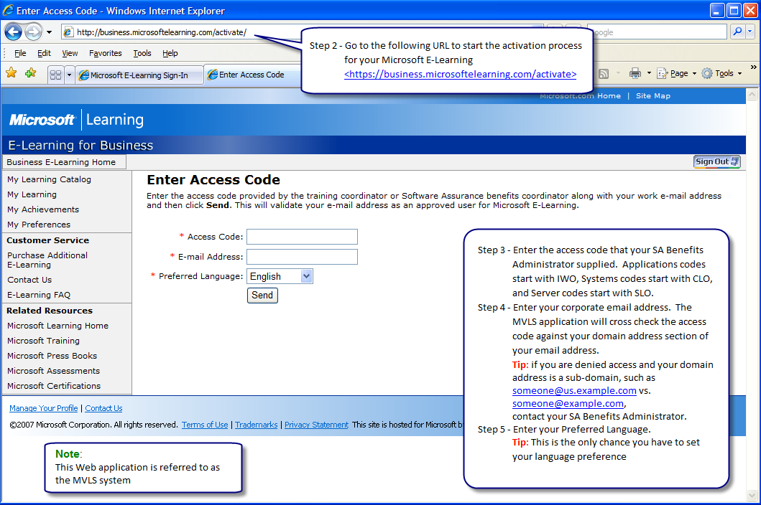

Step 6 | Sign In
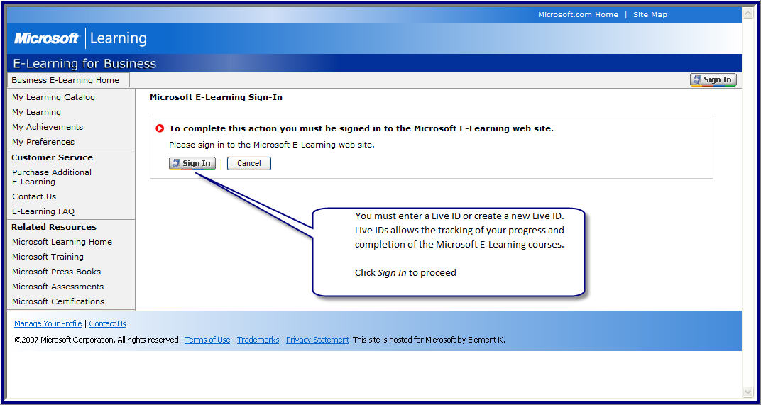

Step 7 | Existing Windows Live™ ID
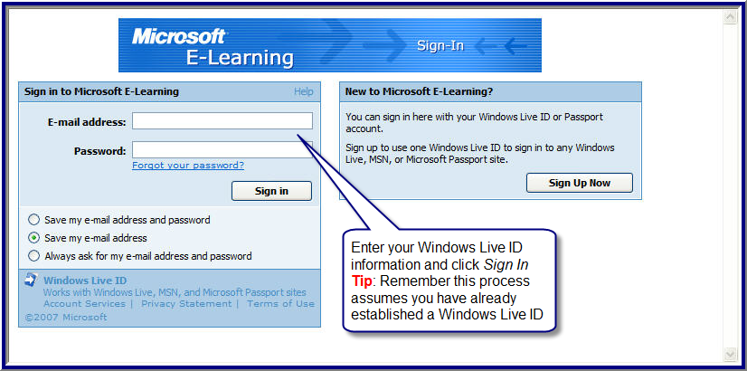

Step 8 | Confirmation
Your Windows Live ID and corporate e-mail address are now linked to provide access to Microsoft E-Learning.
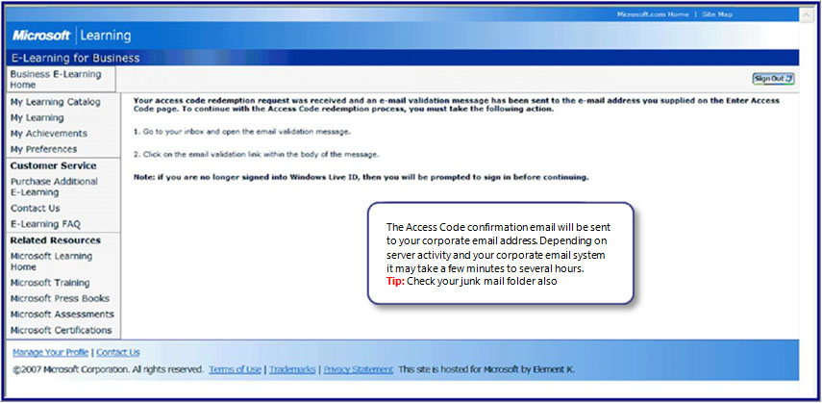

Step 9 | Activation E-Mail
Click on the link in the e-mail message to complete the activation of your Software Assurance E-Learning benefits. If you do not receive the e-mail message, call (866) 230-0560 or send an e-mail message to mvlshelpa@msdirectservices.com.
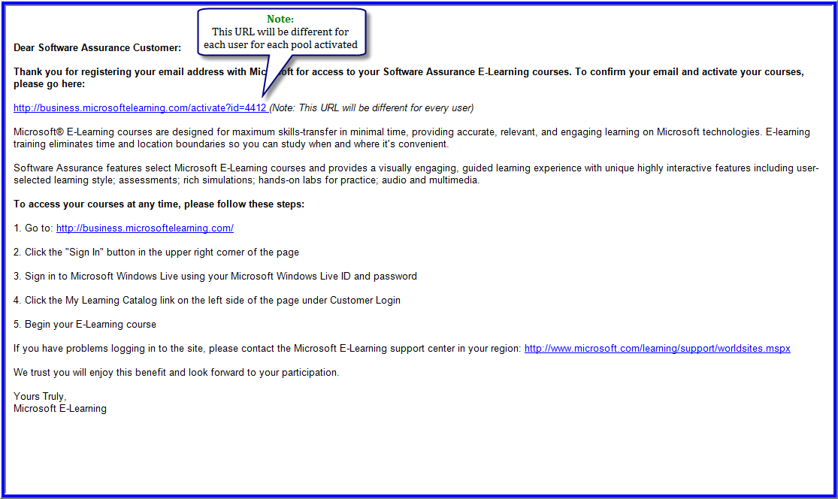
Step 10 | My Learning Catalog
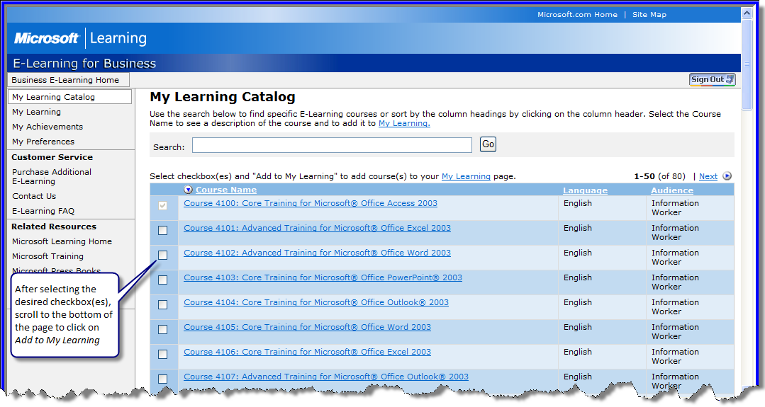
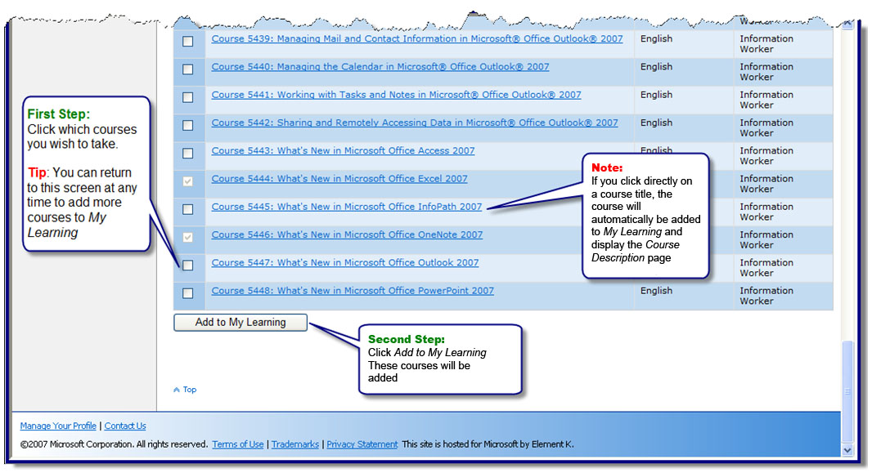

Step 11 | My Learning
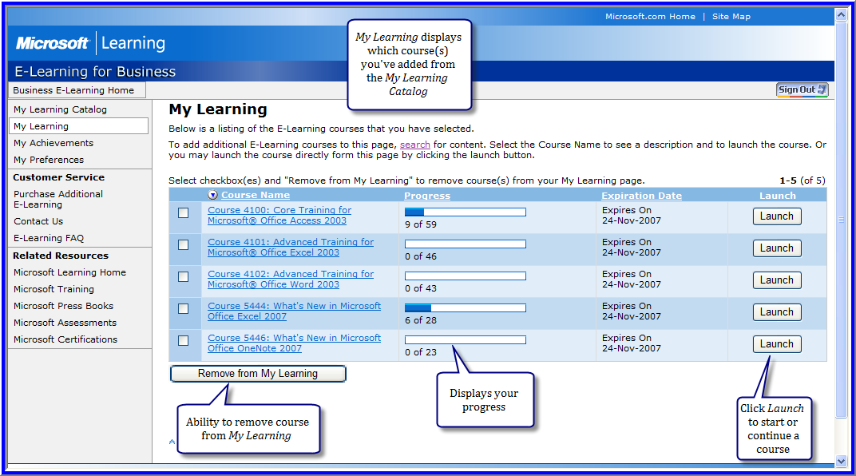

Q. I don’t have a Windows Live ID. How do I establish one?
A. Establishing a Windows Live ID is easy. When establishing a Windows Live ID, you can use an existing e-mail address or your corporate e-mail address (check your company policies first), or you can establish a new MSN® Hotmail® account. You can establish your new Windows Live ID before proceeding with the activation process for Microsoft E-Learning, or you can do it during the process. The next few screens assume that you are establishing a new Windows Live ID (a new MSN Hotmail account) during the activation process and that Steps 1 through 6 from the previous Q&A have been completed.
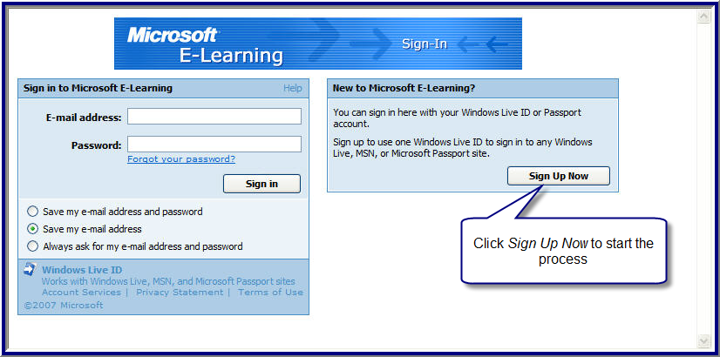

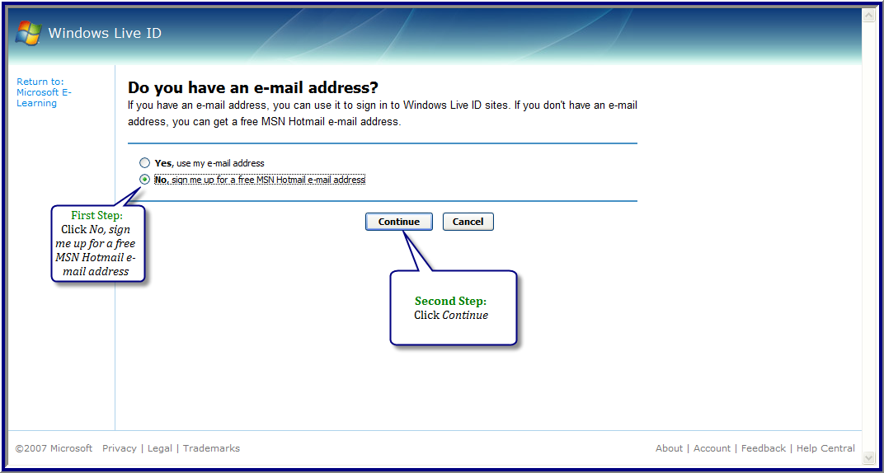
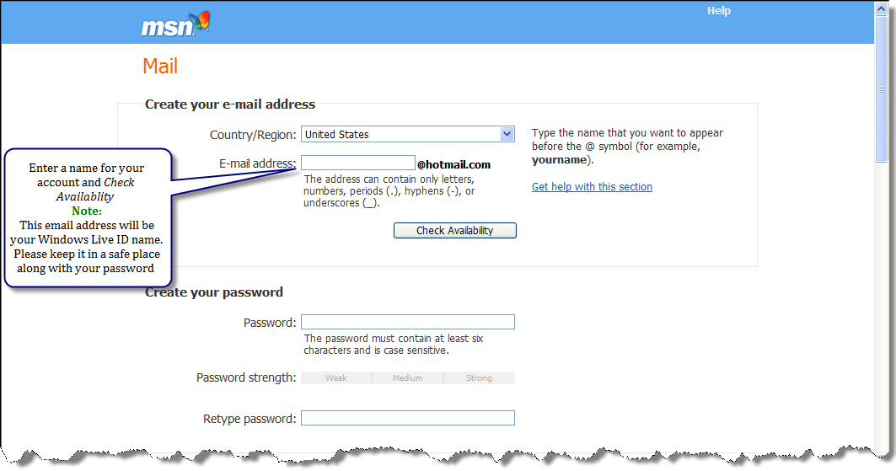
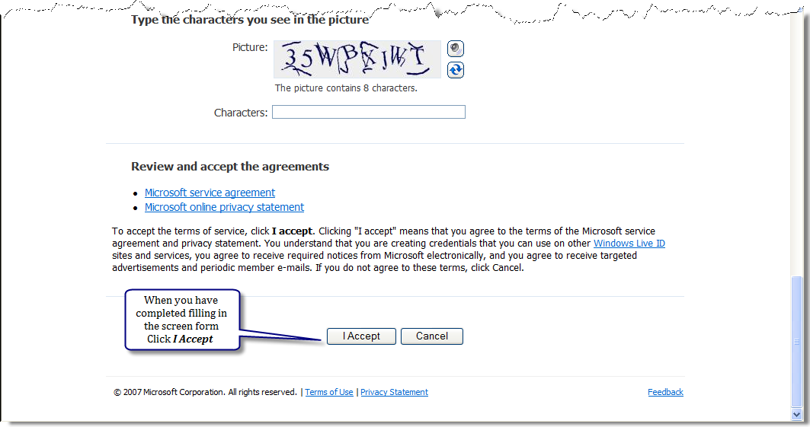

The following screen will indicate your Windows Live ID creation was successful
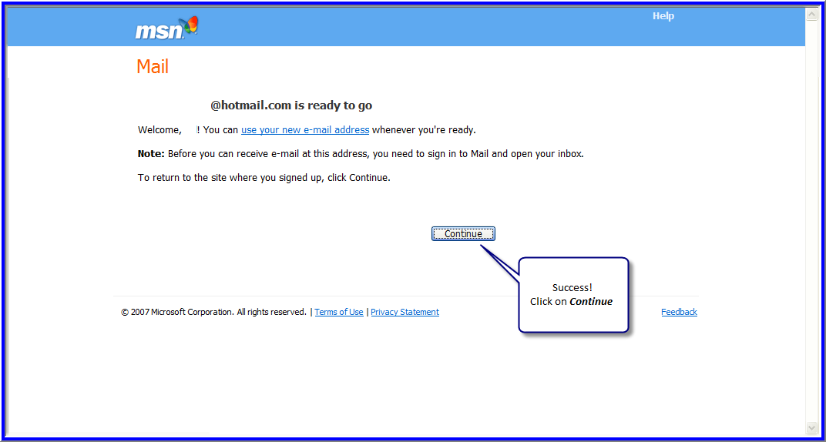

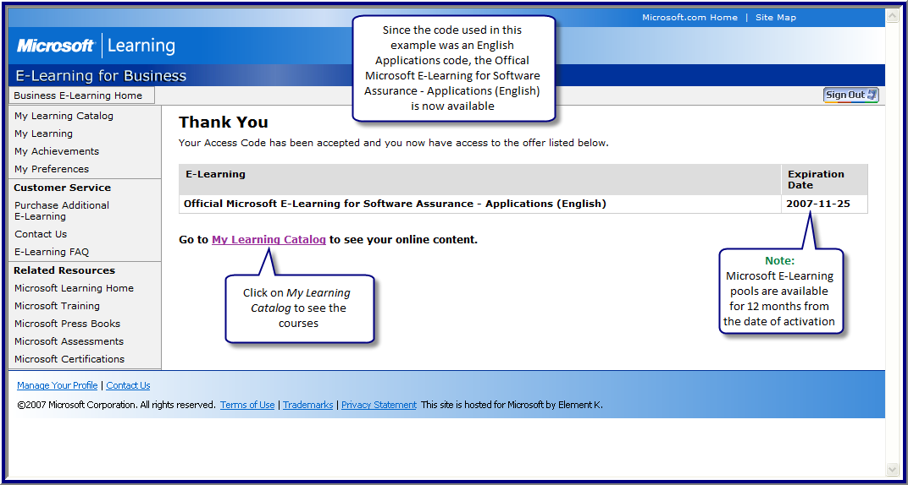
Click My Learning Catalog to return to Step 10.

Q. After activating my Microsoft E-Learning, how do I return next time to continue training?
A. Go to https://business.microsoftelearning.com.
On the following screen, click Sign In and follow the prompts.
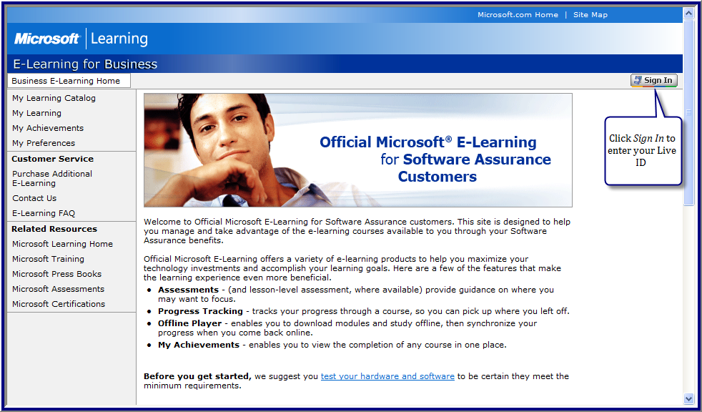

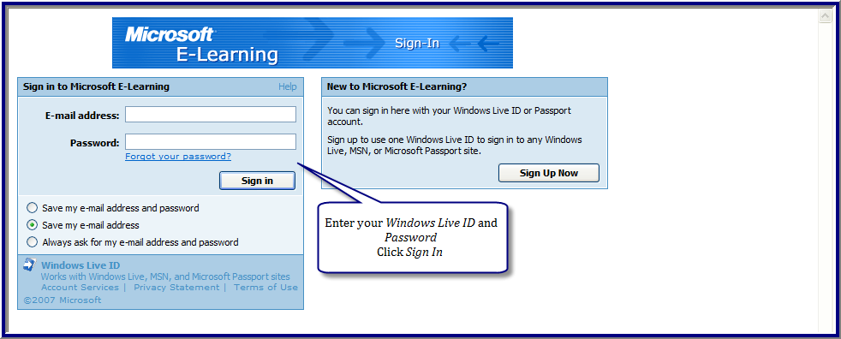

After you sign in, you will be returned to the Home Page (not the My Learning Catalog). From there, click My Learning to continue with your training, or click My Learning Catalog to view courses that are available to you.
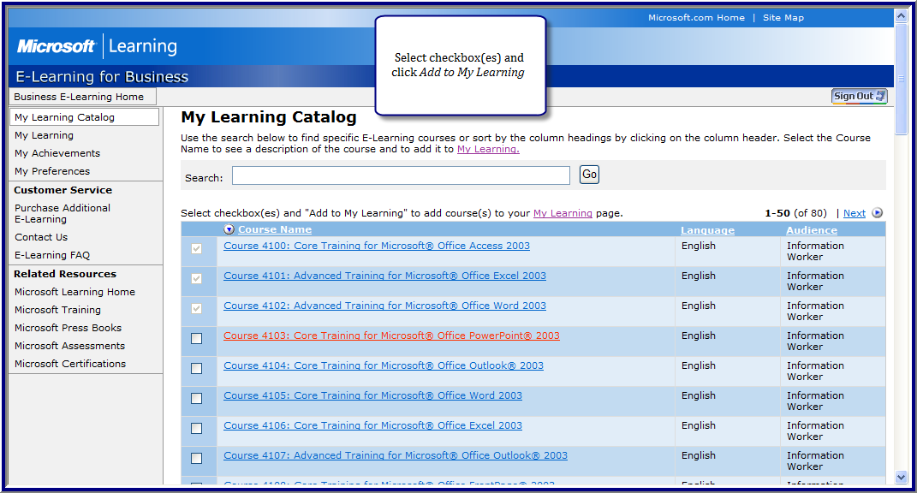

Microsoft provides this material solely for informational purposes. Customers should refer to their agreements for a full understanding of their rights and obligations under Microsoft Volume Licensing programs. Microsoft software is licensed, not sold. The value and benefit gained through use of Microsoft software and services may vary by customer. Customers with questions about differences between this material and the agreements should contact their reseller or Microsoft account manager. Microsoft does not set final prices or payment terms for licenses acquired through resellers. Final prices and payment terms are determined by agreement between the customer and its reseller. Eligibility for Software Assurance benefits varies by offering and region and is subject to change. The Terms and Conditions of your Volume License Agreement and the Terms and Conditions under which any specific Software Assurance benefits are offered will take precedence in the case of any conflict with the information provided here. For eligibility criteria and current benefit program rules, see the Microsoft Product List, see http://www.microsoftvolumelicensing.com/.

Information in this document, including URL and other Internet Web site references, is subject to change without notice. Unless otherwise noted, the companies, organizations, products, domain names, e-mail addresses, logos, people, places, and events depicted in examples herein are fictitious. No association with any real company, organization, product, domain name, e-mail address, logo, person, place, or event is intended or should be inferred. Complying with all applicable copyright laws is the responsibility of the user. Without limiting the rights under copyright, no part of this document may be reproduced, stored in or introduced into a retrieval system, or transmitted in any form or by any means (electronic, mechanical, photocopying, recording, or otherwise), or for any purpose, without the express written permission of Microsoft Corporation. If, however, your only means of access is electronic, permission to print one copy is hereby granted.
Microsoft may have patents, patent applications, trademarks, copyrights, or other intellectual property rights covering subject matter in this document. Except as expressly provided in any written license agreement from Microsoft, the furnishing of this document does not give you any license to these patents, trademarks, copyrights, or other intellectual property.
© 2008 Microsoft Corporation. All rights reserved.
Hotmail, Microsoft, MSN, Vista, Windows, and Windows Live are trademarks of the Microsoft group of companies.

