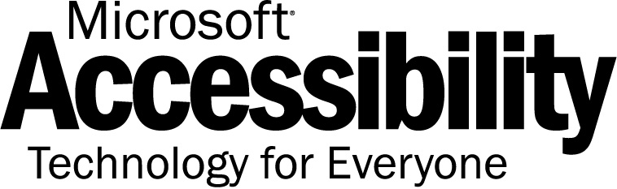


Overview of Accessibility

Our Mission – Realizing Potential
Microsoft's accessible technology solutions enable people of all abilities to realize their potential.

Computer technology
is an important and
powerful tool for people with difficulties and impairments.
Over the last three decades, technology has transformed the way we work, play, and communicate. Groundbreaking technologies have opened the door to innovations in every field of human endeavor—delivering new opportunity, convenience, and value to our lives.
Since its founding in 1975, Microsoft has been a leader in this transformation. As a reflection of that role⎯and to help focus on
the opportunities that lie ahead⎯we established and embraced our corporate mission: To enable people and businesses throughout
the world to realize their full potential.
Enabling Opportunity for People of All Abilities
At Microsoft, we're committed to this mission of helping our customers scale new heights and achieve goals they never thought possible. Delivering on this mission means we strive to build products that are accessible to everyone—including people with disabilities and impairments.
Accessible technology is technology that is flexible and adjustable to an individual’s visual, mobility, hearing, language, and learning needs, and can therefore be accessed by people regardless of their functional abilities. Accessible technology includes accessibility options and utilities built into products (such as Windows XP) as well as specialty assistive technology products such as voice recognition and screen readers for computer users who are blind.
Every day we are connecting with customers, understanding their needs and how they use technology, and providing value through information and support to help them realize their potential with the use of accessible technology.
Longstanding Commitment to Accessibility
Microsoft recognized early that computer technology is an important and powerful tool for people with disabilities and impairments. For more than a decade, we have been exploring and evolving accessibility solutions that are integrated with our products. We are committed to continuous innovation in this area.
Microsoft’s Accessible Technology Group has taken a strategic approach to our accessibility efforts. These efforts include:
• Leadership and Awareness
As a leader in the software industry, we recognize our responsibility to raise the standard for the whole industry in the area of accessible technology. We actively increase awareness of accessibility through conferences, publishing articles and case studies, and meeting with government agencies and leading businesses.
www.microsoft.com/enable/
The Microsoft Accessibility Web site and the free Accessibility Update
e-newsletter (both at www.microsoft.com/enable/) provide in-depth information about the accessibility of Microsoft products. The site hosts free step-by-step tutorials and resource guides. This information helps people with various types of impairments find the right technology solutions to meet their specific needs.
By publishing Accessible Technology in Today’s Business (MSPress book, 2002), Microsoft raised awareness of accessible technology currently available to professionals with impairments; and to show businesses how to integrate accessible technology into the workplace. We also produced a video that showcases professionals across various industries using accessible technology to be successful in their careers.
• Built-in Accessibility in Microsoft Products
Microsoft is continually exploring and evolving accessibility solutions that are integrated with our products. Microsoft products increase productivity by allowing individuals to adjust the technology to meet their needs, enhance collaboration and communication, and lower costs for our enterprise and government customers who use Microsoft products across their organizations. We’ve discovered that designing accessible technology yields better products overall. For example, high-contrast color schemes were designed for people with visual impairments, but they are also useful to many people with tired eyes at the end of a long day. The same is true for adjustable font sizes and styles. Providing keyboard access is essential for people with disabilities, but also generates a productivity boost for power users. Learn more at www.microsoft.com/enable/
products/.
• Continued Innovation and Compatible Assistive Technology
Microsoft is committed to partnerships around the world that drive innovation and move the industry forward. Windows XP was the most accessible operating system released to-date, and had compatible assistive technology available the day it launched. This was accomplished by working closely with assistive technology manufacturers to ensure specialized products such as screen readers, screen magnifiers, alternative and on-screen keyboards, and augmentative communication devices are compatible with Microsoft products—and offer people with disabilities innovative and timely solutions. We provide an online catalog of assistive technology products compatible with Windows at www.microsoft.com/enable/at/.
• Collaboration and Strategic Alliances
Microsoft strives to build strong relationships with key worldwide governmental agencies and organizations that advocate on behalf of people with disabilities. Together, we draw on collective resources and expertise to increase the understanding of accessible technology. As part of this effort, we work with various “advisors” from disability organizations throughout the world. By leveraging their expertise, we obtain pertinent customer feedback on our products during product design reviews, beta testing, and customer scenarios.
Accessibility Resources
Microsoft Accessibility Web Site
www.microsoft.com/enable/
Free Subscription to the Accessibility Update E-Newsletter
www.microsoft.com/enable/news/subscribe/

