**Automating IT Service Management with System Center**

Microsoft System Center Service Manager Overview Whitepaper

April 2006

# Table of Contents

Table of Contents 2

Executive Summary 3

Introduction 3

IT Service Management Automation 4

System Center Service Manager (SvcMgr) 5

Extensibility Solution Packs 5

CMDB 5

Workflow 6

Knowledge 6

Console 6

Integration 7

System Center Service Manager Operational Scenarios 8

More Information 10

# Executive Summary

To automate IT Service Management, it is necessary to implement a single point of contact in the service desk for all service requests, knowledge, and workflows, and for processes such as incident, problem, change, and asset management. This paper provides a high-level description of the Microsoft System Center solution for IT Service Management currently under development and named System Center Service Manager (SvcMgr).

# Introduction

To automate IT Service Management, one must manage the people, processes, and technologies that make up the IT Service Management discipline. Microsoft System Center management products enable best practice support to manage the various IT Service Management functions defined by the Microsoft Operating Framework (MOF) and Information Technology Infrastructure Library (ITIL). A key function of IT Service Management is the service desk. The service desk provides a contact point where people interact with IT services on issues such as problem or change management. The service desk also provides an organization’s management visibility into the overall performance of the IT environment through reports and dashboards. Microsoft’s Service Manager (SvcMgr) is designed to meet this need as part of the System Center family of solutions and help organizations reduce costs by automating their IT Service Management processes and making access to technology and organizational expert knowledge easier.

A lot of help desk products are available today, but many of these products have tackled only one area of IT Service Management automation and few have developed a solution that can be easily extended to grow and adapt to the changing needs of business. Microsoft has developed a solution that will address many common IT Service Management functions out of the box and is easily extended by customers, partners, and Microsoft to cover future needs of IT Service Management. Microsoft has done this by:

* Deeply integrating across Microsoft technologies and offering seamless workflows from inventory discovery and event detection to Service Management processes such as incident, problem, and change management that draw on this information.
* Leveraging the Microsoft technologies that most users already use or are familiar with to deliver a recognizable and common user experience and build on existing corporate IT knowledge.
* Investing in Self Service Portal technologies to help organizations reduce support costs.
* Pre-building and including process-automated workflows based on the Microsoft Operating Framework (MOF).
* Building an extensible Solution Pack framework, similar to the Microsoft Operations Manager Management Packs, for customers and partners to develop additional custom functionality for Service Manager.
* Configuration Management Database (CMDB) based on Service Modeling Language (SML) and Common Model language (CML).

Across the company, Microsoft has made deep investments in the core technologies that make up the foundation of a great Service Management solution. The Service Manager product will use Office Server technologies such as SharePoint and InfoPath Server for its knowledge repository and Web-based forms. Windows Workflow Foundation provides the workflow engine driving process automation, and the configuration management database (CMDB) will be based on SML. These technologies, along with embedded MOF processes and easy, open integration to other management tools, will produce a highly extensible, simple-to-use, Service Management solution that will provide an unprecedented view into an organization’s IT Service Management environment.

The initial product release will focus on the IT Service Management functions of incident, problem, change, and asset management. Integrations to other System Center products, such as System Center Operations Manager and System Center Configuration Manager, will be the focus for the initial release. The programming interfaces and connector infrastructure will also be available for Microsoft Partners to build integrations and add-ons for many third-party tools.

This paper provides a high-level overview of IT Service Management as well as the architecture of the System Center Service Manager product and some example scenarios to show the functionality that System Center Service Manager will offer.

# IT Service Management Automation

The service desk is the central point of contact between the IT organization and its customers and users on a day-to-day basis. The service desk is the customer touch point for the IT organization, allowing business processes to be integrated into the Service Management framework. One of the major responsibilities of the service desk is to coordinate the incident management function, but the service desk also provides an interface for customers and users to other Service Management activities, including change and asset management.

The service desk records all inbound user calls, whether it’s an incident, a request for new service, or simply a question. In the case of an incident, the function of the service desk is to minimize the business disruption by facilitating the prompt restoration of normal service. In the case of a service request, the function of the service desk is to deal with the request in the most appropriate manner, either by satisfying the request directly or by escalating/referring the request to an appropriate group.

The automation of IT Service Management through the service desk requires that the service desk product be able to automate the key tasks within the specific IT Service Management function. For example, if automating incident management, the service desk tool needs to make logging the call details easy and quick. It also needs to provide the user or analyst with access to expert knowledge so that the incident can be resolved. If the incident cannot be resolved at the service desk, the escalation process and path need to be well-defined and easy to follow. The workflows need to be easily defined and modifiable as Service Management processes evolve within an organization.

Self-service portals are an important interface for customers of IT Services; they provide an easy way to reduce cost and effort involved in routine service requests that can be easily automated. Users need to have easy access to the forms and tools required to execute typical service management activities, such as change approval or service request submissions.

Finally, the Service Management solution needs to be open and provide simple, easy access for anyone in the organization to understand the status of service requests and for managers to run desired reports.

Microsoft’s System Center management products provide IT staff members who are responsible for desktops, servers, and devices with a set of easy-to-use solutions for managing their infrastructure and the services delivered using that infrastructure. Delivering a product in the service desk area will provide powerful new functionality in the areas of incidents, problems, and asset and change management that, when tightly integrated with the existing System Center products, will result in a tremendously productive platform for end-to-end automation of IT processes.

# System Center Service Manager (SvcMgr)

The basic architecture of a consolidated service desk includes a database for storing service requests, configuration items, and a console for users to enter, display, and interact with service requests. For the System Center Service Manager product, Microsoft is extending this basic architecture to enhance the service desk extensibility and functionality.

### Extensibility Solution Packs

System Center Service Manager is designed to be an extensible platform, which allows for the automation of IT Service Management processes and helps organizations reduce cost by connecting customers and users with the workflow and knowledge in the IT environment. Customers and ISVs can easily enhance Service Manager workflows by layering on Solution Packs. Solution Packs will allow development of reusable forms, workflows, and reports which plug into System Center Service Manager. For example, an organization could develop a New Employee Solution Pack. This Solution Pack would include forms for entering new employee information, workflow to create user accounts and mailboxes, change requests to order computers or telephones, and reports to show progress. Any organizational process requiring forms, workflow, and a data repository can be created as a Solution Pack. Moreover, ISVs could develop Solution Packs to include knowledge, actions, and reports on how to identify and resolve issues with their software products.

The Solution Pack functionality allows System Center Service Manager to easily add new functionality without a version upgrade, making it more flexible to adapt with your organization.

### CMDB

A CMDB is a database store that provides an authoritative view of your managed IT infrastructure and services, including all relevant information about current and desired state, history and future plans, associated incidents and problems, and related change requests. It also stores information about all of your assets and who is using them. Through federation with other System Center data stores to establish a unified view of the environment, the CMDB plays a critical role in ensuring consistency across your incident, problem, change, configuration, and asset management and planning IT processes.

System Center Service Manager will have a CMDB database based on the Service Modeling Language (SML). The SML is a language or a meta-model that is used to describe the structure and behavior (set of applicable operational tasks, rules, and policies) of a distributed system. Using this rich language as the foundation for a CMDB enables Service Manager to capture a more detailed, comprehensive, and accurate description of the IT environment, greatly improving Service Manager’s ability to consistently manage the environment. Further, the SML is the core modeling technology at the heart of Microsoft’s Dynamic Systems Initiative (DSI), which is being adopted across the company. Using this same language that is also being adopted by the Visual Studio development tools to describe an application from its conception will additionally result in applications that are more rapidly developed and will easily populate the CMDB with rich information relevant to management when deployed to drive down ongoing operational costs.

### Workflow

To automate the IT Service Management functions that the Service Manager will manage requires a robust workflow engine. A workflow is a set of activities stored as a model that describes a real-world process. Work passes through the model from start to finish and activities can be executed by people or by system functions. Workflow provides a way of describing the order of execution and dependent relationships between pieces of short- or long-running work. System Center Service Manager will use the Microsoft WinFX Windows Workflow Foundation for its workflow engine. Windows Workflow Foundation will allow predefined workflows based on MOF processes to ship with System Center Service Manager. Customers can also customize or build their own workflows using Windows Workflow Foundation for execution within Service Manager.

### Knowledge

For a service desk to be effective, the user must have easy access to detailed expert knowledge. System Center Service Manager will include expert knowledge for troubleshooting and problem-solving, including the ability to leverage the Microsoft Product Groups and Microsoft Premier Support Services Knowledge Base. The included knowledge will also extend to procedures and processes defined by MOF, and users can customize or add their own organization-specific knowledge to Service Manager. Existing knowledge from other sources, such as Microsoft Operations Manager, or websites, such as Microsoft TechNet, will also be accessible through integrations to the Service Manager console and portal.

### Console

System Center Service Manager will have a Web-based interface (thin client) and a Windows Forms (thick client) console as well. The thick client console will provide a robust interface for high-volume users of the and administrators. The thick client console will have a similar look and feel to other Microsoft products, such as Microsoft Outlook or the Operations Manager consoles. This similarity will make Service Manager easier to use for users already familiar with these other Microsoft products.

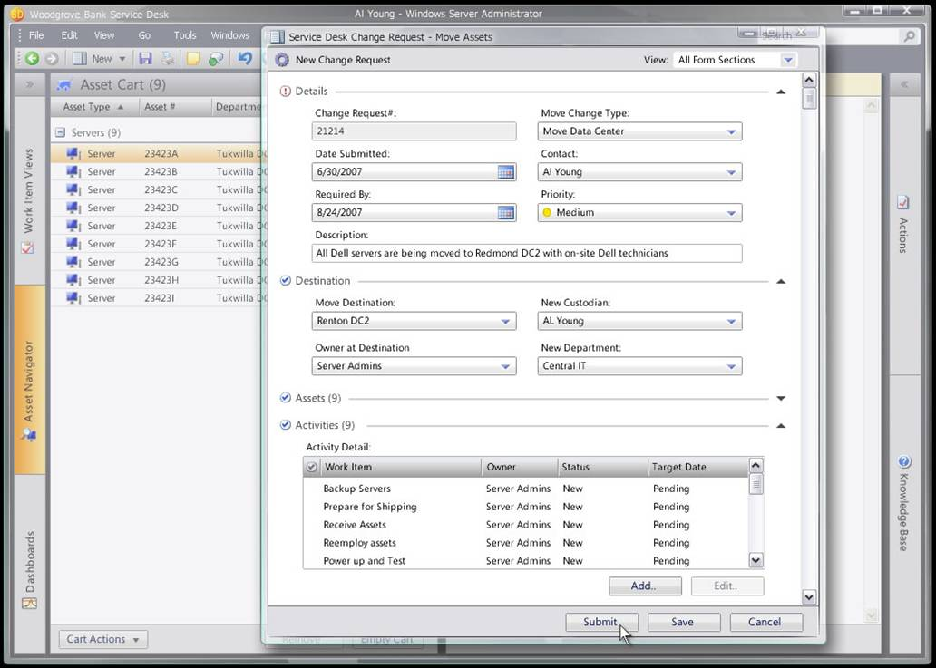

System Center Service Manager thin client will be based on SharePoint-based Web portals. The Self-Service Portal is a personalized end-user portal that will provide self-service functionality, such as notification, request submissions, knowledge search, and request tracking. The portal will also provide a Web-based version of the thick client console for operators and administrators. Users such as Change Approvers or Support Analysts will have access to work items, knowledge, and reports through the IT Portal. The Self-Service Portal functionality will be extensible through Service Manager Solution Packs. If customers or partners want to add new processes or functionality to Service Manager, it can easily be exposed through the Self-Service Portal.

### Integration

One of the strengths of the System Center management products is the level of integration between the products. System Center Service Manager will include a linking framework with integrations out-of-the-box for Operations Manager, SMS, and Visual Studio Team System (VSTS). One possible scenario could unfold as follows: System Center Operations Manager detects the failure of a custom line-of-business application and opens an incident ticket in Service Manager. An incident record is then created in Service Manager. After the root cause of the incident is determined, the incident is escalated to development through Service Manager’s connector to VSTS. This causes a bug to be created in VSTS that is linked to the incident record in Service Manager. When development has a fix ready, they update the bug which causes the incident in Service Manager to be updated, indicating that a fix is available. A change manager can then open a change request in Service Manager to have the patch deployed. Through workflow, Service Manager then automates the deployment of the patch through SMS. Once completed, Service Manager automatically closes the incident record and any other related incidents and updates key stakeholders that the problem has been resolved.

The integration within Service Manager is provided by the linking framework, and it will be extensible through APIs and software development kits to allow development of connectors to other non-Microsoft management products. Microsoft is currently working with several partners to provide integrations to non-Microsoft management products.

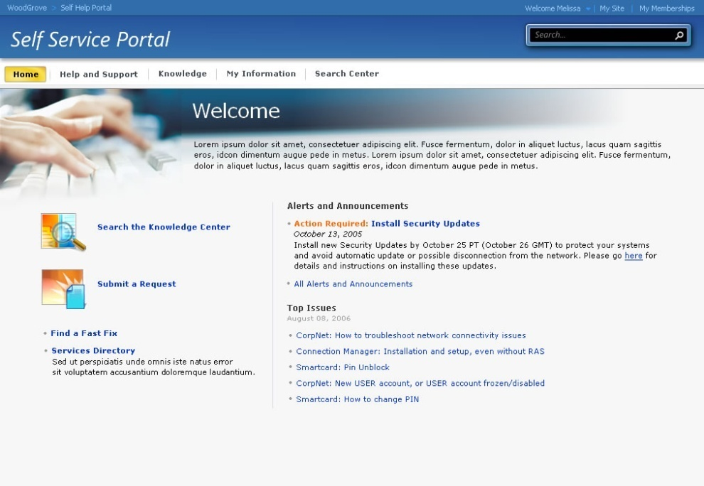

# System Center Service Manager Operational Scenarios

The following are some example scenarios illustrating the types of IT Service Management functions that System Center Service Manager will help organizations with.

**Incident Management - Create Incident records based on information in management tools**

“I want management tools to automatically create a Incident ticket when they detect a specific event or a sequence of events.”

A Business Application Administrator wants Operations Manager to automatically create incident records whenever the performance of certain business applications falls below a specific threshold or when certain events appear in the Windows Event Log. They use the Operations Manager Rules Wizard to define the criteria and the set of events, which should result in a new incident in Service Manager. The wizard allows them to specify the priority of the incident ticket.

The Business Application Administrator is also able to obtain updated Operations Manager Management Packs for Service Manager, which have been set up to create incidents and problems when certain conditions (known to Microsoft) are detected in the production environment. They are able to customize the rules and event conditions provided within these Management Packs to suit their needs.

**Problem Management - Identify problems by searching common incidents**

“I want to be able to associate multiple incidents to a single problem for analysis.”

Often a series of similar incidents on one or more machines may be an indicator of a more serious problem. Service Manager will allow administrators to search for like incidents and link them to a problem record for root cause analysis. Once the problem is resolved Service Manager can automatically close all the related incidents and notify the stakeholders.

**Asset Management - Track movement and ownership of hardware assets**

“I need to be able to track the movement of assets and ensure that they are assigned to the correct cost center.”

Assuming that a Change Request has been used to transfer the ownership of an asset to another user or cost center, the asset record is automatically updated (in Service Manager) when the request is successfully closed. However, assets are often transferred between users in the same department or cost center without going through any form of change management. A Manager who has received a new laptop, for example, allocates their existing machine to a direct report. Service Manager needs to provide a mechanism that enables the current or previous owner to indicate change of ownership and the current location of the asset.

The Manager opens the Asset Management view in the Service Manager UI and searches for the asset they are interested in. Having found it, they select the option to view “Asset History.” The UI displays the history of the asset, from its original purchase to its current state. The Manager notices that the asset was recently disposed of and selects this item to view more detailed information.

**Change Management -** **Review and approve Change Request**

“I need to be able to review and approve all changes to IT components and services to ensure that no new security vulnerabilities are introduced into the production environment.”

The Change Advisory Board (CAB) is responsible for reviewing all major changes to production systems; CAB members are notified that a new Change Request requires their approval. They open the Service Manager UI and see all of the change requests they need to review and approve. They select one of these requests and open it to view more detailed information.

They view the business justification, implementation plan, configuration items, and supporting documentation associated with the request and decide to approve it; they select the “Approve Change” option in the UI. Service Manager automatically notifies the person requesting the change to indicate that the CAB has approved it.

**Self Service -** **Resolve an issue without calling the Service Manager**

“I forgot my password to the Customer Management System (CMS) and I need to get it reset so that I can get in.”

When an employee has an IT problem, they can turn to the IT Portal first for assistance. Employees have to remember multiple username and password combinations for use on the different internal systems (i.e., no single sign-on).

When the employee arrives at the Portal page, they notice a text box that says “Find Answers.” When the employee begins typing “password,” they immediately get a drop-down list of suggested terms to complete their search. The employee selects “Password Forgotten” because that best represents the problem.

Without delay, a list of search results is displayed grouped in logical categories: FAQs, Articles, Forms, and Previous Requests. The employee focuses on a “QuickFix Solutions” box entitled “Did you forget your password?” In it, the employee gets an overview of what the QuickFix password reset tool does. The employee clicks the tool link and the tool walks the user through the process of resetting a password.

# More Information

The following links provide more information on System Center and Microsoft Operations and Management solutions.

Microsoft System Center Service Manager <http://www.microsoft.com/windowsserversystem/systemcenter/sd/default.mspx>

Microsoft System Center Management Products <http://www.microsoft.com/systemcenter>

Microsoft Operating Framework <http://www.microsoft.com/mof>

Microsoft Dynamic Systems Initiative <http://www.microsoft.com/dsi>