“With automated SAM tools, we no longer have to travel to each office and check each computer. This has greatly improved the efficiency of our IT workflow, increased system reliability, and strengthened security.”
For more information about other Microsoft customer successes, please visit: www.microsoft.com/casestudies

Customer: Northwest Regional Development Agency
Web Site: www.nwda.co.uk
Customer Size: 600
Country or Region: England
Industry: Regional government

Customer Profile
The Northwest Regional Development Agency leads the economic development and regeneration of the Northwest area of England. The agency’s mission is to encourage investment and help create the economic conditions that support business growth.

Software and Services
- Microsoft® Server Product Portfolio
- Windows Server® 2003 Enterprise Edition
- Windows® XP
- Centennial Discovery

Hardware
- Dell PowerEdge server computers
Stuart Dicken, Information and Communication Technology Service Manager, Northwest Regional Development Agency
The Northwest Regional Development Agency (NWDA) promotes economic development in Northwest England. The agency leads by example in adhering to established guidelines for IT excellence and encourages businesses to follow best practices. These guidelines include Software Asset Management (SAM), and in 2003 the NWDA implemented a SAM program that the agency has continued to refine over the years. SAM has helped the NWDA simplify IT management and reduce costs.

Business Needs
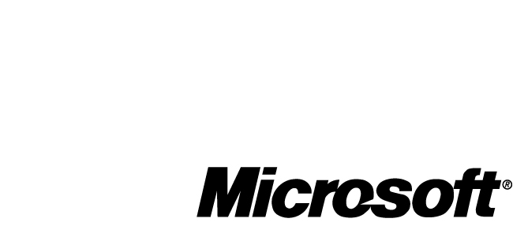

Headquartered in Warrington, Cheshire, the NWDA provides strategic leadership, programs, and funding to ensure the sustainable economic development and regeneration of England’s Northwest region. This government agency matches available worker skills to regional employers’ needs, creates conditions for economic growth, and promotes a high quality of life for residents.

The NWDA enthusiastically follows—and encourages other businesses to follow—the guidelines of the Information Technology Infrastructure Library (ITIL) in pursuit of operational excellence. ITIL is a collection of best practices and processes published by the Office of Government Commerce that helps organizations efficiently deliver high-quality mission-critical IT services. In the future, the NWDA will also seek certification from the International Standards Organization (ISO) in the areas of IT service management (ISO 20000), IT security management (ISO 27001), and Software Asset Management (ISO-19770-1). “The NWDA wants to promote superior IT management practices among the Northwest businesses it serves,” explains Stuart Dicken, Information and Communication Technology Service Manager at the NWDA. “And we strive to be a public-sector leader by implementing these practices ourselves.” To achieve these goals, the NWDA employs ITIL-certified staff who continually seek ways to better control the agency’s IT infrastructure and manage its software assets, thus providing better overall service to its internal and external customers.

Solution
As early as 2003, the NWDA recognized the need to include SAM as a fundamental part of IT operations. At that time, and on its own initiative, the agency conducted an inventory of software and licenses and compared it with an analysis identifying the products that the organization actually needed. Next, the NWDA developed a comprehensive SAM program that includes the following policies and practices:

- Standardizing the IT environment on the Windows® XP and Windows Server® 2003 operating systems
- Defining a standard disk image for first-time setup of all agency computers
- Restricting users from making significant system changes
- Establishing a formal, written policy for software usage, distribution, and compliance
- Maintaining an up-to-date list of software titles and licenses and storing licensing records in a fireproof safe
- Giving the IT department sole authority for purchasing and distributing software
- Using automated third-party tools to deploy software and maintain license keys
- Entering into an Enterprise Agreement to cover Microsoft® software
- Licensing standardized software for employees to use on their personal computers at home and establishing usage policies for these computers
- Conducting IT foundation courses to educate employees about SAM policies and practices
- Designating a software and policy analyst to serve as a first contact for SAM issues
- Joining the Microsoft Software Assurance maintenance program

Additionally, the NWDA deployed Centennial Discovery—a SAM tool created by Centennial Software, a Microsoft Certified Partner. This tool automatically discovers and monitors an organization’s IT assets, including client and server computers and network hardware. It also tracks software usage in real time and notifies the IT department if a particular computer runs an unauthorized program.

By 2004, the NWDA had fully deployed its SAM program, and the agency has continued to refine and expand the program ever since.

Benefits
Through SAM, the NWDA has improved IT efficiency and reduced costs. SAM also contributes to best practices that serve as an example in improving efficiency through high IT management and quality standards.

- Streamlines IT Management, Strengthens Security. “SAM has been very useful in helping us identify which computers need upgrades or other maintenance,” says Dicken. “With automated SAM tools, we no longer have to travel to each office and check each computer. This has greatly improved the efficiency of our IT workflow, increased system reliability, and strengthened security.” As an example of strengthened security, the NWDA was able to rapidly contain a recent virus infection. “Because we now have a controlled IT environment, our tools identified 12 infected computers across 11 locations. In just a few minutes, we contained and repaired these computers—all remotely.”

- Reduces IT Costs. Automated SAM tools help the department use staff more efficiently, avoiding the cost of hiring additional workers. Also, the NWDA is a government agency that carefully tracks its licenses, so it benefits from the government’s overall bulk-buying discounts. Additionally, through improved planning, SAM helps the NWDA know exactly what its software assets and needs are before entering into price negotiations with vendors. As a result, the agency buys the right number of licenses at the right price. Finally, Software Assurance includes valuable upgrade and training benefits, so the IT department can train staff without consuming the agency’s other training budgets. And, when the NWDA chooses to upgrade, it is already licensed for Windows Vista™ and the 2007 Microsoft Office system.
“We estimate that having a SAM program saves the agency as much as U.S.$106,000 a year in IT costs,” says Dicken.

- Supports Operational Excellence and Best Practices. SAM is part of a broad initiative at the NWDA to comply with high IT management and quality standards and to encourage Northwest businesses to do the same. “When we work with a business, we don’t just say, ‘This is a best practice, so you should do it.’ Instead, we say, ‘Let us show you how this practice helped us as an organization,’” concludes Dicken. “Our mission is to help our business become more efficient, and SAM is an important part of that.”

