“The investment in Data#3 yielded about a 600 percent return on investment due to a 57 percent reduction in spending needed to become compliant.”
For more information about other Microsoft customer successes, please visit:
- www.microsoft.com/casestudies
Partner: Data#3
Web Site: www.data3.com.au
Company Size: 320
Country or Region: Australia
Industry: Professional services
- Customer: Motor vehicle and household insurance company

Partner Profile
Data#3 delivers information and communication technology solutions in the areas of software licensing, integration and managed services, enterprise infrastructure, product sourcing, and recruitment. Based in Brisbane, Australia, Data#3 has 320 employees.

Software and Services
- Microsoft Server Product Portfolio
- Windows Server® 2003 Enterprise Edition
- Microsoft SQL Server™ 2000
- Centennial Discovery
Adam Shaw, National Manager, Software Asset Management Services, Data#3
A major motor vehicle and household insurance company purchased most of its software and hardware through an outsourced IT organization, but was unsure of its software compliance status. The company worked with Data#3, a Microsoft® Gold Certified Partner, to implement a Software Asset Management (SAM) program. Data#3 helped the company to ascertain and maintain its compliance, while reducing software purchase costs and achieving a 600 percent return on investment.

Business Needs
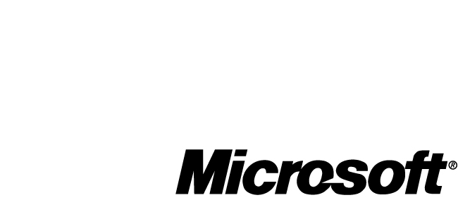

One of Australia’s most trusted and respected insurance companies, with more than 1.4 million policy holders, was experiencing poor visibility into its software assets. Because of record-keeping challenges between the company and its outsourced IT provider, the company was unsure of the software licenses it owned and the status of its software compliance. This caused worry that at any time a surprise audit could find the company at legal risk. The company wanted confidence that its licenses were in compliance and that it was purchasing and using software efficiently.

Solution
Both the company and its IT service provider had previously purchased software from Data#3, an information and communication technology solutions company based in Brisbane, Australia. In addition to product procurement, integration services, enterprise solutions, and recruitment, Data#3 specializes in software licensing and Software Asset Management (SAM). In fact, the company won the 2006 Global Software Asset Management, Licensing Solutions Award at the Microsoft Worldwide Partner Conference. The award recognizes the company’s experience with Microsoft software and particularly with Software Asset Management.

In June 2005, on learning of the customer’s challenges, Data#3 approached the customer about a possible SAM engagement. “Our first step, as always, was to sit down with the customer and take a site survey—an environmental snapshot of the software environment,” says Adam Shaw, National Manager, Software Asset Management Services at Data#3. Once this site questionnaire was completed, Data#3 created a proposal for service outlining the SAM tasks to be completed, project timeline, and associated costs.

The customer accepted the proposal immediately, and Data#3 set to work on the project in August 2005. Data#3 uses a standardized 10-step methodology for all customers:

- Identify key personnel related to establishing and maintaining the SAM program.
- Review or develop policies and procedures for software requests, purchases, and compliance, as well as for areas such as Internet, e-mail, and media use.
- Create a software asset register (a comprehensive document listing all software licenses, purchase dates, license keys, expiration dates, etc.).
- Establish where licenses are to be deployed and maintained.
- Ensure software media is stored in a safe and easily accessible area.
- Perform a software inventory using the customer’s software tool of choice.
- Conduct a “gap analysis” to reconcile actual licenses with software inventory results.
- Perform software rationalization to identify licenses that are installed, but no longer in use.
- Purchase, pool, or retire licenses as necessary and uninstall software.
- Review licensing agreements and contracts; ensure that the most cost-effective and business appropriate licenses are in use.

The first task of the customer’s comprehensive SAM solution was to obtain a software inventory and usage tool. The customer chose Centennial Discovery, which runs on the Windows Server® 2003 operating system and Microsoft SQL Server™ 2000.

Once the inventory was completed, Data#3 and the customer created a comprehensive software asset register to record important software license information. Data#3 found that many of the licenses the customer owned were underused. These licenses were allocated to a software “pool,” to be reused for future licensing needs.

Benefits
The SAM program managed by Data#3 saved the customer 57 percent on the software investment needed to become compliant. With 100 percent assurance of software compliance, the customer is also more productive and focused on its core business.

- Achieved ROI of 600 percent. Data#3 found that many of the licenses the company owned were actually not being used. “The customer was quite surprised at how many applications were never used or seldom used,” says Shaw. “We exchanged a lot of Microsoft professional product versions for their standard version equivalents, and we replaced other products with a simple viewer or reader,” Shaw says. Excess licenses were retired to the software pool, eliminating the need to purchase a new license the next time that software is needed. “The investment in Data#3 yielded about a 600 percent return on investment due to a 57 percent reduction in spending needed to become compliant,” says Shaw.

- Increased core business focus. “The customer doesn’t need anywhere near the number of internal resources it once did for software licensing,” says Shaw. While one person’s focus has been entirely redirected away from SAM, another’s is now only 40 percent fixed on SAM. “So there is increased focus on core business.”

- Gained 100 percent certainty of software compliance. With the assurance of an accurate, up-to-date, and verifiable state of compliance, the company is no longer in worry mode. “There was a lot of concern that Microsoft or Adobe or Symantec or anyone could walk through the door and conduct an audit,” says Shaw. The SAM program has eliminated that worry. “The environment went from being a very reactive one to a very proactive one.

“A lot of our customers use well in excess of 1,500 software products. To know the licensing terms and conditions and end user requirements—it’s something that just can’t be done without a SAM program. A managed SAM environment is a way that organizations can rest easy and no longer worry about SAM.”

The customer has retained Data #3 for maintenance of its SAM solution. During regular visits, Data#3 reviews the effectiveness of policies and procedures and ensures the company is continuing to use software efficiently.

