“The legal risks as well as the risks related to information system downtime are almost eliminated.”
For more information about other Microsoft customer successes, please visit: www.microsoft.com/resources/casestudies
Customer: ASTON
Web Site: www.aston.ru/en
Customer Size: 2,500 employees
Country or Region: Russia
Industry: Manufacturing

Customer Profile
Russia-based ASTON is a burgeoning agro-industrial firm that imports and exports grain and oil products on three continents. The company is also known for shipbuilding and repair.

Software and Services
- Microsoft® Server Product Portfolio
- Microsoft Windows Server™ 2003

Aleksandr Kiryutenko, Vice Chairman of the Board for Information Technology, ASTON
After a decade of rapid growth through acquisition and expansion, Russia-based ASTON needed to streamline a disjointed, inconsistent IT infrastructure. In 2005, the company worked with Microsoft to implement a Software Asset Management (SAM) program. Today, the agro-industrial firm has a streamlined IT department with well-established corporate policies for purchasing, managing, and maintaining the company’s software assets.

Business Needs
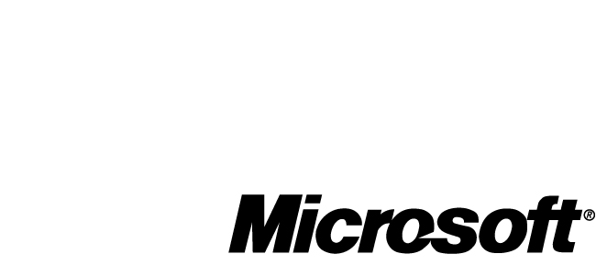

Well-known throughout Europe, Asia, and Africa, ASTON is the managing company of a group of agricultural and industrial enterprises. Based in Rostov-on-Don, Russia, the conglomerate is a leading importer and exporter of grain and oil products; it also builds and repairs ships. The company was founded in Germany in the 1990s and has expanded quickly throughout the last decade. With revenues from product sales in 2005 of U.S.$200 million, ASTON currently employs more than 2,500 people in dozens of locations throughout Russia and Germany.

Over the years, the company’s rapid growth made for an increasingly complex IT infrastructure. Each new enterprise the company launched or acquired had its own IT group. Without a centralized, corporate IT department, ASTON didn’t have a standardized process for purchasing and tracking software on enterprise systems, workstations, and PCs. And ASTON employees, who work in many diverse disciplines, required a variety of systems and software programs to do their jobs. Sometimes it was hard for employees to share data because these systems and software versions were incompatible. Consequently, it was difficult and costly for ASTON to manage and support its software companywide.

Aleksandr Kiryutenko, Vice Chairman of the Board for Information Technology at ASTON, suspected that the broad—and inconsistent—spectrum of hardware, operating systems, and application software was causing the company’s support costs to skyrocket. “We wanted to have a comprehensive idea of the existing software and hardware components in the corporation’s IT infrastructure.” Ultimately, the company wanted to update and standardize its IT infrastructure and choose an appropriate software licensing program. But before it could do that, the company needed to conduct a thorough inventory of its hardware and software assets.

Solution
Toward this goal, in late 2005, ASTON began working with Microsoft to implement a Software Asset Management (SAM) program. “We are carrying on a high-tech business, so we turned to the recognized global leader [Microsoft] in this area,” says Eduard Kravchenko, Vice Chairman of the Board for Corporate Finance, ASTON.

Based on industry-standard best practices, SAM is not a product but rather a process that helps enterprises value and manage their software as an important corporate asset. SAM guides IT departments through four tasks: conducting an inventory, matching existing software to licenses, reviewing corporate policies and procedures, and developing a workable plan for managing media licenses.

ASTON conducted a comprehensive inventory of its hardware and software using an automated tool running on the Microsoft Windows Server® 2003 operating system. The results helped the company identify and eliminate weak points in its IT infrastructure. For example, Kiryutenko says that the report helped the IT department identify which workstations were running unnecessary programs, resulting in high software and support costs.

After reviewing its software licenses and corporate policies and procedures, ASTON worked with Microsoft to define the following objectives:

- Standardize its IT department enterprisewide on Windows Server integrated server software.
- Standardize its workstations on the Microsoft Windows® XP Professional operating system and the Microsoft Office system.
- Select an appropriate licensing scheme and update all out-of-date programs.
- Define and enforce corporate policies for managing software usage and security.
- Simplify and standardize procedures for managing software and security updates.

The company defined specific configurations for employee workstations, identifying the exact hardware and software needed for specific jobs in each division of the company. It then chose an appropriate licensing program and updated its software and operating systems to compatible versions.

Benefits
Before 2005, getting control of its fragmented IT infrastructure was a daunting task for ASTON. But with help from Microsoft, ASTON developed a SAM program that has yielded positive results.

- Lower software costs. The SAM program helped ASTON choose a new licensing plan that saved the company 60,000–200,000 rubles (approximately U.S.$2,200–$7,500) on its initial upgrade project. “Before, the IT group didn’t know what or how much software it owned, so it was impossible to come up with a licensing scheme that made sense. New software and licenses were purchased on a case-by-case basis,” says Kiryutenko. “After taking inventory of the software we owned, which versions, and how many copies we had, it was easy to determine the best licensing scheme.” Under the new three-year licensing plan, individual IT groups consolidate their purchases and receive volume discounts, reducing the company’s overall software expenditures.
- Secure, compliant, and reliable IT environment. After upgrading its software to current and compatible versions, the company’s IT environment is not only more reliable but also compliant with new corporate policies for security. For example, employees are not allowed to install software on their workstations. “The legal risks as well as the risks related to information systems downtime are almost eliminated,” says Kiryutenko.
- Increased efficiency and productivity. With a consistent, controlled IT infrastructure, the IT department is now able to quickly install software programs and updates and use scripts to automate routine maintenance tasks. Kiryutenko estimates that his staff has saved 150–200 hours per month, which leaves administrators more time to devote to high-priority tasks.
- Improved short-term and long-term planning. Knowing the price of preconfigured workstations for specific job roles enables ASTON executives to accurately predict the cost of launching new projects. It also helps them evaluate and control the cost of increasing their investment in ongoing projects.
- Improved potential for capitalization. Kravchenko believes the SAM program helps the company achieve at least two of its strategic priorities: extending business capitalization and improving the company’s attractiveness as a viable investment. "Execution of this agreement is a logical and natural step in this direction."

