Microsoft Office Professional Plus 2007

September 2006



Table of Contents

Cover is for   
position only

Microsoft Office Professional Plus 2007 i

Overview of Microsoft Office Professional Plus 2007 2

Key Design Considerations in Office Professional Plus 2007 2

Work More Efficiently with Better Results 2

Collaborate with Others Across Boundaries 3

Make Better Use of Information 4

Streamline Processes and Control Content 5

Key Technology Advancements 6

Microsoft Office Fluent User Interface 6

Microsoft Office SharePoint Server 2007 7

Ecma Office Open XML Formats 8

Work More Efficiently with Better Results 9

Microsoft Office Fluent User Interface 10

Key Features 10

The Ribbon 10

The Microsoft Office Button 11

Contextual Command Tabs 12

Galleries 13

Live Preview 13

Enhanced ScreenTips 14

Create High-Impact Documents Quickly and Easily 14

SmartArtTM Diagramming and Enhanced Charting Capabilities 14

Building Blocks in Office Word 2007 15

PowerPoint Slide Libraries 16

Manage Your Time and Information Effectively 17

To-Do Bar in Office Outlook 2007 17

Task Integration on the Calendar in Office Outlook 2007 17

Collaborate with Others Across Boundaries 18

Communicate More Effectively and with Greater Flexibility 19

Easily Share Files and Calendars with Others 19

Document Inspector Feature 19

Enhanced Calendar Sharing Capabilities in Office Outlook 2007 20

Collaborate on Documents in a Structured Way 21

Document Comparison in Office Word 2007 21

Advanced Collaboration Environment with Windows SharePoint Services 22

Make Better Use of Information 23

Find Critical Information Fast 24

Instant Search in Office Outlook 2007 24

RSS Feed Integration in Office Outlook 2007 25

Office Outlook 2007 Integration with SharePoint Document Libraries and Lists 26

Gain Deeper Insight from Data 26

Data Visualization Tools in Office Excel 2007 26

Database Solution Templates in Office Access 2007 27

Connect to Important Business Information 28

Ecma Office Open XML Formats 29

Data Binding in Office Word 2007 29

Data Connection Library in Office Excel 2007 30

Streamline Processes and Control Content 31

Simplify Data Collection 32

Electronic Forms Tools and Templates in Office InfoPath 2007 32

E-Mail Forms in Office InfoPath 2007 33

Streamline Business Processes 34

Simplified Review and Approval Workflows 34

Streamlined Deployment of Electronic Forms 34

Manage Content with Office SharePoint Server 2007 35

Information Rights Management 35

Records Management 35

Information Management Policies 36

Keeping Your Content Safer with Office SharePoint Server 2007 36

Help and Office Online Services 37

Online Help and Training 37

Help 37

Assistance on Office Online 37

Training on Office Online 37

Downloads Web Site 38

Templates on Office Online 38

Clip Art and Media Web Site 39

Accessibility Features 39

Deployment and Migration 40

Microsoft Office Migration Management Technologies 40

Microsoft Office Migration Planning Manager 41

Microsoft Office File Conversion Tool 41

Microsoft Office Setup Controller 41

Microsoft Office Customization Tool 42

Microsoft Office Local Installation Source 42

Microsoft Office Resource Kit 42

What’s New for Developers 43

Introduction 43

Client Solution Highlights 43

Program Features 45

Office Word 2007 45

Office Excel 2007 48

Office PowerPoint 2007 51

Office Outlook 2007 52

Office Access 2007 55

Office InfoPath 2007 57

Office Publisher 2007 58

Office Communicator 2007 61

Summary 62

Resources 63

System Requirements 63

# Overview of Microsoft Office Professional Plus 2007

Welcome to Microsoft® Office Professional Plus 2007, a powerful set of tools designed to help information workers and their organizations work more efficiently with information. The Microsoft Office Fluent™ user interface makes it easier to get more out of the Microsoft Office system programs you use every day, so you can deliver better results faster.

Through integration with the new Microsoft Office SharePoint® Server 2007 and Microsoft Windows® SharePoint Services, Office Professional Plus 2007 offers advances in collaboration that simplify how you work with others, both within and outside your organization. Enhanced support for XML and electronic forms technology creates new opportunities for streamlining business processes, enabling new levels of individual and organizational performance.

## Key Design Considerations in Office Professional Plus 2007

To address the needs of customers as well as emerging workplace trends, Microsoft focused the design of Office Professional Plus 2007 around four key goals. These goals correspond to long-term investment areas that Microsoft began with Microsoft Office 2003 and continues to focus on today.

### Work More Efficiently with Better Results

In developing Office Professional Plus 2007, our focus was on empowering individual workers to help them increase their self-sufficiency and effectiveness. Office Professional Plus 2007 delivers on that with the streamlined Office Fluent user interface and powerful new capabilities that help you work with information more efficiently, so you can deliver better results faster.

* **New! Redesigned Office Fluent user interface** across the Microsoft Office system programs simplifies the way you work, reducing the need for training and making it easier for you to quickly deliver great results.
* **New! Diagramming and charting capabilities** help you easily produce high-impact documents, spreadsheets, and presentations without spending hours on formatting.
* **New! Innovative tools**—including Microsoft Office Word 2007 Building Blocks, the Microsoft Office Outlook® 2007 To-Do Bar, Microsoft Office Excel® 2007 data visualization tools, and Microsoft Office Access 2007 tracking templates—give you powerful new ways to work with information.
* **New! Microsoft Office PowerPoint® 2007 Slide Libraries** in Office SharePoint Server 2007 provide a central location to publish slides for later reuse, improving the consistency of corporate communications.
* **New! Organizational tools in Office Outlook 2007**, such as the To-Do Bar and task integration with the calendar, help you better manage your time and daily priorities.

### Collaborate with Others Across Boundaries

Office Professional Plus 2007 was designed to streamline communication and information sharing, keeping you in sync with coworkers, customers, and partners. Tight integration with Microsoft collaboration infrastructure technologies helps you share information and work with others across organizational boundaries.

* **New! Communicate more effectively with greater flexibility.** Microsoft Office Communicator 2007 makes communicating with colleagues in different locations or time zones easier by providing a range of different communication options, including instant messaging (IM), voice, and video.
* **New! The Document Inspector feature** makes it easy for you to remove “invisible” information such as comments, hidden text, and properties in your Word documents, Excel spreadsheets, and PowerPoint presentations, so you can share your work with confidence.
* **New! Calendar sharing capabilities in Office Outlook 2007** help you more efficiently schedule meetings with others, even those outside your organization.
* **Improved! Integration with SharePoint team calendars in Office Outlook 2007** enables you to view and edit team calendars on SharePoint sites just as easily as you would your own schedule.
* **Improved! Document Comparison features in Office Word 2007** make it easier to review and incorporate document revisions.
* **Improved! Integration with Windows SharePoint Services** enables you to easily create sites that centralize document storage, version tracking, and feedback management, helping to reduce the complexity of working together on documents.

### Make Better Use of Information

A key goal in the development of Office Professional Plus 2007 was to make the expertise, information, and data dispersed throughout your organization available to more people. Office Professional Plus 2007 meets that objective by helping you find, use, and manage information through a broad array of advanced information search, management, and analysis technologies.

* **New! Instant Search in Office Outlook 2007** helps you search through your e-mail, e-mail attachments, calendar, contacts, and tasks simultaneously, helping you find the information you need much faster.
* **New! RSS subscriptions integration in Office Outlook 2007** enables Really Simple Syndication (RSS) feeds to be delivered directly to your inbox.
* **Improved! Integration with Windows SharePoint Services in Office Outlook 2007** makes it possible for you to keep synchronized copies of team site document libraries and lists within Office Outlook 2007 so that you can work on them offline.
* **New! Visualization tools in Office Excel 2007**, including data bars, three-color gradients, and performance indicator icons, give you powerful new ways to analyze data.
* **New! Tracking application templates in Office Access 2007** help you easily build and use tracking applications for managing complicated sets of information.
* **New! Ecma Office Open XML Formats** provide compact, robust file formats that facilitate better data integration between documents and back-end systems so it’s easier to share information with others.
* **New! Data Connection Library in Office Excel 2007 and Data Binding in Office Word 2007** give you the ability to easily connect your spreadsheets and documents to corporate data sources, helping to ensure that they reflect the most current and accurate information.

### Streamline Processes and Control Content

Microsoft Office 2003 helped organizations collaborate on documents more easily. Office Professional Plus 2007 furthers that by empowering organizations to better control content and more efficiently execute business processes. Through advanced electronic forms technologies, Office Professional Plus 2007 provides enhanced features that help automate processes, helping companies to lower costs and simplify content management.

* **New! Tools and templates in the Microsoft Office InfoPath® 2007 information-gathering program** help you to easily create electronic forms to gather information in a structured way.
* **New! Office InfoPath 2007 E-Mail Forms** give you a faster way to collect information from coworkers by embedding an InfoPath form within an Outlook e-mail message.
* **New! Streamlined review and approval workflows through Office SharePoint Server 2007** simplify the process of reviewing and approving content, reducing time spent managing documents through their life cycles.
* **New! Office InfoPath 2007 integration with InfoPath Forms Services provided in Office SharePoint Server 2007** enables forms-based workflows that are accessible through a Web browser, streamlining business processes both within and across your corporate firewall.
* **Improved! Integration with Windows Rights Management Services** helps you safeguard digital information from unauthorized use by giving you the ability to assign usage rights to your documents, spreadsheets, presentations, and e-mail messages.

## Key Technology Advancements

### Microsoft Office Fluent User Interface

Office Professional Plus 2007 features the Office Fluent user interface that makes program features easier to find and use, simplifying the way the Microsoft Office system works and helping you deliver better results faster.

Features are easier to find because they have been reorganized into a set of tabs that more directly correspond to the tasks you perform in Office Word 2007, Office PowerPoint 2007, Office Excel 2007, and Office Access 2007. Specialized features are presented when they are needed and stay out of the way when you do not need them.

The Live Preview feature enables you to preview how your formatting or editing change will look before you make it. Galleries enable you to browse potential options and simply “pick and click” to get the result you want—no more puzzling your way through complicated dialog boxes. ScreenTips have also been enhanced with more illustrations and help text to make it easier for you to discover new features that help you get your work done quickly.

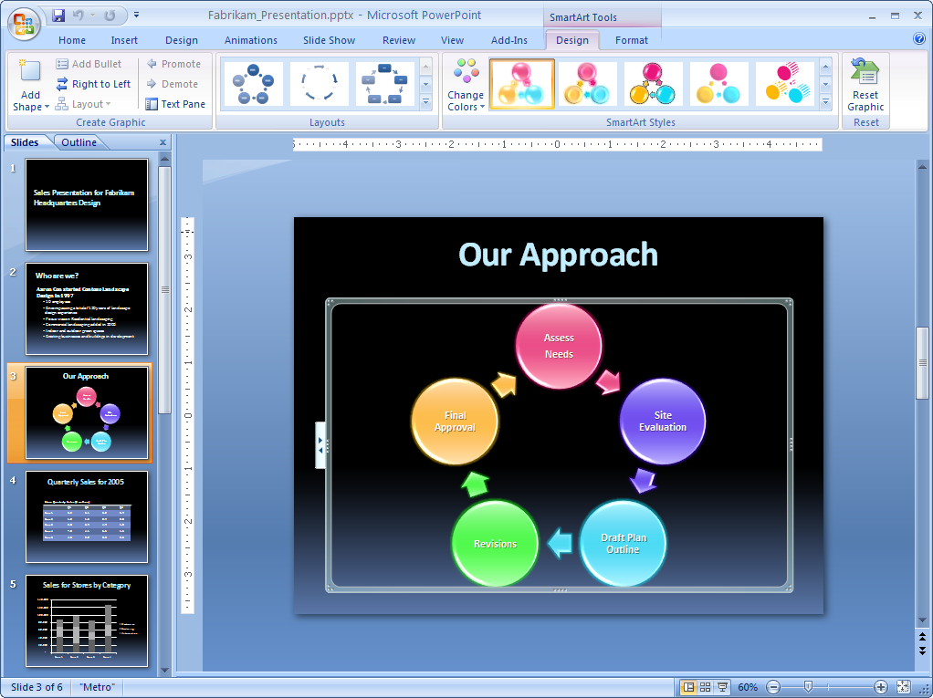

Figure 1: The Office Fluent user interface makes it easy to access powerful new capabilities.

### Microsoft Office SharePoint Server 2007

With the release of the 2007 Microsoft Office system, Microsoft introduces Office SharePoint Server 2007. This suite of easy-to-use server applications is tightly integrated with Office Professional Plus 2007 and boosts organizational effectiveness by helping workers:

* **Manage content comprehensively for increased business value.** Rich capabilities in Office SharePoint Server 2007 make it easy to manage and reuse content. An intuitive publishing user interface makes it easy to submit content for internal or external sites. Out-of-the-box document library templates facilitate simplified content repurposing for multilingual sites. Office SharePoint Server 2007 is also tightly integrated with Windows Rights Management Services, so you can help protect sensitive company information and easily comply with regulatory requirements.
* **Accelerate internal and external shared business processes.** Office SharePoint Server 2007 helps workers to spend less time on mundane, everyday activities. Out-of-the-box workflows give you the ability to automate common business processes like document review, approval, and signature collection. With electronic forms solutions, you can collect business information from coworkers, partners, and customers through a Web browser, without any custom coding. This information can be easily integrated into back-end systems, giving you access to real-time, accurate data, and eliminating duplicate efforts and errors caused by manual data entry.
* **Efficiently access information to drive better-informed decisions.** Office SharePoint Server 2007 facilitates better decision-making by connecting workers to critical business data. Managed Document Repositories give workers one central location to access business documents and content from across the enterprise. Out-of-the-box connectors and Web Parts for common line-of-business systems make it easy to access enterprise data by using only your Web browser. Integrated business intelligence (BI) capabilities like dashboards, BI Web Parts, and business data connectivity technologies help you create live, interactive BI portals that assemble business-critical information from disparate sources. Integrated Enterprise Search ties it all together by incorporating people, business data, documents, and Web pages to return comprehensive and relevant search results.

### Ecma Office Open XML Formats

By default, documents created in the Office Professional Plus 2007 programs are saved by using new, XML-based file formats. Distinct from the XML formats in past Microsoft Office system releases, the new Office XML Formats are compact, robust file formats that enable better data integration between documents and back-end systems. Using Office XML Formats, you can rapidly create documents from different data sources, speeding your ability to assemble documents, mine data, and reuse content. An open, royalty-free file format specification means your files can be opened and used in any environment.

Office Word 2007, Office Excel 2007, and Office PowerPoint 2007 each take advantage of Office XML Formats. As a result, it is faster than ever to create documents, spreadsheets, and presentations that incorporate data from a variety of sources and are easily shared with others.

# Work More Efficiently with Better Results

To maintain a competitive edge, companies must continuously strive to improve the efficiencies of their operations, including operations that are dependent on information work. Inefficient information work can negatively impact every aspect of the business—from sales performance to customer service to manufacturing to profitability. In addition, the agility with which an organization responds to changing market conditions or competitive threats can be adversely affected by inefficient information work.

When workers use tools inefficiently, it hinders their ability to positively impact the company’s bottom line. For example, the growing volumes of e-mail, tasks, and meeting requests that workers deal with every day is becoming increasingly difficult to manage. The volume of e-mail alone has increased so much that the average worker now spends 20 percent of his or her work time on e-mail each day, according to research from the Information Work Productivity Council. This makes it more difficult for workers to process and act on information, which reduces organizational effectiveness.

Office Professional Plus 2007 is designed to help Microsoft Office users increase their impact across the organization. The redesigned, streamlined Office Fluent user interface makes it easier for you to get more out of the programs you use every day. Powerful new capabilities help you work with information more efficiently, so you can deliver better results faster.

## Redesigned Microsoft Office Fluent™ User Interface

Office Professional Plus 2007 features the completely redesigned Office Fluent user interface—the most significant update to the Microsoft Office system user interface in more than a decade.

Microsoft redesigned the user interface because as more functionality has been added to the applications over time, it has become harder to find and use the features you need. The original Microsoft Word 1.0 contained just 100 commands, while Microsoft Office Word 2003 has more than 1,500 commands. Making these advanced features easier to find and use was a key goal in the redesign of the Microsoft Office system user interface.

Another goal was to create a streamlined, uncluttered workspace that minimizes distractions, so you can focus on your work. With these goals in mind, Microsoft developed a results-oriented user interface that makes Microsoft Office system programs easier to work with.

### Key Features

Early testing indicates that people quickly feel comfortable in the Office Fluent user interface and rapidly become accustomed to the new way that the applications work. The speed with which people acclimate to the Fluent interface is due to the simplicity of the interface features.

### The Ribbon

The traditional menus and toolbars have been replaced by the Ribbon—a new device that presents commands organized into a set of tabs. The tabs on the Ribbon display the commands that are most relevant for each of the task areas in Office Word 2007, Office PowerPoint 2007, Office Excel 2007, or Office Access 2007. For example, in Office Word 2007, the tabs group commands for activities such as Insert, Page Layout, References, Mailings, and Review. The Home tab provides easy access to the most frequently used commands. Office Excel 2007 has a similar set of tabs that make sense for spreadsheet work including tabs for working with formulas, managing data, and reviewing. These tabs simplify accessing application features because they organize the commands in a way that corresponds directly to the tasks people perform in these programs.

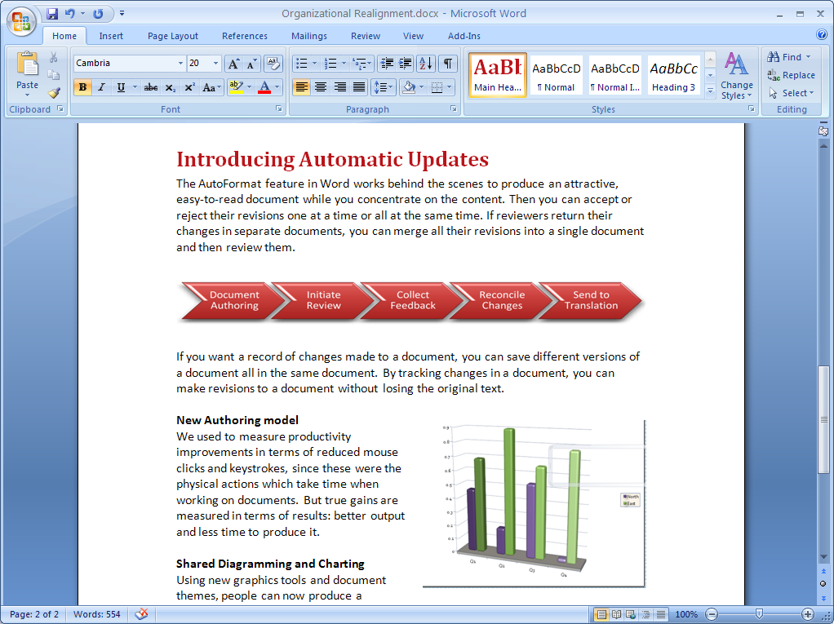

Figure 2: The streamlined workspace and easy-to-browse tabs make program  
 features easier to find and use.

## The Microsoft Office Button

Many of the most valuable features in previous versions of Microsoft Office were not about the document authoring experience at all. Instead, they were about all the things you can do with a document: share it, protect it, print it, publish it, and send it. In spite of that, previous releases of the Microsoft Office programs lacked a single central location where a user can see all of these capabilities in one place. File-level features were mixed in with authoring features.

The Office Fluent user interface brings together the capabilities of the Microsoft Office system into a single place: the Microsoft Office Button, which makes them easier to find and use.

### Contextual Command Tabs

Certain sets of commands are only relevant when objects of a particular type are being edited. For example, the commands for editing a chart are not relevant until a chart appears in a spreadsheet and the user is focusing on modifying it. In current versions of Microsoft Office programs, these commands can be difficult to find. In Office Excel 2007, clicking on a chart causes a contextual tab to appear with commands used for chart editing. Contextual tabs only appear when they are needed and make it much easier to find and use the commands needed for the operation at hand.

### Galleries

Galleries are at the heart of the redesigned programs. Galleries provide users with a set of clear results to choose from when working on a document, spreadsheet, presentation, or Access database. By presenting a simple set of potential results, rather than a complex dialog box with numerous options, Galleries simplify the process of producing professional-looking work. The traditional dialog box interfaces are still available for those who want a greater degree of control over the result of the operation.

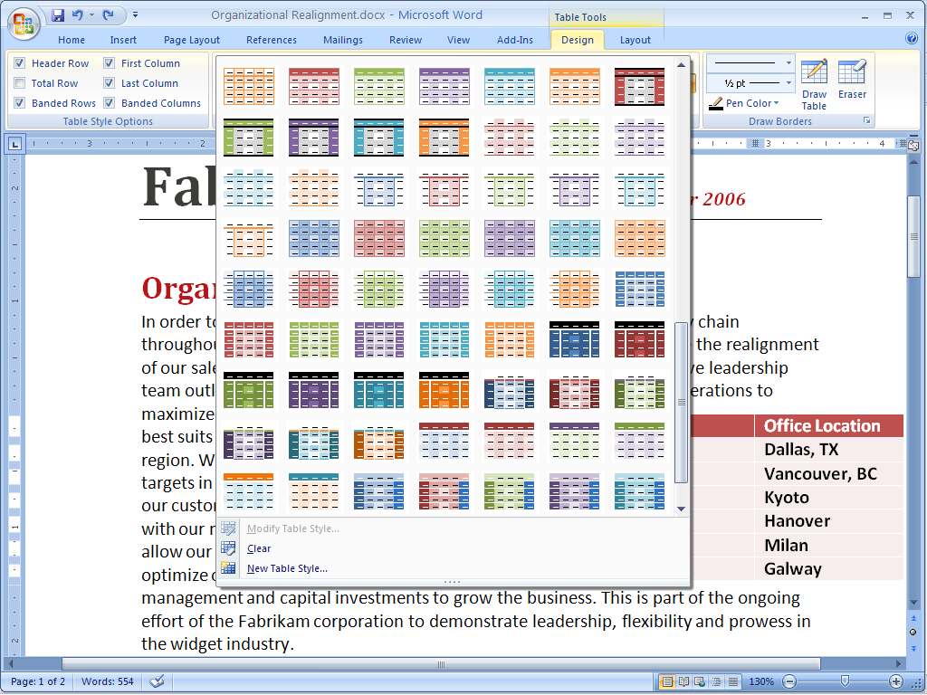

Figure 3: Galleries simplify complex formatting procedures.

### Live Preview

Live Preview is a new technology that shows the results of applying an editing or formatting change as the user moves the pointer over the results presented in a Gallery. This new, dynamic capability streamlines the process of laying out, editing, and formatting, so users can create professional results with less time and effort.

### Enhanced ScreenTips

The Office Fluent user interface dramatically streamlines access to information about commands and tools. Enhanced ToolTips provide links to auxiliary information, such as training or help topics, directly from the command. You no longer have to discover the name of a command, open the Help window, and type in the command name—the link is now built into the user interface. This in-context information helps you learn unfamiliar functionality quickly.

Because commands are organized according to the way you work, you can easily find and take advantage of the new and advanced capabilities in the 2007 Microsoft Office system. With its streamlined look and dynamic Galleries, the Fluent user interface helps you spend less time figuring out how the programs work so you can spend more time on content and analysis.

## Create High-Impact Documents Quickly and Easily

In addition to its Office Fluent user interface, Office Professional Plus 2007 includes many tools to help you create professional-looking documents easily and in less time. These tools include:

### SmartArtTM Diagramming and Enhanced Charting Capabilities

The new SmartArt diagramming and enhanced charting capabilities in Office Professional Plus 2007 applications make it easy to create great-looking diagrams and charts. Simply choose the chart type, the layout, and the format from visual galleries of predefined options, or take a bulleted list and convert it to a compelling diagram with just a couple of clicks. You can also reuse content by saving your favorite charts as a chart template. In addition, the graphics capabilities of the Microsoft Office system have been enhanced so you can easily use professional effects like shading, reflections, glow, transparency, and other 3-D effects.



Figure 4: SmartArt diagramming and enhanced charting capabilities in Office Professional Plus 2007   
applications make it easy to create great-looking charts.

Because the diagramming and charting tools are shared among Office Word 2007, Office Excel 2007, and Office PowerPoint 2007, you can produce consistent, professional-quality results across the Microsoft Office system.

### Building Blocks in Office Word 2007

Some information in your documents always remains the same, no matter what type of document you create. In the past, some users spent hours finding and reentering repetitive information, such as company contact information, team biographies, legal disclaimers, or standard proposal text. Locating and retyping this information every time you create a document can be time-consuming.

With the new Building Blocks feature in Office Word 2007, you can save time and reduce errors by creating Building Blocks of frequently used information that can be easily updated. To insert this standard information, simply select the content you want from the Building Blocks menu and insert it into your document.

### PowerPoint Slide Libraries

Using Office PowerPoint 2007 with Office SharePoint Server 2007 provides you with even richer capabilities for sharing presentations through PowerPoint Slide Libraries. This new feature gives you one centralized storage area for all your personal or team presentations. In fact, you can publish presentations to a PowerPoint Slide Library directly from Office PowerPoint 2007. Because PowerPoint Slide Libraries have the same look as SharePoint sites you are already accustomed to, it is easy to navigate the site and repurpose the information stored there.

PowerPoint Slide Libraries also reduce the need to re-create content, because you can easily repurpose existing content stored in a PowerPoint Slide Library. This way, if you or your teammates have created a presentation and you need one or two slides, it is easy to insert this content into your presentation without ever having to leave PowerPoint. In this respect, PowerPoint Slide Libraries remove many of the inefficiencies associated with trying to repurpose content while managing multiple presentations stored in different locations.

Additionally, you can create new presentations from an existing slide set. After you enter the PowerPoint Slide Library, you can select individual slides to send to PowerPoint so that you can easily create a new presentation without any unnecessary steps. PowerPoint Slide Libraries help ensure that your content is up-to-date, because you can choose to link slides in your presentation to the server version. If the server version changes, you are automatically prompted to update your slides. This is very similar to how documents stored in Microsoft Office SharePoint Portal Server 2003 document libraries work today.

## Manage Your Time and Information Effectively

With the volumes of e-mail and other information we deal with daily, it is becoming more difficult to manage time effectively. Office Professional Plus 2007 includes new and enhanced capabilities to help you organize your schedule and prioritize your daily work, including:

### To-Do Bar in Office Outlook 2007

Tracking your tasks can be time-consuming, because often they are implicitly contained within e-mail or stored in other locations. The new To-Do Bar integrates your tasks, e-mails flagged for follow-up, upcoming appointments, and calendar information in one convenient place. It also includes tasks from the Microsoft Office OneNote® 2007 note-taking program, Microsoft Office Project 2007, and SharePoint Web sites. The To-Do Bar gives you a consolidated view of your priorities for the day, so you do not have to waste time checking multiple locations to plan your schedule.

### Task Integration on the Calendar in Office Outlook 2007

Previously you may have scheduled “appointments” on your calendar to account for the time your tasks would take. Office Outlook 2007 integrates tasks in the calendar on the Daily Task List so that you see them displayed beneath your daily appointments and meetings. To allocate time for working on a task, you simply drag the task onto your calendar. When you complete a task on a given day, the task “sticks” to that day, providing a visual record of the work you performed. Tasks you do not complete roll over to the next day and accumulate until you mark them as complete.

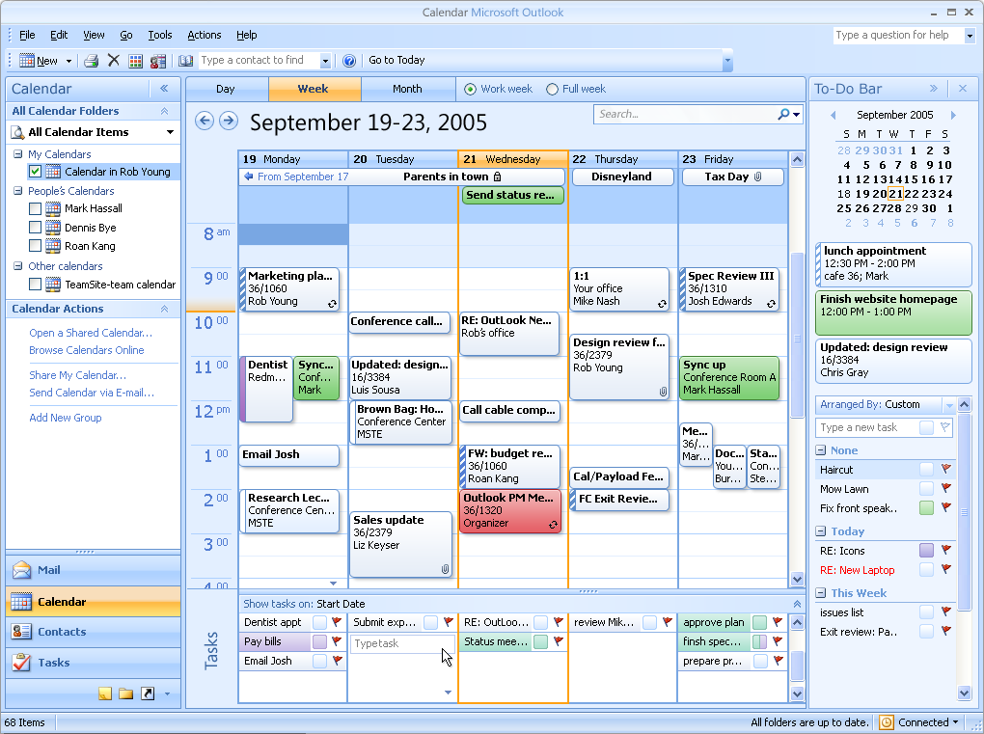

Figure 5: Office Outlook 2007 integrates tasks in the calendar on the Daily Task List so that   
you see them displayed beneath your daily appointments and meetings.

# Collaborate with Others Across Boundaries

Inefficiencies in processes for sharing information and collaborating on information work can hurt the overall efficiency and success of any organization. Additionally, sharing information with partners in a way that does not jeopardize an organization’s confidential information is difficult to set up and manage. And today’s teams are distributed not just across the organization, but across time zones and national borders, introducing additional challenges.

Office Professional Plus 2007 addresses these challenges with new tools that enhance your ability to work with others across organizational boundaries. These tools make sharing information and working together easier, safer, and more productive—no matter where team members are located. With tight integration with Microsoft collaboration and infrastructure technologies, Office Professional Plus 2007 helps teams work together more efficiently, right out of the box.

## Communicate More Effectively and with Greater Flexibility

Office Communicator 2007 is now part of the Office Professional Plus 2007 suite. Office Communicator 2007 helps people be more productive by enabling them to communicate easily with others in different locations or time zones, with a range of different communication options, including instant messaging (IM), phone and voice conferencing, video conferencing, or Web conferencing. Integration with 2007 Microsoft Office system programs—Office Outlook 2007, Office Word 2007, Office Excel 2007, Office PowerPoint 2007, and Office SharePoint Server 2007—gives teams quick access to a full set of collaboration tools.

## Easily Share Files and Calendars with Others

Sharing your files and calendars with others used to be difficult, particularly if they worked outside your organization or on other platforms. Office Professional Plus 2007 makes sharing and scheduling easier with new tools and capabilities, including:

### Document Inspector Feature

With the new Document Inspector feature in Office Professional Plus 2007, you can share files with confidence. Document Inspector helps you easily remove “invisible” information such as comments, hidden text, and properties in your documents, spreadsheets, and presentations so you can avoid sharing hidden content that violates corporate policy or that otherwise should not be distributed. Whether you are working in Office Word 2007, Office Excel 2007, or Office PowerPoint 2007, you can access Document Inspector from the same place within the Microsoft Office Fluent user interface.

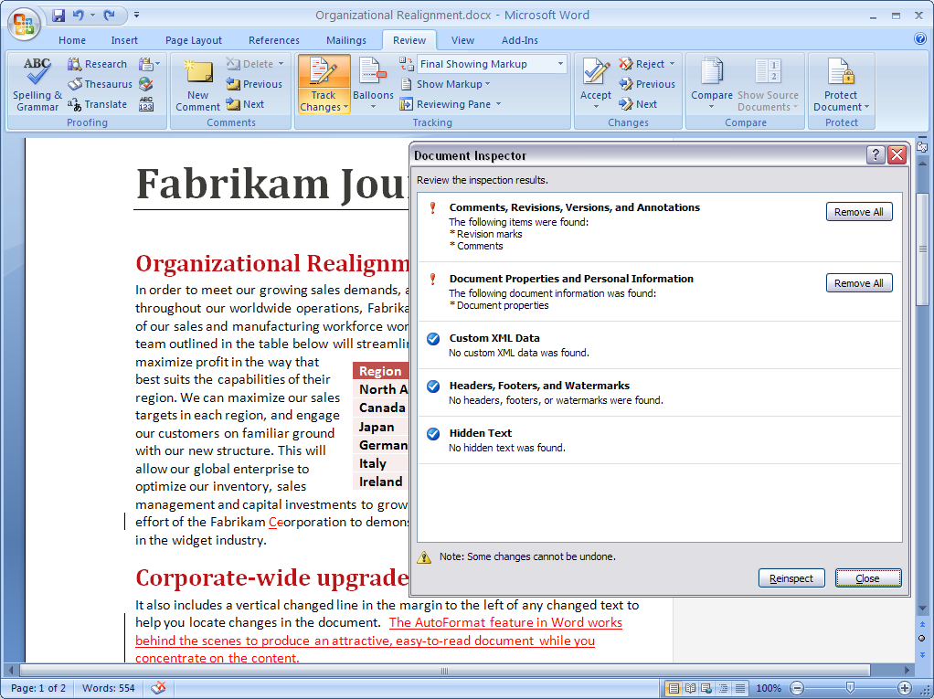

Figure 6: Document Inspector helps you easily remove “invisible” information such as comments, hidden text, and properties in your documents, spreadsheets, and presentations.

### Enhanced Calendar Sharing Capabilities in Office Outlook 2007

With new native support for Internet calendars, you can easily create a new Internet calendar from within Office Outlook 2007 and publish it to Microsoft Office Online. Using the enhanced security provided by Microsoft Windows Live® ID credentials, you can then grant others access to this calendar so that everyone has the latest information. Or you can use Calendar Snapshots to send an HTML snapshot of your calendar through e-mail, making it easy to schedule meetings with anyone without having to play phone tag.

Office Outlook 2007 also keeps you organized and in sync with team members by giving you easy access to team calendars stored on SharePoint sites. You can open SharePoint team calendars from within Office Outlook 2007 and view and edit them just as easily as you would your own calendars—even if you are offline. Any changes that you make to shared calendars in Outlook are reflected in the server versions.

## Collaborate on Documents in a Structured Way

Office Professional Plus 2007 streamlines the process of collaborating on documents. Enhanced capabilities provide an organized, structured way for you to work together, such as:

### Document Comparison in Office Word 2007

People often need to compare two versions of a document to see what has changed, even if they do not know who made those changes. This step can be critical when seeking out changes in documents that might radically alter their overall meaning.

With the new Document Comparison feature in Office Word 2007, you can easily see the difference between two different documents by comparing them side by side. You can also use the new tri-pane review panel to view the two different documents, as well as one document that combines the changes from each. Simultaneous scrolling for all three views makes it easy to systematically follow the changes.

It is also easier to conduct more thorough reviews because Office Word 2007 tracks moved text and changes within tables. As a result, it is easier to see what portions of a document have changed.

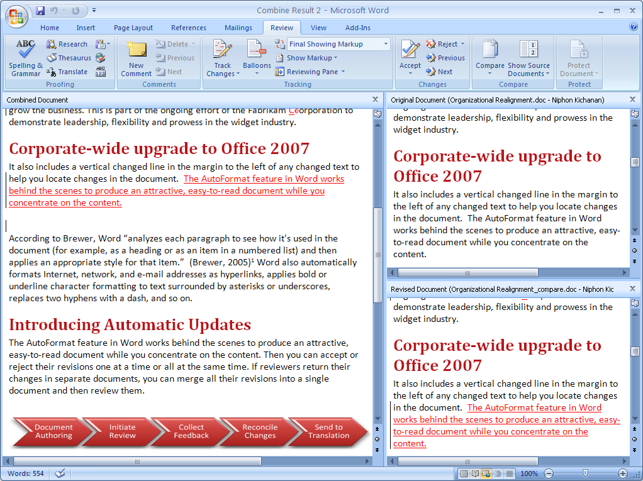

Figure 7: A new tri-pane review panel helps you see two versions of a document   
with the deleted, inserted, and moved text clearly marked, as well as a merged view of both documents.

### Advanced Collaboration Environment with Windows SharePoint Services

Workers often find it challenging to manage and work together on business-critical documents. Document copies are frequently scattered throughout the organization, and it can be difficult to determine whether you are working with the most current version.

Because Office Professional Plus 2007 is integrated with Windows SharePoint Services, you can create team sites for collaborating on projects with coworkers, partners, and customers. Using a team site, you can:

* **Create libraries** of all documents related to a project.
* **Manage permissions** to define who can access the site and which specific documents they can access.
* **Simplify document creation and review** with built-in document versioning plus check-in and check-out capabilities.
* **Enable e-mail alerts** to notify you and other team members when project documents and information have changed.
* **Read and edit all site content** from directly within Office Word 2007, Office Excel 2007, Office PowerPoint 2007, or Office Outlook 2007.

Setting up a Windows SharePoint Services team site facilitates much more structured information sharing than a simple file share. You can classify documents as a specific type of content with a specific purpose, making it easy to capture important metadata about the document. Then team members can find the right document based on type, other metadata, or its current state in the workflow.

# Make Better Use of Information

In many organizations, important information is locked in documents, people, and line-of-business applications. Increasing employees’ access to this data is critical for better decision-making and increased organizational competitiveness.

The relationship between the accessibility of information and employee productivity is direct: The more time an employee spends looking for information, the less time they have to actually work with that information. This reduces the employee’s ability to positively impact the organization. The problem is exacerbated by the increasing volumes of data that are available to workers, because it becomes difficult to find the most up-to-date, accurate data and derive business insight from it. Decisions can be made with greater confidence when organizations address these challenges.

Office Professional Plus 2007 helps with a broad range of advanced information search, management, and analysis technologies that extend from the inbox to the data center. These technologies connect you to business applications and data, making it easier for you to find, analyze, and use information throughout the organization. Office Professional Plus 2007 makes data available to more people so organizations can derive more value from content, documents, and data across the enterprise.

## Find Critical Information Fast

Many workers spend too much time looking for information on their desktops or corporate intranets, impacting their productivity. Office Professional Plus 2007 makes it easier to find the information you need, with advanced new features including:

### Instant Search in Office Outlook 2007

With new and powerful integrated Instant Search in Office Outlook 2007, you can quickly locate the information you need, whether it is in your e-mail, calendar, contacts, or tasks. Type in a keyword and Instant Search quickly searches your Outlook data, highlighting the locations where that search term appears. Instant Search does “word-wheeling,” which means that results begin to appear as soon as you start typing your search terms.

Instant Search can search broadly across all your Outlook items and folders, or you can specify a search within a particular folder in a given location. Instant Search even searches within e-mail attachments. You also have the flexibility to create queries with different Outlook criteria such as date, from, Color Categories, mail importance, and more, and Instant Search finds and delivers the results.

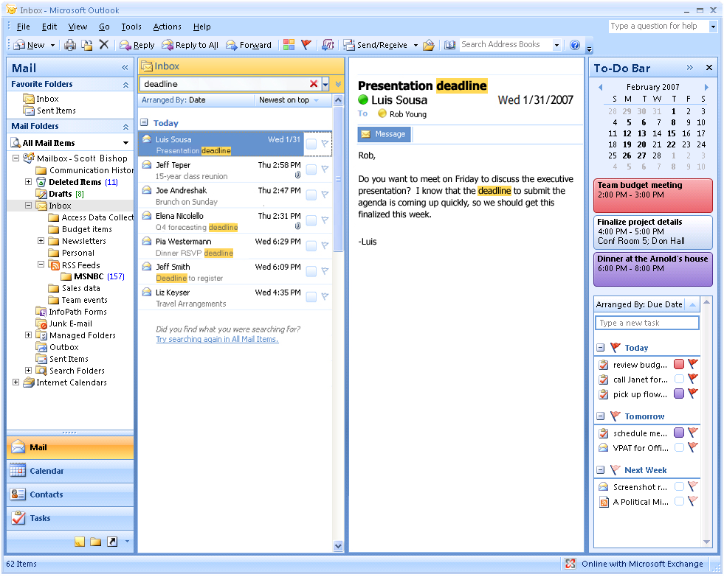

Figure 8: Instant Search in Office Outlook 2007 makes it easy to locate mail   
stored in Outlook with only a keyword.

### RSS Feed Integration in Office Outlook 2007

Office Outlook 2007 has native aggregation support for Really Simple Syndication (RSS) feeds, so you can easily subscribe and stay up-to-date with the latest news sites and blogs. Subscribing to these types of informational alerts makes it easy to stay up to speed on relevant business and industry information, or the latest information on your hobbies and personal interests. You can manage your RSS feeds in Office Outlook 2007 just like your e-mail, so you can flag them for follow-up, assign them Color Categories, or automate how they are processed by using the rules engine.

Integration with your existing e-mail accounts makes managing this information easy from directly within Office Outlook; bringing RSS items into your existing e-mail workflow has never been simpler than in Office Outlook 2007. If you have never used RSS feeds before, the built-in RSS directory hosted by Microsoft Office Online provides instructions and sample feeds from around the Web to get you started in a few easy steps.

### Office Outlook 2007 Integration with SharePoint Document Libraries and Lists

Office Outlook 2007 now provides even deeper integration with Windows SharePoint Services, so you can keep synchronized copies of SharePoint document libraries and lists within your Outlook folders. This makes it easy to organize and browse documents in these folders, just as you would any e-mail. You can work on these SharePoint documents within their respective applications in Office Outlook 2007 at any time, even when you are offline. So if you connect a Word document from your SharePoint site to Office Outlook 2007, you simply open the document from Office Outlook 2007 and work with it in Word like any other document. To help ensure that you have easy access to edited documents, Office Outlook 2007 files all these edited and connected documents in a separate folder. When you are back online, you can easily identify the edited documents and simply synchronize your changes with the server version.

## Gain Deeper Insight from Data

With so much data available to workers today, it is harder than ever to effectively analyze and use it to guide decisions and positively impact the organization. Office Professional Plus 2007 helps you gain deeper insight from data with new tools and features including:

### Data Visualization Tools in Office Excel 2007

You can now discover and illustrate important trends and highlight exceptions in your data by using conditional formatting with rich visualization schemes in Office Excel 2007. You can apply conditional formatting more easily and identify trends by using colored gradients, data bars, and icons. When you apply conditional formatting such as a three-color gradient, you can identify relevant values within the data and get a better idea of where these values lie within the range of data in question. You can then reorganize this data with sorting options like Sort by Smallest to Largest or Cell Color.

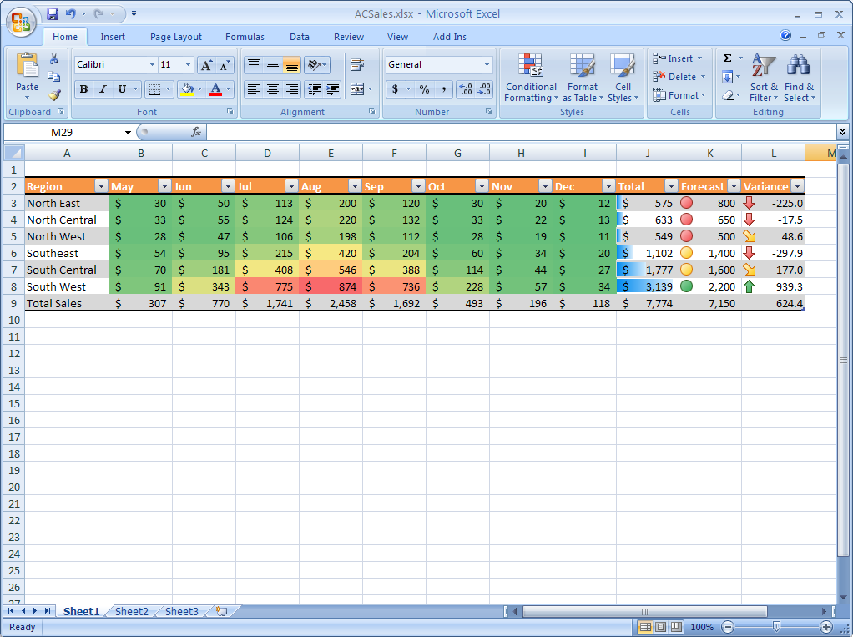

Figure 9: You can now discover and illustrate important trends and highlight exceptions   
in your data by using conditional formatting with rich visualization schemes in Office Excel 2007.

### Database Solution Templates in Office Access 2007

Office Access 2007 provides you with an improved startup experience that helps you start working with database solutions quickly—even if you have no previous experience in database schemas or programming languages. The new Getting Started screen includes a variety of prebuilt database applications. You can use these applications right out of the box—or you can treat them like templates and enhance and refine them to accommodate the kind of information you want to track and the way in which you want to track it.

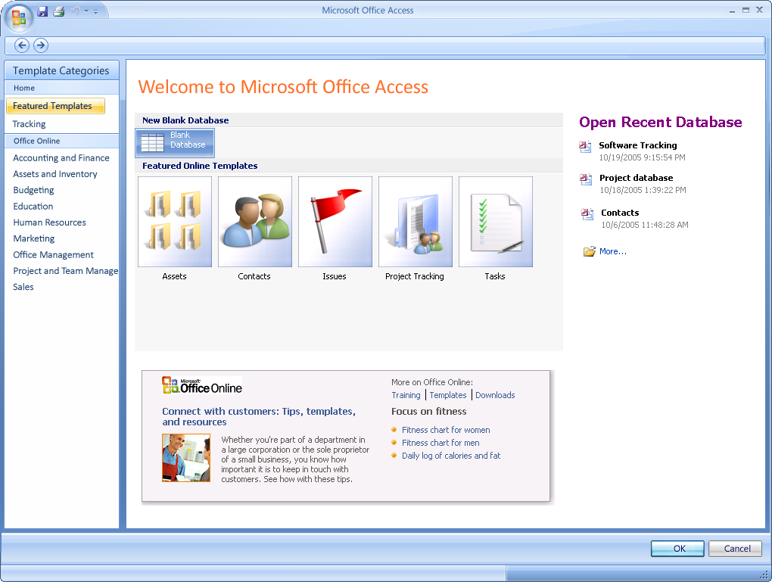

Figure 10: Office Access 2007 provides you with an improved startup experience that   
helps you start working with tracking applications quickly.

These predefined applications can help you track contacts, events, issues, assets, tasks, and more. Other application templates will be available over time, and you can then download them directly from Office Online. Many of the packaged applications share a common schema with SharePoint lists, providing a consistent experience when you transfer your application into a SharePoint Web site.

## Connect to Important Business Information

You cannot create and present your documents with confidence if you think that they may contain outdated or inaccurate information. Office Professional Plus 2007 helps you connect your documents to the latest corporate data sources, with powerful features including:

### Ecma Office Open XML Formats

Ecma Office Open XML Formats, included in the 2007 releases of Office Word, Office Excel, and Office PowerPoint, give you the ability to easily integrate data in your documents with back-end systems. This makes it easier to assemble documents and helps ensure that they include the most up-to-date and accurate information.

Because they use ZIP compression technologies, Office XML Formats have the added benefit of dramatically reducing file sizes. This reduces the disk space required to store files and decreases the bandwidth needed to send files by e-mail, over networks, and across the Internet. As a result, you can actively share your documents and collaborate more efficiently.

Segmented data storage within the file formats greatly aids the recovery of corrupt documents. This type of storage improves the ability to open files even if one part of the file is damaged, reducing the risk of lost information.

Office XML Formats are based on industry-standard XML and ZIP technologies and are available through a royalty-free license to any technology provider. They are designed for easy integration and compatibility—anyone using Microsoft Office XP or Microsoft Office 2003 can open, edit, and save documents in one of the Office XML Formats by installing a simple update.

### Data Binding in Office Word 2007

Because Office Word 2007 offers the ability to bind parts of a document to external information sources, it is now faster and easier to incorporate the right information without having to force people to use clumsy cut-and-paste methods. Too often, people add important business information to documents by using the cut-and-paste tools, resulting in documents that contain outdated, unmanaged information. This prevents people from sharing a single version of business information when circulating documents, which can result in expensive misunderstandings.

The new Data Binding feature in Office Word 2007 helps alleviate this issue by providing a way to build document templates that have live connections to external information sources. By “binding” document contents to XML sources, documents stay connected to important business information. When you use Data Binding with the new Word XML Formats, you can easily update the XML data store (stored within the Word file) to help ensure the content of the Word document is updated.

XML integration through Data Binding helps ensure organizations can build and deploy structured document templates that help users get the right information into their documents without troubling them with extensive searches in external applications.

### Data Connection Library in Office Excel 2007

Office Excel 2007 offers server-based control that helps ensure consistency across an organization’s spreadsheets by enabling automatic data refreshing and report delivery functionality.

With the Data Connection Library in Office Excel 2007, when you and your team need to access external data and import it into a spreadsheet, you no longer need to know the names of corporate data sources or call for help from IT. After your organization’s IT department has determined a set of common databases to which you need access, you can use the Data Connection Library to access these sources and import information directly into your spreadsheet—without having to provide password authentication.

In Office Excel 2007, the connections are exposed to simplify the process of creating a new external data object, such as a PivotTable® dynamic view or OLAP formula. A reference to the data connection file is added to the Office Excel 2007 spreadsheet. When the spreadsheet is executed in Excel Services, the server checks the connection in the library to see if it has been updated. If it has, the server updates the connection in the spreadsheet prior to refreshing the external data.

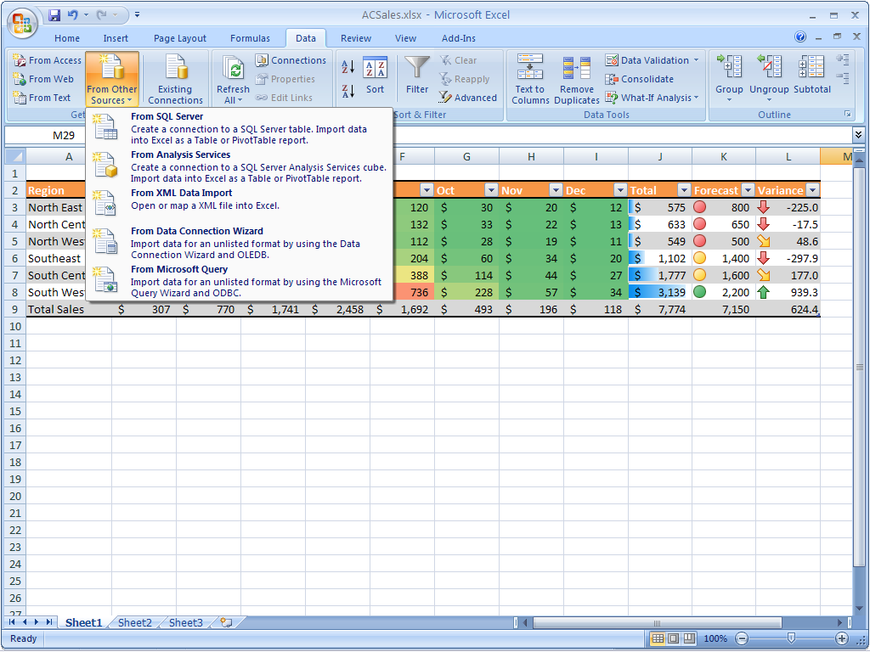

Figure 11: With the Data Connection Library in Office Excel 2007, you can easily access external data and import it into a spreadsheet—without the names of the corporate data sources or help from IT.

A Data Connection Library also simplifies the maintenance of data connections. If a connection changes, it needs only to be updated in the library instead of in the individual spreadsheets that are linked to the original data source.

# Streamline Processes and Control Content

Organizations everywhere are looking for better ways to control content and streamline their business processes. It is clear why this is a focus for organizations: Inefficient business processes, such as using e-mail for document review and revision, lead to increased costs and decreased employee effectiveness. And multiple processes for managing the production of documents and Web content can create inefficiencies that lead to errors and suboptimal organizational performance.

The increased pressure on organizations to comply with regulatory requirements complicates matters further. Many organizations lack the systems to support compliance efforts efficiently. Of course, protecting intellectual property while increasing the transparency of business activities is also a tricky balancing act for most organizations.

Office Professional Plus 2007 addresses these needs by integrating process and approval capabilities into familiar Microsoft Office system programs, making it easier to create and approve content. Advanced electronic forms technologies help organizations lower costs by streamlining everyday business processes. Finally, Office Professional Plus 2007 helps you centrally control access rights, making it easier to manage your organization’s valuable information assets.

## Simplify Data Collection

Gathering information from coworkers can be cumbersome, particularly if you are using e-mail to do so. Office Professional Plus 2007 streamlines data collection with new capabilities in Office InfoPath 2007, including:

### Electronic Forms Tools and Templates in Office InfoPath 2007

Unlike forms-only alternatives that lock users into a static document format with the data trapped inside, Office InfoPath 2007 helps people quickly build effective forms solutions that make data available in a wide range of business processes. If you need to build a new form, Office InfoPath 2007 provides the tools to build it quickly and easily. The WYSIWYG (what you see is what you get) form development environment and the drag-and-drop placement of form controls make it easy to lay out a form in a manner that is most comfortable and useful to the people who ultimately will complete the form. You can even build new forms by using prebuilt template parts residing in a forms library, which makes it easy for larger organizations to build forms consistently across the organization. Form developers can simply drag prebuilt parts into the new form.

### E-Mail Forms in Office InfoPath 2007

You can now use Office Outlook 2007 to send forms and collect data. The full integration of Office Outlook 2007 with Office InfoPath 2007 enables you to embed an Office InfoPath form within an e-mail message and send it to others with a request to fill out the needed information. The only action required by the recipient is to reply to your mail and complete the embedded form. After you have collected the respondents’ answers, you can export the data to Office Excel 2007 or Office Access 2007 for analysis or merge the answers from the form you sent into one master form.

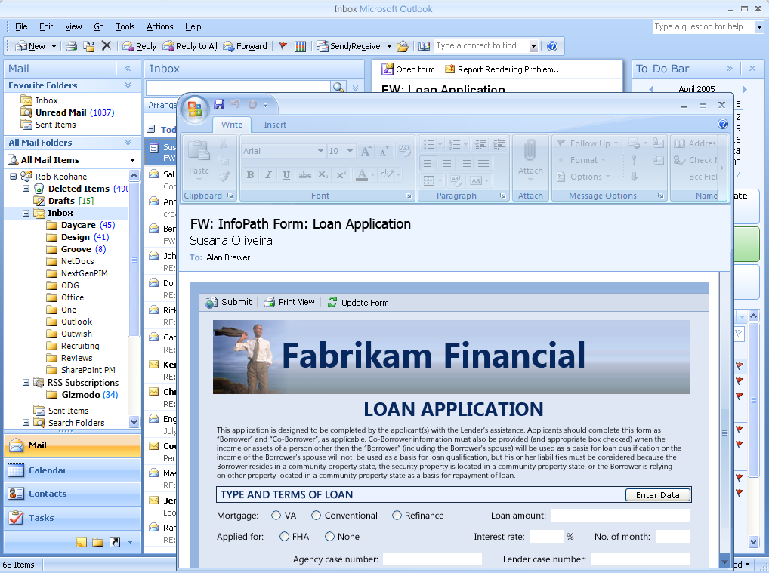

Figure 12: Office InfoPath 2007 and Office Outlook 2007 help you complete forms without leaving the familiar Office Outlook environment so you can complete your forms quickly and efficiently.

## Streamline Business Processes

Managing documents throughout their life cycle used to be time-consuming due to inefficient business processes. With its integration with new Office SharePoint Server 2007, Office Professional Plus 2007 helps you streamline processes and simplify content creation, reviews, and approvals:

### Simplified Review and Approval Workflows

Managing the review and approval cycle often can be frustrating and time-consuming. In the past, you probably sent an e-mail message with an attachment to everyone who needed to review a document. Then you had to track down who had submitted their reviews and who had not responded. And finally, you had to save all the review documents in one place.

Office Professional Plus 2007 is designed to work with Office SharePoint Server 2007, so you can take advantage of the review and approval workflow directly from within the authoring applications. This feature reduces cycle times for important document processes. To initiate a document review workflow, simply load the document into a document library directly from the Office Professional Plus 2007 application. Document libraries are preconfigured to initiate and manage the review process. Reviewers are automatically sent an e-mail message to notify them of the review. When they finish reviewing, they post their documents in the document library where they are readily accessible.

### Streamlined Deployment of Electronic Forms

With Office InfoPath 2007 and the InfoPath Forms Services capabilities of Office SharePoint Server 2007, you can administer and deploy your business forms beyond the corporate firewall. InfoPath Forms Services can render Office InfoPath form templates as browser-based forms that do not require a local installation of Office InfoPath. In fact, browser forms offered by InfoPath Forms Services require no software download whatsoever. Your external users gain the benefits you have built into your Office InfoPath forms—including data validation, calculations, and repeating and optional sections—without having to wait for program updates or lengthy downloads. To help ensure the broadest possible reach, your external users can complete Web-enabled Office InfoPath forms by using Microsoft Internet Explorer®, Safari, Netscape Navigator, and Mozilla Firefox browsers.

## Manage Content with Office SharePoint Server 2007

Companies are increasingly challenged by compliance regulations. Although many have started using electronic business and document-management processes, it can be difficult to start managing and auditing electronic business records.

When a document has been completed and is ready to be shared, you need to be confident that it is not inadvertently shared with people who should not see it. You should also be confident that your work does not include unintentional content or editing marks. Furthermore, you should be able to restrict access to potentially sensitive content within your documents. Finally, you may also need to indicate that your document is the document of record that indicates an official company policy or procedure for a given topic.

Using Office Professional Plus 2007, Office SharePoint Server 2007, and Windows Rights Management Services, there are many more ways to help protect and manage your information.

### Information Rights Management

You may need to protect and control access of company information, especially if you are creating documents with confidential information. By using Office Professional Plus 2007 with the Windows Rights Management Services of Microsoft Windows Server® 2003, you can assign permissions that prevent others from copying, printing, or editing your document.

### Records Management

Office SharePoint Server 2007 provides a managed document repository built on Windows SharePoint Services to store the document record, or the master document, in a Records Repository. You can upload your work to this repository directly from Office Professional Plus 2007. This ability provides a way for people to publish documents without having to resort to an external tool or Web browser interface.

### Information Management Policies

When using Office SharePoint Server 2007, you can apply information management policies that consistently enforce the labeling, auditing, and expiration of documents. You can configure policies for a specific storage location or content type. For example, organizations can help ensure that all documents are stored the same way by setting the expiration dates on common criteria, such as the end of the fiscal year.

Office SharePoint Server 2007 supports a set of information management policies that can be defined for an entire site or a specific list, library, or content type. You can also create a policy statement informing users how the content is governed. For documents, this policy statement is embedded in the document. For instance, the policy statement might indicate that a document expires after a certain period of time or that it is sensitive information that should not be communicated outside the company. It can even provide a contact name if the recipient needs more information.

### Keeping Your Content Safer with Office SharePoint Server 2007

It can be extremely challenging to implement consistent information management policies across an organization that has a wide range of sites. To solve this issue, Office SharePoint Server 2007 makes it possible for policy decision-makers—such as IT staff, records managers, or compliance officers—to define site policies that users can apply without worrying about the specific details. Each site policy can include any number of settings, like labeling expiration or auditing. As a result, you can add an extra layer of security to your documents by designating access to them. For example, if you only want to give a certain department access to documents, you can easily set up the document to require the correct credentials.

# Help and Office Online Services

## Online Help and Training

Office Professional Plus 2007 offers smooth integration with Microsoft Office Online Web services. More powerful and with a sophisticated online interface, these services are available from within Office Professional Plus 2007 programs. The Office Online Web site, also available through a browser at [office.microsoft.com](http://office.microsoft.com), has home pages for each Office Professional Plus 2007 program where you can find product information, Help and how-to articles, training courses, templates, and more.

### Help

Help in Office Professional Plus 2007 has been extended beyond your computer. If you are connected to the Internet when searching in the program for a Help topic, you see not only information from the local system, but also from the Office Online Web site. This provides you with the most current information on the topic you need help with and quick access to additional resources online.

### Assistance on Office Online

The Assistance site is your one-stop online resource for Help articles, video demos, columns, and tips for everyday tasks. You can find answers to common questions, learn about features in Office Professional Plus 2007, look for specific help in newsgroups, and suggest topics for future articles.

### Training on Office Online

The Training site offers Web-based interactive training courses and self-paced exercises with which you can develop deeper knowledge of tasks and program features, such as creating an outline in Office Word or by using motion paths in PowerPoint slides. Additional courses can help you make the transition to the Office Fluent user interface in Office Professional Plus 2007. All courses include practice sessions in the actual program and short tests to assess comprehension.

## Downloads Web Site

The Downloads Web site on Office Online offers a variety of updates, converters, viewers, publications, and other useful downloads for Microsoft Office system programs. On the Downloads home page, you can check for free updates that improve the stability, security, and performance of the 2007 Microsoft Office system. Simply click the Check for Updates button to start the automatic detection tool, which scans your computer and then returns a list of downloads that are available and compatible with your release of the Microsoft Office system. Or you can search or browse for other downloads, such as add-ins and stationery, in the downloads catalog.

## Templates on Office Online

Templates help optimize productivity by providing timesaving document templates for simple and complex tasks. The Templates site offers thousands of templates to choose from—for business use and for fun.

It is now easier than ever to find the perfect template thanks to the improved connection between many Office Professional Plus 2007 programs and the Templates home page on Office Online. With an active Internet connection, the redesigned File/New dialog box for those programs helps you browse online templates as easily as if they were on your computer. The available templates are organized into logical categories for easy browsing.

When you select a template to view, you can see the size of the template, approximate download time, and any additional system requirements that are necessary (if applicable). With one click, you can download and open the template in the appropriate Office Professional Plus 2007 program.

You can provide feedback, make suggestions for new templates, or opt to receive a newsletter on the Templates site. Another great Templates feature is the ability for Microsoft Office system users around the world to publish their own templates on Office Online. These customer-submitted templates are an excellent resource for users and a way to share expertise with the millions of people who use Word, Excel, PowerPoint, and OneNote.

## Clip Art and Media Web Site

The Clip Art and Media Web site offers more than 150,000 high-quality images and media selections to brighten up documents. All clips and media are arranged in categories for quick and easy browsing. The Featured Collections section of the Web site offers specially selected categories. The Clip of the Day features a new image that has been added to our inventory that day. You can simply drag the clip of the day directly into a Microsoft Office system document.

To use clip art, you can either copy and paste an image from the site or select a file for download by adding it to your Selection Basket. All clip art selections are displayed in the basket, and you can view the total number of clips accumulated, file size, and approximate download time for each clip. You can download all of the clips in the Selection Basket at one time by clicking the Download Now button.

## Accessibility Features

Office Professional Plus 2007 provides new and improved features for accessibility:

* Keyboard shortcuts for using the Help Task Pane and Help window
* Keyboard shortcuts for using the Ask a Question box
* Options to change the appearance of a Help topic by altering the background or color

Specific to Office Word are keyboard shortcuts for customization options and tips for working more efficiently. For Office Access, developers and users who create and edit Microsoft SQL Server™ queries can control the font size of the text in the SQL Server window.

For more information about accessibility, go to <http://www.microsoft.com/enable>.

# Deployment and Migration

Microsoft has heard customer concerns about evolving security threats, privacy, and the difficulty implementing software updates and patches. We have made significant investments to address these issues in Office Professional Plus 2007.

Microsoft has changed how it builds software, and the results are significant. New processes are aimed at helping ensure that Microsoft software has enhanced security before it ships and that settings are as secure as possible by default when software is installed. Microsoft is investing in simpler, more consistent patch deployment for IT teams. On an ongoing basis, Microsoft also makes valuable quality improvements to both application code and online help content by using real-time feedback technologies incorporated into all Office Professional Plus 2007 programs.

For IT professionals, Microsoft is also making the experience of patching easier and the entire process of upgrading to Office Professional Plus 2007 faster, less costly, and much more predictable.

## Microsoft Office Migration Management Technologies

To more effectively plan, build, and deploy an upgrade to Office Professional Plus 2007, desktop administrators will want to use Microsoft Office Migration Management Technologies. Expanded to support Office Professional Plus 2007, these tools, technologies, and end-to-end guidance can assist IT groups through all phases of the upgrade process. As a result, IT groups can dramatically reduce the cost of upgrading (especially compared to the costs the organization may have experienced if their last major software upgrade was five or six years ago).

IT professionals will also be able to reduce the time required to complete the upgrade, and they will find that structured guidance from Microsoft can remove many of the risks and uncertainties that were sometimes part of upgrading in the past. All Office Migration Management Technologies are available free of charge. Some of the technologies are designed into Office Professional Plus 2007. Other components are available through a free download at Office Online. Microsoft Office Migration Management Technologies include:

* Microsoft Office Migration Planning Manager
* Microsoft Office File Conversion Tool
* Microsoft Office Setup Controller
* Microsoft Office Customization Tool
* Microsoft Office Local Installation Source
* Microsoft Office Resource Kit

Together, these technologies make upgrades, migration, and deployment procedures easier.

### Microsoft Office Migration Planning Manager

The Microsoft Office Migration Planning Manager is a utility (a command-line scanner) that enables desktop administrators to scan any client computer, file server, SharePoint server, or any other WebDAV-enabled document library. The Office Migration Planning Manager inventories all Microsoft Office documents and determines their properties. Known issues are identified within those files so that they can be addressed before they are opened with, or converted to, Office Professional Plus 2007.

### Microsoft Office File Conversion Tool

In the process of upgrading to Office Professional Plus 2007, organizations may want to move all or many of their existing documents to the new Office XML Formats. The Office File Conversion Tool enables desktop administrators to convert documents saved in the Microsoft Office 97 to Microsoft Office 2003 Editions formats to the new Office XML Formats. By using output from the Office Migration Planning Manager, the Office File Conversion Tool can be employed to run documents through an open-and-save-as process.

### Microsoft Office Setup Controller

The Microsoft Office Setup Controller manages the overall Office Professional Plus 2007 installation experience. It is responsible for making sure the local installation source is present and complete. After checking that each computer has been properly prepared, the setup engine installs and configures the product being installed. Changes are made to both the file system and registry by using the underlying Microsoft Windows Installer technology. This helps ensure maximum compatibility and robustness for all users of the computer.

### Microsoft Office Customization Tool

The Microsoft Office Customization Tool is used to customize Microsoft Office system installations. It can customize any part of the Microsoft Office setup process, including initial customization and the modification of software products that are already installed. The Office Customization Tool enables administrators to customize things like the behavior of the Office Setup Controller, the Local Installation Source, and how the Windows Installer processes the Windows Installer packages used to deliver Microsoft Office system applications. The Office Customization Tool consolidates the multiple wizards and tools required in previous releases of the Microsoft Office system.

### Microsoft Office Local Installation Source

The Microsoft Office Local Installation Source provides a complete, but compressed, copy of the Microsoft Office system to be cached on the user’s computer. That way it is available for any activities that require media, such as install, resiliency, install on demand, patching, and so on. Office Local Installation Source also minimizes demand on an organization’s network in several ways: first, by sending a compressed copy of the Microsoft Office system over the network; and second, by enabling desktop administrators to separate distribution of the new Microsoft Office system source files from the actual installation process. First introduced with Microsoft Office 2003, Local Installation Source is today a required component of Office Professional Plus 2007.

### Microsoft Office Resource Kit

The Microsoft Office Resource Kit is the definitive source of information for planning, deploying, and supporting the Microsoft Office system. Updated to support Office Professional Plus 2007, the Office Resource Kit provides tools and complete step-by-step technical guidance for administrators, IT professionals, and support technicians. The Office Resource Kit is available online for free download and as a published volume for sale by Microsoft Press® retailers.

# What’s New for Developers

## Introduction

Although the Office Professional Plus 2007 client programs provide significant new out-of-the-box value to individuals and organizations, both as stand-alone programs and when used with Office SharePoint Server 2007 capabilities, the programmable extensibility of the Microsoft Office system client programs has also been expanded. Organizations have implemented custom solutions by using the client programs for many years that better help streamline business processes and improve the efficiency with which people work with corporate information. New capabilities make it easier for developers to build solutions that deliver organization-wide benefits with less investment.

## Client Solution Highlights

There have been many advances in the capabilities of the client programs that improve how organizations can build solutions. This list highlights a few of the new opportunities.

* **Microsoft Office Fluent user interface extensibility:** The Office Fluent user interface makes it easier for users to find and use commands. Likewise, organizations can extend the Office Fluent user interface to incorporate logical and visual software tools for users to execute custom commands within the context of working with Word documents, Excel spreadsheets, and PowerPoint presentations. The interface helps users find, understand, and initiate custom actions that are smoothly intermixed with Microsoft Office system commands.
* **New default file format:** Documents are becoming less about a physical sheet of paper and more about a software container for corporate information that gets compiled and reused in different ways. Increasingly, business systems create and consume documents as frequently as people do. The Ecma Office XML Formats introduced with Office Professional Plus 2007 facilitate this by storing document content in XML. XML helps organizations more easily manipulate Microsoft Office system document content by using their existing software on heterogeneous systems. Data can be more easily merged into documents from business systems and it creates new opportunities for streamlining the capture and use of information across organizations.
* **Integration with Microsoft Visual Studio:** A high level of productivity, enhanced security, and flexibility has led many developers to use Microsoft Visual Studio® development system tools for custom software development. Office Professional Plus 2007 introduces developer-focused capabilities that create new opportunities for custom solutions. With Office Professional Plus 2007, it is easier for developers to create add-on components, display a Task Pane panel of custom content within the Microsoft Office system client programs, and deploy and maintain custom solution code from server locations.
* **Integration with servers:** The new Office SharePoint Server 2007 provides critical infrastructure to facilitate collaboration and content management within enterprises. The integration between servers and the Office Professional Plus 2007 clients provides new opportunities for developers to define custom workflows for data and content, create document-handling processes, help users collaborate through portals and workspaces with custom reports, views, and tools, and connect users to information in any business system in an enterprise. (The server technologies are grounded in an ASP.NET infrastructure.)
* **Spreadsheets on servers:** Office Professional Plus 2007 is furthering solution possibilities around spreadsheets by providing a server capability for spreadsheets to be centrally managed and accessible by using a browser, the Office Excel client, or Web services. Solutions can be created to access spreadsheets for returning calculation results, spreadsheet views, and charts for custom needs.

# Program Features

## Office Word 2007

Office Word 2007 offers a range of features to help you get your work done more efficiently and more quickly. Office Word 2007 delivers the results-oriented Office Fluent user interface that presents the tools people need when they need them. The Office Fluent user interface adds new, easy-to-use quick formatting controls, mathematical equation editing, and predefined and customizable Building Blocks for adding commonly used content like citations, references, headers, and footers.

In addition, Office Word 2007 document templates can be structured and deployed across organizations to standardize document formats and can be used to connect and present information stored in back-end systems by using the new Data Binding capability.

To learn more, please see the Office Word 2007 product guide at [www.microsoft.com/office/word](http://www.microsoft.com/office/word).

**Key Features**

* **New! Add Building Blocks** of predefined content and reduce the errors associated with copying and pasting frequently used content.
* **New! Quick Styles** save you time by quickly formatting text and tables throughout your document.
* **New! Document Themes** apply the same colors, fonts, and effects to your documents for a consistent look.
* **New! SmartArt Diagrams and a new Charting engine** help youadd a professional look to documents. Shared diagramming and charting with Office Excel 2007 and Office PowerPoint 2007 help ensure a consistent look across your documents, spreadsheets, and presentations.
* **New!** **Compose and publish Web Logs (Blogs) directly from within** **Word** by using the familiar Word interface to create your blog posts complete with pictures, rich formatting, spelling checker, and more. Publish your blogs from Word to many common blog services including Microsoft Office SharePoint Server 2007, MSN Spaces, Blogger, TypePad, Community Server, and more.
* **New! The Equation Builder** helps you construct mathematical equations by using real mathematical symbols, prebuilt equations, and automatic formatting.
* **New! Live word count** keeps track of the number of words in your document as you type.
* **Improved!** **Typographic capabilities** offer improved bullets and numbering lists, numbered list styles, and new fonts designed to improve on-screen reading.
* **New! Citations and references** give you the ability to add references, footnotes, endnotes, table of contents, table of figures, or table of authorities. Format your reference automatically by selecting examples from predefined style guides, including AP, MLA, Chicago Manual of Style, and others.
* **New! Contextual Spelling Checker** helps you avoid common mistakes and misuse of similarly spelled words.
* **New! The tri-pane review** **panel** makes it easy to compare and combine two versions of a Word document, helping you detect the smallest changes when dealing with changes from reviewers.
* **New! Initiate an Office SharePoint Server 2007 review and approval workflow process** directly from Office Word 2007. You can simplify the document review and approval process across your organization by using familiar tools integrated with powerful server capabilities.
* **New! Save as Portable Document Format (PDF) or an XML Paper Specification (XPS) file[1]\*** option gives you the ability to share your documents with people who may not have Word.
* **New! The Document Inspector feature** helps you detect and remove unwanted comments, personally identifiable information, hidden text, or other information from the document so that private information stays that way.
* **Improved! Digital Signatures** can be added to a document to help others verify that content has not been changed since it was published. A new signature line can be added to prompt other Word users for their signature, or to provide a visible digital signature within your documents.
* **Improved! Reading Mode** offers you an immersive, full-screen reading experience that makes online reading easier, reducing the need to print. New navigation controls and typography display improvements make the reading experience better than ever.
* **New! Open XML Formats** give developers unprecedented access to the contents of your documents, enabling broad interoperability with a wide range of programs and solutions.
* **New! The Document Information Panel** helps you solve the problem of having users enter the correct metadata, by making it possible for you to link document properties to Windows SharePoint Services or other external data sources.
* **New! Document Controls** help you structure the document authoring process by requiring specific types of information or by adding sections of documents that may not be edited or reformatted.
* **Improved! Custom-defined schema** support of the Open XML Formats enables developers to host their own content within Word documents, by using their own custom XML vocabularies. Instead of expensive translations, custom XML content is hosted directly within the file.
* **Improved! Data Bindings** in Office Word 2007 provide developers with an easy way to link the contents of external data sources and custom-defined schemas to their Word documents.
* **New! Participate in Office SharePoint Server 2007 workflows without leaving Word** to make users more efficient when working in a managed environment. You can start workflows, interact with workflow tasks, or get information about your documents from the new Document Alert Bar.
* **New! Managed document repositories** can be accessed from within Office Word 2007, so you have greater control over document versions.
* **New!** **Information management policies** consistently enforce the labeling, auditing, and expiration of documents stored in Office SharePoint Server 2007 managed document repositories.

## Office Excel 2007

Office Excel 2007 offers a range of capabilities that help you analyze, communicate, share, and manage information to make more informed decisions. With the results-oriented Office Fluent interface, you have access to relevant tools when you need them most. With PivotTable dynamic views that are much easier to assemble, Office Excel 2007 delivers powerful tools to help you organize and understand business data.

You can also discern key trends at a glance by applying conditional formatting that helps you visualize your business performance in a graphically rich way. Summarize your analysis in professional-looking charts by using intuitive galleries. Publish spreadsheets to Office SharePoint Server 2007 to share and manage sensitive business information with greater confidence and control.

To learn more, please see the Office Excel 2007 product guide at [www.microsoft.com/office/excel](http://www.microsoft.com/office/excel).

**Key Features**

* **New! Increased spreadsheet row and column capacity** of one million rows by 16,000 columns provides the ability to import and work with massive amounts of data.
* **New! Achieve faster calculation performance** in large, formula-intensive spreadsheets with support for dual processors and multithreaded chipsets.
* **Improved! Support for working with tables of data** helps you create and format a table with a rich table styles gallery. Column headings remain in view as you scroll, and autofill populates and expands any table automatically.
* **New! Fast formatting with Cell Styles** helps you assemble a great-looking report faster, with fewer clicks.
* **Improved! Formula authoring experience** includes a resizable formula bar and context-based Formula AutoComplete so that you can write the proper formula syntax the first time, every time. You can also refer to named ranges and tables within formulas and functions.
* **New! Conditional formatting with rich data visualization schemes** helps you set conditions more easily to discover trends or patterns in your information.
* **Improved! Sorting and filtering** helps you find the information you need quickly and easily. Office Excel 2007 supports up to 64 levels to sort data, including the ability to sort by color.
* **Improved! Create a PivotTable or PivotChart® dynamic view** more easilyby using data fields to reorient data quickly and find the answers you need.
* **New! Full support for Microsoft SQL Server 2005 Analysis Services** helps you query your most current business data by using the flexibility of Office Excel 2007.
* **New! Chart Formatting tools** help you create and format professional-looking charts with greater ease, using fewer clicks.
* **New! Use dramatic visual effects in charts** such as 3-D, soft shadowing, antialiasing, and glow.
* **New! Shared diagramming and charting** with Office Word 2007 and Office PowerPoint 2007 help ensure a consistent look across your spreadsheets, documents, and presentations.
* **New! Edit headers and footers easily** with the new Page Layout View that displays headers and footers in plain view.
* **Improved! A better printing experience** helps ensure that what you see on screen is what you will get in printed output.
* **Improved! Customization with Microsoft Office Art**, predefined styles, and integrated graphics makes it possible for you to apply a consistent, professional look to your spreadsheets that can easily be placed in other Microsoft Office system documents.
* **New! Support for PDF and XPS** file formats enables you to convert your spreadsheets into a fixed file format for easier sharing.
* **New! The Data Connection Library** enables you to import external data into a spreadsheet by using preconfigured external sources of business information.
* **New! Publish to Office SharePoint Server 2007** to prevent the spread of multiple copies of business-critical spreadsheets throughout your organization, help protect sensitive business information, and help ensure people are working with the most current data. The specific capabilities are:
  + **New! Dynamically render a spreadsheet in HTML** and then enable others to view only the parts of a spreadsheet you want them to see by using their Web browser.
  + **New! High fidelity between the Office Excel 2007 client and spreadsheets** that are rendered by using Excel Services enables you to navigate, sort, filter, and interact with tables or PivotTable dynamic views from a Web browser.
  + **New! Business dashboards can be easily created from spreadsheets** to track key performance indicators (KPIs), and then you can share these broadly through a Web browser.
  + **New! Excel Services Application Programming Interface (API)** enables developers to use the powerful Office Excel 2007 calculation engine in other applications, such as a Web-based mortgage calculator or an options pricing model.
  + **New! Report management features** help protect confidential business information while helping to ensure people can view the data they need.
  + **New! Permissions-based control** enables you to manage who can access, view, and make changes to spreadsheets stored on the server.

## Office PowerPoint 2007

Office PowerPoint 2007 provides many enhancements and new capabilities over previous versions. With an emphasis on more professional presentations that are easier to create, Office PowerPoint 2007 puts the power of design into your hands. The result is that you can create more effective, professional-looking presentations more quickly and easily.

Office PowerPoint 2007 helps you share and reuse information so that you do not waste time re-creating presentations or working with information that is out of date. With Office PowerPoint 2007, you get the tools you need to easily format and create high-impact presentations. As a result, it is easier for you—and everyone in your company—to create professional-looking presentations more quickly.

To learn more, please see the Office PowerPoint 2007 product guide at [www.microsoft.com/office/powerpoint](http://www.microsoft.com/office/powerpoint).

**Key Features**

* **New! Custom layouts** help you quickly create precisely the layout you envision without being confined to one of the prepackaged standard layouts.
* **New! Graphics and other shape effects** give you the ability to add 3-D, glow, shadowing, and other powerful visuals to your presentation elements.
* **New! SmartArt diagram tools** help you create professional diagrams and flow models.
* **New! Rich text and typography effects** boost the impact of your design.
* **New! Office PowerPoint Themes** apply a consistent look to every graphic, font, and table color in a PowerPoint presentation with a single click.
* **New! Office Themes** help ensure a consistent appearance when you create Word documents, Excel spreadsheets, and PowerPoint presentations.
* **New! PowerPoint Slide Libraries** give you the ability to publish and share slides and layouts while easily accessing content from other presentations.
* **New! PowerPoint XML Formats** make documents more compact, so you can share presentations more effectively.
* **New! Save as PDF or XPS functionality** helps you share your presentations with customers or clients on other platforms.
* **New! Initiate and simplify the review and approval workflow process** directly from Office PowerPoint 2007 by using Office SharePoint Server 2007.
* **New! Managed document repositories** can be accessed from within Office PowerPoint 2007, so you have greater control over presentation versions.
* **New! Digital Signatures** enable you to apply a digital signature to PowerPoint presentations, so others can verify that the content has not changed since it was published.
* **New! Document Inspector** helps ensure private data stays that way by helping you detect and remove unwanted comments, personal information, and hidden text.

## Office Outlook 2007

Office Outlook 2007 provides you with a comprehensive time and information manager. Using new features such as Instant Search and the To-Do Bar, you can organize and quickly locate the information you need. New calendar sharing capabilities, Microsoft Exchange Server 2007 technology, and improved access to Windows SharePoint Services information help you share data stored in Office Outlook 2007 with coworkers, friends, and family, no matter where they are located. Office Outlook 2007 makes it easier for you to prioritize and control your time so you can focus on the things that matter most.

To learn more, please see the Office Outlook 2007 product guide at [www.microsoft.com/office/outlook](http://www.microsoft.com/office/outlook).

**Key Features**

* **New! Instant Search** helps you search through all of your e-mail, e-mail attachments, calendars, contacts, and tasks, so you can find the information you need much faster.
* **New! The To-Do Bar** gives you a consolidated view of your daily priorities by integrating tasks, e-mails flagged for follow-up, upcoming appointments, and calendar information in one convenient place.
* **New! Color Categories** give you the ability to create and assign customized categories to any type of information, helping you organize and quickly search your information and visually distinguish items from one another.
* **New! Flagging e-mail as tasks** makes it possible for you to create tasks from e-mail in one simple step.
* **New! Task integration on the calendar** provides an interactive way to work with your tasks and flagged e-mail by dragging them onto your calendar to schedule time to complete them.
* **New! Attachment Preview** shows you previews of attachments in the reading pane, giving you quick insight into e-mail attachments and speeding decision-making.
* **Improved! Scheduling capabilities** make scheduling meetings for large groups using Microsoft Exchange Server 2007 easier by suggesting ideal meeting times and locations.
* **Improved! Integration with Windows SharePoint Services information** provides a way for you to connect to documents, calendars, contacts, or tasks stored on SharePoint sites, and have full editing capabilities whether you are online or offline.
* **New! Calendar publishing through Office Online** helps you easily post and share your calendar information.
* **New! Calendar Snapshots** provide an easy and visual way to share calendar information with people outside of your organization.
* **New! Calendar overlay mode** gives you a way to view and navigate multiple calendars simultaneously.
* **New! RSS feed integration** enables RSS subscriptions to be delivered directly to your inbox.
* **New! Electronic Business Cards** provide an easy way for you to customize your contact information, making contacts more personally relevant and easier to locate.
* **New! Auto Account Setup** gives Office Outlook 2007 the tools to easily set up your Exchange Server, POP, and IMAP e-mail accounts by using only your e-mail address and password.
* **New! Integration with Office InfoPath 2007** enables you to embed an Office InfoPath form within an e-mail message to gather information, and then export it to an Excel spreadsheet for analysis.
* **New! Sharing requests** make it easy for you to share your information by giving permissions to Outlook folders to anyone using Exchange Server 2007.
* **Improved! Out-of-office capabilities** using Exchange Server 2007 make it possible for you to schedule your auto-response messages for a specified date and time, and send different messages to internal and external contacts.
* **New! Unified messaging using Exchange Server 2007** enables Office Outlook 2007 to understand message types of all kinds, so you can have voice mail and faxes delivered along with e-mail to your inbox.
* **New! Office Outlook E-Mail Postmark** helps ensure that e-mail reaching your inbox is legitimate and that e-mails sent by Office Outlook 2007 are trusted by the recipient’s computer.
* **New and improved! Anti-phishing and junk e-mail technologies** help prevent both junk and malicious e-mail messages from entering your inbox.
* **New! Managed Folders**, used with Exchange Server 2007, help companies enforce e-mail retention, storage, and archival policies on workers’ mailboxes, including ways to designate other users’ access to these folders.
* **Improved! Information rights management (IRM)**, integrated in all 2007 Microsoft Office system programs, helps you protect your company’s confidential business information when you send e-mail messages or documents to others.
* **Improved! Free/Busy information management**, used with Exchange Server 2007, helps you to determine and set a variety of levels as to who can view your free/busy information, keeping you in control of your personal data.

## Office Access 2007

Office Access 2007 empowers you to create and edit database solutions quickly and easily, even if you do not possess deep database development knowledge. It makes it easy to start a new project by offering a library of prebuilt database applications (templates) that support a wide range of common tracking requirements. An improved interface and interactive design capabilities eliminate the need for deep database knowledge. At the same time, Office Access 2007 makes it easy to modify a template and create new fields and tables—so you can adapt your application templates to meet your changing business needs.

To learn more, please see the Office Access 2007 product guide at [www.microsoft.com/office/access](http://www.microsoft.com/office/access).

**Key Features**

* **New! Getting Started** experience offers a library of prebuilt database solutions.
* **Improved! Field insertion** in a table is as simple as typing a value in a new column in a datasheet.
* **Improved! Data transfer capabilities** enable you to paste an Excel spreadsheet into a new Access table for easy data transfer.
* **New! Automatic data type detection in tables** improves schema and table creation.
* **New! Attaching external documents and files** to individual records in the data store helps you incorporate even more information into your applications.
* **Improved! Importing and exporting information** is easier than ever. You can even save frequently used import and export operations for quick reuse.
* **New! The Navigation Pane** provides easy access to all object types, including tables, forms, and reports.
* **New! Tabbed document window viewing** displays all open objects in the same window for easier navigation.
* **New! Interactive form design capabilities** provide a WYSIWYG experience. You can modify form layout while seeing the results of your changes in real time.
* **New! Integration with Office Outlook 2007** enables you to use e-mail to collect or update data in an Access table.
* **New! Automatically generate an InfoPath or HTML form** based on the fields in an Access table.
* **Improved! Automatic or manual data imports** improve data collection for your tracking.
* **New! Close integration with Windows SharePoint Services** makes it possible for you to move your application to a SharePoint list where your coworkers can access, edit, or add information and view reports.
* **Improved! Rich reports** can be created with one click.
* **New! Interactive design capabilities** help you to edit your reports in a true WYSIWYG experience:
* **Filter and sort** information more easily.
* **Use grouping** capabilities to organize information in one or more layers and add subtotals.
* **Add totals and counts** quickly and easily to any report.
* **Drag-and-drop editing** helps you add new fields to a report by dragging the field to the desired position from the field list pane.
* **Improved! Title and graphics support** enables you to place titles and graphics directly in the report layout and see your changes quickly.
* **Improved! Instant text search** helps you find information quickly.
* **Improved! PivotTable dynamic views and chart support** give you the ability to analyze across data collections.
* **New! One-click moving** to a SharePoint Web site.
* **New! Revision history** is available within Office Access 2007 and within SharePoint lists.
* **New! Recycle Bin for deleted data** helps you to recover erroneously deleted data.
* **New! Server-side backup** helps you maintain the integrity of your tracking applications.

## Office InfoPath 2007

Office InfoPath 2007 helps you and your organization gather information more efficiently and effectively than ever. It provides you with the tools you need to create and deploy effective business forms solutions. Office InfoPath 2007 also gives form developers at any skill level the ability to build efficiency and reliability into their data-gathering processes. In concert with InfoPath Forms Services, it can extend your business processes to virtually any user, anywhere—improving collaboration and decision-making to positively impact your business.

To learn more, please see the Office InfoPath 2007 product guide at [www.microsoft.com/office/infopath](http://www.microsoft.com/office/infopath).

**Key Features**

* **New! Convert Word documents and Excel spreadsheets** to InfoPath forms and build structure into your data collection processes.
* **New! Create PDF or XPS records** of your form data. Office InfoPath 2007 enables you to create a PDF or XPS version of your completed InfoPath form for archival and records management.
* **New! Build forms by using predefined parts.** Office InfoPath 2007 helps the form builders in your organization build forms quickly and consistently, by using a simple drag-and-drop interface and prebuilt template parts that can include sophisticated data connectivity features.
* **New! Gather information by using e-mail messages from Office Outlook 2007.** Office InfoPath 2007 enables you to complete forms without leaving the familiar Outlook environment, helping you complete your forms quickly and efficiently.
* **New! Complete InfoPath forms by using Web browsers and mobile devices.** Office InfoPath 2007 and InfoPath Forms Services make it easy to extend InfoPath solutions beyond your firewall by enabling forms to be completed by using many different Web browsers and mobile devices. Supported browsers include Internet Explorer, Mozilla Firefox, and Safari.
* **New! Design a single form for multiple client environments**, including the InfoPath client, the Web, and mobile devices—by using a real-time design checker to help ensure compatibility.
* **New! Automate business processes** by integrating InfoPath forms with Office SharePoint Server 2007 workflow capabilities.
* **New! Add information rights management** to InfoPath forms to help protect the content in your form templates from unwanted use or distribution.
* **New! Examine the dependencies in your forms** in an organized way by using the Logic Inspector.
* **Improved! Extend Office InfoPath 2007 solutions** through integration with the Visual Studio 2005 development system.

## Office Publisher 2007

In today’s competitive business environment, keeping in touch with existing clients and reaching prospective clients is essential to staying in business. Creating communication materials quickly and efficiently in-house makes this easier.

Office Publisher 2007 brings together all the tools you need for efficient and effective marketing from concept to delivery, including capabilities to guide you through the process of creating a wide range of marketing materials, building your brand, managing client lists, and tracking your marketing campaigns—all in-house.

To learn more, please see the Office Publisher 2007 product guide at [www.microsoft.com/office/publisher](http://www.microsoft.com/office/publisher).

**Key Features**

* **Improved!** Choose from a library of hundreds of professionally designed templates. Office Publisher 2007 includes dozens of new templates for popular print, e-mail, and Web publication types such as brochures, postcards, flyers, e-mail newsletters, Web sites, and more.
* **New!** Locate, preview, and open Publisher templates from the Office Online Template Gallery within Office Publisher 2007.
* **Improved!** Easily categorize, preview, open, and save your newly created publication templates within My Templates.
* **New!** Apply elements from your brand identity (including colors, fonts, logos, and business information) to all Publisher templates before you start creating your material for a more relevant Getting Started experience.
* **New!** Publisher Tasks assist you with common Publisher procedures for creating, publishing, and distribution. Turn to Publisher Tasks for help in adding text and images, changing the design, sending your publications as e-mail messages, and compiling your mailing list. Publisher Tasks even offer tips for effective writing.
* **Improved!** Create a Business Information Set that includes your company name, contact information, and logo. If your business has different brand identities for different departments or product lines, you can use Publisher to create an unlimited number of business information sets to apply to your publications.
* **Improved!** Quickly build custom collateral such as a datasheet, directory, or catalog for distribution to a targeted client or client segment by using Catalog Merge. The improved Catalog Merge Wizard guides you through the process of merging text and photos from a database to create your publication.
* **Improved!** Choose from more than 100 new blank page sizes when you start creating a publication from scratch, including postcards, booklets, and more.
* **Improved!** Desktop publishing features enable you to further customize your publications by using the Publisher collection of intuitive design, layout, and typography tools such as tracking and kerning, multiple master pages, baseline alignment, and more.
* **Improved!** Design checker helps you identify and correct any common desktop, commercial print, Web, or e-mail problems before you print or distribute.
* **New!** Publish your Publisher files as PDF or XPS for easy sharing and printing. Set options for online viewing, high-quality printing, or commercial press–ready printing.
* **New!** Save your publication as a PDF file for online viewing, sharing, and printing. The press-ready PDF option and Pack and Go improvements make it easier than ever to print Publisher files at commercial printers.
* **New!** Apply an e-mail template to multipage publications—a newsletter, for example—and distribute them as an e-mail message. You can add bookmarks to help readers quickly browse the e-mail message.
* **Improved!** The robust e-mail capabilities of Office Publisher 2007 mean your customers can receive e-mail publications that look exactly as you sent them, regardless of their e-mail program.
* **Improved!** Use Office Outlook 2007 or Outlook Express 6.0 or later to e-mail your Publisher files as PDF or XPS attachments.
* **Improved!** Full commercial printing support for larger quantities and higher-quality printing makes it easier to take your publications to commercial printers. Office Publisher 2007 includes four-color process and spot color printing support, CMYK composite PostScript support, and professional commercial printing tools. An improved Pack and Go Wizard bundles your Publisher files and associated graphics and fonts, as well as a new press-ready PDF file, for transport to a commercial printer.
* **Improved!** The Convert to Web Publication feature gives you the ability to convert print publications for viewing on the Web. Office Publisher 2007 makes it easy to add additional pages, hyperlinks, and a customizable navigation bar, as well as to edit, update, and post your publication for online viewing.
* **New!** Create personalized e-mail publications by using the new E-Mail Merge. You can now add bookmarks to help readers navigate through an e-mail newsletter, or add personalized hyperlinks to direct users to more information online.
* **New!** Create, manage, and store a single-client list or data list in Office Publisher 2007 by combining and editing lists from multiple sources, including Excel, Outlook, Office Outlook 2007 with Business Contact Manager, Access, and more.
* **New!** Use targeted lists from Office Outlook 2007 with Business Contact Manager. You can identify a target set of clients within Office Outlook 2007 with Business Contact Manager, save this filter list to an Outlook folder, and access this list from within Publisher to create and distribute targeted, personalized marketing materials.
* **New!** Publisher Tasks assist you with common Office Publisher 2007 procedures for creating, publishing, and distribution. Turn to Publisher Tasks for help in personalizing your publication, preparing your mailing lists, preparing your publication for commercial printing, publishing and distributing your material, and tracking your marketing effectiveness.
* **New!** Initiate and manage Office Publisher 2007 marketing campaigns from within Office Outlook 2007 with Business Contact Manager.
* **New!** Measure the effectiveness of your marketing campaigns. Improved Office Publisher 2007 integration with Office Outlook 2007 with Business Contact Manager (available only in Microsoft Office Small Business 2007 and Office Professional Plus 2007) provides new tools that help you easily track marketing materials you send and the responses you receive. For example, you can add tracking codes to your Office Publisher materials and track client responses in Office Outlook 2007 with Business Contact Manager.
* **Improved!** Manage broad e-mail campaigns with Office Publisher 2007 and Microsoft List Builder, a powerful fee-based e-mail marketing tool that can help you run an e-mail marketing campaign. List Builder processes opt-out responses and tracks client responses. For more information about Microsoft List Builder, go to [www.microsoft.com/smallbusiness/online/email-marketing/list-builder/detail.mspx](http://www.microsoft.com/smallbusiness/online/email-marketing/list-builder/detail.mspx).

## Office Communicator 2007

Office Communicator 2007 is now part of the Office Professional Plus 2007 suite. Office Communicator 2007 helps people be more productive by enabling them to easily communicate with others in different locations or time zones, with a range of different communication options, including instant messaging (IM), phone, and voice conferencing, video conferencing, or Web conferencing. Integration with 2007 Microsoft Office system programs—Outlook, Word, Excel, PowerPoint, and Office SharePoint Server—gives teams quick access to a full set of collaboration tools.

# Summary

Microsoft Office Professional Plus 2007 is designed to take you and your organization to new levels of productivity and performance. With the Office Fluent user interface, Office Professional Plus 2007 makes it easy to find the tools you need, so you can work more efficiently and produce your best results. Innovative new tools throughout the Microsoft Office system programs give you powerful new ways to work with information and manage your time more productively.

Office Professional Plus 2007 programs also help to simplify the way you share information and work with others, even those outside your organization. Improved integration with Windows SharePoint Services technologies and enhanced capabilities in Office Professional Plus 2007 programs give you new ways to coordinate and collaborate on everything from schedules to document reviews. New Ecma Office Open XML Formats make it easier by providing a compact, robust format that can be more easily shared with anyone on any platform.

Office XML Formats also provide a powerful way to integrate data in your documents with back-end systems. And this increased ability to connect you to the business data you need is a key focus for the new Microsoft Office system. Office Professional Plus 2007 programs are designed to give you quick access to key information, plus the tools to analyze that data and derive more value from it across the enterprise.

With new Office SharePoint Server 2007, Office Professional Plus 2007 helps organizations lower the costs they incur from inefficient business processes. With its built-in workflows and forms-based automation technologies, Office SharePoint Server 2007 helps you efficiently collect information from others and streamline processes you follow to complete common tasks. In particular, Office Professional Plus 2007 gives you the tools to manage content throughout its life cycle and to better protect your organization’s critical information assets.

# Resources

For more information about Office Professional Plus 2007, please visit [www.microsoft.com/office/suites/professionalplus](http://www.microsoft.com/office/suites/professionalplus).

# System Requirements

For complete system requirements, visit [www.microsoft.com/office/suites/professionalplus](http://www.microsoft.com/office/suites/professionalplus).

This document is for informational purposes only. MICROSOFT MAKES NO WARRANTIES, EXPRESS OR IMPLIED, IN THIS DOCUMENT.

© 2006 Microsoft Corporation. All rights reserved.

Microsoft, Excel, InfoPath, Internet Explorer, Microsoft Press, the Office logo, OneNote, Outlook, PivotChart, PivotTable, PowerPoint, SharePoint, Visual Studio, Windows, Windows Live, SmartArt, Fluent, and Windows Server are either registered trademarks or trademarks of Microsoft Corporation in the United States and/or other countries. All other trademarks are property of their respective owners.

1. * You can save as a PDF or XPS file from a 2007 Microsoft Office system program only after you install an add-in. For more information, see [Install and use a PDF or XPS add-in](http://r.office.microsoft.com/r/rlidOOPDFXPSAddin?clid=1033).