How to Add Contacts in Other Organizations
Using Live Communications Server 2005
Live Communications Server 2005 and Windows Messenger 5 allow you to use instant messaging and presence awareness in a secure environment, all integrated with the Microsoft Office system. Now with LCS 2005, this secured environment can be extended to other companies that use LCS 2005, such as your customers, partners and suppliers, through federation. Federation is a feature that creates a trusted connection between your organization’s Live Communications Server 2005 environment and another organization’s Live Communications Server 2005 environment. This federation connection allows you to add people from another organization to your contacts list so that you can see their presence information and send and receive instant messages.
.
To add a contact from another
organization, please follow these steps:

- Once you are logged into Windows Messenger 5, click on Tools, then select Add a Contact.
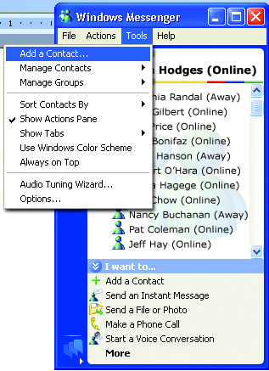

- A new dialog box will open; select by email address or sign-in name and click Next.

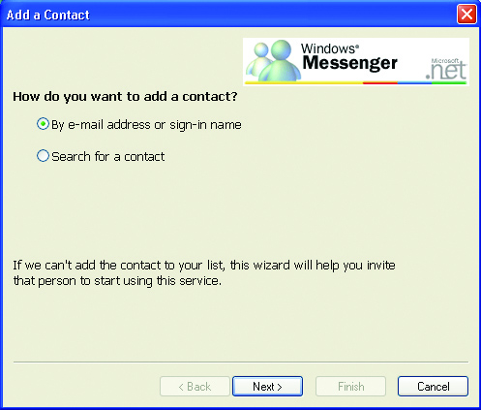

- Make sure “SIP Communications Service”
is selected. Then type your contact’s
IM address in the space provided and
click Next.

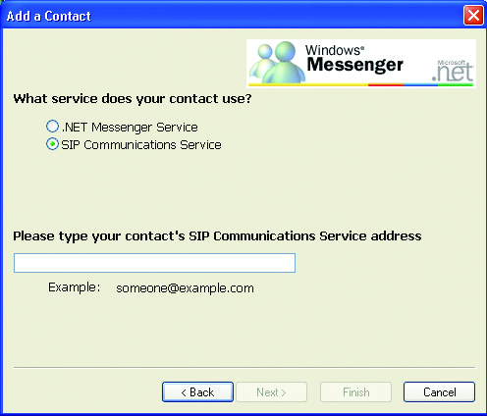

- When the contact has been added, you will
see a message indicating success, and will
be prompted to add the contact to one of your groups. If you get an error message, check
the IM address and spelling, and ensure
that you are not on the person’s Blocked Senders list. If you continue to receive an error message, make sure that your IT department has a federated connection with the company you are trying to communicate with.
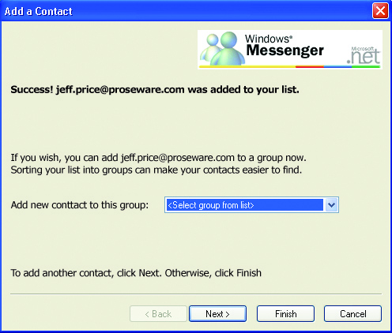

- Click Next if you wish to add more contacts; otherwise, click Finish.

For more information or for updates to the content within this document, please visit: http://www.microsoft.com/office/windowsmessenger

