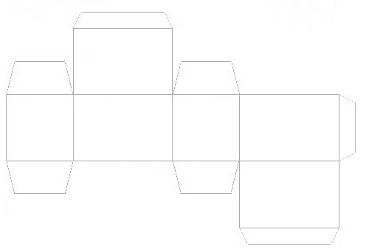
Chocolate truffle box template
Add text boxes and images to decorate. Go to Insert > Text Box and then Insert > Picture. Use the cursor to move it around.

