Extending Enterprise Search Capabilities to your Business Intelligence Applications

Technical White Paper

Author: Guy Mounier: BA-Insight
Contributors: Mohammed Nazeeruddin, Thierry D'Hers, Michael Tejedor: Microsoft

Published: June 2007
Applies To: SQL Server 2005 SP2, Office SharePoint Server 2007

Summary:
This technical white paper discusses the integration of SQL Server 2005 Analysis Services (SSAS) and Reporting Services (SSRS) with Office SharePoint Server 2007 (MOSS). The paper provides a detailed overview of integrating SharePoint Search, Business Data Catalog, Excel Services, and the Reporting Services Add-in to deliver Business Intelligence (BI) and Line-Of-Business (LOB) Application data in the SharePoint search result.
For Analysis Services and Reporting Services users who are new to working with MOSS, this paper will help you get up and running quickly on the key concepts of the Business Data Catalog and Excel Services, two new features in MOSS. For users familiar with MOSS, the paper will show how the Business Data Catalog and Excel Services can be integrated with SSAS and SSRS to deliver BI in the search result. It also presents some tips and tricks that can help you make the most of the integration between the two core platform products.

About BA-Insight:
BA-Insight is a next-generation information access company, unifying the ease of search with the analytical power of business intelligence. Combining patent-pending intellectual property, and a deep focus on user experience, BA-Insight’s flagship product Longitude, helps people quickly connect, find, and analyze information in ways never before possible. Leading global organizations like Booz Allen Hamilton, Bechtel Engineering, Lockheed Martin, and Time Warner rely on BA-Insight products to deliver actionable insights to every part of their organizations.
Headquartered in White Plains, New York, USA, BA-Insight is a private company with worldwide operations. For more information: http://www.ba-insight.net or info@ba-insight.net.
Copyright

This is a preliminary document and may be changed substantially prior to final commercial release of the software described herein.

The information contained in this document represents the current view of Microsoft Corporation on the issues discussed as of the date of publication. Because Microsoft must respond to changing market conditions, it should not be interpreted to be a commitment on the part of Microsoft, and Microsoft cannot guarantee the accuracy of any information presented after the date of publication.

This White Paper is for informational purposes only. MICROSOFT MAKES NO WARRANTIES, EXPRESS, IMPLIED OR STATUTORY, AS TO THE INFORMATION IN THIS DOCUMENT.

Complying with all applicable copyright laws is the responsibility of the user. Without limiting the rights under copyright, no part of this document may be reproduced, stored in or introduced into a retrieval system, or transmitted in any form or by any means (electronic, mechanical, photocopying, recording, or otherwise), or for any purpose, without the express written permission of Microsoft Corporation.

Microsoft may have patents, patent applications, trademarks, copyrights, or other intellectual property rights covering subject matter in this document. Except as expressly provided in any written license agreement from Microsoft, the furnishing of this document does not give you any license to these patents, trademarks, copyrights, or other intellectual property.

Unless otherwise noted, the example companies, organizations, products, domain names, e-mail addresses, logos, people, places and events depicted herein are fictitious, and no association with any real company, organization, product, domain name, e-mail address, logo, person, place or event is intended or should be inferred.

© 2007 Microsoft Corporation. All rights reserved.

Microsoft SQL Server 2005, Reporting Services, Analysis Services, Office SharePoint Server 2007, Business Data Catalog, and Excel Services are either registered trademarks or trademarks of Microsoft Corporation in the United States and/or other countries.

The names of actual companies and products mentioned herein may be the trademarks of their respective owners.

Table of Contents

Introduction 1
Prerequisites 1
Deploying Prerequisite Components 2
Tips for Installing SQL Server 2005 2
Tips for Installing MOSS and Reporting Services Add-in for SharePoint 2
Deploying AdventureWorks Sample Databases 2
Creating a Site Collection in MOSS and Configuring Excel Services 2
Configuring Reporting Services in SharePoint Integrated Mode 3
Configuring Custom Components 3
Deploying AdventureWorks Sample Reports to Reporting Services 4
Deploying AdventureWorks Sample Excel 2007 Dashboard to Excel Services 4
Creating the Dashboard and Report Pages 5
Defining the Business Data Catalog Application for Analysis Services 7
Defining the Business Data Catalog Application for Reporting Services 10
Crawling and Indexing the Business Data Catalog Applications 12
Updating the Search Result Web Part XSLT Template 12
Running Sample Searches 13
Security Considerations for Real-World Deployments 13
Conclusion 13
References 14
Acknowledgements 14

Introduction

Search is typically designed to locate a particular document, not to answer a question such as “How are my sales doing this quarter”. It is possible to converge BI and Search to make the retrieval of data from Line of Business applications, Corporate Reports and other elements of BI applications easier for end-users to locate. Market leaders such as Microsoft recognize that search is a critical information access point for all corporate data, regardless of where its location or format, and has recently released new features in Office SharePoint Server 2007 such as the Business Data Catalog that enable these types of capabilities.
The following sections walk you through the required steps to integrate the various platform components of the overall search-enabled BI solution, namely SQL Server 2005 Analysis Services and Reporting Services with Office SharePoint Server 2007 Search, the Business Data Catalog, and Excel Services. The solution will reuse the Adventure Works sample databases.

Prerequisites
The configuration of the solution assumes the use of two servers, both with Windows Server 2003 R2 and on the same domain. One server, called the “database” server, is dedicated to SQL Server Analysis Services and Database Engine, the other server, called the “front-end” server, is dedicated to SQL Server Reporting Services and MOSS. Putting all components on one server machine, while feasible, will have you miss some important security considerations, and is not representative of a real production environment.
The “database” server must have the following components installed:
- Microsoft SQL Server 2005 Database Engine with Service Pack 2
- Microsoft SQL Server 2005 Analysis Services (SSAS) with Service Pack 2
- SQL Server 2005 Sample Databases (AdventureWorks)
The “front-end” server must have the following components installed:
- Microsoft SQL Server 2005 Reporting Services (SSRS) with Service Pack 2
- Microsoft Office SharePoint Server 2007 (MOSS) Enterprise Edition
- Microsoft Reporting Services Add-in for SharePoint
The following client applications must also be available:
- Microsoft Excel 2007 (to publish Excel Services dashboards to MOSS)
- Microsoft SQL Server Management Studio
- Microsoft Visual Studio 2005 for Business Intelligence (to publish Adventure Works SSAS database and reports)
- Microsoft Visual Studio 2005 (optionally, to implement MOSS search security trimming)

Deploying Prerequisite Components
This section provides key pointers for deploying the pre-requisite components. It will not cover the detailed steps required to install these components, as the Microsoft documentation, referred to in the References section, provides all the necessary information. However, there are certain tips and tricks discussed below that you need to be aware of.

Tips for Installing SQL Server 2005
You need to deploy SQL Server 2005 Database engine SP2 and SQL Server 2005 Analysis Services SP2 on the “database” server. You can use either the default instance (used by the sample solution described here) or a named instance for each server application. The Service Pack 2 of SQL Server 2005 is required for configuring Reporting Services in SharePoint Integration Mode. Reporting Services will be configured on the “front-end” server. We’ll come to that later.

Tips for Installing MOSS and Reporting Services Add-in for SharePoint

You need to deploy MOSS Enterprise on the “front-end” server using the farm option, not standalone or basic, and point to the “database” server for creating the various SharePoint content and search databases. The Enterprise Edition is required for the use of the Business Data Catalog and Excel Services features. These features are not part of the Standard Edition. By default, you can have all shared services, in particular Search, Business Data Catalog, and Excel Services, run under the same Shared Service Provider. In a real-world production environment, these services are distributed across multiple servers to properly scale out, which does not impact the configuration of the sample solution.
You also need to install the Reporting Services Add-in for SharePoint. It will simply add Reporting Services Management Options in the Central Administration > Application Management tab.

Deploying AdventureWorks Sample Databases
The AdventureWorks sample databases can be found at the Microsoft Download web site. Make sure to use the latest SQL Server 2005 samples published in February 2005. AdventureWorks OLTP database, DW data warehouse, and BI project and database are all needed for the sample solution. The AdventureWorks DW Cube needs to be built and deployed from Visual Studio 2005 for Business Intelligence.

Creating a Site Collection in MOSS and Configuring Excel Services

You need to create a new Web Application with port 80 and host header “reportcenter”, and then create a site collection with the template “Report Center” found under the Enterprise tab. Do not forget to add the Host Header “reportcenter” as Alias in your DNS server. The new Site Collection can be accessed by typing http://reportcenter/.
You will not be authorized to run any Excel dashboards in the http://reportcenter site until you explicitly specify it in the settings. Under the Shared Service Provider Application tab, add http://reportcenter to the Trusted File Location (enable Trust Children and Trusted data connection libraries and embedded). Navigate to the sample dashboard to ensure that Excel Services is working properly.
You will notice that a default “Reports Library” document library was created as part of the Report Center, which stores all the sample dashboards and reports. You will be publishing the AdventureWorks samples to this library later on.
Finally, you need to add a New Site under Site Actions with the template “Search Center” (stored under the Enterprise tab). This will add a Search tab to your MOSS Portal.

Configuring Reporting Services in SharePoint Integrated Mode
You need to install SQL Server 2005 Reporting Services SP2 on the “front-end” server. You do not need to install the Report Manager sub-feature since report management will be done in MOSS rather than a dedicated Report Manager site.
In Report Server Configuration Manager, start by creating a new ReportServer database in SharePoint Integrated Mode. You will also need to specify
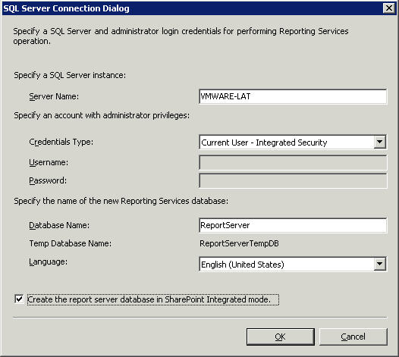

Figure 1: Reporting Services Configuration Manager – Create a New Report Server Database in SharePoint Integrated Mode
For more information about installing Reporting Services in SharePoint Integrated Mode, go to the article Configuring Reporting Services for SharePoint 3.0 Integration in the reference section.

Configuring Custom Components
This section provides detailed information about the steps and code samples required to get all the custom components setup, such as the dashboard and report aspx pages, BDC application and the Security Trimmer.
The sample solution uses two entities, Product in SSAS and Employee in SSRS, to illustrate the BI Search capabilities of the MS platform.

Deploying AdventureWorks Sample Reports to Reporting Services
The SQL Server 2005 SSRS AdventureWorks Report samples can be found as part of this package. Open the sample solution in Visual Studio 2005 for Business Intelligence. Set the data sources to point to your reporting services server. In the deployment properties, since Reporting Services is running in SharePoint Integration Mode, specify the full SharePoint URL pointing to the Reports Library document library in the http://reportcenter site. New report and data sources folders will be created as specified in the URL.
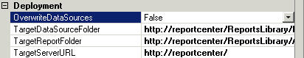

Figure 2: BI Development Visual Studio 2005 – Report Server Solution Deployment Options

Deploying AdventureWorks Sample Excel 2007 Dashboard to Excel Services
As part of the package, an Excel 2007 dashboard has been provided with AdventureWorks PivotTable reports. The sample dashboard will be published to Excel Services to demonstrate the use of the Product entity for SSAS.
- Open the file in Excel 2007 and Edit the Connection String to provide a valid user ID and password:
Provider=MSOLAP.3;Password=pwd;Persist Security Info=True;User ID=domain\userID;Initial Catalog=Adventure Works DW;Data Source=ServerName;MDX Compatibility=1;Safety Options=2;MDX Missing Member Mode=Error
Make sure that the Excel Services Authentication Settings are set to None. Otherwise, the connection string will not save the User ID and Password.
Note that the sample solution embeds security information into the Excel file for simplicity. For a detailed discussion on security considerations, go to related section in this document.
- Go to Start > Publish > Excel Services and type the URL http://reportcenter/ReportsLibrary/Adventure Works DW SSAS Product.xlsx to publish the workbook in the Reports Library.
- In the Excel Services Options, you need to select the PivotTable and Chart reports items to show: Chart_ProductTrend, Product By Territory and Channel, and add the parameters: Product, Product2
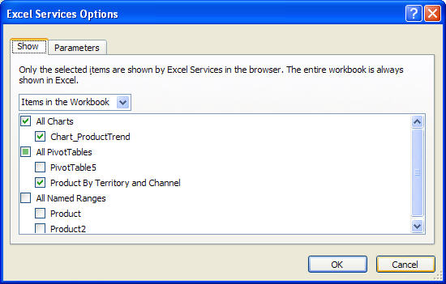

Figure 3: Excel Services Options

- Navigate to the dashboard link to confirm that the dashboard can be opened with Excel Services.

Creating the Dashboard and Report Pages
Two pages will need to be created to display the business intelligence information. The first page displays information about the Product entity in Excel Services and SSAS.
- In the http://reportcenter site, create a new Blank Web Part Page called “dashboard.aspx”.
- Add the following three web parts: Query String (URL) Filter Web Part and two Excel Web Access Web Parts.
- Configure each Excel Web Access Web Part to display the product-related PivotTable reports published in http://reportcenter/ReportsLibrary/Adventure Works DW SSAS Product.xlsx. Set the following Web Part properties:
  - Set the Workbook property to http://reportcenter/ReportsLibrary/Adventure Works DW SSAS Product.xlsx.
  - Set the Named Item property to “Chart_Trend” or “Product By Territory and Channel” respectively
- Configure the Query String (URL) Filter Web Part to pickup parameter “ProductID” from the URL query string.
  - Set the Query String Parameter Name property to “ProductID”
  - Leave the Default Value property to Blank
  - Go to Edit > Connections > Send Filter Values To and select the Excel Web Access web part title for Name Item “Chart_Trend”
  - Set the Filter Value to “Product 2”
  - Go to Edit > Connections > Send Filter Values To and select the Excel Web Access web part title for Name Item “Product By Territory and Channel”
  - Set the Filter Value to “Product”
- Test that the page is picking up the URL string parameter “ProductID” correctly by typing the following URL: http://reportcenter/Pages/dashboard.aspx?ProductID=[Product].[Product].%26[355]
Note: PivotTable parameters running against SSAS require the UniqueID of the parameter value, e.g. [Product].[Product].&[355]. The “&” character has to be URL encoded to “%26” to be properly picked up by the Query String (URL) Filter Web Part. In a later section, you will need to update the XSLT in the search result page to enable such URL encoding.
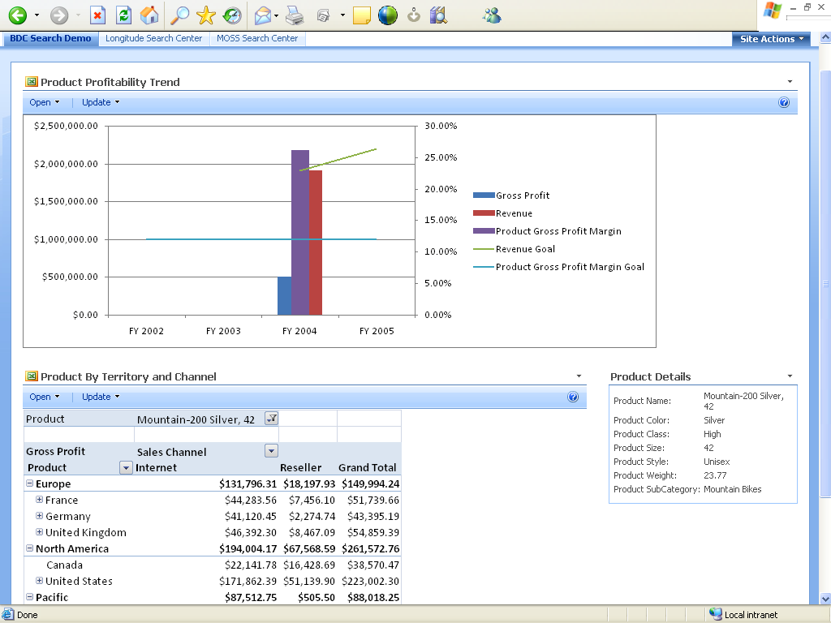

Figure 4: Sample Excel Dashboard page

The second page displays information about the Employee entity in SSRS.

- In the http://reportcenter site, create a new Blank Web Part Page called “report.aspx”.
- Add the following two web parts: Query String (URL) Filter Web Part and Report Viewer Web Part.
- Configure the Query String (URL) Filter Web Part to pickup parameter “EmployeeID” from the URL query string.
- Configure the Report Viewer Web Part to display the employee-related report called “Employee Sales Summary”.
- Connect the Query String (URL) Filter Web Part parameter to the Report Viewer Web Part parameter “EmpID”.

Note: If you do not see the Report Viewer Web Part in the gallery, import it from the following location: <drive>:\Program Files\Common Files\Microsoft Shared\web server extensions\12\TEMPLATE\FEATURES\ReportServer\ReportViewer.dwp.

- Test that the page is picking up the URL string parameter “EmployeeID” correctly by typing the following URL: http://reportcenter/Pages/report.aspx?EmployeeID=284

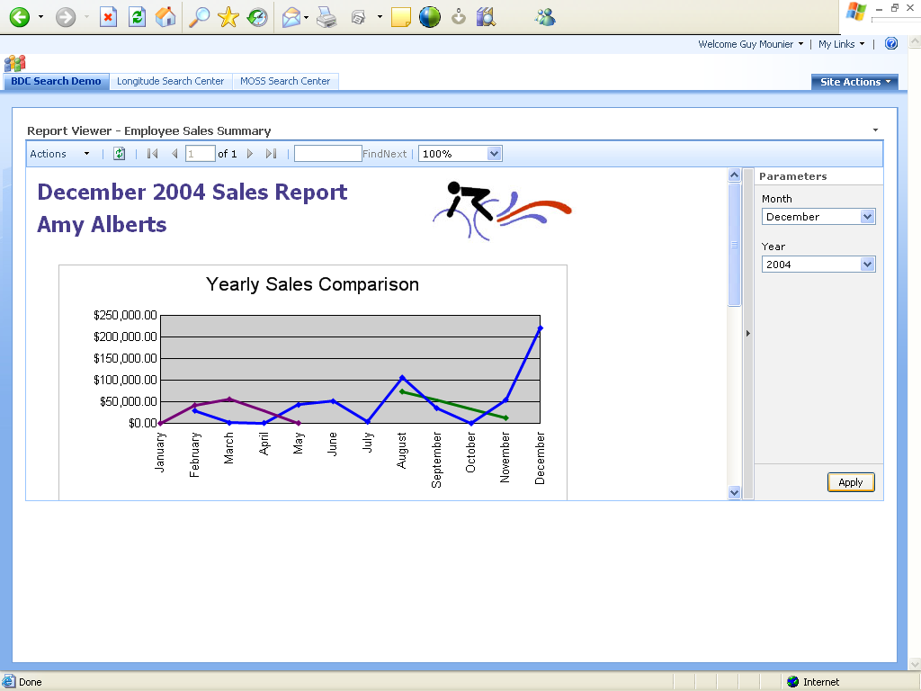

Figure 5: Sample Report page

Defining the Business Data Catalog Application for Analysis Services

The first entity to be mapped in the BDC is the Product Dimension of the AdventureWorks cube. The entire BDC XML definition can be found in the attached package.
In order to produce tabular data that the BDC can consume, an SQL linked server name has to be created and an OPENQUERY statement needs to be defined.
In SQL Server Management Studio, run the following SQL statement:
EXEC sp_dropserver 'LINKED_OLAP' -- run if the linked server exists
EXEC sp_addlinkedserver
@server='LINKED_OLAP', -- local SQL name given to the linked server
@srvproduct='', -- not used
@provider='MSOLAP', -- OLE DB provider
@datasrc='<server name>', -- analysis server name (machine name)
@catalog='Adventure Works DW'
A “LINKED_OLAP” linked server object will be created under Server Objects > Linked Servers.
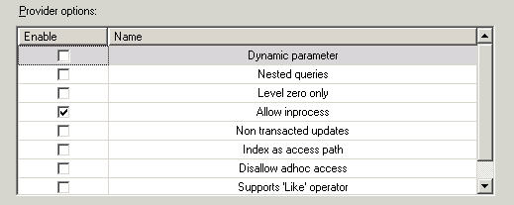
Make sure that the MSOLAP OLE DB Provider found under Server Objects > Linked Servers > Providers has the property “Allow inProcess” selected.
Figure 6: MSOLAP OLE DB Provider Properties

The Product Dimension data is now going to be exposed to SQL Server as an SQL View object. For more information on how to query cube dimensions, refer to an excellent article about Querying Dimensions in MDC in the Reference section. Create a new database called “LINKED_OLAP” and create the following view called “Product”:

CREATE VIEW [dbo].[Product]
AS
SELECT
CAST([[Product]].[Product]].[Product]].[MEMBER_UNIQUE_NAME]]] AS nvarchar(255)) AS ProductID,
CAST([[Measures]].[ProductName]]] AS nvarchar(255)) AS ProductName,
CAST([[Measures]].[Color]]] AS nvarchar(255)) AS Color,
CAST([[Measures]].[Class]]] AS nvarchar(255)) AS Class, CAST([[Measures]].[Size]]] AS nvarchar(255)) AS Size,
CAST([[Measures]].[Style]]] AS nvarchar(255)) AS Style, CAST([[Measures]].[Weight]]] AS nvarchar(255)) AS Weight,
CAST([[Measures]].[SubCategory]]] AS nvarchar(255)) AS SubCategory
FROM OPENQUERY(LINKED_OLAP,
'WITH
MEMBER Measures.ProductName AS [Product].[Product].MEMBER_NAME
MEMBER Measures.Color AS [Product].[Color].MEMBER_NAME
MEMBER Measures.Class AS [Product].[Class].MEMBER_NAME
MEMBER Measures.Size AS [Product].[Size].MEMBER_NAME
MEMBER Measures.Style AS [Product].[Style].MEMBER_NAME
MEMBER Measures.Weight AS [Product].[Weight].MEMBER_NAME
MEMBER Measures.SubCategory AS [Product].[Subcategory].MEMBER_NAME
SELECT
{
Measures.ProductName,
Measures.Color,
Measures.Class,
Measures.Size,
Measures.Style,
Measures.Weight,
Measures.SubCategory
} ON 0,
[Product].[Product].Children PROPERTIES MEMBER_UNIQUE_NAME ON 1
FROM $Product
')

Run the following SQL statement to make sure that your linked server is running correctly:

USE [LINKED_OLAP]
SELECT * FROM Product

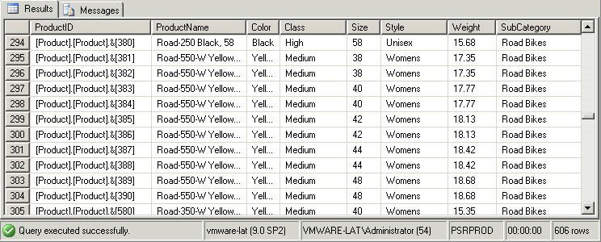
The results should look like this:
Figure 7: Tabular Data from the AdventureWorks Product Dimension

Note that we are selecting the Member Unique Name for the Product ID. The ID is what will be indexed by MOSS Search and passed to Excel Services for rendering the dashboard.
Important: Make sure that the default crawling account used by MOSS to index content sources such as the BDC application has the appropriate rights to query the database, and in particular query the Product view in the LINKED_OLAP database. If you don’t know the crawling account name, go to the Shared Service Provider Application Tab and look up the account name in Search Settings under the Search section.

The Business Data Catalog definition file is an XML file that models and describes the Product entity, how to crawl it in MOSS and access it from the dashboard.aspx page. The file called “SSAS BDC Definition.xml” is part of the package that comes with this white paper. To load the BDC application, perform the following steps:

- Edit the file to set the connection string to point to your database server and database name
<Property Name="AuthenticationMode" […]>RevertToSelf</Property>
<Property Name="DatabaseAccessProvider" […]>SqlServer</Property>
<Property Name="RdbConnection Data Source" […]>sql server name</Property>
<Property Name="RdbConnection Initial Catalog" […]>LINKED_OLAP</Property>
<Property Name="RdbConnection Integrated Security" […]>SSPI</Property>
- Edit the file path to the dashboard.aspx page if the site name of page name is different from the default values.
<Actions>
<Action Position="1" IsOpenedInNewWindow="false" Url="http://reportcenter/Pages/dashboard.aspx?ProductID={0}" ImageUrl="/_layouts/1033/images/viewprof.gif" Name="View Profile">
<ActionParameters>
<ActionParameter Index="0" Name="ProductID" />
</ActionParameters>
</Action>
</Actions>
- Go to MOSS Shared Service Provider Management Tab
- Go to Import Application link in the BDC Application Management session
- Browse to the sample file “SSAS BDC Definition.xml” and Upload.
- Navigate to the list of BDC Application and click on the newly added database application called by default “MSOLAPBI”.
- Edit the security and make sure that your testing User Account or User Group has Edit and Execute rights to the application.

Below is an overview of the SQL queries defined in the BDC application definition file. None of the queries need to be modifled unless you named the Product view or other field names differently.

Two methods are defined in the BDC application for the Product Entity.
The GetProductID method, of instance type Finder and SpecificFinder, returns one or more Product entities using the following parameterized SQL query:
<Property Name="RdbCommandText" Type="System.String">
SELECT * FROM Product WHERE (ProductID BETWEEN @MinProductID AND @MaxProductID)
</Property>
The ProductIDEnumerator method, of instance type IDEnumerator, returns the collection of all Product ID’s using the following SQL query:
<Property Name="RdbCommandText" Type="System.String">
SELECT ProductID FROM Product
</Property>

The MOSS Indexing engine first queries ProductIDEnumerator to list of entities of type Product, and then calls GetProductID to retrieve each individual Product record with related attributes.

Defining the Business Data Catalog Application for Reporting Services
The second entity to be mapped in the BDC is the Employee report parameter of the Employee Sales Summary report data set, connected to the AdventureWorks OLTP database. The entire BDC XML definition is called “SSRS BDC Definition.xml” and can be found in the attached package.
Important: Make sure that the default crawling account used by MOSS to index content sources such as the BDC application has the appropriate rights to query the AdventureWorks database, and in particular query the HumanResources.Employee,
Sales.SalesPerson, Person.Contact records. If you don’t know the crawling account name, go to the Shared Service Provider Application Tab and look up the account name in Search Settings under the Search section.
To load the BDC application, you need to perform the following steps:
- Edit the file to set the connection string to point to your database server name. The database name is “AdventureWorks”.
<Property Name="AuthenticationMode" […]>RevertToSelf</Property>
<Property Name="DatabaseAccessProvider" […]>SqlServer</Property>
<Property Name="RdbConnection Data Source" […]>sql server name</Property>
<Property Name="RdbConnection Initial Catalog” […]>AdventureWorks</Property>
<Property Name="RdbConnection Integrated Security" […]>SSPI</Property>
- Edit the file path to the dashboard.aspx page if the site name of page name is different from the default values.
<Actions>
<Action Position="1" IsOpenedInNewWindow="false" Url="http://reportcenter/Pages/report.aspx?EmployeeID={0}" ImageUrl="/_layouts/1033/images/viewprof.gif" Name="View Profile">
<ActionParameters>
<ActionParameter Index="0" Name="ProductID" />
</ActionParameters>
</Action>
</Actions>
- Go to MOSS Shared Service Provider Management Tab
- Go to Import Application link in the BDC Application Management session
- Browse to the sample file “SSRS BDC Definition.xml” and Upload.
- Navigate to the list of BDC Application and click on the newly added database application called by default “SSRS”.
- Edit the security and make sure that your testing User Account or User Group has Edit and Execute rights to the application.

Below is an overview of the SQL queries defined in the BDC application definition file. None of the queries need to be modifled unless you named the Product view or other field names differently
The following two methods are defined in the BDC application for the Employee Entity.
The GetEmployeeID method, of instance type Finder and SpecificFinder, returns one or more Employee entities using the following parameterized SQL query:
<Property Name="RdbCommandText" Type="System.String">
SELECT E.EmployeeID, C.FirstName + N' ' + C.LastName AS Employee
FROM HumanResources.Employee E INNER JOIN
Sales.SalesPerson SP ON E.EmployeeID = SP.SalesPersonID INNER JOIN Person.Contact C ON E.ContactID = C.ContactID
WHERE
ORDER BY C.LastName, C.FirstName
</Property>
The EmployeeIDEnumerator method, of instance type IDEnumerator, returns the collection of all Employee ID’s using the following SQL query:
<Property Name="RdbCommandText" Type="System.String">
SELECT E.EmployeeID
FROM HumanResources.Employee E INNER JOIN
Sales.SalesPerson SP ON E.EmployeeID = SP.SalesPersonID INNER JOIN Person.Contact C ON E.ContactID = C.ContactID
WHERE (E.EmployeeID BETWEEN @MinEmployeeID AND @MaxEmployeeID)
ORDER BY C.LastName, C.FirstName
</Property>

An action to call the report.aspx page for each Employee ID needs to be defined. This action will be the default action provides in the search result.
<Actions>
<Action Position="1" IsOpenedInNewWindow="false" Url="http://reportcenter/Pages/report.aspx?EmployeeID={0}" ImageUrl="/_layouts/1033/images/viewprof.gif" Name="View Profile">
<ActionParameters>
<ActionParameter Index="0" Name="EmployeeID" />
</ActionParameters>
</Action>
</Actions>
Note that if you were to use an existing Reporting Services implementation (not in SharePoint Integrated Mode for example), you could simply link the action to the actual report server link and feed the appropriate report parameter value in the URL. It would look something like this:
http://MyServer/ReportServer?/SampleReports/Employee Sales Summary&EmpID={0}

Crawling and Indexing the Business Data Catalog Applications

You are now ready to crawl and index both BDC Applications. Make sure that the user account used to run searches has access to the BDC Applications.
- Go to MOSS Central Administration and click on the Shared Services Administration link pointing to the Search Shared Service Provider
- Go to Search Settings in the Search seciton
- Click on the Content Sources link
- Click on New Content Source
  - Input the name of the content source e.g. "MSOLAP BDC Application"
  - Select content type as Business Data
  - Select the BDC Application instance "MSOLAPInstance"
  - Check the box "Start a full crawl of this content source" and click OK
  - Perform the steps a. through d. for Content Source "SSRS BDC Application" and Application instance "SSRSInstance"
- Click on Start Crawl Now.

Note: Check the Crawl Log to make sure that the data is being indexed. If you are running into any issues, monitor SQL Server with the SQL Server Profiler to ensure that the proper user account is connecting to it and executing the queries. Moreover, the MOSS log files located at <drive>:\Program Files\Common Files\Microsoft Shared\web server extensions\12\LOGS can provide detailed error information.

Updating the Search Result Web Part XSLT Template
As discussed earlier, The UniqueID of the Product entity needs to be passed to the Excel Dashboard. The “&” character needs to be URL encoded as “%26” for the Excel dashboard link to work. The XSLT template of the Search Result Web Part needs to be modified to enable proper URL encoding.
- Run a sample search in MOSS and edit the Search Result page.
- Edit the Search Core Result web part properties
- Click XSL Editor and Edit the text in NotePad
- Add the following “replace-string” template right before the <xsl:template match="Result"> template
<xsl:template name="replace-string">
<xsl:param name="text"/>
<xsl:param name="from"/>
<xsl:param name="to"/>
<xsl:choose>
<xsl:when test="contains($text, $from)">
<xsl:variable name="before" select="substring-before($text, $from)"/>
<xsl:variable name="after" select="substring-after($text, $from)"/>
<xsl:variable name="prefix" select="concat($before, $to)"/>
<xsl:value-of select="$before"/>
<xsl:value-of select="$to"/>
<xsl:call-template name="replace-string">
<xsl:with-param name="text" select="$after"/>
<xsl:with-param name="from" select="$from"/>
<xsl:with-param name="to" select="$to"/>
</xsl:call-template>
</xsl:when>
<xsl:otherwise>
<xsl:value-of select="$text"/>
</xsl:otherwise>
</xsl:choose>
</xsl:template>
- Update the <xsl:template match="Result"> template that constructs the search result list item and replace the url variable <xsl:variable name="url" select="url"/> with the following:
<xsl:variable name="url">
<xsl:call-template name="replace-string">
<xsl:with-param name="text">
<xsl:value-of select="url"/>
</xsl:with-param>
<xsl:with-param name="from" select="'&amp;'"/>
<xsl:with-param name="to" select="'%26'"/>
</xsl:call-template>
</xsl:variable>
Note that a sample file “Search Core Results.xslt” is included in the package. However, in real world deployments, customers often customize the search result list with the XSLT template.

Running Sample Searches
You are now ready to get business intelligence in the search result.
- Run a search for “Amy Alberts” and click on the link to report.aspx that will display Amy’s sales performance in SSRS.
- Run a search for “mountain bikes” and click on of the product links to dashboard.aspx. It will display the actual financial performance of the product line based on SSAS data.

Security Considerations for Real-World Deployments
In a real world deployment, some careful considerations need to be given to security.
First of all, it is recommended to have Kerberos configured in your environment so that Excel Services can function properly in a Windows Authentication mode, where the MOSS logon account is passed to SSAS via Excel Services to run the actual PivotTable query.
Moreover, it is highly unlikely that all entity data (product or employee) would be accessible to an end-user. Therefore, you will need to effectively trim the values a user doesn’t have access to from the search result. This can be implemented via the ISecurityTrimmer interface of the MOSS Search object model, or a BDC method instance of type AccessChecker. For more information, refer to the References section.

Conclusion
This paper has provided a guide to setup a complete search-enabled BI solution using MOSS and SQL Server 2005 Search and BI features. This paper also covered the key search scenarios encountered by end-users when looking for mission-critical business intelligence. The Microsoft platform can be leveraged by partners such as BA-Insight to deliver compelling BI Search applications to the marketplace today.

References
This section lists sites on the Web where you can find more information about the topics discussed in this paper.
- SQL Server Reporting Services home page: http://www.microsoft.com/sql/reporting/default.asp
- Querying Dimensions in MDX: http://www.sqljunkies.com/WebLog/mosha/archive/2006/10/11/query_dimensions_mdx.aspx
- How to perform a SQL Server distributed query with OLAP Server: http://support.microsoft.com/kb/218592
- SQL Server 2005 Samples and Sample Databases (February 2005 Release): http://download.microsoft.com
- Business Data Catalog Overview: http://msdn2.microsoft.com/en-us/library/ms551230.aspx
- Configuring Reporting Services for SharePoint 3.0 Integration: http://msdn2.microsoft.com/en-us/library/bb326356.aspx
- Business Data Catalog Security Trimmer: http://msdn2.microsoft.com/en-us/library/aa980904.aspx
- Microsoft SQL Server 2005 SP2 Reporting Services integration with WSS 3.0 and MOSS 2007: http://blogs.msdn.com/sharepoint/archive/2007/02/19/microsoft-sql-server-2005-sp2-reporting-services-integration-with-wss-3-0-and-moss-2007.aspx
- SQL Server Reporting Services Books Online: http://msdn2.microsoft.com/en-us/library/ms159106(SQL.90).aspx

Acknowledgements
Thanks to Mohammed Nazeeruddin, Thierry D'Hers, Michael Tejedor, Tony Malandain and everyone else at Microsoft and BA-Insight who helped along the way.

Also Included in this Package:
- AdventureWorks Excel 2007 Dashboard (xlsx format)
- AdventureWorks sample SSRS Reports (rdl files and Visual Studio solution)
- BDC XML Application Definition files for Analysis Services and Reporting Services

