
Operating System
Microsoft® Windows® 2000 Windows Internet Service (WINS) Overview

White Paper
Abstract
The Microsoft® Windows® 2000 operating system Internet Name Service (WINS) introduces new features and enhancements to the WINS server, WINS client, and WINS Manager. WINS provides a distributed database for registering and querying dynamic computer name-to-IP address mapping in a routed network environment.

© 1999 Microsoft Corporation. All rights reserved.
The information contained in this document represents the current view of Microsoft Corporation on the issues discussed as of the date of publication. Because Microsoft must respond to changing market conditions, it should not be interpreted to be a commitment on the part of Microsoft, and Microsoft cannot guarantee the accuracy of any information presented after the date of publication.
This White Paper is for informational purposes only. MICROSOFT MAKES NO WARRANTIES, EXPRESS OR IMPLIED, IN THIS DOCUMENT.
The BackOffice logo, Microsoft, Windows, and Windows NT are registered trademarks of Microsoft Corporation.
Other product or company names mentioned herein may be the trademarks of their respective owners.
Microsoft Corporation • One Microsoft Way • Redmond, WA 98052-6399 • USA
0499

Introduction 1
Contents
WINS Functional Description 4
New features of Windows 2000 WINS 5
Persistent Connections 5
Manual Tombstoning 6
Improved Management Tools 7
Microsoft Management Console (MMC) 7
Higher Performance 7
Resizable Columns 8
List View 8
Enhanced Filtering and Record Searching 8
Dynamic Record Deletion and Multi-Select 9
Record Verification and Version Number Validation 9
Consistency Checking 10
Autodiscovery of WINS Partners 10
Monitoring 10
Export Function 10
Increased Fault Tolerance 10
Dynamic Re-registration 11
Summary 12
For More Information 13

Microsoft® Windows® Internet Name Service (WINS) has been enhanced for the release of Microsoft Windows 2000 Server. The result is an easier-to-manage and more robust solution for mapping NetBIOS names to IP addresses on Transmission Control Protocol/Internet Protocol (TCP/IP) networks.

Introduction
Windows 2000 WINS includes server enhancements, additional client functions, and an improved management tool. WINS provides a distributed database for registering and querying dynamic computer name-to-IP address mapping in a routed network environment. This support for dynamic registering of NetBIOS computer names means that WINS can be used with Dynamic Host Configuration Protocol (DHCP) services to provide easy configuration and administration of Windows-based TCP/IP networks.
The WINS server solves the problems inherent in resolving NetBIOS names through IP broadcasts, and frees network administrators from the demands of updating static mapping files, such as LMHOST files. WINS, which is compliant with the NetBIOS Name Server (NBNS) RFCs (1001/1002), also automatically updates the WINS database when dynamic addressing through DHCP results in new IP addresses for computers that move between subnets. Neither the user nor the network administrator needs to make manual accommodations for such name resolutions.
The new implementation of WINS provides a number of features, including:
- Persistent connections—This configurable feature allows each WINS server to maintain a persistent connection with one or more replication partners to eliminate the overhead of opening and terminating connections and to increase the speed of replication.
- Manual tombstoning—Use of the Manual tombstoning feature marks a record for deletion so that the tombstone state for the record is replicated across all WINS servers, preventing an undeleted copy of the record on a different server database from being re-propagated.
- Improved management tools—The WINS Manager is fully integrated with the Microsoft Management Console (MMC), providing a more user-friendly and powerful environment for viewing and managing WINS information.
- Enhanced filtering and record searching—These functions help locate records of interest by showing only those that fit a specific criteria. This is particularly useful for analyzing very large WINS databases.
- Dynamic record deletion and multi-select—Managing the WINS database is made easier with dynamic record deletion and multi-select. Dynamic and static records can be deleted, and the point-and-click interface makes it possible to delete files with non-alphanumeric characters that could not be handled from the command line.
- Record verification and version number validation—Two tools are available for quickly checking the consistency between various WINS servers. The tests are done by comparing the IP addresses of a NetBIOS name query returned from different WINS servers or by examining owner address to version-number mapping tables.
- Export function—The Export command can be used to place WINS data into a comma-delimited text file that can be imported into Microsoft Excel, reporting tools, scripting applications, and so on, for analysis and reporting.
- Increased fault tolerance—Windows 2000 and Windows 98 allow a client to specify more than two WINS servers (up to a maximum of 12 addresses) per interface. The extra WINS server addresses are used only if the primary and secondary WINS servers fail to respond.
- Dynamic re-registration—WINS clients can now re-register their NetBIOS name-to- IP address mapping without rebooting the server.
All of this combines to make Windows 2000 WINS a superior choice for NetBIOS name resolution. The new generation of WINS services are designed to make many network management tasks much easier for network managers.

Please refer to the white paper “Microsoft Windows NT Server 4.0 Windows Internet Naming Service (WINS) Architecture and Capacity Planning” (available at http://www.microsoft.com/ntserver) for a detailed description of WINS elements and functions.

WINS Functional Description
Windows 2000 WINS contains significant enhancements, many of which were suggested by network managers. The result is an even more powerful and easier-to-manage NetBIOS-to-IP address service. New features include:

New features of Windows 2000 WINS
- Persistent connections
- Manual tombstoning
- Improved management tool
- Enhanced filtering and record searching
- Dynamic record deletion and multi-select
- Record verification and version number validation
- Export function
- Increased fault tolerance
- Dynamic re-registration

Persistent Connections
Windows 2000 WINS introduces persistent connections between WINS server replication partners. This is important because the WINS database is collectively managed by a set of WINS servers, each of which has a copy of the WINS database. To keep these copies consistent, servers replicate records among each other. Each WINS server is configured with a set of one or more replication partners. Each new computer added to or substituted on the network registers its name and IP address with a WINS server, which in turn propagates the new record to all other WINS servers in the enterprise. The result is that every server has the record pertaining to that new computer.
Earlier versions of WINS required a new connection to be established between the WINS servers whenever replication was to occur, each of which required a modest number of processor cycles.
Therefore, network managers would set their systems to accumulate a configurable number of records prior to having servers establish connection with replication partners. This caused a delay to be introduced in the updating of the entire database, perhaps as long as several minutes, which could cause windows of inconsistency with replication partners.
Windows 2000 WINS provides a configurable feature that allows a server to request a persistent connection with one or more replication partners, which eliminates the overhead of opening and terminating connections. Persistent connections increase the speed of replication because a server can immediately send records to its partners without incurring the cost of establishing temporary connections each time. This provides the opportunity for every record received be immediately updated across the network, making records more consistent. The bandwidth used by persistent connections is minimal because the connection is usually idle.
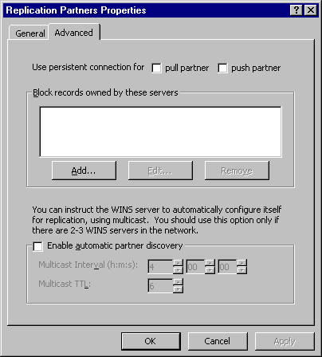
Figure 1. Windows 2000 WINS configured to Use persistent connection

Manual Tombstoning
Windows 2000 WINS gives network managers the ability to manually tombstone records, marking them for deletion so that the order to delete is propagated across all WINS servers. This is significant because WINS is a distributed environment. Each server holds the entire database, and replication is used to propagate updates to every server.
In earlier versions of WINS, the removal of unwanted records could be difficult. Records were marked for removal on only one server, and that information is replicated to other WINS replication partners. Depending upon replication configuration, record removal might not occur correctly.
The manual tombstoning option of Windows 2000 WINS addresses such problems. The timing of the tombstoned state exceeds the propagation delay incurred with replication across the network. When the time limit is reached, tombstoned records are removed on all servers. Manual tombstoning provides an excellent way of dealing with static records, too. Manual tombstoning is available from both the WINS graphical user interface and the WINS command-line interface.
In WINS Manager, tombstoning is displayed as an option under the record deletion function. A record can be either deleted or tombstoned. The ability to manually tombstone records requires Windows 2000–enabled WINS servers, but tombstoned records replicate to Windows NT 3.51 and Windows NT 4.0 WINS servers.
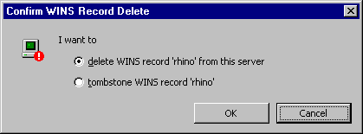
Figure 2. Manual tombstoning function in the WINS Manager
For a more information on tombstoning, see the white paper, “Microsoft Windows NT Server 4.0 Windows Internet Naming Service (WINS) Architecture and Capacity Planning.”

Improved Management Tools
The Windows 2000 WINS Manager has an updated graphical user interface, incorporating all of the user-friendly features of the Windows interface, including resizable windows.
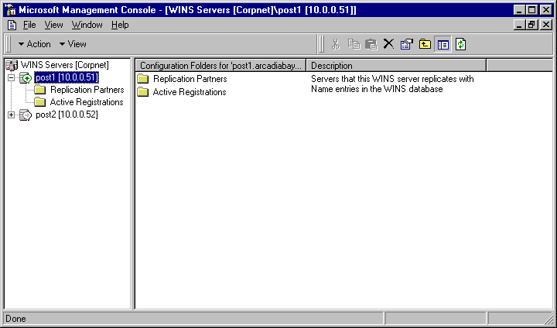
Figure 3. The Microsoft Management Console user-friendly interface

Microsoft Management Console (MMC)
The Windows 2000 WINS Manager is fully integrated with the robust Microsoft Management Console (MMC). This provides network managers with the consistency of using the MMC for all of their administrative tasks. With MMC, multiple WINS Manager windows can be opened at once.

Higher Performance
A major enhancement to the Windows 2000 WINS Manager is a multithreaded user interface (UI), which allows background tasks to take place while a foreground task is being performed, providing much faster response. Multithreading of the UI permits a network manager to run multiple UI tasks simultaneously. A manager can select the Active Registration node to display the database, and then—rather than waiting for the complete database to be displayed—can select the node of another server, change the configuration of replication partners, or perform other tasks.

Resizable Columns
The window for database records now features resizable display columns. Using standard left-right drag, users can resize columns to accommodate their current tasks.

List View
List View provides a flexible, Explorer-like, function for sorting information according to column type. This means network managers can, with the click of the mouse, sort data according to:
- Record name
- IP address
- Type
- Static/dynamic
- Status
- Expiration date
- Version number

Enhanced Filtering and Record Searching
A Quick Find function has been added to the WINS Manager to help network managers and support staff search for only a few records without downloading and viewing the entire database.
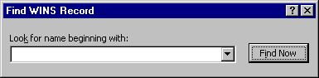
Figure 4. The new Quick Find function
For example, a network manager may want to review all WINS records that contain the location name for St. Louis, MO. This would allow the network manager to selectively view all records that contain the STL string, without requiring a retrieval of the entire database. The Quick Find function selects the records containing the STL string and presents only those records to the network manager.
Filtering capability eliminates the need to examine every record in an entire database by stating which type of record is desired. After an entire database is downloaded, a search can be refined to a certain type of computer. (For more detail on NetBIOS name registrations and their types, see the white paper, “Microsoft Windows NT Server 4.0 Windows Internet Naming Service (WINS) Architecture and Capacity Planning.”) Searches can also be done for domain controllers only, and multiple filters can be applied to view a combined display of records for computers that act as RAS servers, file servers, or other types of computers, and in various combinations.
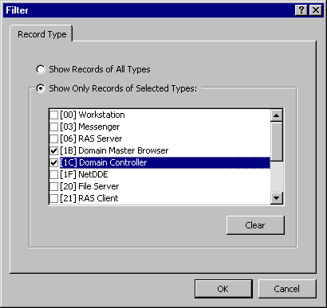
Figure 5. Searching by computer type

Dynamic Record Deletion and Multi-Select
In addition to static record deletion available in previous versions of WINS, dynamic records can now be deleted. Multi-select can be used to delete a number of records at once. To select a range of contiguous records, click the first record to delete, and then SHIFT+click the last record in the range to delete. This delete function also includes manual tombstoning.
The point-and-click record deletion is especially helpful when dealing with file names containing non-alphanumeric characters, which prevent them from being deleted from the command line.

Record Verification and Version Number Validation
Record verification allows network managers to verify a set of WINS records against a set of WINS servers by sending name queries to each server to ensure that the names are consistent among all servers.
Version number validation ensures consistency of version IDs between servers. It first obtains the owner address-to- version number maps from different WINS servers. It then checks the consistency of their databases by ensuring that a WINS server always has the highest version number among the network of WINS servers for records owned by it.

Consistency Checking
Consistency checking can be done from the MMC. Network managers can configure the frequency with which the system compares the WINS databases. However, consistency checking is very network bandwidth-intensive and consumes a great many cycles on the WINS server. To perform consistency checking, a WINS replicates all of a particular owner’s records from another WINS, and then checks them to determine whether its database is synchronized with the other WINS for that owner.

Autodiscovery of WINS Partners
The autodiscovery feature, which can be turned on from the MMC, enables a WINS server to automatically discover its replication partners. Periodically WINS servers announce their presence on the network. WINS servers that have the autodiscovery feature turned on listen for these announcements and learn about other WINS servers on the network. WINS servers discovered in this way are automatically added to the partners list as both a push and pull partner. The WINS announcements are sent by multicast on a multicast address reserved for WINS. (224.0.1.24). This feature should not be used if there are more than three WINS servers on the network.

Monitoring
The monitoring features of MMC provide network managers with the status of WINS servers. Monitoring can check for consistency between servers, detect version-number inconsistencies, detect communication failures between WINS servers, and verify replication configuration setup.

Export Function
Windows 2000 WINS Manager provides an Export command,. To see this command, right-click the Active Registration folder. The Export function copies any data on the right-hand side of the MMC window into a comma-delimited text file. The exported data can then be imported into Microsoft Excel, reporting tools, scripting applications, or other files. This function permits network managers use whatever tools they choose for generating reports, analyzing network performance, and other functions.

Increased Fault Tolerance
Windows 2000 and Windows 98 provide an extra measure of fault tolerance by allowing a client to specify more than two WINS servers (up to a maximum of 12 addresses) per interface through either DHCP or Setup. The extra WINS server addresses are used to resolve names only if the primary and secondary WINS servers fail to respond. If one of the extra WINS servers is used, its name resolutions are cached to be used the next time the primary and secondary WINS servers fail to resolve the name.

Dynamic Re-registration
WINS clients have been improved to allow them to re-register their NetBIOS name-to-IP address mappings without rebooting the computers. This is useful when incorrect static entries exists or if a WINS database is restored with an old record, for example. The version ID is updated on the server to cause re-replication.

Microsoft Windows Internet Name for Windows 2000 Server provides a solid platform for managing NetBIOS name-to-IP address resolution on a routed TCP/IP network. The enhancements and new features in this version of WINS are to a great extent influenced by feedback from network managers in the field.

Summary
Persistent connections allow each WINS server to maintain a connection with one or more replication partners to eliminate the overhead of opening and terminating connections and to increase the speed of replication.
Manual tombstoning ensures that records marked for deletion are deleted across the distributed database to prevent records from re-propagating back across the WINS servers.
An improved WINS Manager tool, including full integration with the Microsoft Management Console, provides a more user-friendly and powerful environment for viewing and managing WINS information. In addition, the searching capability speeds up database record retrieval, and filtering cuts down on the number of records that need to be displayed.
Managing the WINS database is made easier with dynamic record deletion and multi-select. Dynamic and static records can be deleted, and the point-and-click interface makes it possible to delete files with non-alphanumeric characters that could not be handled from the command line.
Record verification and version-number validation provide quick checks for consistency between WINS servers. Full database consistency checking is available right from the WINS Manager.
The Export command can be used to place WINS data into a comma-delimited text file that can be imported into Microsoft Excel, reporting tools, scripting applications, and so on, for analysis and reporting.
WINS clients can now re-register without rebooting the server, and they have better fault tolerance because they can query against more than two WINS servers.
These features combine to make the Windows 2000 Windows Internet Name Service a much improved solution for managing dynamic NetBIOS name resolution across a routed TCP/IP network.

For the latest information on Windows 2000 Server and Windows NT Server, visit the Web site at http://www.microsoft.com/ntserver and the Windows NT Server Forum on the Microsoft Network (GO WORD: MSNTS).

For More Information

