Setup instructions: Office Business Application for Store Operations
These steps outline the process of installing and setting up the sample application. There are some prerequisites that should be reviewed before installing the toolkit.

Technology Prerequisites
To successfully run the toolkit, understand its functionality, and run the demos requires the following:
- BizTalk Server 2006
- SQL Server 2005
- Microsoft Business Score Card Manager
- Windows SharePoint Server
- .NET Framework 2.0

Installation and Configuration Steps
- Download CSToolkit.zip from MSDN site and unzip the file.
- CSToolkit.Zip will have code.zip, Database-backup.zip, Infopath.zip and MSI.zip.
- Database restore
  - Unzip the Database-backup,zip file which gives two BAKUP files
    - Test_StoreDb – Restore this DB in SQL Server
    - Test_HQDB– Restore this DB in SQL Server
- Unzip the code.zip file and you will find the code files and follow the following steps
  - Open the BizTalk solution in Visual Studio 2005 and configure the mail IDs in the config.xml of BizTalkHelper project.
    - Merchandiser
    - Headquarter manager
  - Compile the BizTalkHelper project.
  - Run the setup.bat from BizTalkWS project. BizTalk orchestration will be configured on the machine and will set up send and receive port locations.
  - Run the Web service publishing wizard as shown in the appendix and it will set up the BizTalk Web service in IIS. The URL to access the BizTalk Web service is http://localhost/BizTalkWS_Proxy/BizTalkWS.asmx.
- Unzip the MSI.zip file and you will find all the set-up files for CS Tool kit. Follow the following steps

  - Set up the store service by configuring the communication server machine URL in Web.config. Run the StoreServiceSetUp as described in the Appendix and it installs the store service in IIS. Access the Store Service at http://localhost/StorService/Service.svc.
  - In the Web.config of the Headquarter application, edit the headquarter mail ID. Install the headquarter Web application from the HQSystemSetUp as described in the Appendix. Access the Headquarter Web application at http://localhost/HQSystemsetup/UpdateItem.aspx.
  - Install the Windows service CSTStoreWinService on the machine running the communication server. This service can be hosted using installutil.exe. Open the Visual Studio command prompt and go to \Code\CSTStoreWinService\bin\Debug directory and execute the following command: installutil CSTStoreWinService.exe.
  - Install the Store Manager application by running the MSI created by the StoreManagerAppSetUp project. This will host the application in C:\Program Files\TCS\Store Manager. Before installing, replace the communication IP in the app.config file with the IP address of the machine where the Windows service is hosted.
  - Install the POS application by running the MSI created by the POSSysSetup project. This will host the application in C:\Program Files\TCS\POS System. Before installing, replace the communication IP in the app.config file with the IP address of the machine where the Windows service is hosted.
  - Install the supplier Web application from the SupplierAppSetUp created as described in the Appendix. Access the supplier Web application at http://localhost/supplierappsetup/supplierapp.aspx.
- Infopath.Zip this component is optional to install in SharePoint portal. Unzip the Infopath.Zip and follow the Deployment of Infopath Application.doc document to set this webpart in sharepoint.

Appendix

Setting up BizTalk Project for the Sample Application
Before configuring the BizTalk project on your machine please make sure that BizTalk Server 2006 and SQL Server 2005 are installed on your machine.
- Open BizTalkWSProj.sln file in Visual Studio .Net.
- Click Run and click Setup.bat found inside BizTalkWS\Setup.bat.(This will build and deploy the BizTalk Solution).
- Setup.bat will place config.xml and CSToolKitLog.txt in %windir%/System32, and the configuration set in this XML file will be used by the Biztalk Web service.
- Once BizTalk project is deployed. You can use BizTalk Web Services Publishing Wizard to create a Web Service out of it by browsing to the Web service .dll. (In our case it is BiztalkWS.dll found in the bin folder.)
- Move the BiztalkWS_Proxy folder into your wwwroot folder. Create a virtual directory named BiztalkWS_Proxy and give anonymous access to it.

Setting up Business Scorecard Manager Project for the Sample Application
The order of Installation is as follows:
- OLAP Services
- Pivot Table Services
- ADOMD.Net
- Sqlxml
- Msxml
- SharePoint Services (WSS 2.0)
- BSM-Builder
- BSM-Server:
- Open CSToolKitAnalysisServices.sln file in Visual Studio .Net.
- In the Solution Explorer browse to Data Source (DSCSToolkit.ds). Right-click DSCSToolkit.ds, select Open.
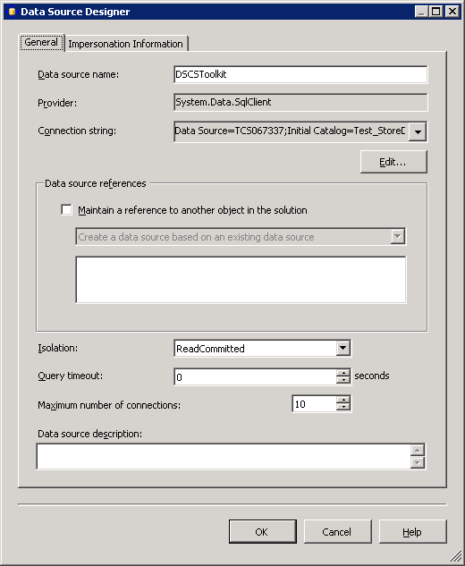
Figure 1: Data Source Designer
- In the General tab click Edit and edit the connection string to point to your DB with appropriate User ID and Password.
- In the Impersonation Information provide the administrator UserId and Password.
- Build and deploy the solution.
- Once the solution is deployed an Analysis Database will be created
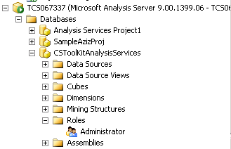
Figure 2: The Analysis database
- Browse to the analysis database Roles option and add New Role as Administrator and provide full control to it.
- In the Membership option add NT Authority/Network Service account to it as shown below.

Working with ScoreCard
- Open ScoreCardCSToolKit.bsw in the ScoreCard Manager Studio. It will look something like this:
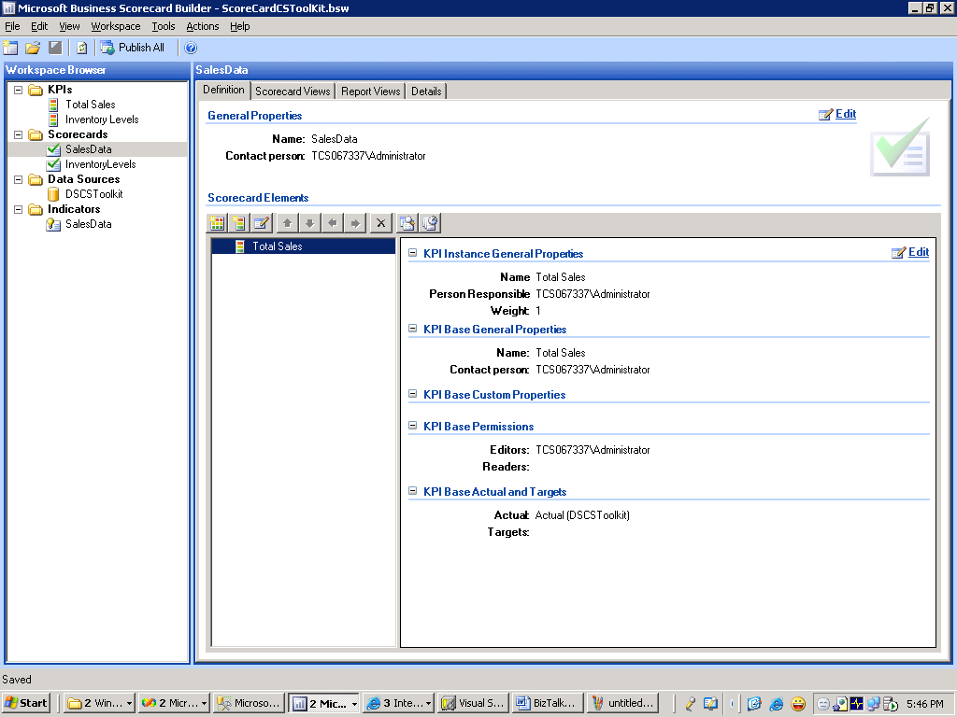
Figure 3: ScoreCard Manager Studio
- From Tools select Server Administration and click Connect. This will connect to the ScoreCard Server.
- From Tools select DeployScoreCard, then select To SharePoint to get the Deploy Scorecard in SharePoint wizard. When you finish the wizard, Share Point will open and publish the page as a dashboard.
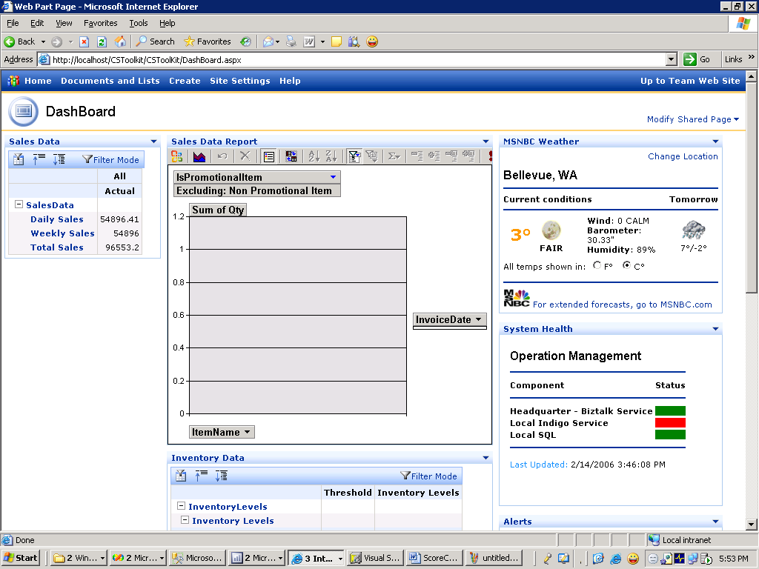
Figure 4: The published dashboard
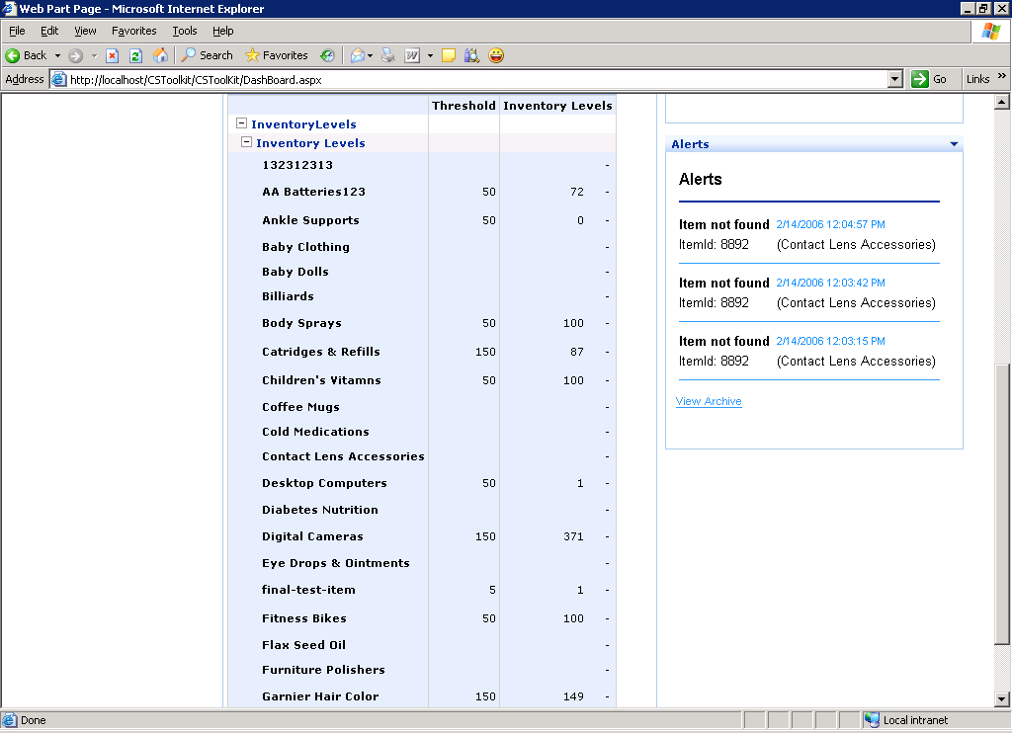
Figure 5: Detailed sales report

Other Web parts (for example, a Weather Web part)
- For Weather use Microsoft Weather Part available within SharePoint, For System Health and Alerts you need to include a Form Web Part, and provide them with the URLs from the SysHealth Project.
- For System Health: http://<Machinename>/SysHealth/OPSDashboard.aspx.
- For Alerts: http://<Machinename>/SysHealth/Alerts.aspx.

Note: Set-up issues
The specific order for installation of components before installing BSM-Builder and Server:
- The BSM needs the Pivot table service installed along with the Service Pack 4 for Windows server 2003.
- For deployment of Web parts and reports, both BSM and SharePoint (WSS) should be on the same machine.
- Security constraints-A user name and password to be supplied while deploying the Web parts in the config file.

Weekly Sales Report:
Following sections describe how to setup reports dashboard using the code.
- The complete solution cstoolkit.sln is present in the CSToolKit_WeeklyReport folder. This solution can be opened in Visual Studio.
- The back up of the Analysis server database (CSToolKit) is given as part of the download.
- Process the dimensions and then process the cube ContosoPortal.
- Open the workspace WeeklySalesReport.bsw. Publish the workspace.
- From Tools click Deploy and select To SharePoint.

Publishing the workspace:
Following section describes how to publish dashboard work space to SharePoint.
- Open the Workspace.
- Check the SharePoint Server Name as well as the Database Server Name and test the connection.
- Check the Database Server Name for the report from the Report View Editor.
- Drag-and-drop the fields that are needed on the chart from the field list.
- Publish the report and deploy it on the SharePoint Site.

Deploying the report:
- Create a new site in SharePoint.
- Deploy both the Notification Web Part and the Sales Report on the same site.
- These Web parts can be added to that site from the Modify shared page by clicking Add Web Parts and then browsing to the Virtual Server Gallery. From the Office Scorecard View option drag-and-drop the Web parts to the site created in Step 1.

Deploying InfoPath form to SharePoint portal - Setting up the secondary data source.
- Open the .xsn file in Design mode.
- From the Tools menu, click Data connections to configure the secondary data source.
- Modify the existing data source by selecting the desired location of the database.
- Click Finish. This will set the data source connection.

Setting up the path for the configuration file
- Open the .xsn file in Design mode.
- Enter the appropriate path of the file containing the configuration settings.
Note: Due to limitation of InfoPath not considering the configuration settings we need to read the configuration settings from a local xml file (part of the download called InfoPathConfig.xml).

Publishing the InfoPath form
- Open the .xsn file in Design mode.
- From the Tools menu click Form Options.
- Select the Security tab.
- From Trust level select Full and sign the form.
- Save the form. It is now ready to be published.

Creating the Set up and MSI for sample applications
This section describes how to create MSI files from code for deployment.

Add Web Deployment Project
- If you do not have the Web Deployment Project ad- in installed, download from:http://msdn.microsoft.com/asp.net/reference/infrastructure/wdp/default.aspx.
- Right-click the Web project you want.
- Select Web Deployment Project from the context menu.
- Right-click and select Property_Page from context menu and fill-in/update the details.

Add Web Setup Project
- Right-click the solution.
- Add Web Setup project template name it.
- Right-click on application folder, select Add, then select Project output
- Select your project from the project list box, for example ABC_WD.
- Make sure Precompiled project output and Configuration as Active are selected.
- Right-click the setup project XYZ_Setup and fill in Output Filename and Location.
- Build Web Setup Project (XYZ_Setup). MSI should be created with the name and location provided in the previous step.
- Select the Web setup project XYZ_Setup from Solution Explorer. Click View , then select Project Windows. Specify options provided.

Run the Web Setup MSI
- Click the .MSI file.
- Provide the required input on the wizard and click Next.
- Edit the Web.config file according to your setup.

To verify the installation
The Web application will be hosted under the virtual directory with the name specified at the time of installation. Otherwise it will be installed with the default name.

Known Issues/Troubleshooting
You might see errors like below in event viewer on machines with Windows 2k3 with SP1 where Indigo service/Supplier or HQSystem Web application is installed:
- The Data cannot be saved because Requested Registry Access is not allowed.
- The Data cannot be saved because the underlying connection was closed: An unexpected error occurred on receive.
This is because the event log does not have the required source for the Web application to log the messages. Web application accounts do not have the required privileges to create the source so an exception will be thrown.

Work around
- Refer to http://support.microsoft.com/default.aspx?scid=kb;en-us;329291
- Add the keys “HQSystem” and “StoreService” at the appropriate locations mentioned in the document.

Hot Fix:
- There are two ways to apply the hotfix. One is to run the command line utility CreateEventLogSource.exe. Without command line parameters to create an event log source in the Application event log with the default names:
- “HQSystem”
- “StoreService,”
- “SysHealth”.
The second way to invoke is from the command prompt. For example: CreateEventLogSource.exe <source1> <source2> to create an event log source in the Application event log. Where <source1> and <source2> are the names provided by the user.
Notes
- If Indigo store service is not accessible from BizTalk server or BizTalk Web service is not accessible from WCF store service then make sure that firewalsl are disabled from respective machines.
- After building the solution if you do not find the MSI in the set location for the project, then make sure that the MSIs are selected in the Configuration Manager Setting for the build. Otherwise you can create it individually by right-clicking the setup project and selecting Build from the context menu.
- Also, you can publish the Web site using the Publish Web site option from the solution’s context menu. Make sure you have created the virtual directory for the site and contents are being published in the physical path of the virtual directory.

Creating the Setup file for the Windows application
- Right-click the solution.
- Add Setup project template and name it ,for example XYZ_Setup.
- Right-click on application folder, then Add, click Project output.
- Select Project from the project list box for which you want to create a setup.
- Make sure Project Output and Configuration as Active are selected.
- Right-click the setup project XYZ_Setup and specify output filename and location.
- Build Web Setup Project (XYZ_Setup). MSI should be created with the name and location provided in the last step.

Run the Web Setup MSI
- Click the .MSI file.
- Provide the required input on the wizard and click Next.
- Edit the <applicationame>.Exe.config file according to your setup.

Creating the Setup file for the Windows service
For more details: http://support.microsoft.com/default.aspx?scid=kb;EN-US;816169

Run the Setup MSI
- Click the .MSI file.
- Provide the required input on the wizard and click Next.
- Edit the <applicationame>.Exe.config file according to your setup.
- Click Start, click Run , click Service.msc, select the service and start.

