A Guide to MSN® Integrated Communication Services:
MSN Spaces
MSN Messenger
MSN Hotmail®

Updated April 2005

For more information, press only:
Rapid Response Team
Waggener Edstrom
(503) 443-7070
rrt@wagged.com

The information contained in this reviewers guide relates to a prerelease software product that may be substantially modified before its first commercial release. Accordingly, the information may not accurately describe or reflect the software product when first commercially released. The reviewers guide is provided for informational purposes only, and Microsoft makes no warranties, express or implied, with respect to the reviewers guide or the information contained in it.

This document is for informational purposes only. MICROSOFT MAKES NO WARRANTIES, EXPRESS OR IMPLIED, IN THIS DOCUMENT.
© 2005 Microsoft Corp. All rights reserved.

* The free MSN service does not include any charges made by a wireless carrier for sending or receiving messages.

Microsoft, MSN, Hotmail, Windows, Windows Media and Encarta are either registered trademarks or trademarks of Microsoft Corp. in the United States and/or other countries.
The names of actual companies and products mentioned herein may be the trademarks of their respective owners.

Contents

MSN Communication Services Overview 4
The Evolution of Communications and Connected Services 5
MSN Spaces 5
Personalization, Self-Expression and Sharing 6
Controlling Access Permissions to MSN Spaces 11
Automatic Notification of Updates to MSN Spaces 12
MSN Messenger 15
Personalization, Self Expression and Sharing 15
More Than Text in the Conversation Window 18
Instant, Rich Communications and Connections 21
Control and Protection 26
MSN Hotmail 27
MSN Communication Services — Working Together 33
Summary 35

MSN Communication Services Overview
MSN® has invested in and delivered rich communication services for years. These efforts have primarily focused on improving and innovating services such as MSN Hotmail® and MSN Messenger, both of which have significant communities of customers that have grown exponentially over the years. In December 2004, MSN introduced a third communication service, MSN Spaces, to complement updates to the Web e-mail and instant messaging services available today in MSN Hotmail and MSN Messenger, at no charge to customers. Each of the services plays an important role in helping MSN meet its vision of bringing consumers closer to the people and information that matter most to them in their individual lives. Although the services address different consumer needs, the integration between the services is critical. It was designed to help customers move in and out of the different communications modes, making the technology more seamless so they can focus on whom they want to communicate with rather than which tool they want to use.

MSN continues to offer value-added subscription communication services, including MSN Premium (the premier all-in-one Web service offering from MSN, optimized to take advantage of a high-speed Internet connection and enhance the online experience and efficiency for broadband users) and Hotmail Plus (the premium Web service for consumers who want to get more out of their MSN Hotmail account). However, this reviewers guide focuses on Microsoft Corp.’s core, free communication services, which serve as the foundation of these premium subscription services.

This set of enhanced communication services focuses on connecting people to their world, helping them more fully express themselves online, and giving them the control they need to connect and share their lives with others. The services outlined in this guide include the following:
- MSN Spaces, an entirely new offering from MSN, provides customers with the features they need to create and publish dynamic online scrapbooks through which they can express their individuality.
- MSN Messenger, one of the most popular instant messaging services in the world, enables consumers to instantly connect with the people they care about most in a personal manner.
- MSN Hotmail, the largest Web e-mail system in the world, enables consumers to access their e-mail from any Internet-connected PC or Web-enabled device in a quick, reliable and easy-to-use manner that offers rich functionality.

Today MSN serves 190 million MSN Hotmail active accounts in 17 languages and 155 million MSN Messenger consumers in 26 languages. The powerful, globally scalable infrastructure on which these consumers communicate facilitates 2.5 billion instant messages and 15 million simultaneous IM connections and prevents more than 3 billion spam e-mail messages every day from reaching our consumers. Continuing to improve these services to scale and help bring these consumers together in ways useful to all of them is key to the MSN vision of integrated communications; the release of these services and upgrades is the first step toward realizing that vision.

The  symbol is used throughout this reviewers guide to highlight interesting features in MSN communication services.

The Evolution of Communications and Connected Services
Different situations and circumstances require different methods of communication. Sometimes people require or want the immediacy of an instant reply; other times a delayed response may work just fine and may actually be desired; and occasionally people just want to make information available that others can view at their leisure and when time permits. This has held true over history with everything from ancient cave drawings, face-to-face conversations, telephone calls and letter writing to other examples such as community bulletin boards or scrapbooks. As time has passed, the desired modes of communication have not really changed, but the technology to facilitate them has evolved.

Since the advent of the personal computer, new forms of communication have begun to become important parts of people’s lives. The earliest computer communications transports were basic e-mail and bulletin boards; then instant messaging and, more recently, new technologies such as blogging and information distribution via RSS have surfaced. Although all these new communications mediums help support individual modes of communications, MSN believes that there are greater benefits for the customer with integration of the technologies where it makes the most sense. In addition, MSN has looked at exciting new ways of enhancing the core features of these technologies to deliver the highest value and communications experience customers desire.

- A key, new integration feature for MSN Communications Services that will be talked about throughout this document is Contact Cards. Contact Cards play an important role in helping customers display and receive updated information about their contacts and easily access and move across MSN Spaces, MSN Messenger and MSN Hotmail. Contact Cards provide quick access to information the contact has chosen to share and also easy access to his or her MSN Space if she or he has set one up. MSN Messenger customers also will see a visual notification called a “gleam” when someone on their contact list has updated her or his Space. Contact Cards, along with other features such as gleams, work together to put customers at the center of their online services and make it easy for them to communicate with those they want to in the way that best suits them.

In the following sections, the new features and enhancements from MSN that deliver on a more integrated and rich communications experience will be explored. In the end, MSN hopes that customers will see the benefits of a complementary set of rich technologies.

MSN Spaces
MSN Spaces, an exciting new community communications offering from MSN, empowers people to express themselves more deeply and interact with those they care about most. Spaces are a customer’s personally managed area and reflection of her or his identity on the Web — a kind of dynamic online scrapbook — where the customer can easily share experiences, thoughts and photos with as many people she or he chooses. MSN Spaces are available at no charge to customers; each Space includes 30 MB of storage for sharing approximately 750 photos, while providing a place and easy-to-use tools to start a Web log (or blog) and share customized information, music lists and more. Yet MSN Spaces also provides flexibility for protection and control over who can access content and how they may do so — as well as enabling consumers to share their Spaces as fully as they want with those in their connected world.

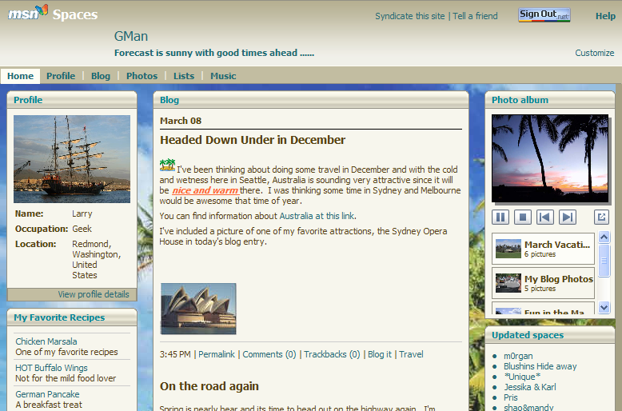
Customized and Published MSN Space

MSN Spaces are easily accessible both to consumers who have created their own Space and those who are visiting someone else’s Space. Consumers can simply go to http://spaces.msn.com, or if they’re among the 155 million MSN Messenger service customers, they can easily access MSN Spaces directly through the latest version of the MSN Messenger client using Contact Cards. Contact Cards are associated with the account of each MSN Spaces creator as well as any contacts on the creator’s MSN Messenger contact list, and if those contacts have a Space, it will be reflected on their Contact Card. MSN Spaces also are easily accessible through the MSN Toolbar for Microsoft Internet Explorer (http://toolbar.msn.com) by clicking on a designated Spaces button.

Personalization, Self-Expression and Sharing
MSN Spaces delivers easy-to-use tools so that consumers can quickly set up and personalize their Space. To initially set up an MSN Space, customers simply go to http://spaces.msn.com, click on “Sign Up Now” and then enter the name of their Space. A valid Passport identity is required, which for any Hotmail or MSN Messenger customer is simply that account name. After the initial setup is complete, customers can customize many aspects of their Space to help represent their personality online. They will see initial placeholders for the more popular basic modules.

Customization of a Space is easily accessible to the creator of the Space and includes options for choosing from among more than 50 Themes (which are similar to Theme Packs in MSN Messenger), different modules and the layout they’d like to use. To access the Theme, Modules and Layout options, customers select the Customize tab in their Space and then begin to select what they’d like to apply to it. Because MSN Spaces is a true online service, all aspects of the service can be customized from any PC with an Internet connection and standard browser. MSN can dynamically deliver updated Themes, Modules and other options as they become available, so customers can have new and exciting ways to update their Space. Below is an example of a Theme being picked for a customer’s space.

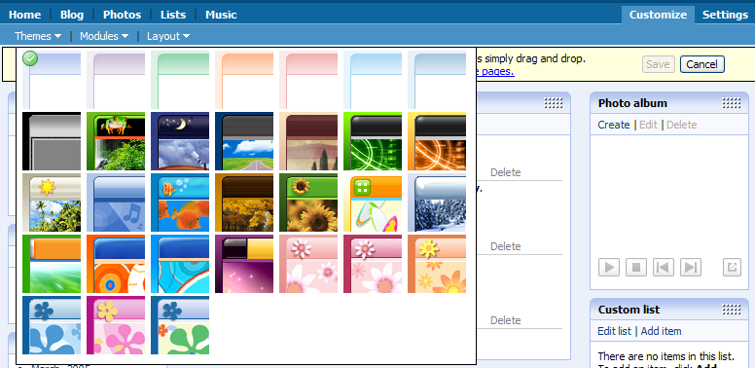
MSN Spaces Themes customization options

Module selection and Layout are also accessible through the Customize tab. Once the customer has chosen the modules they would like to include and the Layout for their space, they can simply drag the Modules around the screen to position them however they likes. At any time they can update the Modules, Layout and themes that they have included in her MSN Space.

Once customers have set up the look and feel of their personal MSN Space, they can begin to populate it with various content. MSN Spaces provides predefined options to help customers get started adding content such as the blogging, photos and music lists; they also can add other custom content and lists. The following is an inclusive list of Modules available in MSN Spaces:

- Profile | - Categories
- Blog | - New Spaces
- Music List | - Custom List
- Photo Album | - Blog List
- Updated Spaces | - Book List
- Archives

The following information will explore some of the Modules available in MSN Spaces.

- MSN Spaces Blog. The blogging phenomenon has certainly taken the online world by storm over the past couple of years, becoming a broad information resource on the Web. While many people consume information from blogs, relatively few have had the ability to publish their own blog. With the introduction of MSN Spaces, MSN has embraced this new communications medium and delivered an easy-to-use blogging module that enables the average consumer to easily create, publish and maintain personal journals, or blogs, online. Any consumer who has used Hotmail or Windows® WordPad will find a familiar, easy-to-use, word-processinglike interface that provides the basic features needed for creating rich, formatted blog entries that can even include photos. Below is the entry screen for an MSN Spaces blog and a picture of the published entry.
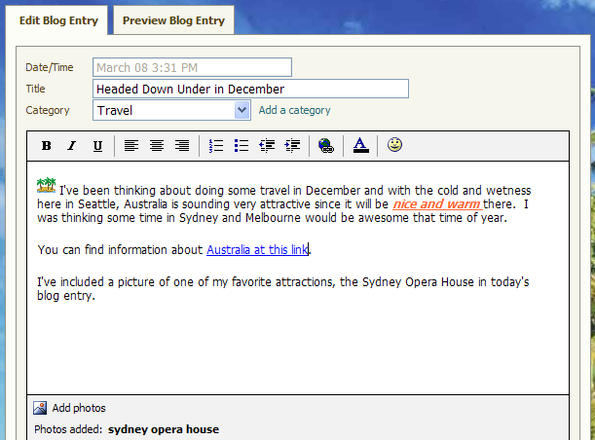 | 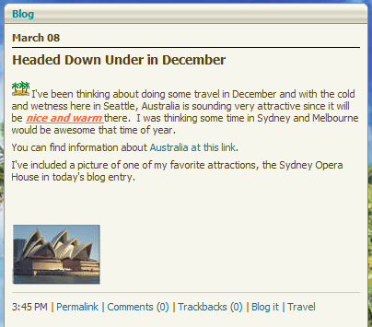
Blog editing and entry screen | Published blog entry

After an individual publishes an entry to her MSN Space Blog, all the MSN Messenger contacts for that person will see a twinkling starburst — or a gleam as MSN refers to it— next to that person’s name in their contact list, indicating a recent update to that person’s MSN Space. Customers of MSN Messenger can go directly to that person’s Space by clicking on her User Tile in the Contact List, which will bring up that person’s Contact Card.
An MSN Spaces blog will include entries for permalink, comments, trackbacks, blog it and category links. These options let blog readers easily link to the blog, comment on the blog they’re reading, see other blogs that have linked to it, and also see blog entries in the related category by simply clicking on the link.
- Updating MSN Spaces from MSN Messenger or Internet Explorer. Since blogging is about capturing what’s going on, ensuring that customers can easily access their MSN Space regardless of what they’re doing online is important. Customers using MSN Messenger can easily access their MSN Space or blog Module through links in the product. Also, customers who have installed the MSN Toolbar Suite can access their MSN Space directly from a button on the toolbar or blog about a Web site they’re visiting; they can even automatically enter a link to that Web site into their blog entry.
- Mobile and remote updates to blogs. In addition to being able to update their MSN Space from any Web browser, customers can also send mobile phone entries to their blog or upload photos they’ve taken with their text-enabled mobile phone* to their Space from those mobile devices. From the Settings tab, customers can set this up on the Mobile Settings page, which will walk them through the process to enable mobile publishing. The MSN Spaces page also takes steps to help ensure that only the Space owner can use mobile publishing on her Space by authorizing the specific e-mail address that is registered to the publisher of the Space. For enablement of a mobile device that phone number would simply be the device’s e-mail address. However, that e-mail address could also simply be an e-mail service address, meaning for example that updates could be sent from a Hotmail account to an MSN Spaces blog. This enables round-the-clock access to MSN Spaces whether at a computer or on the go with an e-mail-enabled mobile device.
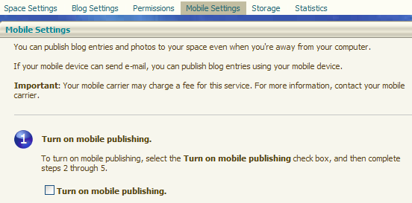
MSN Spaces Mobile publishing settings

- Online photo albums. With MSN Spaces, customers can easily share photos stored on their computers or use photos that they have online in their Space to create online photo albums they can share with others. Visitors to a customer’s MSN Space can view slide shows of the online photos through the photo module and also see photos embedded in blogs on the Space.
Each customer’s Space receives 30 MB of storage for photos, which equates to roughly 750 photos. Within the design mode of MSN Spaces, customers can create as many albums as they like up to 30 MB, to share their photos and title each album individually.
From the Photo Album module on their MSN Space, customers select the Create option to begin creating photo albums and populating them with photos from their hard drive or other albums on MSN Spaces. When in the Add Photos dialog box, customers can not only add photos to their album, they can also perform basic photo editing such as rotation, brightness, contrast and cropping on the screen. Below is an example of the Add Photos dialog box, which includes thumbnail views of the photos that can be selected for uploading as well as a convenient storage meter that shows exactly how much space is available for photo uploads.
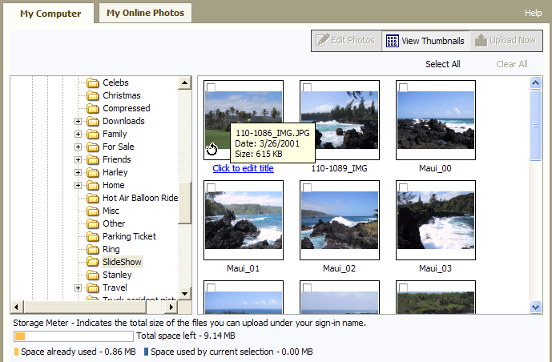
MSN Spaces Add Photos dialog box

Once photos have been edited and selected, the customer simply clicks the Upload Now button, and the photos are sent to the MSN Space where they can be shared and viewed by others. When visitors come to an MSN Space with a photo album module displayed they will see a list of all the albums available from the space creator as well as any photos that are hosted in the person’s blog module.
- Music lists from Windows Media playlists. MSN Spaces makes creating and publishing favorite lists of music extremely easy for customers who use Windows Media® Player for their music management and playing. In the Music module of MSN Spaces, customers can easily import their Windows Media playlists to show others the music they like and are listening to. Customers can also create fully customized music lists in their Spaces separately from Windows Media Player if they don’t have the actual music that they would like to highlight in the list. In delivering music list functionality, MSN wanted to ensure that customers had the flexibility to make updates or changes whenever they want. For example, song information can be added a single song at a time or though the easy Windows Media importing feature, and entire lists can be renamed or deleted as well by the MSN Spaces owner.
Once a list is created, visitors to the owner’s MSN Space will see a dropdown list of all the music lists the MSN Spaces owner has created. Visitors can even rate the music lists using a system of one to five stars to indicate their like or dislike of the contents. Details found in the music list can include the song, artist and album name as well as a specific URL on the MSN Music site from which to download tracks.
- MSN Spaces Music List connections to the MSN Music service. Visitors to MSN Spaces Music Lists will discover that MSN has made it convenient to find the actual music associated with the songs, artists and albums in the lists they view. By clicking on a tab in the Music Lists, the Spaces visitor will be taken to the MSN Music service where she can find related information and in many cases will even directly purchase music. The MSN Spaces Music list feature makes it easy to share musical interests with visitors to a customer’s Space. These lists can easily be compiled manually or by using Windows Media playlists. Visitors to MSN Spaces will find the information easy to access; they will be directly linked from the Music List content they’re viewing to the MSN Music service where they can find more high-quality information on songs and artists as well as directly purchase music.
- Other list types (books, blogs and custom lists). MSN Spaces delivers a set of default list types such as the previously described Music List feature and also template lists for books and information on other blogs. Because there are so many interests on the Web, MSN Spaces also delivers the flexibility for creating customized lists. For example, one person may want to share a list of her favorite recipes online; another person may have a list of local restaurants; and yet another may want to share her top 10 favorite vacation getaways. MSN Spaces caters to those individual interests and makes it easy for Space creators to express themselves on their terms.
MSN Spaces makes it easy to create a personalized place on the Web. Customers can quickly get set up and choose exactly the look and feel that they’d like for their Space including the Theme, Module and Layout. Whether they want to share recent photos from a vacation or weekend outing, or lists of the music they enjoy, or simply create a rich daily journal or blog that can also include photos, MSN Spaces provides customers with easy-to-use but powerful tools. Sharing information has reached new levels of ease with MSN Spaces.

Controlling Access Permissions to MSN Spaces
MSN Spaces helps ensure that customers’ information and experiences are shared only with whom they choose, and on the terms they choose. MSN Spaces makes it easy for customers to apply levels of permission to the contents of their Space and write privileges in the blogging area. Integration of MSN services has been shown to be a useful tool in helping to keep MSN Spaces contacts up to date, and that integration also makes it easy to set permissions regarding who can view a publisher’s Space.

- Permissions settings. Customers can easily limit who can view their MSN Spaces content. A simple and easy-to-understand Permissions page helps customers adjust their settings. They can enable broad public viewing by anyone on the Internet; limit it to people on their MSN Messenger Allow list; or allow only the people they select in their MSN Address Book to view their Space.
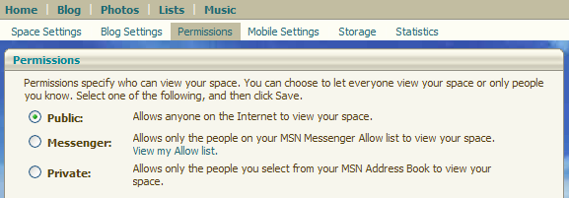
Permission settings available to MSN Spaces publishers

- Blogging specific permission settings. Customers not only have the ability to broadly place permissions on their entire MSN Space, they can also set more granular permissions on the blog module in their Spaces. They can choose whether to allow comments on their blog entries and whether to disable or enable trackbacks; they can also decide whether those trackbacks can be from any public Web site or only other MSN Spaces.
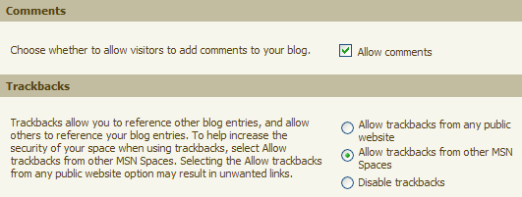
MSN Spaces blog permission settings

- Site visit statistics. MSN Spaces include statistics and referrer information so Spaces publishers can see how many page views to their site have occurred over time; the service even provides specifics on the date and title of the page. This information helps Spaces owners understand what others find interesting on their site and where they may want to add or enrich their content.
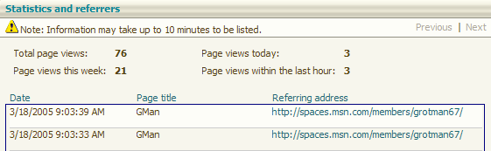
MSN Spaces visitor statistics information

Putting customers in control of how and with whom their information is shared was a key consideration when MSN Spaces was designed. The Permission settings in Spaces are easy to understand and help customers choose how broadly or narrowly they want to share their information, from the entire Internet down to specific individuals they know or with whom they already communicate.

Automatic Notification of Updates to MSN Spaces
MSN Spaces delivers exciting capabilities for creating a personalized place to easily share information and express one’s interests, but also powerful ways to help others locate the information online. MSN Spaces was created to not only enable personalization and sharing, but to provide customers with new ways to connect with the people they know. Enabling features that make connecting with and notifying others of new information was a key design goal for MSN Spaces.

Whether customers are on a computer using a communications program such as MSN Messenger or roaming about with their mobile phone, MSN Spaces enables notification features so customers are always up to date on changes made to Spaces that interest them. Some of the exciting features that help MSN Spaces customers automatically notify others when they’ve made updates include MSN Messenger notification gleams, Contact Cards, RSS publishing and mobile alert updates.

- MSN Messenger notification gleams. Many MSN Spaces customers also use MSN Messenger for the instantaneous communication benefits it provides. With the release of the newest version of MSN Messenger these customers will also see new “gleams,” or starbursts, next to the names in their MSN Messenger contact lists for those people who maintain MSN Spaces and have recently updated them. These gleams provide an automated way for Space publishers to notify people with whom they have MSN Messenger relationships that the publisher has updated their MSN Space with a new blog entry, additional photos or modifications to lists on their Space. Gleams are also a great way to let those with whom the publisher may not have contacted via instant messaging recently know that they have an MSN Space and some information that they would like to share. Through this point of integration, Spaces creators will find that they’ll have more visitors to their site, faster responses to new postings, and possibly closer relationships.
- Contact Cards. Contact Cards are a complementary feature to MSN Messenger notification gleams that help MSN Messenger customers easily access an MSN Space when a notification gleam signals an update. When a customer sees a gleam on their MSN Messenger contact list, they can simply click on the gleam to see a Contact Card for that person and get direct access to the contact’s MSN Space or areas n the Space such as the latest blog postings or photo album entries. In addition to the information listed on the front of the Contact Card, if the card is “flipped” over, other information the contact chooses to share such as e-mail addresses and phone numbers for the Contact Card owner will be shown.
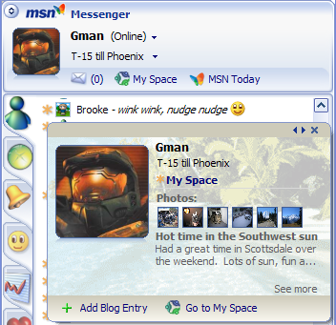
Contact Card in MSN Messenger showing access to MSN Spaces, photos and blogs. Also in the background an MSN Messenger gleam icon is shown to the left of contact name in the list.

- RSS publishing. Web users have started to adopt RSS technologies so they can receive updated information from specific sources without going to the source's Web sites. MSN Spaces incorporates support for publishing using RSS so that people interested in receiving automatic updates on Spaces they’re interested in can do so through any standard RSS reader. MSN Spaces customers simply select Settings while in design mode; they then can scroll down the page to a syndicate checkbox for enabling RSS publishing and syndication for their Space. Space publishers simply check that box and click on the Save button, and their Space will be syndicate, and standard RSS newsreaders and aggregators will be able to receive feeds from it.
MSN also recently made an RSS aggregation module available on personalized My MSN.com pages so customers can include RSS feeds on their My MSN page for a truly customized experience. These feeds also can include those syndicated by MSN Spaces.
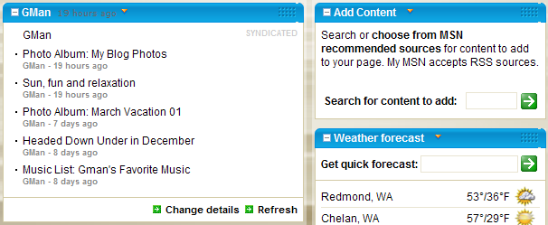
My MSN RSS aggregation of MSN Spaces content and the Add Content module for incorporating new RSS feeds onto a My MSN page

- Alerts for MSN Spaces updates. MSN Spaces customers can sign up to be alerted when their favorite public Spaces are updated or when a visitor comments on their own Space. Alerts can be received via e-mail, SMS text message* or MSN Messenger instant messenger “toast.”
By delivering these automatic notification features, MSN Spaces makes it effortless for Space publishers to alert others that they’ve posted updated and possibly interesting content on their Space. People interested in following content in MSN Spaces have multiple ways of doing so: simply keeping a list of favorite Spaces they enjoy visiting; using the Contact Cards in MSN Messenger to quickly jump to the Spaces of their Messenger contacts; or using some of the automated notification methods such as gleams in MSN Messenger or viewing the syndicated RSS feeds from MSN Spaces. MSN Spaces and complementary technologies such as MSN Messenger and My MSN make it easy to stay up to date on new information in MSN Spaces.

MSN Spaces delivers a comprehensive set of personalization and information management features to help MSN customers create a presence online that represents who they are and where they can easily share what interests them. Spaces deliver to customers the flexibility that allows them to choose exactly the modules and theme they want as well as the ability to simply drag and drop the modules to design their Space — all of which can be changed at any time. Once a Space has been established, customers can populate it with happenings in their daily lives through blogs, photo albums, or the creation of lists, regardless of scope or topic.

Customers can choose exactly with whom they share their information through the easy to set permissions in Spaces. Once they’ve established their Space and chosen who may visit, they simply send a link via e-mail letting people know it’s available. Contacts who are MSN Messenger customers will automatically be notified through gleams in Messenger and can go directly to the Space by accessing Contact Cards through their MSN Messenger contact list.

MSN Messenger

Since its launch in the summer of 1999, MSN Messenger has seen its instant messaging community grow to more than 155 million customers. MSN Messenger has evolved from a basic software tool for exchanging quick bursts of text to a rich, fully featured tool for communicating and sharing experiences and information online. Today with MSN Messenger customers can not only enjoy instant messaging, they can also initiate rich audio and video conversations, play games, and easily exchange files and pictures with others. MSN has incorporated ways of providing a more personalized experience for consumers, such as enabling them to display custom user tiles or create custom backgrounds that help represent their interests and personality.
MSN Messenger 7.0 delivers even more personalization flexibility and rich ways of connecting with friends and others through exciting new communication options. Consumers who use MSN Messenger and MSN Spaces will discover methods of more fully expressing themselves online and helping to automatically update their MSN contacts when they’ve made changes to their Space. When an MSN Messenger contact on someone’s list has updated their MSN Space, there will be a visual indicator called a gleam displayed next to the contact icon as a way of notifying others that there is an update on the contact’s MSN Space.
This release of MSN Messenger also delivers closer connections to MSN Hotmail, with MSN Web Messenger integration built into the MSN Hotmail experience. The goal with these updates is to provide the richest possible communications service experience for customers and enable benefits for customers who use multiple offerings such as MSN Messenger, MSN Spaces and MSN Hotmail. The following information will look at the new release of MSN Messenger and the powerful features it delivers to help customers personalize and extend their instant messaging experience beyond words.

Personalization, Self Expression and Sharing
Beginning as early as MSN Messenger 5.5, personalization and sharing features began to be incorporated into MSN Messenger, and they have continued to be areas in which MSN has invested heavily based on customer feedback and research. With the new version of MSN Messenger, the focus on personalization and enabling customers to express themselves has continued, offering them exciting new ways to show their online personality such as a custom picture display, creation of customer emoticons or providing information about music they enjoy.
Exploring the MSN Messenger Contact List
MSN Messenger customers will notice exciting new updates to Messenger the first time they open their contact list. They’ll see not only contact names and status icons but updated information for themselves and all their contacts, especially those who have also upgraded to the latest version of MSN Messenger and are using MSN Spaces.
Some of the updates in the primary contact list window include the following:
- Personal message field that is fully customizable
- Music playlist integration in the personal message field
- Customizable display picture and dynamic display pictures
- E-mail status notification
- Easy access to MSN Spaces
- Gleam notifications, denoting updated MSN Space information for members on the contact list
- Quick and easy Contact Card access and viewing

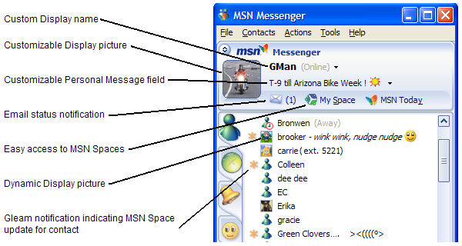
Overview of contact list features

While MSN Messenger customers have been able to modify properties such as their display name and user tile for some time, they’ve continued to ask for more personalization options to help express themselves to their contacts while online. This version delivers on these customer requests in a variety of ways.
Changeable display picture. MSN Messenger has included the ability to change the display picture, or user tile, for some time. These pictures can be chosen from those included with MSN Messenger, but they can also be downloaded images, fully customized art or actual pictures from the customer’s digital photo library. Changing the display picture can help represent one’s online persona thorough a visual representation shown in the contact list, as well as during instant messaging conversations.
- Dynamic Display Pictures. The new release of MSN Messenger brings an exciting new update to the display picture area, known as Dynamic Display Pictures (DDP). Dynamic Display Pictures not only allow a customer to change the visual image that represents her online, they are also animated and will act out emotions based on the corresponding emoticons the customer enters during conversations with others. For example if a customer types a ☹ during an IM conversation, the Dynamic Display Picture may make a related gesture symbolizing sadness. Customers also can go to the dropdown menu below their DDP to choose emotions and actions from a custom list made for that specific character. Below are examples that show differing emotion option menus for two DDPs.
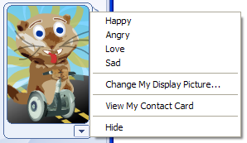 | 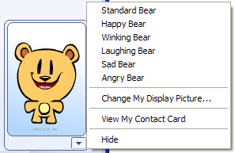
Sample Dynamic Display Pictures and related emotion animations

A selection of DDPs will be available free to MSN Messenger customers. However, an additional broad and growing selection of DDPs will be available for a minimal cost. Customers will simply make a nominal payment for those DDPs to be able to download them. There are also a variety of DDPs available from Blue Mountain, including some that can be customized. Muggins are an example of customizable DDPs where the customer can pick the character, expressions, outfit, environment and other features.
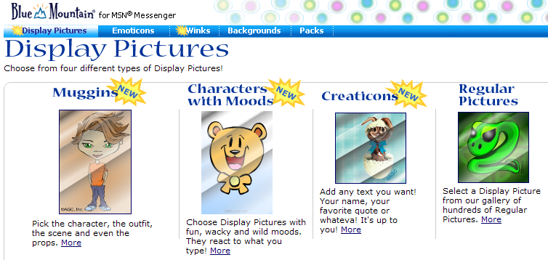
Various Dynamic Display Pictures options

- Customizable Personal Message entry field. Many customers had taken advantage of the customization capabilities available for changing their Display Name to help express a change in location, mood and other life happenings. With the new version of MSN Messenger it gets even easier to customize the Display Name. Now in the main contact list window, customers can click directly on the new Personal Message entry field to change it whenever and as frequently as they want. They can even include fun emoticons as part of their Personal Message entry field. Customers can view the personal messages of the friends on their contact list alongside the display icon and display name for those contacts. Customizable personal message fields are just one of the fun new ways to enhance the instant messaging experience with MSN Messenger.
- Music personal message. Not only can the Personal Message entry field be used to display custom text by MSN Messenger customers, it also allows customers to select a simple option for sharing information on what they’re listening to in Windows Media Player with their MSN Messenger contacts. By clicking the dropdown box next to the Personal Message entry field in the conversation window, customers will see an option that says “Turn On ‘What I’m Listening To’”. Alternatively, they can select the menu item on the Tools / Options / Personal settings screen that says “Show song information from Windows Media Player as a personal message”. Once they’ve selected this option, whenever they’re listening to content in Windows Media Player, the information on that content will be displayed in place of their existing personal message. In addition, for those markets where MSN has an online music presence, the information being displayed in MSN Messenger can be clicked on so that the Messenger contact can jump directly to the MSN Music site to find more information about that music, preview the song, or even purchase it. Music personal messages even show what’s playing when someone is using the iTunes player. Music personal messaging is a great way of sharing musical interests with other MSN Messenger contacts and even providing them with a direct way to acquire the same music their contacts are listening to.
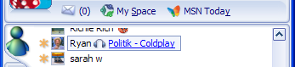
Music personal message showing in a MSN Messenger contact list

- Gleaming, Contact Cards and connections to MSN Spaces. MSN Messenger makes it easy to see when a Messenger contact has updated her MSN Space. With the addition of gleams to the contact list, a quick glance will reveal who has updated her MSN Space. Automatic notification tools help bring in the friends of an MSN Spaces publisher to check out her new additions. Clicking on a gleam or a personal display picture in the MSN Messenger contact list will bring up that person’s Contact Card. The front of the Contact Card provides summary information on a customer’s MSN Space and direct access to the Space as well through a convenient My Space link. The Contact Card can also be turned over by clicking on the navigation buttons in the upper right corner of the card to display contact information such as e-mail addresses and telephone numbers the contact has chosen to supply.
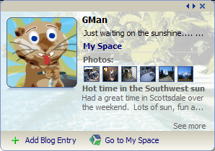
Front of Contact Card with MSN Spaces look and information | Back of Contact Card with supplied contact information
With the combination of gleams and Contact Cards, MSN Messenger customers have a convenient way of knowing if someone on their list has updated her MSN Space and of getting quick summary information and access to the Space via a direct link on the Contact Card.

More Than Text in the Conversation Window
The MSN Messenger conversation window benefits from several exciting enhancements in this version as well, including features such as Winks, ink handwriting on any computer and new activities. Traditionally, instant messaging conversations were simply that — text messages being exchanged instantly. However in the last couple of years there have been ongoing developments that have enriched the instant messaging experience and incorporated new levels of self-expression.
When MSN Messenger enabled the use of emoticons, they were an instantaneous new favorite and broadly used feature. No longer was a smile a simple character-based representation such as :-) in an IM conversation; now it took on a personality . In addition, MSN Messenger delivered animated icons such as a winking smiley face or a birthday cake with fluttering candles that would actually show action in the IM conversation window. Customers not only began to use these animated icons in conversation, but to represent their moods as part of their display names. In the interest of delivering the broadest customization possibilities, MSN also enabled custom emoticons so customers could draw their own or even use scaled-down digital photos as emoticons. Sites such as ilovemessenger (http://www.ilovemessenger.com) serve as online areas where the MSN Messenger community can come together to exchange custom emoticons they’ve created. At the time this reviewers guide was created, there were nearly 6,000 custom emoticons available on ilovemessenger alone available for download.
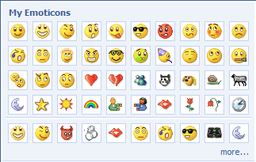 | 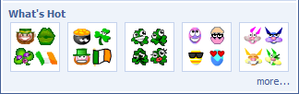
Emoticons available in MSN Messenger | Rotating selection of emoticons based on holidays and other events
- Winks . Building on the popularity of emoticons, MSN took the concept a step further and introduced Winks in this version of MSN Messenger. Winks are visual and audible animated expressions that help customers get their point across by temporarily taking over a portion of the screen of the person the customer is IMing. After receiving a Wink, customers can replay it while they have their MSN Messenger session open. If customers don’t see the expression they’re looking for in the Winks included in MSN Messenger, they can download additional ones. Many Winks will be available as part of free MSN Theme Packs and others will be available through MSN partners for a minimal charge. An up-to-date version of Macromedia Flash is required to use the Winks feature in MSN Messenger.
- Theme Packs . Customers can add personality to MSN Messenger sessions by applying a theme to the instant messaging conversation window with rich free and paid-for content. Theme Packs can include background images, display pictures, custom emoticons, Winks and other features. Customers can access Theme Packs by clicking on the package icon in a conversation window.
- Backgrounds. Customers can customize the entire background of the MSN Messenger window by choosing from background options available in MSN Messenger, or they can create custom backgrounds from virtually any digital image. Consumers can also share their background with those with whom they have engaged in IM conversations. The customer can create a custom background just by dragging and dropping a photo onto their Messenger conversation window.
- Nudge . Sometimes it’s important to make sure the person on the other end of an instant messaging conversation hasn’t tuned out. MSN Messenger gives customers the power to give a virtual tap on the shoulder by sending a “nudge.” A nudge shakes the MSN Messenger window of the other people in the IM conversation, to make sure they’re still paying attention. Nudges are just another way of adding some fun to the IM experience.
- Free-form handwriting. Previous versions of MSN Messenger enabled the sending of “ink” messages when consumers were using Windows-based Tablet PCs. Now this functionality has been extended to all MSN Messenger consumers, so they can personalize their experience by including their writing or doodling in their MSN Messenger conversation. To use ink in an MSN Messenger conversation, customers simply click on the pen symbol at the bottom of the conversation entry window. This will switch them to inking mode, and then they just write or draw using their mouse.
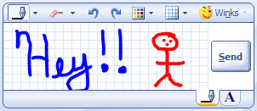
Handwriting example in the MSN Messenger conversation window
Anything that can be written or drawn can be entered as ink conversations. It’s a great way of communicating things that words just won’t capture. Customers can even switch back and forth between ink and standard text IM conversations by clicking on the pen or A tabs at the bottom of the text entry window.

Instant, Rich Communications and Connections
The core of any compelling communications experience is flexibility and the ways in which it brings people or groups together. MSN Messenger delivers exciting and diverse ways of communicating while online. Whether people are at their PC or somewhere else and want to simply communicate via text, engage in a rich video and audio conversation, or exchange such things as files or pictures, MSN Messenger delivers the tools to enable the experience.
As the Internet has evolved and customers have adopted broadband at increasingly accelerated rates, the opportunities to deliver enhanced communication options in MSN Messenger have increased. Over time the instant messaging options have matured from simple text to the rich, full multimedia communications experience MSN Messenger offers today.
- Full screen video complemented by excellent audio quality at no charge. With this release of MSN Messenger, MSN delivers a new, seamless video and audio conversation experience to its customers. Previous versions of MSN Messenger laid the foundation for what is in today’s product by delivering basic video and audio conversation capabilities. These previous implementations had their limitations, such as small video window size, an audio feature that only worked in specific networking environments and a nonjoined experience between the video and audio capabilities. This version of the offering works to address these limitations and deliver a rich and easy-to-use video and audio conversation capability.
MSN Messenger customers who have video and audio capabilities, such as an audio/video enabled webcam like those Logitech offers, attached to their computer can now start a synchronized, combined video and audio conversation by clicking on a single option, or they can choose to start an audio-only or a video-only conversation. The choice is theirs. The quality of the experience will depend on the customer’s Internet connection speed; those that are on a standard broadband connection can expect high quality for both video and audio. Customers on slower connections such as dial-up may find a better-quality with audio only or video only.
MSN has aggressively worked to deliver a complete audio-video experience that works across the majority of PC network configurations including firewalls and routers. In most situations, customers will find that they are quickly connected after initiating a Video Conversation.
To start an audio-video combined conversation while in an MSN Messenger session in which both parties have webcams, customers simply click on the Webcam icon on the main task toolbar in MSN Messenger and then select “Start a Video Conversation”. Once they’ve done this, an invitation will be sent to the other person in the instant messaging conversation asking her to accept or decline the invitation. Once the invitation is accepted, the two machines begin the connection process, which may take a few minutes depending on the network configuration for both machines.
When the connection is established, both parties will see live video presented in place of their current display tile and begin to hear audio as well. This mode of audio-video conversation allows for simultaneous instant messaging activities while having the conversation. However, if a customer would like to experience full-screen video, she can either click on an icon in the active embedded video window in the current IM conversation or choose Full Screen on the dropdown menu below the video. In full-screen mode the computer screen turns into a video display, covering all other applications. The video image from the customer’s own camera will be presented as a small, active image in the lower right corner of the full screen video image of the other customer. To return to a smaller image, the customer simply clicks on the lower left corner of the screen where there is an icon for restoring the size.
With the new version of MSN Messenger, customers who have a webcam, microphone and speakers will discover rich new capabilities for connecting with others. These rich media features enable a new level of expression and fun for Messenger customers and accessing the experience is only a single-click process.
- Search and Shared Search integration. The rise in interest related to searching on the Internet and its value as an information resource has not gone unnoticed by the MSN Messenger team. With the release of MSN Search in February 2005 there are exciting new ways of accessing information related to conversations in MSN Messenger. For example if people are having an IM conversation about a restaurant or a vacation getaway, they may want to find details such as location, phone numbers or reviews. MSN believes there is no reason for people to ruin the flow of their conversation by jumping from one application to another looking for these details. MSN Messenger provides various entry points to MSN Search in the IM experience so customers can search for information as a complement to their other communications.
Customers can choose how and when to execute an MSN Search in MSN Messenger. They may simply choose to do a search outside of an IM conversation and see the results separately, or they can have those results included directly in their MSN Messenger conversation as a Shared Search. If they would like to do a separate search from their conversation, they can simply enter the search subject in the search bar on the MSN Messenger contact list, or they can right-click on words that have entered their IM conversation. Customers can highlight words in an IM conversation, then right-click on the words and choose the location for their search, whether it is the Web or local desktop, or Web categories such as news or images. Customers can use the Near Me vertical search option, which uses reverse IP technologies or the customer set location found in MSN Search settings to determine the location of businesses and other entities that are close to them. The results will be displayed to them in a browser window.
With Shared Search customers can perform a search that returns results directly in their instant messaging conversation. To perform a Shared Search while in an IM conversation, customers simply click on the new Search button below the Send button in the Messenger conversation window, or they can right-click on a set of words and select Shared Search from the menu options to initiate a search in the conversation.
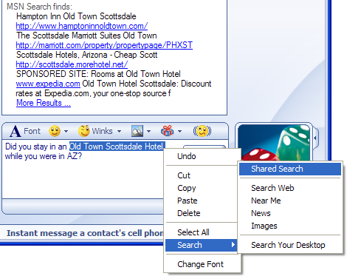 | 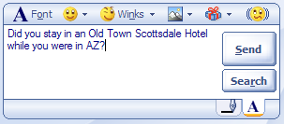
Shared Search and other options for executing searches during an MSN Messenger Conversation | New Search button on the conversation window
When a Shared Search is performed, the top results are presented directly into the IM conversation window. If there is a direct answer available in MSN Search, it will be presented at the top of the results and called out with “Answer:” and the corresponding information.
The integration of the MSN Search experience into MSN Messenger opens up a world of new possibilities for easily and seamlessly getting to information. Customers of MSN Messenger can choose to see that information presented separately or as part of an actual conversation.
- Interactive activities. MSN Messenger includes a dynamic list of activities that customers can engage in during their connected IM conversations. This list changes occasionally and will include new activities as they become available. The activities include those that are available to customers at no charge, including MSN Photo Swap. A new activity included in this release of MSN Messenger is The Conversationator, which demonstrates a fun way to inject humorous additions into an IM conversation. Other activities include File Sharing and collaborative Movie Trailer viewing. MSN Messenger delivers a variety of activities to enable creative uses of customers’ IM connections.
- Interactive games. MSN Messenger continues to add a variety of free and pay-to-play games, available through the games icon on the toolbar, making it more fun to connect with others on MSN Messenger. The list of games in MSN Messenger is dynamic and can be updated independently of the client software, so customers should check back regularly to see if new games have been added. The MSN Instant Games Clubhouse, now available in 25 countries, is a subscription service offering a range of popular, well-known games, including “Wheel of Fortune” and chess. The Games page also offers free games, which vary by market. With the connections created by MSN Messenger customers during conversations, adding games to those conversations is as easy as the click of a button on the toolbar.
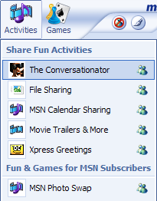 | 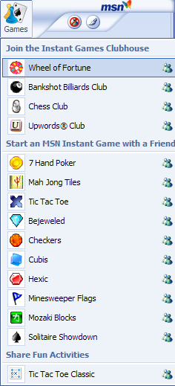
MSN Messenger Activities List | MSN Messenger Games List

Web Messenger client. Customers can now easily connect to MSN Messenger from virtually any computer that has an Internet connection. Without downloading any software they can simply go to http://webmessenger.msn.com and sign in, using their existing MSN Messenger account information. Although they will not receive the full, rich experience provided by the full MSN Messenger client, customers will find that the MSN Web Messenger experience provides the basic features they need to contact those in their instant messaging world from any location.
- Single address book. Extensive work has gone into a feature that customers will not readily see but that will benefit them. Now customers can use a single address book to manage detailed information about their Messenger contacts and Hotmail e-mail contacts. Since there are so many points where the functionality touches each of these programs, delivering an integrated contact and address book experience will make information management easier for customers.
- Mobile messaging.* MSN Messenger supports several mobile messaging scenarios, whether it’s sending messages from MSN Messenger to mobile devices or receiving messages from mobile devices to MSN Messenger. These options ensure that MSN Messenger customers are only a Short Message Service (SMS) message away from their contacts as long as they have their mobile device.
To enable outgoing mobile messaging to contacts in MSN Messenger, customers can simply add mobile phone number details to the information for the people already on their Messenger contact list if the information isn’t already there. Then when these contacts are offline in MSN Messenger, their icon will take on a yellow designation with a mobile symbol on it. Clicking on these yellow messenger icons will open a Messenger conversation window as normal; however text entered and sent will go to the contacts mobile device via SMS instead. The mobile message receiver can then simply reply as they would to any SMS message and it will be sent back to the MSN Messenger client.
Even if someone is not an MSN Messenger contact, she can still be set up as a mobile MSN Messenger contact. Even though the MSN Messenger customer would not be able to directly IM the contact, she could send an SMS message anytime from the MSN Messenger client by selecting the yellow mobile icon, typing the message into the conversation window and sending it as she would a normal MSN Messenger message. The message would then be delivered via SMS to the contact’s mobile device. The mobile message receiver can then simply reply as she would to any SMS message, and it will be sent back to the MSN Messenger client.
MSN Messenger customers can set their mobile message settings so their MSN Messenger contacts can easily send them messages while the customer is offline. All the customer needs to do is enter her mobile phone number and check the box to enable the capability in the Tools / Options / Phone settings menu in Messenger. When she logs into MSN Messenger at her computer, she will see the messages and can reply to them.
- Two new additional features enable even greater mobile functionality for MSN Messenger customers: Customers can now use special commands on their mobile handset to see who on their Messenger contact list is online, and initiate conversations from the mobile device and receive replies.
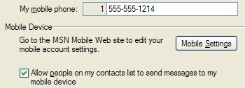 | 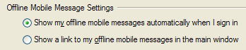
Tools / Options / Phone mobile settings | Tools / Options / Messages mobile settings

These exciting new mobile features in MSN Messenger enable scenarios where customers can always stay in contact with people on their Messenger list, regardless of whether they’re at their computer or on their mobile device.

With MSN Messenger consumers have powerful tools for enabling exciting communication options, staying connected to their contacts and finding the information they need to answer questions. Whether they’re at their PC or roaming, they can get access to their MSN Messenger community through the rich client or the convenient Web-accessible MSN Messenger client, available through virtually any Internet-connected Window-based PC. If a subscriber contact is designated as mobile-enabled, the subscriber can simply IM that contact from MSN Messenger to the contact’s cell phone as well. MSN Messenger delivers the options and tools that consumers need to be in contact with their IM world.

Control and Protection
- Status message. Customers can now set their status before they sign in or at any time while they’re signed in, so they can control whether and how their contacts view their online presence. A stealth sign-in mode enables customers to sign in without appearing to be online, so they won’t be interrupted if they don’t want to be.
  - Contact list management. MSN Messenger enables customers to choose who will appear on their contact lists through an accept or opt-in model of adding new contacts. Before a person is ever added to the Messenger contact list, customers can use their Allow List to help ensure that they receive messages from those people they choose or use Block to keep people out of their contact list.
  - Helping to protect against anonymous IMs. MSN Messenger helps protect consumers from IMs sent from unknown or anonymous senders by blocking these by default. These messages are typically “spim,” or instant messaging spam.
  - Integration with anti-virus software. Customers who have antivirus software installed on their PC hard drives can choose to have that software automatically scan file transfers that they receive via MSN Messenger. This option is enabled through the Tools / Options menu; customers simply browse to find the antivirus program on their hard drive and add it in. Once they’ve done so, whenever someone transfers a file to them, it will automatically activate the antivirus software, which will scan the file before making it available to the customer.
  - Accept wanted items from file transfers. MSN Messenger customers can decide to accept or decline what is sent to them during IM conversations, including invitations for advanced communication features such as webcam, and audio conversation or file transfers from people with whom they’re in IM conversations. For file transfers of graphic images and various document files consumers are presented with thumbnail representations so they can get an idea of what they’re about to transfer as well. When customers are unsure of the content of a file or the destination of a URL in an IM conversation, they should not accept or click on those links to help prevent the download of malicious files to their machine.
  - Security enhancements to the Messenger Service infrastructure. Updates have been made to the underlying Messenger service infrastructure to help increase protection for customers of the service, including features designed to provide early awareness of viruses, worms, spim and other malicious activities.
  - MSN Parental Controls integration. Customers who subscribe to MSN Premium services can also apply Parental Controls to their children’s Messenger account to approve any requests to add or be added to other MSN Messenger contacts. Even if a child goes to another computer or uses another Messenger service client such as Windows Messenger, those controls are applied to the account and contact list.

MSN Messenger strives to incorporate features that help consumers stay in control of their instant messaging experience and those with whom they communicate. Many of the features and benefits are transparent, but consumers enjoy the benefits of a real-time communications experience while using MSN Messenger because of them.

MSN Hotmail

Like MSN Spaces and MSN Messenger, enhanced MSN Hotmail connects people to their world on their terms, delivering on consumer requests for greater protection and control of their e-mail experiences, and greater means for self-expression and sharing. It also enhances productivity so people can save time and still get more done.

Consumers using MSN Hotmail will see new areas that help bring the MSN Messenger and MSN Hotmail experiences together. While consumers are in Hotmail, they can instantly reply to a contact if that person is an MSN Messenger consumer and is online. In addition, with the new single address book location and integration with MSN Spaces through Contact Cards, consumers can more easily find information on people they’re interested in and contact them.

Increased Productivity
MSN Hotmail has recently made enhancements to help ensure that consumers have the storage room they need to grow and convenient tools to get more done while communicating via e-mail and staying in contact with others. MSN Hotmail provides the tools that consumers need to be productive while they’re active in e-mail in one convenient Web interface.
- More storage. Consumers in select markets can store more e-mail messages and information with an expansive 250MB inbox and can send large photos and files with attachments as large as 10 MB.
- MSN Hotmail Calendar. MSN Hotmail provides a calendar to help consumers manage their time and share their schedule with others.
- Single address book. Now consumers benefit from a single address book providing them with one location for managing detailed information about their Messenger contacts and Hotmail email contacts.
- Instant reply. While consumers are in MSN Hotmail they can instantly reply to contacts within e-mail messages using MSN Messenger’s Web client. If a contact who sent an e-mail message is online, her presence will be shown in the Hotmail message.
- Powerful grammar features. For U.S. consumers, MSN Hotmail also offers spell-check as well as Microsoft Encarta® thesaurus and dictionary capabilities.
- Easily create contact lists. Using the Contact Builder in MSN Hotmail, consumers can add new contacts from their saved e-mail messages to their contact list.
- Alerts and reminders. MSN Hotmail includes personal time management tools to help people keep track of important tasks with alerts and reminders.
- Hotmail mobile access, virtually anywhere. Because MSN Hotmail is Web-based, it is available from virtually anywhere an Internet connection can be found, including on mobile phones with Internet access.
By delivering the storage that consumers need and the tools that help make them more productive, MSN Hotmail provides an all-in-one location for e-mail communication needs. With features such as alerts and mobile access to MSN Hotmail, consumers receive the information they want when they need it and have the ability to access their full online e-mail from virtually any Internet-connected location in the world.

Self-Expression and Sharing

MSN Hotmail strives to help consumers be more productive and provide them with the ability to personalize and share their experiences with others. New features help make it easy for consumers to discover events happening in their friends’ lives through easy access to MSN Spaces or to share photos more easily than ever. Other features help make the personalization of e-mail simple. The following looks at some of these features:

- Easy access to MSN Spaces. When MSN Hotmail consumers receive e-mail from contacts who have an MSN Space, they can simply click on the Contact Card in the contacts section of MSN Hotmail to visit the contact’s blogs, lists and photos on their Space.
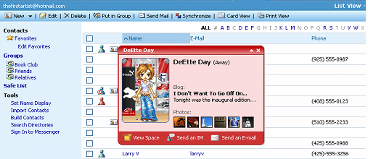
Clicking on a contact in Hotmail brings up that person’s contact card
- Easy photo uploading. Consumers can easily attach and resize photos with the new MSN Hotmail Photo Upload Tool. Consumers who also use MSN Spaces will notice that the upload tool is the same one they use to load pictures onto their Space.
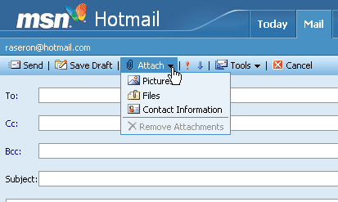
Choosing Attach/Pictures starts the Photo Upload Tool 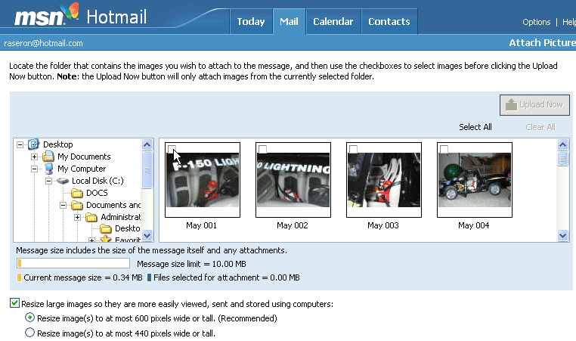
Hotmail Photo Upload Tool —-the same familiar one MSN Spaces uses

- Instant reply with MSN Web Messenger. With MSN Hotmail, consumers can see when the people they’ve received e-mail from are online with MSN Messenger. If so, the e-mail recipient can simply click on the MSN Messenger contact icon, and MSN Web Messenger will launch, so the sender and recipient can begin a real-time conversation.
- Emoticons in e-mail. MSN Hotmail incorporates the expressive emoticons found in MSN Messenger. Consumers can add emoticons by simply selecting them from the drop-down list to help express their moods and feelings in e-mail.
- Designer-style e-mail. Consumers can create designer-style e-mail messages using rich fonts, backgrounds and paragraph formatting. When combining other features of MSN Hotmail such as photos and emoticons, consumers have multiple ways of creating rich e-mail that goes far beyond text-only e-mail.
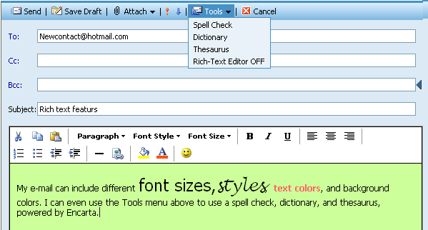
Easy access to text-editing features
- Custom signatures. MSN Hotmail now enables consumers to create a tagline for their e-mail messages with custom signatures that can be automatically appended when composing an e-mail.
- Country specific-domains. Many consumers in the United Kingdom, Japan, France, Germany and Italy now are choosing to create a personalized MSN Hotmail address specific to their country.
MSN Hotmail provides the creative tools consumers need to personalize and stylize their e-mail. Using familiar tools, such as the Photo Upload Tool also available in MSN Spaces, consumers can share moments from their lives with others and also access shared information in their contacts’ MSN Spaces.

Protection and Control
MSN Hotmail provides consumers with features to help address their concerns about e-mail use, including viruses and spam. Below are just some of the features MSN delivers to consumers, but there are many others in the service to help ensure that consumers have a hassle-free communications experience.

- Helping to protect against viruses. Hotmail delivers free automatic scanning and cleaning of incoming and outgoing mail to help protect consumers from viruses.
- Helping to protect against spam. The MSN Hotmail Junk Mail Filter examines incoming messages to help prevent e-mail that it identifies as spam from entering a user’s inbox. Consumers of MSN Hotmail can choose one of three levels of protection: Default, Enhanced or Exclusive. Consumers can choose to receive e-mail only from individuals already set up in their contacts list or from specified domains. This feature is optional and offers an even greater level of protection against unwanted e-mail. The Block Sender feature allows users of MSN Hotmail to refuse e-mail from a specific sender. Under Options, users can type in the e-mail address of the sender(s) whose e-mail they don’t want to receive.
- Spam reporting. Consumers of MSN Hotmail can easily report spam back to Hotmail with the click of a button.
- Helping to protect privacy. MSN Hotmail helps protect the privacy of consumers by providing a security-enhanced login and default session timing expiration, which is also customizable. In addition, MSN Hotmail delivers a strong privacy policy and actively participates in the TRUSTe Privacy Program.
- Integration with MSN Premium Parental Controls. Parental Controls are available for MSN Premium consumers to help manage children who communicate with MSN Hotmail.
Without privacy and protection features in place, any communications medium has limited value. MSN Hotmail works to help ensure that consumers have solid protection mechanisms in place that can be easily accessed and applied. MSN Hotmail also works to help protect the privacy and e-mail content of consumers since in many cases they will be accessing their e-mail from remote or roaming locations.

MSN Communication Services — Working Together
As shown above, each of the three main elements of the enhanced MSN communications services — MSN Spaces, MSN Messenger and MSN Hotmail — deliver significant value on their own. However with this wave of services from MSN, consumers will also realize new benefits through the ways that the services work together, helping consumers stay connected to the people and information they want.

Consumers can now discover if a contact on their MSN Messenger list has recently updated her MSN Space or if a person they’ve received an MSN Hotmail message from is currently online using MSN Messenger. These are simple and convenient ways in which consumers will be able to benefit from a more connected world where they can express themselves and their personality while communicating and sharing their world with others.

MSN Spaces connections to MSN Messenger and MSN Hotmail
With the launch of MSN Spaces, consumers have a new way of expressing themselves to their friends and family. Whether that expression comes through chronicling their daily activities in a blog or sharing their digital images, consumers will find that MSN Spaces provides an easy to way to create, maintain and share these activities with others. Some of the ways that consumers can share their information and updates on MSN Spaces with others include the following:
- Contact Cards. Easily share contact information and updates to Spaces with Hotmail and Messenger consumers through the Contact Card.
- Gleaming. When a consumer changes or updates her Space, her MSN Messenger contact icon will light up, notifying her MSN Messenger contacts that it’s time to visit their MSN Space.
- Single-click access. Both MSN Messenger and MSN Hotmail make it easy to access MSN Spaces directly from their environments. Consumers won’t need long URLs and complex steps to get to their information.
- Windows Media playlist display. Consumers can create and manage lists of information that is important to them, such as their favorite music, books or travel destinations. Consumers can easily share playlists through their Space with Microsoft Windows Media technologies. With just two clicks, people can sample a 30-second song on someone’s playlist through MSN Music.
- Single address book. Consumers of MSN Messenger, MSN Hotmail and MSN Spaces now will benefit from a single address book, providing them with one location for managing detailed information about their Messenger contacts and Hotmail e-mail contacts.

MSN Messenger connections to MSN Spaces and MSN Hotmail
MSN Messenger has grown from simple instant messaging to a rich and robust communications tool that integrates powerful features such as video and audio conversations and simple ways of sharing information and files. More personalization features also have been incorporated into MSN Messenger to help consumers express themselves. One of the greatest values MSN Messenger provides is that of “presence” — visual cues when someone is available or online. With this release of MSN Messenger, the idea of presence is taken a step further with features that help others know not only when a Messenger contact is online, but when they’ve updated their information. These include the following:
- Contact Cards. From the MSN Messenger contact list consumers can easily access information on updates that contacts have made to their MSN Spaces. Consumers of MSN Messenger will also find easy access to information such as MSN Hotmail e-mail addresses.
- Gleaming. Consumers of MSN Messenger will know when one of the contacts on their list has an updated MSN Space through a visual cue of a gleam or starburst on the Messenger contact icon.
- Single-click access. Consumers can easily access MSN Spaces directly from MSN Messenger and MSN Hotmail. Consumers won’t need long URLs and complex steps to get to their information.
- Single address book. Now consumers of MSN Messenger and MSN Hotmail will benefit from a single address book that provides them with one location for managing detailed information about their Messenger contacts and Hotmail e-mail contacts.
- Easy access to MSN Search. MSN Messenger consumers can easily access MSN Search while they’re using the service. Convenient access is provided on the primary Messenger contact window, but consumers can also highlight and right-click on any words in a conversation window to initiate a MSN Search.

MSN Hotmail connections to MSN Messenger and MSN Spaces
MSN Hotmail has grown rapidly and today reaches more than 190 million consumers worldwide. Over the years, MSN has continued to look at new ways of delivering continued value to its consumers, most recently by upgrading storage limits for both free and subscription accounts and new safety features such as anti-virus scanning and cleaning of all incoming e-mail. MSN strives to deliver value to consumers of its individual services, and it also offers features that help bring those services closer together. Some examples are listed below:
- Instant reply with MSN Web Messenger. With MSN Hotmail, consumers can see when the people they’ve received e-mail from are online with MSN Messenger. If so, the e-mail recipient can simply click on the MSN Messenger buddy icon, and MSN Web Messenger will launch, so the sender and recipient can begin a real-time conversation.
- Single-click access. Consumers can easily access MSN Spaces directly from MSN Hotmail and MSN Messenger. Consumers won’t need long URLs and complex steps to get to their information.
- Single address book. Now consumers of MSN Hotmail, MSN Messenger and MSN Spaces will benefit from a single address book that provides them with one location for managing detailed information about their Messenger contacts and Hotmail e-mail contacts.

Summary
MSN is excited to deliver this new wave of services — MSN Spaces, MSN Messenger and MSN Hotmail — to consumers. These new offerings not only deliver rich features, but also incorporate new ways of helping consumers easily work across the services to get the most out of their time online when communicating. With the advent of MSN Spaces consumers have an easy new way of sharing information that interests them with others and accessing their Space to modify or add to it. Whether a consumer is in MSN Messenger or MSN Hotmail, she can easily jump to their Space or that of someone on their Contact list through convenient links. MSN Messenger consumers will know when someone on their list has an updated Space through the gleam on the Messenger icon. All the examples outlined in this guide provide basic information on the exciting new opportunities for consumers to communicate more powerfully with the people they care about and experience the benefits of integrated services.

250MB inbox available only in the 50 United States, District of Columbia and Puerto Rico. Eligible Hotmail users will first receive 25 MB at setup. Please allow at least 30 days for activation of your 250MB storage to verify your account and help stop abuse. Microsoft Corp. reserves the right to provide 250MB inbox to free Hotmail accounts at its discretion.

