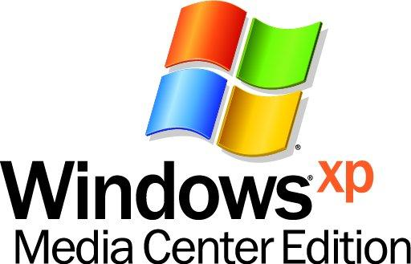
How to Submit Media Center Software to Windows Marketplace

Here are the steps to follow to submit your downloadable software application to Windows Marketplace.

- Prepare your software application. We will test for the following, so be sure you are ready before you upload your product.
  - Your application must be virus and spyware-free, and must not perform any malicious operation on the customer’s PC.
  - When the application is installed, a tile for the application must appear in More Programs.
  - When the customer clicks on that tile, he or she must be taken to a 10' experience.
  - The customer must be able to navigate your application with the remote control.
  - Your application design must feature large buttons and fonts so that it is readable on a TV screen.
  - Installing the application must not add a link to the top Media Center navigation menu (next to My music, My Pictures, etc.).
  - Your application’s text must be in English.
  - You must have the rights to any content used in your application.

These restrictions are in place to ensure that products on Windows Marketplace deliver a quality experience.

- Register your products with CNET. The vast majority of data on Windows Marketplace is licensed from CNET. Click here to read about the listing packages available for CNET’s Upload.com submission service: Free listing, Basic ($9USD/mo) or Premium ($99USD/mo). Software uploaded here will appear on download.com and other online services such as MSN Shopping.

When you are ready, create an account, log in, and complete the submission form to upload your software products. Be sure to choose “Windows MCE” as your Operating System, and submit each listing.

- Check your listing. Depending on the listing package you choose, give CNET some time to verify your application, then visit download.com to make sure your product appears there. Two to three days after your listing appears on download.com, it will show up on windowsmarketplace.com.
Once you see your product on Windows Marketplace, double-check that it also appears in the appropriate section of the Media Center Store.

Software FAQ

Can I charge for my software?

While CNET does have a requirement that publishers offer free trials of their programs to be listed on download.com and Windows Marketplace, you may subsequently charge for your software. There are a couple of ways to do this:

- CNET’s Mechant Services. CNET offers merchant services in cooperation with a company called Protexis. Merchant Services are available for all listing packages (free, basic, and premium), and they offer global payments, local tax support, and e-commerce support. In return, CNET takes a revenue share on each sale: 8% for Premium, 10% for Basic, and 12% for Free Listing products

- Link from your product. If you are offering a free trial on your product that expires after a certain number of uses or days, you can include a link to a web page on your own website or another merchant site that allows customers to buy your product online.

Can I sell boxed software rather than downloadable software?

If you prefer to ship physical goods to your customers rather than allow for downloadable bits only, use CNET’s shopper.com site instead. This website offers physical goods for sale. Visit this page to sign up with shopper.com and get started.

My software is already listed on download.com. Does that mean it’s automatically on Windows Marketplace?

Yes, it should automatically appear on Windows Marketplace a few days after it appears on download.com To make sure your product appears on Windows Marketplace, conduct a search on www.windowsmarketplace.com for your product. If it appears there but does not appear in the Plug-Ins section of the Media Center Store, please send mail to mceapps@microsoft.com.

The best way to make sure that your software is appearing in the right place on download.com is to update your product information to include Windows MCE as a compatible operating system.

How do I promote my software on download.com?

The easiest (and cheapest) way for publishers to drive downloads to their listings is by placing a Download.com button on their homepages. Any publisher with a Download.com listing can do this for free, and it will ensure that all of their downloads are being credited toward their popularity rating on Download.com. If you check out the Most Popular list you'll find that most of those products are driving traffic to their Download.com listing from their homepages. Learn more about the free Download.com button program.

CNET also has the Pay Per Download program, which is an auction-style sponsorship program where publishers are able to bid for top-shelf placement in their category: The benefits of this program are guaranteed top-shelf placement in the listings, the fact that publishers only pay for completed downloads, and the ability to set a monthly spend cap for the sponsored listing.

For a product to be eligible for inclusion in the Windows Marketplace, it must be compatible with current Microsoft Windows operating systems and be listed in the Download.com software library. Microsoft and CNET reserve the right to add or remove any product from Windows Marketplace at any time without prior notice. For additional information, please see the Windows Marketplace section of CNET’s knowledgebase.

© 2005 Microsoft Corporation. All rights reserved. Microsoft, Windows, and the Windows logo are either registered trademarks or trademarks of Microsoft Corporation in the United States and/or other countries. The names of actual companies and products mentioned herein may be the trademarks of their respective owners.

