

Report Builder

Table of Contents
Report Builder 3
Lab Setup 4
Exercise 1 Generate a Report Model 5
Exercise 2 Refining the Report Model Presentation 10
Exercise 3 Model Calculations, Drillthrough and Perspectives 16

Report Builder

Objectives  NOTE: This lab focuses on the concepts in this module and as a result may not comply with Microsoft security recommendations.  NOTE: For the latest details on  SQL Server 2005, please visit http://www.microsoft.com/sql/. | After completing this lab, you will be able to:  - Auto-generate a Report Model in Model Designer  - Refine the model using model item properties  - Understand how model item properties affect end user reporting  Not all model item properties are covered in this lab. For documentation on all model items properties, see the Working with Models topic in SQL Server 2005 Books Online. Search for Model Designer.
Scenario | Adventure Works, the bicycle sales company you work for, wants to roll out end user reporting to its employees using Reporting Services’ features: Model Designer and Report Builder. You have been tasked with defining the report model these business users will interact with when building their ad hoc reports. Your data is already in a SQL Server database called Adventure Works, and you have Model Designer and Report Builder installed and ready to be tested. Your task is to build the report model and refine it so that your end users can use it.
Prerequisites | None.
Estimated Time to Complete This Lab | 60 Minutes

Lab Setup

Tasks | Detailed Steps
- Log in. | - Log in using the Administrator user account. The password is Pass@word1.

Exercise 1
Generate a Report Model
Scenario

Report models add a business layer of metadata on top of databases to make end user reporting possible using Report Builder in Reporting Services 2005. Report models can be generated from Microsoft® SQL Server® or Analysis Services databases and can be built using Model Designer, Report Manager, SQL Server Management Studio, or through one of the Reporting Services APIs. This lab covers creating report models from SQL Server databases using Model Designer only.
In this exercise, you will use Model Designer to generate a report model from the Adventure Works sample database. A report model consists of three parts: a data source that provides connection information to the database the model will be generated from, a data source view which describes the physical database and provides the binding information for the report model metadata, and finally, the report model metadata itself. Once you generate your model, you will be able to build a report using Report Builder.

Tasks | Detailed Steps
- Create a Report Model Project. | - Click Start | All Programs | Microsoft SQL Server 2005 | SQL Server Business Intelligence Development Studio.  - Click File | New | Project.  - In the New Project dialog box, in the Project Types pane, click the Business Intelligence Projects folder.  - In the Templates pane, click the Report Model Project icon.  - In the Name text box, type Adventure Works HOL Model.  - In the Location text box, enter C:\MSLabs\SQL Server 2005\User Projects\  - If checked, uncheck the Create directory for Solution checkbox and click OK.  The project is created in a new solution; the solution is the largest unit of management in the Business Intelligence Development Studio environment. Each solution contains one or more projects.  You can view the solution and its projects in the Solution Explorer pane on the right-hand side in the Business Intelligence Development Studio. If the Solution Explorer is not visible, you can view it by selecting the View | Solution Explorer menu item (or the keyboard shortcut Ctrl + Alt + L).
- Create a Data Source. | - In the Solution Explorer pane, under the Adventure Works HOL Model project, right-click the Data Sources folder, and then select Add New Data Source from the context menu.  - In the Data Source Wizard dialog box, on the Welcome to the Data Source Wizard page, click Next.  - On the Select how to define the connection page, make sure the Create a data source based on an existing or new connection radio button is chosen. Click New ….  - In the Connection Manager dialog, notice how the SqlClient Data Provider is selected and not changeable.  - In the Server name drop-down list type localhost.  - Under Log on to the server, click Use Windows Authentication.  - In the Select or enter a database name drop-down list, click AdventureWorks.  - Click Test Connection. Click OK to dismiss the message box  - In the Connection Manager box, click OK.  - In the Data Source Wizard box, on the Select how to define the connection page, verify that localhost.AdventureWorks is selected, and click Next.  - On the Completing the Data Source Wizard page, leave the default Data source name Adventure Works unchanged, and then click Finish.  You have now set up the information how to connect to the database you are working with. It is now time to define the schema information you want to use in the solution. You do this through the Data Source View.
- Create a Data Source View. | - In the Solution Explorer pane, under the Adventure Works HOL Model project, right-click the Data Source Views folder, and then select Add New Data Source View from the context menu.  - In the Data Source View Wizard dialog box, on the Welcome to the Data Source View Wizard page, click Next.  - On the Select Data Source page, in the Relational data sources pane, verify that Adventure Works is selected, and then click Next. The wizard will connect to the data source selected and expose a list of available objects.  - On the Select Tables and Views page, select all the tables and move them to the Included objects list by clicking the add button (represented by the ‘>’ symbol in the middle of the wizard page).  Note: You can use views in a report model. They are excluded from this exercise for simplicity of the resulting model and time.  - Click Next.  - On the Completing the Wizard page, in the Name text box, enter Adventure Works HOL and then click Finish. If you’d like, you can double click on the Adventure Works HOL.dsv item in the Solution Explorer to examine the data source view you have defined.
- Generate a Report Model.  NOTE: The Report Model Wizard will take a few moments to generate the model. | - In the Solution Explorer pane, under the Adventure Works HOL Model project, right-click the Report Models folder, and then select Add New Report Model from the context menu.  - In the Report Model Wizard dialog box, on the Welcome to the Report Model Wizard page, click Next.  - On the Select Data Source View page, in the Available data source views list, make sure Adventure Works HOL.dsv is selected and click Next.  The Select report model generation rules page allows you to refine the report model generation options including selecting a language for the model itself.  - On the Select report model generation rules, accept the defaults and click Next.  - On the Collect Model Statistics page, verify that the Update model statistics before generating option is selected and click Next.  - On the Completing the Wizard page, click the Run button to generate the model.  - When the wizard finishes, click Finish.  - You will be prompted that the Adventure Works HOL.dsv has been updated. Click Yes on the dialog when prompted to reload.  - Explore the report model by clicking on entities under the Model node in the Report Model designer. View the fields, roles and variations of each entity that are listed to the right of the model tree in the designer. For example, find the Product entity and view its fields including Name, Size, and Class and roles including Product Subcategory and Product Category.  Note: This area will be referred to as the model items tree in subsequent tasks.  - Explore the Properties of each type of item: Entities (Product), Fields (Class)  and Roles (Product Subcategory).  Note: The right side of the model designer surface will be referred to as the model list or list area in subsequent tasks.  Note: Properties are displayed in the Properties Window. If the Properties Window is not displayed, select Properties Window on the View menu.
- Deploy the Report Model Project.  NOTE: It might take a moment for IIS and Reporting Services to initialize. | - In the Solution Explorer pane, right-click the Adventure Works Report Model project item, and then select Deploy from the context menu.  - Close Business Intelligence Development Studio by selecting File | Exit. You should not be prompted to save anything. As part of deployment, Business Intelligence Development Studio saves your work.  - Click Start | All Programs | Internet Explorer.  - In the Address bar, enter http://localhost/reports/ and press Enter. Once navigation is complete, your browser window should be similar to the one in Figure 1.  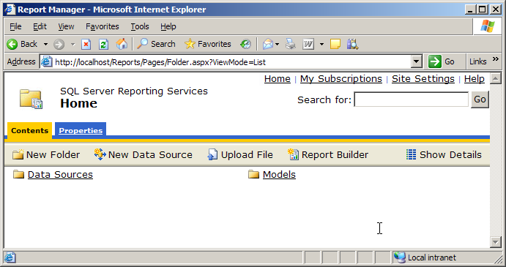  Figure 3: Reporting Services home page  - Click the Data Sources link. You will see the Adventure Works data source. Click the Back button of your browser.  - Click the Models link. You see the Adventure Works HOL report model.  - Click the Adventure Works HOL link. In the Description field, type Adventure Works Hands-on Lab Report Model and click the Apply button.  - In the upper-left corner, click the Home link. Keep Internet Explorer open for the next task.

Tasks | Detailed Steps
- Deploy Report Builder and test the new model | - On the Reporting Services toolbar, click the Report Builder option (see Figure 2). This starts the installation process of Report Builder.  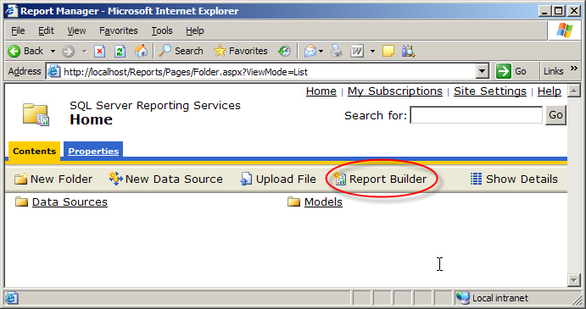  Figure 2: The button to launch Report Builder.  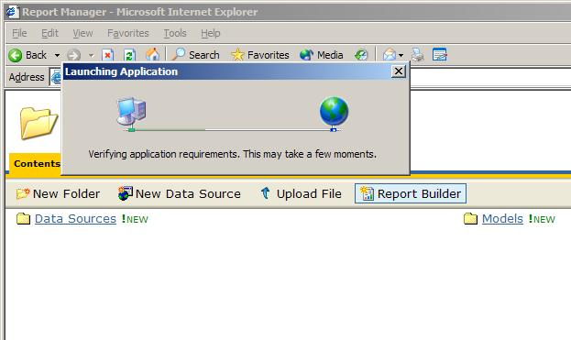  Figure 3: Report Builder launching and verifying installation requirements.  - After the initial check for the .NET Framework 2.0 is made, a security warning dialog will appear, similar to Figure 4. Click Run to continue the download process and start Report Builder.  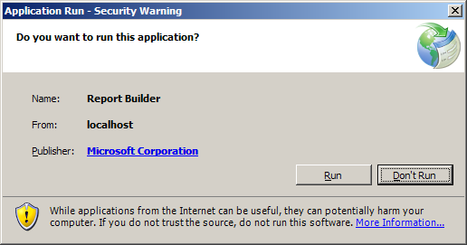  Figure 4: Application Run – Security Warning before starting Report Builder.  - After you click the Run button, a download dialog may appear and the Report Builder will start.  - In the Getting Started pane, verify that the Adventure Works HOL model is selected and click OK.  - In the Entities list, find Sales Order Header and click on it.  - From the Fields list, drag and drop Total Total Due to the Drag and drop column fields area on the design surface.  - In the Entities list, find, select, and then drag and drop the Sales Person entity to the left of the Total Total Due field in the design area. Notice that the National ID Number and Commission Pct fields are added (see Figure 5).  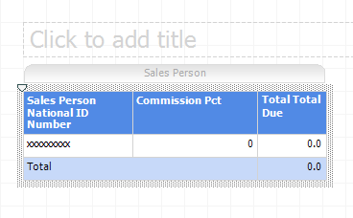  Figure 5: The completed detail section of the report.  - Select View | Run Report to run the report.  - Select File | Exit to close Report Builder. You do not need to save the report if prompted.
Exercise 2
Refining the Report Model Presentation
Scenario

Now that you have created your report model and tested it using Report Builder, you will refine the model. In this exercise, you will make modifications to the report model and build simple Report Builder reports to see the effect of your changes.

Tasks | Detailed Steps
- Start Business Intelligence Studio and open the solution from the previous exercise.  If Business Intelligence Studio is still running with the report model solution still open, continue to the next task. | - If necessary, restart Business Intelligence Development Studio. Click Start | All Programs | Microsoft SQL Server 2005 | SQL Server Business Intelligence Development Studio.  - If necessary, re-open the report model created in the previous exercise. Select File | Open | Project/Solution.  - In the Open Project dialog box, navigate to C:\MSLabs\SQL Server 2005\User Projects\Adventure Works HOL Model\ and select the Adventure Works HOL Model.sln file and click Open.
- Add descriptions | - If necessary, open the design window for the existing report model. It’s listed as Adventure Works HOL.smdl under the Report Models folder in the Solution Explorer window.  - Select the Report Model tab (see Figure 1) to select the model.  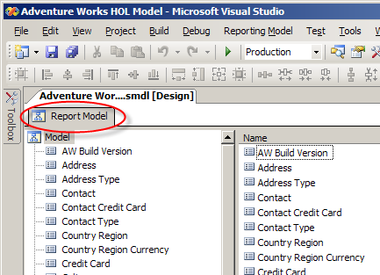  Figure 1: Selecting the Report Model tab in the Report Model Designer.  - If it’s not open, open the Properties Sheet via View | Properties Window.  - In the Properties Windows, enter This is a report model for the Adventure Works database. in the Description field.  - Select the Sales Person node under the Model node, and enter All Sales People are employees. in the Description field.  - When you select an entity in the tree list, its fields are visible in the list view. With the Sales Person node selected, the Sales Quotas field should be visible. Select the Sales Quota field and enter Sales quotas are updated quarterly. in the Description field using the Properties Window.  Note: Descriptions will show up as tooltips when an item with a description is hovered over in Report Builder.  - Select File | Save All to save your changes.
- Organizing the model | The Adventure Works model has many entities. To organize some of these entities and make them easier for users to find and interact with, you’ll create a folder.  - Select the Model node (under the Report Model tab) so that the entities list is visible in the list view.  - Right-click the model design area and select New | Folder from the context menu as in Figure 2. (The new folder will be added to the bottom of the entities list).  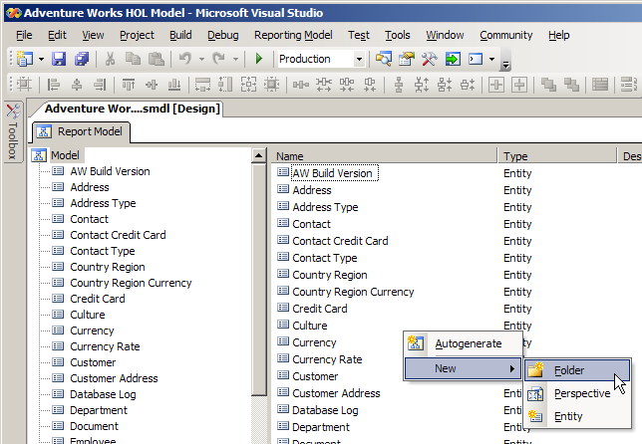  Figure 2: Creating a new folder in the entities list.  - Scroll the window to find the new folder labeled NewFolder.  - Right-click on the new folder, select Rename and change the name to Product Details.  - In the list view (on the right), select all of the entity nodes that have Product in their name except the Product entity.  - Drag and drop the selected entities on to the Product Details folder (in the model tree).  You could continue to add additional folders to organize the entities further.
- Renaming and hiding | Some of the entity names in our model are not end user friendly and should be changed to reflect how our end users think of these entities.  - In the model tree, select the Sales Order Header entity. Right-click and select Rename from the context menu and change the name to Sales Order.  - With the Sales Order entity selected in the model tree, find the Sales Order Details role in the list view and rename it to Sales.  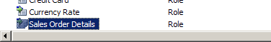  Figure 3: The Sales Order Details role selected in the list view.  - With the Sales Order entity still selected in the model tree, find the Rowguid attribute.  - Select it and change the Hidden property to True in the Properties Window.  - Select the Sales Order Details node in the model tree and change the entity’s name to Sales.  Roles and entity names, although they may reference the same underlying item, can have different names depending on the context in which they are used. You renamed the Sales Order Details role to Sales in step 2 and just now renamed the Sales Order Details entity to Sales.  - Select the Sales Person node in the model tree. Notice that there is a Sales Person role created during auto-generation. The name of this role is misleading. Rename the Sales Person role (see Figure 4) in the list view to Employee as this role goes to the Employee entity.  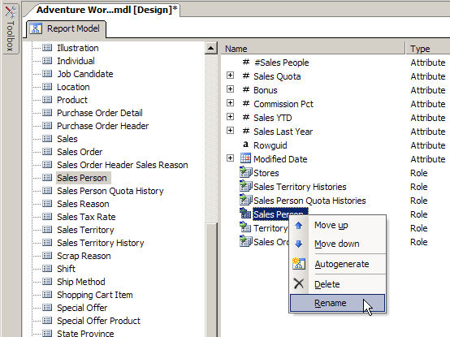  Figure 4: Starting to rename the Sales Person role to Employee.
- Sizing and formatting | - Select the Sales Order node in the model tree.  - Expand the Total Due field in the list view.  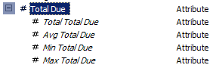  Figure 5: The expanded Total Due field.  - Click the Total Total Due field.  - In the Properties Window, find the Format property and type c2 for currency with two decimal places.  Note: Any valid .NET format string can be used.  - For the Total Total Due, change the Width property to 15. This is the default width that will be shown to the user when the field is added to a report.
- Default Detail Attributes | Default Detail Attributes are the attributes that are displayed for the entity on in the detail section of the report when an entity is dropped onto the design surface.  - In the model tree, select the Sales Person entity.  - In the Properties Window, find and click the DefaultDetailAttributes property.  - Click the ellipsis button (…) to open the AttributeReference Collection Editor.  - In the AttributeReference Collection Editor, highlight Commission Pct field in the Members list and then click the Remove button.  - Click the Add button.  - Under the Sales Person entity in the Entities list, click the Employee entity.  - Under Employee, click the Contact entity.  - In the Fields list, select the First Name, Middle Name, and Last Name and click the OK button.  - Click OK to close the AttributeReference Collection Editor.  Note that the DefaultDetailAttributes property shows four attributes. When interacting with the Sales Person entity, you will now see the Sales Person’s first, middle, and last names in addition to their National ID Number.  - Select File | Save All.  - Select Build | Deploy Adventure Works HOL Model to deploy the new model to the server.
- Validate changes in Report Builder | - Click Start | All Programs | Internet Explorer.  - In the Address bar, enter http://localhost/reports/ and press Enter.  - On the Reporting Services toolbar, click the Report Builder option.  - In the Getting Started Pane, verify that the Adventure Works HOL model is selected and click OK.  - Click the Sales Order entity.  - Drag and drop the Total Total Due field to on the Drag and drop column fields area of the report design surface. Notice the new currency formatting.  - With the Sales Orders entity selected, review the field list and notice that the Rowguid field is no longer in the list.  - From Sales Orders, navigate to the Sales Person entity and drag and drop the Sales Person entity to the left of the Sum Total Due field. Notice that the National ID Number, First Name, Middle Name and Last Name fields are added to the report.  - This is the same report as you built earlier except now your new model changes are displayed. To view the changes, click the Run Report button. Note the widths for some of these columns should be widened to fit the data.  - Click the Design Report button to return to design mode.  - Select File | New. The Getting Started task pane will appear.  - To create a new report, click OK when the Getting Started pane appears making sure that the Adventure Works HOL model is selected.  - When prompted to save your previously created report, select No.  - In the Entities list, navigate to the Product entity.  - Drag and drop the Product entity to the design surface.  - Locate the Product Subcategory entity listed below the Product entity in the Entities list. Click on it.  Note the Product Category entity below the Product Subcategory entity. These entities only have one interesting attribute associated with them; the Name attribute corresponding to the Product Subcategory and Category names. It would be nice to just see these as attributes of Product rather than having to navigate to get to them.  - Select File | Exit.  - When prompted to save your work, select No.
- Lookups and inheritance | - Return to Business Intelligence Studio.  - In the model items tree, expand the Product Details folder.  - Select the Product Subcategory field. Note that Product Subcategory has only one identifying attribute and it is the Name field. Lookup entities can only have one identifying attribute.  - Using the Properties Window, change the IsLookup property for the Product Subcategory entity to True.  - Under the Product Details folder, select the Product Category entity.  - Using the Properties Window, change the IsLookup property for the Product Category entity to True.  - Re-select the Product Subcategory entity under the Product Details folder.  - Select the Product Category role in the list view (see Figure 6).  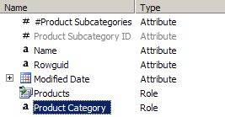  Figure 6: The Product Category role selected.  - Using the Properties Window, change the PromoteLookup property for the Product Category role to True. This will “promote” the Product Category lookup entity so it is shown at the same level as Product Subcategory in Report Builder.  - In the model items tree, select the Product entity.  - In the list view, select the Product Subcategory role. Right-click the role and select Move up. Repeat until the Product Subcategory role is right beneath the Name attribute for Product.  - In the Adventure Works model, all sales people are employees. As such, it would be nice to just see the properties of Employees when we are looking at the Sales Person entity. Locate the Sales Person entity in the model items tree and select it.  - In the Properties Window, locate the Inheritance property. Click the + sign next to the property name to expand it.  - Set the InheritsFrom property of the Inheritance property to Employee from the drop down list.  - Set the Binding property of the Inheritance property to FK_SalesPerson_Employee_SalesPersonID from the drop down list. This is the relationship used to join Sales Person to Employee.  - Select File | Save All.  - Select Build | Deploy Adventure Works HOL Model to deploy the new model to the server.
- Validate lookup and inheritance changes in Report Builder | - Click Start | All Programs | Internet Explorer.  - In the Address bar, enter http://localhost/reports/ and press Enter.  - On the Reporting Services toolbar, click the Report Builder option.  - In the Getting Started Pane, verify that the Adventure Works HOL model is selected and click OK.  - Select the Product entity in the Entities list. Notice that Product Subcategory and Product Category should look like fields right below the Name property (if you moved Product Subcategory all the way up the list as directed in the previous task).  - Drag and drop the Product entity to the Drag and drop column fields section on the design surface.  - Under the Product entity in the Entities list, select Purchase Order Details.  - From the Fields list, drag and drop the Total Order Qty field to the right of the Name field.  - From the Fields list, drag and drop the Total Rejected Qty field to the right of the previously added Total Order Qty field.  - Click the Run Report button on the toolbar.  - Click on the value 150 in the view of the report under the Total Order Qty column for the Bearing Ball product.  You are now viewing a drillthrough report showing the Purchase Orders for Bearing Balls. Notice that the drillthrough report shows Order Date, Modified Date, Due Date, Product Name, Order Qty, Unit Price and Line Total. These fields are determined by model settings also.  - Select File | Exit.  - When prompted to save your work, select No.
Exercise 3
Model Calculations, Drillthrough and Perspectives
Scenario

Some interesting and useful items for end user reporting may not be directly available from the physical database. In this case, you can add calculated fields to the report model to make often used calculations available to your end users. Additional properties that affect fields are also discussed.

Tasks | Detailed Steps
- Start Business Intelligence Studio and open the solution from the previous exercise.  If Business Intelligence Studio is still running with the report model solution still open, continue to the next task. | - If necessary, restart Business Intelligence Development Studio. Click Start | All Programs | Microsoft SQL Server 2005 | SQL Server Business Intelligence Development Studio.  - If necessary, re-open the report model created in the previous exercise. Select File | Open | Project/Solution.  - In the Open Project dialog box, navigate to C:\MSLabs\SQL Server 2005\User Projects\Adventure Works HOL Model\ and select the Adventure Works HOL Model.sln file and click Open.
- Create a new field | - If necessary, open the design window for the existing report model. It’s listed as Adventure Works HOL.smdl under the Report Models folder in the Solution Explorer window.  - Select the Purchase Order Detail entity in the model item tree.  - Right-click in an empty area of the list view and select New | Expression.  - When the Define Formula dialog opens, Purchase Order Detail should be selected in the Entities list.  - Double-click the Order Qty field in the Fields list to add it to the formula definition.  - Click the – (minus) button (see Figure 1).  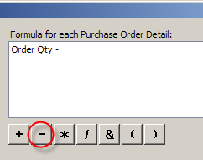  Figure 1: The minus button highlighted.  - Double-click the Rejected Qty field in the Fields list. The formula should read Order Qty – Rejected Qty (order quantity minus rejected quantity).  - Click OK to close the Define Formula dialog.  - Right-click on the NewExpression attribute and select Rename. Change the name to Fulfilled Qty.  - In the Properties Window, locate the Nullable property and set the value to True. This field is not required to be populated.  - Right-click in an empty area of the list view and select New | Expression.  - In the Define Formula dialog, select the Functions tab.  - Expand the Aggregate folder in the list.  - Double-click on Sum to add it to the formula.  - Select the Fields tab. Note how the keyword aggregate is highlighted in the formula field.  - Double-click Fulfilled Qty in the Fields list to add it to the formula. The formula should read Sum(Fulfilled Qty).  - Click OK to close the dialog.  - Right-click on the NewExpression attribute and select Rename. Change the name to Sum(Fulfilled Qty).  - In the Properties Window, select the IsAggreate property and set the value to True.  - Select the Nullable property and set the value to True.  - Select the EnableDrillthrough property and set the value to True.  - Select the VariationOf property in the Properties Window and select Fulfilled Qty as the property value. This marks the attribute as a variation of the scalar Fulfilled Qty. Once you have done this you should see the Sum Fulfilled Qty nested under Fulfilled Qty if you expand Fulfilled Qty in the list area.  - Select Fulfilled Qty in the list area.  - Select the DefaultAggregateAttribute property and set the value to Sum(Fulfilled Qty). This will cause Report Builder to show the Sum field at the top with the Fulfilled Qty field nested below it.
- Default details for multi instance clickthrough reports | There are two clickthrough templates for each entity: a single instance template and a multi instance template. The single instance template is used when an instance of the entity is requested in a clickthrough. The multi instance template is used when an aggregate is clicked and multiple instances for the entity are displayed.  - In the model items tree, click the Purchase Order Detail entity.  - In the Properties Window, click the DefaultDetailAttributes property.  - Click the ellipsis button (…) to open the AttributeReference Collection Editor.  - Select the second Modified Date in the Members list (it will have the #3 next to it) and click the Remove button.  - Click the Add button to open the Default Detail Attributes dialog.  - In the Entities list, select Purchase Order.  - In the Fields list, select Purchase Order ID and click OK.  - Click the Add button again.  - Select both the Received Qty and Rejected Qty fields and click OK.  - Click OK to close the AttributeReference Collection Editor.  Note: By default, a multi instance clickthrough report for an entity contains the DefaultDetailAttributes for the entity and all DefaultAggregateAttributes for entities that are one to many in cardinality from the entity.
- Create a perspective | Perspectives are subsets of the model. For models with many subject areas, it may be helpful to your users to have the subject areas separated into perspectives for easier navigation.  - Click on the Model node of the model items tree.  - Right-click on the empty space in the list area and select New | Perspective.  - In the Edit Perspective dialog, click the Clear All button.  - Find the Purchase Order Detail entity and put a check in the check box next to its name to include it in the perspective.  - Click the check box for the Purchase Order Header entity to clear the check, and then click it again to full select the entity.  - Click the check box for the Product entity to clear the check, and then click it again to full select the entity.  - Click OK to close the Edit Perspective dialog and create the perspective. The new perspective, named NewPerspective will appear at the bottom of the list area.  - Right-click on NewPerspective and rename it to Products and Purchases.  - Select File | Save All.  - Select Build | Deploy Adventure Works HOL Model to deploy the new model to the server.
- Validate your changes in Report Builder | - Click Start | All Programs | Internet Explorer.  - In the Address bar, enter http://localhost/reports/ and press Enter.  - On the Reporting Services toolbar, click the Report Builder option.  - In the Getting Started Pane, verify that the Adventure Works HOL model is selected. Notice there is a new plus icon next to your Adventure Works HOL model.  - Click the plus sign to expand the node.  - The Products and Purchases perspective you created is listed below the model. Click on Products and Purchases.  - Click OK.  Notice only a few entities from the full model are available in this perspective.  - Drag and drop the Product entity to the design surface.  - Select Purchase Order Details in the Entities list.  - Drag and drop Total Received Qty to the right of the Name field.  Notice your new fields Sum(Fulfilled Qty) and Fulfilled Qty are listed at the bottom of the fields list for Purchase Order Details. Note that your Sum(Fulfilled Qty) is shown at the top level with Fulfilled Qty nested below it.  - Drag and drop Sum(Fulfilled Qty) to the right of Total Received Qty field on the design surface.  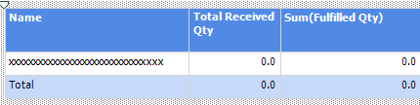  Figure 2: The new fields on the design surface.  - Click the Run Report button on the toolbar.  Notice that you can click on items in the Sum(Fulfilled Qty) column as well as the Total Received Qty column.  - Click on 147.00 in the Sum(Fulfilled Qty) column for the Bearing Ball row.  In the clickthrough report, note that the second Modified Data has been removed and that the Received Qty and Rejected Qty fields have been added.  .
In this lab you created and modified a report model and built custom reports using Report Builder.

