

Creating Reports with Microsoft® Dynamics™ AX SQL Reporting Services

Hands-On Lab

Table of Contents

Lab 1: Building a Report 1
Lab Objective 1
Pre-lab Exercise 2
Exercise 1: Familiarize Yourself with the Setup 2
Exercise 2: Building a Report 6
Exercise 3: Publish Report Data to Microsoft Excel 14
Exercise 4: Subscribe to a Report 17
Post-lab Exercise 21
Lab Summary 22

Lab 1: Building a Report

Lab Objective
In this HOL you can walk through at your own pace creating a report for Microsoft® Dynamics™ AX with SQL Server Reporting Service (SSRS) Enhancements. Understand how the report is built and the new experience for the report developer and user.
This solution has been built running on a Microsoft Windows Server™ 2003. Microsoft Dynamics AX has been deployed on this VPC to keep the installation simple. In an end-customer deployment, the SSRS may be deployed on its one server or across many servers to spread the processing load.
This lab uses a range of Microsoft technologies:
- Microsoft Dynamics™ AX 4.0 (Build 4.0.1523.0)
- Microsoft SQL Server™ 2005 and SQL Reporting Services
- .NET Framework 2.0
- Microsoft Office Excel® 2003

This lab scenario: You are an MBS partner working with “The Light Company”. You have been asked by your management to deliver a new solution to allow end users to have more flexible access to the data being captured in Microsoft Dynamics AX. You have decided to deploy the new SSRS features available in Microsoft Dynamics AX for the customer.

In this lab, you will perform the following exercises:
- Exercise 1: Familiarize Yourself with the Setup
- Exercise 2: Building a Report
- Exercise 3: Publish Report Data to Microsoft Excel
- Exercise 4: Subscribe to a Report

This lab will take approximately 60 minutes to complete.

Pre-lab Exercise
Note: When completing this lab through the HOL LaunchPad, you do not need to interact directly with Microsoft Virtual PC and can proceed directly to step 3 in task 1.

Task 1: Log in to the virtual machine
- From the physical host machine’s desktop, find the header for this Hands-On Lab:
- BAP006 Creating Reports with Microsoft Dynamics AX SQL Reporting Services
- On the desktop, click on the link of the header to begin the lab.
Note: Wait for the virtual machine to load. This will take a few minutes. At this point, you should have only Dynamics AX running.
- Log on to the Dynamics AX Virtual PC with the following credentials:
- User name: Administrator
- Password: pass@word1
- Click OK
Note: You may enter full-screen mode by pressing Right Alt-Enter. You may exit full-screen mode at any point by pressing the key combination again.

Exercise 1: Familiarize Yourself with the Setup
In this exercise, you will get an understanding of the menu items used to set up Microsoft Dynamics AX with Microsoft SQL Reporting Services Report Builder. You will be guided through the areas of configuration for Reporting Services. This configuration has already been done for you on this machine so this exercise is just to orientate you to the menus and options.

Task 1: Start Microsoft Dynamics AX
- Navigate to Start, Administrative Tools, Services.
- Ensure that the Dynamics Server$01-Axapta service is running. If not, right-click on it and select Start.
- Start the Microsoft Dynamics AX client by clicking Start, All Programs, Microsoft Dynamics AX.
Note: You will be logged in to the Microsoft Dynamics AX Administrator using Windows Authentication as you are logged on to this machine as the Administrator.
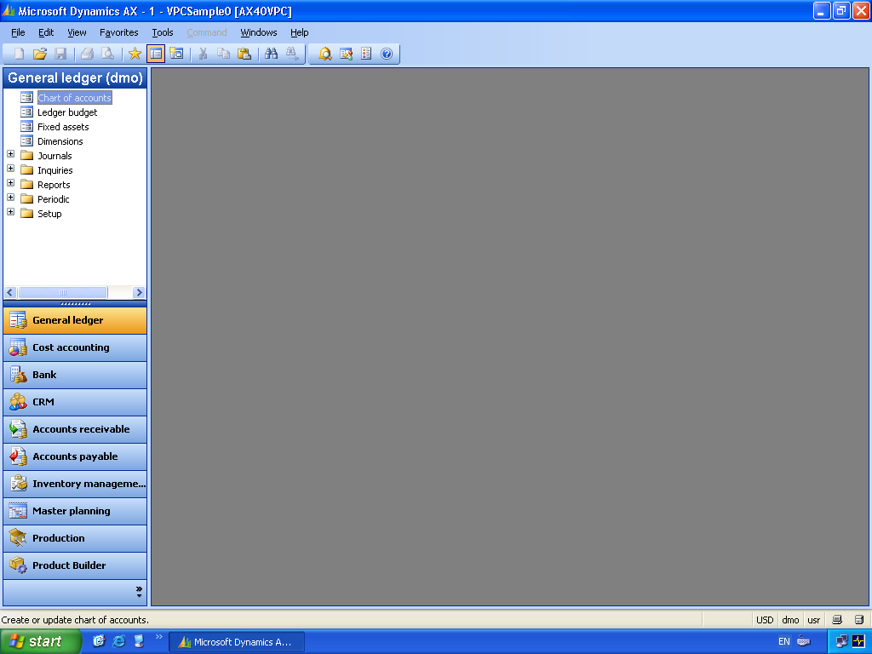
Figure 1.1 Microsoft Dynamics AX

Task 2: Locate the Reporting Server menu
- From the Tools menu from the menu bar, select Reporting Tools, Reporting Servers. This will open the Reporting Servers form. This is the main form for linking Microsoft Dynamics AX to the installed Reporting Server. A record in this table represents one reporting server.
- On this form you will find the name of the server as referenced in Microsoft Dynamics AX, the location of the Web server that is hosting the Microsoft SQL Reporting Services. In this example we are running on a Web server on this VPC called AX40VPC. The location of the Reports Manager is: http://AX40VPC/Reports
- On the General tab you will see a summary of the setup parameters. Notice the Web service URL. This is the location of the administration Web services for the Microsoft SQL Report.
- On the Advanced tab you will find the name of the Microsoft Dynamics report folder that will be used to store the Microsoft Dynamics AX reports and configuration in the Reports Manager. In this example, Dynamics is the folder that will be used.
- This form also has a button on the right-hand side labeled Validate. Click Validate to test the connection to the reports manager. As this has already been configured on the machine you are using, the validation will be successful.
- Close the Infolog window that opened when you clicked the Validate button.
- You can use this form to create multiple relationships to reports servers. This would allow you to share network load for reporting purposes and place reporting servers in different departments in an enterprise that has deployed Microsoft Dynamics AX.
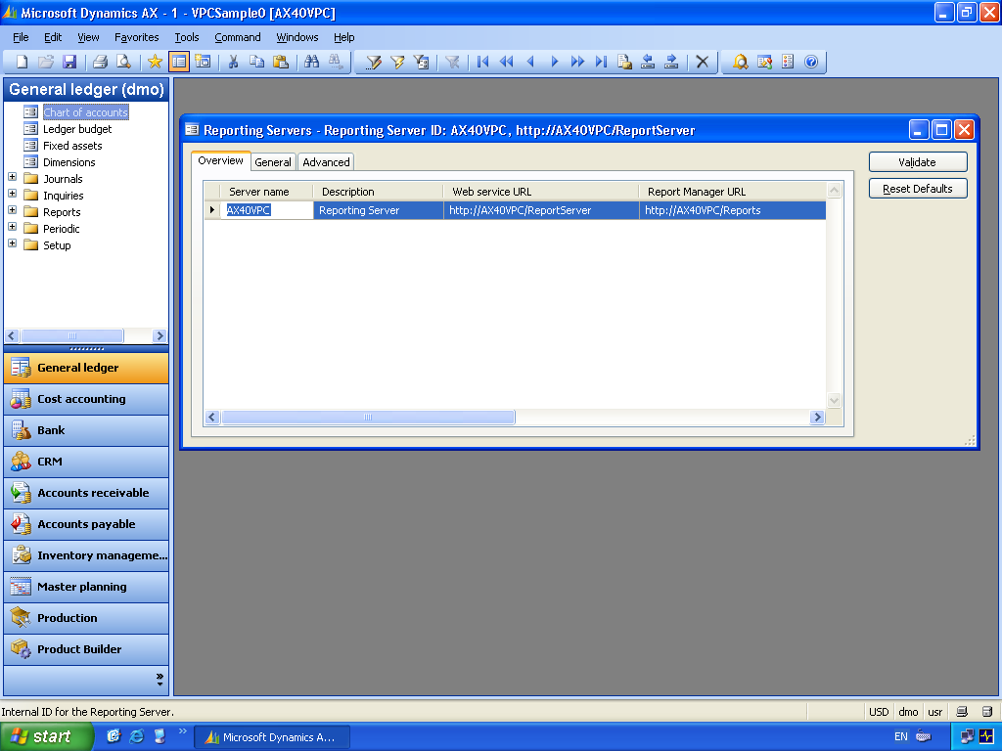
Figure 1.2 Report Server setup

Task 3: Model Generation
- For Microsoft SQL Server Reporting Services to be able to understand the data structures in Microsoft Dynamics AX we have to publish the models. We are provided with a menu to do this. Click Tools, Reporting tools, Model generation options.
- On the General tab on this form you will find setup options like the Model Destination and update options. These control the behavior of the model generation.
- On the Content tab you will find the Default exchange rate company and the Default currency for total amounts. These are important options as they control the use of currencies for amount fields on reports.
- On the Languages tab you will notice the setup of the languages. This option controls the display of the table and field labels when they are used in the report builder.
- To update the models click the Update models button.
- On the form presented you will notice that a model is published for each language you have configured in Microsoft Dynamics AX. In this example we only have the US English language installed and this will be the default option.
- Click Cancel, as updating the model will take a while to run. Because you have limited time to complete this exercise we will skip this step as it has already been run for you. If you want to watch it run and have the time you can update the model.
- You can also get to the Report Server configuration from the Main menu Administration, Setup, Business Analysis, Reporting Services.
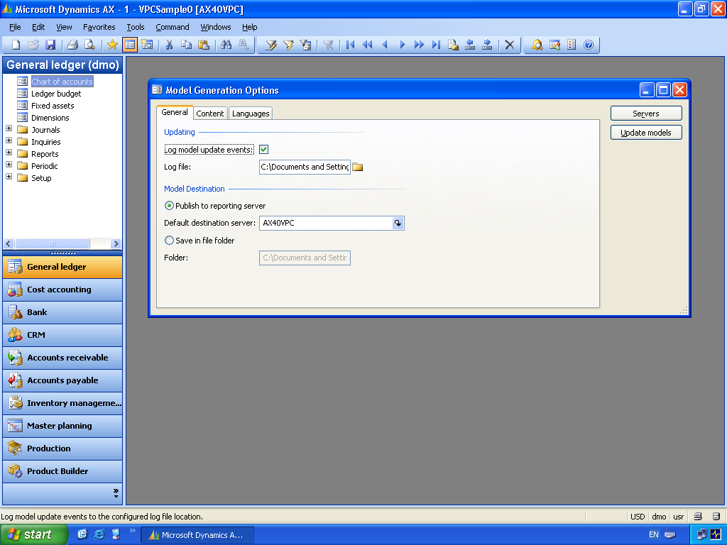
Figure 1.3 Model Generation options

Task 4: Perspectives
If you are not interested in the development aspects of the model you can skip this step.
- For the model generation to be successful, we need to define the data tables we want to publish. To do this we have a new node in the Microsoft Dynamics AX AOT called Perspectives.
- Open the AOT. You can do this either by using the shortcut keys CTRL+D or by clicking on the icon provided on the right-hand side of the toolbar.
- When the AOT is open, expand the tree by clicking the plus (+) sign located next to the tree branches. Expand Data Dictionary and expand Perspectives.
- In this example we have two Perspectives created: AccountsPayable and AccountsReceivable
- A Perspective is a collection of tables or a grouping. This can be used to represent an end-user role for reporting purposes. Because there are more than 2,000 tables in Microsoft Dynamics AX, creating a Perspective for your end users will let you group a set of tables that are relevant for their role.
- Perspectives are created by dragging and dropping tables into the Perspective.
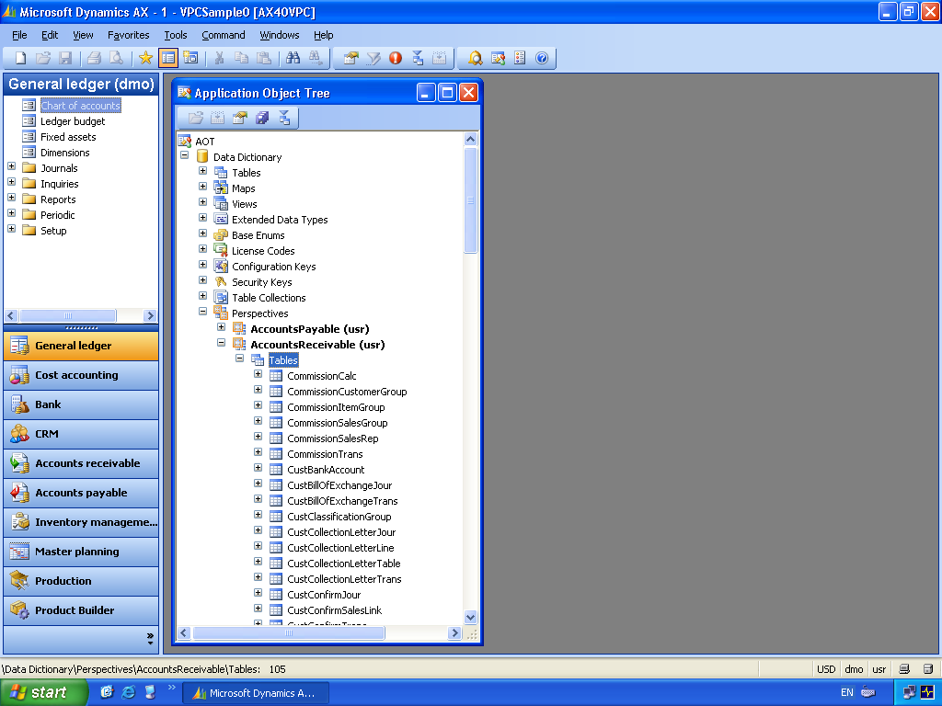
Figure 1.4 Perspectives

Exercise 2: Building a Report
In this exercise, you will use the Microsoft SQL Server Reporting Services Report Builder to create a new report.

Task 1: Report Manager
- To develop a new report we need to access the Report Builder. This can be done from the menu option provided in Microsoft Dynamics AX and from the SQL Reporting Services portal.
- Access the portal from the menu provided in Microsoft Dynamics AX: Tools, Reporting tools, Report Manager.
- You will notice at the bottom of the menu there is also a direct link to the Report Builder, but in this exercise we will go straight to the Report Manager to explore this tool.
- When you click on the Report Manager option, a copy of Internet Explorer will start.
- You will notice that in the main body of the page there is a folder for Dynamics. This was created when you published the model from Microsoft Dynamics AX. Click on the link for the Dynamics folder.
- This will open the list of models that have been published. In this case we have two—one for Dynamics – AccountsPayable (EUR – English(United States)) and one for Dynamics – AccountsReceivable (EUR – English(United States)). These where created when the models were published from Microsoft Dynamics AX.
- We can create a new report by clicking on the Report Builder button that is located on the toolbar.
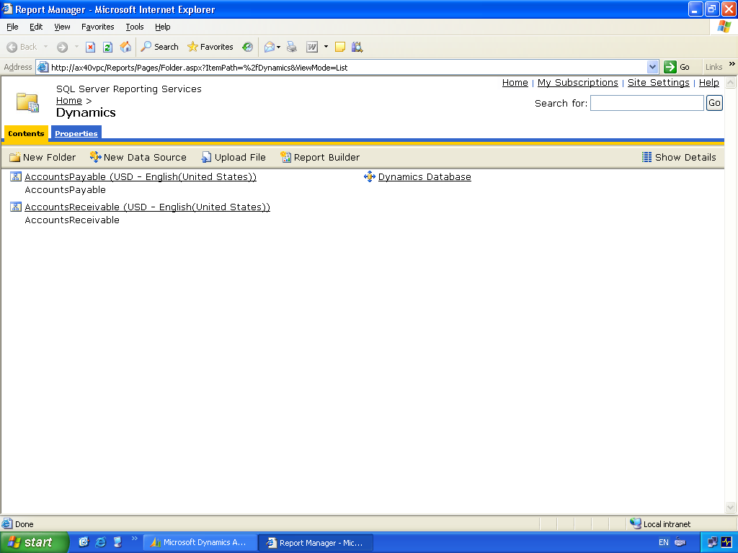
Figure 2.1 Report Manager

Task 2: Build the report
- The Report Builder will start. If this is the first time a user accesses the Report Builder the user will be asked to install the client. This is a small .NET application that will be downloaded and installed via ClickOnce deployment on the user’s machine.
- In this case the Report Builder will start and you will be presented with some options. The first option to select from the right-hand task pane is the model to use.
- You will see that the list of models available are the ones that have been published from Microsoft Dynamics AX: the AccountsReceivable model and the AccountsPayable model.
- Select the AccountsReceivable model as we will create a report based on Customer data.
- At the bottom of the task pane you can change the type of report you want to build. In this example select the Matrix (cross-table) option. You will notice you have other options like Table for transaction-type reports and Chart for graphical reports.
- Then click the OK button.
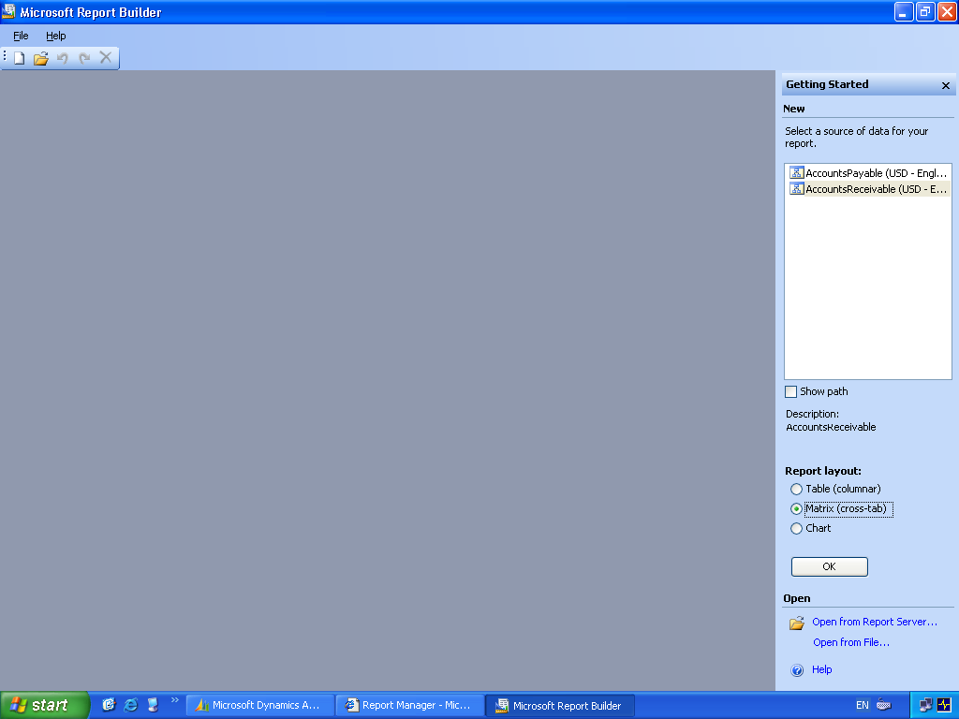
Figure 2.2 Report Builder

Task 3: Design the report
- The Report Builder will now open to display the design surface for a matrix report.
- In the left-hand Explorer you will notice the list of tables from Microsoft Dynamics AX.
- This explorer is broken into two panes. The top pane displays the list of tables and the bottom pane displays a list of fields from the table you have selected.
- In this report we will create a report of Customer Transactions by Dimension.
- In the top Explorer pane locate the Accounts receivable tables.
- In this list locate the Customer transactions table.
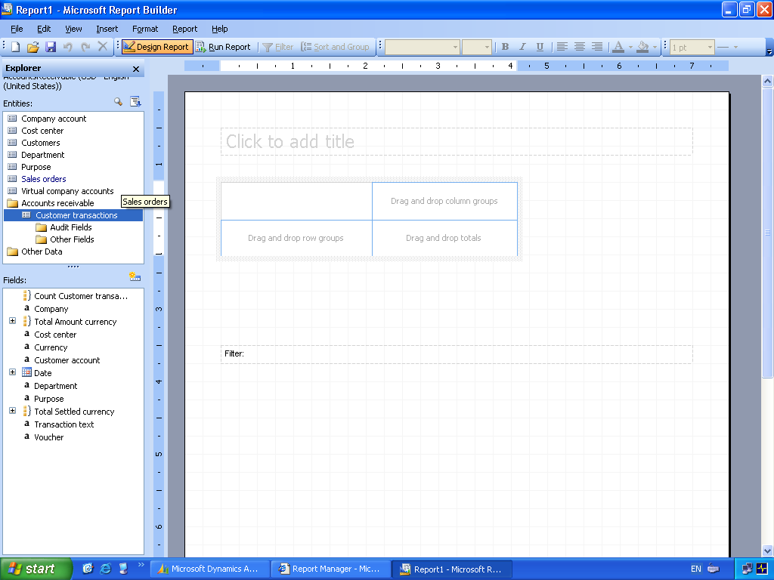
Figure 2.3 Report layout

Task 4: Add controls to the report surface (1)
- You can now drag the relevant fields onto the design surface.
- In the bottom Explorer pane locate the Customer Account. Drag this from the list onto the left-hand side of the matrix.
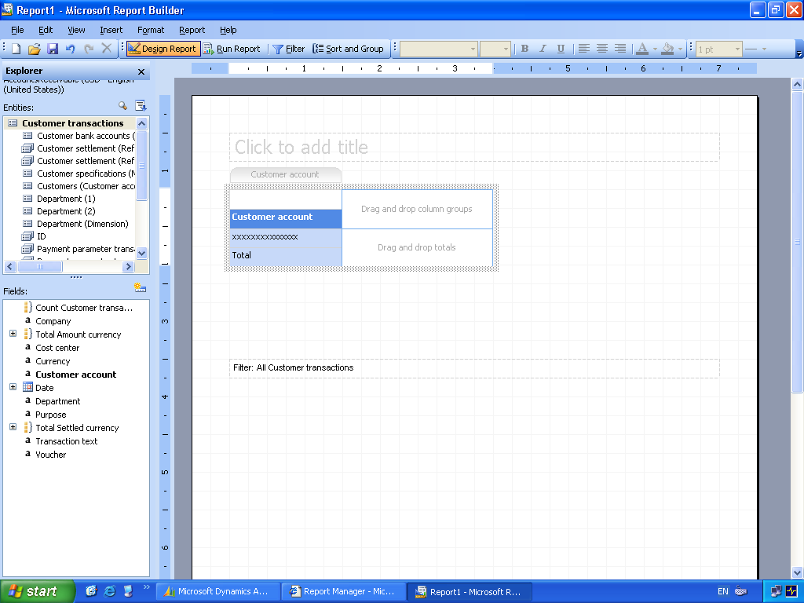
Figure 2.4 Report layout

Task 5: Add controls to the report surface (2)
- In the bottom Explorer pane locate the Department. Drag this from the list onto the top of the matrix.
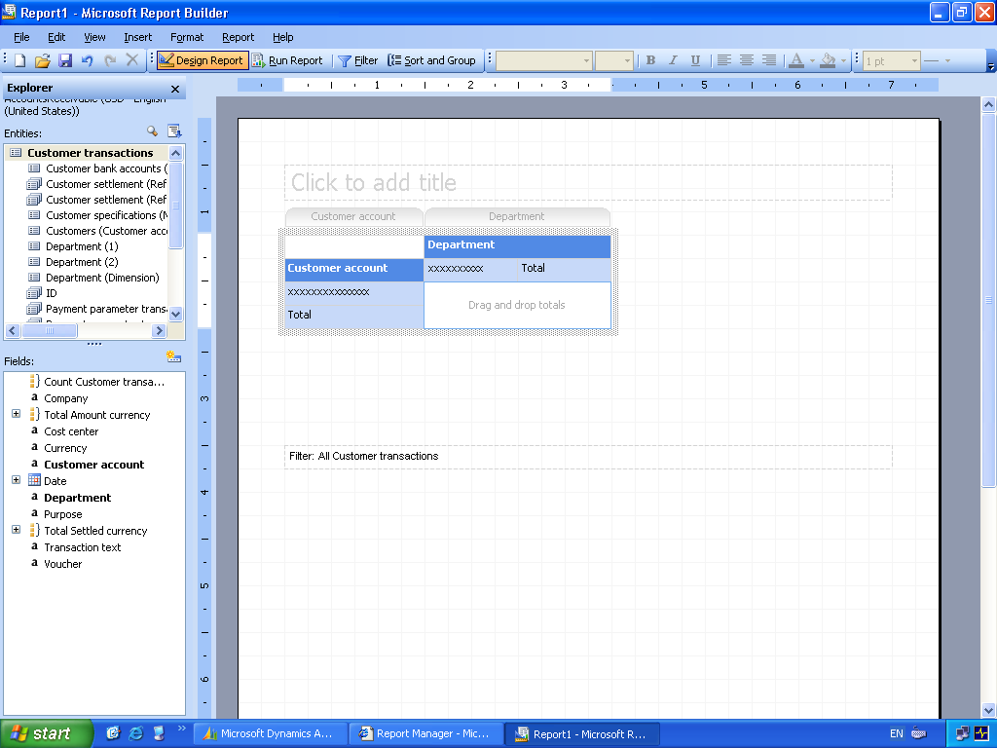
Figure 2.5 Report layout

Task 6: Add controls to the report surface (3)
- In the bottom Explorer pane locate the Total Amount Currency. Drag this from the list onto the totals area of the report.
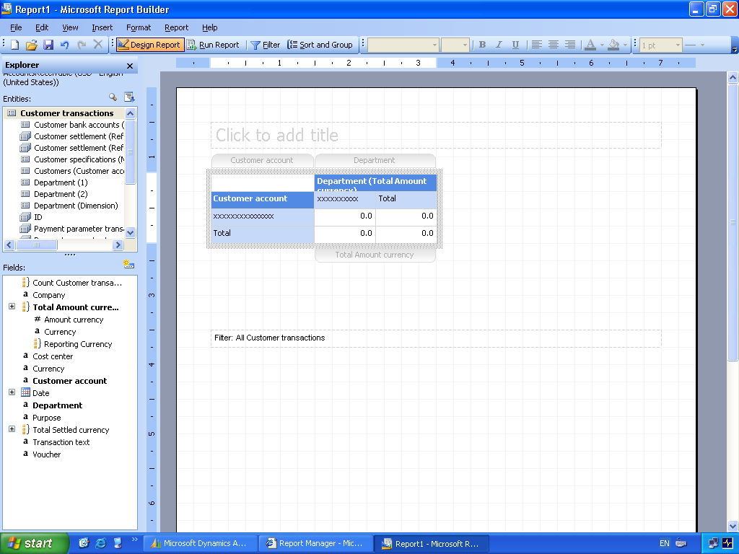
Figure 2.6 Report layout

Task 7: Add a title
- You can add a report title by clicking in the field provided.
- Type in a title, for example, Customers By Department.
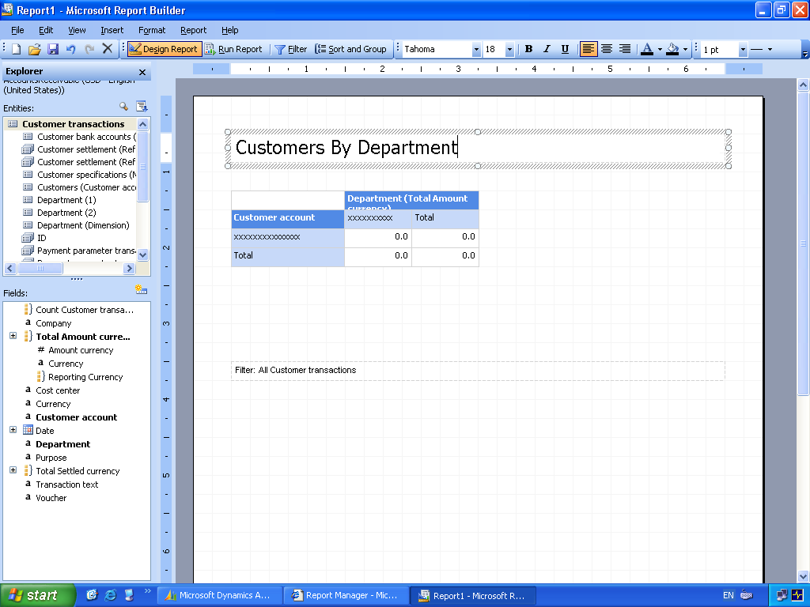
Figure 2.7 Report layout

Task 8: Save the report
- You can save your report to use late and publish to other users.
- Click the Save button. Save the report in the Dynamics folder as Customers By Department.

Exercise 3: Publish Report Data to Microsoft Excel
In this exercise, you will use the report that you have created to run and report and publish the data to Microsoft Excel.

Task 1: Run Report
- Run the report by clicking the Run Report icon on the toolbar.
- When the report has run you will notice icons on the toolbar to Filter and Sort and Group. You can use these to change the display of data in the report.
- You will also notice the columns in the report, in this case Customer account. You can click on the title of the column in the report to change the sorting.
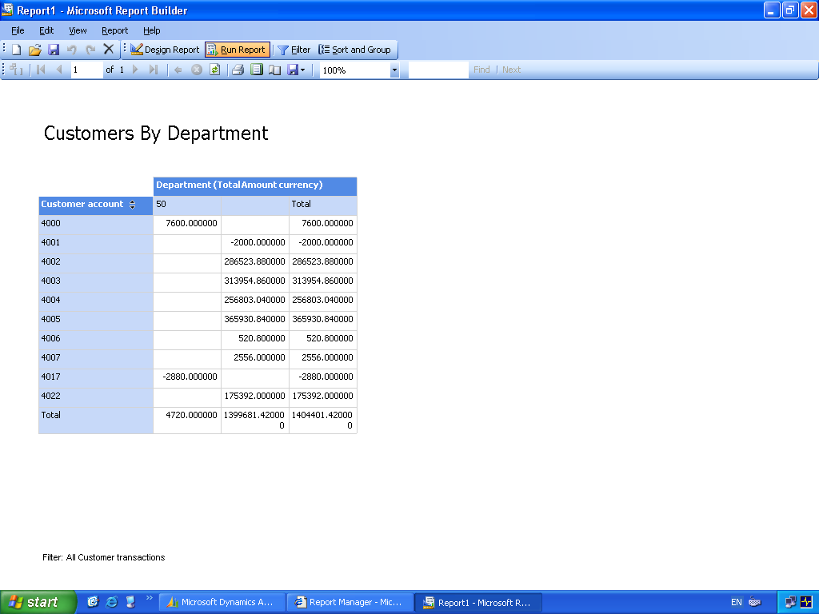
Figure 3.1 Run Report

Task 2: Export to Excel
- Locate the Export tool on the toolbar. This is displayed as a small diskette similar to the Save icon but with an additional drop-down menu to the right of the icon.
- Click the option to export to Excel.
- You will be prompted to save the report as an XLS workbook. When the save dialog is open, click the desktop icon and save the report as Report.xls.
- Click Save.
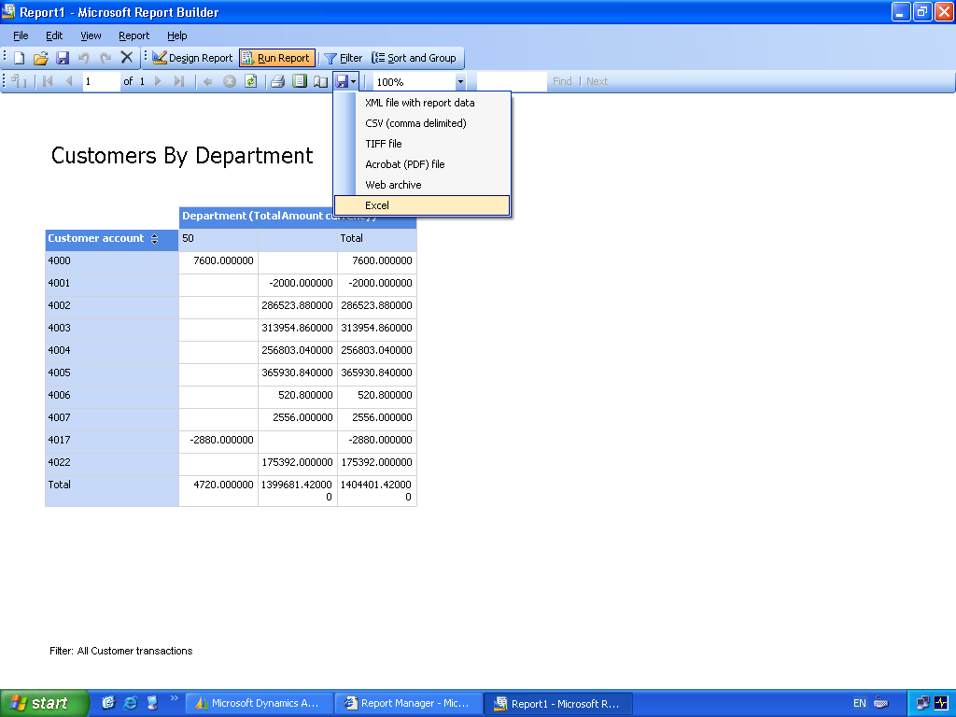
Figure 3.2 Export to Excel

Task 3: Open in Excel
- Start Microsoft Excel by clicking Start, All Programs, Microsoft Office, Microsoft Office Excel 2003.
- When Excel is open, click File, Open.
- Choose the desktop in the Open dialog box.
- Click on the Report.xls located on the desktop.
- Click Open.
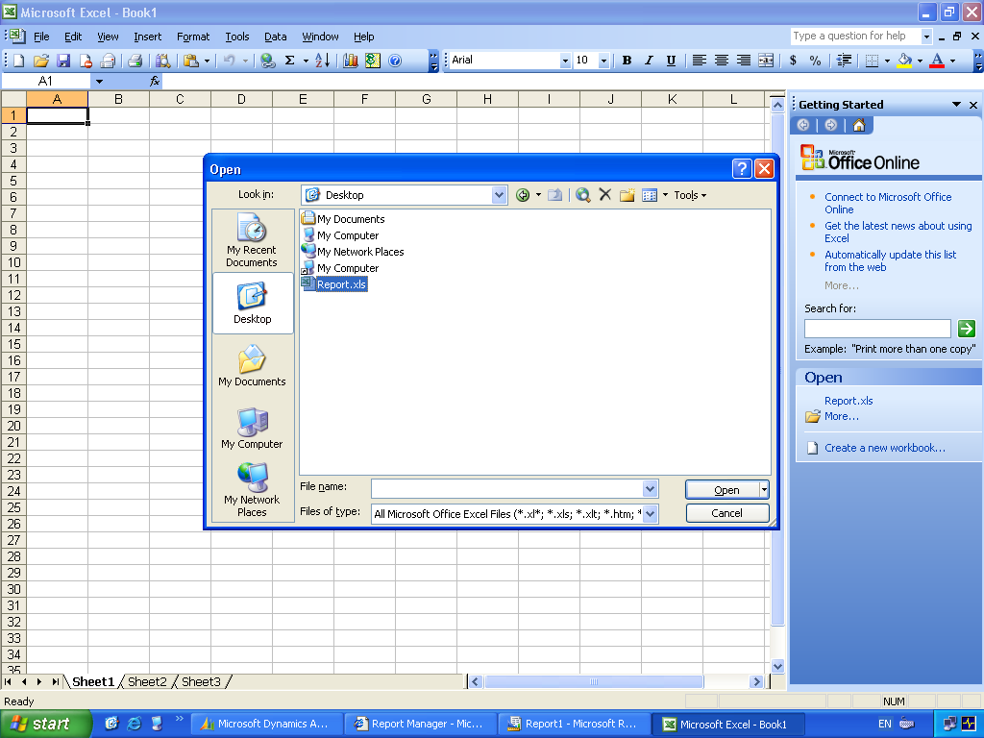
Figure 3.3 Open in Excel

Task 4: View in Excel
- You will now see the exported report data in Microsoft Excel and you can continue your analysis of the data.
- You have other Export format options: XML, CSV, TIFF, PDF, Web Archive. These give you the flexibility to start working with your data outside Microsoft Dynamics AX in Microsoft Excel.
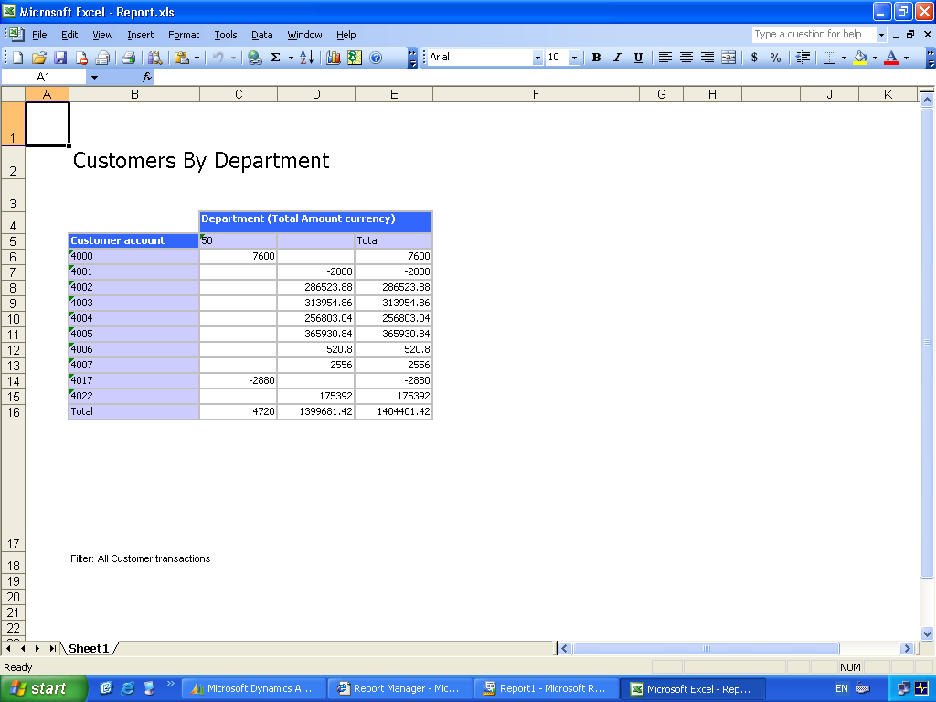
Figure 3.4 View in Excel

Exercise 4: Subscribe to a Report
In this exercise, you will use the Report Manage to subscribe to a report so that it can be executed and sent to your email inbox. Users can use this option to simplify the distribution of the report as it will be sent to their inbox.

Task 1: Run Report
- Navigate to the Report Manager. From the Microsoft Dynamics AX client access the menu Tools, Reporting Tools, Report Manager.
- When the report manager has started click the link to Home.
- You will see the link to the report that you saved in the earlier exercise. Customers By Department.
- Run this report by clicking on the Customers By Department link.

Task 2: Subscribe
- When the report is displayed in the Web browser you will notice a New Subscription button in the toolbar of the report viewer.
- Click on the New Subscription button.
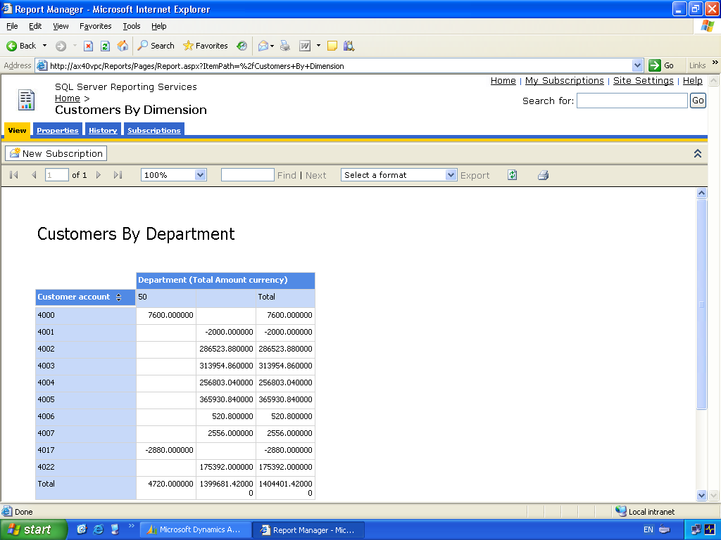
Figure 4.1 Subscribe

Task 3: Subscribe details
- In the details for the subscription you will notice that the default Delivery method is by Email.
- Change the To: field to Administrator@dynamicsax.com.
- Change the Render Format. For example, you can have the report e-mailed and it will be attached in Excel format if you nominate this.
- Enter a brief comment in the Comment field.
- Click on the Select Schedule button to schedule the report.
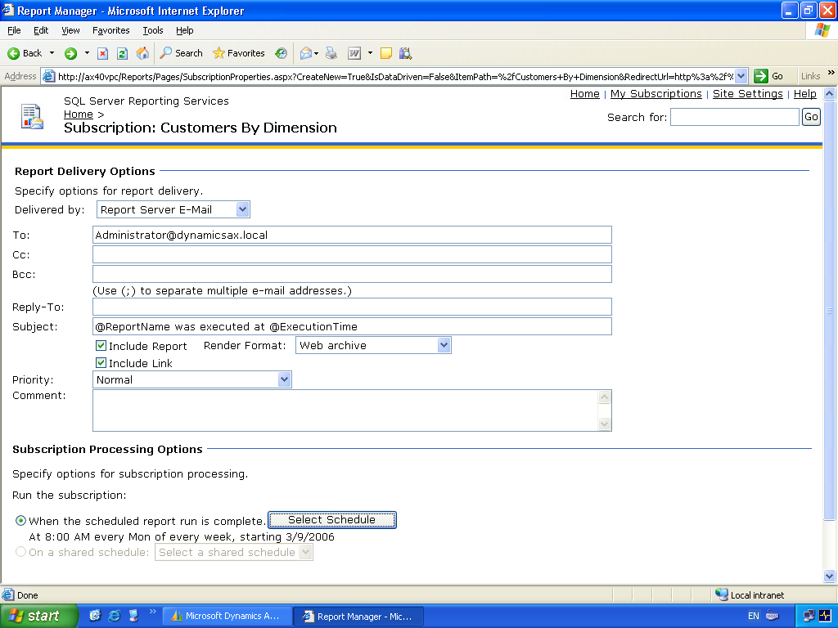
Figure 4.2 Subscribe details

Task 4: Subscribe details
- Select the option to run the report Once.
- Right-click on the task bar and click Properties.
- Select Show the clock and click OK.
- You will have to enter a time for the report to run. Enter a time value that is 2-3 minutes in advance of current machine time. Keep in mind this may be different from the actual time.
- Click the OK button to accept the schedule.
- You will be returned to the subscription details. Click OK to complete the subscription.
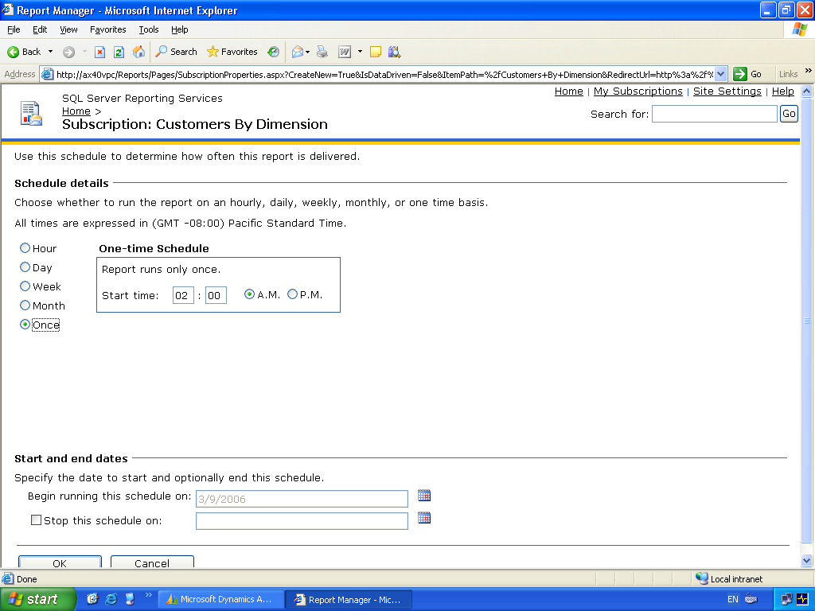
Figure 4.3 Subscribe details

Task 5: View published report
- You will have to wait for the amount of time that you nominated in the previous step.
- Start Outlook. Click Start, All Programs, Microsoft Office, Microsoft Office Outlook 2003.
- Click on Send/Receive.
- A previous report will exist in the Inbox. The comment that you entered during the report configuration will allow you to distinguish between the e-mails.
- You will be logged in to the administrator’s e-mail.
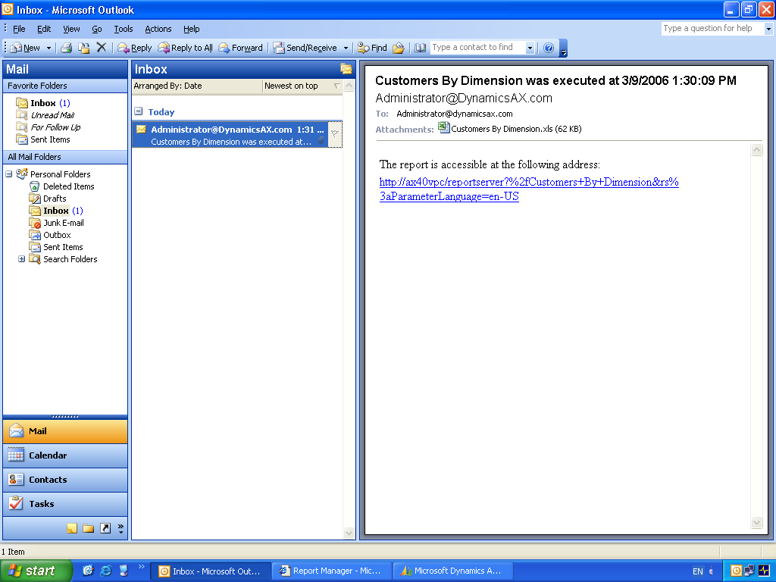
Figure 4.4 Delivered report

Post-lab Exercise
Note: When completing this lab through the HOL LaunchPad, you do not need to interact directly with Microsoft Virtual PC and can proceed directly to the lab evaluation.

Task 1: Shut down the Virtual PCs
- If you are in full-screen mode, press Right Alt-Enter to return to windowed mode.
- For each open Virtual PC, select Close from the Action menu on the Virtual PC 2004 menu bar.

Lab Summary
These exercises have shown you four important pieces of knowledge about Microsoft Dynamics AX.
- Microsoft Dynamics AX now has the ability to use Microsoft SQL Reporting Services for expanded flexible ad-hoc reporting.
- The data model can be published from Microsoft Dynamics AX and grouped by perspectives to suit the collection of tables for your end-user reporting needs.
- The security is controlled via Windows Authentication and the permissions are controlled in Microsoft Dynamics AX.
- You can export report data to many formats and can subscribe to reports to schedule the execution of the report and have it sent your e-mail inbox.

