

Exchange Server 2007 Unified Messaging
White Paper
Published: July 2006
For the latest information, please see http://www.microsoft.com/exchange/


Contents
Introduction 2
Benefits of Unified Messaging 5
Unified Messaging Reduces Wasted Time 5
Unified Messaging Broadens Access 6
Unified Messaging Reduces Costs 8
Unified Messaging Adds Capability 9
Exchange Unified Messaging Explained 11
Voice over IP Gateways 11
Unified Messaging Server Role 12
Site and System Consolidation with Exchange Unified Messaging 16
Site vs. Server Consolidation 17
Planning and Executing Consolidation 17
Conclusion 18

Introduction
Communications and collaboration are critical elements of business success. Companies that are able to successfully integrate communication and collaboration processes in their business workflows can lower expenses, increase efficiency, and realize the value of information assets they already have.
Part of this integration process involves integrating different communications methods and systems. Historically, e-mail (and related data, like calendar, contact, and task data), voice mail, and fax traffic have traveled on separate paths through communications networks, and they've been accessible through separate tools: computers, telephones, and fax machines. In the new world of work, employees require easier access to these communication types, leading to the integration of telephony, fax, and e-mail capabilities into desktop and mobile clients. The first set of unified messaging solutions put the emphasis on allowing individual users to originate different kinds of communications traffic, including desktop faxing and e-mail, but lacked an effective set of server-based reception, storage, management, and policy control capabilities. As the market matured, unified messaging systems added fax and voice mail capabilities to existing e-mail systems, but these improved products are typically tied to specific proprietary phone systems.
Microsoft's introduction of unified messaging support in Microsoft® Exchange Server 2007 marks the start of the third wave of unified messaging technology: robust, interoperable, server-based tools that integrate with desktop and mobile clients to give information workers access to voice, fax, and e-mail data from wherever they are and allows users to use the telephone to manage their email, calendar, and personal contacts. Exchange Server 2007 Unified Messaging offers five key benefits:
- Less wasted time. People are able to quickly send, receive, and find the exact information they need, no matter what form it was delivered in and no matter where they are.
- One inbox. Exchange Server 2007 seamlessly delivers e-mail, voice mail, calendar data, and fax messages into users' inboxes. Users can sort, manage, and act on multiple message types without having to switch between applications or systems.
- Anywhere access. Exchange Unified Messaging delivers access from familiar clients like Microsoft Office Outlook®, Outlook Web Access, a variety of mobile devices, and ordinary telephones.
- Reduced costs. Integrated unified messaging systems allow site and server consolidation, reducing the total number of servers required to provide voice mail and fax service. Consolidation can dramatically lower maintenance and upkeep costs, particularly for organizations with remote or branch offices.
- Foundation for unified communications. The combination of e-mail, voice mail, and fax capability can be augmented with presence, instant messaging (IM), and real-time conferencing capability to expand the ways in which users can share information and communicate.
Exchange Unified Messaging is implemented by the Unified Messaging server role of Exchange Server 2007. The UM server is responsible for providing several key services:
- It provides an entry point for data from the physical telephone system (including internal phone lines and trunks that connect to the public switched telephone network, or PSTN) to the Exchange infrastructure. In particular, the UM server allows voicemail and fax messages to be stored in the Exchange rather than in separate systems.
- It contains logical objects that reflect the telephony infrastructure of the organization. Single unified messaging servers can support multiple private branch exchanges (PBXs) using numbering schemes that already exist within the organization, and users can be grouped into various classes of service that that control who can use voice mail and what they can do with it.
- It provides a customizable, speech-enabled Automated Attendant service that answers internal and external phone calls and automates dialing through directory integration with the Global Address List, acting as a highly advanced switchboard-type application.
- It runs Outlook Voice Access, which provides telephone-based access to inbox data using speech or Touch-Tone (dual-tone multi-frequency, or DTMF) recognition, and offers text-to-speech functionality to read e-mail calendar, personal contacts, and directory information back to the caller.
Figure 1 shows the relationship between the Exchange Unified Messaging server role and other components of the communication system.
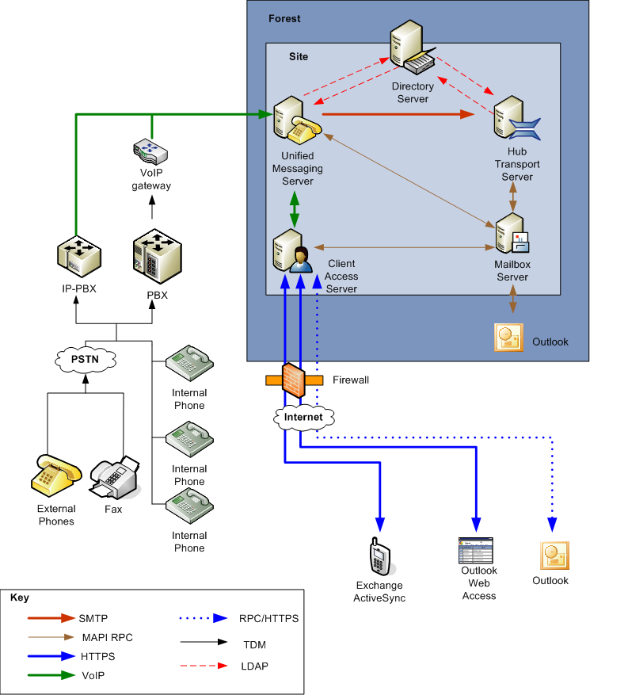
Figure 1: The relationship of the UM server role and OVA to clients, phones, and PSTN

Benefits of Unified Messaging
Unified messaging makes it possible for information workers to be productive from almost anywhere and during time that might otherwise be wasted, using a broad range of devices. The unified messaging features of Exchange Server 2007 help deliver the business benefits of unified messaging in four ways:
- Exchange Unified Messaging helps consolidate information in one place: the user’s inbox. Voice mail, faxes, e-mail, appointment data, and contacts appear in one place, making it easier for users to access, find, and act on them.
- Exchange Unified Messaging helps save time by giving information workers access to the same set of inbox data wherever, and whenever, is most appropriate for them. Because people, workloads, and workflows differ, broadening access lets each person tailor their access patterns to best match their needs. This personalization helps increase individual information worker productivity, at the same time giving users more flexibility in how they choose to work..
- Unified Messaging can reduce costs in two ways: it allows consolidation of voice messaging infrastructure; and it takes advantage of existing investment in Exchange servers, training, and infrastructure components.
As part of an overall unified communications strategy, Unified Messaging can be deployed in combination with other technologies, like Microsoft Office Live Communications Server 2005, to provide voice over IP (VoIP) telephony, call control, and instant messaging. Deploying Unified Messaging gives you an immediate way to build new business processes or improve and streamline existing processes, helping to prepare for future updates to your telephony and communications systems.

Unified Messaging Reduces Wasted Time
Employees today are almost always under some kind of time or deadline constraint. No matter what industry you work in, competitive and operational pressures put a premium on the ability to quickly get access to the right information or people needed to get work done. Anything that reduces the amount of time it takes to create, send, receive, or act on business information helps deal with these pressures effectively and productively..
Over the last few years, several prominent analyst firms have emphasized that the best rate of return comes from investments in raising the productivity of individual knowledge workers and in enterprise and team collaboration. Exchange Unified Messaging helps deliver individual knowledge worker productivity by:
- Helping individual users who spend most of their time working with Outlook work without needing to check separate systems or mailboxes. By delivering messages, voice mail, and faxes into the same inbox as other messaging types, employees can easily access the information they need immediately instead of constantly switching from one tool to another. This allows them to focus on value adding activities, not on trying to keep up with their communications.
- Enabling highly mobile users to stay connected by providing them quick access to all of their communications-- voice mail, e-mail, and faxes-- from Outlook 2007, Outlook Web Access 2007, Exchange ActiveSync®-capable devices and the new Outlook Voice Access (a component of Exchange Server 2007, like Outlook Web Access).
- Giving users broad access to calendar, contact and corporate directory data through the telephone, including reading calendar information to users and allowing them to look up and voice dial people both from their own contacts folder and from the corporate directory.
- Allowing users to handle their messages and calendar data (including listening to, forwarding, and replying to e-mails and making, updating, or responding to meeting requests) over the telephone. Users can flag messages for follow-up, skip to the next unread, hide or delete conversations, and even find messages from particular users, all using either voice navigation or a standard touch-tone keypad.
- Providing Automated Attendant capability to help both internal and external callers find the right person quickly. The Automated Attendant uses information from Active Directory® to route calls both to specific employees and to roles or departments; for example, a caller who asks the attendant for "sales" can be routed to a specific extension, a hunt group (a group of extensions that can be accessed via a single number), or a group voice mailbox.
Adding these capabilities to existing messaging and collaboration systems makes it easier for employees to process information in whatever way is most convenient. This clearly reduces the amount of time wasted in replying to or taking action on message content; in addition, because information workers can take action without having to wait until they're near their personal workstation, actions can happen faster.
Analyst research indicates that organizations that broadly deploy Internet Protocol-based communication systems may realize productivity gains of three or more hours per employee per week. This gain comes directly from the improved access to voice, e-mail, and fax communications that is possible with unified messaging systems like the one integrated into Exchange Server 2007.

Unified Messaging Broadens Access
Messaging and collaboration have evolved significantly over the ten years since Exchange Server first shipped. During that time, the way that users access their mail has evolved, too. In the beginning, e-mail access was primarily done using LAN-attached clients. Remote users might have dial-up network access, which for some mail systems required a separate remote-capable client. However, for most users there was essentially no such thing as home-based remote access, nor were there widely deployed Web clients. The few mobile devices that existed ten years ago had little or no wireless data capability, and even if they did, their use was limited to closed services like CompuServe and America Online. Later devices gained the ability to access Internet content through the Wireless Application Protocol (WAP), but WAP gateways were tightly controlled by mobile network operators and generally couldn't be used for remote access to corporate networks.
Fast-forward to today, when powerful browser-based clients like Outlook Web Access are widely deployed, virtual private networks (VPNs) are in widespread use, PDAs and Smartphones with high-speed wireless data access are becoming ubiquitous, and Outlook Anywhere (using RPC-over-HTTP) provides easy access to Outlook data from almost any Internet-connected computer running Windows.
These trends are amplified by the fact that most companies now have a much more mobile workforce than in the past. Users have become accustomed to working on the road, from remote offices and customer sites, and from home. To be effective in these situations, they need to get their e-mail, calendar, and contact data from multiple locations and devices, and have the contents of their inbox consistently accessible (and synchronized) across multiple devices.
Exchange Server 2003 already provides broad mobile access for e-mail and calendar data. However, two key communication types are missing from this model: in most organizations, voice mail and fax data are tied to an individual phone extension or fax machine. Users are required to switch communications modes, from computer to phone and back again, to get complete access to all the data they need for their jobs. The Exchange Server 2007 Unified Messaging server solves this problem by making voice mail and fax data accessible alongside existing e-mail, calendar, contact, and task data. Users can choose the tools that work best for them, including:
- Outlook Voice Access, which provides telephone access (with both Touch-Tone and speech recognition) to calendar, contact, and e-mail data from any telephone, anywhere in the world. This enables travelers or mobile workers to quickly get or send updates to their calendar, access their contact data, or receive new e-mail messages without requiring a laptop, mobile devices, or Web browser access.
- Outlook 2007, which integrates voice mail as a first-class data type. The Outlook 2007 interface allows users to sort, search, and prioritize voice mail messages along with other data items; in addition, users can play voice mail messages on their desk phones, and add notes to voice mail messages so that the contents of the message are indexed along with associated sender and date information. (See Figure 2.) Outlook also provides complete support for user-configurable unified messaging options, including configuring greetings and resetting PINs.
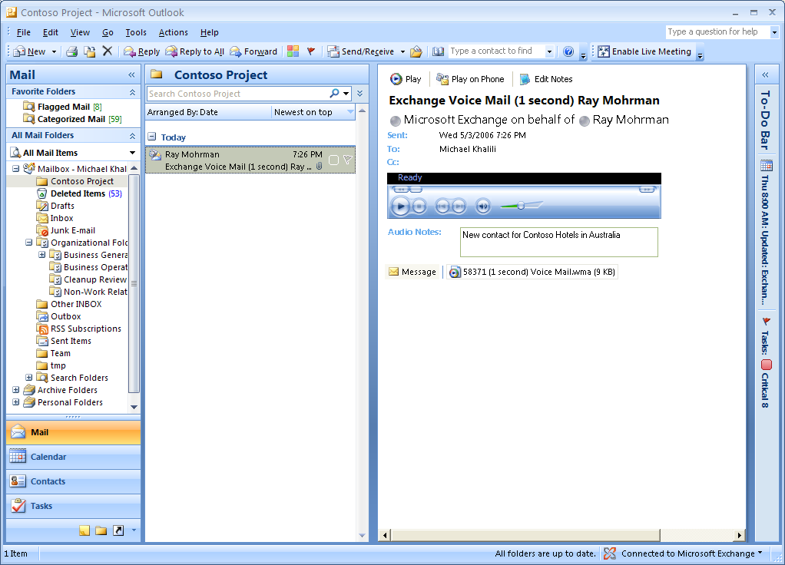
Figure 2: Outlook 2007 presents voice mail as a first-class data type in the Inbox
- Outlook Web Access 2007, which lets users access their voice mail and fax data from within a browser session. OWA 2007 provides ubiquitous browser-based access to many of the features of Outlook 2007, including the ability to play back voice mail messages on the computer or the telephone and the ability to create and listen to audio notes. (See Figure 3.)
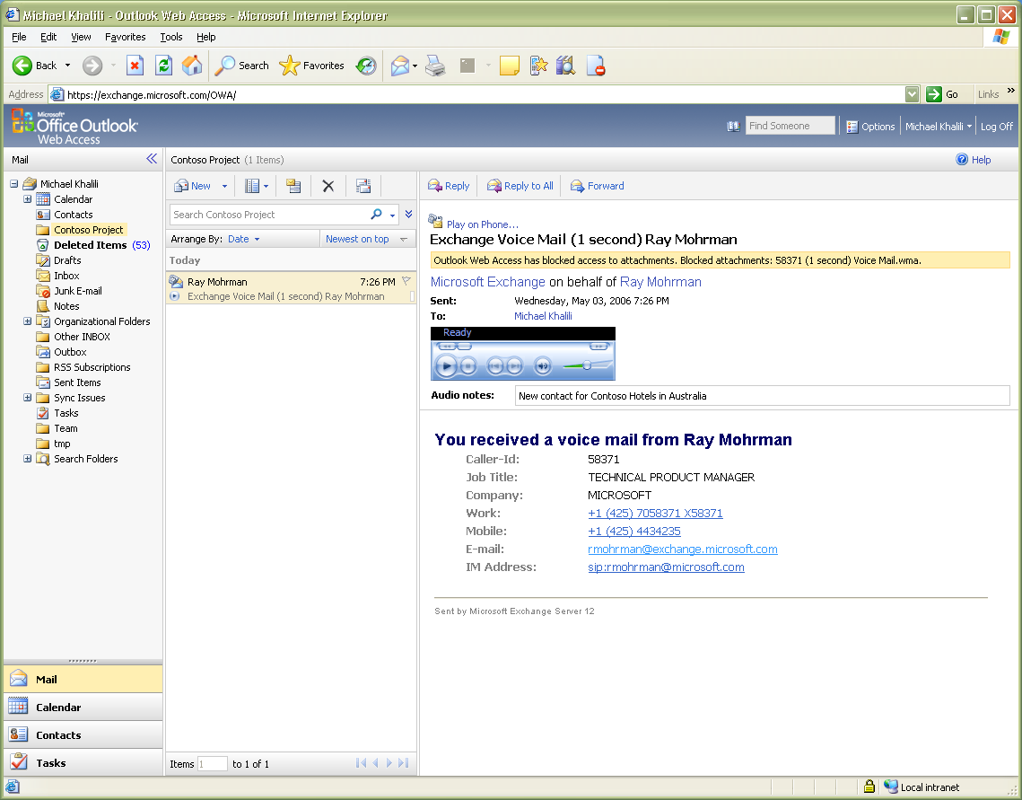
Figure 3: Outlook Web Access 2007 provides a directly accessible view of voice mail messages
- Mobile devices that support the Exchange ActiveSync protocol, which provide wireless and mobile access to inbox data, including voice mail.
- Other clients, like Microsoft Entourage® for Mac OS X, which allow users to listen to voice mail messages if the necessary audio codecs are available on the host computer. This provides additional flexibility for users in heterogeneous environments.
Helping users access their voice mail, fax, and e-mail messages from a wide range of devices destroys several barriers to efficiency, including the former requirements that users go to a physical fax machine or telephone to access their fax or voice mail data, or that they use a computer with an Internet connection to read their e-mail messages. With these barriers removed, users can get more work done in less time, and on a schedule that suits their individual needs.

Unified Messaging Reduces Costs
Computing power (as measured by storage and CPU capacity) has been dropping in price for nearly 20 years. The emergence of powerful but affordable x86-based servers has driven the use of computers to store and process a wide range of business-critical information. The economics of information technology have changed over this period, and businesses have moved from a completely centralized model using mainframes in a data center to a mixed model that decentralizes some activities and centralizes others. This mixed model allows for cost savings through centralization of shared resources like e-mail servers, while still providing flexibility for user-focused resources like team sites.
Over the same period, specialized voice mail and telephony systems have delivered an extensive set of telephony capabilities directly to users, including automated attendants that direct calls to the right recipients, voice mail (including group messaging, transfer, and forwarding), call control features like forwarding and routing calls, and conferencing. However, these features are implemented by the voice mail and PBX hardware, which is typically distributed to the edges of the network topology. For example, companies with branch offices normally have to maintain a separate voice mail system at each location; the purchase and maintenance cost of these systems can consume a significant part of communications budgets. The same things are true of fax capabilities: distributing fax sending and receiving capabilities increases the purchase and upkeep cost while at the same time increasing the possibility of misdirected or "lost" faxes.
The Exchange Server 2007 Unified Messaging features help address these problems in the simplest possible way: voice mail and fax messages are centralized and stored on the organization's existing e-mail servers, where they can be stored, backed up, and managed alongside other business-critical messaging and collaboration data. Many companies now have voice mail systems that use different types of voice mail servers and PBXs in different locations. This greatly adds to the overhead, and cost, required to provide voice mail services to users. By enabling consolidation of voice mail services on Exchange Unified Messaging, Exchange Server 2007 cuts both the initial and ongoing cost of voice mail service by reducing the number of legacy voice mail systems required to provide every employee with voice mail. In the same way, consolidating the ability to receive faxes by co-locating it with the messaging and voice mail services means that the costs of operating fax service drop dramatically.
Because voice mail and fax data are consolidated on the organization’s Exchange servers, the same security and backup policies apply to voice mail, faxes, and conventional Exchange data. Journaling, compliance, and retention support are included and can be applied consistently across all data types. As an additional benefit, Exchange administrators can manage the Unified Messaging environment using their existing skills and the familiar Microsoft management interfaces they already use. This further reduces costs by allowing your company to take advantage of skills and capabilities you already have on staff.

Unified Messaging Adds Capability
Exchange Unified Messaging works together with other Microsoft communications and collaboration products, including Microsoft Office Outlook, Microsoft Office Communications Server 2007, and Microsoft Office Communicator. Communications Server provides powerful call control and routing features that allow you to transfer and route calls based on your physical location and presence status, while Exchange Unified Messaging handles voice mail, provides the Automated Attendant service, and delivers anywhere access to your stored communications.
To see how Communications Server and Exchange Unified Messaging work together, consider this example. Alice is trying to reach Bob, whose company has both Exchange Unified Messaging and Communications Server deployed. When Alice calls Bob, the following things can happen:
- If Bob is on the phone. Alice’s call is automatically routed to the Exchange Unified Messaging server by the PBX. The Unified Messaging server records a voice mail message, which appears in Bob’s inbox.
- Bob is working from home and connected though a virtual private network connection to his office network. When Alice calls his office phone, Communications Server sends a call notification to his computer, which appears as a small popup. Bob can choose to forward the call to his mobile phone, in which case Communications Server instructs the PBX to transfer the call
- If Bob chooses not to answer Alice’s call, the call is transferred to the Exchange Unified Messaging server.
This process offers a great deal of flexibility; users can choose to take calls or forward them to voice mail, and as long as they’re on the network they can see incoming call notifications on their computer even when they’re not physically near their phone extension. Communications Server enables them to take those calls, and Exchange Unified Messaging provides access to voice mails and faxes that arrive when they aren’t able to take calls.

Exchange Unified Messaging Explained
From an architectural perspective, Exchange Server 2007 is significantly enhanced from Exchange Server 2003. Exchange Server 2007 is a modular system of five server roles—Edge Transport, Hub Transport, Mailbox, Client Access, and Unified Messaging—that perform specific operations in an Exchange organization. With the exception of Edge Transport, which must sit in the perimeter network, all roles can be run on a single server, or broken up onto multiple servers based upon the size and requirements of the organization. There are several roles that participate in delivering Unified Messaging services to end users:
- The Unified Messaging server role communicates with both the telephone and e-mail components of the organization to accept and route calls, record and play back voice messages, receive faxes, and route messages to subscribers' mailboxes. (Subscribers are users whose accounts have been enabled for Unified Messaging access and who have Exchange Server 2007 mailboxes.) It offers Outlook Voice Access service and hosts any Automated Attendants that the organization might have configured.
- The Mailbox server role holds user mailboxes, where voice mail and fax messages are stored in users' inboxes along with conventional e-mail.
- The Client Access server role provides a means for clients, including Exchange ActiveSync, Outlook, and Outlook Web Access, to communicate with the mailbox.
- The Hub Transport server role moves messages between the other server roles, while allowing policies to be applied in transit.

Voice over IP Gateways
The Exchange Server 2007 Unified Messaging role can communicate with two distinct types of PBX. Some PBX hardware, referred to as IP-PBXs, directly implements Voice over IP (VoIP) capability. Most PBXs, however, don't directly provide VoIP services, but instead use legacy, proprietary, circuit-switched protocols to transport phone traffic. (Time Division Multiplexing (TDM), is one such circuit-switched method of transporting phone traffic.) These PBXs require the use of a VoIP gateway that translates between circuit switched protocols and packet based internet protocols compatible with the VoIP network stack that exists in Exchange Unified Messaging.
When the PBX receives an inbound call, it is responsible for ringing the selected extension and, if the call is not answered, using its own call coverage configuration to determine where the call should go next. Assuming that the coverage configuration specifies transfer to Exchange Unified Messaging, the PBX routes the call from the original destination extension to the hunt group configured to point to Exchange Unified Messaging. In the case of an IP-PBX, the call is directly connected without a gateway; for traditional PBXs, the PBX reaches Exchange UM through a VoIP gateway.
This gateway is responsible for converting the call data from circuit-switched to packet-switched protocols. Exchange Unified Messaging uses Session Initiation Protocol (SIP) for call setup and signaling, the Real-time Transport Protocol (RTP) for voice sessions, and the T.38 (fax over IP) protocol for fax data. Exchange supports (but does not require) the use of the Transport Layer Security (TLS) protocol to secure and authenticate communications between the PBX or gateway and the Exchange Unified Messaging server.
Intel and AudioCodes are offering gateway products that link Exchange Unified Messaging servers with legacy PBX systems. For the latest information on the availability of IP-to-PBX gateways that are certified to work with Exchange Server 2007, see Microsoft's Exchange Web site at http://www.microsoft.com/exchange.

Unified Messaging Server Role
The Unified Messaging server handles interactions between telephone callers and the rest of the messaging system. This server role accepts call requests from the PBX (using a gateway when necessary), offers call answering for voice mail and fax calls, delivers Outlook Voice Access services to subscribers records and plays back voice messages, receives faxes, and hosts the Automated Attendant,. Understanding the UM server role is critical for understanding how Exchange 2007 supports unified messaging and how it can be deployed to deliver the benefits described in the preceding portions of this paper.

What Happens When the Phone Rings?
When someone calls an Exchange Server 2007 Unified Messaging subscriber, what happens? The process is fairly straightforward, but walking through it will help clarify what the UM server role does and how it interacts with other components of the telephone and messaging systems.

When a voice call arrives
First, the caller places the call, which is routed to the recipient's phone using the public switched telephone network (PSTN) or the organization's internal telephone lines. The call circuit is established. If the called number is a direct inward dial (DID) extension, the PBX may ring the desired extension, or, if the dialed party is already on the phone, may transfer the call to the pilot number of the Exchange Unified Messaging server. The protocol used to accomplish this transfer will depend on the type of PBX:
- If the PBX is an IP-PBX, it establishes a session with the UM server using the Session Initiation Protocol (SIP); once the session is set up, the live voice traffic is transferred using the Real-Time Protocol (RTP).
- If the PBX is a traditional PBX, the circuit-switched call data is sent to the VoIP gateway, which establishes a session with the UM server using SIP, then translates the call and forwards the live voice data to the UM server using RTP.
The original called party information is maintained as part of the supplementary signaling information when the call is transferred. When the call arrives at the Unified Messaging server, the called party information and the PBX source of the call is used to look up the user in Active Directory and retrieve their mailbox greeting. This is possible because each UM-enabled user has an associated extension. The Unified Messaging server retrieves the user’s welcome greeting, plays it, and records any message that the caller might wish to leave.

When a fax call arrives
Fax works in a similar method to voice call answering. All users are enabled for fax by default. The organization can provide one fax number for all users, or individual numbers for each user. Dedicated numbers won’t actually ring any phones; when a fax is sent to a dedicated number, the PBX will simply directly transfer the call to the Unified Messaging hunt group. The organization may also set up a central fax number with a central fax inbox.

When calling Outlook Voice Access
For Outlook Voice Access, subscribers call the hunt group of the Unified Messaging system directly. There is no called party information in this case since the call was not redirected by the PBX from another called party. The Unified Messaging server will answer these calls with the main menu that asks the user to identify their mailbox number and allows them to log in.

When calling an Automated Attendant
Automated Attendant objects are configured like voice users. In the PBX, a dedicated number is given to the Automated Attendant. This number is set up in the PBX to always redirect to Unified Messaging. When an incoming call arrives at the Unified Messaging server, the called party information is used by UM to identify that the call is addressed to a particular Automated Attendant object. The greetings and menus of that Automated Attendant are then played to the caller.

How Do Messages Reach the Inbox?
When the caller leaves a message, the Unified Messaging server records the message. When a caller leaves a message, the Unified Messaging server creates a new MIME-formatted SMTP message, with the audio message attached, and sends it to the subscriber's mailbox. In practice, that means that the message is first sent to the responsible Hub Transport server role. The Hub Transport server can apply rules to the message to ensure it complies with organizational policies, and it can store the message for later delivery if network problems prevent immediate delivery to the mailbox server.
Messages are recorded using the audio codec specified by the Unified Messaging server administrator. Exchange Unified Messaging supports three methods of encoding received audio: uncompressed (16kB/sec) using the G.711 PCM codec, compressed with the industry-standard GSM 06.10 codec (approximately 1.6KB/sec), or compressed with the built-in Windows Media voice codec (approximately 1.1KB/sec). Even lengthy voice mail messages can take up less space than typical document attachments. While Windows Media has a larger header size, for messages that are 15 seconds or longer WMA provides the best overall storage efficiency. Because the average voice mail message size is around 30 seconds, Windows Media encoding is the default. Voice data compressed with the Windows Media codec can be played back on any computer with an up-to-date version of Windows Media Player installed.
Once the message is delivered to the user's Inbox, she can access the voice mail message through her choice of client, including Outlook 2007, Outlook Web Access 2007, and Outlook Voice Access. (Other clients, including older versions of Outlook and clients using Exchange ActiveSync, present voice mail messages and faxes as attachments that can be opened by the user, but lack the integrated, context sensitive support for these messages that is built into the latest generation of clients.) This process is basically the same for incoming faxes, except that the T.38 protocol is used to route the fax information to the UM server, and that the message in the user's Inbox contains a TIFF image with the fax contents.

How Does Outlook Voice Access Work?
Outlook Voice Access actually consists of two related interfaces: the voice user interface (VUI) allows subscribers to control UM activities with their voices, and the telephone user interface (TUI) lets subscribers control UM activities with touch-tone tones. The VUI is, as of Exchange 2007, only supported in English (United States, United Kingdom, and Australia) while the TUI is available in English (United States), English (United Kingdom), French (France), French (Canada), German, Japanese, Italian, Spanish (Spain), Spanish (Latin America), Portuguese (Brazil), Korean, Mandarin (China PRC), Mandarin (Taiwan ROC), Dutch, and English (Australia). When a subscriber calls the Outlook Voice Access number, their call is routed by the PBX to Exchange Unified Messaging using the same process described above. Once the subscriber is connected to the Exchange Unified Messaging server, the subscriber logs in using DTMF. Outlook Voice Access then allows the subscriber to listen to voice messages, play e-mail messages, hear calendar appointments, accept or reject meeting requests, send “I’ll be late” messages to meeting participants, get contact information, connect to contacts, or search the directory. Figure 5 shows a portion of the Outlook Voice Access command tree for voice users, and Figure 6 shows a portion of the Outlook Voice Access DTMF interface.
Exchange Unified Messaging protects users’ voice mail access using personal identification numbers (PINs). Every UM-enabled mailbox has a PIN, which is separate from the user’s Active Directory account password. The PIN is stored as an encrypted attribute of the user’s Active Directory account object.
When a user mailbox is enabled for UM, the administrator specifies an initial PIN, which the user can change. Users can reset their own PINs through Outlook Web Access or through the Outlook Voice Access interface. Administrators can set policies for PIN length and expiration; different PIN policies can be applied to different groups of users.

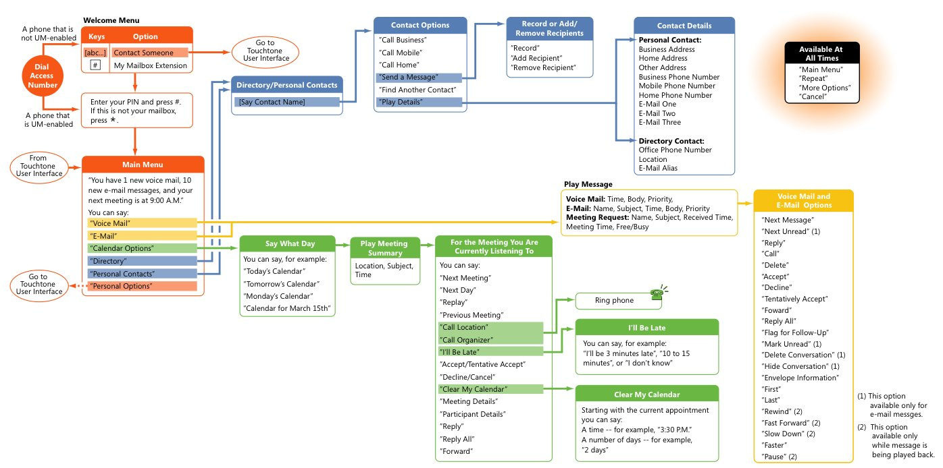
Figure 5: Part of the Outlook Voice Access command tree for voice users
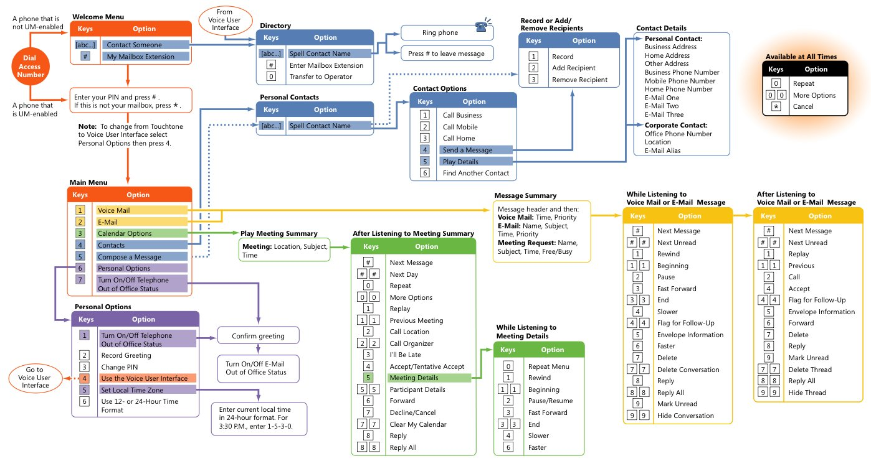
Figure 6: Part of the Outlook Voice Access command tree for DTMF users

Site and System Consolidation with Exchange Unified Messaging
One of the biggest differences between Exchange Unified Messaging and traditional voice mail and unified messaging systems is that Exchange Unified Messaging enables site and system consolidation. Exchange Server 2003 was widely adopted in large part because it helped companies to reduce the total number of servers required to provide e-mail and calendar services to their employees. Exchange Server 2007 provides the same kind of benefits for voice and fax services.
Consider a typical midsized company with offices in multiple locations. In most cases, that means that the company will have separate PBX and voice mail systems in each location. Telephony is an important infrastructure service. Because many telephony problems require physical access to hardware and wiring for troubleshooting, having separate systems at each location means that the company has to provide PBX and voice mail support staff at each location—either as employees or by buying expensive service contracts with the equipment vendor or third parties. These costs aren't recoverable, and since such systems don’t support centralization or consolidation, those approaches will not help reduce costs. To add another complication, these systems may not be from the same vendor; if the company has grown through mergers and acquisitions, or if its offices are in different countries, it is more likely that there are several different vendors represented in the organization's telephony system. This adds dramatically to support costs because it removes some efficiencies of scale that might otherwise be possible
Exchange Unified Messaging provides a valuable alternative to voice mail sprawl by delivering centralized enterprise-grade voice mail and fax services. Centralizing voice mail and fax services with Exchange Unified Messaging offers several attractive benefits:
- Exchange Unified Messaging is hardware-agnostic. There's no need to move to a particular type of PBX. Because Exchange Unified Messaging works with both IP-PBXs and legacy PBXs through gateways, the type of PBX equipment at each office becomes largely irrelevant to the choice of voice messaging infrastructure; PBX hardware can be upgraded when it makes business sense to do so.
- Replacing individual offices' voice mail systems with a single centralized system can drastically lower support and maintenance costs for the voice mail system by eliminating the most expensive component: legacy voice mail hardware.
- A single Exchange Unified Messaging system can host multiple voicemail user groups (dial plans) each with their own unique set of configuration options. This makes it possible to host multiple voicemail systems, with distinct settings, policies, and Automated Attendant configurations, on a single server.
- Centralizing voice mail and fax functionality makes your electronic records—e-mail, voice mail, calendar, contacts, and faxes—universally accessible to employees throughout your organization. At the same time, voice mail and fax data benefits from Exchange 2007’s integrated compliance, journaling, and retention controls (including separate compliance and quota policies for voice mail messages and faxes).
- Standardizing on Exchange Unified Messaging lets you take advantage of the skills, experience, and tools your messaging and collaboration administrators already have.
- By utilizing already established investments in Active Directory for user management, new employees can quickly be provisioned in one place for all message types rather than being separately configured in voice mail and e-mail systems.

Site vs. Server Consolidation
Exchange Unified Messaging supports two related types of consolidation: site consolidation reduces the number of sites that have their own dedicated voice mail systems, and system consolidation reduces the number of voice mail systems required to provide service to a given number of subscribers. These two types of consolidation may be undertaken together or separately. The exact mix of site and server consolidation at your company will depend on how many voice mail systems you have, where they are located, and how many subscribers they host. However, because Exchange Unified Messaging uses standard Internet protocols for signaling and voice transport, it's easy to selectively replace individual voice mail systems no matter where they're located.

Planning and Executing Consolidation
There are several different approaches to consolidation, ranging from overnight cutover plans that move all users to Exchange Unified Messaging at once to phased consolidations that move individual workgroups, offices, or geographical regions according to a pre-defined schedule. Because provisioning subscribers for Exchange Unified Messaging access is simple, you can move users and groups on whatever schedule makes the most business sense for your organization. When planning consolidations, Microsoft recommends these best practices:
- Identify physical sites that can benefit from consolidation. These sites will typically have older voice mail systems that are either unsupported or near end-of-life; sites that have unstable or poorly performing systems are good candidates for immediate consolidation. Rank your sites to develop a consolidation plan, taking into account the number of users, the type of PBX and voice mail hardware already installed, and that site’s place in your overall Exchange Server 2007 deployment plan.
- As you plan other upgrades to your telephony system, look for PBX hardware that is compatible with Exchange Unified Messaging, either by selecting compatible IP-PBXs or by verifying compatibility of your PBX choice with gateways from Intel and AudioCodes.
- If you have groups of users who are highly mobile, move them higher on the consolidation schedule so they can get the benefits of Exchange Unified Messaging sooner. For example, field sales staff, on-site customer support engineers, and frequent business travelers will all benefit from having universal access to their voice mail, fax, and e-mail messages.
- Consider how best to deploy the speech-enabled Automated Attendant. You can use it to replace or supplement existing PBX-based attendant services, or to provide new services to internal or external users

Conclusion
Integrating voice mail and fax messages with e-mail and calendaring systems offers some valuable benefits, including reduced costs, improved productivity, and greater ease of use. Exchange Server 2007 Unified Messaging can help deliver these benefits by unifying voice mail and fax traffic with other data items in users' existing inboxes, then making all of these data items available to users in a variety of ways. By allowing for centralized deployment and management of unified messaging services, Exchange Server 2007 lowers the cost of providing voice mail and fax services while simultaneously delivering services—like voice access to calendar items—that aren't available on other systems.

Disclaimer

This is a preliminary document and may be changed substantially prior to final commercial release of the software described herein.

The information contained in this document represents the current view of Microsoft Corporation on the issues discussed as of the date of publication. Because Microsoft must respond to changing market conditions, it should not be interpreted to be a commitment on the part of Microsoft, and Microsoft cannot guarantee the accuracy of any information presented after the date of publication.

This White Paper is for informational purposes only. MICROSOFT MAKES NO WARRANTIES, EXPRESS, IMPLIED OR STATUTORY, AS TO THE INFORMATION IN THIS DOCUMENT.

Complying with all applicable copyright laws is the responsibility of the user. Without limiting the rights under copyright, no part of this document may be reproduced, stored in or introduced into a retrieval system, or transmitted in any form or by any means (electronic, mechanical, photocopying, recording, or otherwise), or for any purpose, without the express written permission of Microsoft Corporation.

Microsoft may have patents, patent applications, trademarks, copyrights, or other intellectual property rights covering subject matter in this document. Except as expressly provided in any written license agreement from Microsoft, the furnishing of this document does not give you any license to these patents, trademarks, copyrights, or other intellectual property.
 2006 Microsoft Corporation. All rights reserved.

Microsoft, Active Directory, ActiveSync, Entourage, and Outlook, are either registered trademarks or trademarks of Microsoft Corporation in the United States and/or other countries.

The names of actual companies and products mentioned herein may be the trademarks of their respective owners.

These benefits require users to have computers and network or Internet connections.

