M

icrosoft® Office Live Meeting is a powerful Web conferencing solution that helps you:

* Form deeper connections across and between organizations with online meetings and training.
* Make meetings more effective with integrated audio, video, and rich media.
* Free up IT staff to work on business-critical projects by offering a trusted, reliable service.

# How It Works

The Live Meeting service is a conferencing solution that connects and engages audiences in online meetings, training, and events through a reliable, enterprise-class hosted service. With meeting attendees participating from their computers, you can deliver a presentation, kick off a project, brainstorm ideas, edit files, collaborate on interactive whiteboards, and negotiate deals at a fraction of the cost and without the overhead of travel.

Organizations that subscribe to dedicated Microsoft Online Services receive Live Meeting adoption services when they purchase a service subscription license for Live Meeting. Adoption services are designed to help Microsoft Online Services customers get working quickly with Live Meeting Web conferencing. Adoption services help customers integrate Live Meeting into existing platforms and provide guidance about how to use the features and functions of the service.

The Live Meeting Standard and Live Meeting Professional desktop clients can both be used with the Live Meeting service. The Live Meeting Professional client provides additional features such as event and class registration, online testing, and breakout rooms. *The license to use Live Meeting Professional is purchased separately*.

Host Collaborative Meetings  
Quickly and Cost-Effectively

* **Conduct high-quality, large-scale events with confidence.**The Live Meeting Standard client lets you scale meetings up to 250 attendees.
* **Share and record your meeting notes.**  
  With the always-on Shared Notes pane every attendee can view and edit shared action items to ensure that everyone is in sync about key deliverables. Store your team meeting notes and record the session for future reference.
* **Highlight and emphasize key aspects of your presentation.**The interactive whiteboard and annotation tools improve online collaboration. Updated tools include rich text, sophisticated shapes, fonts, and flowcharts to help you create more informative and dynamic presentations.
* **Interact with other participants.** If you want to communicate privately with another meeting participant, you can use the chat feature. Or, if you want to ask the presenter a question, you can use the Question and Answer feature.
* **Schedule a meeting in advance.** With the Live Meeting service, you can schedule meetings using the Conferencing Add-in for Microsoft Office Outlook® or the online Microsoft Office Live Meeting Manager.
* **Give non-Windows users access to meetings.**  
  The Live Meeting Web Access client is available for use on computers running Windows® operating systems. Audience members are not required to use the Windows-based client to attend your meetings.
* **Know who is in attendance.**  
  The Seating Chart provides a real-time view of the number of attendees. The configuration of the seating chart is based on the size of the audience, and is selected while scheduling.

Engage Your Audience by Using  
Rich Media and Video Conferencing

* **Connect remote participants and teams.**   
  The new 360-degree panoramic video of all conference room participants, delivered together with the Polycom CX5000/Microsoft RoundTable™ communications and archival system, enriches collaboration sessions and makes participants feel like they are in the room with the other attendees.
* **Make a bigger impact with dynamic audio and video.**   
  Movie clips, Flash animations, and audio files make presentations more memorable. Presenters can easily upload media files, and all media clips are virus scanned by Microsoft Forefront™ client security before distribution to meeting attendees.

Register today for a FREE trial!

www.microsoft.com/livemeeting

Reliable and More Secure Service

* **Dependable service you can count on.**  
  The Live Meeting record of high availability is proven by a decade of operating experience and backed by the resources of a Fortune 100 company.
* **Enhanced security features help provide protection.**  
  Data centers with Verizon Security Management Program (formerly Cybertrust) and SAS 70 certification help to provide security-enhanced content storage. More secure communication across firewalls, single socket layer (SSL) data encryption, strong password authentication policies, and 128-bit encryption combine to dramatically improve security.
* **Integrate with the Active Directory® service.**  
  Capitalize on your existing identity infrastructure for a rapid and integrated deployment. The Live Meeting Service Portal automatically creates user accounts and authenticates them by using Active Directory. *Customers host and deploy the Service Portal.*

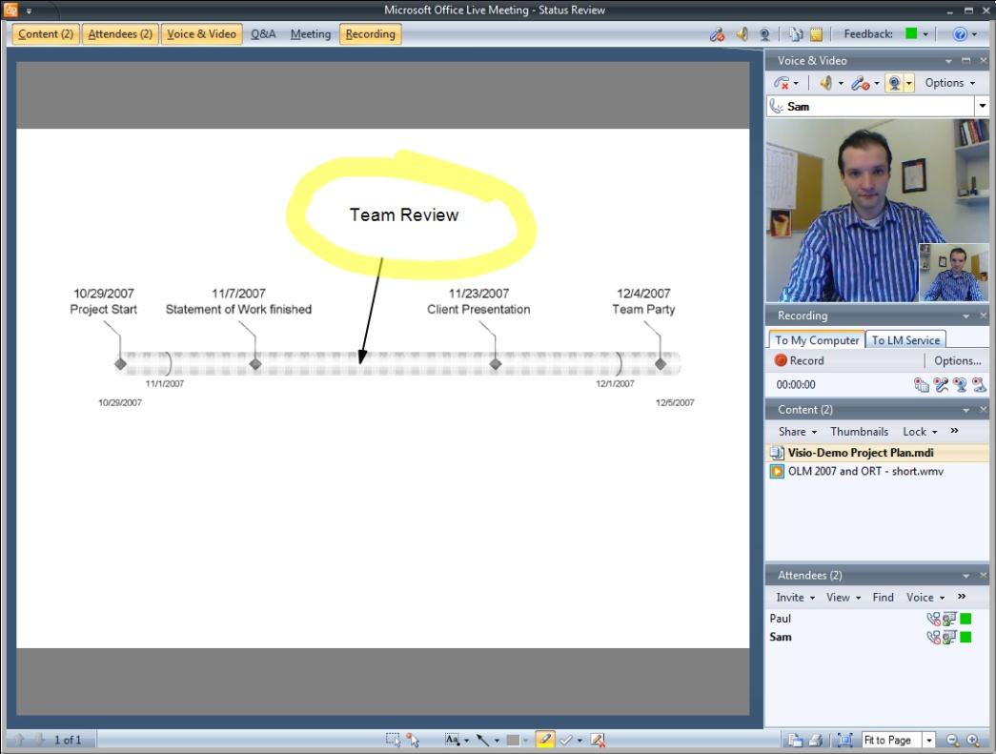





Live Meeting console

© 2010 MICROSOFT CORPORATION. All rights reserved.  
Microsoft, Active Directory, Forefront, Outlook, RoundTable, and Windows are trademarks of the Microsoft group of companies.  
This datasheet is for informational purposes only. Microsoft makes no warranties, express or implied, in this summary.