

**Exchange Hosted Archive**

**Microsoft Exchange Hosted Archive (EHA) provides a centralized, easily accessible, and multi-functioning e-mail and IM repository to assist organizations with managing increasingly complex retention, compliance, e-discovery, and regulatory requirements.**



Message retention has become a way of business life, increasingly crossing different corporate initiatives. IT walks a tightrope between optimizing the message environment and allowing users to save e-mail. Legal departments increasingly need to recall messages related to an investigation and industry related regulations often include guidelines or mandates for message retention. Today’s business demands the need for a centralized, easily accessible and multi-functioning mail repository. Microsoft Exchange Hosted Archive (EHA) assists with this enterprise goal.

## Features

* With Microsoft Forefront Online Protection for Exchange, the archive captures messages after they’ve been filtered which helps to keep spam, viruses and other unwanted content out of the archive
* Unified web-based interface for simplified administration of all Exchange Hosted Services
* Centralized archive of e-mail , IM and Bloomberg data provides unified search and monitoring across common communication channels
* Multiple retention periods offered to help enforce governance policies
* Indexed storage and architecture based on the same infrastructure as Microsoft® SQL Azure™ enables fast retrieval of messages for investigations and e-discovery events
* Single-click legal hold preserves messages easily and quickly
* Granular permissions structure and custom role creation assists with access security
* Built-in compliance monitoring workflow assists with detailed message supervision with keyword lists and/or percentage sampling
* Familiar interface helps minimize the need for extensive training
* Detailed reports and granular logging helps facilitate service management and auditing

## Benefits

* Easily works with existing on-premises Microsoft Exchange infrastructure or Exchange Online
* Helps free up IT to focus on other projects
* Enables a predictable subscription-based cost model
* Eliminates up-front capital investment
* Simplifies IT environment by eliminating deployment and maintenance of in-house archive servers and applications
* Scales to meet the needs of virtually any enterprise
* Peace of mind from 24/7 phone and e-mail support

**HOW IT WORKS**

The Hosted Archive solution is embedded in the Microsoft Exchange Hosted Services (EHS) network and with both Forefront Online Protection for Exchange (FOPE) and EHA subscriptions in place, the online repository benefits from the edge based spam and virus protection. The network receives messages via an MX record redirect, and after being filtered, clean messages are delivered to the corporate mail server and a copy is added to the archive.

E-mail is also-copied directly from the corporate mail server to the online archive using the journaling function of Microsoft Exchange Online or Exchange Server 2003, 2007 and 2010 servers in order to capture internal e-mail or e-mail for Exchange customers who do not have a FOPE subscription. A de-duplication process in the archive eliminates duplicate messages and single instance storage is employed for maximum storage optimization. A variety of Instant Message solutions and Bloomberg messaging are compatible with EHA so that IM conversations can also be archived. Messages are assigned a capture and expiration timestamp according to the organization’s configured corporate policy. The system automatically tracks message lifecycle, deleting accordingly. Legal hold is also available to temporarily freeze message expiration if needed.

*Microsoft Exchange Hosted Archive Flow Diagram*

For additional information about Exchange Hosted Services, visit: [www.microsoft.com/online/](http://www.microsoft.com/online/default.mspx)

*Microsoft Exchange Hosted Archive Flow Diagram*

## 

For additional information about Exchange Hosted Services or to sign up for a free trial, visit: [www.microsoft.com/online/](http://www.microsoft.com/online/default.mspx)





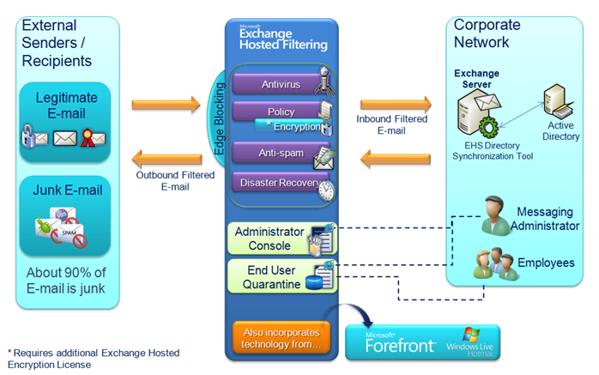

© 2010 Microsoft Corporation. All rights reserved.

This document is for informational purposes only. MICROSOFT MAKES NO WARRANTIES, EXPRESS, IMPLIED OR STATUTORY, AS TO THE INFORMATION IN THIS DOCUMENT. Microsoft, Active Directory and Azure are either registered trademarks or trademarks of Microsoft Corporation in the United States and/or other countries.

## Using the archive

Once messages are captured, the archive system applies full text indexing to the header, subject line, message body and a variety of common business attachments. Simple and complex searches are possible, using a variety of query parameters such as date, e-mail address, full/partial name, aliases, keyword (with or without advanced operators), filename/file attachment type and message size. As messages are retrieved, a variety of actions can be taken including: filing messages to folder, sampling messages for compliance or service monitoring, exporting to .ZIP or .PST files and restoring messages to original recipients.

The archive can be administered through the same administrative console as Forefront Online Protection for Exchange and can be accessed via a security-enhanced, web-based application. A user’s role in the system determines their ability to access message content, as well as the functions available. EHA provides granular permissions and the ability for organizations to create custom roles to meet their user, compliance and administrative needs.

## Why microsoft®?

Microsoft® has a long history of developing and delivering innovative software and services for businesses and individuals. Designed to meet your unique business needs, our software-plus-services strategy brings together the best of rich on-premises applications and flexible, Internet-based hosted services to give you ready access to unparalleled software without costly deployment and maintenance overhead.

**FEATURES AND BENEFITS BY ORGANIZATIONAL ROLE**

|  |  |  |  |
| --- | --- | --- | --- |
| **Employee** | **HR/Legal** | **IT** | **Compliance** |
| * Reduce the need to contact IT helpdesk with end user message search and restoration * Compose functionality allows users to create and send messages in case of emergency outage | * Preserve messages with Legal Hold feature * Discover messages with self-search capability using granular parameters to find messages by header, subject line, attachments, sender, recipients, internal or external communications * Help reduce risk with multiple retention periods including per user retention policy * Manage investigations with folder organization, folder sharing and intuitive workflow * Export messages for further analysis and production of data | * Manage message lifespan with automatic message expiration * Automate account creation and deactivation with Directory Synchronization Tool (optional) * Enhance service management capabilities by providing statistics on user activity and volume with detailed system reports * Gain usage and administrative insight from activity logs and reports * Enable fast implementation by redirecting the domain MX record and enabling Exchange transport journaling * Streamline on-boarding with detailed online training * Protect e-mail boundary and archive clean e-mail with Microsoft Forefront Online Protection for Exchange (available in various CAL packages or standalone) * Get help with comprehensive self-help tools, administrative guides and 24x7 technical support via the phone, web form or e-mail | * Automated message lifecycle management helps enforce corporate retention policies * Implement multiple retention policies to help adhere to organization governance policies * Help maintain data integrity with immutable storage format * Configure message supervision sampling for detailed monitoring based on keyword list and/or percentage * Monitor supervision reviewer activities using in-depth system reports including an archive evidentiary report |

For additional information about Microsoft Online Services, visit:

[www.microsoft.com/online/](http://www.microsoft.com/online/default.mspx)



**Exchange Hosted Archive**

