Microsoft Certificate Lifecycle Manager Beta 1
A White Paper

February 2006


Contents
Executive Summary 1
Introduction 2
Architecture 4
Software Components 5
Development Tools 7
Scalability 7
Extensibility 7
Application Fundamentals 8
CLM Profile Templates 8
Application Roles and Permissions 11
User Authentication 12
Subscribers 12
Managers 13
Smart Card and Certificate Lifecycle Operations 15
Smart Card and Certificate Enrollment 15
Recovery 15
Smart Card PIN Unblocking 15
Manager Approvals 16
Smart Card PIN Change 16
Conclusion 17

Executive Summary
Enterprise organizations are increasingly opening their networks and resources to facilitate employee access and overall interconnectivity with customers and partners. While this increased access assists productivity, it also presents significant security challenges for authenticating users. Many organizations are realizing that traditional user name and password solutions are no longer sufficient to secure access control for business assets and sensitive data. In response to this need, technology firms are offering sophisticated authentication solutions such as smart cards with digital certificates.
Microsoft® Windows Server™ 2003 provides a best-of-breed platform for issuing digital-certificate-based strong credentials for a variety of services, such as the use of smart cards for strong authentication. While digital certificates and smart cards are an excellent solution, they can be complex and costly to manage. Information technology (IT) administrators need a centralized point of management for digital and smart card certificates that is easy to deploy and maintain. This technology must be flexible, work seamlessly with the existing infrastructure, and have the capability to extend to a broad variety of defense-in-depth measures.
Microsoft Certificate Lifecycle Manager (CLM) is a policy and workflow driven system that helps organizations manage the life cycle of digital certificates and smart cards. CLM significantly lowers the costs associated with digital certificates and smart cards by enabling organizations to more efficiently deploy, manage, and maintain a certificate-based infrastructure. It also streamlines the provisioning, configuration, and management of digital certificates and smart cards, while increasing security through strong, multifactor authentication technology.
CLM was designed based on the principle that every enterprise is unique, and therefore has unique security and management requirements. CLM is flexible to those requirements, thanks to a workflow-driven model that allows policy-based configuration of the authentication process. Another benefit to CLM is that it allows for the deployment and lifecycle management of digital certificates with or without smart cards. For companies that deploy CLM without smart cards and later decide to add them, CLM can assist with the seamless migration to smart cards without the addition of other systems. The smart cards can then be managed as part of the same system—including requirements for smart card logon, secure e-mail, virtual private network (VPN), and other enterprise requirements. CLM’s management functionality includes inventory management, card enrollment, recovery, unblocking, and other features required for successful enterprise deployment.

Introduction
CLM provides an identity assurance management system to maximize the trust and flexibility associated with digital certificates and smart cards by providing enhanced management facilities for Windows Server 2003. CLM simplifies the administrative processes required to convey trust, and ensures distribution of certificates and cards in a secure and structured manner. The result is a highly configurable and robust registration and management solution that provides simple deployment, improved manageability, and increased flexibility:
Ease of Deployment
Microsoft CLM is the only Microsoft Windows®-based certificate management solution that provides turnkey deployment and is designed to require no development work to implement in an organization. CLM simplifies digital certificate and smart card deployment in the enterprise environment by using services such as Microsoft Active Directory® directory service and Windows Server 2003 Certificate Services extensively, providing enterprise customers with an integrated security solution.
CLM is also able to easily grow with an organization and can scale without requiring software modifications. As a typical Web application, CLM consists of several layers: database, business components, and presentation (Web). These layers can be placed on physically separate servers in various combinations, maximizing deployment flexibility and scalability. In addition, Network Load Balancing, Windows Clustering, and Application Center technologies can be used to further facilitate scaling.
Manageability
CLM provides Web-based, policy-driven workflow management that helps organizations manage administrative and end-user experiences. In addition, the technology lowers the overall cost of Windows-based digital certificate and smart card infrastructures by providing tools that automate common administrative functions and enable users to self-administer common tasks.
By simplifying the administrative processes required to convey trust, CLM ensures distribution in a secure and structured manner. CLM’s enhanced management facilities for Windows Server 2003 help administer multiple certificates, multiple certificate authorities (CAs), and certificates for computers and devices. To reduce administrative overhead, CLM provides a self-service Web portal for subscribers and managers and temporary cards to solve the problem of employees forgetting cards at home or other locations.
CLM provides a flexible and transparent way to update card content information, including adding a new certificate template, renewing certificates, and performing applet management functions. CLM also includes features to personalize and manage Java applets required to operate Java cards, allowing organizations to personalize smart cards as part of the enrollment process and simplify the overall deployment process.
Flexibility
Microsoft CLM offers broad flexibility by providing IT administrators with the ability to modify certificate and smart card management process and adapt CLM to their organizational policy requirements and unique infrastructures. CLM delivers an integrated solution that provides simplified management and end-user experiences through advanced policy and workflow.
CLM is designed based on the principle that every enterprise is unique, and therefore has unique security and management requirements. Certificate registration varies greatly with each organization, and CLM was designed to address this challenge by providing a certificate registration and management framework that can be used in many different ways when required.
The remainder of this paper will explore CLM’s role in a Smart Card and Digital Certificate infrastructure from a technical perspective, including:
- The architecture that makes the above benefits possible
- The fundamental applications that CLM interacts with
- How authentication roles and permissions can be centrally managed
- CLM’s role in the smart card and certificate lifecycle

Architecture
CLM provides sophisticated management features to Windows Server 2003 CAs (single or multiple) by acting as an administrative proxy. Once installed within an organization, all digital certificate and smart card management functions pass through CLM.
Figure 1: CLM Architectural Overview
Component Architecture









Microsoft
Certificate
Lifecycle
Manager
Microsoft
CAs
End User
Internet Explorer
CLM Browser Control
Physical Architecture
SQL
Active
Directory
E-mail
Smart Card Middleware
CLM AD Integration
CLM Web App
Internet Information Server
Microsoft Certificate Authority
CLM Policy Module
CLM Exit Module
This functionality is achieved by adding three high-level components to the overall software solution:
- CLM server-side components. The CLM server can exist as a dedicated server, can be shared with a CA server, or can be shared by other applications. The server provides a Web interface and is the focal point of administrative functions. It is responsible for implementing all CLM functionality, communicating with the CLM database (which can be located separately), communicating with Active Directory, and communicating with all managed CAs. Using this approach provides the customer with rich certificate management for a specific CA, as well as a potential aggregate view of multiple CAs within the organization.
- CLM Certificate Authority Plug-In. In order to actively manage a CA, a CLM policy module and an exit module must be installed and configured locally on each CA server. These modules communicate with the CLM server, control the behavior of the CA, and provide rich logging and auditing in a central location.
- CLM client-side components. The Certificate Lifecycle Manager client enables end users and administrators to manage cards by providing a connection from the computer to the smart card. It includes the following sub-components:
o Smart Card Self Service Control, which provides certificate management capabilities
o Smart Card Personalization Control, which provides java card management
o Bulk Smart Card Issuance Tool, which is an application for centralized large scale smart card deployment scenarios

CLM Components
The components of a CLM deployment consist of at least one CLM server and one Windows Server 2003 CA. It is possible for a single CLM server to manage multiple CAs simultaneously, or for multiple CLM servers to manage a single CA. The CLM server consists of a Windows Server 2003 (Standard Edition or subsequent version) computer that acts as an administrative proxy to the CAs. This server provides an easy-to-use Web interface to an application engine that is integrated with Active Directory and certificate services. All application configuration information is stored in an SQL server database that is accessed by the CLM server and the CA modules.
The CLM system consists of several functional components. Each component consists of a number of core modules. The components include the following:
- Microsoft Certificate Authority
- CLM server-side components
- Certificate managers and subscribers (Microsoft Internet Explorer)
- Smart cards (available from a variety of third-party vendors)

Microsoft Certificate Authority
CLM supports the Windows Server 2003 Certificate Authority. Because CLM controls the behavior of the Windows Server 2003 CA, providing greater flexibility and manageability, several modules must be installed directly on the CA. These modules include a CLM policy module and exit module.

CLM Server-Side Components
The CLM server-side components consist of a Web application server and a relational data store, which is Microsoft SQL Server™ 2000. CLM does not require a dedicated SQL Server, but does require Windows Server 2003 and Microsoft Internet Information Server (IIS) version 6 or subsequent versions. It can be located on a third-party server such as an enterprise database server, and the CLM installation package can create the appropriate databases. CLM is an ASP.NET application that requires the Microsoft .NET Framework to be installed on the server platform. The .NET Framework is a separate but mandatory installation component.
CLM has been designed to integrate tightly with the Windows Server 2003 operating system and Active Directory. The goal is to provide highly flexible and powerful certificate management functions, while maintaining consistency with the operating system and using operating system services whenever possible. Microsoft support for digital certificates within Microsoft desktop and server applications is expanding, and the power of the Windows Server 2003 CA is also increasing. This combination increasingly showcases the value of digital certificate services within the enterprise, and CLM further extends that value.
In addition to the core CLM server, the smart card management capabilities consist of two main components. These components include a server component that is integrated with the CLM Web application and a Web browser integrated client that uses smart card middleware to perform management functions on the smart card.
CLM server components provide various Web interfaces that are determined by Active Directory permissions. These interfaces include a subscriber Web portal and a manager Web portal.
The server components do not access the smart cards directly, but instead provide the business processes and storage of information that is needed for the smart card module’s operation and interaction with the rest of the system. The server components are also responsible for generating client workflows and user interface Web pages. These components include:
Subscriber Web Portal. This is the component of the CLM server that interacts directly with the certificate subscribers in a self-service mode. The specific functionality available to users is based on their group memberships and permissions within Active Directory. Permissions are configured using standard Active Directory and permission management tools that are extended to include CLM permissions.
Manager Web Portal. This component of the CLM solution interacts with CLM certificate managers and exposes functionality used for managing end-user certificates. CLM manager permissions are granted using the standard Active Directory security management tools.

Certificate Managers and Subscribers (Internet Explorer)
Internet Explorer (version 6) provides the required browser-based access to the CLM environment. Because CLM requires Secure Sockets Layer/Transport Layer Secuity (SSL/TLS) for all administrative traffic and certificates for all administrative users, the application does have some browser dependencies. Additionally, the application has advanced scripting features that are optimized for Internet Explorer versions 5 and 6.
CLM does not require any client-side software for the management of software-based certificates. CLM does require an optional client component accessed through Internet Explorer for deployments using smart cards.

Smart Cards
CLM supports the use and deployment of smart cards, assuming the availability of the following:
- Supported smart card
- Supported smart card reader
- Supported Cryptographic Service Provider (CSP)
CLM also supports more advanced smart card management functionality using a client-side Web module that adds the following features:
- Complete personal identification number (PIN) management features for user PINs and unblocking PINs that can be managed in a self-serve manner or by an administrative user
- Complete reporting and audit ability of all smart card lifecycle activities
- A card inventory system that updates upon activation of a card, simplifying the initial distribution of cards
- Highly flexible deployment process that uses existing organizational relationships and processes

Development Tools
CLM is designed to support customizations and extensions that may be required by specific customers. These extensions can be developed using a variety of tools that support the .NET Framework including Microsoft Visual Studio® .NET. Within Visual Studio .NET, C# is the preferred development language for customizations.

Scalability
CLM is able to scale out without any software modifications and is a Web application that consists of several layers: database, business components, and presentation (Web). These layers can be placed on physically separate servers in various combinations. Network Load Balancing, Windows Clustering, and Application Center technologies can be used to facilitate scaling out of CLM. The policy and exit modules must be installed on the CAs and cannot be physically separated from them.

Extensibility
Certificate registration varies greatly from one customer to another, making it difficult to design a single out-of-the-box solution that satisfies all business requirements. CLM is designed to address this challenge by providing a well-documented certificate registration and management framework that can be used in many different ways when required. In addition, CLM ships with a full-featured Web-based application that uses this framework to provide an implementation of certificate registration and management for Microsoft Certificate Server.

Application Fundamentals
CLM integrates three major technology components to deliver its enterprise management features: Active Directory, the Windows Server 2003 Certificate Authority, and smart cards
(if required). The core functionality of CLM is focused on making those three components operate together seamlessly for all management tasks—the activities that provide the full life cycle for digital certificates and smart cards within an enterprise environment.
In order to deliver seamless integration for these management tasks, CLM unites Active Directory, the certificate authority, and the selected smart card hardware and software.

CLM Profile Templates
A profile template is a core component of all management activities within CLM. The purpose of a profile template is to provide a single administrative unit that includes all of the information necessary to manage multiple certificates that may be required by a user community throughout the certificate’s entire life cycle.
A profile template also includes information related to the final location for those certificates, which can be software-based (stored on the local computer) or hardware-based (stored on a smart card). In the case that the certificates are stored on a smart card, a CLM profile template is also configured with the information necessary to manage the smart card, and therefore provides a single point of administration for the smart card and the certificates.
A profile template can contain one or more certificate templates that can be managed as a single item. Without this approach, an organization is forced to manage multiple user certificates independently, which is expensive and prone to error. A profile template allows for the deployment of authentication and encryption type certificates in a single step.
Additionally, CLM is able to handle authentication certificates and encryption certificates differently depending on whether the encryption certificates are backed up for future recovery. For example, when CLM is asked to recover a particular profile because a smart card may have been lost, the application generates new authentication certificates but recovers the existing encryption certificates. At the same time, CLM manages the administrative details associated with initializing the smart card.

Figure 2: CLM Profile Templates
Certificate Template(s)
Management Policies
Work flow
Self-Service
Data
Collection
Enrollment
Work flow
Self-Service
Data
Collection
Recovery
Work flow
Self-Service
Data
Collection
Policy X
Smart Card Information (optional)

Figure 2 shows the general configuration for a profile template and the various items that are included in that configuration. It allows the specification of the profile template as software-based or hardware-based (smart card). The certificate templates section provides the ability to add or remove certificate templates. These certificate templates are read directly from Active Directory and are issued from a selected certificate authority. If desired, the individual certificate templates can even be issued from different certificate authorities. In most cases, the collection of certificate templates includes a combination of signing/authentication and encryption certificates.
If the profile template is configured to support a smart card deployment, then management details for the actual smart card can be provided. Some of these details are shown in Figure 3 and include the smart card provider, password rules, and administrative password configuration.
Figure 3: Profile Template Smart Card Configuration
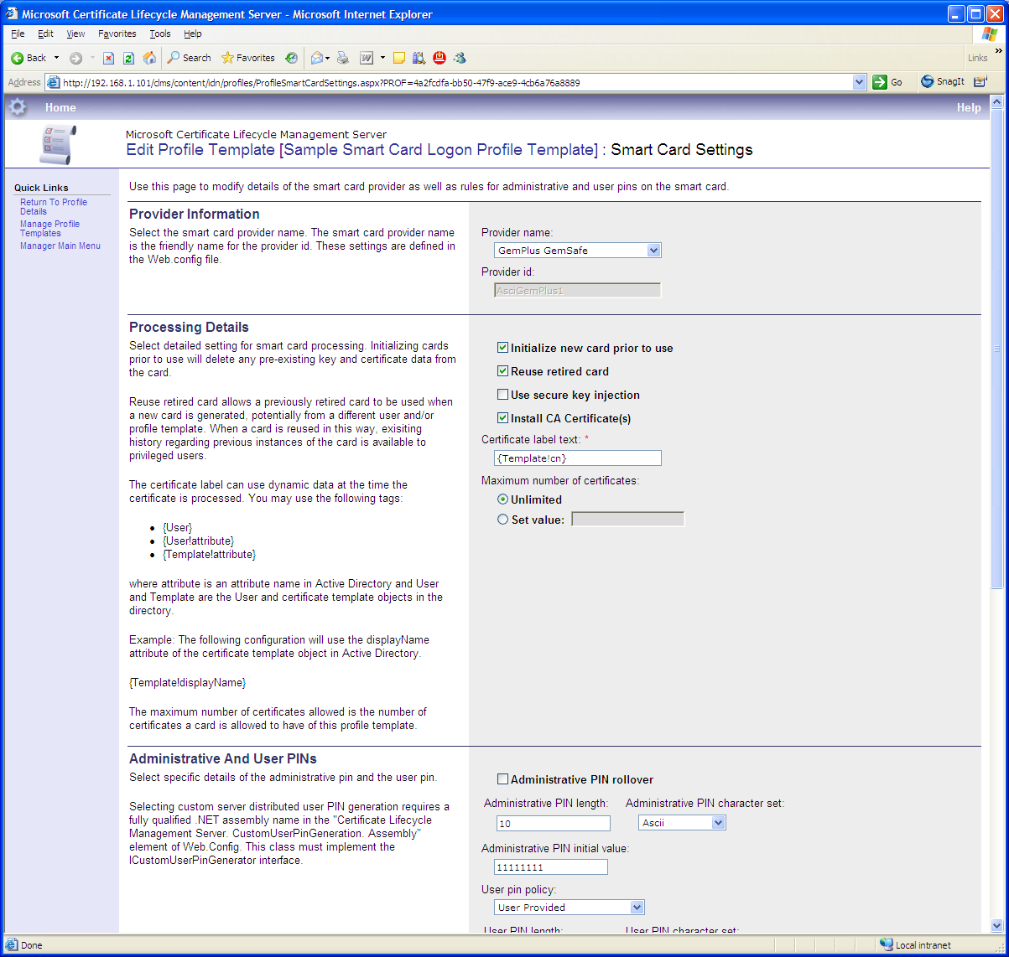

The profile template includes configuration for the management policies that are used to manage the deployed profile. These management tasks include:
- Enrollment
- Recover (Replace)
- Renewal
- Revocation
- Disable
- Unblock (for smart card profiles)
- Duplicate (for smart card profiles)
Each of these tasks can be configured separately so that the way a profile is enrolled might be different from how it is recovered or renewed. This provides the enterprise customer with a wide variety of choices in terms of how these tasks are managed.
Each management task can capture information using Web forms that can be stored or validated against other data sources. This configuration is performed as part of the application management and does not require any custom development activities.
Furthermore, there can also be a predetermined approval mechanism and distribution of approval information such as e-mails and one-time passwords. All of this information is captured and configured at the profile level. Once complete, the profile is simply put into use and the software implements the rules, workflow, and permissions. Figure 4 shows an example of a CLM profile template configuration.
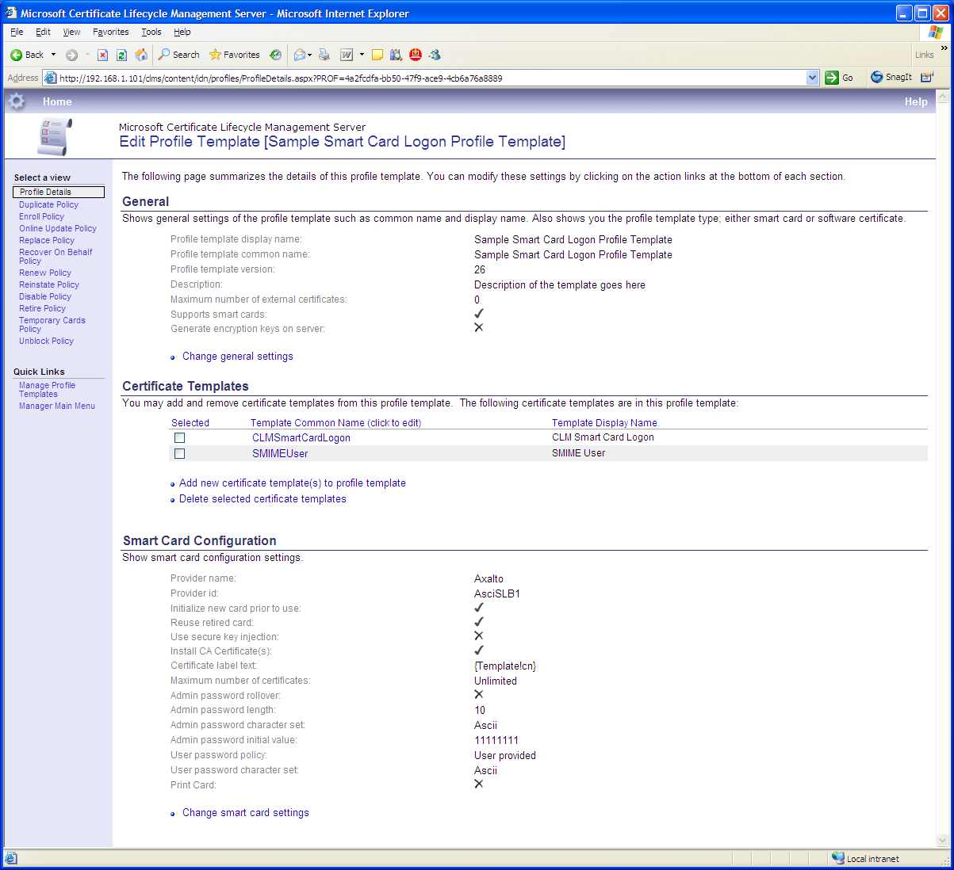
Figure 4: CLM Profile Template

Application Roles and Permissions
A flexible smart card and certificate management solution requires delegation of responsibilities, and therefore sophisticated role management and granular permissions. These roles determine permissions within the system to perform certificate management functions for specific users, as well as permissions to configure the application environment. CLM uses Active Directory extensively for this functionality and extends the environment to include CLM permissions. The benefit of this approach is that the customer does not need to build a separate system of users and permissions for the certificate or smart card deployment but rather uses the existing infrastructure.
Figure 5: Managing permission settings through Active Directory Profiles
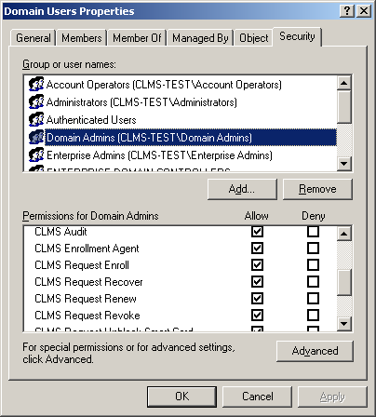

Certificate managers receive their permissions within the system based on their group memberships and permissions within Active Directory. Permissions are configured using standard Active Directory and permission management tools that are extended to include CLM permissions.
At the highest level, a certificate and smart card deployment has at least two roles: subscribers and managers. Subscribers are simply end users that need certificates with or without smart cards. Managers are users that have some level of permissions within CLM to either administer other users or to administer the application itself. Because the permission system within CLM actually uses Active Directory groups, there are few restrictions on how the management of the application and users can be delegated.

Subscribers
A subscriber is an end user that requires smart card and certificate services. This user may require a digital certificate for smart card logon, wireless access, secure e-mail, VPN services, or many other public key infrastructure (PKI)-aware applications. The goal of CLM is to make the management of these certificates as easy as possible for end users, while simultaneously providing the organization with an appropriate level of security.
CLM provides a subscriber Web portal that enables specific self-service management functions. Self-service functions can be attractive to organizations that are attempting to minimize administrative costs; however, self-service functions also have disadvantages from a pure security perspective. CLM handles this challenge by allowing organizations to define which functions should be available for self-service and which should not. This can be done on an individual profile template basis or user group basis, which means that one type of profile can be managed in a self-service fashion while another is not. All workflow functions are integrated with the Web portal e-mail system for notification and automatic distribution of authentication and approval information (if desired).
Figure 6: Subscriber Portal
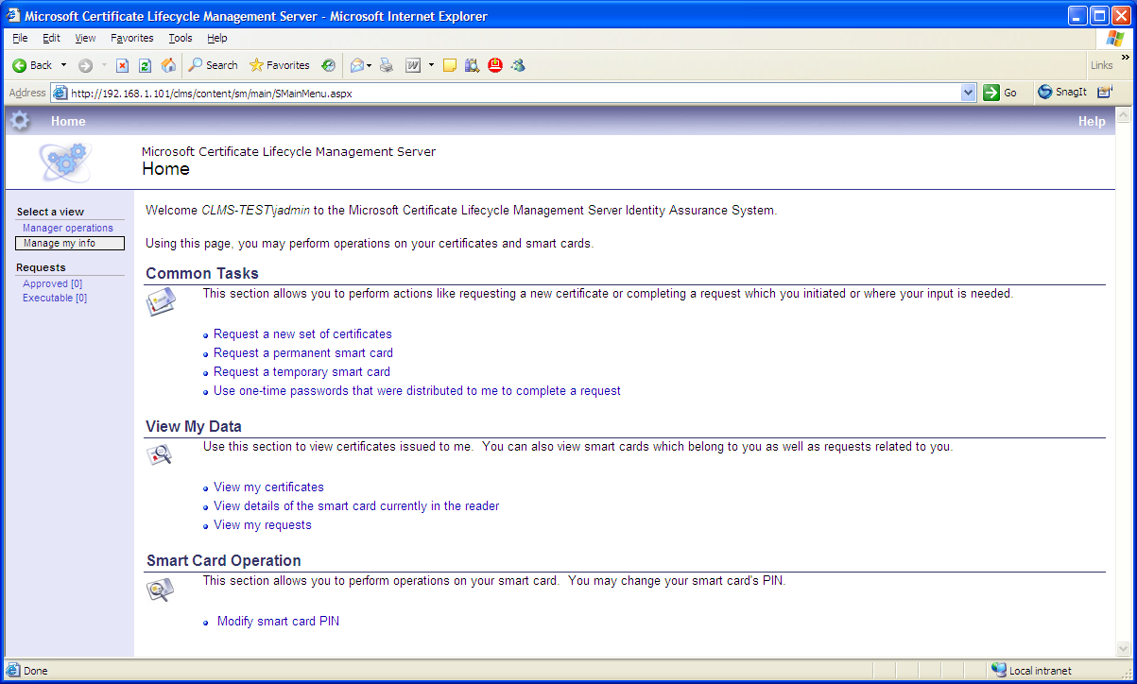
Figure 6 shows a typical configuration for the subscriber portal. From this portal, it is possible for subscriber to view and manage their certificates and smart cards (based on configuration and policy). This includes potentially being able to request a smart card or recover a smart card. How the request is processed is determined by the profile template. Examples include the request being completed immediately, or potentially requiring an approval from help desk or some other individual such as the user’s manager.

User Authentication
CLM can use a variety of authentication mechanisms to the portal for subscribers and managers. Because CLM uses Active Directory to determine a user’s permissions, the user must ultimately authenticate with his or her domain credentials to the portal. CLM can be configured to use integrated authentication, in which case the user can simply navigate to the CLM portal, and if the user is authenticated to the domain, the user will not be prompted to authenticate again. Other options can also be used, including basic authentication (domain user name and password) or certificate/smart-card-based authentication, if desired. The most important implication of this approach is that CLM does not require a separate database of users, passwords, and permissions. It is possible to provide a group of users, such as a help desk, with access to CLM by simply granting the appropriate permissions to that user group within Active Directory. The rest is handled in a completely integrated fashion with the operating system and Active Directory.

Managers
A manager within CLM is an individual that has been granted permissions to access the CLM manager Web portal (see Figure 7). This portal resides on the same CLM server as the certificate subscriber portal but exposes functionality used for managing other users and application information. Permissions are granted to a certificate manager using the standard Active Directory security management tools. Typically, this means users must be granted access to CLM and are then granted access to specific CLM functions such as enroll, recover, or revoke. Finally, they are given permissions to manage a particular group or groups of end users. Even more granularity is possible by granting access to specific certificate templates that they can manage, while restricting other certificate management functions.
Managers can also be granted permissions to approve the certificate requests of other managers or end users that have submitted self-service requests. These requests are handled through the easy-to-use Web portal, coupled with e-mail support once the requests have been processed. Reporting and auditing functions are then available to track activities and to perform analysis and verification of certificate management functions. Because auditing is a specific CLM permission, it is possible to configure a user role that is only able to generate reports and not perform any actual certificate management functions.

Figure 7: Administrator Portal
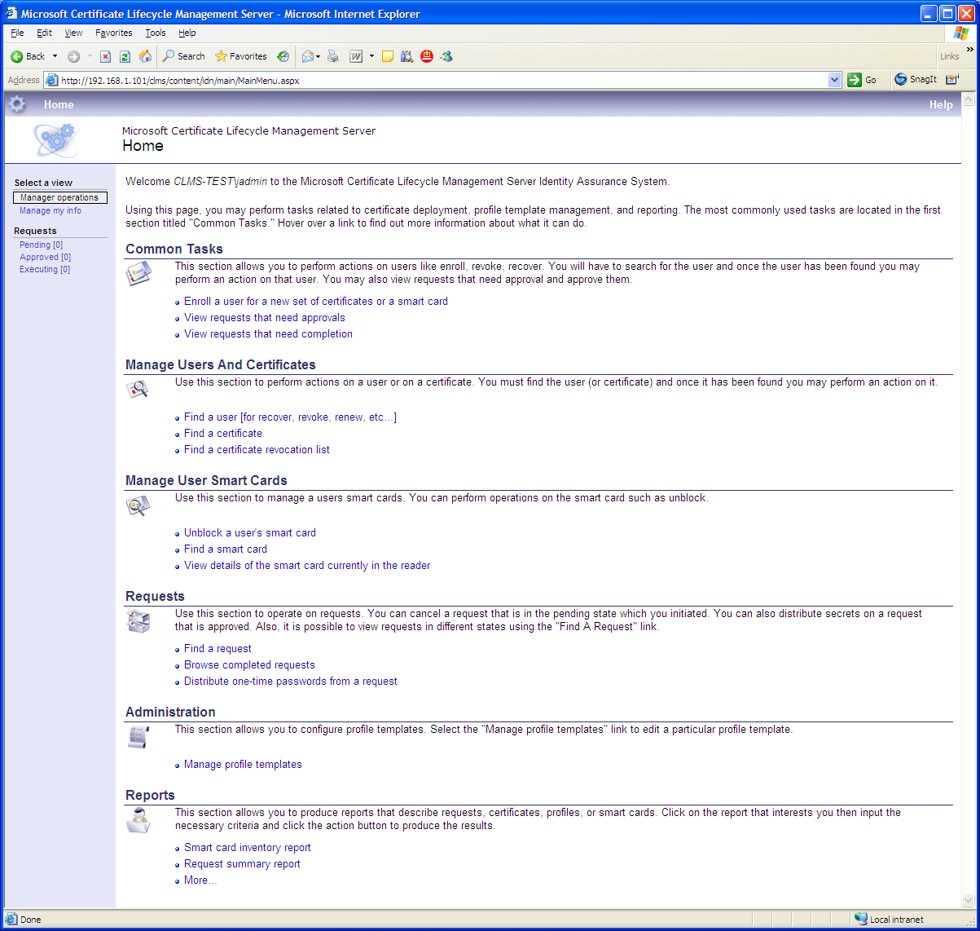

Smart Card and Certificate Lifecycle Operations
Supported smart card and certificate lifecycle operations include the following:
- Smart card and certificate enrollment
- Recovery
- Smart card PIN unblocking
- Manager approvals
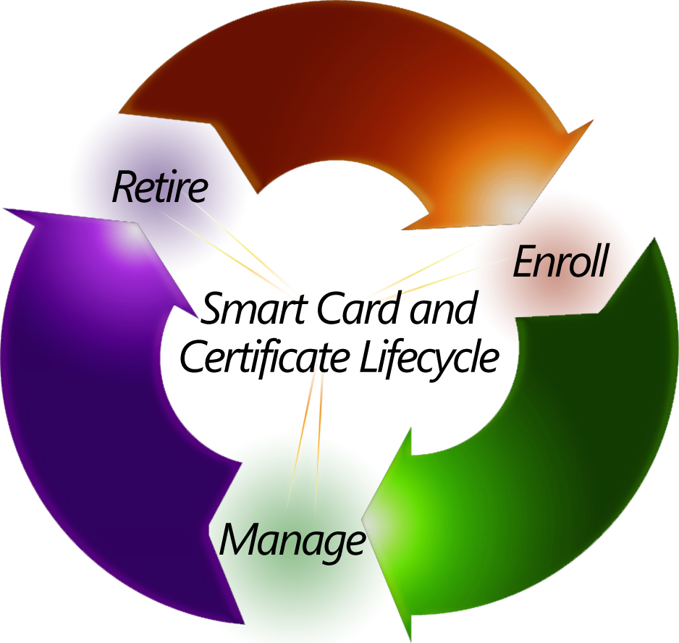
- Smart card PIN change

Smart Card and Certificate Enrollment
Once a user is authenticated to the system, it is then possible to initialize the smart card and to provide the digital certificate process. This card initialization process can contain several steps, including updating the smart card database with the card’s serial number, changing the unblocking PIN, establishing the user PIN, determining the user’s distinguished name (DN), creating the certificate request, and many others. The certificate management process can then be configured to require manager functions or approval (also provided by CLM).

Recovery
If a smart card is damaged or lost it, is sometimes necessary to recover a user’s encryption keys. Signing keys are always generated on the smart card and never leave the card, and therefore cannot be recovered. Instead, new keys must be issued. In the case of encryption keys, they often must be recovered because data exists that can be decrypted only with those keys. As with other CLM functions, it is possible to perform recovery operations in either a self-serve or manager-driven process.

Smart Card PIN Unblocking
A smart card is a new device for most users and it is quite common for users to block a smart card by forgetting their password (PIN). This can have a productivity impact for organizations, and involving a help desk to solve these problems can be expensive. An alternative approach is to provide users with a self-serve mechanism to request or complete the unblocking procedure.
Using this technique, a user must authenticate to the portal using one of the available authentication mechanisms. The CLM system can then unblock the card and provide the user with the ability to enter a new PIN. This procedure can also be achieved using a registration authority (RA) function if desired.

Smart Card PIN Change
CLM’s Smart card PIN change functionality interacts with the smart card client software to perform a smart card PIN change. The user needs to know the existing smart card PIN to perform the operation.

Manager Approvals
Managers can approve and deny management functions that have been configured to require approvals. This is achieved through the certificate manager portal using an intuitive interface. Once the request has received final approval, the user is issued one-time PIN that can be distributed using a variety of distribution methods.

Conclusion
Microsoft anticipates that smart cards and digital certificates will become a critical element of identity and access for organizations. CLM is an important component of Microsoft’s overall strategy to provide an identity and access management solution that is easy to administer, ensuring organizations can fully use technologies currently within Windows. As new smart-card-based technologies emerge, CLM will help customers to integrate these new technologies into their existing certificate infrastructures.
CLM enables organizations to increase the security of authentication processes and reduce the costs and complexity of digital certificates and smart card management, helping them to more efficiently deploy, manage, and maintain digital certificate and smart-card-based infrastructures. By streamlining the provisioning, configuration, and management of smart cards through a policy and workflow-driven management system, CLM increases security through strong, multifactor authentication technology.
Unlike competing solutions—which require significant technical development costs, time, and resources and fail to take advantage of existing Microsoft infrastructure—CLM provides a complete certificate lifecycle management solution that is flexible to an organization’s existing infrastructure, and it enables IT professionals to use existing investments in Windows, Active Directory, and PKI implementations.

This is a preliminary document and may be changed substantially prior to final commercial release of the software described herein.
The information contained in this document represents the current view of Microsoft Corporation on the issues discussed as of the date of publication. Because Microsoft must respond to changing market conditions, it should not be interpreted to be a commitment on the part of Microsoft, and Microsoft cannot guarantee the accuracy of any information presented after the date of publication.
This White Paper is for informational purposes only. MICROSOFT MAKES NO WARRANTIES, EXPRESS, IMPLIED OR STATUTORY, AS TO THE INFORMATION IN THIS DOCUMENT.
Complying with all applicable copyright laws is the responsibility of the user. Without limiting the rights under copyright, no part of this document may be reproduced, stored in or introduced into a retrieval system, or transmitted in any form or by any means (electronic, mechanical, photocopying, recording, or otherwise), or for any purpose, without the express written permission of Microsoft Corporation.
Microsoft may have patents, patent applications, trademarks, copyrights, or other intellectual property rights covering subject matter in this document. Except as expressly provided in any written license agreement from Microsoft, the furnishing of this document does not give you any license to these patents, trademarks, copyrights, or other intellectual property.
©2006 Microsoft Corporation. All rights reserved.
Microsoft, Active Directory, Visual Studio, Windows, and Windows Server are either registered trademarks or trademarks of Microsoft Corporation in the United States and/or other countries.
The names of actual companies and products mentioned herein may be the trademarks of their respective owners.

