

Windows Server Update Services Reviewer’s Guide
Release Candidate

Microsoft Corporation
Published: March 2005



This is a preliminary document and may be changed substantially prior to final commercial release of the software described herein.
The information contained in this document represents the current view of Microsoft Corporation on the issues discussed as of the date of publication. Because Microsoft must respond to changing market conditions, it should not be interpreted to be a commitment on the part of Microsoft, and Microsoft cannot guarantee the accuracy of any information presented after the date of publication.
This White Paper is for informational purposes only. MICROSOFT MAKES NO WARRANTIES, EXPRESS, IMPLIED OR STATUTORY, AS TO THE INFORMATION IN THIS DOCUMENT.
Complying with all applicable copyright laws is the responsibility of the user. Without limiting the rights under copyright, no part of this document may be reproduced, stored in or introduced into a retrieval system, or transmitted in any form or by any means (electronic, mechanical, photocopying, recording, or otherwise), or for any purpose, without the express written permission of Microsoft Corporation.
Microsoft may have patents, patent applications, trademarks, copyrights, or other intellectual property rights covering subject matter in this document. Except as expressly provided in any written license agreement from Microsoft, the furnishing of this document does not give you any license to these patents, trademarks, copyrights, or other intellectual property.
Unless otherwise noted, the example companies, organizations, products, domain names, e-mail addresses, logos, people, places, and events depicted herein are fictitious, and no association with any real company, organization, product, domain name, email address, logo, person, place, or event is intended or should be inferred.
© 2005 Microsoft Corporation. All rights reserved.
Microsoft, Active Directory, SQL Server, Windows, and Windows Server are either registered trademarks or trademarks of Microsoft Corporation in the United States and/or other countries.
The names of actual companies and products mentioned herein may be the trademarks of their respective owners.
Contents
Product Overview 1
Concepts 2
Update Services Components 2
Computers and Groups 2
Synchronization 3
Update Management 4
Reporting 6
Windows Server Update Services Deployment Strategies 8
Simple Deployment 8
Two Tier Deployment 8
Replica Deployment 9
Managing Windows Update Agent Using Group Policy 9
Automatic Updates Group Policy Settings 10
Getting Started 13
Installing a New Update Services Server 13
Migrating from Software Update Services to Update Services 16
Upgrading the Automatic Updates Client 18
Update Services Features at a Glance 19
SUS Feature Comparison 23
Update Services Installation Requirements 25
Software Components 25
Test Driving Update Services 26
Infrastructure Overview 26
Building the Test-Drive Environment 26
Installing Update Services 28
Configuring Server Proxy Settings (Optional) 28
Manually Running a Synchronization 29
Configuring Synchronization Settings 29
Enabling Self Update for the Automatic Updates Client 29
Creating Computers and Groups 30
Configuring Group Policy to Deploy Updates 30
Updating Group Policy on the Client 31
Forcing an Automatic Updated Detection Cycle 32
Searching for and Approving Critical Updates for a Group 32
Forcing an Automatic Updated Detection Cycle and Installing Updates 33
Exploring Update Services Reporting 33
Appendix A: Update Services Content Types 34

Product Overview
Patch and update management is challenge for many IT organizations worldwide. Windows Server Update Services delivers major enhancements over Microsoft Software Update Services (SUS) to address this customer challenge and enable effective update management within the organization.
Available as a free add-on, Microsoft® Windows Server Update Services is the update management component of Microsoft Windows Server™. Update Services benefits IT organizations by helping automate the update management process and by reducing the amount of time, effort, cost, and risk associated with the process.
Update Services accomplishes this by enabling an organization’s administrator to synchronize available updates and patches from Microsoft Update servers, decide which updates are applicable to the organization, and approve or disapprove updates based on their operational requirements and compatibility needs.
Update Services represents the first step toward delivering core software distribution and update management infrastructure in Windows. Over time, it is expected that management products from Microsoft and other vendors will build on this core infrastructure to deliver enhanced management solutions and support updating third-party and in-house developed software via the Update Services infrastructure.
Update Services delivers new functionality to:
- Update additional Microsoft products.
- Improve administrative control over the update management process.
- Minimize network bandwidth utilization and impact of network issues.
- Deliver status reporting capabilities.
- Optimize the end user experience.
- Improve ease and flexibility of system implementation.
- Increase administrator productivity.
Unlike SUS, Update Services has the ability to deliver updates for Microsoft products other than the operating system. When initially released, Update Services will support updating versions of Microsoft Windows®, Microsoft Office, Microsoft Exchange, Microsoft SQL Server™, and Microsoft SQL Server 2000 Desktop Engine (MSDE). Support for updating other Microsoft software will be enabled on an ongoing basis without requiring an upgrade or re-deployment of existing Update Services implementations.
Update Services also supports additional update types (critical driver updates, non-critical updates, and so on), providing a single mechanism for deploying all types of Microsoft updates.
Updates Services significantly expands the scope of functionality and granularity of control for update management. For example, the scanning of computer systems for missing updates is integrated into the solution, simplifying detection of missing patches and allowing administrators to easily determine which systems need to be updated and which updates need to be deployed to the target systems.
Update Services adds the ability to rollback updates and allows targeting update deployment or un-installation to groups of systems. Administrators can now control the frequency with which clients check for and download approved updates, and specify deadlines by when the installation of an update should be enforced.

Concepts

Update Services Components
To fully understand and manage Update Services, you must be familiar with the following components and technologies.

Windows Server Update Services
This is the server based software component that controls management and distribution of software updates. You configure Update Services to download updates from Microsoft Update, or a parent Update Services server on a defined schedule. This is referred to as synchronization. Windows Update clients download approved updates from the Update Services server.

Microsoft Update
A service provided by Microsoft. Microsoft Update is a central repository of updates for all Microsoft products. Microsoft Update contains many types of updates, including security patches, drivers, documentation, tools, service packs, and much more. Microsoft Update is a superset of Windows Update. Microsoft Update and Windows Update will both exist when Microsoft Update is made available to the public.

Windows Update Agent
This is the client side software component that downloads and installs updates made available by Microsoft Update or Update Services. The user experience of that agent is called Automatic Updates and it uses the new Background Intelligent Transfer Service (BITS) 2.0 to efficiently download updates, utilizing available bandwidth. Update Services includes a new version of the agent. The new agent is automatically installed on Windows 2000 Service Pack 3 (SP3) and later, when the computer connects to a Update Services server for the first time. This process is known as self update.

Background Intelligent Transfer Service (BITS) 2.0
BITS is a file transfer mechanism that use idle bandwidth on the client to transfer files. BITS supports both upload and download operations, as well as scheduling, pausing, and restarting downloads. Update Services and the Automatic Updates client use BITS for transferring files between Update Services servers and Microsoft Update, between Update Services servers, and from a Update Services server to an Automatic Updates client. Update Services uses BITS 2.0, but must be installed prior to installation of Update Services on a server.

Group Policy
When Update Services clients are members of an Active Directory® domain, you can use Group Policy to configure the Automatic Updates client software. You can configure settings such as which Update Services server to use, when to download updates, and which computer groups a computer is a member of.

Computers and Groups

Administrators are often faced with the challenge of deploying updates on a subset of the computers in their environment. Update Services addresses this challenge by providing the ability for the administrator to create groups of client computers that can be used when approving updates for distribution. A computer group is a collection of computers, with each computer identified by its fully qualified domain name (FQDN). Update Services contains a default group named All Computers, which contains all client computers configured to use the Update Services server. The administrator can create additional groups as needed to control distribution of updates. For example, one might create a computer group named Critical, which contains all critical server computers such as domain controllers, and another group named Important, which contains all infrastructure servers. This allows the administrator to approve some updates for critical servers, and some updates for servers classified as important. In addition, one can impose individual installation deadlines for updates for each computer group, or scan a computer group to evaluate if an update is required. All computers are members of the All Computers group and can be members of one additional computer group.
There are two ways computers become members of groups. In environments that are based on Active Directory, the Enable client-side targeting group policy setting configures computers to automatically join computer groups that exist on the Update Services server. For environments that are not based on Active Directory, the Update Services administrator can manually add computers to computer groups.

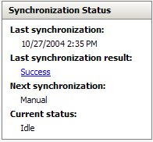
Synchronization
Synchronization occurs when the Update Services server connects to Microsoft Update and downloads updates or information about which updates are available. Update Services supports both a manual and a scheduled synchronization. Update Services also supports content filtering using products types and update classifications. For example, you might configure Update Services to synchronize only critical and security related updates for Windows XP and Office with Microsoft Update every Sunday night. By default, Update Services synchronizes only critical and security updates for all Windows products. Update Services uses both an MSDE database and a file system directory structure to store update binaries and metadata.

Advanced Synchronization Options
Update Services provides granular control over how and when updates are downloaded to the local store on the Update Services server. In its default configuration, Update Services downloads update files only after they have been approved during the synchronization process. Only update descriptions and metadata about the update are initially downloaded. This minimizes the impact on bandwidth and disk storage by only downloading update files that you intend to install on client computers. This behavior can be changed to always download update binaries, or use the update files on Microsoft Update.
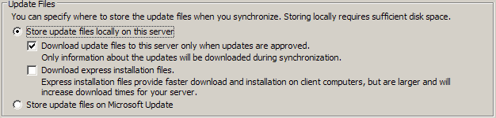
If the administrator chooses to only download information about updates, or metadata, individual clients will download the update files you approve directly from Microsoft Update. This is advantageous when clients are primarily roaming clients and are not always on the local network. Home users with internet connections can benefit from this configuration also.
Downloading express installation files is a good way to reduce the impact of installation on the clients. In this configuration, a greater amount of information is downloaded to the Update Services server from Microsoft Update, but a much smaller amount is distributed to individual clients. This can provide a significant reduction in network bandwidth consumption if there are a very large number of clients or limited bandwidth.
Updates typically consist of new versions of files that already exist on a computer being updated. On a binary level these existing files might not differ very much from updated versions. The express installation files feature is a way of identifying the exact bytes that change between different versions of files, creating and distributing updates that include just these differences, and then merging the original file with the update on the client computer. Sometimes this is called delta delivery because it downloads only the difference or delta between two versions of a file.
When updates are distributed using this method, an initial investment in bandwidth is required. Express installation files are larger than the updates they are meant to distribute. This is because the express installation file must contain all the possible variations of each file it is meant to update.
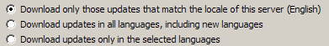
The administrator has control over the exact languages of the update files to be downloaded. The default configuration is to download all updates in all languages. This consumes a large amount of disk space. As a best practice, only download updates that apply to the locales on the computers in the organization.


Update Management
Update Services includes a rich feature set which allows you to manage updates that have been downloaded from Microsoft Update. In general, update management involves reviewing, testing, and approving/unapproving updates. Update Services improves and simplifies update management by including built-in scanning capability, which reports which computers require a particular update. After synchronization has run, information about available updates are accessed from the Updates icon. From the Updates area, administrators can search for updates, review metadata about each update, scan for computers which require the updates, approve updates, and set installation deadlines.

Metadata
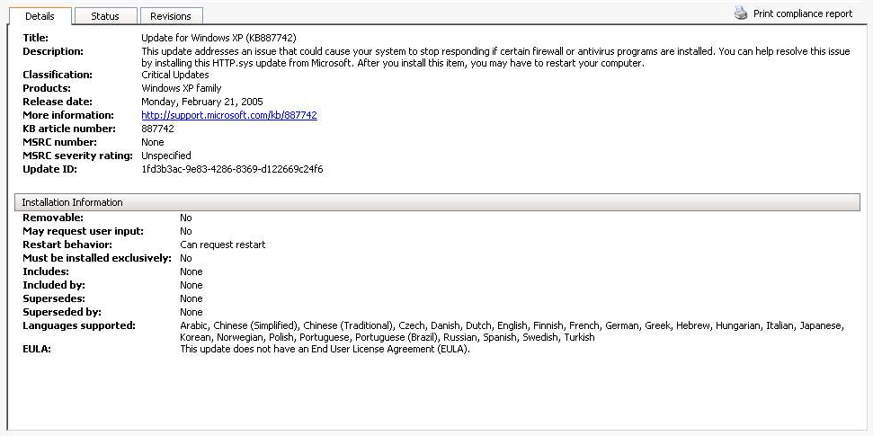
Each update contains numerous details that can be used when determining the applicability and impact of an update. Some of the information that an administrator can use to review and update include:
- Update title and description
- Release date
- Reboot behavior
- Supported languages
- Which updates are prerequisites
- Current status, including computers that have received the update or failed to receive the update
- Revisions and updates

Searching for Updates
Microsoft Update contains many updates for various Microsoft products. Finding the right update to approve or unapprove can be a challenging task. To ease this challenge, Update Services allows the administrator to specify various search criteria when managing updates and find an update easily. Searches can be based on product type, name, or update type, as well as status (approved/unapproved) and date/time criteria. For example Update Services also includes a text search option, which allows the administrator to locate updates based on keywords such as product names or security bulletin numbers. By providing a more robust search feature, Update Services can reduce the number of administrative mistakes, improving the overall security of the network.

Scanning for Updates
Prior to Update Services, an external scanning tool known as the Microsoft Baseline Security Analyzer (MBSA) was used to identify computers that were missing updates. Update Services now incorporates this detection feature, which scans all computers and reports back to the Update Services server the update status of each client. This information can be used to determine how many systems are affected by any given update. It is also useful when determining how quickly an update should be deployed. For example, if detection indicates that a large number of computers require a critical update, the administrator should evaluate how quickly to deploy that update.

Approving and Not Approving Updates
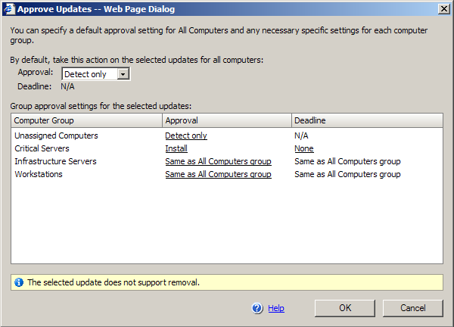
Once and update has been identified and tested, the update can be approved. The Update Services user interface allows the administrator to select multiple updates using the CTRL or Shift key on the keyboard. When updates are approved, the administrator can choose to approve the update for all computers, or select a single, or multiple computer groups. In addition, an installation deadline can be imposed, preventing users from postponing installation indefinitely. This fine level of control ensures that corporate security standards for patch management are strictly enforced at all times. Finally, the administrator can use the Detect option to scan all computers for the update. This reports which computers have the update installed, and which need it.

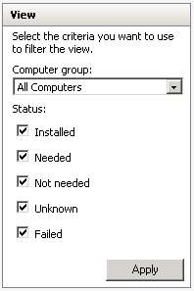
Reporting

Update Services includes a comprehensive set of reports. One important report is the Status of Computers report, which gives a summary of compliance of all the computers being managed by the Update Services server. Very quickly the administrator can identify which computers have updates to be installed. Reports can be viewed online using the Update Services administrator, downloaded as XML files or printed. Each report contains multiple views and allows filtering of results. A sample report is shown below.
The following reports are available.
- Status of updates: A report of the installation status of each approved update. The report can be filtered by computer groups, and contains lists of each approved update, along with the number of times it has been installed, failed to install, or needs to be installed. The report can also be viewed on a computer by computer basis.
- Synchronization Results: A report of the most recent synchronization events, including which updates were downloaded, how long the process took, and which errors, if any, were encountered.
- Settings Summary: A details listing of all configuration settings on the Update Services server.
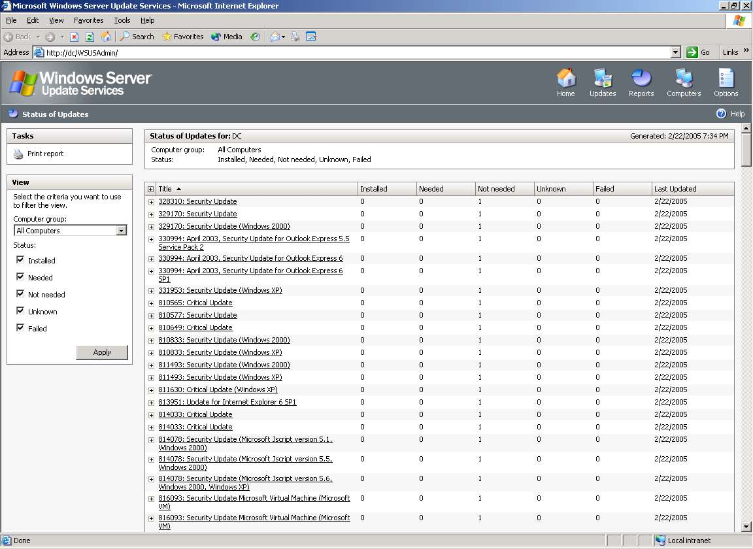
Downstream (Child) Servers
In distributed environments, especially those with multiple physical locations or slow WAN links, it can be desirable to implement more than one Update Services server. One Update Services server can be implemented at the main office, and another at a location such as a remote branch office. The remote branch office Update Services server is then configured to download updates from the main office Update Services server, rather than from Microsoft Update. This simplifies update deployment in remote branch offices by ensuring that the only updates branch office administrators can approve are those updates that have already been tested and approved by the main office. The branch office Update Services server is called the downstream server. The main office Update Services server is called the upstream server. The downstream server is administered in the same manner as the upstream server using subscriptions, reports, and computer groups.
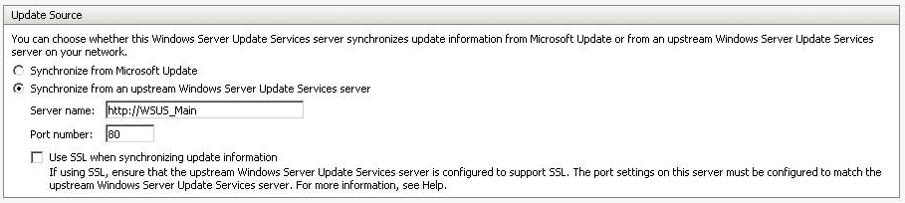
When synchronization is run on the downstream server, updates are downloaded via BITS from the upstream server, rather than from Microsoft Update. Only updates that have been approved on the upstream server are eligible for download. This functionality allows the main office Update Services administrator to approve a global set of updates for the entire organization. Downstream Update Services administrators download the globally approved updates, and then approve only those that are applicable to their part of the organization. Downstream Update Services administrators cannot download or approve updates that the upstream Update Services administrator has not already approved, ensuring a consistent update deployment process throughout the entire organization.

Windows Server Update Services Deployment Strategies
Effective patch management depends on effective deployment of update software such as Update Services. In general, there are several strategies for deploying Update Services. The strategies vary, depending on the size and goals of the organization involved.

Simple Deployment
The simplest deployment is to configure one Update Services server in a Microsoft Active Directory based network. The Update Services server downloads all updates from Microsoft Update. The administrator then reviews, tests, and approves updates. Group Policy can be used to configure clients to automatically download and install updates. Update Services computer groups can be used to separate client computers used for testing or pilot projects from production client computers.
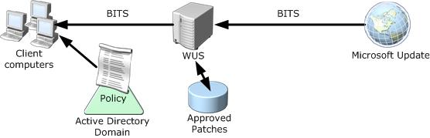

Two Tier Deployment
A two tier deployment involves configuring one Update Services server as the upstream parent server and one or more Update Services servers as downstream child Update Services servers.
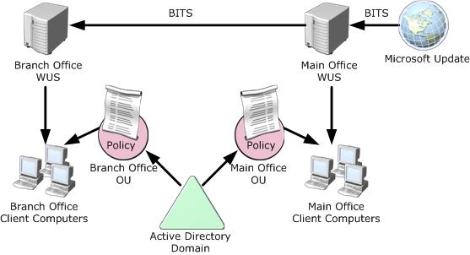

Scenario 1: Large Branch Office with Administrator
A single Update Services server is deployed at the main office, and at each branch office. The Update Services administrator approves all updates for computers at the main office at and branch offices. Branch office Update Services servers are configured to download approved updates from the main office Update Services server. Branch office administrators approve updates specific to individual branch offices.

Scenario 2: Small Branch Office with no Administrator
A single Update Services server is deployed at the main office, and at each branch office. The Update Services administrator approves all update for computers at the man office and at branch offices. Branch office Update Services servers are configured to automatically approve updates. This ensures that updates are approved in one place, but distributed with the minimum impact on available bandwidth and minimal administrative effort.

Replica Deployment
Update Services includes support for deploying a replica server to help manage bandwidth and clients in a distributed network. A replica Update Services server replicates updates, metadata, and configuration information from a parent Update Services server. Although group definitions are replicated, group memberships are not. This allows a main office Update Services administrator to define the Update Services configuration, approve updates, and create all computer groups for the entire organization, but still allows individual branch offices to control group membership. Branch office administrators can then populate groups based on their configuration. For example, a main office administrator might create computer groups named Critical Systems, Important Systems, and Low Risk systems. Updates would be approved for each computer group, based on the urgency of update deployment and the phase of testing the update has passed. Branch office Update Services servers replicate the groups, updates, and approvals for each computer group. Branch office administrators then populate the computer groups, based on the classification of each system at the branch office. This deployment method places a very small administrative burden on the branch office.

Managing Windows Update Agent Using Group Policy
Update Services includes Group Policy administrative templates which can be used to configure legacy and updated clients. The new administrative templates are installed in the %windir%\inf folder on the Update Services server. The templates include an updated wuau.adm, which contains settings specific to the Update Services client.
To configure Update Services clients using Group Policy, the administrator must first ensure that all computers which need to be managed are members of an Active Directory domain. Computers are generally organized into an organizational unit (OU) structure, such as the one shown below.
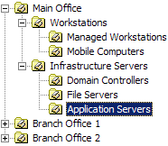
To control the Update Services client behavior a Group Policy Object (GPO) must first be created, then settings specific to the Automatic Update agent can be configured by navigating to the Computer Configuration/Administrative Templates/Windows Components/Windows Update portion of the GPO as shown below.
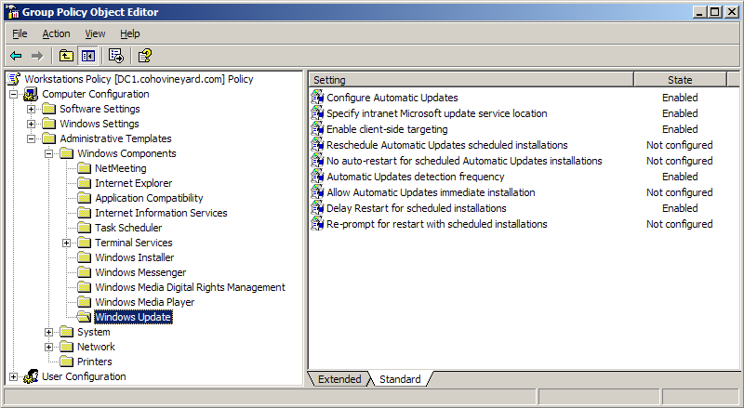
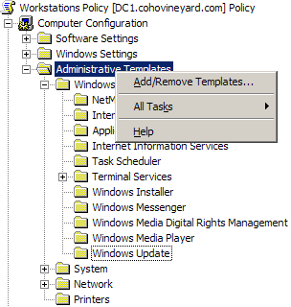
If this procedure is not performed from a computer with the updated version of WUAU.ADM administrative template, not all settings will be available. By default, only the Update Services server itself and client computers which have the Update Services-compatible version of Automatic Updates contain the updated file. To update any other computer with the administrative template settings, simply copy the WUAU.ADM file from the %windir%/inf folder on the Update Services server to the %windir%/inf folder on the computer requiring the new template. This only needs to be done on the computers which will be used to create or modify group policy settings, not on client computers that will receive the settings.

Automatic Updates Group Policy Settings
The Automatic Updates client supports the following group policy settings.

Configure Automatic Updates
Used to enable or disable automatic updates. If disabled, users must manually download updates from Microsoft Update. If enabled, the administrator can set the method of download using the Configure Automatic Update property. If Configure Automatic Updates option is set to a value of 4 - Auto download and schedule the install, it is possible to also configure the time at which scheduled installations can occur. If the value is set to 5 – Allow local admin to choose setting, the local administrator has the ability to configure automatic updates, but cannot disable automatic updates.

Specify Intranet Microsoft Update Server Location
The URL used to locate the Update Services server is entered here. When enabled, the administrator must specify a URL for update detection and for statistics. Both these URL’s will be the URL selected when Update Services was installed. For example, a default installation generates a URL of http://<servernamehere>. If the server is configured to a custom port, the URL will be http://<servernamehere>:<port>.

Enable Client-side Targeting
When Update Services is configured to control group membership using group policy or registry settings, the Update Services computer group name must be specified here. For example, entering a value of Accounting will populate the Accounting computer group with the names of computers which receive this policy.
NOTE: This setting has no effect unless Update Services is configured to control client computer group assignment using group policy or the registry, and the applicable computer groups are created.

Reschedule Automatic Updates Scheduled Installations
This setting instructs the client computer to wait a specified time after startup before proceeding with scheduled installations of updates that have been missed. If updates are downloaded and installation is scheduled for a time when the client computer is not powered on, the installation will proceed as soon as the client computer is powered on. Some installations may fail if not all services are started, or are slow to start. Delaying the installation allows the client computer to reach a stable state before installing updates.

No Auto-Restart for Scheduled Automatic Updates Installations
If any update required a restart of the client computer, and a user is currently logged on, enabling this setting will prompt the user to restart the computer. It is recommended that this setting is enabled if the Reschedule Automatic Updates scheduled installations setting is also enabled.

Automatic Updated Detection Frequency
This setting specifies how long the Automatic Updates client waits checks for available updates. The detection frequency is measured in hours and automatically calculates an offset of +/- 20% of the configured interval to ensure the Update Services server is not flooded with synchronization requests. The exact offset is random and not visible in the user interface.

Allow Automatic Updates Immediate Installation
This setting allows Windows to immediately install updates that do not require service restart, service interruption, or computer restart. These updates are installed as soon as they are downloaded and available. The client computer does not wait for the scheduled installation interval.

Delay Restart for Scheduled Installations
If this setting is not configured, the client computer will restart 5 minutes after a scheduled installation if a restart is necessary. When configured, the computer will restart after the specified number of minutes.

Re-Prompt for Restart with Schedule Installations
This setting controls how long to wait before re-prompting to restart the client computer after a scheduled installation restart was postponed. This reminds the user that there is a pending restart to ensure updates are completely installed.

Allow Non-Administrators To Receive Update Notifications
By default, only administrators receive notifications that updates are ready for download or installation. This policy setting extends this notification to non-administrators who are interactively logged on to the computer.

Using Group Policy to manage deployment of updates provides the ability to customize delivery based on specific requirements within the environment. One common scenario involves automatically installing updates on client computers without user intervention, while providing administrators control over which updates are installed on servers, and when. To solve this scenario, the administrator would create two GPOs, linked to different OUs. The GPO used for managing client computers is configured to automatically download and install all updates, and assigns all client computers to the Update Services computer group clients. The GPO used for managing servers is configured to download updates, but notify administrators of the need to install them. It would also assign all servers to the Update Services computer group Servers. The Update Services administrator can approve updates for client computers for only the client’s computer group and updates for servers for only the Servers computer group. Client computers are updated automatically without user knowledge, while individual server administrators are prompted to review and install updates when they log on. The individual server administrators can choose a convenient time to install the new updates.

Getting Started
Installing Update Services involves installing the Update Services software itself, updating the Automatic Updates client, and optionally, migrating approvals and updates from an existing SUS server.

Installing a New Update Services Server
Update Services has a setup process based on MSI. Users of SUS will find the installation familiar, but with a few changes. The screen shots below highlight some of the key decision points during a Update Services installation.
After launching setup, reviewing the setup screen and license agreement, administrators will be prompted to choose the storage location for updates. Here the administrator can choose where to install Update Services itself, and then, optionally, specify a different location for the storage of updates. This allows the administrator to store updates on dedicated disk system for high load servers. For smaller organizations, organizations which do not have adequate disk space, or bandwidth which may support many remote users, the administrator has the option to leave all updates stored on Microsoft Update.
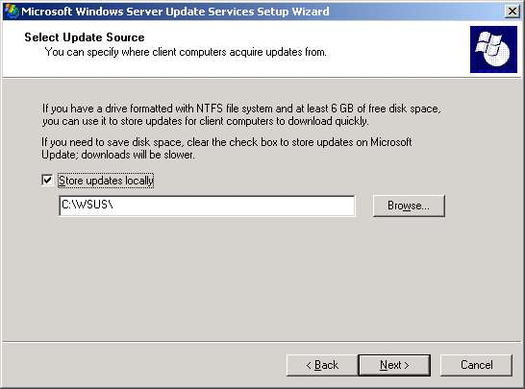
The administrator must also choose which database server to use. Update Services includes an installation of MSDE but allows administrators to specify an existing SQL Server computer. This database is used to hold update metadata and Update Services configuration.
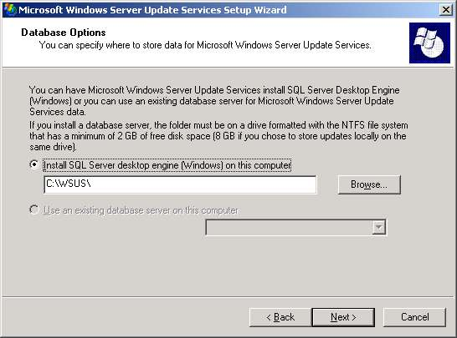

The administrator must choose the Web site that will host the Update Services administration pages.
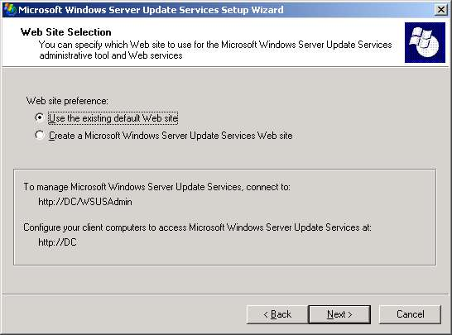
After Update Services has installed, a welcome page is displayed. This is where all Update Services administration is performed, including setting preferences, connection options, creating groups, and configuring subscriptions.
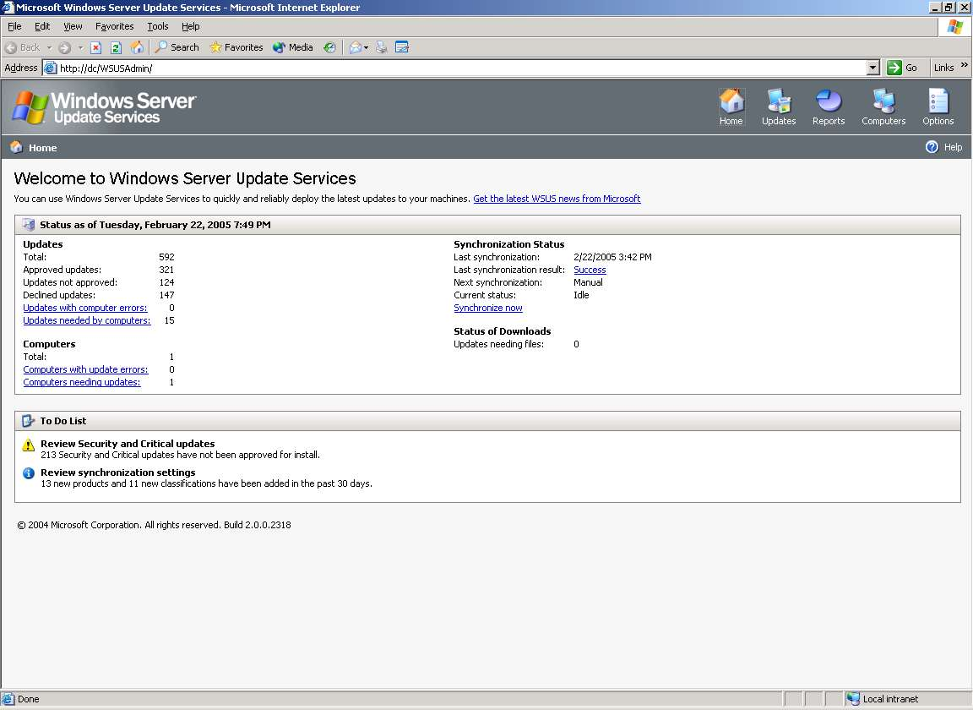

Migrating from Software Update Services to Update Services
Update Services includes an easy to use migration tool to migrate updates and approvals from an existing SUS server to Update Services. This eases implementation and reduces the initial administration required to move from SUS to Update Services. In all cases, Automatic Updates clients will self-update when the new Update Services server in place. The migration tool supports three migration scenarios.

Scenario 1: Same Server Migration
In this scenario, the Update Services administrator installs Update Services on the server that is currently running SUS. The migration tool copies updates and approvals from SUS to Update Services and then launches an update sequence to download any missing metadata. Actual updates are not downloaded again, if they were present in SUS.
During the installation of Update Services on a server running SUS, the Update Services website is bound to port 8530. Once migration is complete and SUS is uninstalled, Update Services can be reconfigured to bind to port 80 or 443 to begin servicing clients.

Scenario 2: Migration to a New Server
In this scenario, you install Update Services on a new server. The migration tool copies all updates and approvals over the network from the SUS server to the Update Services server. An update sequence is then launched to download any missing metadata.
Following the installation of Update Services, the administrator would need to make any necessary configuration changes to allow clients to begin downloading updates from the Update Services server. This could include DNS namespace updates or group policy updates.

Scenario 3: Phased Migration
The administrator can configure a phased migration, in which clients are gradually moved from SUS to Update Services. This can be accomplished using Scenario 1 or Scenario 2 in parallel with an existing SUS implementation. Once you are confident in the functionality of Update Services, the SUS infrastructure can be phased out.

Migrating Existing SUS Content and Approvals to Update Services
Migration from SUS to Update Services is accomplished using the Update ServicesUTIL.EXE command line tool. Update ServicesUTIL.EXE can be found in the \Program Filesadmin\Microsoft Update Services\Tools folder. Update ServicesUTIL.EXE supports several commands. The MigrateSUS command is used to migrate settings from SUS to Update Services and supports the following options.
- /content <share> - Instructs Update ServicesUTIL.EXE to migrate updates from the UNC share specified. For this to work, you must share the \SUS\Content\Cabs folder on your SUS server.
- /approvals <server> <target_group> - Instructs Update ServicesUTIL.EXE to migrate approvals. The server name is the FQDN of the existing SUS server. The target group specifies the name of an existing Update Services computer group. If specified, migrated approvals are only approved from this group.
Before using the Update ServicesUTIL.EXE command, the administrator needs to perform an initial content synchronization with Microsoft Update. In the Update Services default configuration, this initial synchronization only downloads update metadata, not the actual binaries. This minimizes the impact on the WAN and network infrastructure. Once the initial metadata synchronization has been completed, the actual update binaries and approvals can be migrated.

Post-migration Configuration Tasks
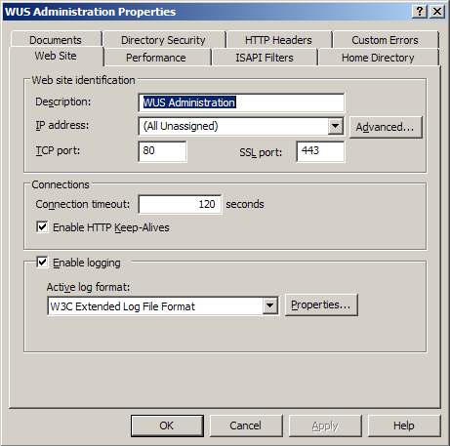
After the migration is complete, the administrator needs to complete a few tasks to ensure clients can download updates from the new Update Services server.

Same Server Migration
When Update Services is installed on the same server as SUS, the Update Services administration and updates web sites are bound to port 8530. By default previous versions of the Automatic Updates client connects to port 80. To migrate the Update Services server to the standard HTTP and HTTPS ports, perform the following steps.
- Uninstall SUS.
- On the Update Services server, open Internet Information Services (IIS) Manager.
- Navigate to Web Sites/WSUSAdmin.
- On the Action menu, click Properties.
- On the Web Site tab, in TCP port, type 80, and in SSL port type 443, and then click OK.
- On the Action menu, click Stop to stop the Update Services Administration web site.
- On the Action menu, click Start, to start the Update Services Administration web site.
NOTE: If desired, the administrator can continue running Update Services on a non-standard port. If you wish to do this, configure a GPO for clients, or directly edit the registry on clients. Using either method, configure the Update Services URL to be HTTP://ServerName:PortNumber or HTTPS://ServerName:PortNumber.

New Server Migration
If Update Services has been installed on a new server and migrated content and approvals to that server, the administrator needs to configure the Automatic Updates clients to use the new Update Services server. There are generally two ways to accomplish this task.
- If you use Group Policy to configure Automatic Updates clients, simply update the appropriate GPO to reference the new servers URL.
- If you use a DNS entry, such as a CNAME record (such as updates.company.com) to allow clients to locate your SUS server, you only need to update this record with the hostname or IP address of the new Update Services server. No changes to Group Policy are required. A similar procedure can be used if your company uses WINS.

Update Services Configuration Tasks
The migration tool will only migrate content and approval settings. It does not migrate SUS server configuration settings. Sever configuration settings such as the synchronization schedule, languages, proxy settings, and update storage will need to be manually configured once Update Services has been installed.

Upgrading the Automatic Updates Client
Update Services uses IIS to automatically update computers to the Update Services–compatible version of Automatic Updates. On the server running Update Services, a virtual directory structure is created, which contains updated Automatic Updates clients for all supported platforms.
On the next detection cycle, the Automatic Updates client will be upgraded to the Update Services-compatible version. This is known as self-update.

Update Services Features at a Glance

Supported Products and Content Types
Operating Systems | Windows 2000 Server (all editions) with SP3 or later and Windows 2000 Professional  Windows Server 2003, all editions  Windows XP Professional and later versions
Servers and Applications | All editions of Microsoft Office 2003 and Microsoft Office XP SP2 and later  Exchange 2003 all editions
Content Types | Security updates  Non-security updates (critical and non-critical) and update rollups  Service packs  Feature packs  Critical driver updates  Other content types

Update Management Features
Detecting Missing Updates | - Automatically detects the operating system and supported products installed on each managed system and generates a report of missing updates for the operating system and each supported product  - Allows identification of all managed systems missing a specific update or set of updates
Downloading Updates from Microsoft | - Allows automatic or manual download of new updates from Microsoft  - Can specify frequency (daily or weekly) for checking for and downloading new updates  - Can specify the products and content types for which new updates should be downloaded
Targeting Updates | - Allows definition of groups of systems for targeting update management actions (install, uninstall, scan for missing updates, and so on)  - Target groups can be defined based on server-side enumerated lists of systems or client-side registry settings that can be centrally configured via Group Policy in Active Directory environments
Approving Updates | - Non-approved updates are not available for download or installation on managed systems  - Updates can be approved for installation on specific target groups or all managed systems  - Can define rules to auto-approve updates for installation to specific target groups
Distributing Updates | - Can specify the frequency with which managed systems should check for approved updates  - Can specify that the list of approved updates be obtained from the Update Services server, but actual updates be downloaded from worldwide Microsoft Update download servers  - Automatically distributes the appropriate language version of updates to target systems
Installing Updates | - Update Services clients can be configured to automatically install downloaded updates on a specified installation schedule or allow the user to select and control installation of downloaded updates  - Administrators can specify a deadline by which an update must be installed and the system will force installation of the update accordingly

Network Optimization Features
Network Resiliency | - Uses BITS to automatically resume downloading from point of network interruption once connection is re-established
Network Transparency | - By default, by leveraging BITS, downloads are done in background mode using only the unused portion of network bandwidth, resulting in no impact on network performance
Minimized Data Transmission Volumes | - Dramatically reduces data transmission volumes associated with update management via use of advanced binary delta updating and compression technologies

Reporting Features
Update Management Reports | - Standard update management reports provide status information about missing updates, update downloads, pending updates, and update installations, on a per-update, per-computer, or per-group basis
Consolidated Reporting | - Reports provide a consolidated view of the entire Update Services implementation; statistics from child servers are rolled up to the parent server
Log Data Storage | - Use of Microsoft SQL Server 2000 Desktop Engine (Windows) (WMSDE) or SQL Server to store log and update management data increases reliability

User Experience Features
One-click Client Configuration | - Allows easy configuration for clients not centrally configured via Group Policy or scripting
Silent Update Installations | - Updates not requiring a reboot on installation can be installed without user interruption
Install Updates at System Shutdown | - For Windows XP Professional SP2 updates that need a reboot on install, the reboot can be deferred to occur at normal system shutdown, eliminating the need for any user interruption
User Notification and Control over Installations | - When desirable, provides the ability to notify the user of new updates and / or control when updates are installed on the user’s system
Warning of Impending Reboot | - When the installation deadline has passed or an update needs to be installed immediately, users receive notification of the impending reboot allowing them to save their work
Multiple-Language Support | - Automatically downloads the appropriate MUI pack and installs on the client if it is not already installed

System Implementation and Security Features
Automated Client Upgrade | - The Update Services client is included in Windows XP SP2. For systems with an older version of the client, administrators can configure the system so the new version of the client is automatically deployed to these systems.
Hierarchical Scale-out Server Deployment | - Supports deploying a hierarchy of Update Services servers – both independently administered servers that synchronize update content from a parent server and replica servers* that inherit content and administrative actions from a parent server – in distributed environment or load balancing scenarios.
Port Selection | - Administrators can specify the port to be used for client-server communications
Proxy Authentication | - Allows specification of username and password to be used in authenticating to a firewall / proxy server that mediates connection to the Internet from the Update Services server
Communication Security | - Communications between Update Services servers and Microsoft Update download servers are encrypted  - Client-server and server-server communications can be configured to be encrypted  - The administrative GUI is only available to administrators of the system on which SUS server is running. The GUI can be accessed remotely and can be configured to encrypt session communications
Server Identity Validation | - Update Services servers validate the identity of the upstream server from which update content is downloaded
Content Authentication | - Update Services servers check digital signatures on all downloaded files to ensure they are authentic Microsoft updates that have not been tampered with  - Update Services clients verify authenticity and integrity of updates before installations

Administrative Productivity Features
New Data Model | - The new update management data model allows specification of relationships between updates (for example, prerequisites, bundle relationships, and supersedence), resulting in higher levels of automation and significantly reduced administrative effort
New Administrative GUI | - The new administrative GUI provides an intuitive, unified console for managing the entire Update Services environment. Administrators can quickly and easily get summary and detailed information about updates, approvals, target groups and managed systems, system health and update management statistics, and so on
Active Directory Based  Group Policy Integration | - Enables scalable centralized administration of geographically distributed environments via Group Policy, allowing efficient configuration of Update Services client settings such as target group specification, preventing end-user access to Windows Update, and so on
Client and Server APIs | - Client and Server APIs allow command-line or programmatic access to Update Services functionality, enabling the creation of scripts to automate administrative tasks
Backup and Recovery | - All relevant system setting and status, update data and metadata, and update management status information stored in a SQL Server or MSDE database enabling reliable and efficient backup and recovery

System Requirements and Language Support
Update Services Server | - Windows 2000 Server: All editions, SP4 and later versions not including 64-bit editions  - Windows Server 2003: All editions not including 64-bit editions  - IIS 5.5 and later versions  - ASP.NET 1.1: Automatically installed if not already on the system  - SQL Server 2000 SP3 and later versions or SQL Server 2003 or MSDE 2000  - Minimum RAM: 512 megabytes (MB)  Recommended RAM: 1 gigabyte (GB)  - Localized for all Windows Server supported languages (English, German, and Japanese for beta version)
Update Services Client | - Windows XP Professional and later versions not including 64-bit editions  - Windows 2000 Server and Professional: All editions (not 64-bit), SP3 and later versions  - Windows Server 2003: All editions, not including 64-bit editions.  NOTE: 64-bit support will be provided with SP1.  - Localized for all Windows client operating system supported languages (English, German, and Japanese for beta version)

SUS Feature Comparison
Update Services includes many features not found in SUS. These features are designed to improve the manageability of updates, and improve administrator control over update deployment. The following table lists key functions and features, and how it is implemented using SUS or Update Services. In many cases the feature is not supported by SUS.
Feature Description | SUS | Update Services
Automatic detection of missing updates | Relies on external tools | Implemented in “Detect” feature
Target updates toward specific clients | Requires multiple SUS servers | Supported using computer groups
Approve updates for clients | Updates can be approved or not approved | Updates can be approved per computer group, with installation deadlines for each group
Update detection | Updates are detected on preconfigured interval | Updates are detected on an administrator configured interval, allowing more rapid update deployment.
Installing updates | Updates are downloaded and executed on the client | Updates are downloaded and executed on the clients. Express updates reduce update size.
Reporting | Very limited reporting implemented as a log file | Rich reporting, with searching and filtering. Reports allow drilldown to specific updates or computers
Support for multiple update types | Only supports security updates | Supports multiple content types, including updates, service packs, feature packs, driver updates, tools, and documentation
Customized download schedules | Download schedule is set per server | Download schedule is managed using subscriptions. Multiple subscriptions used to download different updates on different schedules
Scale out sever deployment for large enterprises | Supports downstream SUS servers | Supports downstream Update Services servers and replica Update Services servers
Automatic Updates client | Standard client | Updated to included additional features including scanning, reporting, and additional administrator options.
Software products updates | Only Operating Systems | Operating systems, Office products, and server products such as SQL Server and Exchange Server
Administrative control via Group Policy | Supports a small number of GPO settings | Supports a larger number of GPO settings including target group and refresh interval
Migration from earlier versions | Not applicable | Includes migration wizard to migrate approvals and updates from SUS
Update detection cycle | Fixed value | Configurable through group policy.

Update Services Installation Requirements
Hardware Requirements: 500 Clients or Less
Component | Minimum | Recommended
RAM | 512 MB | 1 GB
CPU | 750 MHz | 1 gigahertz (GHz)  or faster
Database Type | WMSDE or MSDE | WMSDE or MSDE
Disk Space | 8 GB | 8 GB
Hardware Requirements: 500 to 15,000 Clients
Component | Minimum | Recommended
RAM | 1 GB | 1 GB
CPU | 1 GHz | 3 GHz dual processor computer or faster  Use dual processors for more than 10,000 clients
Database Type | SQL Server 2000 SP3a | SQL Server 2000 SP3a
Disk Space | 8 GB | 8 GB

Software Components
The following is a list of required software. Make sure the Update Services server meets this list of requirements prior to running Update Services setup.
- Windows Server 2003, or Windows 2000 Server with SP4 or later
- IIS 5.0 or later
- Microsoft .NET Framework 1.1 SP1 (download it from the Download Center at http://www.microsoft.com/downloads/details.aspx?FamilyID=a8f5654f-088e-40b2-bbdb-a83353618b38&displaylang=en)
- Microsoft Internet Explorer 6.0 SP1 (download it from the Internet Explorer site at http://www.microsoft.com/windows/ie/downloads/critical/ie6sp1/default.mspx
- BITS 2.0 (download it from the Download Center at http://www.microsoft.com/downloads/details.aspx?FamilyID=b93356b1-ba43-480f-983d-eb19368f9047&displaylang=en)

Test Driving Update Services
The following infrastructure is suggested for successful evaluation of Update Services. This infrastructure can be created using physical client and server computers, or using virtual computers running on Microsoft Virtual PC 2004 or Microsoft Virtual Server 2005.

Infrastructure Overview
Element | Configuration Notes
Domain Controller | Computer Name: DC1  Operating System: Windows Server 2003  Active Directory Domain Name: cohovineyard.com
Update Services Server | Computer Name: Update Services1  Operating System: Windows Server 2003  Member of cohovineyard.com domain
Client | Computer Name: Client1  Operating System: Windows XP Professional with SP2  Member of cohovineyard.com domain

Building the Test-Drive Environment
The procedures in this section are intended as a general guide to implementing Update Services in a test environment. This configuration will allow you to explore key features of Update Services in a controlled environment, without impact on existing infrastructure servers. The test drive environment consists of three computers, a Domain Controller, a Member Server which will run Update Services, and a Windows XP client. Consider the following points when choosing your test drive computers.
- All three computers will require access to the Internet during the initial setup and configuration if you choose to activate your Windows Software. The server being used as your Update Services server will require continuous access to the Internet to run subscriptions. As a best practice, ensure your computers are protected by a firewall at all times.
- All three computers will require IP addresses which allow communication to other computers and the Internet. You may need to request these addresses from your IT department.
- For a more robust evaluation environment, configure your three computers as virtual computers using either Microsoft Virtual PC 2004 or Microsoft Virtual Server 2005. A suggested configuration is to allocate 256 MB of RAM to each Windows Server 2003 virtual machine and 128 MB of RAM to the Windows XP virtual machine. Configure each virtual machine to use undo disks, which will allow you to roll back changes to your evaluation environment. For more information about Microsoft Virtual PC 2004, or to download an evaluation copy, visit http://www.microsoft.com/virtualpc. For more information about Virtual Server 2005, or to download an evaluation copy, visit the Virtual Server Web site at http://www.microsoft.com/virtualserver.

Install Windows Server 2003 as a Domain Controller
- Using your product CD, install Windows Server 2003 Standard Edition or Enterprise Edition.
- When prompted, name the computer DC1.
IMPORTANT: For security reasons, it is recommended that you disconnect any network cables, and disable any wireless adapters while installing Windows Server 2003. Once installed, you should enable Internet Connection Firewall on each network interface before connecting to any network. For more information about Internet Connection Firewall, see Windows Help and Support.
- Configure an IP Address on the Network Interface Card that is connected to your network. The IP address information should be sufficient to allow you to access the Internet.
- Connect to Windows Update and install all available security updates. This process will take several minutes, and may require rebooting.
- Once all security updates have been installed, disable Internet Connection Firewall, if enabled.
IMPORTANT: For security reasons, ensure that your test drive computers are protected by a firewall, such as Microsoft Internet Security and Acceleration Server 2004.
- Install Active Directory. When prompted, use the following values.
- DNS Domain Name: cohovineyard.com
- NETBios Domain Name: cohovineyard
- DNS Configuration: Install and configure DNS on this computer.
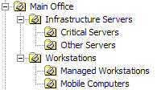
- When Active Directory installation has completed, open Active Directory Users and Computers. Create the following OU structure.

Install Windows Server 2003 as a Member Server
- Using your product CD, install Windows Server 2003 Standard Edition or Enterprise Edition.
- When prompted, name the computer Update Services1.
IMPORTANT: For security reasons, it is recommended that you disconnect any network cables, and disable any wireless adapters while installing Windows Server 2003. Once installed, you should enable Internet Connection Firewall on each network interface before connecting to any network. For more information about Internet Connection Firewall, see Windows Help and Support.
- Configure an IP Address on the Network Interface Card that is connected to your network. The IP address information should be sufficient to allow communication with the domain controller. Ensure your primary DNS server is set to the IP address of your domain controller.
- Connect to Windows Update and install all available security updates. This process will take several minutes, and may require rebooting.
- Once all security updates have been installed, disable Internet Connection Firewall, if enabled.
IMPORTANT: For security reasons, ensure that your test drive computers are protected by a firewall, such as Microsoft Internet Security and Acceleration Server 2004.
- Join Update Services1 to the cohovineyard.com domain.
- Install Group Policy Management Console.

Install Windows XP Professional with SP2 as a client
- Using your product CD, install Windows XP Professional with SP2
- When prompted, name the computer Client1.
IMPORTANT: For security reasons, it is recommended that you disconnect any network cables, and disable any wireless adapters while installing Windows XP. Once installed, you should enable Windows Firewall Services on each network interface before connecting to any network. For more information about Windows Firewall Services, see Windows Help and Support.
- Configure an IP Address on the Network Interface Card that is connected to your network. The IP address information should be sufficient to allow communication with the domain controller. Ensure your primary DNS server is set to the IP address of your domain controller.
IMPORTANT: For security reasons, ensure that your test drive computers are protected by a firewall, such as Microsoft Internet Security and Acceleration Server 2004.
- Join Client1 to the cohovineyard.com domain.

Installing Update Services
In this procedure, you will install Update Services on a member server. During the installation you will use the default file storage location and website. When you do not have an existing SQL Server 2000 server, you will use WMSDE, included with Update Services.
- Launch the Update Services installer.
- On the welcome page, click Next.
- Accept the license agreement, and then click Next.
- On the Select Update Source page, type a location such as c:\Update Services and then click Next. Ensure the Store update locally check box is checked. This instructs Update Services to download approved updates from Microsoft Update.
- On the Database Options page, click Next.
- On the Web Site Selection page, click Next twice, and then click Finish. Update Services will install.

Configuring Server Proxy Settings (Optional)
Now that Update Services is installed, you need to configure any settings required to allow Update Services to connect to the Internet and Microsoft Update. This includes any proxy information your organization requires.
- Open the Update Services administration page by navigating to http://Update Services1/Update ServicesAdmin in Internet Explorer.
- Click Options.
- Click Synchronization Options
- Under Proxy Server, if your organization uses a proxy server, or a proxy server which requires user authentication to access the Internet, configure these settings here and then, under Tasks, click Save settings.

Manually Running a Synchronization
At this point, you would normally wait for your initial synchronizations to occur. It may be desirable to download subscriptions immediately to make them available to clients. In this case you will manually run both subscriptions to populate the Update Services database with available updates.
IMPORTANT: Manually synchronizing your Update Services server could put significant load on your network infrastructure and WAN connections. Consult with your IT staff before performing these steps as an unanticipated load might cause disruptions in network connectivity. If this precludes you from synchronizing immediately, reconfigure the Update Services server to synchronize at an acceptable time and skip this step. Note that many of the following procedures require synchronization to be before they produce the desired results.
- Under Tasks, click Synchronize now. Depending on the speed of your WAN connection, this may take an extended period of time.

Configuring Synchronization Settings
You will configure Update Services to download updates for Office products and for the Windows family. You will also and an additional product classification. These custom synchronization filters allow you to only download the updates that apply to your organization, and can be extended to included additional update types as they become available. The synchronization schedule gives you control over what time of day synchronization occurs. Normally, you configure this to be a time of low WAN usage.
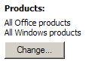
- On the Synchronization Options page, under Products and Classifications, under Products, click Change.
- In Add/Remove Products, click Office, and then click OK.
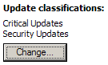
- On the Synchronization Options page, under Products and Classifications, under Update Classifications, click Change.
- In Add/Remove Classifications, click Updates, and then click OK.
- Under Schedule, click Synchronize daily at, and then click 3:00 AM.
- Under Tasks, click Save Settings.
- Under Update Files and Languages, click Advanced.
- In Advanced Synchronization Options, uncheck Download update files to this server only when updates are approved. This configures Update Services to download all updates on the next synchronization. Configuring this setting allows updates to be distributed to clients immediately after they are approved. You do not need to initiate a second synchronization cycle after approval to download update binaries.

Enabling Self Update for the Automatic Updates Client
Update Services clients must be running the Update Services compatible version of Automatic Updates before they can receive updates from the Update Services server. The upgrade process happens automatically and is transparent to end users. Once self-update has been enabled, cliens will self-update on the next scheduled automatic
- On Update Services1, open a Command Prompt.
- In the Command Prompt window, type cscript “c:\program files\Microsoft Update Services\setup\selfupdate.vbs”

Creating Computers and Groups
To facilitate the deployment of critical patches to critical servers, you will create several computer groups. Using computer groups allows you to approve updates for only a subset of the clients of your Update Services server. Each subset of clients supports a custom installation deadline.
- Click Computers, and then click Create a computer group.
- In the Add Computer Group dialog box, in Name, type Critical Servers, and then click OK.
- Create another group named Client Computers.
- Create a third group named Infrastructure Servers.

Configuring Group Policy to Deploy Updates
You will use several GPOs to configure client computers. After an OU structure has been created, you will create GPOs at several locations. One GPO, linked to the topmost OU, will implement global settings to be applied to all Update Services clients, such as the Update Services server name. Other settings, such as the group name, Automatic Updates configuration, and detection frequency will be implement at each OU.
- Open Group Policy Management Console.
- Navigate to the Main Office OU.
- On the Action menu, click Create and Link a GPO Here, type Update Services Policy, and then click OK.
- Click Update Services Policy, and then on the Action menu, click Edit.
- In Group Policy Object Editor, navigate to Computer Configuration/Administrative Settings/Windows Components/Windows Update.
- Click Specify intranet Microsoft update service location and then on Action menu, click Properties.
- Click Enabled, in both text boxes, type HTTP://Update Services1, and then click OK.
- Click Allow Automatic Updated immediate installation, and then on the Action menu, click Properties.
- Click Enabled, and then click OK.
- Close Group Policy Object Editor.
- Navigate to the Critical Servers OU.
- On the Action menu, click Create and Link a GPO Here, type Critical Servers Update Policy, and then click OK.
- Click Critical Servers Update Policy, and then on the Action menu, click Edit.
- In Group Policy Object Editor, navigate to Computer Coifiguration/Administrative Settings/Windows Components/Windows Update.
- Click Configure Automatic Updates, and then on the Action menu, click Properties.
- Click Enabled, and then click OK.
- Click Enable client-side targeting, and then on the Action menu, click Properties.
- Click Enabled, type Critical Servers, and then click OK. This step configures the automatic client to joint the Critical Servers computer group on Update Services1, if the group exists. If the group does not exist, the computer is placed in the unassigned computers group.
- Close Group Policy Object Editor.
- Navigate to the Infrastructure Servers OU.
- On the Action menu, click Create and Link a GPO Here, type Infrastructure Servers Update Policy, and then click OK.
- Click Infrastructure Servers Update Policy, and then on the Action menu, click Edit.
- In Group Policy Object Editor, navigate to Computer Configuration/Administrative Settings/Windows Components/Windows Update.
- Click Configure Automatic Updates, and then on the Action menu, click Properties.
- Click Enabled, in Configure automatic updating, select option 4, and then click OK.
- Click Enable client-side targeting, and then on the Action menu, click Properties.
- Click Enabled, type Infrastructure Servers, and then click OK.
- Close Group Policy Object Editor.
- Navigate to the Workstations OU.
- On the Action menu, click Create and Link a GPO Here, type Workstations Update Policy, and then click OK.
- Click Workstations Update Policy, and then on the Action menu, click Edit.
- In Group Policy Object Editor, navigate to Computer Configuration/Administrative Settings/Windows Components/Windows Update.
- Click Enabled, in Configure automatic updating, select option 4, and then click OK.
- Click Enabled, and then click OK.
- Click Enable client-side targeting, and then on the Action menu, click Properties.
- Click Enabled, type Client Computers, and then click OK.
- Close Group Policy Object Editor.

Updating Group Policy on the Client
It is not necessary to force a refresh of Group Policy in a production environment. Group Policy settings will be automatically updated with new settings as soon as the next update cycle runs. For test drive purposes, we will force this refresh.
- On DC1, open Active Directory Users and Computers.
- Navigate to the Computers container.
- Click Client1, and then on the Action menu, click Move,
- In the Move dialog box, navigate to the Managed Workstations OU, and then click OK.
- In Active Directory Users and Computers, navigate to the Managed Workstations OU, and verify that Client1 is listed.
- On Client1, open a command prompt and type gpudate /force.
- On Client1, click Start, click Run, type rsop.msc, and then click OK.
- Navigate to Computer Configuration/Administrative Settings/Windows Components/Windows Update.
- Verify that all Group Policy Settings have been applied.

Forcing an Automatic Updated Detection Cycle
It is not necessary to force an Automatic Updates detection cycle in a production environment. The Automatic Updates client will run automatically on the next scheduled interval. For test drive purposes, we will force an automatic updates detection cycle. This step is necessary to ensure that Update Services processes computer group membership.
NOTE: No updates will be installed at this time, as none have been approved on the Update Services server.
- On Client1, open a command prompt.
- Navigate to c:\Windows\System32.
- Run the command wuauclt /detectnow.

Searching for and Approving Critical Updates for a Group
NOTE: Your initial content synchronization must be complete for this procedure to be successful.
Update Services allows you to approve different updates for different computer groups. Here you will approve Critical and Security updates that apply to Windows Server 2003 computers. You will also approve office updates for only client computers. In both cases, you will set different installation deadlines which adhere to your corporate security policy.
- On Update Services1, click the Updates tab.
- Under Current View, in Products and classifications, click Critical and Security updates, and then click Apply. The list of updates will be filtered to include only Critical and Security updates.
- Under Current View, in Products and classifications, click Custom, and then click Change custom.
- Check the Windows Server 2003, Security Updates, and Critical Updates check boxes, and then click OK.
- Click Apply.
- Holding the SHIFT key, click the first update and the last update, selecting all updates, and then click Approve for installation.
- In the Approve for Installation dialog box, click Install on selected groups of computers only, with optional deadline.
- Click the Critical Servers checkbox, and then click Set deadline.
- In the Set Deadline dialog box, click Require installation by, select a date that is 2 days in the future, and then click OK.
- Click the Infrastructure Servers checkbox, and then click Set deadline.
- In the Set Deadline dialog box, click Require installation by, select a date that is one week in the future, and then click OK.
- In the Approve for Installation dialog box, click OK. All updates will be approved. You may be prompted to accept a license agreement. If this occurs, click I Accept.
- Under Current View, click Change custom.
- Check only the Windows XP family, Security Updates, and Critical Updates check boxes, and then click OK.
- In Show updates that are, click Approved and Unapproved
- Click Apply.
- Holding the SHIFT key, click the first update and the last update, selecting all updates, and then click Approve for installation.
- In the Approve for Installation dialog box, click Install on selected groups of computers only, with optional deadline.
- Click the Client Computers checkbox, and then click Set deadline.
- In the Set Deadline dialog box, click Require installation by, select a date that is 2 days in the future, and then click OK.

Forcing an Automatic Updated Detection Cycle and Installing Updates
It is not necessary to force an Automatic Updates detection cycle in a production environment. The Automatic Updates client will run automatically on the next scheduled interval. For test drive purposes, we will force an automatic updates detection cycle.
- On Client1, open a command prompt.
- Navigate to c:\Windows\System32.
- Run the command wuauclt /detectnow.
NOTE: Automate Updates records activity in a log file named c:\Windows\WindowsUpdate.log. You can observe the activity generated by Automatic Updates by reviewing this log file. Specifically, you can look for the line AU Detection callback: <n> updates detected. This line indicates how many, if any updates were detected during a given cycle. In addition, if you have installed the Windows Server 2003 Resource Kit Tools from http://www.microsoft.com/reskit, you can use the Tail command to observe the log file entries as they occur.
- In the tasktray area, click the Automatic Updates icon.
- Install the pending updates using the Express installation method.
NOTE: The Automatic Updates icon only appears when the current user is an Administrator on the local machine. Users who are not administrators do not see the notification in the task tray. In these cases, installation of updates proceeds on the scheduled interval without user interaction. The Allow non-administrators to receive update notifications Group Policy setting modifies this behavior/

Exploring Update Services Reporting
Update Services provides extensive reporting to help you analyze update deployment. Reports are based on computers, computer groups, individual updates, and can be filtered to include any time interval. Reporting also includes an export feature, which allows export to outside reporting systems such as Microsoft Excel. Each report includes a View results in new window option, which contains a printing function.
- Click Reports.
- Click Status of Updates to review deployment status of all available updates.

Appendix A: Update Services Content Types
Microsoft is adopting the following standard terminology to describe software updates:
NOTE: Not all these types of updates will be available through Update Services at release.

Connector
Definition: A connector is a software component that is designed to support connections between software.

Critical Update
Definition: A critical update is a broadly released fix for a specific problem that addresses a critical, non-security-related bug.
Additional Information: Critical updates are available for customers to download and are accompanied by a Microsoft Knowledge Base article.

Development Kit
Definition: A development kit is software that is designed to help developers to write new programs. Development kits typically include a visual builder, an editor, and a compiler.

Driver
Definition: A driver is a software component that is designed to support new hardware.

Feature Pack
Definition: A feature pack is new product functionality that is first distributed outside the context of a product release and that is typically included in the next full product release.

Guidance
Definition: Guidance includes scripts, sample code, and technical documentation that is designed to help deploy and use a product or a technology.

Hotfix
Definition: A hotfix is a single, cumulative package that includes one or more files that are used to address a problem in a product. Hotfixes address a specific customer situation and may not be distributed outside the customer organization.
Additional Information: Hotfixes are distributed by Microsoft Product Support Services. Customers may not redistribute hotfixes without written, legal consent from Microsoft.

Security Update
Definition: A security update is a broadly released fix for a product-specific, security-related vulnerability. Security vulnerabilities are rated based on their severity. The severity rating is indicated in the Microsoft security bulletin as critical, important, moderate, or low.
Additional Information: Microsoft security updates are available for customers to download and are accompanied by two documents: a security bulletin and a Microsoft Knowledge Base article. For additional information about the format of Microsoft Knowledge Base articles for Microsoft security updates, click the following article number to view the article in the Microsoft Knowledge Base:
824689 Description of the format of Microsoft Knowledge Base Articles for Microsoft security updates

Service Pack
Definition: A service pack is a tested, cumulative set of all hotfixes, security updates, critical updates, and updates. Service packs may also contain additional fixes for problems that are found internally since the release of the product and a limited number of customer-requested design changes or features.
Additional Information: Microsoft service packs are available for download and are accompanied by Microsoft Knowledge Base articles.

Software Update
Definition: A software update is any update, update rollup, service pack, feature pack, critical update, security update, or hotfix that is used to improve or to fix a software product that is released by Microsoft Corporation.
Additional Information: A Microsoft software update is accompanied by a Microsoft Knowledge Base article.

Tool
Definition: A tool is a utility or a feature that helps to complete a task or a set of tasks.

Update
Definition: An update is a broadly released fix for a specific problem. An update addresses a non-critical, non-security-related bug.
Additional Information: Microsoft updates are available for customers to download and are accompanied by a Microsoft Knowledge Base article.

Update Rollup
Definition: An update rollup is a tested, cumulative set of hotfixes, security updates, critical updates, and updates that are packaged together for easy deployment. A rollup generally targets a specific area, such as security, or a component of a product, such as IIS.
Additional Information: Microsoft update rollups are available for customers to download and are accompanied by a Microsoft Knowledge Base article.

Upgrade
Definition: An upgrade is a software package that replaces an installed version of a product with a newer version of the same product. The upgrade process typically leaves existing customer data and preferences intact while replacing the existing software with the newer version.

