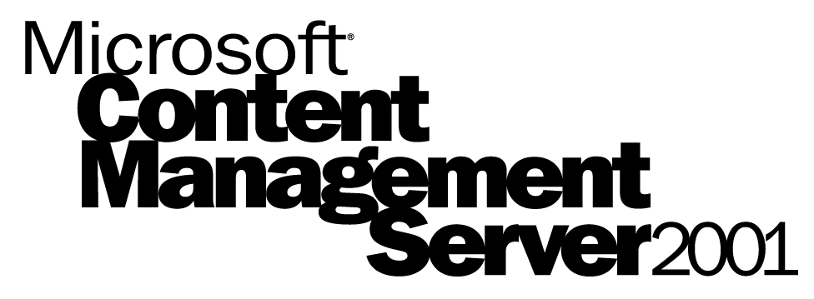

The dynamic Web site management solution for the enterprise.

Microsoft Content Management Server 2001 is the enterprise content management system that enables businesses to quickly and cost-effectively deploy highly dynamic and personalized Internet, intranet, and extranet sites.

www.microsoft.com/
cmserver

Product Highlights
Microsoft® Content Management Server reduces the time required to build and deploy content-driven Web sites, and provides extremely high scalability, reliability, and performance for those sites. Content Management Server 2001 empowers content providers to manage their own content, provides site users with a targeted and personalized experience tailored to their profiles and browsing devices, and enables IT departments to quickly deploy scalable dynamic sites.

Empower your entire team
Microsoft Content Management Server empowers your entire team to create effective Web sites by providing powerful tools for business and technical staff.

Business users can create, manage, and publish their own content directly on the Web site using a browser-based interface. Workflow and approval processes ensure information is always timely, accurate, and relevant.

Web developers and designers create publishing templates that provide centralized control over site usability, layout, and branding. Developers and designers also manage user rights and permissions both for creating and publishing content and for site visitors.
With Microsoft Content Management Server 2001, your entire team is empowered to work faster and more effectively to build e-business Web sites.

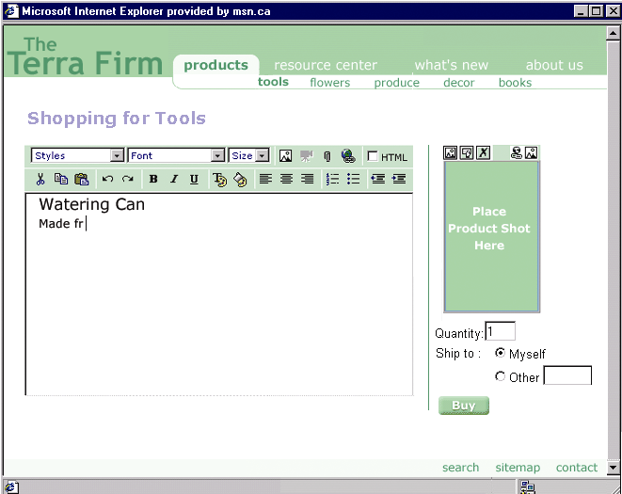

Content contributors use a simple browser-based interface and centrally controlled templates to publish and manage their own content.

Build dynamic and targeted enterprise Web sites
With Content Management Server 2001 content is served dynamically enabling real-time content targeting and personalization.

Pages are assembled from a smart server cache as requested, resulting in content that can be reused and served specifically for different devices, audiences, or individuals without complex coding or duplication of effort.

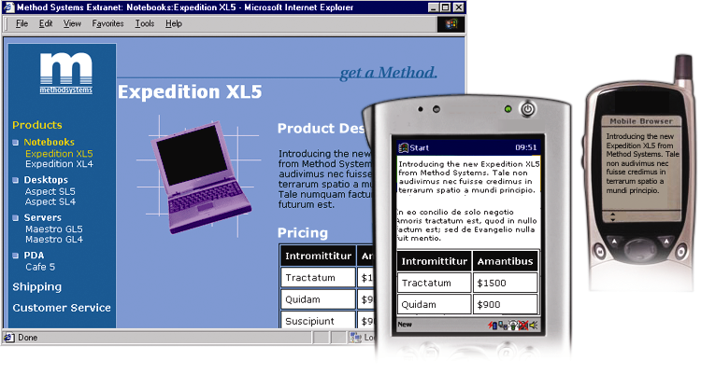
Content components can be served to a variety of devices using “template switching.”

A seamless integration with Microsoft Commerce Server 2001 enables robust targeting and personalization of rich Web content for e-commerce sites.

Get to market fast
Launch new Web sites in a matter of weeks, not months. Content Management Server relies on familiar tools to speed site development. Site developers and designers can use existing HTML tools to create templates. IT staff can implement user rights with user authentication schemes already in place in your organization. Business users create content using a familiar browser-based interface.

In addition to being quick to deploy, Content Management Server is quick to re-deploy. Leverage reusable content, site structure, templates, and user rights across enterprise Internet, intranet, and extranet sites.

The Content Management Server Publishing API enables ease of integration with other e-business applications across your organization.

Product Features
Content Management Server 2001 offers complete feature sets for content contribution and delivery, site development, and enterprise site management to enable businesses to effectively create, deploy, and manage Internet, intranet, and extranet Web sites.

Content Contribution: Empower business users to create, manage, and publish their own content.
Browser-based content creation and contribution | Content contributors use a familiar Web interface to publish and manage content. There is no desktop software to install or support.
Extensible workflow and e-mail notification | Automated multi-level approval workflow supports e-mail notification.
Complete publishing features | Web Author offers complete set of publishing features for business users, including drag-and-drop content from office applications, spell check, and revision tracking and history.

Content Delivery: Deliver personalized content for multiple audiences, devices, and purposes.
Publication scheduling | Authors schedule content for automatic publishing, ensuring content is always timely, relevant, and up to date. Publication scheduling is built into the workflow, ensuring all live content is properly approved.
Personalization and targeting | Content is easily targeted for different individuals, user groups, and devices like Pocket PCs and other wireless devices. A seamless integration with Commerce Server 2000 enables personalization and targeting e-commerce sites.  User-definable metadata enables business users to classify content for audiences and areas of interest.
Multilingual content | Non-technical business users can publish content in any language that uses the Unicode character set, such as Japanese.

Site Development: Quickly build and deploy manageable sites.
Centralized templating | Web designers and developers use popular HTML editors to build templates that control site layout and enforce corporate branding. Manage access to templates based on site areas and user groups.
Rapid development  and deployment | Content Management Server hooks into common tools Web teams are already using enabling rapid development. No proprietary languages or scripting is required. Entire Web sites can be built in 4-to-6 weeks.
Low maintenance | Since content experts are responsible for managing their own content and links are automatically updated, a site powered by Content Management Server practically maintains itself—freeing the Web team to work on new site features and releases.
Flexible API (Application Programming Interface) | The flexible COM API promotes ease of integration with other applications like e-commerce and customer relationship management and enables developers to create automatically updating pages.
Dynamic content repository | Content repository combines the benefits of an industry-standard relational database with flexible object model. All content, including templates, pages, and resources, is stored in the content repository and accessible through the Publishing API.

Enterprise Site Management: Manage scalable Web applications across your enterprise.
Enterprise deployment scalability | Site deployment features enable you to roll out applications across your organization by sharing content, templates, and site structure between multiple development and production servers.
Performance and security scalability | Servers can be clustered to work with load-balancing hardware and software. Content Management Server 2001 performance scales with additional CPUs.
Unified user management | Users are authenticated using existing authentication schemes: the Windows® 2000 Active Directory™ service, Windows NT Domain, or LDAP authentication.
Dynamic server cache | Pages are assembled from content objects as requested. A sophisticated server cache ensures server performance remains high, while serving the most up-to-date content.

System Requirements

The following are the minimum recommended system requirements for Microsoft Content Management Server 2001.

Microsoft Content Management Server 2001
Windows 2000 Server, Advanced Server, or DataCenter Server with Internet Information Services (IIS) 5
SQL Server™ 7 or 2000
Pentium III 800 with 512 MB RAM
500 MB disk space for server
1 GB disk space for database devices
150 MB disk space free at all times

Microsoft Content Management Server Site Builder
Windows 2000 Professional, Server, or Advanced Server, Windows Me, or Windows 98
Internet Explorer 5.x
Pentium III or equivalent processor
128 MB RAM
20 MB disk space for Site Builder client

Microsoft Content Management Server 2001 Web Author
Windows 2000 Professional, Server, Advanced Server, Windows Me, or Windows 98
Macintosh OS X
Internet Explorer 5.x or 5.5
Netscape 4.73

For more information about Microsoft Content Management Server, please call 1-888-304-2222.

© 2001 Microsoft Corporation. All rights reserved.
This datasheet is for informational purposes only. MICROSOFT MAKES NO WARRANTIES, EXPRESS OR IMPLIED, IN THIS DOCUMENT. The example companies, organizations, products, people, and events depicted herein are fictitious. No association with any real company, organization, product, person, or event is intended or should be inferred.
Microsoft, Active Directory, Windows are all either registered trademarks or trademarks of Microsoft Corporation in the United States and/or other countries.
The names of actual companies and products mentioned herein may be the trademarks of their respective owners.
Microsoft Corporation • One Microsoft Way • Redmond, WA
98052-6399 • USA
0601 Part No. 098-91767

