Microsoft Software Inventory Analyzer 4.0
User Guide

Table of Contents

1. About This Guide 3
1.1. Target Audience 3
2. Introduction 3
3. MSIA Wizard 3
3.1. Step-by-Step Guide 4
3.1.1. Welcome Screen 4
3.1.2. Scan Settings 4
3.1.3. Local or Network Scan 8
3.1.4. Machine Selection Mode 11
3.1.5. Machine Selection 13
3.1.6. Product Selection 16
3.1.7. Report Formats 16
3.1.8. Consolidate Reports 18
3.1.9. Confirm Settings 18
3.1.10. Scanning 20
3.1.11. Rescanning 21
3.1.12. Completing the MSIA Wizard 22
3.1.13. License Information 24
3.1.14. Provide Feedback or Report a Problem 26
4. Reports 28
4.1. Summary Report 28
4.2. Product Details Report 30
4.3. Detailed Report 31
5. Consolidation of Summary Reports 31
6. Windows 98, Windows Millennium Edition– Network Scanning 32
6.1. Enabling the Remote Administration Service 32
6.2. Installing the Remote Registry Service 32
6.3. Logon Script for Windows 98, Windows Millennium Edition Systems 33
6.3.1. Overview 33
6.3.2. Working of Logon Script 33
6.3.3. Set up Logon Script Feature on Domain Controller 34
7. Windows Vista – Network Scanning 36
7.1. Logon Script for Windows Vista 36
7.1.1. Overview 36
7.1.2. Working of Logon Script 36
7.1.3. Set up Logon Script Feature on Domain Controller 37
8. System Requirements 39
9. Feedback and Support 39

About This Guide
This user guide helps you familiarize with Microsoft Software Inventory Analyzer (MSIA 4.0) and tells you how to use the application effectively.

Target Audience
This user guide is intended for System Administrators.

Introduction
The Microsoft Software Inventory Analyzer tool (MSIA) scans and analyzes the inventory of Microsoft software products installed on machines. The results of the scan are generated in the form of reports.

These reports give details like the names of all the installed Microsoft products, their type and the number of licenses for every product, link to the list of machines scanned, and link to the error log.

This information is useful for you if you are taking care of the system administration, licensing, and inventory of Microsoft software products in your organization. This program can be run on a standalone machine or on the Microsoft Windows Network. The operating systems supported by this tool are:

- Microsoft Windows® 98
- Windows® Millennium Edition
- Windows NT® Workstation 4.0
- Windows NT® Server 4.0
- Windows® 2000 Server
- Windows® 2000 Professional
- Windows® 2000 Advanced Server
- Windows® XP Professional and Windows XP Home Edition
- Windows® Server 2003 Standard Edition and Enterprise Edition
- Windows Vista® (Starter, Home Basic, Home Premium, Business, Ultimate)

MSIA Wizard

Using the MSIA wizard, you can specify the mode of scan, machines to be scanned, products to scan for, and the kinds of reports to be generated. You can download the latest version of data files and also specify the path for storing the reports. The tool lets you save these settings for future use.

The MSIA wizard will guide you through the steps required for scanning.

Note: To avoid frequent input entries, there is a provision to save the current settings and make use of them in future.

Step-by-Step Guide
Each step of the MSIA program has been documented to provide information and answer any questions you may have as you run through the MSIA Wizard.

Note: The steps in the wizard will change based on the scan mode or the Custom Settings options you select.

Welcome Screen

The welcome screen briefly states the purpose of the tool.
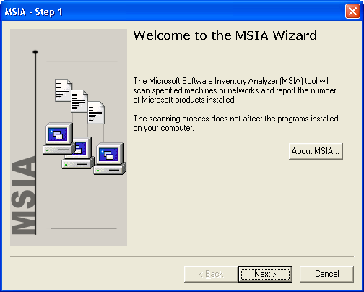

Scan Settings

MSIA provides options for specifying the scan settings. MSIA can be executed by the following ways:

- Scan using Wizard (recommended for one time scanning)
- Scan using Custom settings (recommended for frequent scanning)

These options allow you to scan by using the wizard directly or by using the existing Custom Settings file or by creating a new Custom Settings file that can be used for scanning in future.

The Scan using Wizard option is selected by default, indicating that you can proceed with scanning by using the wizard.

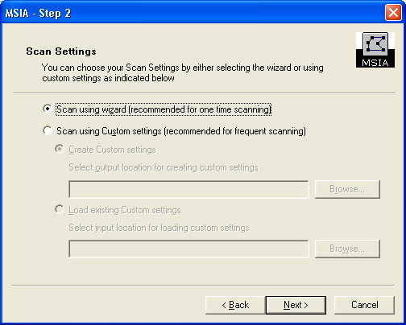

The Custom Settings file can be created by selecting the Create Custom settings option. If you select this option, you will have to specify the folder where the Custom Settings file has to be created by browsing for the folder.

The Custom Settings file enables you to scan from the command prompt, without going through the wizard, as all required inputs are present in the Custom Settings file. The Custom Settings file also helps you in saving and modifying your settings so that repetitive scanning of same set of machines and products is faster and easier.

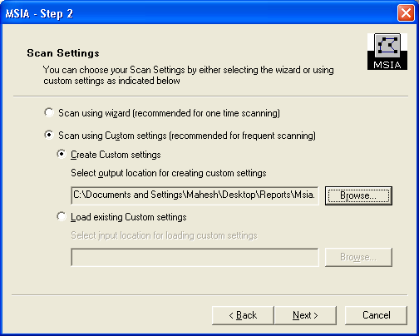

The Load existing Custom settings option enables you to specify the Custom Settings file that was created earlier for scanning. This file will have information about the machine(s) and product(s) to be scanned. This option also enables scanning without going through the entire wizard, as all the information required for scanning is present in the Custom settings file you selected.

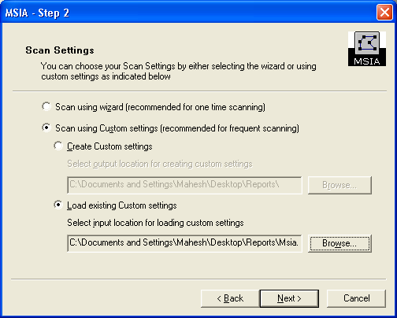

Local or Network Scan

MSIA provides the option for scanning either the local machine or the Microsoft Windows Network. Using Report Consolidation, you can consolidate all existing reports as required.
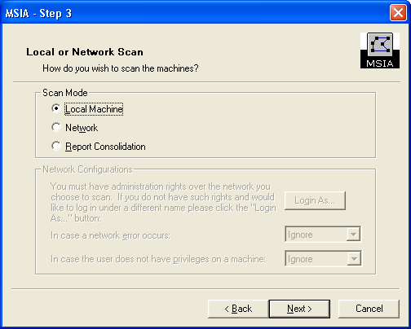
If you select Network as the mode of scan, the screen will appear as shown.
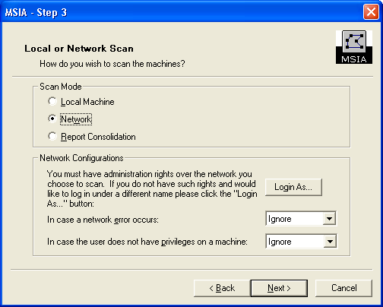
If you want to select Network as scan mode, you must have administrative rights over the network you chose to scan. MSIA will use the user name and password used to log on to the current machine as the default setting.

Note: While creating Custom settings, the Network Configurations settings are disabled, as the logon credentials are not stored in the Custom settings file. Also when scanned using Custom settings file, network errors and insufficient user privileges are ignored and consequently corresponding machines are not scanned.

If you do not have administrative rights and would like to log in under a different name, click Login As. The Login As dialog box appears.

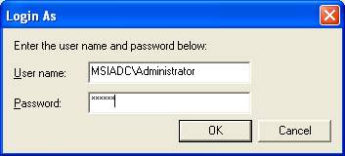

Additionally, you must specify what action is to be taken, if a network error occurs.

The options available are:

- Abort—to quit the current operation.
- Ignore—to ignore the error, log it, and continue without required input.
- Prompt—to prompt for input and wait for response.

If you do not have sufficient user privileges on a machine, you must specify the action to be taken from the following options:

- Ignore—to ignore the error, log it, and continue without required input.
- Prompt—to prompt for input and wait for response.

If you select Report Consolidation, MSIA will not scan any machines. Instead, it allows you to consolidate the existing reports.

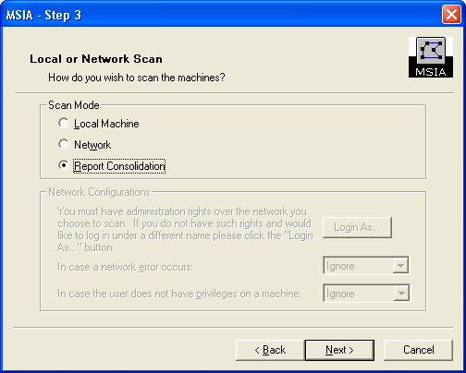

Machine Selection Mode

For a Network scan, MSIA provides options for specifying machines using various machine selection modes as shown below:
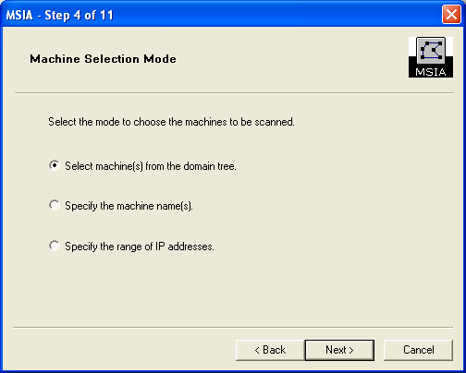

Choose Select machine(s) from the domain tree to specify machines by selecting machines from the domain tree as shown in next step.

Choose Specify the machine name(s) to specify the machine/domain names in a text field for scanning.

Choose Specify the range of IP addresses to specify a range of IP addresses in case the machine names are not known. This option should be used for machines in a large IP address range, because resolving the IP address range can take considerable amount of time.

Machine Selection

Domain Tree mode
This screen displays the entire network in a tree view.
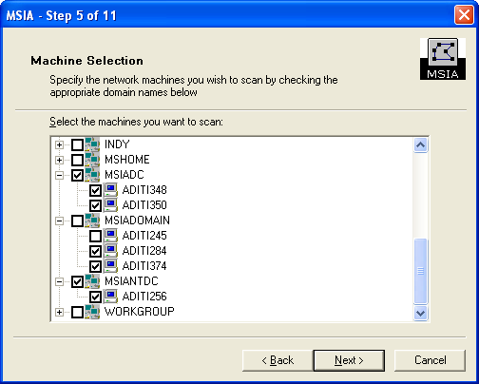
If you select a domain, the system includes all the machines in the domain along with the child domain's machines for scanning, if any.

Note: You need to select at least one machine for scanning.

Machine Names Mode

This is another method of specifying machines for scanning. In this mode, the machine/domain names or even IP addresses can be specified in the text field. This mode is especially useful when some machines that are hidden and not visible in the domain tree mode are to be scanned.

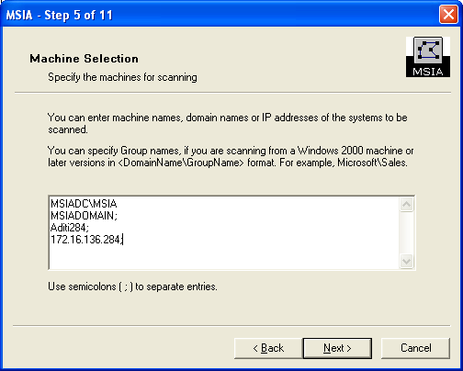

The machine names can be separated by semicolon or can be entered in multiple lines. Ideally, this mode should be used for specifying a small number of machines, where the machines specified need not belong to the same domain in the network, or specify a domain name or domain name/group name to scan all the machines in that domain or group.

IP Range mode

This is another method of specifying machines for scanning. This mode is used for specifying machines that fall in a large range of IP addresses. It is suggested that you need not use this mode for scanning if the range is small, because validating IP addresses can take considerable amount of time.

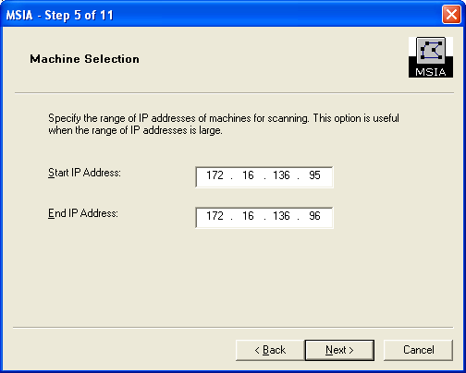

Product Selection

Using this screen, you can select the products for scanning. Selecting Scan for Service Packs also option will also scan for the Service Packs for the products selected.
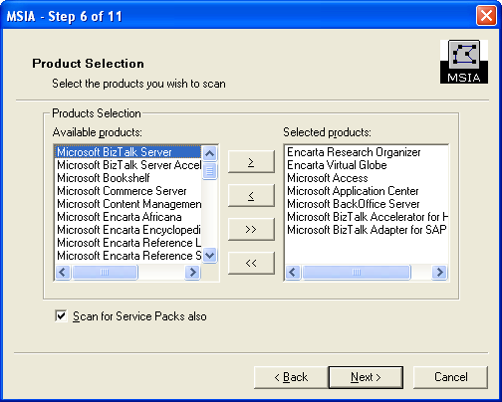
Note: You need to select at least one product for scanning.

Report Formats

Using this screen, you can specify the formats in which you want to view the reports.

You can generate reports in one of the following formats:

- HTML
- Microsoft Office Excel®
  - Excel 2003
  - Excel 2007
- Text

You can also specify the path for storing the reports in the Select the output location for saving reports text box.
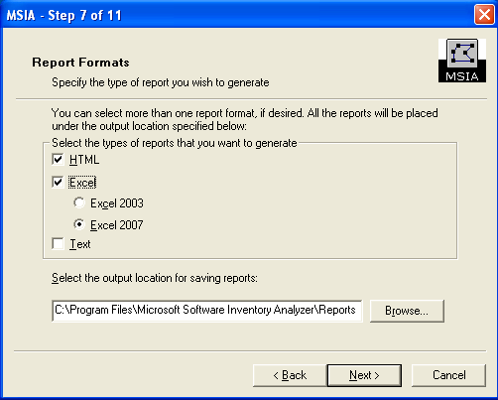
Note:
- The applications required for generating and viewing the reports need to be present on your machine. For instance, Microsoft Excel® 97 or later should be installed on the machine to generate and view reports in Microsoft Office Excel 2003 format.
- The Excel 2007 option will be available for selection if Office 2007/Excel 2007 are installed.

Consolidate Reports

Following is the screen where you specify the option to consolidate reports.

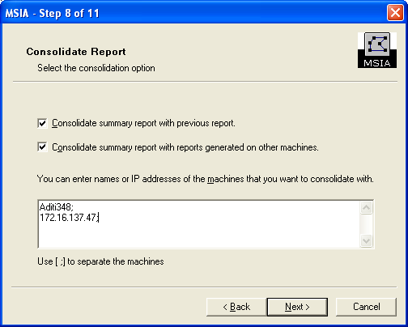

Select Consolidate summary report with previous report if you want to consolidate the previous reports generated on the machine you are scanning from.

Select Consolidate summary report with reports generated on other machines if you want to consolidate multiple reports present on different machines. In this case, you need to enter the machine names for which you want to consolidate reports.

Note: If you have chosen Report Consolidation in Local or Network Scan screen, then the Consolidate summary report with reports generated on other machines option, by default, will be selected and disabled. If the machine selected for scanning does not have any reports to consolidate, the Consolidate summary report with previous report option is disabled.

Confirm Settings

Before scanning
Use this screen to verify the settings for the scan.

Click Scan to start the scanning process.
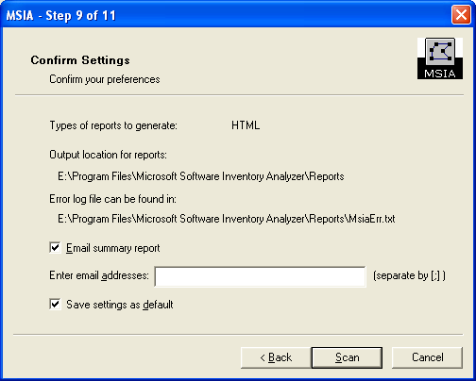

Before creating custom settings file
Use this screen to verify the settings for creating the Custom settings file.

Click Create to generate the Custom settings file.

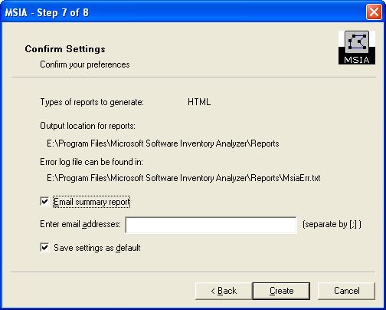

Scanning

This screen displays the approximate percentage of progress with regard to the scanning process.

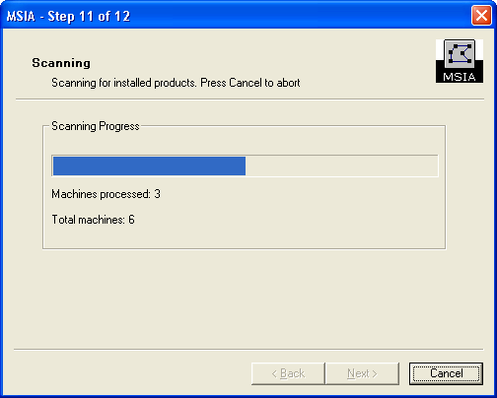

Machines Processed displays either the number machines scanned or the number of machines selected for consolidating reports.

Total machines displays the sum of machines chosen for scanning and the number of machines scanned earlier for consolidating the reports from the system from which you are running the present scan.

Rescanning
For any reason, if MSIA fails to scan one or more machines, then you will see the following Rescan screen.
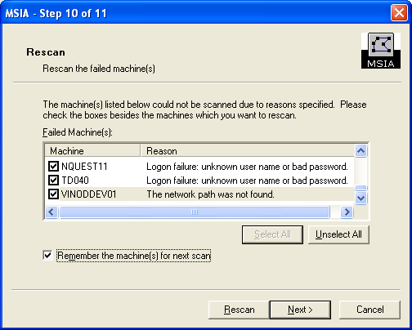

This screen lists the machines that were not scanned and provides the reasons for failure. You can rescan these machines now by selecting them, and clicking on the Rescan button. Otherwise click Next to go to the Finish screen.

If you want MSIA to remember the machines, which are not scanned, select Remember the machine(s) for next scan. This option allows you to scan the selected machines the next time you run the application.

Completing the MSIA Wizard

This screen appears at the end of the scanning process. If the View reports now check box is selected, the chosen reports will be displayed after you click Finish.

At this time, you can click License to provide information about the number of licenses you have purchased for the products installed. See License Information for more details.

Note: The settings you selected using the wizard will not be saved if you do not click Finish. The Back and Cancel buttons are disabled in this screen.
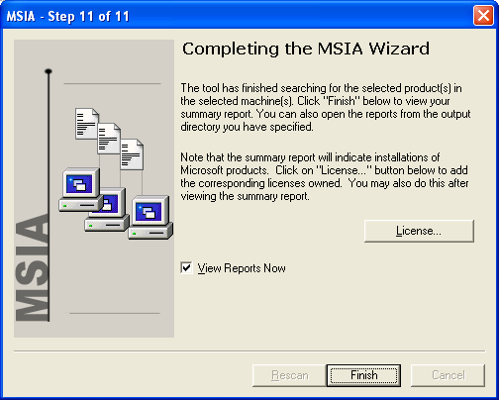

Completing Creation of the Custom Settings File
This screen appears at the end of the Custom settings file creation process.

Note: The settings you selected using the wizard will not be saved if you do not click Finish. Back and Cancel buttons are disabled in this screen.

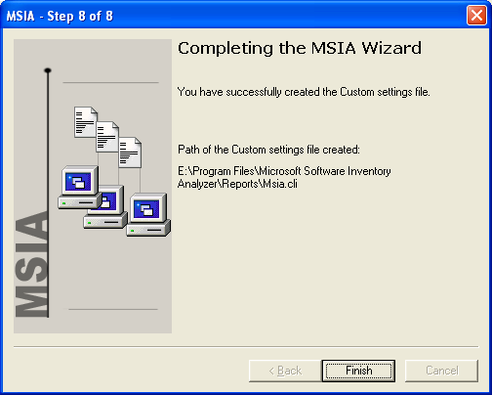

License Information

This dialog box enables you to manually enter or update license information for all the products scanned by the tool. The information provided will be maintained for future use and will be available the next time you use MSIA.

This license information input step is completely voluntary and confidential. The information will be shared with no one. The information provided here is for your own license reconciliation needs and is meant to help you understand your license position. The information submitted to MSIA is not transmitted to Microsoft Corporation or available to anyone except the MSIA user. The information you input is used to compare the licenses installed (as detected by MSIA) with the licenses you have purchased. The result of this comparison is displayed in the Summary Report (see section 4.1).

If you choose not to enter license information at this step, license information will not be displayed in the License Purchase Summary section of the Summary Report.

The list of products found by MSIA will be displayed in the Products list. When a product is selected, its current license details will be displayed in the corresponding edit box to its right. Users can view and modify them as appropriate. The total license for a particular product will be displayed in the Total box.

To help you complete the License Information step, below is a description of each license type:
OEM licenses are already pre-installed on new computers when you purchase the computer. Typically, Windows operating systems are pre-installed on new computers. Microsoft Office and other applications may also be pre-installed on your new computers.
Retail licenses are purchased from a retail store in a shrink-wrapped box. Typically, these are licenses that you have installed yourself, or have had a service provider install for you.
Open licenses are acquired by small and medium businesses through the Open License Programs.
Select licenses are acquired by medium and large businesses through the Select License Program.
Enterprise licenses are acquired by large businesses through an Enterprise Agreement.
The Other license category would be used to capture any license not acquired from the options listed above.

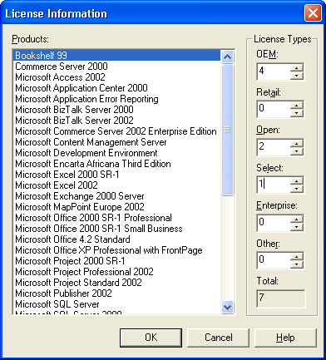

Provide Feedback or Report a Problem

You can report a problem or provide feedback on MSIA by using the provide feedback or report a problem link on the MSIA HTML summary report.

When you click this link, the Provide Feedback wizard will appear, allowing you to enter the details of your feedback or issue. This wizard can also be invoked by clicking the Feedback.dlg file in the reports folder. In addition, you can provide feedback or report a problem by sending an e-mail message to msiahelp@microsoft.com.

This screen allows you to provide your company/contact information.
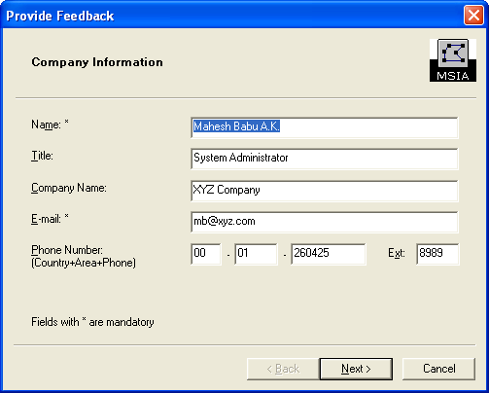
This screen allows you to provide the scenarios during scanning.
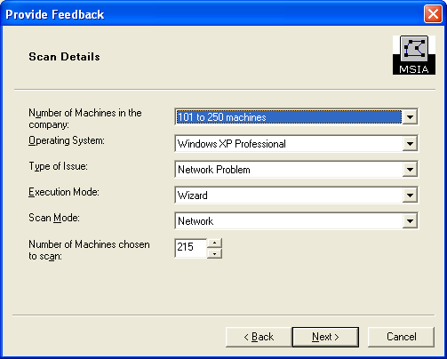
This screen allows you to attach error information file MSIADetailedLog.txt that are generated during scanning. This file contains the detailed log information that is generated with scanning. This log contains an error/status update information, especially errors that occurred due to network failure or remote registry access failure, which are usually the common scenarios where scanning could not be completed successfully. This information helps the support personnel analyze the errors easily and accurately and reply to the queries faster.
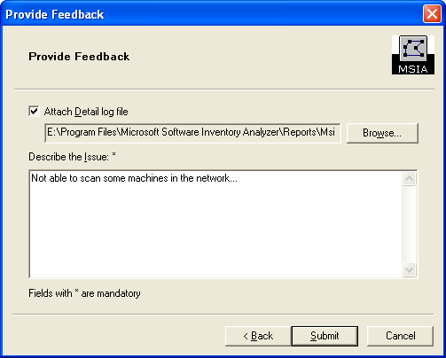
A text box is provided to describe the issue or the exact scenario in detail so that the support personnel can reply to queries faster.

Reports

Summary Report
Following is an example of the summary report generated in HTML format.
The summary report provides links to various information, like number of machines scanned, error log, and list of machines.

Apart from this, an HTML summary report has the following links:

- Add/Update license purchase information
- Provide feedback or report a problem
- FAQ on MSIA

Each product serves as a link to the Detailed Product Report, which provides a list of machines on which the product was scanned and detected. Each machine is a link to the Detailed Report, which provides a detailed report of all the products that were scanned and detected on that system.
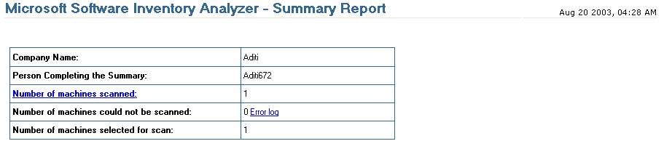
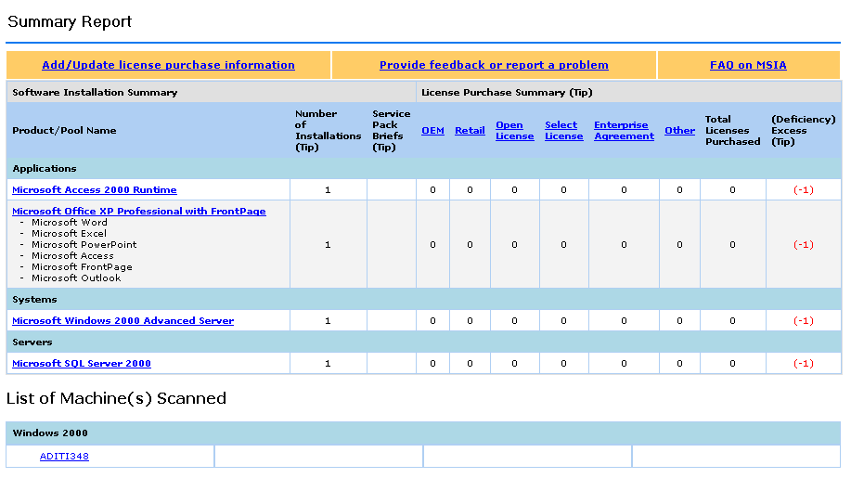

Product Details Report

The product details report is shown when you click a particular product link in the Summary Report. This report provides product information with a list of machines on which the product was successfully scanned. Each of the machines under each product is a link to the detailed report for that machine.
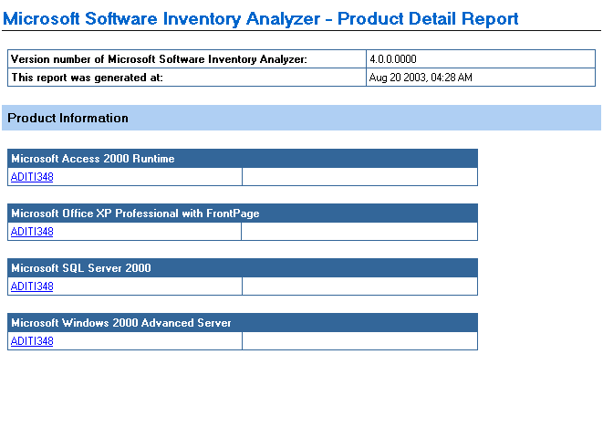

Detailed Report
The Detailed Report is shown when you click the machine name in either the Summary Report or the Detail Product Report. This report has a list of all the products that were successfully scanned on the specified system.
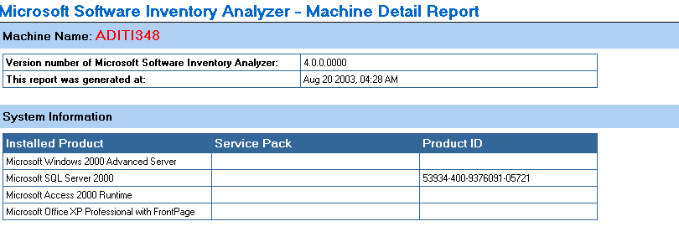

Consolidation of Summary Reports

MSIA 2.1 or higher versions let you merge/consolidate summary reports. Briefly, it works like this:

- You create a Summary Report by running a Network or a Local scan.
- You then run a scan of additional machines that are not included in the earlier scan from the same machine.
- You consolidate the latter with the previous one.
- You should not delete or move any MSIA report related files manually.

MSIA 3.1 or above allows you to consolidate reports from multiple machines. Consolidation of multiple reports works as follows:

- You create summary reports in different machines, say in machine A and machine B.
- You then run MSIA in Machine C.
- You choose Report Consolidation in Local or Network Mode screen.
- In Consolidate Report screen of the wizard, enter machine A and B, separated by semicolon.
- The resultant summary report will be the consolidated report of machine A and B.

Windows 98, Windows Millennium Edition– Network Scanning

MSIA is capable of scanning computers that are running Windows 98 provided that the Remote Registry Service is installed and enabled.

Enabling the Remote Administration Service

- Click Start, point to Settings, click Control Panel, and then double-click Network.
- Click File And Print Sharing. Select both the "I want to be able to give others access to my files" and "I want to be able to allow others to print to my printer(s)" check boxes, and then click OK.
- In Control Panel, double-click Passwords.
- On the Remote Administration tab, select the Enable remote administration of this server check box.
- Set a password for Remote Administration and then click OK.

Note: If you are using user-level security, you do not receive a password dialog box. Instead, add users to the list by clicking Add.

Installing the Remote Registry Service

To install the Remote Registry service, you must be using user-level security and will have the Remote Administration option enabled.

To install the Remote Registry service, do the following:

Note: If you are already using user-level security, skip steps 1, 2, and 3.

- Click Start, point to Settings, click Control Panel, and then double-click Network.
- On the Access Control tab, click User-Level Access Control.
- Click OK.
- In Control Panel, double-click Network.
- Click Add, click Service, click Add, and then click Have Disk.
- In the Copy Manufacturer's Files From box, type the path Admin\Nettools\RemoteReg folder on your Windows 95 CD-ROM, or Tools\Reskit\Netadmin\Remotereg on your Windows 98 CD-ROM, and then click OK.

When the Microsoft Remote Registry Service has been added to the list of installed components, click OK and restart your computer when prompted.

Logon Script for Windows 98, Windows Millennium Edition Systems

The logon script for Windows 98 feature in MSIA 3.0 and greater provides a facility to enable remote registry and remote administration services. This feature allows you to remotely configure the Windows 98 systems to enable remote network scan.

Overview

MSIA is used for obtaining an inventory of Microsoft products on local and remote systems on a network. MSIA runs on the audit system and obtains inventory information of remote systems by connecting to them. This requires proper privileges and configuration for accessing the remote system.

The remote registry and remote administration services are by default enabled on Windows NT and Windows 2000 systems. For Windows 98 and Windows Millennium Edition systems, they are not enabled by default and have to be enabled manually. This process was done manually in MSIA 2.0. The process of enabling Remote Registry and Remote Administration services has been automated in MSIA 3.0 and greater by using a logon script that could be run on target (Windows 98) systems.

Working of Logon Script

To enable the remote registry and remote administration services, you need to create some registry entries by copying necessary files to the target (Windows 98) system. This is achieved by executing a logon script on Windows 98 systems. It requires a domain user to log on to the target (Windows 98) system. The logon script is a batch file that resides in the NETLOGON path on the domain controller. This is executed on the target (Windows 98) system whenever a domain user logs on to the domain on the target system, for whom the logon script has been set by the domain administrator.

To set up the logon script on the domain controller, the necessary files have to be copied to the NETLOGON shared folder in the domain controller. To perform this operation, a batch file DCLogonScriptSetup.bat has been provided, which can be located in the ForWin98 folder under the installation directory of MSIA. This batch file requires two parameters: NETLOGON shared folder path and the Domain controller machine name. This batch file will put all the necessary files in the NETLOGON shared folder.

The Domain Admin has to specify the logon script in the properties of each individual user. This has to be done on the domain controller machine using Administrative Tools. Then, after the user logs on from a Windows 98 machine to the domain, the batch file will be executed on the target (Windows 98) machine and all the necessary registry entries will be created and necessary files will be copied to the target (Windows 98) system.

Set up Logon Script Feature on Domain Controller

For Windows 2000/2003 Servers

To copy files for logon script, do the following:

  - Run MSIA 3.0 or greater Setup. This will install the required files for the logon script.
  - Go to Programs > Administrative Tools > Computer Management from the Start menu.
  - Under Computer Management (Local) > System Tools > Shared Folders > Shares, there will be an entry for NETLOGON under the Shared Folder column. Note the Shared Path entry for NETLOGON. (You can double-click on NETLOGON to open the property window.)
  - Open command window from the Start menu (Start > Run).
  - Go to ForWin98 folder under the installation directory of MSIA.
  - Run the DCLogonScriptSetup.bat file with the NETLOGON shared path (noted in Step 3) as the first parameter and the Domain Controller machine name as the second parameter as shown:

DCLogonScriptSetup.bat <NETLOGON shared path> <machine name>

  - If you are running the above batch file on a Domain Controller with a language other than English, then you have to supply an additional parameter for the Domain Administrator Group name (“DOMAIN ADMINS” equivalent).

- DCLogonScriptSetup.bat <NETLOGON shared path> <machine name> <DOMAIN ADMIN GROUP>

Note: The execution of DCLogonScriptSetup.bat file will create another batch file by name MSIALogon98.bat. This batch file along with some other files is copied to the NETLOGON shared folder. MSIALogon98.bat will act as the logon script batch file. While executing, the Logon script will copy these required files to the Windows 98 machine. In order to copy these files, a drive on the Windows 98 machine needs to be mapped to the NETLOGON shared drive on the Domain Controller.

This drive letter is by default set to drive “r:” in the DCLogonScriptSetup.bat file. You can change this drive name to any other drive letter (other than the ones already reserved for operating system and other devices) of your choice by editing the DCLogonScriptSetup.bat file, and changing the drive in the following way in the file.
Set DCDrive=r:

Setting logon script for users

- From the Start menu, go to Programs >Administrative Tools > Active Directory Users and Computers.
- Expand the domain name tree, and then click on Users.
- Select an existing user of domain or create a new user.
- Right-click on the user, and click Properties.
- Select the Profile tab from the Properties window.
- Enter the Logon Script file name as MSIALogon98.bat in the Logon script text box.
- Click OK to save the settings.
- Close the Active Directory Users and Computers console window.

For Windows NT Servers

To copy files for the logon script, do the following:
- Run MSIA Setup to install the required files for MSIA.
- From the Start menu, go to Programs > Administrative Tools (Common) > Server Manager.
- Select the domain controller machine name from the machines listed.
- Select Computer >Shared Directories from the menu bar.
- There will be an entry for NETLOGON under the Shared Folder column. Note the Shared Path entry for NETLOGON.
- Open the command window from the Start menu (Start → Run).
- Go to the ForWin98 folder under the installation directory of MSIA.
- Run the DCLogonScriptSetup.bat file with the NETLOGON shared path (noted in Step 3) as the first parameter and the Domain Controller machine name as the second parameter as shown:

DCLogonScriptSetup.bat <NETLOGON shared path> <machine name>

- If you are running the above batch file on a Domain Controller with a language other than English, then you have to supply an additional parameter for the Domain Administrator Group Name (“DOMAIN ADMINS” equivalent).

DCLogonScriptSetup.bat <NETLOGON shared path> <machine name> <DOMAIN ADMIN GROUP>

Note: The execution of DCLogonScriptSetup.bat file will create another batch file by name MSIALogon98.bat. This batch file along with some other files is copied to the NETLOGON shared folder. MSIALogon98.bat will act as the logon script batch file. While executing, the Logon script will copy these required files to the Windows 98 machine. In order to copy these files, a drive on the Windows 98 machine needs to be mapped to the NETLOGON shared drive on the Domain Controller.

This drive letter is by default set to drive “r:” in the DCLogonScriptSetup.bat file. You can change this drive name to any other drive letter (other than the ones already reserved for operating systems and other devices) of your choice by editing the DCLogonScriptSetup.bat file and changing the drive in the following way in the file.

Set DCDrive=r:

Setting Logon Script for Users

- From the Start menu, go to Programs > Administrative Tools (Common) > User Manager for Domain.
- Select the user for whom you want to enable the logon script from the list of users.
- Go to the User menu and select Properties.
- Click Profile on the Properties window.
- Enter the Logon Script file name as "MSIALogon98.bat" in the Logon script Name text box.
- Click OK to save the settings.
- Close the User Manager for Domain console window.

Windows Vista – Network Scanning

Logon Script for Windows Vista
The logon script for Windows Vista feature in MSIA 4.0 provides a facility to enable remote registry. This feature allows you to remotely configure the Windows Vista systems to enable remote network scan.

Overview

For Windows Vista, remote registry is not enabled by default and has to be enabled manually. The process of enabling Remote Registry is automated using a logon script. The logon script is required only for Windows Vista systems, where remote registry is enabled manually but not available by default.

Working of Logon Script

Enabling the remote registry requires updating registry entries. This is achieved by executing a logon script on Windows Vista systems. For the logon script to be executed it requires a domain user to logon on the target (Windows Vista) system. The logon script is a batch file that resides in the NETLOGON path on the domain controller. This is executed on the target (Windows Vista) system whenever a domain user logs on to the domain on the target system, for whom the logon script has been set by the domain administrator.

To setup the logon script on the domain controller, necessary files have to be copied to the NETLOGON shared folder in the domain controller. To perform this operation, a batch file DCLogonScriptSetupforVista.bat has been provided, which can be located in the ForVista folder under the installation directory of MSIA. This batch file requires two parameters: NETLOGON shared folder path and the Domain controller machine name. This batch file will put all the necessary files in the NETLOGON shared folder.

The Domain Admin has to specify the logon script in the properties of each individual user. This has to be done on the domain controller machine using Administrative Tools. Then, once the user logs on from a Windows Vista machine to the domain, the batch file will be executed on the target (Windows Vista) machine and all the necessary registry entries will be updated on to the target (Windows Vista) system.

Set up Logon Script Feature on Domain Controller

For Windows 2000/2003 Servers

To copy files for logon script, do the following:

- Run MSIA 4.0 setup. This will install the required files for logon script.
- Go to Programs → Administrative Tools → Computer Management from Start menu.
- Under Computer Management (Local) → System Tools → Shared Folders → Shares, there will be an entry for NETLOGON under Shared Folder column. Note the Shared Path entry for NETLOGON. (You can double-click on NETLOGON to open the property window.)
- Open command window from Start menu (Start → Run).
- Go to ForVista folder under the installation directory of MSIA.
- Run the DCLogonScriptSetupforVista.bat file with the NETLOGON shared path (noted in step 3) as the first parameter and the Domain Controller machine name as the second parameter as shown:

DCLogonScriptSetupforVista.bat <NETLOGON shared path> <machine name>

- If you are running the above batch file on a Domain Controller with a language other than English, then you have to supply an additional parameter for the Domain Administrator Group name (“DOMAIN ADMINS” equivalent).

DCLogonScriptSetupforVista.bat <NETLOGON shared path> <machine name>
<DOMAIN ADMIN GROUP>

Note: The execution of DCLogonScriptSetupforVista.bat file will create another batch file by name MSIALogonVista.bat. This batch file is copied to the NETLOGON shared folder. MSIALogonVista.bat will act as the logon script batch file. While executing, the Logon script will copy these required files to the Windows Vista machine. In order to copy these files, a drive on the Windows Vista machine needs to be mapped to the NETLOGON shared drive on the domain controller.
This drive letter is by default set to drive “r:” in the DCLogonScriptSetupforVista.bat file. You can change this drive name to any other drive letter (other than the ones already reserved for operating system and other devices) of your choice by editing the DCLogonScriptSetupforVista.bat file, and changing the drive in the following way in the file.

Set DCDrive=r:

Setting logon script for users
- From the Start menu, go to Programs →Administrative Tools → Active Directory Users and Computers.
- Expand the domain name tree and then click on Users.
- Select an existing user of domain or create a new user.
- Right-click on the user, and click Properties.
- Select the Profile tab from the Properties window.
- Enter the Logon Script file name as MSIALogonVista.bat in the Logon script text box.
- Click OK to save the settings.
- Close the Active Directory Users and Computers console window.

For Windows NT Servers

To copy files for the logon script, do the following:
- Run MSIA setup to install the required files for MSIA.
- From the Start menu, go to Programs → Administrative Tools (Common) → Server Manager.
- Select the domain controller machine name from the machines listed.
- Select Computer → Shared Directories from the menu bar.
- There will be an entry for NETLOGON under Shared Folder column. Note the Shared Path entry for NETLOGON.
- Open command window from Start menu (Start → Run).
- Go to the ForVista folder under the installation directory of MSIA.
- Run the DCLogonScriptSetupforVista.bat file with the NETLOGON shared path (noted in step 3) as the first parameter and the Domain Controller machine name as the second parameter as shown:
DCLogonScriptSetupforVista.bat <NETLOGON shared path> <machine name>
- If you are running the above batch file on a Domain Controller with a language other than English, then you have to supply an additional parameter for the Domain Administrator Group Name (“DOMAIN ADMINS” equivalent).

DCLogonScriptSetupforVista.bat <NETLOGON shared path> <machine name> <DOMAIN ADMIN GROUP>

Note: The execution of DCLogonScriptSetupforVista.bat file will create another batch file by name MSIALogonVista.bat. This batch file is copied to the NETLOGON shared folder. MSIALogonVista.bat will act as the logon script batch file. While executing, the Logon script will copy these required files to the Windows Vista machine. In order to copy these files, a drive on the Windows Vista machine needs to be mapped to the NETLOGON shared drive on the domain controller.
This drive letter is by default set to drive “r:” in the DCLogonScriptSetupforVista.bat file. You can change this drive name to any other drive letter (other than the ones already reserved for operating system and other devices) of your choice by editing the DCLogonScriptSetupforVista.bat file and changing the drive in the following way in the file.

Set DCDrive=r:

Setting Logon Script for Users

- From the Start menu, go to Programs → Administrative Tools (Common) → User Manager for Domain.
- Select the user for whom you want to enable the logon script from the list of users.
- Go to the User menu and select Properties.
- Click Profile on the Properties window.
- Enter the Logon Script file name as "MSIALogonVista.bat" in the Logon script Name" text box.
- Click OK to save the settings.
- Close the User Manager for Domain console window.

System Requirements

- Your computer(s) must meet the following minimum system requirements for MSIA to work effectively.

Operating System | Windows 98 or greater
CPU Processor | Pentium III or greater
RAM | 64 MB (128 MB recommended)
Storage space | 20 MB free space (for storing reports in all three formats for approximately 200 machines)
Browser | Internet Explorer 5.0 or greater

- If attempting to scan a network using the Network Scan mode, the user must have administrative rights over the network chosen to scan.
- If you are attempting to scan a network that contains computers with Windows 98 or Windows Millennium Edition operating systems you must enable the Remote Administration Service and Install Remote Registry Service for each computer to be scanned.

Note: If you do not perform these functions, you will receive an error message when attempting to scan Windows 98 or Windows Millennium Edition machines. See Windows 98, Millennium - Network Scanning for details.

- If you are attempting to scan a network that contains computers with Windows Vista operating systems, you must enable Remote Registry Service for each computer to be scanned.

Feedback and Support
We want to hear from you! To submit questions or feedback about Microsoft Software Inventory Analyzer, please send an e-mail message to msiahelp@microsoft.com.

© 2007 Microsoft Corporation. All rights reserved.
Microsoft, Microsoft Office Excel, Windows, Windows NT, and Windows Vista are registered trademarks or trademarks of Microsoft Corporation in the United States and other countries.

