

Microsoft CRM Best Practices
Upgrading Supported Microsoft CRM 1.2 Environments to Microsoft CRM 3.0

Published: August 2005

This is a preliminary document and may be changed substantially prior to final commercial release of the software described herein.

The information contained in this document represents the current view of Microsoft Corporation on the issues discussed as of the date of publication. Because Microsoft must respond to changing market conditions, it should not be interpreted to be a commitment on the part of Microsoft, and Microsoft cannot guarantee the accuracy of any information presented after the date of publication.

This White Paper is for informational purposes only. MICROSOFT MAKES NO WARRANTIES, EXPRESS OR IMPLIED, AS TO THE INFORMATION IN THIS DOCUMENT.

Complying with all applicable copyright laws is the responsibility of the user. Without limiting the rights under copyright, no part of this document may be reproduced, stored in or introduced into a retrieval system, or transmitted in any form or by any means (electronic, mechanical, photocopying, recording, or otherwise), or for any purpose, without the express written permission of Microsoft Corporation.

Microsoft may have patents, patent applications, trademarks, copyrights, or other intellectual property rights covering subject matter in this document. Except as expressly provided in any written license agreement from Microsoft, the furnishing of this document does not give you any license to these patents, trademarks, copyrights, or other intellectual property.

© 2005 Microsoft Corporation. All rights reserved.

Microsoft, Active Directory, Windows, and Windows Server are either registered trademarks or trademarks of Microsoft Corporation in the United States and/or other countries.

The names of actual companies and products mentioned herein may be the trademarks of their respective owners.

Summary
The purpose of this document is to assist you in a successful upgrade from Microsoft CRM 1.2 to Microsoft CRM 3.0. This document will review the key components you should prepare in your environment that are important for a successful upgrade to Microsoft CRM 3.0. This technical white paper should be considered as a supplement to the Microsoft CRM Implementation Guide found on your Microsoft CRM documentation CD.

Supported Upgrade Scenarios
Below are two supported server upgrade scenarios that exist in a Microsoft CRM 1.2 environment. If you have an environment that does not meet this criterion you will want to refer to the Microsoft CRM Implementation Guide for more assistance.

Single Server
- Microsoft Small Business Server 2003 Premium Edition

NOTE: Microsoft CRM 3.0 does not support Microsoft Small Business
Server 2000.

Multiple Servers
- Domain Controller
  - Windows Server 2003
  - Windows 2000 Server with SP4
- Exchange Server
  - Exchange 2003
  - Exchange 2000 with SP3
- Microsoft CRM Web Server (non-domain controller)
  - Windows Server 2003
  - Windows 2000 Server with SP4
- Microsoft CRM database server
  - SQL Server 2000 with SP4

NOTE: Microsoft CRM is supported in a two server environment where Exchange Server is installed on a domain controller, and the Microsoft CRM application is installed on the SQL server.

Client
- Operating system
  - Windows 2000 Professional SP4
  - Windows XP Professional (minimum of SP1)
  - Windows XP Tablet Edition (minimum of SP1)
- Microsoft Office
  - Office XP with SP3
  - Office 2003 with SP1
- Internet Explorer version 6 or 7
- MSDE 2000 SP3

Best Practices for Microsoft CRM Environments
Below is a list of best practices that should be followed for your Microsoft CRM environment. If your environment does not meet these criteria, you should still experience a successful upgrade to Microsoft CRM 3.0. These recommendations will greatly improve performance of your Microsoft CRM environment.

Single Server –Small Business Server 2003
- Minimum 2GB RAM
- Two hard drives in RAID1 configuration
  - This configuration should include the operating system and the SQL Server log files
- Three or more hard drives in RAID5 configuration for database files
- Dual Xeon processors

Multiple Servers
- Domain Controller (Best practices recommendations are to have multiple domain controllers, to protect from Active Directory data loss or corruption, in the event that one domain controller fails)
  - 1-2GB RAM
  - Two hard drives in RAID1 configuration
  - 1-2 Xeon processors
  - Windows Server 2003
- Exchange Server (Best practices recommendations are to install Microsoft Exchange Server on a machine that is not a domain controller, to make sure Exchange Server can quickly connect to another domain controller in the event the first domain controller fails)
  - Minimum 2GB RAM
  - Two hard drives in RAID1 configuration
    - This configuration should include the operating system and the Exchange Server log files
  - Three or more hard drives in RAID5 configuration for the Exchange database files
  - Two or more Xeon processors
  - Windows Server 2003
  - Exchange Server 2003
- Microsoft CRM database server (Best practices recommendations are to separate the database and application servers for better performance)
  - Minimum 2GB RAM
  - Two hard drives in RAID1
    - This configuration should include the Windows Server operating system and the SQL Server log files
  - Three or more hard drives in RAID5 configuration for database files
  - Two or more Xeon processors
  - Windows Server 2003
  - SQL Server 2000
- CRM application server (Best practices recommendations are to separate the database and application servers, for better performance)
  - 2GB RAM
  - Two hard drives in RAID1 configuration
  - Windows Server 2003

Microsoft CRM 3.0 Upgrade Preparation
Client Preparation
Client preparation should occur prior to prepping the CRM server. If the client PC is offline during the upgrade process, there is a possibility of data local to the client PC being lost. It is also best to have all clients online prior to backing up the SQL databases on the server. This will help make sure all data is current prior to upgrading.

NOTE: If a Microsoft CRM Sales for Outlook client was offline during the upgrade to 3.0 you will still be able to go online after the upgrade is performed.

Server Preparation
Before you upgrade your Microsoft CRM 1.x environment make sure you have reviewed the following steps.
Backup
- Microsoft CRM databases
  - Open SQL Enterprise Manager on the CRM database server
  - Expand SQL Server Instance and find the CRM databases
  - Right click [Organization Unit Name]_MSCRM database and choose Backup Database
  - Choose whether to back up to disk or tape
  - Repeat steps for
    - [Organization Unit Name]_METABASE
    - [Organization Unit Name]_CRMCrystal
- System data
  - Backup your system files including the operating system and system state (to tape or disk)
  - Backup data related to Microsoft CRM
      - IIS Metabase
      - ISV.config
      - Web.config
      - OutlookCleint.xml
      - Registry
- Backup Microsoft CRM customizations
- Logon to the Microsoft CRM application server
- Open the Microsoft CRM Deployment Manager
- Right mouse click on Deployment Manager and choose All Tasks – Export Customization…
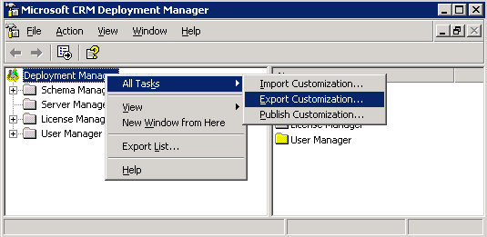

- Choose a location to save your file and write this down for future reference
- Backup Crystal Reports
  - Use the Backup Crystal tool found in the Microsoft CRM Redeployment Tools application to backup your Crystal reports used in Microsoft CRM
NOTE: We recommend you back up your Crystal Reports prior to the upgrade to prevent unwanted data loss.
  - Download the Microsoft CRM Redeployment Tool from:
http://www.microsoft.com/downloads/details.aspx?FamilyID=bfced393-61db-49af-9a50-4a90b311fa7d&DisplayLang=en
Extract the files and navigate to the Reports Tool folder
  - Run the BackupCrystal.exe to create backups of your Crystal Reports
  - Make sure you have separate backups of any custom Crystal Reports created for Microsoft CRM
- Backup Custom Crystal Reports
  - Install Crystal Reports version 9.2.2 Developer Edition on a client PC (See Crystal Reports installation guide)
  - Install Crystal Reports Enhancement for CRM 1.2 (Located on the Microsoft CRM installation disc 4)
  - Open Crystal Reports and choose File - Logon APS
  - Enter CRM server name in APS field and enter Crystal Enterprise password (by default this should be blank unless your organized changed the password)
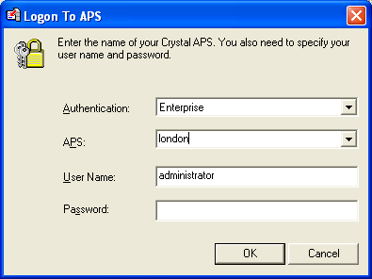
  - After Logon completes, click Open, choose “Enterprise” on left pane
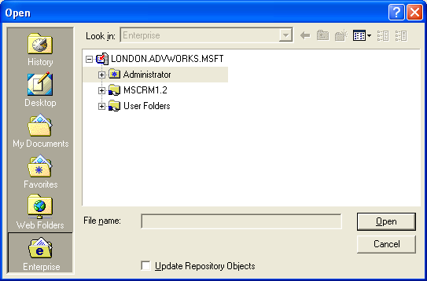
  - Drill down through MSCRM 1.2, choose custom report you want to open
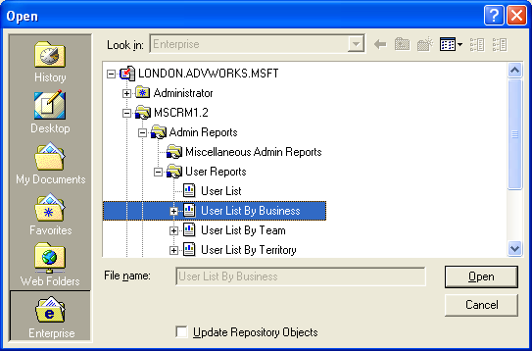
  - Once report is open click Save As and choose a name and location for the file
NOTE: Save all files to a location other than the database server
NOTE: All custom Crystal Reports will have to be re-written in SQL Reporting Services, after upgrading to CRM 3.0.

Environment Preparation
- Active Directory
  - The Microsoft CRM 3.0 Exchange email router requires the use of an Active Directory user account. This user account is not an existing CRM user and should be created from scratch within Active Directory.
  - This user account must be an account that is not a CRM user, has no limitation on mailbox size and the password does not expire.
  - Steps to create the Microsoft CRM 3.0 email router user account
    - Login to your domain controller
    - Open the Active Directory Users and Computers console
    - Highlight the Organizational Unit that your users reside in and choose “New User”
    - Create the user account and click Next
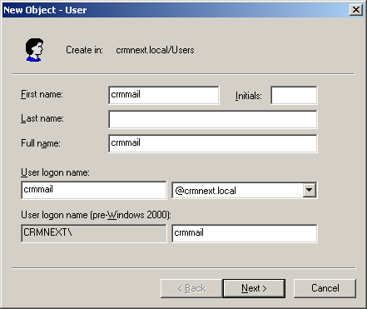
    - Enter password and select “Password Never Expires”
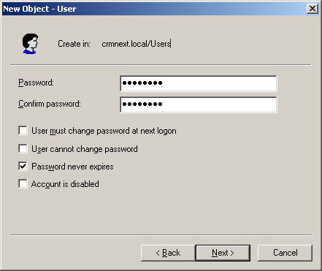
  - Leave the defaults for Exchange mailbox settings and click Next
  - Review settings and click Finish
    - If your Exchange environment has mailbox storage limits set up, open properties for new user account and click Exchange general tab
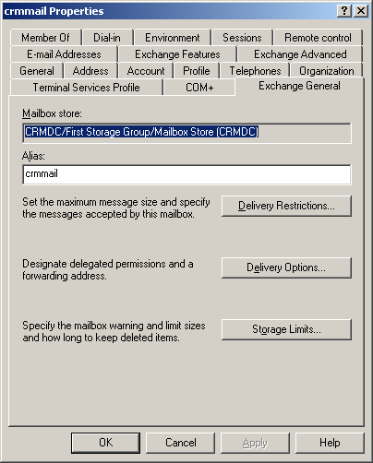
    - Click “Storage Limits”, uncheck “Use mailbox store limits” and make the limits a large number like 1GB
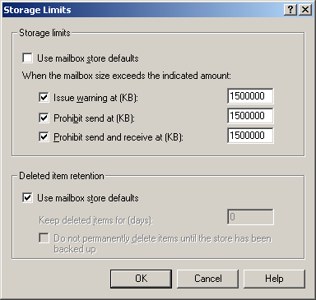
NOTE: While the CRM Exchange E-mail Router mailbox should not need to store that much data (it is only a forwarding mailbox), it is a good idea to make sure the limits are not set so low that it stops working.
- Cleanup old CRM users
  - Validate that all disabled CRM users have had their licenses removed
  - If you try and remove a license and you receive an error message than the user account was most likely deleted within Active Directory. In order to recover the CRM license you will need to review Knowledge Base article 835319
http://support.microsoft.com/?kbid=835319Third Party or ISV Solutions
  - It is important that you contact your Third Party or ISV vendor to find out if their solution is supported with Microsoft CRM 3.0

  - Consider upgrading client machines to Windows XP SP2 and Office 2003

NOTE: If Windows XP SP2 has been applied, and the Windows Firewall is enabled on the client, it is recommended you either allow traffic through port 2525 or allow an exception for the Microsoft CRM Sales for Outlook Client to make sure the client tool functions properly.
- SQL Database Maintenance/Optimization
  - It is a good idea to optimize your Microsoft CRM 1.2 SQL environment prior to upgrading to Microsoft CRM 3.0
  - See the Microsoft Whitepaper for optimizing CRM 1.2 for more details:
http://www.microsoft.com/downloads/details.aspx?FamilyID=E1A00070-2E5A-410A-881F-D859F8474933&displaylang=en
- Cleanup inactive SQL Publisher Agents
  - Log onto the CRM database server and open SQL
Enterprise Manager
  - Expand SQL Server Instance
  - Open the Replication Monitor
  - Open Publishers
  - Open the SQL Server where CRM is installed
  - Click on the METABASE publisher
  - Review the agents in the right-hand pane and determine the ones that can be removed
  - Right-click the inactive agent in right-hand pane and choose “Delete Deactivated Anonymous Subscription”
  - You will see the following alert:
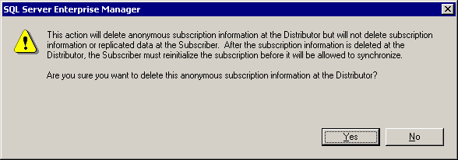
  - Click Yes
  - Repeat these steps for the MSCRM Publisher

Standard Microsoft CRM 1.x Upgrade Process
This upgrade process would apply to both single server (SBS 2003) and multiple server environments. For a single server environment, all server-based functions would be on the Small Business Server.
Upgrade Microsoft CRM Exchange Email Router
This step can be completed post upgrade but it is recommended to be run first to help prevent any lost email traffic with Microsoft CRM.

- Insert Microsoft CRM Server disc 1 in Exchange Server
- On splash screen, click “Install Microsoft CRM Exchange Email Router”
- Click “Start Installation”, accept license agreement
- Select features you want to install
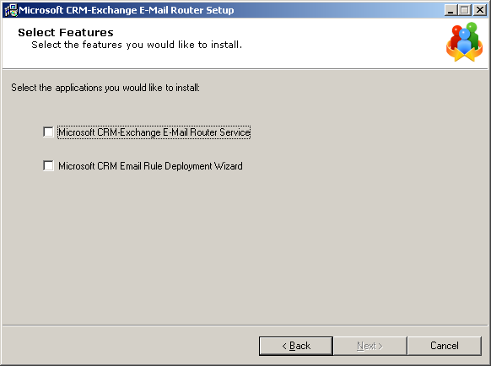
- Enter URL for CRM website
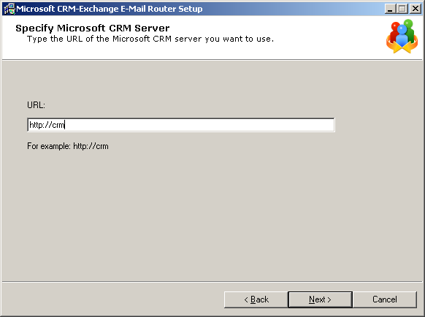
- Click Yes on the upgrade screen, click Next
- Specify the System Mailbox – Use the mailbox name from Active Directory account created in preparation steps
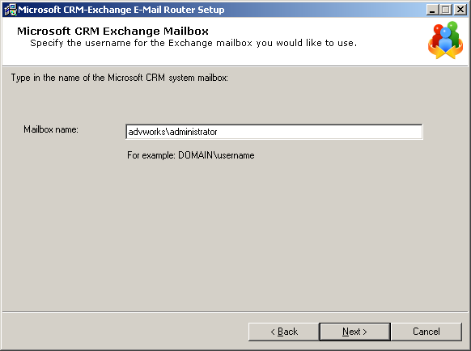
- Specify install location
- Setup verifies system requirements are met. If all checks are ok then
click Next
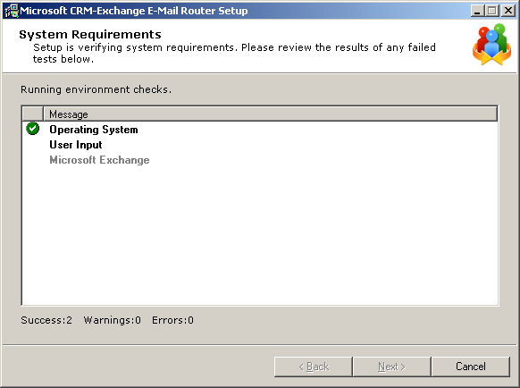
- Click Finish once the installation is complete
- Start CRM E-mail Router Configuration
(Start – All Programs – Microsoft CRM Exchange Connector – Rule Deployment Wizard)
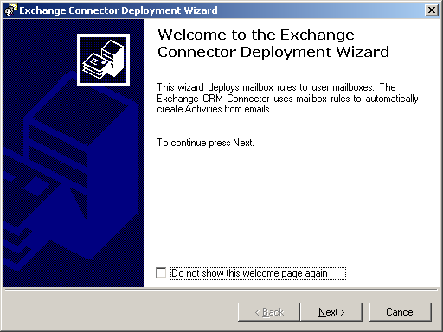

- Choose your CRM Application Server or manually enter the server name
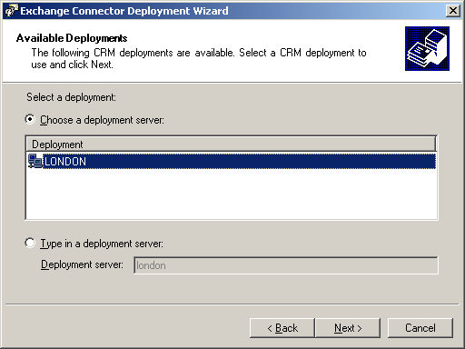

- Enter the URL for your CRM website
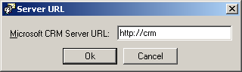

- Enter the Forward Email address
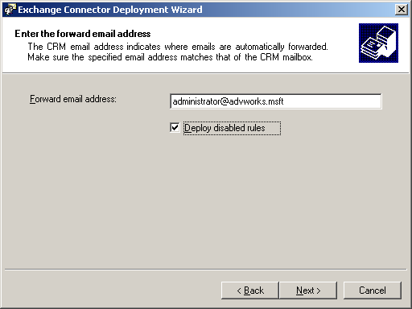
NOTE: This is the forward address for all CRM-related email traffic. This address should be the user account you created in the preparation steps discussed earlier in this document.

- Setup will verify rules and/or deploy rules for this mailbox
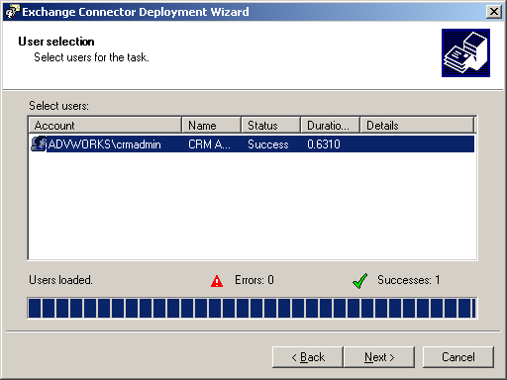

- Once setup is complete you can then re-deploy, verify or remove rules for the new CRM email router mailbox
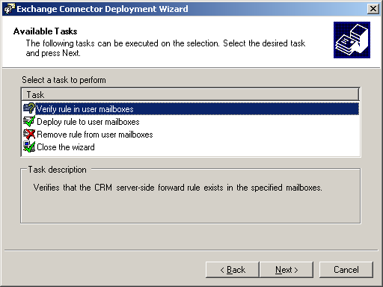
Uninstall CRM 1.x Exchange Email Connector
After successfully installing the new CRM email router you will want to uninstall the CRM 1.2 email connector.
  - Logon to the Exchange server and go to Add/Remove programs in
Control Panel
  - Remove the Microsoft CRM 1.x Exchange Email Connector

NOTE: Removing the connector should not require a reboot of the server.
Upgrade CRM Application Server
- Install the Microsoft CRM Server CD into the Microsoft CRM Server
- At the CRM Server Splash Screen click “Install Microsoft CRM Server”
- Enter the new license keys for Microsoft CRM 3.0 (the 3.0 license keys are located on the media for new customers – i.e. CDs)
- At the License Agreement screen, click “I accept license agreement” – Next
- The Microsoft CRM installation process will look for additional prerequisite software needed to install Microsoft CRM 3.0.
- Install Microsoft CRM Prerequisite software as dictated by the wizard
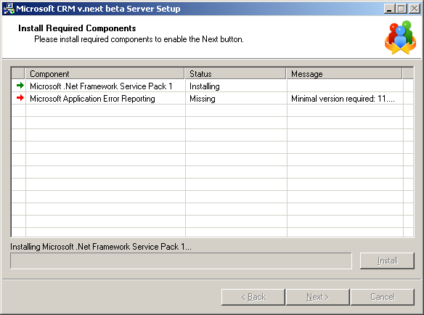

- Setup will detect that you have a previous version of Microsoft CRM. Click Next on this screen.
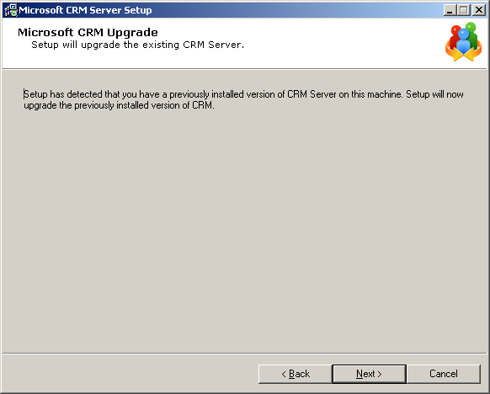
- The CRM organization name will default to the same name used for the 1.x installation. Click Next to continue.
- On the CEI Opt-in Option screen – Select Yes or No
- Determine whether or not you need to install a new SRS Report Server
  - If you already have SRS installed, and are using it for CRM 1.2, you can use it instead of installing SRS during the upgrade process
  - If you have SRS installed for other applications you should install SRS for CRM during the upgrade process as Microsoft CRM needs its own instance of SRS

- Backup your existing Crystal Reports by selecting Yes. The default password for the Crystal APS is blank unless your organization changed the account.
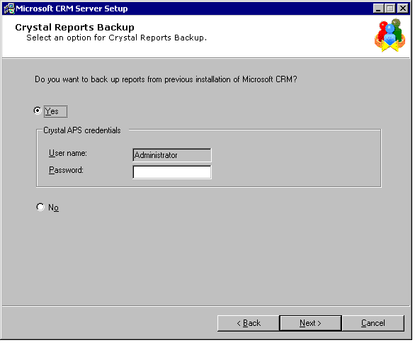

- Specify the security account to be used for installing the CRM services and click Next
- Specify the Incoming Exchange Server using the fully qualified domain name of your Exchange server (mail.advworks.msft)
- Setup will verify system requirements
- Review for errors

  - Highlight any errors and double click. A help window will popup detailing the error and how to resolve the issue.

- If there are no errors click Next
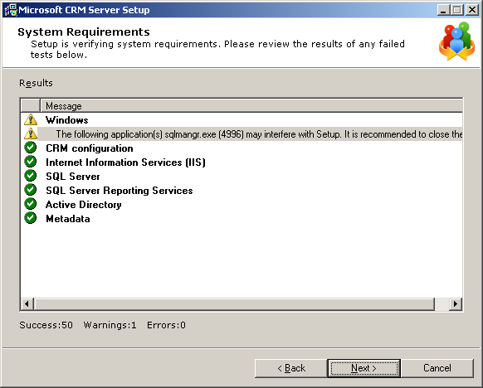
- Click Upgrade
- Setup will begin
- Once setup is complete click Finish and reboot the server
- After the server has rebooted you should verify the installation was successful by accessing the CRM web portal
Upgrade Clients
Microsoft CRM 3.0 ships with two installations of the CRM client. The Microsoft CRM Outlook Laptop installation is for users who need to go offline with Microsoft CRM. The Microsoft CRM Outlook Desktop version is for users who never need to leave the office. Select the proper installation for each user when installing the Microsoft CRM client installation.
NOTE: It is highly recommended that you upgrade the CRM server first followed by upgrading client machines.
- Choose the preferred CRM client installation
- Choose “Accept License Agreement”
- Setup will scan for required Microsoft CRM components
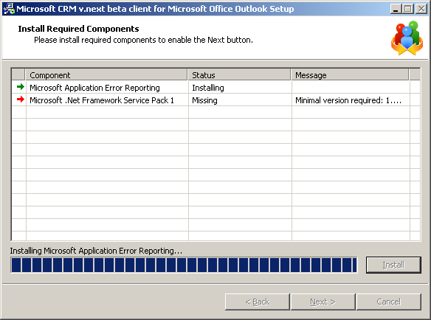
- Install any required components determined by the wizard

- If the .Net Framework SP1 is not yet installed, a reboot will be required

- Once all the required components are installed click Next
- Click Upgrade and wait for the installation to complete
- Click Finish
- Reboot the client PC
- Verify successful upgrade by opening Outlook and click on the Account folder within Microsoft CRM

Post Upgrade
Verify Functionality/Stability of Application
- Verify CRM Web Application functionality.
  - Log on to CRM web portal as licensed CRM user
  - Create records in CRM, access/modify records to verify functionality and security still remain
- Verify CRM Exchange Email Router functionality
  - Send test email from CRM
- Verify CRM Outlook Client functionality
  - Open Outlook from upgraded client PC and validate there are
no errors
  - Create test records, modify test records and delete test records
  - Track activates and emails with the CRM Outlook client
  - If the CRM Outlook client is the laptop client try going offline and verify there are no errors
- Verify database integrity
  - On the CRM database server, open SQL Query Analyzer
  - Type DBCC CHECKDB ([Organization Unit Name]_MSCRM)
  - Type DBCC CHECKDB ([Organization Unit name]_METABASE)
  - Type DBCC CHECKDB ([Organization Unit name]_CRMCRYSTAL)
  - Make sure all checks come back with no errors

Other Considerations
- Set up Maintenance Plans in SQL Enterprise Manager
(If they do not currently exist)
  - Open SQL Enterprise Manager
  - Expand “Management” Right click “Maintenance Plans” choose New Maintenance Plan
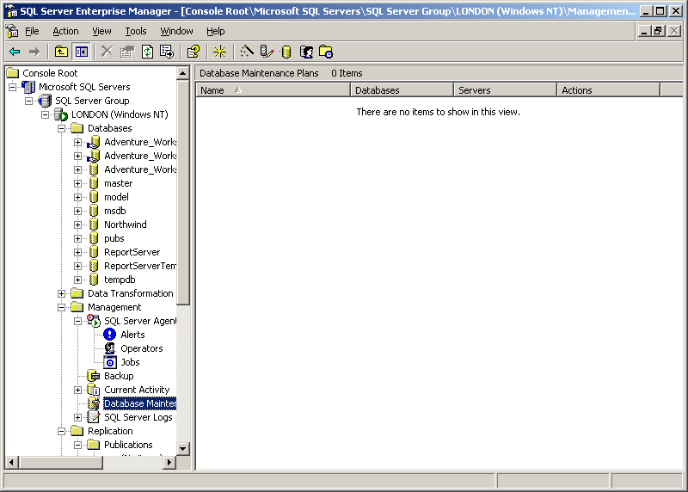
  - Select <company_name>_MSCRM and <company_name>_METABASE databases, click Next
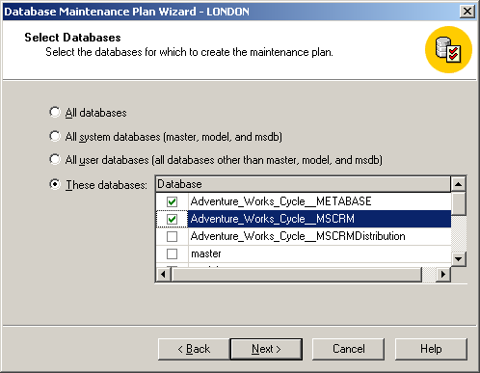
  - Select parameters for Database Optimizations
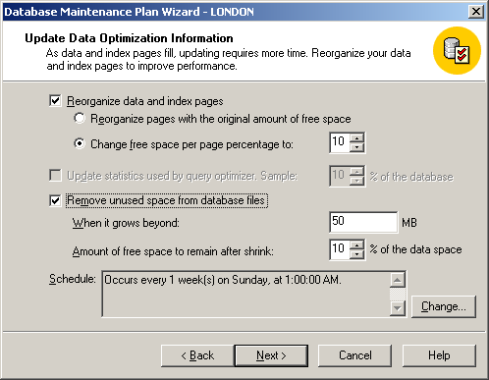
  - Select parameters for Database Integrity Check
  - Select parameters for Database Backup (Whether to back up to disk or tape, schedule, etc)
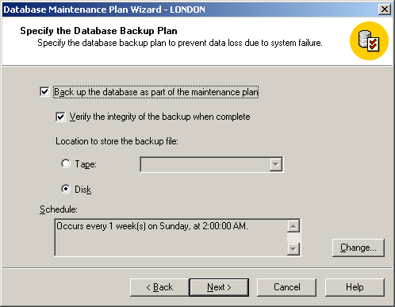
  - If backing up to disk, select options for location and how long to retain backup files on disk
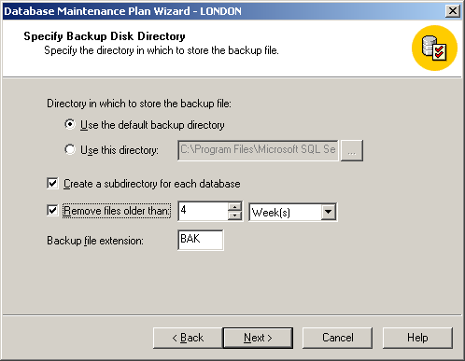
  - Repeat steps for Transaction Log backups
  - Select parameters for Database Maintenance Plan Reports
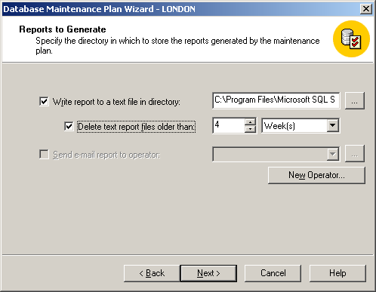
  - Select parameters for Maintenance Plan History
  - Review selections
  - Name the maintenance plan
  - Click Finish
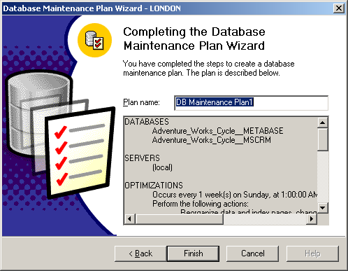
- Clean Up Active Directory
  - You can safely clean up Active Directory security groups created in CRM 1.2 (The scecurity roles are now stored in SQL) The only groups the you need to keep are:
    - <PrivUserGroup>
    - <SQLAccessGroup>
    - <UserGroup>
    - <ReportingGroup>
  - In Active Directory Users and Computers, Highlight your CRM Organizational Unit
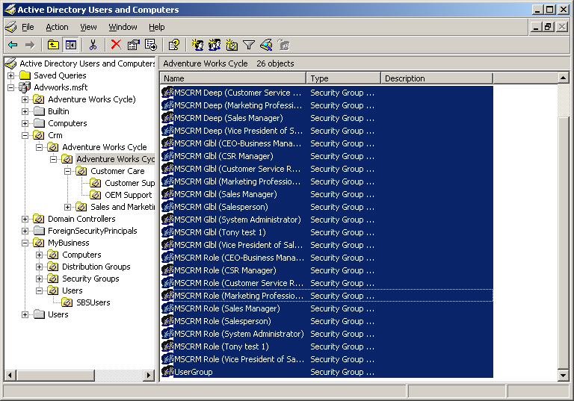
  - Highlight all the security groups and hit “Delete”
  - You can also safely delete any OUs related to Business Units created in CRM 1.2, as they are no longer stored in Active Directory
NOTE: It is very important that you DO NOT delete the four security groups mentioned above.

- Microsoft CRM 3.0 no longer uses Replication to sync Outlook clients so you can disable publishing for Microsoft CRM once all clients have been upgrade to 3.0
Note: Make sure Replication is not being used by any other databases or applications prior to disabling publishing
  - In SQL Enterprise Manager, Select Tools – Replication – Disable Publishing
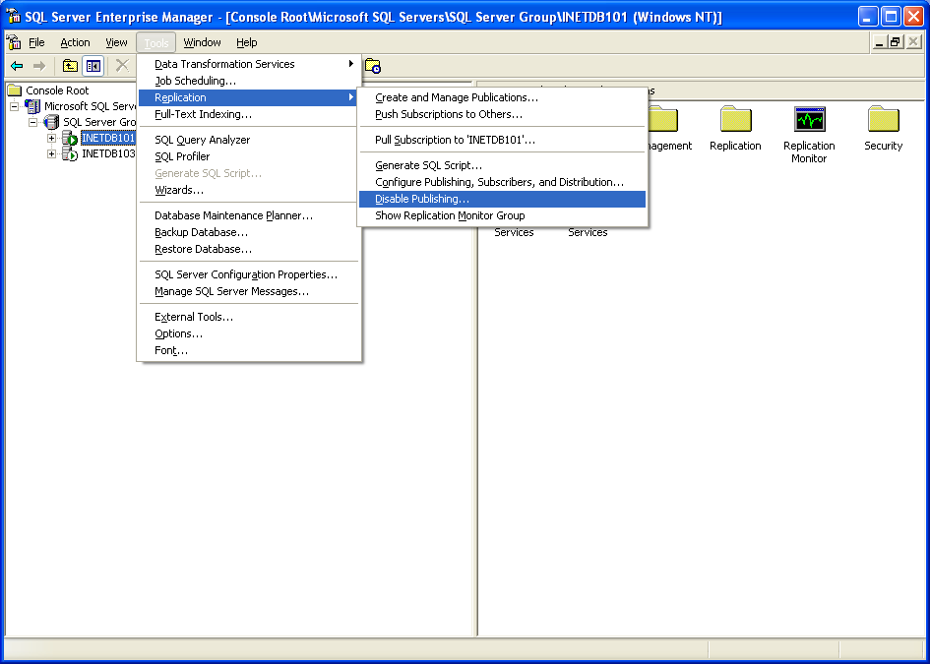
  - Choose “Yes Disable Publishing on (servername)”
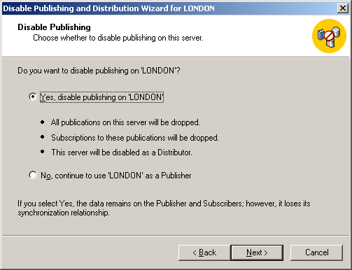
  - Review selections and click Finish

Remove Remaining Replication System Objects

After you disable publishing, run the following script to clean up any remaining replication system objects.
Important Execute this script against the <OrgName>_MSCRM database only.
SET NOCOUNT ON
CREATE TABLE ASReplicationObjects
(
name sysname,
type char(2),
crdate datetime
)

DECLARE @objectName sysname
DECLARE @objectType sysname

DECLARE @sqlStatement nvarchar(1024)
DECLARE @sqlStatementBegin sysname
DECLARE @sqlStatementAndType sysname
DECLARE @sqlStatementDropTrigger sysname
DECLARE @sqlStatementDropProcedure sysname
DECLARE @sqlStatementDropView sysname
DECLARE @sqlStatementDropTable sysname

SET @sqlStatementBegin = N'IF EXISTS (SELECT name FROM sysobjects WHERE
name = N'''
SET @sqlStatementAndType = N''' AND type=N'''
SET @sqlStatementDropTrigger = N''') DROP TRIGGER '
SET @sqlStatementDropProcedure = N''') DROP PROCEDURE '
SET @sqlStatementDropView = N''') DROP VIEW '
SET @sqlStatementDropTable = N''') DROP TABLE '

--Delete triggers.
SET @objectType = N'TR'
insert into ASReplicationObjects
select name, type, crdate from sysobjects where (type=@objectType) and
(name like N'del_%' or name like N'ins_%' or name like N'upd_%' )
order by name

select count(*) from ASReplicationObjects as CountTriggers

DECLARE trigger_cursor CURSOR FOR
SELECT name FROM ASReplicationObjects WHERE type = @objectType

OPEN trigger_cursor
FETCH NEXT FROM trigger_cursor INTO @objectName
WHILE @@FETCH_STATUS = 0
BEGIN
SET @sqlStatement = @sqlStatementBegin + @objectName +
@sqlStatementAndType +@objectType + @sqlStatementDropTrigger +
@objectName
PRINT @sqlStatement
EXEC sp_executesql @stmt = @sqlStatement
FETCH NEXT FROM trigger_cursor INTO @objectName
END

CLOSE trigger_cursor
DEALLOCATE trigger_cursor

DELETE ASReplicationObjects

--Delete stored procedures.
SET @objectType = N'P'
insert into ASReplicationObjects
select name, type, crdate from sysobjects where (type =@objectType) and
(name like N'sp_cft_%' or name like N'sp_ins_%' or
name like N'sp_sel_%' or name like N'sp_upd_%' or name like N'sel_%')
order by name

select count(*) from ASReplicationObjects as CountStoredProcedures_cft_ins_sel_upd

DECLARE storproc_cursor CURSOR FOR
SELECT name FROM ASReplicationObjects WHERE type = @objectType

OPEN storproc_cursor
FETCH NEXT FROM storproc_cursor INTO @objectName
WHILE @@FETCH_STATUS = 0
BEGIN
SET @sqlStatement = @sqlStatementBegin + @objectName +
@sqlStatementAndType +@objectType + @sqlStatementDropProcedure +
@objectName
PRINT @sqlStatement
EXEC sp_executesql @stmt = @sqlStatement
FETCH NEXT FROM storproc_cursor INTO @objectName
END

CLOSE storproc_cursor
DEALLOCATE storproc_cursor

DELETE ASReplicationObjects

--Delete stored procedures, for example, %xp and _% . 53 sp, for each –
--Replication setup.
SET @objectType = N'P'
insert into ASReplicationObjects
select name, type, crdate from sysobjects where (type =@objectType) and
(name like N'%xpand_%' or name like N'%p_cft_%')
order by name

select count(*) from ASReplicationObjects as CountStoredProceduresLikeExpand

DECLARE storproc_cursor2 CURSOR FOR
SELECT name FROM ASReplicationObjects WHERE type = @objectType

OPEN storproc_cursor2
FETCH NEXT FROM storproc_cursor2 INTO @objectName
WHILE @@FETCH_STATUS = 0
BEGIN
SET @sqlStatement = @sqlStatementBegin + @objectName +
@sqlStatementAndType +@objectType + @sqlStatementDropProcedure +
@objectName
PRINT @sqlStatement
EXEC sp_executesql @stmt = @sqlStatement
FETCH NEXT FROM storproc_cursor2 INTO @objectName
END

CLOSE storproc_cursor2
DEALLOCATE storproc_cursor2

DELETE ASReplicationObjects

--Delete views.
SET @objectType = N'V'
insert into ASReplicationObjects
-- In case views should be removed from metabase.
select name, type, crdate from sysobjects where (type='V') and
(name like N'ctsv_%' or name like N'tsvw_%' or name like N'CRMPub%'
or name like N'CRMMetaPub%')
order by name

select count(*) from ASReplicationObjects as CountViews

DECLARE view_cursor CURSOR FOR
SELECT name FROM ASReplicationObjects WHERE type = @objectType

OPEN view_cursor
FETCH NEXT FROM view_cursor INTO @objectName
WHILE @@FETCH_STATUS = 0
BEGIN
SET @sqlStatement = @sqlStatementBegin + @objectName +
@sqlStatementAndType +@objectType + @sqlStatementDropView +
N'['+@objectName +N']'
PRINT @sqlStatement
EXEC sp_executesql @stmt = @sqlStatement
FETCH NEXT FROM view_cursor INTO @objectName
END

CLOSE view_cursor
DEALLOCATE view_cursor

DELETE ASReplicationObjects

--Delete tables.
SET @objectType = N'U'
insert into ASReplicationObjects
select name, type, crdate from sysobjects where (type='U') and
(name like N'%onflict_%' )
order by name

select count(*) from ASReplicationObjects as CountTables

DECLARE table_cursor CURSOR FOR
SELECT name FROM ASReplicationObjects WHERE type = @objectType

OPEN table_cursor
FETCH NEXT FROM table_cursor INTO @objectName
WHILE @@FETCH_STATUS = 0
BEGIN
-- "-" in table name has a syntax problem, so add [] around table name.
SET @sqlStatement = @sqlStatementBegin + @objectName +
@sqlStatementAndType +@objectType + @sqlStatementDropTable +
N'['+@objectName + N']'
PRINT @sqlStatement
EXEC sp_executesql @stmt = @sqlStatement
FETCH NEXT FROM table_cursor INTO @objectName
END

CLOSE table_cursor
DEALLOCATE table_cursor
DELETE ASReplicationObjects
DROP TABLE ASReplicationObjects

This is a preliminary document and may be changed substantially prior to final commercial release of the software described herein.

The information contained in this document represents the current view of Microsoft Corporation on the issues discussed as of the date of publication. Because Microsoft must respond to changing market conditions, it should not be interpreted to be a commitment on the part of Microsoft, and Microsoft cannot guarantee the accuracy of any information presented after the date of publication.

This White Paper is for informational purposes only. MICROSOFT MAKES NO WARRANTIES, EXPRESS OR IMPLIED, AS TO THE INFORMATION IN THIS DOCUMENT.

Complying with all applicable copyright laws is the responsibility of the user. Without limiting the rights under copyright, no part of this document may be reproduced, stored in or introduced into a retrieval system, or transmitted in any form or by any means (electronic, mechanical, photocopying, recording, or otherwise), or for any purpose, without the express written permission of Microsoft Corporation.

Microsoft may have patents, patent applications, trademarks, copyrights, or other intellectual property rights covering subject matter in this document. Except as expressly provided in any written license agreement from Microsoft, the furnishing of this document does not give you any license to these patents, trademarks, copyrights, or other intellectual property.

© 2005 Microsoft Corporation. All rights reserved.

Microsoft, Active Directory, Windows, and Windows Server are either registered trademarks or trademarks of Microsoft Corporation in the United States and/or other countries.

The names of actual companies and products mentioned herein may be the trademarks of their respective owners.

