

Step-by-Step Guide for Configuring Remote Access Policies Using Routing and Remote Access
Microsoft Corporation
Published: July 2005

Abstract
This step-by-step guide describes how to configure remote access policies through the Routing and Remote Access snap-in when Routing and Remote Access is configured to use a Windows authentication provider and through the Internet Authentication Service (IAS) snap-in when Routing and Remote Access is configured to use a Remote Authentication Dial-In User Service (RADIUS) authentication provider. This guide offers only step-by-step procedures for configuring remote access policies, not strategies for implementing remote access connectivity. It is intended for administrators who have experience managing the remote access features of Microsoft® Windows Server™ 2003 operating systems.

Information in this document, including URL and other Internet Web site references, is subject to change without notice. Unless otherwise noted, the example companies, organizations, products, domain names, e-mail addresses, logos, people, places, and events depicted herein are fictitious, and no association with any real company, organization, product, domain name, e-mail address, logo, person, place, or event is intended or should be inferred. Complying with all applicable copyright laws is the responsibility of the user. Without limiting the rights under copyright, no part of this document may be reproduced, stored in or introduced into a retrieval system, or transmitted in any form or by any means (electronic, mechanical, photocopying, recording, or otherwise), or for any purpose, without the express written permission of Microsoft Corporation.

Microsoft may have patents, patent applications, trademarks, copyrights, or other intellectual property rights covering subject matter in this document. Except as expressly provided in any written license agreement from Microsoft, the furnishing of this document does not give you any license to these patents, trademarks, copyrights, or other intellectual property.

© 2005 Microsoft Corporation. All rights reserved.

Microsoft, Windows, Windows NT, Windows Server, and Active Directory are either registered trademarks or trademarks of Microsoft Corporation in the United States and/or other countries.

All other trademarks are property of their respective owners.

Contents
Step-by-Step Guide for Configuring Remote Access Policies Using Routing and Remote Access 7
Overview of Remote Access Policies 7
Remote Access Policies and the Routing and Remote Access Service 8
Authorizing Access 8
Authorization by User 9
Authorization by Group 9
Configuring Remote Access Policies Using Routing and Remote Access 9
User Permissions and Groups 10
To raise the domain functional level to either Windows 2000 native or Windows Server 2003 11
To enable remote access permission 11
Authentication Providers and Methods 13
To specify an authentication provider 13
To configure authentication methods 14
Default Remote Access Policy: Granting or Denying Access 14
To configure a remote access policy to grant or deny access 15
Remote Access Policies: Adding, Deleting, Renaming, and Changing Priority 16
To add a remote access policy 16
To delete a remote access policy 18
To rename a remote access policy 18
To change the priority of a remote access policy 19
Remote Access Policies: Configuring Conditions and Profiles 19
To configure the conditions of a remote access policy 19
To configure the profile of a remote access policy 21
Summary and Examples 27
Allow Dial-up Connection Using Group Membership 28
Restrict Connections to a Maximum Session Time 29

Step-by-Step Guide for Configuring Remote Access Policies Using Routing and Remote Access
This guide provides an overview of remote access policies, procedures for configuring remote access policies using Routing and Remote Access, and examples of remote access policies from a Routing and Remote Access perspective.

Overview of Remote Access Policies
For the Routing and Remote Access service in Microsoft® Windows Server™ 2003 and Windows® 2000 operating systems, users are granted access to a network from remote locations based on remote access policies and the properties of the users' accounts.
Remote access policies are an ordered set of rules that define whether connection attempts are either authorized or rejected. Each rule includes one or more conditions, a set of profile settings, and a permission setting for remote access. For information about connection restrictions that you can configure through a remote access policy profile, see Elements of a remote access policy.
If Routing and Remote Access is configured to use a Windows authentication provider, you configure remote access policies through the Routing and Remote Access snap-in and store those policies on the server that is running Routing and Remote Access. If Routing and Remote Access is configured to use a Remote Authentication Dial-In User Service (RADIUS) authentication provider, you configure remote access policies through Internet Authentication Service (IAS) and store the policies on the server running IAS. For more information about using IAS to administer remote access policies, see "Remote Access Policies and the Routing and Remote Access Service" later in this guide.
If the remote access policy authorizes a connection, the policy profile specifies a set of connection restrictions. The connection properties of the user account also provide a set of restrictions. Where connection restrictions conflict, account restrictions override those of the remote access policy. For information about connection restrictions that you can configure on a user account, see Dial-in properties of a user account.

Remote Access Policies and the Routing and Remote Access Service
For servers running Routing and Remote Access that are configured for a Windows authentication provider, you administer remote access policies from the Routing and Remote Access snap-in, and the policies apply only to the connections of the server running Routing and Remote Access. For servers that are running Routing and Remote Access and that are configured for a RADIUS authentication provider, you cannot configure remote access policies using the Routing and Remote Access snap-in. If the RADIUS server is an IAS server, you administer remote access policies from IAS. For more information about selecting an authentication provider, see "Authentication Providers" later in this guide.
To centrally manage a single set of remote access policies for multiple remote access or virtual private networking (VPN) servers using an IAS server, you must do the following:
1. Install IAS as a RADIUS server. For more information, see Checklist: Configuring IAS for dial-up and VPN access.
2. Configure IAS with RADIUS clients that correspond to each of the remote access or VPN servers. For more information, see Add RADIUS clients.
3. On the IAS server, create the central set of policies that all servers running Routing and Remote Access will use. For more information, see "To add a remote access policy" later in this guide.
4. Configure each of the servers running Routing and Remote Access as RADIUS clients to the IAS server. For more information, see Use RADIUS authentication.
For more information about deploying IAS for centralized management of remote access policies, see Using RADIUS for multiple remote access servers.
Note:
You can also use centralized management of remote access policies for remote access servers that are running the Routing and Remote Access Service (RRAS) on the Microsoft Windows NT® Server 4.0 operating systems. You can configure your server as a RADIUS client to an IAS server. However, you cannot configure a remote access server running Windows NT 4.0 without RRAS to use centralized remote access policies.

Authorizing Access
You can use remote access policies to grant authorization in two ways:
• By user
• By group

Authorization by User
If you are managing authorization by user, set the remote access permission on the user or computer account to either grant or deny access and, optionally, create different remote access policies based on different types of connections. For example, you might want to use one remote access policy for dial-up connections and another for wireless connections.
Important:
Managing authorization by user is recommended only if you have a small number of user or computer accounts to manage.
For more information about setting remote access permissions on user accounts, see "User Permissions and Groups" later in this guide.

Authorization by Group
If you are managing authorization by group, set the remote access permission on the user account to control access through remote access policy and create remote access policies that are based on different types of connections and membership in different groups. For example, you could have one remote access policy for employees (members of the Employees group) and another for contractors (members of the Contractors group).
Important:
Setting the remote access permission on user accounts to control access through remote access policy, rather than using groups to manage network access, is not recommended.
For procedures about setting remote access permissions on user accounts, see "User Permissions and Groups" later in this guide.

Configuring Remote Access Policies Using Routing and Remote Access
This section describes how to configure remote access policies using Routing and Remote Access. This guide assumes that your servers are already running Routing and Remote Access. If they are not, see Enable the Routing and Remote Access service for more information.
The following topics are covered in this section:
• User Permissions and Groups
• Authentication Providers and Methods
• Default Remote Access Policy: Granting or Denying Access
• Remote Access Policies: Adding, Deleting, Renaming, and Changing Priority
• Remote Access Policies: Configuring Conditions and Profiles

User Permissions and Groups
Before you configure a remote access policy, you must enable remote access permission for your user accounts. You may also need to create a user group to contain those user accounts. For information about creating user accounts, creating groups, and adding user accounts to groups, see Manage Users, Groups, and Computers.
Important:
Before you enable remote access permission for your user accounts, you may need to raise the functional level of your domain to Windows 2000 native or Windows Server 2003. The following procedure describes how to perform that task. However, you must be logged on as a member of either the Domain Admins group in the domain for which you want to raise the functional level, you must be logged on as a member of the Enterprise Admins group in the Active Directory® directory service, or you must have been granted the appropriate authority. For more information, see Domain and forest functionality.
If you have or will have any domain controllers running Windows NT, do not raise the domain functional level to Windows 2000 native. If you set the domain functional level to Windows 2000 native, you cannot change it back to Windows 2000 mixed.
Likewise, if you have or will have any domain controllers running Windows NT or Windows 2000, do not raise the domain functional level to Windows Server 2003. If you set the domain functional level to Windows Server 2003, you cannot change it back to Windows 2000 mixed or Windows 2000 native.
Note:
You can see a domain's current functional level under Current domain functional level in the Raise Domain Functional Level dialog box. The following procedure provides steps for opening that dialog box.

To raise the domain functional level to either Windows 2000 native or Windows Server 2003
1. Click Start, point to Programs, point to Administrative Tools, and click Active Directory Domains and Trusts. If necessary, double-click the domain name to expand the tree.
2. In the tree, right-click the domain for which you want to raise the domain functional level, and then click Raise Domain Functional Level to open the Raise Domain Functional Level dialog box.
3. In Select an available domain functional level, click either Windows 2000 native or Windows Server 2003, and then click Raise.
The following procedure describes how to enable remote access permission for user accounts.
Note:
Remote access permissions in user accounts override those in remote access policies.

To enable remote access permission
1. Click Start, point to Programs, point to Administrative Tools, and click Active Directory Users and Computers. If necessary, double-click the domain name to expand the tree.
2. In the tree, click the Users folder.
3. Double-click the user account for which you want to enable remote access permission.
4. On the Dial-in tab, click either Allow access, Deny access, or Control access through Remote Access Policy, as shown in the following figure.
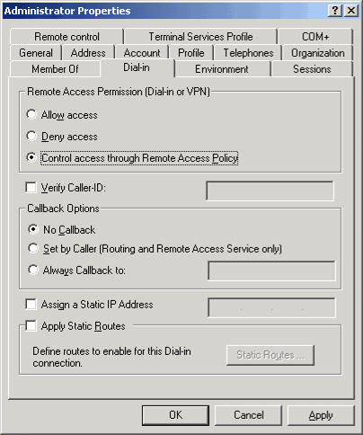

If you click Allow access, the remote access server will determine whether the connection attempt matches all conditions of the given policy. If all conditions are met, the server applies the connection settings of the policy profile and user account. If not all conditions are met, the server rejects the connection attempt.
If you click Deny access, the remote access server rejects the connection attempt.
If you click Control access through Remote Access Policy, the remote access server determines whether the connection attempt matches all policy conditions and checks the remote access permission of the given policy. If you have specified Grant remote access permission, the server applies the connection settings of the policy profile and user account. If you have specified Deny remote access permission, the server rejects the connection attempt.
5. Click OK.
6. Repeat steps 3 through 5 as necessary.

Authentication Providers and Methods
Before you configure your remote access policies, you must choose an authentication provider and configure the authentication methods for your remote access servers. The following procedures describe how you do that.

To specify an authentication provider
1. Click Start, point to Programs, point to Administrative Tools, and then click Routing and Remote Access.
2. In the tree, right-click the server, click Properties, and then click the Security tab.
3. Under Authentication provider, click either RADIUS Authentication or Windows Authentication, as shown in the following figure.
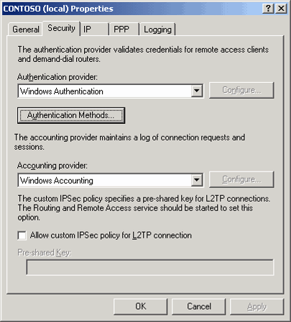

See "Remote Access Policies and the Routing and Remote Access Service" earlier in this guide for more information about choosing an authentication provider.
4. Click OK.

To configure authentication methods
1. Click Start, point to Programs, point to Administrative Tools, and then click Routing and Remote Access.
2. In the tree, right-click the server, click Properties, and then click the Security tab.
3. Click Authentication Methods, and then specify any required settings.
For detailed information about the different authentication methods settings associated with remote access servers, see Remote Access Authentication Methods.
4. Click OK.

Default Remote Access Policy: Granting or Denying Access
The default remote access policy is set to deny all access to everyone. Your users will not be able to connect to your dial-up or VPN server until you either edit the default policy to allow access or replace the default policy with your own policies. For more information about creating your own policies, see "To add a remote access policy" later in this guide.
If you need to re-create the default remote access policy, see Re-create the default remote access policy.
Important:
If your server has been previously configured as a remote access server or if IAS has been configured on your server, the remote access policy or policies that appear in Routing and Remote Access might be configured differently from the default remote access policy. Carefully review all of your remote access policies to ensure that you have allowed and denied remote access according to your network needs. Be sure that you are not accidentally allowing or denying more remote access to your network than you intend.
The following procedure describes how to configure a remote access policy to grant or deny network access.
Note:
The Remote Access Permission setting on the properties of the user or computer account overrides this setting if it is set to either Allow access or Deny access.

To configure a remote access policy to grant or deny access
1. Click Start, point to Programs, point to Administrative Tools, and click Routing and Remote Access. If necessary, double-click the server name to expand the tree.
2. In the tree, click Remote Access Policies.
3. In the details pane, double-click the policy that you want to configure.
4. Under If a connection request matches the specified conditions, click Grant remote access permission or Deny remote access permission, as shown in the following figure.
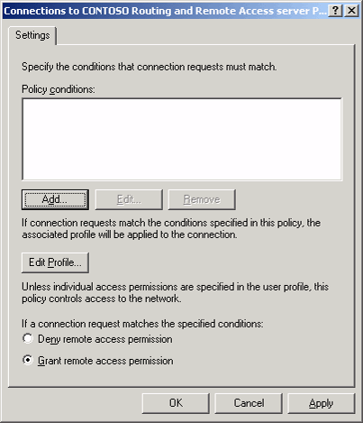

5. Click OK.

Remote Access Policies: Adding, Deleting, Renaming, and Changing Priority
The following procedures describe how to add, delete, rename, and change the priority of remote access policies.

To add a remote access policy
Important:
You cannot use this procedure to configure a remote access policy unless a remote access server is already installed on your network. After installing one or more remote access servers, use this procedure and the New Remote Access Policy Wizard to configure a new remote access policy.
1. Click Start, point to Programs, point to Administrative Tools, and click Routing and Remote Access. If necessary, double-click the server name to expand the tree.
2. In the tree, right-click Remote Access Policies, and then click New Remote Access Policy, as shown in the following figure.
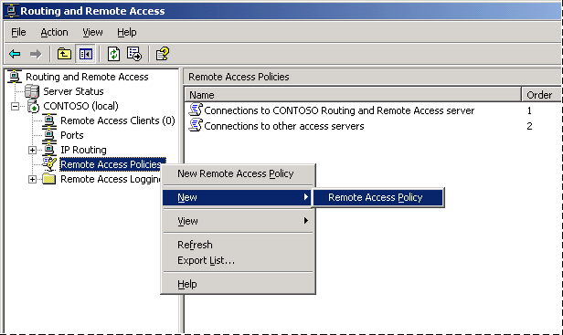

3. Use the New Remote Access Policy Wizard to create a policy, as shown in the following figure.
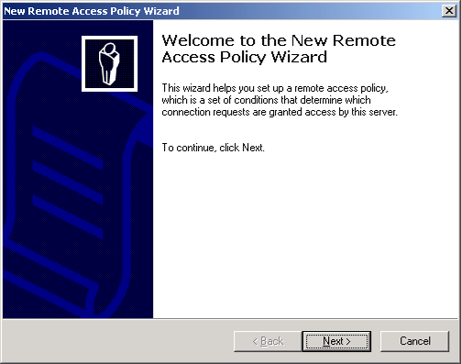

When you use the New Remote Access Policy Wizard to create a common policy:
• The access method is used to automatically configure the NAS Port Type condition.
• If you choose to grant access by group, the Windows Groups condition is automatically set to the selected groups.
• The authentication settings are used to set the profile settings on the Authentication tab.
• The encryption levels are used to set the profile settings on the Encryption tab.
• The remote access permission is always set to Grant remote access permission.
For a common policy, you must choose the following:
• An access method:
• VPN
• Dial-up
• Wireless
• Ethernet
• Whether to grant access permission by user or by group.
• Authentication methods. (See "To configure the profile of a remote access policy" later in this guide.)
• Levels of allowed encryption, depending on the access method selected. (See "To configure the profile of a remote access policy" later in this guide.)
For a custom policy, you must configure the following:
• A set of policy conditions. (See "To configure the conditions of a remote access policy" later in this guide.)
• Whether remote access permission for the policy is granted or denied.
• Remote access policy profile settings. (See "To configure the profile of a remote access policy" later in this guide.)

To delete a remote access policy
1. Click Start, point to Programs, point to Administrative Tools, and click Routing and Remote Access. If necessary, double-click the server name to expand the tree.
2. In the tree, click Remote Access Policies.
3. In the details pane, right-click the policy that you want to delete, and then click Delete.

To rename a remote access policy
1. Click Start, point to Programs, point to Administrative Tools, and click Routing and Remote Access. If necessary, double-click the server name to expand the tree.
2. In the tree, click Remote Access Policies.
3. In the details pane, right-click the policy that you want to rename, and then click Rename.
4. Type a new name for the policy, and then press ENTER.

To change the priority of a remote access policy
1. Click Start, point to Programs, point to Administrative Tools, and click Routing and Remote Access. If necessary, double-click the server name to expand the tree.
2. In the tree, click Remote Access Policies.
3. In the details pane, right-click the policy that you want to change the priority of, and then click Move Up or Move Down.
Note:
Remote access policies are listed in order of priority in the details pane.

Remote Access Policies: Configuring Conditions and Profiles
Remote access policy conditions are one or more attributes that the remote access server compares to the settings of the connection attempt. If policy includes multiple conditions, the attempt must match all of the conditions for the server to allow access. A remote access policy profile is a set of properties that are applied to a connection when it is authorized. You specify these properties either through the user account or policy permission settings.
The following procedures describe how to configure the conditions and profiles of new and existing remote access policies.

To configure the conditions of a remote access policy
1. Click Start, point to Programs, point to Administrative Tools, and click Routing and Remote Access. If necessary, double-click the server name to expand the tree.
2. In the tree, click Remote Access Policies.
3. In the details pane, double-click the policy that you want to configure.
4. To configure a new condition, click Add under Policy conditions and then do the following:
• In the Select Attribute dialog box, click the attribute to add, and then click Add, as shown in the following figure.
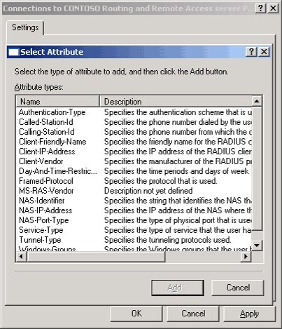

For detailed information about the different attributes associated with remote access policy conditions, see Elements of a remote access policy.
• In the Authentication–Type dialog box, configure the authentication type, as shown in the following figure.
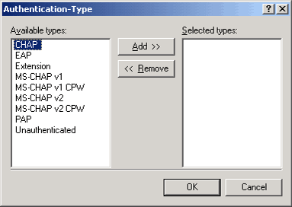

5. Click OK.
6. To change the configuration of an existing condition, do the following:
• Click the condition, and then click Edit.
• In the Select Attribute and Authentication–Type dialog boxes, specify the required settings, and then click OK.
For detailed information about the different attributes associated with remote access policy conditions, see Elements of a remote access policy.

To configure the profile of a remote access policy
1. Click Start, point to Programs, point to Administrative Tools, and click Routing and Remote Access. If necessary, double-click the server name to expand the tree.
2. In the tree, click Remote Access Policies.
3. In the details pane, double-click the policy that you want to configure.
4. Click Edit Profile.
5. To configure connection constraints, click the Dial-in Constraints tab (if necessary), and then specify any required settings, as shown in the following figure.
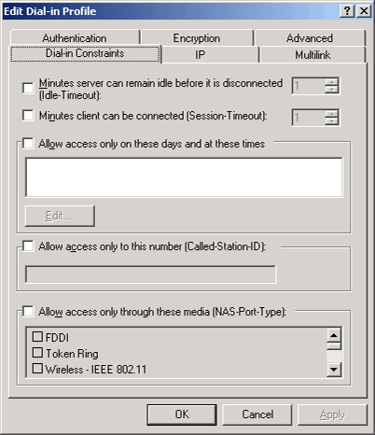

For detailed information about the different constraints associated with remote access policies, see Elements of a remote access policy.
6. Click OK.
7. To configure IP options, click the IP tab, and then specify any required settings, as shown in the following figure.
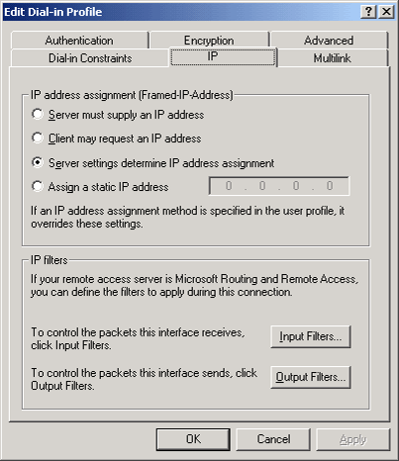

For detailed information about the different IP settings associated with remote access policies, see Elements of a remote access policy.
8. Click OK.
9. To configure multilink options, click the Multilink tab, and then specify any required settings, as shown in the following figure.
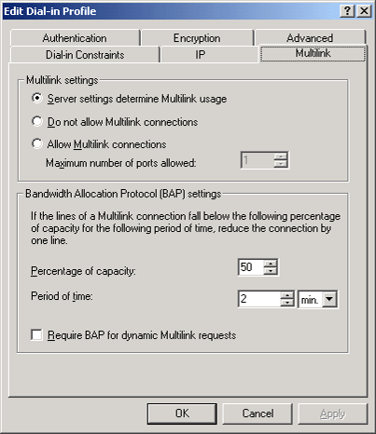

For detailed information about the different multilink settings associated with remote access policies, see Elements of a remote access policy.
10. Click OK.
11. To configure authentication methods, click the Authentication tab, and then specify any required settings, as shown in the following figure.
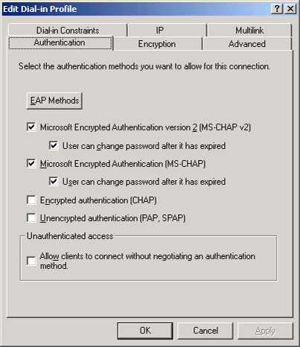

Important:
Ensure the authentication methods configured in your remote access policies match the authentication methods you configured for the remote access server that contains those policies.
For detailed information about the different authentication methods associated with remote access policies, see Elements of a remote access policy and Configure PEAP and EAP methods.
12. Click OK.
13. To configure encryption levels, click the Encryption tab, and then specify any required settings, as shown in the following figure.
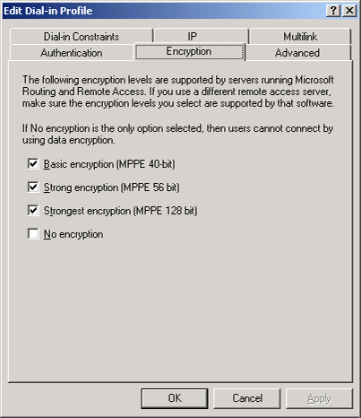

For detailed information about the different encryption settings associated with remote access policies, see Elements of a remote access policy.
14. Click OK.
15. To configure additional connection attributes, click the Advanced tab, and then specify any required settings, as shown in the following figure.
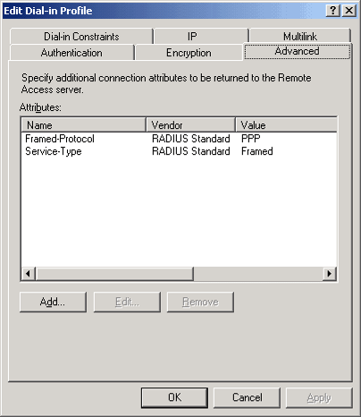

For more information, see Add RADIUS attributes to a remote access policy and Configure vendor-specific attributes for a remote access policy.
16. Click OK.

Summary and Examples
By using remote access policies, you can gain a tremendous amount of flexibility in accepting connections based on policy evaluation order, policy conditions, user and policy connection permissions, and both policy profile and user account properties.
This section describes two examples of how you could use remote access policies:

Allow Dial-up Connection Using Group Membership
In this example, the network administrator is managing authorization by using groups. All user accounts have the Remote Access Permission (Dial-in or VPN) option set to Control access through Remote Access Policy.
The network administrator wants to allow dial-up connections for only those user accounts that belong to a specific set of groups. After remote access permission is set for all user accounts and the users have been added to their associated groups, the administrator completes the following steps:
1. Click Start, point to Programs, point to Administrative Tools, and click Routing and Remote Access.
2. In the tree, right-click Remote Access Policies, and then click New Remote Access Policy.
3. Use the New Remote Access Policy Wizard to create a common dial-up policy with the following settings:
• Policy name: Dial-up access for allowed groups
• Access Method: Dial-up access
• User or Group: Specify Group, and then specify the set of groups for which dial-up access is allowed.
• Authentication methods: Select Microsoft Encrypted Authentication version 2 (MS-CHAP v2) and Microsoft Encrypted Authentication.
• Policy Encryption Level: Select all check boxes.
4. In the details pane, right-click both default policies, and then click Delete.
Note:
You do not need a separate remote access policy for each group. You can specify multiple groups or you can use nested groups to both delegate administration of and consolidate group membership. For a remote access or IAS server in a Windows 2000 native domain or a Windows Server 2003 domain, you can use universal groups. For more information, see Domain and forest functionality.
You cannot use built-in or local domain groups when specifying group names.

Restrict Connections to a Maximum Session Time
In this example, the network administrator is managing authorization by using groups. All user accounts have the Remote Access Permission (Dial-in or VPN) option set to Control access through Remote Access Policy.
To conserve resources, the network administrator wants to limit the maximum session time for all dial-up users (members of the DialUpUsers group) to 20 minutes.
To implement this restriction through a remote access policy using Routing and Remote Access, the administrator completes the following steps:
1. Click Start, point to Programs, point to Administrative Tools, and click Routing and Remote Access.
2. In the tree, right-click Remote Access Policies, and then click New Remote Access Policy.
3. Use the New Remote Access Policy Wizard to create a custom policy with the following settings:
• Policy name: Maximum session time of 20 minutes
• Conditions: NAS-Port-Type matches Async (Modem); Windows-Groups matches DialUpUsers
• Permission: Grant remote access permission
• Profile settings, Dial-in Constraints tab: Select the Minutes client can be connected check box, and then type 20.
4. In the details pane, right-click both default policies (Connections to CONTOSO Routing and Remote Access server and Connections to other access servers), and then click Delete.

